Q1 Antimicrobial Prescribing Audit Report 2022/23
Introduction:
This audit report summarises the key findings of the antimicrobial prescribing audit conducted in July 2022 and it is used to monitor antimicrobial prescribing trends and quality indicators as part of the Trust wide Antimicrobial Stewardship initiatives
Method and Standards:
The ELFT pharmacy team collect data across all sites every quarter during a two weeks period. For each antimicrobial prescription found during the audit period, the clinical notes and medication charts are reviewed and compared against antimicrobial guidelines and/or microbiology advice provided. For each prescription, compliance is measured against standards, which are derived from the ELFT Antimicrobial Stewardship Policy. This policy defines the processes, which ensure that antimicrobial prescribing within ELFT is safe, effective and appropriate. The audit standards are as follows:
- Appropriate treatment choice: All antimicrobials prescribed should be in accordance with the recommendations in the relevant local or national guidelines or microbiology advice.
- Completion of the allergy box: 100% of antimicrobial prescriptions should also have a clearly documented allergy status for the patient on the prescription chart.
- Documentation: All antimicrobial prescriptions should have the clinical indication clearly documented in the patient medical record or on the prescription chart
- Course length: All antimicrobial prescriptions should have a clearly documented duration (or review date) which is appropriate for the indication and is in accordance with recommendations in the relevant local or national guideline or microbiology advice.

The RAG rating parameters are set as follows:
RAG Rating | Required parameter
Red – Poor Compliance | Below 50% total compliance
Amber – Good Compliance, improvement needed | Total compliance between 50%- 89%
Green – Excellent Compliance | Above 90% total compliance (100% for allergy status documentation)
No colour | Insufficient forms to RAG rate
Key Findings:
A total of 565 prescriptions were audited across all sites in July 2022, of which 18 were prescribed antibiotics. Findings for Q1 are summarised in table 1 below.
Site | n | Completion of Allergy Status | Appropriate Treatment Choice | Documentation in RIO progress notes and medication chart
 |  |  |  | Indication | Dose/Course Length | Stop/Review Date
Bedfordshire & Luton | 6 | 100% | 100% | 80% | 100% | 100%
Tower Hamlets | 2 | 100% | 100% | 100% | 50% | 50%
Newham | 3 | 100% | 100% | 100% | 100% | 100%
City & Hackney | 1 | 100% | 100% | 100% | 100% | 100%
CAMHS | 1 | 100% | 100% | 100% | 100% | 100%
Forensics | 2 | 100% | 100% | 50% | 50% | 100%
CHN Adults | 3 | 100% | 100% | 100% | 100% | 100%
TOTAL | 18 | 100% | 100% | 90% | 85% | 92%
Table 1: Compliance scores Q1

Also, a comparison chart was developed for July ‘21, Oct ‘21, Feb ‘22 and July ‘22 in table 2 below:
Table 2: Compliance scores summary
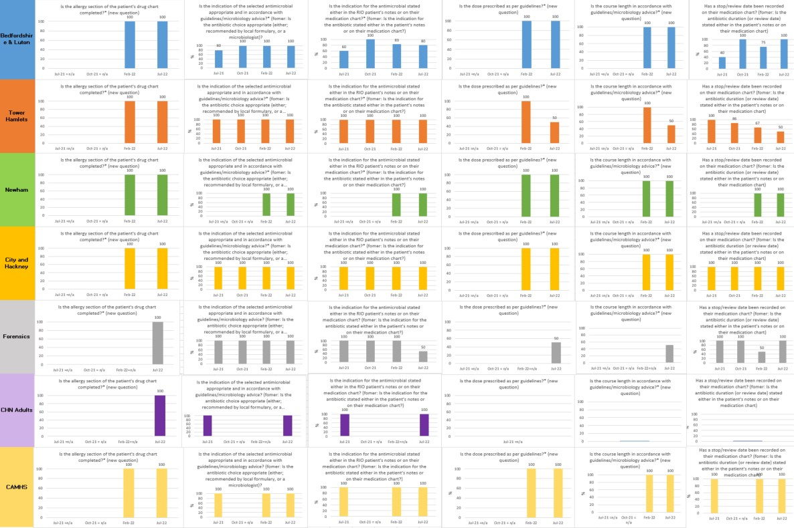

Bedfordshire & Luton: Overall results showed good compliance with audit standards. Compliance with the indication stated in RIO or medication chart in Q1 was 80% (one audit form was non-compliant).
Tower Hamlets: This service has demonstrated good compliance with most audit standards this quarter. Compliance with the dose/course, stop/review date recorded on the medication chart in Q1 was 50%, this was due to 1 audit form which was non-compliant.
Newham, City & Hackney, CAMHS and CHN Adults: Overall results showed excellent compliance (100%) with audit standards.
Forensics: This service has demonstrated good compliance with most audit standards this quarter. Compliance with the stop/review date recorded on the medication chart in Q4 was 50%; this was due to one audit form which was non-compliant.

Top TEN Wards Prescribing Antimicrobials
As per attached graphic, the top 10 wards prescribing Antimicrobials for Q1 2022/23 were:
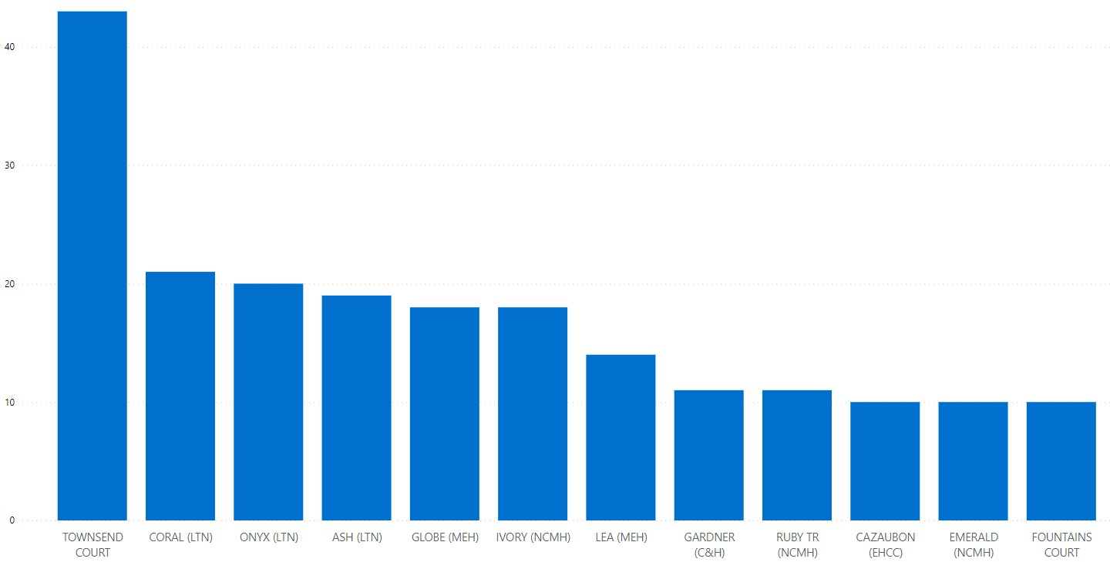

Top TEN Antimicrobials Prescribed
As per attached graphic, the top 10 Antimicrobials Prescribed for Q1 2022/23 were:

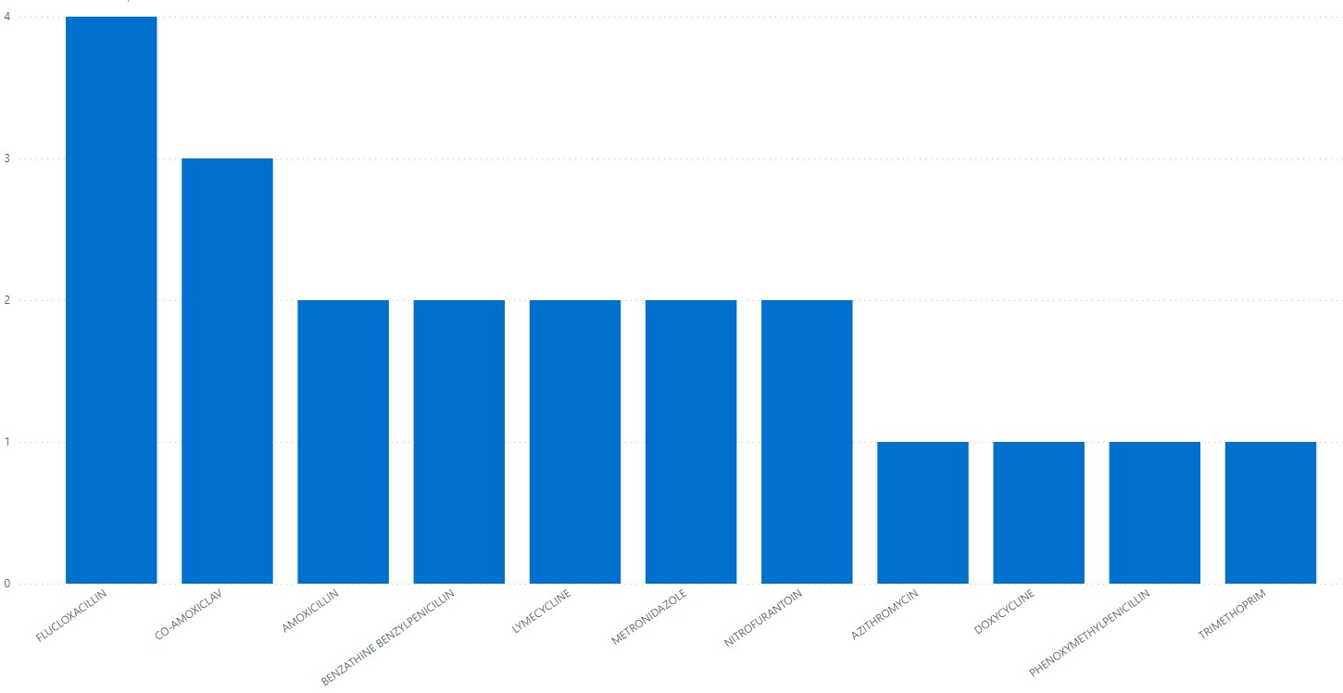

Action Plan
The following action plan has been formulated to address areas of non-compliance and concern as well as some overarching antimicrobial stewardship objectives in order to improve use of antimicrobials.
Action No | Action | By When
1 | Circulate report to all Pharmacists, Prescribers, and Clinical Directors to discuss at respective quality and governance meetings. Present findings of the audit to each divisional IPC subgroup and IPC Committee. | Aug 2022
2 | Services with good to poor compliance (RAG rated as amber or red) will be asked to develop local action plans to improve antimicrobial prescribing. This will involve close working between local prescribers, pharmacy teams and the antimicrobial pharmacist. | Aug 2022

