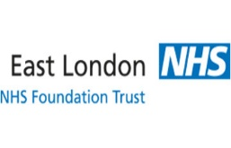
Foot Health Services – Newsletter October 2022

Newsflash! Focus Group (Remote on MS Teams)
Date: Tuesday 13th October 2022 11am-12noon.
With basic diabetes foot health presentation by our clinicians

For our Tower Hamlets residents the Emergency Clinic continues to run Mondays - Friday (excluding bank holidays)…please arrive at 8:30am for us to promptly treat your acute issue/emergency of a wound; blister; open sore or ingrowing toenail before our routine clinics start at 9:30am.
All clinicians within our team are testing weekly to ensure they are clear of COVID, and as well as this - we are currently encouraging all clinical staff to have their Flu jab in order to keep well and continue serving your foot health needs, as our Tower Hamlets residents.
We hope that you to have taken up your Flu jab offer from your GP or pharmacy this year.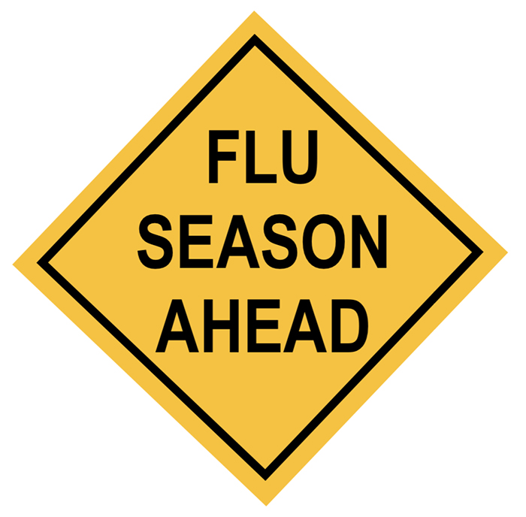
- Mask wearing within the department and our clinics is still mandatory in order to reduce the risk of COVID infection.
We have new heat deflecting film and blinds fitted to our windows in order to keep you warmer this coming winter and hopefully cooler in next year’s summer months.
Please continue assist us to ensure we have your correct details on our database by informing us of any name, telephone or address changes, when we have the correct mobile number contact you will receive an SMS text message as a reminder of your appointment. It also really helps if you can provide us with a next of kin contact, please inform your clinician or admin staff if any personal information needs updating.
Looking forward to you joining our focus group to participate in improving your service. We want to hear your views – Your voice counts!

Please email Steph Benjamin Foot Health Clinical Lead at BHNT.Foothealth@nhs.net to book attendance & for an invite.
Or please contact: John Louis Kauzeni (People Participation Lead) Mobile: 07939931650

