Venous Thromboembolism
Reducing the risk

Version number : | 3.2
Consultation Groups | Clinical Policies alignment group,  Trust Physical Health in Mental Health Committee  Clinical Directors in Mental Health
Approved by (Sponsor Group) | Physical Health in Mental Health Committee
Ratified by: | Physical Health in Mental Health Committee
Date ratified: | 15th March 2023
Name of originator/author: | Director of Physical Health and Physical Health Lead Nurse
Executive Director lead : | Medical director
Implementation Date : | March 2023
Last Review Date | March 2023
Next Review date: | March 2026

Services | Applicable
Trustwide | X
Mental Health and LD
Community Health Services

Version Control Summary
Version | Date | Author | Status | Comment
1 | 16/3/13 | Trust Physical Health Lead |  | Approved clinical effectiveness Committee
Version 2 | October 2019 | Director of Physical Health and Physical Health Lead Nurse |  | Updated in line with the below guidance 2018
Version 3 | April 2021 | Lead Pharmacist |  | Updated to reflect risk in Covid-19see section 9.2  No 15 and 16 ref
Version 3.1 | November 2021 | Medical Director Community services |  | Incorporate NICE QS 201 and Rio template Appendix
Version 3.2 | 10 March 2023 | Interim Medical Director, London Mental Health Services |  | Clarifications of roles/responsibilities, updating of appendices and of prescribing tables

Item Contents Page
1.0 | Introduction | 4
2.0 | Venous Thromboembolism definition | 4
3.0 | Purpose | 4
4.0 | Duties | 4
4.1 | Duties within the Organisation | 4
5.0 | VTE Prevention Quality Standard | 5
6.0 | Risk Factors for VTE | 5
6.1 | VTE Risk Factors Include | 5
7.0 | Clinical Presentation of DVT | 6
7.1 | Common Presenting Features | 6
8.0 | Risk Assessment for VTE | 6
8.1 | Community Health Services Inpatient Wards | 6
8.2 | Mental Health Inpatient Wards | 6
8.3 | Interventions for pregnant women and women who gave birth or had a miscarriage or termination of pregnancy in the past 6 weeks | 7
8.4 | Interventions for people having palliative care | 8
8.5 | Community Services | 8
9.0 | Preventative Regimes for Patients at Risk of Thromboembolism | 8
9.1 | Low Molecular Weight Heparin (LMWH) | 8
9.2 | Reducing the risk of VTE with COVID-19 | 9
10.0 | Mechanical Prophylaxis | 10
11.0 | Making the Decision Not to Treat with LMWH | 11
12.0 | Procedures to be Followed if DVT is Suspected | 11
13.0 | Discharging from Inpatient Units / Wards | 11
14.0 | Training | 12
15.0 | Audit | 12
16.0 | Review | 12
 | Further Information and References  Appendices | 13-14  15-18

1.0 Introduction

In August 2019 the National Institute for Health and Clinical Excellence (NICE) updated the guidelines on venous thromboembolism “Venous thromboembolism in over 16s: reducing the risk of hospital-acquired deep vein thrombosis or pulmonary embolism” NICE guideline [NG89]

East London NHS Foundation Trust will implement the NICE guidance, to ensure that all adult service users admitted are risk-assessed for VTE and where appropriate receive thrombo-prophylaxis and treatment.

This policy describes the processes for:

- Identifying at risk patients on our inpatient wards and implementing the NICE guidance.
- Thromboprophylaxis implementation and management.

This policy should be read in conjunction with NICE guidance CG92 March 2010 Venous Thromboembolism

2.0 Venous Thromboembolism definition: (VTE)

- Venous Thromboembolism (VTE) is a term used to include the formation of a blood clot (a thrombus) in a vein which may dislodge from its site of origin and travel in the blood, a phenomenon called embolism. A thrombus most commonly occurs in the deep veins of the legs; this is called deep vein thrombosis. A dislodged thrombus that travels to the lungs is known as a pulmonary embolism.

- VTE encompasses a range of clinical presentations. Venous thrombosis may be completely asymptomatic or it may cause pain and swelling in the leg. Part or all of the thrombus/clot can come free and travel to the lungs as a potentially fatal pulmonary embolism. Symptomatic venous thrombosis carries a considerable burden of morbidity, sometimes long-term due to chronic venous insufficiency. This in turn can cause venous ulceration and development of a post-thrombotic limb (characterised by chronic pain, swelling and skin changes).

3.0 Purpose

The purpose of this policy is to ensure that patients in community bedded units and mental health in-patient units are appropriately assessed for their risk of developing a VTE, they receive appropriate treatment and that the level of risk is reviewed throughout their stay on any of the inpatient wards.

- To reduce the risk of VTE in service users / patients found to have risk factors.

- To ensure that all patients are assessed for their individual risk of VTE and that the outcome is documented with regard to appropriate risk-reduction measures.

- To ensure a provision of appropriate risk reduction measures including adequate information to staff and patients.

4.0 Duties

4.1 Duties within the Organisation

Trust directors are accountable for all procedures within their area of operation.

A director will nominate a procedure lead to carry out the development work in accordance with this policy. They will ensure that all new and revised policies are effectively implemented and monitored.

5.0 VTE prevention quality standard

- All patients, on admission, must receive an assessment of VTE and bleeding risk using the clinical risk assessment criteria described in the national tool.
- Patients/carers are offered verbal and written information on VTE prevention as part of the admission process.
- Patients are assessed within 14 hours of admission for risk of VTE and bleeding.
- Patients are re-assessed during admission whenever their ability to mobilise changes for risk of VTE and bleeding.
- Patients assessed to be at risk of VTE are offered VTE prophylaxis in accordance with NICE guidance.
- Patients/carers are offered verbal and written information on VTE prevention as part of the discharge process.

6.0 Risk Factors for VTE

Venous thromboembolism (VTE) includes several manifestations of the same disease process: deep-vein thrombosis (DVT), ischemic stroke, and pulmonary embolism (PE). Without thrombo-prophylaxis, the incidence of objectively documented DVT ranges from 16% to 55%

The assessment of a patient’s risk is based on a number of risk factors that have been identified from epidemiologic studies. Some of the more defined risk factors are briefly summarized in the following section.

The risk of developing VTE depends on the condition and/or procedure for which the patient is admitted and on any predisposing risk factors (such as age, obesity and concomitant conditions).

NICE Guidance recommends that:

- Assess all patients on admission to identify those who are at increased risk of VTE.
- Regard patients as being at increased risk of VTE if they have had or are expected to have:
  - significantly reduced mobility for 3 days or more or
  - ongoing reduced mobility relative to their normal state together with one or more of the risk factors shown in 6.1 below
- In ELFT inpatient settings (including but not limited to mental health wards), risk factors may include being bedbound, unable to walk unaided or likely to spend a substantial proportion of the day in bed or in a chair. This could be secondary to prolonged seclusion, catatonia, rapid tranquilisation or severe depression.

6.1 VTE risk factors

- Details of risk factors for VTE can be found in the NICE Guidance on reducing the risk and on the associated Risk Assessment from the Department of Health (Appendix 2 in this policy). Relevant factors include:

- Recent immobility
- Some medications (e.g. antipsychotics)
- Obesity (BMI greater than 30kg/m2)
- Dehydration
- Seclusion
- Long term conditions, such as those listed in appendix 2.
- Previous DVT
- Intravenous drug user
- Long haul air flight
- Underlying malignant disease
- Family history thrombosis
- Known thrombophilic defect
- Use of HRT
- One or more significant medical co-morbidities
- Greater than 60 years old
- Recent surgery
- Recent injury or trauma
- Covid-19 and other infectious diseases.

7.0 Clinical presentation of DVT

A diagnosis of DVT is usually suspected in patients who complain of a painful swollen limb.

However, the clinical picture can vary widely and none of the clinical features is sufficiently specific to be diagnostic. Less than a third of patients referred for tests after initial history and clinical examinations prove to have a DVT. Clinical diagnosis is notoriously difficult as the manifestations of venous thromboembolism (VTE) are constantly changing.

7.1 Common Presenting Features

- Pain or tenderness of the leg (calf or thigh)
- Swelling of calf or thigh
- Pitting oedema
- Palpable venous thrombosis
- Increased temperature in the leg
- Fever
- Discoloration or erythema of the leg
- Venous distension

8.0 Risk Assessment for VTE

8.1 Community Health Services inpatient wards

For patients on the community bedded units an initial risk assessment must be completed (within 4-6 hours) and, where appropriate, prophylaxis prescribed within 14 hours of admission by doctors. Staff must use the NICE guidance/VTE risk assessment and make referral to the GP/ward duty doctor for full assessment and if prophylaxis treatment is indicated.

8.2 Mental Health inpatient wards

- All patients admitted to mental health inpatient wards must have a baseline physical history, lifestyle and medication assessment and an initial physical examination by medical staff and baseline observations undertaken by a nurse on admission.

- All patients admitted to mental health inpatient wards must have a VTE risk assessment completed by the admitting medical staff. This should be carried out as soon as possible on admission (within 4-6 hours) and recorded on the “Risk Assessment for Venous Thromboembolism” form on RiO, which can be found in the Physical Health (MH) Folder. Prophylaxis, where indicated, must be prescribed within 14 hours of admission.

- Nursing and medical staff have a responsibility to keep this under review and remain mindful of the risk factors for VTE. This is included in the “Observations and Measurements” form located within the Physical Health (MH) folder on RiO, that is completed by nursing staff that is completed on a regular basis (at least weekly), but concerns should be responded to as soon as they are observed to occur. Nursing staff should highlight any concerns warranting further assessment to the medical staff, such as when mobility changes or other VTE risk factors heighten (see section 6.1 for areas to consider). The doctor should then complete a full clinical assessment, including the “Risk Assessment for Venous Thromboembolism” form and consideration of VTE prophylaxis.

- As noted in Section 6, seclusion potentially increases the risk of VTE. This would be a time when keeping the risk under review would be important.

- The above recommendations are in keeping with NICE (2018) guidance. The Trust has more stringent guidance for when assessments should occur. The NICE guidance states the following for mental health inpatient wards.

  - Assess all acute psychiatric patients to identify their risk of VTE and bleeding:
    - as soon as possible after admission to hospital or by the time of the first consultant review
    - using a tool published by a national UK body, professional network or peer-reviewed journal.
A tool commonly used to develop a treatment plan for surgical patients is the Department of Health VTE risk assessment tool. (Reproduced with the permission of the Department of Health and Social Care under the Open Government Licence.) [2018, amended 2021]

  - Reassess all people admitted to an acute psychiatric ward for risk of VTE and bleeding at the point of consultant review or if their clinical condition changes. [2018]
  - Consider pharmacological VTE prophylaxis with LMWH for people admitted to an acute psychiatric ward whose risk of VTE outweighs their risk of bleeding. [2018]
  - Consider pharmacological VTE prophylaxis with fondaparinux sodium if LMWH is contraindicated for people admitted to an acute psychiatric ward whose risk of VTE outweighs their risk of bleeding. [2018]
  - Continue pharmacological VTE prophylaxis for people admitted to an acute psychiatric ward until the person is no longer at increased risk of VTE. [2018]

8.3 Interventions for pregnant women and women who gave birth or had a miscarriage or termination of pregnancy in the past 6 weeks

The below may be of particular importance for the mental health inpatient Mother and Baby Units, but the principles apply across all services.

- Consider Low Molecular Weight Heparin (LMWH) (See point 9.1) for all women who are admitted to hospital or a midwife-led unit if they are pregnant or gave birth, had a miscarriage or had a termination of pregnancy in the past 6 weeks, and whose risk of VTE outweighs their risk of bleeding. [2018]
- Do not offer VTE prophylaxis to women admitted to hospital or a midwife-led unit who are in active labour. [2018]
- Stop pharmacological VTE prophylaxis when women are in labour. [2018]
- If using LMWH in pregnant women, start it as soon as possible and within 14 hours of the risk assessment being completed and continue until the woman is no longer at increased risk of VTE or until discharge from hospital or the midwife-led unit. [2018]
- If using LMWH in women who gave birth or had a miscarriage or termination of pregnancy, start 4 -8 hours after the event unless contraindicated and continue for a minimum of 7 days. [2018]
- Consider combined prophylaxis with LMWH plus mechanical prophylaxis for pregnant women or women who gave birth or had a miscarriage or termination of pregnancy in the past 6 weeks and who are likely to be immobilised, or have significantly reduced mobility relative to their normal or anticipated mobility for 3 or more days after surgery, including caesarean section:
- Use intermittent pneumatic compression as first-line treatment. If intermittent pneumatic compression is contraindicated, use anti-embolism stockings. Continue until the woman no longer has significantly reduced mobility relative to her normal or anticipated mobility or until discharge from hospital. [2018]. Within mental health settings, other risks associated with this should be considered, e.g. in relation to ligature.

8.4 Interventions for people having palliative care

- Consider pharmacological VTE prophylaxis for people who are having palliative care.
- Take into account temporary increases in thrombotic risk factors, risk of bleeding, likely life expectancy
- Consider the views of the service user and their family members or carers (as appropriate):
- Use LMWH as first-line treatment.
- If LMWH is contraindicated, use fondaparinux sodium. [2018]
- Do not offer VTE prophylaxis to people in the last days of life. [2018]
- For recommendations on shared decision-making in the last days of life, see the NICE guideline on care of dying adults in the last days of life. [2018]
- Review VTE prophylaxis daily for people who are having palliative care, taking into account the views of the person, their family members or carers (as appropriate) and the multidisciplinary team. [2018]
NICE. (2018). venous thromboembolism in over 16s: reducing the risk of hospital-acquired deep vein thrombosis or pulmonary embolism. Available: https://www.nice.org.uk/guidance/NG89

8.5 Community Services

Most patients will present with symptoms to their GP either at the surgery or in their own home. Community teams are not required to complete the risk assessment but must immediately refer any patients they see to their GP if clinical features of DVT are present or suspected. This must be documented in the patient’s care record and communicated to the GP.

9.0 Preventative Regimes for Patients at Risk of Thromboembolism.

Following a positive risk assessment a decision will be made on management, utilising the guidelines below as recommended by NICE and our local pharmacy team.

Prior to the development of low molecular weight heparins (LMWH) the traditional management of DVT was to treat the patient on an inpatient basis. However, uncomplicated DVT is now widely managed on an outpatient basis and most patients can be treated at home without problems (Winter et al, 2005).

9.1 Low Molecular Weight Heparin (LMWH)

LMWH is recommended for many patients at risk of developing venous thromboembolism and is used as a prophylaxis. LMWH produces an immediate anticoagulant effect whereas oral anticoagulants act slowly and their effect builds up over 2-3 days.

LMWH will be prescribed by the GP/Responsible Clinician/medical prescriber and administered by the nursing staff. Treatment will generally last for the period of reduced immobility.

If a prescriber is unsure of the most appropriate prescribing options, they should seek advice from another clinician. The appropriateness of the guidance below may be impacted by the presence of other medical conditions or medications.

There are a variety of available LMWHs available. Inpatients in East London NHS Foundation Trust should generally be prescribed

Drug | Patient’s Weight | Dose
Enoxaparin (Clexane) | <50kg | 20mg (Once daily)
Enoxaparin (Clexane) | 51-100kg | 40mg (Once daily)
Enoxaparin (Clexane) | 101-150kg | 60mg (Once daily)
Enoxaparin (Clexane) | >150kg | 80mg (Once daily)

9.2 Reducing the risk of VTE in Covid-19

There are reports that patients infected with COVID-19 are at a heightened risk of venous thromboembolism (VTE). The following recommendations are for adult non-pregnant patients admitted to hospital with suspected or confirmed COVID-19. For pregnant patients please refer to the latest RCOG guidance.
Where patients are on therapeutic doses of oral anticoagulants at the time of admission this guidance does not apply, those patients should continue therapeutic anticoagulation.
Guidance for people with Covid-19 is subject to change as new evidence emerges. It is important to check that the prescribing guidance below remains applicable at the time of prescribing, through liaison with pharmacy and other expert clinicians.
- On admission
  - Assess patient risk for VTE as for all newly admitted patients, as detailed in section 8 above.

  - If pharmacological VTE prophylaxis is indicated, and there are no contraindications, prescribe Enoxaparin as directed:
In those who are low risk (have a D-dimer <3):
Weight | CrCl > 30 ml/mil | CrCl < 30 ml/mil
<50kg | 20mg OD | 20mg OD
50-100kg | 40mg OD | 20mg OD
100-150kg | 60mg OD | 20mg OD
> 150kg | 80mg OD | 20mg OD

In those who are high risk (have a D-Dimer >3):
Weight | CrCl > 30 ml/mil | CrCl < 30 ml/mil
<50kg | 40mg OD | 20mg OD
50-100kg | 40mg BD | 40mg OD
100-150kg | 60mg BD | 60mg OD
>150kg | 80mg BD | 80mg OD

- During inpatient stay:
  - If the patient’s clinical condition changes, assess risk of VTE in the same way recommended for all patients, as per section 8 above.

- At discharge
  - Ensure that patients will be completing pharmacological VTE prophylaxis after discharge
  - Prescribe an extra 14 days thromboprophylaxis if patient is expected to have reduced mobility (or considered high risk for VTE) after discharge.
    - 1st line – Apixaban PO 2.5mg BD
  - Where the prescriber is unsure about the approach or which prescribing to undertake, they should seek advice from an appropriately qualified clinician.

10.0 Mechanical prophylaxis

Do not offer anti-embolism stockings to people who have:
- suspected or proven peripheral arterial disease
- peripheral arterial bypass grafting
- peripheral neuropathy or other causes of sensory impairment
- any local conditions in which anti-embolism stockings may cause damage – for example, fragile 'tissue paper' skin, dermatitis, gangrene or recent skin graft
- known allergy to material of manufacture
- severe leg oedema
- Major limb deformity or unusual leg size or shape preventing correct fit.
Use caution and clinical judgement when applying anti-embolism stockings over venous ulcers or wounds. [2010, amended 2018]
Where anti-embolism stockings are indicated:
- Ensure that people who need anti-embolism stockings have their legs measured and that they are provided with the correct size of stocking. Anti-embolism stockings should be fitted and patients shown how to use them by staff trained in their use. [2010]
- Ensure that people who develop oedema or postoperative swelling have their legs re-measured and anti-embolism stockings refitted. [2010]
- If arterial disease is suspected, seek expert opinion before fitting anti-embolism stockings. [2010]
- Use anti-embolism stockings that provide graduated compression and produce a calf pressure of 14 15 mmHg. (This relates to a pressure of 14–18 mmHg at the ankle and is in line with British Standards BS 6612:1985 Specification for graduated compression hosiery and BS 7672:1993 Specification for compression, stiffness and labelling of anti-embolism hosiery.) [2010]
- Encourage people to wear their anti-embolism stockings day and night until they no longer have significantly reduced mobility. [2010]
- Remove anti-embolism stockings daily for hygiene purposes and to inspect skin condition. In people with a significant reduction in mobility, poor skin integrity or any sensory loss, inspect the skin 2 or 3 times a day, particularly over the heels and bony prominences. [2010]
- Monitor the use of anti-embolism stockings and offer assistance if they are not being worn correctly. [2010]
- Stop the use of anti-embolism stockings if there is marking, blistering or discolouration of the skin, particularly over the heels and bony prominences, or if the person experiences pain or discomfort. If suitable, offer intermittent pneumatic compression as an alternative. [2010, amended 2018]
- Do not offer intermittent pneumatic compression to people with a known allergy to the material of manufacture. [2010, amended 2018]
- Advise the person to wear their device for as much time as possible. [2010, amended 2018]

11.0 Making the Decision not to treat with LMWH

LMWH such as Enoxaparin, Tinzaparin are contraindicated in groups of patients with the following physical health problems. For these service users it is recommended that advice is sought from the medical team.

- Actively bleeding patients or those at risk of bleeding.
- Patients with renal impairment
- Patients at high risk of falls
- Those with a severe hepatic disease
- Patients with a platelet level of less than 75
- Patients with a BP > 200 systolic or > 120 diastolic
- If patient is already on anticoagulants or antiplatelet medication
Consider other factors for increased bleeding risk, such as age and alcohol use.

12.0 Procedures to be followed if DVT is suspected

Medical staff are encouraged to seek advice from appropriate specialists if lacking confidence in appropriate management of DVT.

If DVT is suspected, the responsible doctor should take bloods for D-dimer tests and organise an ultra-sound scan to image the leg. Ultrasound scan (USS) has become the investigation of choice in the diagnosis of DVT. It will detect more than 90% of proximal DVTs (i.e. popliteal vein and above). It is less sensitive for calf vein thrombosis (about only 50% are detected) but pulmonary embolism from this site is rare and unlikely to cause significant haemodynamic disturbance even if it occurs. While this is being organised, treatment for possible DVT should begin, seeking advice about this if needed.

13.0 Discharging from Inpatient Units/Wards

Discuss with the GP practice nurse, district nurses or Community Mental Health Team if continuing treatment is required and document this in the care record.

Necessary information should be included in verbal transfer/handover information sheets. Prior to transfer, clearly state the duration of treatment on the discharge summary and transfer of care form.

14.0 Training

All qualified nursing staff working in adult inpatient mental health wards and community inpatient units will receive training in completing the risk assessment and administering appropriate treatment as part of their local induction. For more details on the local induction process, please refer to the Induction Training Policy.

15.0 Audit

Audits will take place within directorates to monitor completion of the Risk Assessment for Venous Thromboembolism form on admission and the Observations and Measurements form that is completed on a regular basis.

Audit findings will be presented to the Physical Health in Mental Health group.

Information regarding patients diagnosed with VTE will be collected as part of Datix incident management.

16.0 Review

This Policy will be reviewed every 3 years or sooner if deemed necessary.

FURTHER INFORMATION AND REFERENCES

NICE. (2018). venous thromboembolism in over 16s: reducing the risk of hospital-acquired deep vein thrombosis or pulmonary embolism. Available: https://www.nice.org.uk/guidance/NG89

Royal College of Obstetricians and Gynaecologists. (2015). Reducing the Risk of Venous Thromboembolism during Pregnancy and the Puerperium. Available: https://www.rcog.org.uk/globalassets/documents/guidelines/gtg-37a.pdf

Venous thromboembolism in adults Quality standard [QS201] Published: 19 August 2021 https://www.nice.org.uk/guidance/qs201

- VTE prevention quality standard: patient information
VTE prevention quality standard: patient information
29 June 2010 (60.93 Kb 17 sec @ 28.8Kbps

- Scottish Intercollegiate Guidelines Network (2010) SIGN Publication No122: Prevention and management of Venous Thromboembolism http://www.sign.ac.uk/pdf/sign122.pdf Geerts, W.H. Bergqvist D, Pineo, G.F, J.A, et al Prevention of venous thromboembolism: the Eighth ACCP Conference on Antithrombotic and Thrombolytic Therapy, Chest 2008; 133:381S-453S

- House of Commons Health Committee 2nd report of session 2004-2005 (2005) The Prevention of venous thromboembolism in hospitalised patients. London: HMSO

- National Institute for Health and Clinical Excellence (NICE) (2007) Venous Thromboembolism – Reducing the risk of venous thromboembolism (deep vein thrombosis and pulmonary embolism) in patients undergoing surgery, April 2007

- Department of Health (2007) Report of the Independent Expert Working Group on the Prevention of Venous Thromboembolism in Hospitalised Patients London

- Dentali F, Douketis J D, Gianni M et al Meta-analysis: anticoagulant prophylaxis to prevent symptomatic venous thromboembolism in hospitalised medical patients. Ann Intern Med 2007; 146:278-288

- National Institute for Health and Clinical Excellence (NICE) (2010) venous thromboembolism: reducing the risk. Reducing the risk of venous thromboembolism (deep vein thrombosis and pulmonary embolism) in patients admitted to hospital. NICE clinical guideline 92 http://www.nice.org.uk/nicemedia/live/12695/47195/47195.pdf

- NICE clinical guidance CG 92 Venous Thromboembolism: reducing the risk, Department of Health January 2010 http://www.nice.org.uk/guidance/CG92 Nursing and Midwifery Council (2008). The Code: Standards of Conduct, Performance and Ethics for Nursing and Midwifery

- NICE. (2018). venous thromboembolism in over 16s: reducing the risk of hospital-acquired deep vein thrombosis or pulmonary embolism. Available: https://www.nice.org.uk/guidance/NG89

- Partsch, H & Blattler, W (2000). Compression and walking versus bed rest in the treatment of proximal deep vein thrombosis with low molecular weight heparin. Journal of Vascular Surgery

- Royal College of Obstetricians and Gynaecologists. (2015). Reducing the Risk of Venous Thromboembolism during Pregnancy and the Puerperium. Available: https://www.rcog.org.uk/globalassets/documents/guidelines/gtg-37a.pdf Last accessed 15th August 2019

- Winter et al (2005). Procedures for the outpatient management of patients with deep vein thrombosis. Clin. Lab. Haem, 2005, 27, 61-66

- Nice.org.uk. 2021. Reducing the risk of venous thromboembolism (VTE) in over 16s with COVID-19 pneumonia. [online] Available at: https://www.nice.org.uk/guidance/ng186/resources/covid19-rapid-guideline-reducing-the-risk-of-venous-thromboembolism-in-over-16s-with-covid19-pdf-66142025041093

- Barts Health NHS Trust Policy. 2020. Thromboprophylaxis and anticoagulation in COVID-19 infection in adults. V1.

- East London NHS Trust Policy. 2019. Venous Thromboembolism reducing the risk. V1.

Appendix 1: Flowchart for VTE Assessment
This flowchart (based on risk assessments before these were done on RiO) does not replace the need to complete the “Risk Assessment for Venous Thromboembolism” form on RiO, but may help as a visual aid.
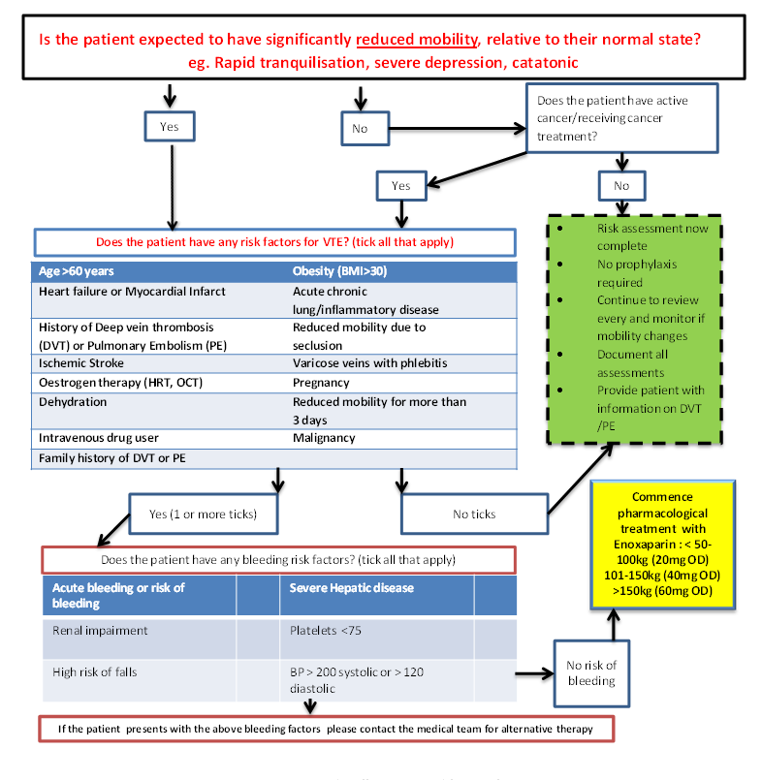
Commence appropriate pharmacological treatment

Appendix 2: Department of Health Risk Assessment for VTE
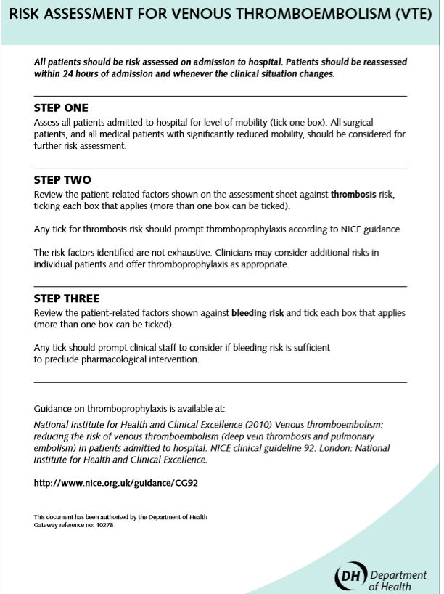
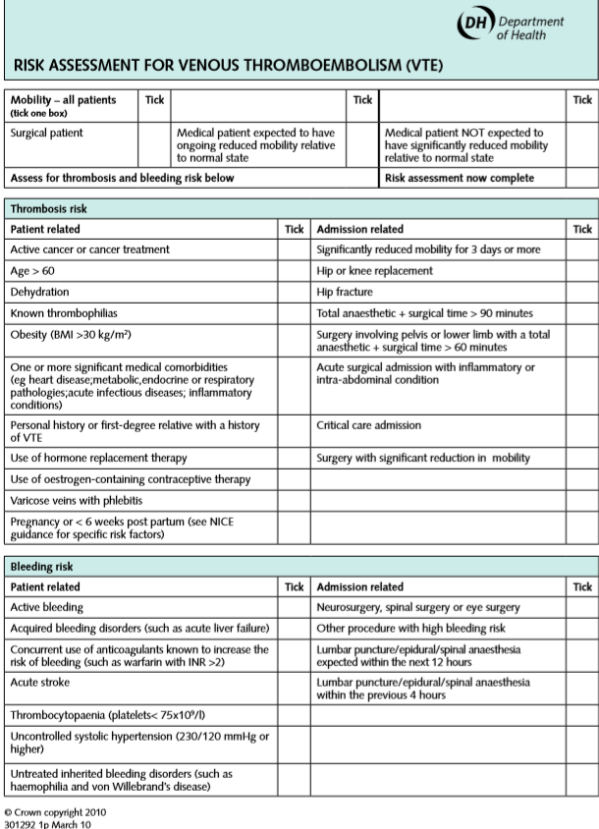

Appendix 3: Risk Factors for VTE in Pregnancy/Puerperium
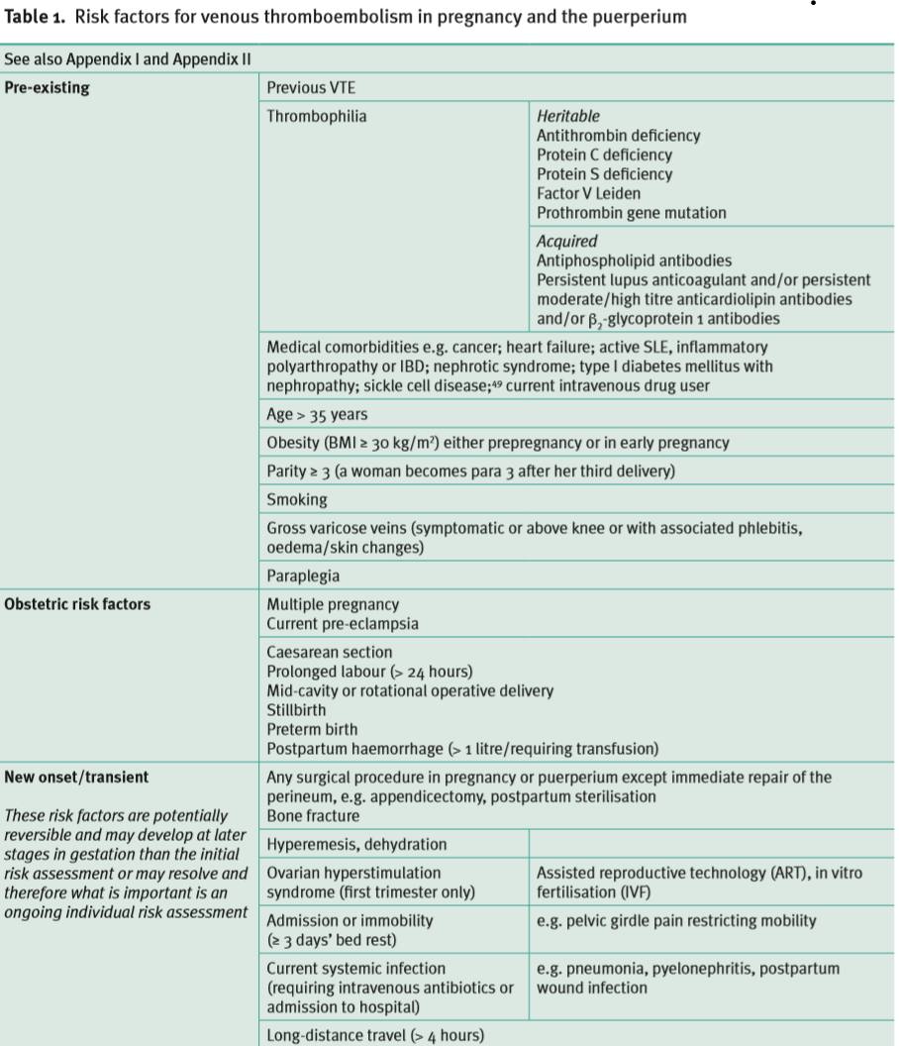
Royal College of Obstetricians and Gynaecologists. (2015). Reducing the Risk of Venous Thromboembolism during Pregnancy and the Puerperium. Available: https://www.rcog.org.uk/globalassets/documents/guidelines/gtg-37a.pdf Last accessed 15th August 2019

