

Dual Diagnosis Policy

|  |  |
| --- | --- |
| Version number : | 3.0 |
| Consultation Groups | Lead Nurses , Clinical Directors |
| Approved by (Sponsor Group) | Lead Nurses |
| Ratified by: | Chief Nurse ( Quality Committee Chair) |
| Date ratified: | November 2018 |
| Name of originator/author: | Service Manager |
| Executive Director lead : | AEO |
| Implementation Date : | November 2018 |
| Last Review Date | November 2018 |
| Next Review date: | November 2021 |

|  |  |
| --- | --- |
| Services | Applicable |
| Trustwide |  |
| Mental Health and LD | x |
| Community Health Services |  |

Version Control Summary

|  |  |  |  |  |
| --- | --- | --- | --- | --- |
| **Version** | **Date** | **Author** | **Status** | **Comment** |
| 1.0 | 1st June 2008 | Duncan Gilbert | Final |  |
| 2.0 | 20th September 2011 | Jacki Butcher - Tower Hamlets Dual Diagnosis Service Manager and  Dr. Ron Alcorn – Consultant Psychiatrist, Newham Specialist Substance Misuse Services/Clinical Director, Specialist Addiction Services | Final | Scheduled three year review and update with clearer outline of duties and practice guidelines. |
| 3.0 | November 2018 | Sharon Hawley | Final | Policy updated to reflect best practice and current organisation structure |

**Contents**

|  |  |
| --- | --- |
| **Section** | **Page Number** |
| 1. **Introduction** | **3** |
| 1. **Pathways** | **4** |
| 1. **Services** | **4** |
| 1. **NICE Recommendations** | **5** |
| 1. **ELFT Dual Diagnosis definition** | **7** |
| 1. **Objectives, Outputs, Outcomes** | **8** |
| 1. **Pathways** | **9** |
| **Pathway 1. High Risk Pathway** | **10** |
| **Pathway 2. Joint Patient Pathway** | **11** |
| **Pathway 3. Discharge** | **12** |

To be read alongside

* ELFT Dual Diagnosis Training Packages
* ELFT policy and procedure (Care Programme Approach Policy, Clinical Risk Assessment and Management Policy etc)
* Local Borough/County Implementation Plans

**1. Introduction**

This policy sets out best practice guidelines for managing patients with coexisting mental health and substance misuse. The aim is to ensure services are coordinated in order to address these difficulties as well as wider health and social care needs.

Mental health problems have a wide ranging impact on all aspects of health and social functioning, affecting people of all ages and all cultural backgrounds. Similarly people using substances typically have multiple health and social issues. Alongside this, drug and alcohol use is as prevalent as ever; 4 in 5 adults dependent on alcohol are not in treatment, opiate deaths are at their highest ever level, there is a national increase in the use of cocaine and novel psychoactive substances (Gov.Uk 2017).

There are a number of challenges in delivering effective treatment to patients with co-existing mental health and drug/alcohol issues. The complexity of issues makes diagnosis, care and treatment more difficult. Patients become at higher risk of relapse, (re)admission to hospital and harm to self or others. One key issue is the number of agencies involved in someone’s care, which without effective coordination, can result in treatment becoming fragmented and duplicated, leading to a poorer experience for the patient and ineffective management of risk.

**2. Purpose.**

The purpose of this policy is to ensure services working with people with coexisting mental health and substance misuse problems deliver evidenced based care and treatment in a clinically coordinated and systematic manner. This will ensure people with co-existing mental health and substance misuse difficulties and their carers and families receive appropriate and effective services equipped to meet their needs.

This policy will deliver

* An integrated service delivery model with 3 seamless Dual Diagnosis pathways
* High risk
* Joint patient
* Discharge across services
* A workforce trained and empowered to deliver the model

**3. Services**

ELFT provides a wide range of community and inpatient services to children, young people, adults of working age, older adults and forensic services to the City of London, Hackney, Newham, Tower Hamlets, Bedfordshire and Luton. We work with some of the most diverse groups of people in the country. Our strategy for delivering effective Dual Diagnosis provision is built on experience, best practice and is by necessity a multi-organisational approach. Key services are Adult Mental Health, Substance Misuse and IAPT.

|  |  |  |  |
| --- | --- | --- | --- |
| **Area** | **AMH provider** | **Adult Drug & Alcohol provider** | **IAPT provider** |
| Bedfordshire | ELFT | ELFT. Path To Recovery (P2R) | ELFT |
| Luton | ELFT | CGL. ResoLUTiONs | Turning Point |
| Tower Hamlets | ELFT | ELFT. Reset | ELFT |
| Newham | ELFT | CGL. Newham Rise | ELFT |
| Hackney | ELFT | WDP & CNWL. Hackney Recovery Service | Homerton Foundation Trust |
| City of London | ELFT | WDP. Alcohol and Drug Service | Turning Point |

**Adult Mental Health**

* Primary Care Mental Health Service (PCMHS)
* Community Mental Health Teams (CMHT)
* In-Patient Wards

Community and In-Patient services managing people in crisis, and those with severe and enduring mental health problems.

**IAPT**

The Improving Access to Psychological Therapies (IAPT) programme began in 2008 to better deliver treatment of adult anxiety disorders and depression in England. Over 900,000 people now access IAPT services each year. The IAPT model provides evidence based treatments for people with:

* Common mental health problems (Anxiety, Low Mood, Depression, Stress)
* Perinatal care – during pregnancy and postnatal
* Long term conditions
* Eating disorders
* Counselling including grief and bilingual options

**Drug and Alcohol Services**

Commissioned through Public Health structures in Local Authorities with no ring-fenced budget. Most treatment systems are delivered by the 3rd sector, including providing provision for patients with high and multiple risk factors. The Trust delivers drug and alcohol services in Bedfordshire and Tower Hamlets. ELFT Drug and Alcohol Services deliver:

* Substitute prescribing for Opiate dependency
* Psychosocial interventions
* Physical Healthcare treatment for Blood Bourne Viruses
* Needle Exchange
* Psychiatric and Psychology interventions
* Carer support and psychoeducation

**4. 2016 NICE Recommendations**

In 2016 NICE published new dual diagnosis guidelines and Public Health England followed with a dual diagnosis guide for commissioners and service providers following in 2017.

|  |
| --- |
| Dual Diagnosis definition; coexisting severe mental illness and substance misuse (NICE 2016)   * Legal or illicit drugs (inc. prescribed & over the counter medicines) * Severe mental illness; a clinical diagnosis of * schizophrenia, schizotypal, delusional disorders * bipolar affective disorder * severe depressive episodes with or without psychotic episodes |

The guidance, supporting tools and resources sets out how services for those dually diagnosed might be improved to 'provide a range of coordinated services that address people’s wider health and social care needs, as well as other issues such as employment and housing.'. NICE contextualises the guidance stating those with a dual diagnosis have some of the worst health, wellbeing and social outcomes; identification is inconsistent and treatment uncoordinated.

It can be difficult to diagnose ‘Dual Diagnosis’ because drug and alcohol intoxication or withdrawal can make it difficult to assess mental illness. Many clinicians report difficulties in identifying whether drug and alcohol use is a cause, or an effect, of mental health issues. Delay in diagnosis can mean a delay in treatment, or patients being passed between services - rather than joining up of services, which would be usual practice for anyone presenting with multiple needs. There can also be stereotyping and stigma, with patients regarded as unreliable, difficult to engage or aggressive and again there can be difficulty establishing whether these behaviours are caused by mental illness and/or intoxication or withdrawal. When there is no effective joint care package, health and social functioning can deteriorate into crisis, often presenting to A&E, the streets or the criminal justice system.

|  |
| --- |
| It is estimated that around 40% of individuals diagnosed with a psychotic illness have misused drugs or alcohol (twice the national average) (NICE 2016) |

|  |
| --- |
| Estimates of dual diagnosis prevalence across Adult Mental Health services are around one third (NICE 2016) |

**Key NICE Recommendations**

* Rather than “dual diagnosis specialist teams” (prevalent in the previous decade) wider services should adapt to and coordinate the care of this group
* Care should be led and co-ordinated through mental health services

There are six detailed recommendations relating to

|  |  |
| --- | --- |
| 1 | First contact with services |
| 2 | Referral to secondary care mental health services |
| 3 | The care plan; joint and multi-agency |
| 4 | Partnership working |
| 5 | Maintaining contact between services and patients |
| 6 | Improving service delivery |

These six recommendations outline best practice and are in line with Trust policies in managing clinical treatment; using and creating opportunities to maintain engagement, working with colleagues in a joined up way, anticipating and planning for crisis, family and support service involvement. <https://www.nice.org.uk/guidance/ng58>

**Key Principles**

* Do not exclude adults and young people with psychosis and coexisting substance misuse from age-appropriate *mental healthcare* because of their substance misuse.
* Do not exclude adults and young people with psychosis and coexisting substance misuse from age-appropriate *substance misuse services* because of a diagnosis of psychosis.
* Consider seeking specialist advice and initiating joint working arrangements with specialist substance misuse services for adults and young people with psychosis being treated by community mental health teams, and known to be:

◦severely dependent on alcohol or

◦dependent on both alcohol and benzodiazepines or

◦dependent on opioids and/or cocaine or crack cocaine

* Adult community mental health services or CAMHS should continue to provide care coordination and treatment for the psychosis within joint working arrangements.
* Do not exclude people from physical health, social care, housing or other support services because of their coexisting severe mental illness and substance misuse.
* Adopt a person-centred approach to reduce stigma and address any inequity to access to services people may face.
* Undertake a comprehensive assessment of the person's mental health and substance misuse needs.

**What’s not in the guidelines?**

* ‘Severe mental illness’ is a requirement for a diagnosis of ‘Dual Diagnosis’, excluding anxiety & mood disorders, personality disorders, complex trauma.
* IAPT: This misses an opportunity to formally make the link between alcohol misuse (in particular, but also cannabis misuse) and anxiety and depression. For instance IAPT is an ideal place to deliver Brief Interventions and Advice on alcohol misuse.
* Individuals with comorbid personality disorder and substance misuse are not included in the guidelines; such individuals frequently present to substance misuse services, with a combination of high degrees of distress and low impulse control. A lack of coordinated input to this group is of concern since they often access multiple services in crisis, including short in-patient stays and coordinated input has the potential to reduce such presentations.

These exclusions represent a large cohort of patients who present to our services. To exclude these groups deviates from good practice for a multitude of patients presenting to multiple services. Therefore this policy is inclusive of anxiety & mood disorders, personality disorders and complex trauma and uses a local definition of Dual Diagnosis that is wider than the NICE 2016 guidelines: Coexisting mental health and substance misuse difficulties

**5. ELFT Dual Diagnosis definition**

|  |
| --- |
| Dual Diagnosis definition: Co-existing mental health and substance misuse difficulties  (including personality disorders, anxiety & mood disorders, and complex trauma) |

Where involved, the secondary care mental health team should:

* Offer interventions that aim to improve engagement with all services, support harm reduction, change behaviour and prevent [relapse](https://www.nice.org.uk/guidance/ng58/chapter/Recommendations#relapse). The team should take advice from substance misuse services (if applicable) about these interventions.
* Offer individual, face-to-face or phone appointment sessions to encourage people with coexisting severe mental illness and substance misuse to use services. Offer phone sessions to their family or carers. Sessions could cover:
* How the person is coping with their current mental health and substance use and its impact on their physical health and social care needs
* Progress on current goals or changes to future goals

Ways to help the person stay safe

* Monitoring symptoms
* Getting support from (and for) their family, carers or providers.
* Develop crisis and contingency plans for the person with coexisting severe mental illness and substance misuse and their family or carers. Ensure these are updated to reflect changing circumstances.
* Consider support to sustain change and prevent relapse.
* Undertake discharge planning, including planning for potential relapses, so the person with coexisting severe mental illness and substance misuse knows which service to contact and the service can provide the right ongoing support.

**6. Objectives, Outputs, Outcomes**

|  |  |  |  |
| --- | --- | --- | --- |
| Objective | Clinical Presentation | Outputs | Outcomes |
| An integrated Dual Diagnosis model | Pathway 1. High risk pathway  Patient at high risk of suicide or significant harm to others (by intent or accident) due to current presentation/lifestyle.  Presentation may include:   * multiple crisis presentations by self or with family * recent crisis admission * Poor motivation to engage with services/improve lifestyle * Multiple services involved * Recent self-harm or harm to others * Actively suicidal * Other high risk factors   In these cases diagnosis is likely to relate to long term personality disorders or acute mental health episodes | Diagnosis or Working Diagnosis    One lead team coordinating treatment  Single joint care plan that takes in   * all services including those not yet involved but likely to be involved e.g. emergency provision, A&E, HTT etc * patient self-management plan * family support plan   Single joint risk assessment  Single joint letter of correspondence to stakeholders  Pathway identification by senior clinician.  Management via regular joint planning meetings led by senior managers  Desktop review by expert colleague post-discharge, or during treatment | * Fully coordinated seamless treatment and care * Early joint interventions * Simplified service navigation * Improved support for patient and family especially in managing crisis/ out of hours * Improved overall knowledge of the patient in order to better plan treatment * Support for staff from expert colleagues * Improved staff skillset * Better use of resources * Avoid duplication of treatment activities * Avoids confusion across services |
|  | Pathway 2. Joint patient pathway  Patient attending both MH and substance misuse services.  Lead service according to assessment of need and diagnosis. | Diagnosis or Working Diagnosis  One lead team coordinating treatment  Single joint care plan matching patient need with best service to provide intervention and includes   * crisis planning * patient self-management plan * family support plan   Single joint risk assessment  Single letter of correspondence to stakeholders  Pathway identification by senior clinician.  Management via regular joint planning meetings led by senior managers  Desktop review by expert colleague post-discharge, or during treatment | * Fully coordinated seamless treatment and care * Early joint interventions * Simplified service navigation * Improved support for patient and family especially in managing crisis/ out of hours * Improved overall knowledge of the patient in order to better plan treatment * Support for staff from expert colleagues * Improved staff skillset * Better use of resources * Avoid duplication of treatment activities * Avoids confusion across services |
|  | Pathway 3. Discharge pathway  Patient not currently attending multiple services. Completing treatment in one service and would benefit from a seamless transition to another service  e.g. transition from IAPT to substance misuse services where work is completed at IAPT and problematic alcohol use has emerged.  e.g. completion of drug treatment with achievement of abstinence where IAPT may address mood issues that have emerged | A seamless transition between services.  Meaningful handover between services and a new treatment plan to address outstanding issues.  No signposting or referral without follow up.  Desktop review by expert colleague post-discharge, or during treatment | * Fully coordinated seamless treatment and care * Simplified service navigation * Improved support for patient and family * Improved overall knowledge of the patient in order to better plan treatment * Avoids duplication ‘starting from scratch’ * Better use of resources |

**7. Pathways**

An integrated model for Dual Diagnosis

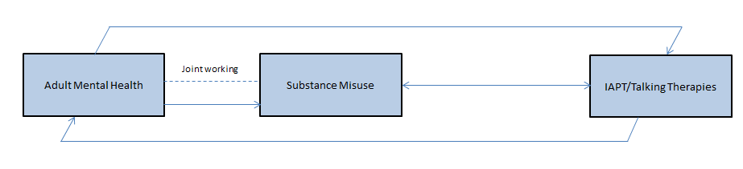

**The importance of diagnosis**

Delivering effective treatment to someone with a mental health problem and a drug and/or alcohol can be challenging. The complexity of issues, alongside intoxication and withdrawal from substances, makes diagnosis more difficult. Without diagnosis there can be no meaningful care plan and no lead agency; higher risk of relapse, (re)admission to hospital and suicide.

* A diagnosis should always be made at in-patient discharge
* If diagnosis is difficult, agree a ‘working diagnosis’, in order to plan treatment

**Electronic Patient Record Systems**

AMH, IAPT and Drug & Alcohol services use different Health Record systems. This is primarily because IAPT and Drug & Alcohol services have to make different national and local data submissions from AMH. Even with ‘read only’ access to another system, it is not possible to check 2 systems (or 3) each time a clinician sees a patient. Clinically this makes joint working more problematic.

To work closely in collaboration teams must develop other forms of communication

Agree a system that works for your Borough/County

* Make sure this system is outlined in your Operational Policy .g.
* A system that checks new referrals against other systems
* That checks against other systems when completing formal patient reviews/CPA etc
* Email information to colleagues in other services when you have a joint patient
* Alert colleagues when you have patients in crisis that may present to other services

|  |  |  |
| --- | --- | --- |
| **Service** | **System** |  |
| AMH | RIO | AMH can request a *‘read only’* licence for Nebula or Carepath |
| IAPT | IAPTUS | IAPT can *‘read only’* RIO |
| Reset Tower Hamlets | Nebula | Reset can *‘read only’* RIO |
| Path To Recovery, Bedfs | Carepath | P2R can *‘read only’* RIO |
| Newham, City, Hackney | unknown | No access, no *‘read only’* for ELFT staff |

**Pathway 1**

**High Risk Pathway**

|  |  |  |  |
| --- | --- | --- | --- |
| Objective | Clinical Presentation | Outputs | Outcomes |
| An integrated Dual Diagnosis model | Pathway 1. High risk pathway  Patient at high risk of suicide or significant harm to others (by intent or accident) due to current presentation/lifestyle.  Presentation may include:   * multiple crisis presentations by self or with family * recent crisis admission * Poor motivation to engage with services/improve lifestyle * Multiple services involved * Recent self-harm or harm to others * Actively suicidal * Other high risk factors   In these cases diagnosis is likely to relate to long term personality disorders or acute mental health episodes | Diagnosis or Working Diagnosis    One lead team coordinating treatment  Single joint care plan that takes in   * all services including those not yet involved but likely to be involved eg emergency provision, A&E, HTT etc * patient self-management plan * family support plan   Single joint risk assessment  Single letter of correspondence to stakeholders  Pathway identification by senior clinician.  Management via regular joint planning meetings led by senior managers  Desktop review by expert colleague post-discharge, or during treatment | * Fully coordinated seamless treatment and care * Early joint interventions * Simplified service navigation * Improved support for patient and family especially in managing crisis/ out of hours * Improved overall knowledge of the patient in order to better plan treatment * Support for staff from expert colleagues * Improved staff skillset * Better use of resources * Avoid duplication of treatment activities * Avoids confusion across services |

**Pathway 1 High Risk Pathway**

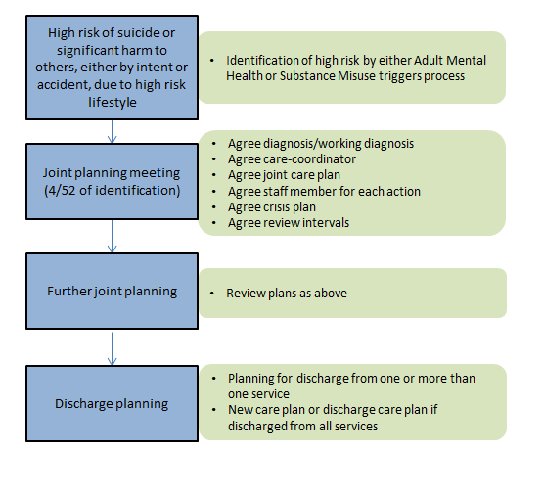

**Pathway 2**

**Joint Patient Pathway**

|  |  |  |
| --- | --- | --- |
| Clinical Presentation | Outputs | Outcomes |
| Pathway 2. Joint patient pathway  Patient attending both MH and substance misuse services.  Lead service according to assessment of need and diagnosis. | Diagnosis or Working Diagnosis  One lead team coordinating treatment  Single joint care plan matching patient need with best service to provide intervention and includes   * crisis planning * patient self-management plan * family support plan   Single joint risk assessment  Single letter of correspondence to stakeholders  Pathway identification by senior clinician.  Management via regular joint planning meetings led by senior managers  Desktop review by expert colleague post-discharge, or during treatment | Fully coordinated seamless treatment and care  Early joint interventions  Simplified service navigation  Improved support for patient and family especially in managing crisis/ out of hours  Improved overall knowledge of the patient in order to better plan treatment  Support for staff from expert colleagues  Improved staff skillset  Better use of resources  Avoid duplication of treatment activities  Avoids confusion across services |

**Pathway 2 Joint Patient Pathway**

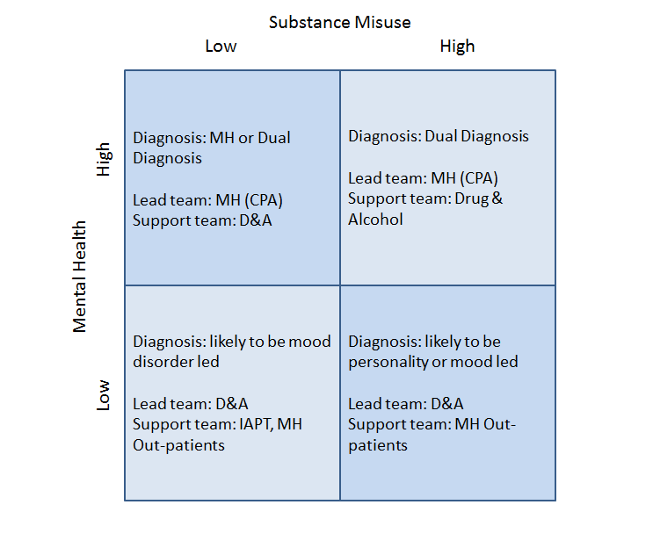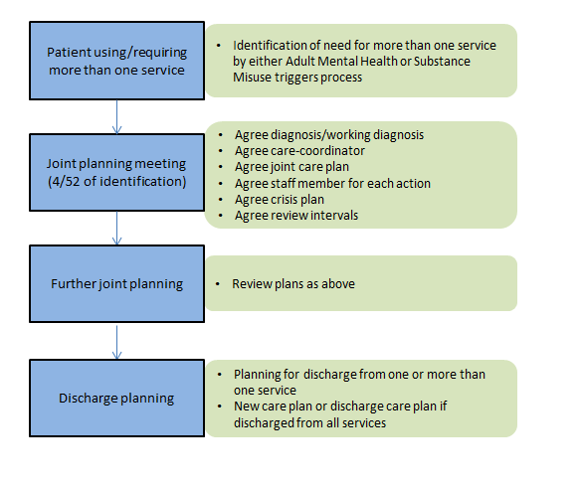

**Pathway 3**

**Discharge Pathway**

|  |  |  |
| --- | --- | --- |
| Clinical Presentation | Outputs | Outcomes |
| Pathway 3. Discharge pathway  Patient not currently attending multiple services  Completing treatment in one service and would benefit from a seamless transition to another service  e.g. transition from IAPT to substance misuse services where work is completed at IAPT and problematic alcohol use has emerged.  e.g. completion of drug treatment with achievement of abstinence where IAPT may address mood issues that have emerged | A seamless transition between services.  Meaningful handover between services and a new treatment plan to address outstanding issues.  No signposting or referral without follow up.  Desktop review by expert colleague post-discharge, or during treatment | * Fully coordinated seamless treatment and care * Simplified service navigation * Improved support for patient and family * Improved overall knowledge of the patient in order to better plan treatment * Avoids duplication ‘starting from scratch’ * Better use of resources |

**Pathway 3 Discharge Pathway**

