Apprenticeship Policy

Version number : | 1.2
Consultation Groups | JSC Sub Committee
Approved by (Sponsor Group) | JSC Sub Committee
Ratified by: | JSC
Date ratified: | 3rd January 2024
Name of originator/author: | Learning and Development Business Partner for Apprenticeships
Executive Director lead: | Chief People Officer
Implementation Date: | January 2024
Last Review Date | January 2024
Next Review date: | January 2027

Services | Applicable To
Trustwide | x
Mental Health and LD

Community Health Services

Version Control Summary

Version | Date | Author | Status | Comment
1.1 | Sept 2022 |  | Extended
1.2 | July 2023 | Harriet Bone – Learning & Development Business Partner for Apprenticeships |  | Updated to reflect ESFA rules, terminology and ELFT governance. Removal of probation period.

Contents
1. Scope 4
2. Definition 4
3. Rationale 5
4. Roles and Responsibilities 5
4.1. Apprenticeship Team responsibilities: 5
4.2. Managers responsibiilities: 5
4.3. Apprentice responsibilities: 6
4.4. Professional Lead responsibilities: 7
4.5. Training Provider responsibilities: 7
5. Eligibility 8
Appendices 9
Appendix 1: Recruiting an apprentice - process map 9
Appendix 2: Becoming an apprentice - process map 10
Appendix 3: Apprenticeship agreement 11
Appendix 4: Responsibility Matrix 12
Appendix 5: ELFT apprenticeship journey 13

Scope
  - This policy applies to all apprentices at the Trust and other relevant stakeholders.

Definition
  - Apprenticeships are nationally recognised vocational qualifications that offer a mixture of work-based training and education. They aim to give people the opportunity to:
- achieve vocational, work-based qualifications
- learn practical job skills and knowledge which are related to specific work roles
- progress within specific careers and educational pathways
  - Apprentices are aged 16 or over and combine working with studying for a work-based qualification. The qualifications range from the equivalent of five GCSEs up to a Masters level. There is no upper age limit and apprentices can be new or existing employees.
  - Apprentice Mentor: This is someone identified within the Apprentice’s workplace who can support them through all aspects of their development and adjustment to work.

  - Apprenticeship Levy: The Apprenticeship Levy came into effect in April 2017 and affects all employers with a pay bill of over £3,000,000. The levy is set at 0.5% of the total pay bill less £15,000. The levy payment goes direct to the treasury via HMRC and can only be utilised to pay for apprenticeship training in England. Employers have 24 months to use the funds once they enter their digital apprenticeship service account, after this point they will expire. Any unspent levy funds within each financial year are used by HMRC to support existing apprentices to complete their training and/or pay for apprenticeship training for smaller employers that do not pay the levy. Apprenticeship levy funds can only be used for apprenticeship training fees; they cannot be used for salary, expenses or backfill.
  - Training Provider: Training providers must be registered to deliver apprenticeships in order to be able to access funding. A full list of training providers and the apprenticeships they can deliver is available on the Salisbury NHS Framework. The Salisbury Commercial Services have created the Dynamic Purchasing System to provide a route for public sector employers to contract training providers without having to conduct a seperate procurement exercise for each apprenticeship and provider.

  - Tutor: The apprentice will be nominated a tutor by the training provider. It is the tutor’s role to ensure the apprentice is supported with all academic aspects of the qualification in partnership with line manager /mentor. The tutor may change throughout the course of the programme depending on the training provider’s capacity; this should be managed in line with the agreed service level agreement.

  - Off-the-job learning (OTJ): This is protected time during working hours for the apprentice to learn and demonstrate the apprenticeship knowledge and skills. It is a requirement for all apprenticeships and necessary to achieve the qualification. Off-the-job learning is formally logged by the apprentice/training provider. The amount of off-the-job learning will vary by apprenticeship programme with a minimum of 6 hours per week. OTJ will be listed on the apprentices training plan, issued by the training provider at the start of programme.

Rationale
  - The Trust is committed to providing opportunities, for both existing staff and local people, to develop through apprenticeships. By providing a more accessible route into professional and further professional training, apprenticeships promote greater diversity in our workforce. There is a sound business case for employing apprentices as they provide committed recruits, improve workforce skills and competencies and can help to reduce bank and agency expenditure. The purpose of this policy and the supporting procedure is to provide a framework for recruiting and managing apprentices within the organisation.

Roles and Responsibilities

Apprenticeship Team responsibilities:
    - Ensure stakeholders are supported with the policy and procedures for employing an apprentice or embarking on apprenticeship qualifications. See Appendix 1 & 2.
    - Identify opportunities for apprenticeships in workforce plans and from evaluating best practice elsewhere within the NHS and beyond.
    - Present the business case, options and risk assessment of new programmes to relevant stakeholders.
    - Lead the procurement process for the selection of training providers, working in partnership with our Integrated Care Board (ICB), where appropriate.
    - Monitor the service level agreements with training providers and hold providers to account for delivery.
    - Be responsible for the financial management of the Apprenticeship Levy funding on behalf of the Trust and for maximising the funding drawn down.
    - Build a strong talent pipeline of future apprentices through collaboration with schools and colleges, local authorities and charitable organisations.
    - Agree and adhere to the Responsbility Matrix. See Appendix 4.

Managers responsibiilities:
    - Consider all vacancies as apprenticeships, where appropriate.
    - Identify, with the apprenticeship team’s support, roles suitable for an apprenticeship scheme.
    - Inform the apprenticeship team and relevant professional lead of any apprentice workforce plans for the next financial year.
    - Adhere to the recruitment process map. See Appendix 1.
    - Complete the ‘Hiring an under-18 apprentice’ safeguarding risk assessment if your vacancy is being externally recruited.
    - Adhere to all existing Trust policies in the management of an apprentice ensuring fair treatment.
    - Hold regular reviews with the apprentice to assess the work, conduct and behaviour of the apprentice and to allow the new apprentice to assess the suitability of the role.
    - Signpost all apprentices to the Trust’s Coaching & Mentoring platform.
    - Release apprentice for off-the-job learning, agreed in advance with apprentice and tutor.
    - Attend quarterly review meetings with apprentice and their tutor/ELFT’s Apprenticeship team to define objectives and feedback on progress.
    - Support the development of relevant skills in the workplace by giving suitable experiences and responsibilities to the apprentice, linked to their objectives.
    - Maintain dialogue between apprentice, tutor and Apprenticeship team if the apprentice is unable to complete any of the academic or work-based components of their programme.
    - Inform the Apprenticeship team and seek appropriate advice if there are any competence or conduct issues that arise during the apprenticeship contract.
    - Contribute to the ’sign-off’ of the work-based component of an apprentice’s accreditation.
    - Support apprentices to identify suitable substantive posts for apprentices to apply for at the end of their apprenticeship. Allow time for apprentices to apply and attend interviews.
    - Notify the Apprenticeship team of any change to the apprenticeship end date, and submit a Change Form to the People & Cultire team at least one month prior to the adjustment date.
    - Inform the Apprenticeship team of the outcome and next steps for the apprentice on completion of their programme.
    - Ensure that the apprentice continues with the apprenticeship qualification if applying for, and accepting, a substantive post prior to completion. If the role is outside of the current team, ensure that the apprentice informs the hiring manager and gains approval to continue before applying for the post.
    - Agree and adhere to the Responsbility Matrix. See Appendix 4.

Apprentice responsibilities:
    - Adhere to all Trust policies and procedures, as well as apprentice processes, and act in accordance with the Trust values. Adhere to the conditions laid out in the apprenticeship agreement. See Appendix 3.
    - Understand that the Trust reserves the right to terminate your apprenticeship if you at any time:
- commit any serious or persistent breach
- gross misconduct or wilful neglect in the discharge of your duties
- are convicted of any criminal offence whether during or outside working hours other than a motoring or other offence which in the reasonable opinion of the Trust does not affect your position
- are in breach of the Trust’s policies regarding confidentiality and / or the disclosure of a criminal offence and / or the disclosure of a financial / pecuniary interest
    - Understand that the Apprenticeship will be terminated if at any time and for any reason it is no longer possible for the Trust to continue to train the Apprentice to obtain the qualification or the Apprentice’s attendance at College or work falls below the level required to complete the qualification within the requisite time period.
    - Attend induction and complete all statutory and mandatory training. Complete and return the apprenticeship agreement to the apprenticeship team (Appendix 3).
    - Attend all scheduled apprentice training and meetings and agree these in advance with line manager.
    - Understand that East London NHS Foundation Trust fund the apprentice salary, as well as the apprenticeship programme and provide paid protected study time (during working hours). ELFT accept expense claims for any on-the-job learning that is outside of the apprentices normal work place i.e. clinical sites or home visits. Travel expenses are not accepted for placements. ELFT do not accept mileage claims to/from the training provider or overnight stays, unless agreed at pre-employment stage. Any expenses claimed will come from the department’s budget.
    - Maintain own workload seeking support from line manager/mentor and tutor, when needed.
    - Meet the assessment or examination requirements at the agreed level set out in the training plan.
    - Maintain dialogue between the line manager, tutor and Apprenticeship team and raise issues as early as possible. Inform the Apprenticeship team and seek appropriate advice if unable to complete any of the academic or work-based components of their programme, or require a Break in Learning.
    - Do not accept Bank shifts, unless they are for your contracted role in the department you work in, or a role you are already competent to work in.
    - Continue with the apprenticeship qualification if applying for, and accepting, a substantive post prior to completion. If the role is outside of the current team, inform the hiring manager and gain approval to continue before applying for the post.
    - Inform the apprenticeship team if you are leaving ELFT and need to withdraw or transfer your apprenticeship.
    - Complete the apprenticeship exit interview at the end of your apprenticeship.
    - Agree and adhere to the Responsbility Matrix. See Appendix 4.

Professional Lead responsibilities:
    - Directly request, or advise Service Leads to request, levy funding approval from the apprenticeship team before starting any apprenticeship recruitment, adhering to the recruitment process map. See Appendix 1.
    - Ensure that the selected training providers are approved and feature on the Salisbury NHS Framework.
    - Inform the apprenticeship team of any new training providers to enable the correct procurement process, prior to recruitment.
    - Remain up to date with the ESFA funding rules and inform the apprenticeship team of any changes in circumstances for learners eg. Break in Learning.
    - Agree and adhere to the Responsbility Matrix. See Appendix 4.

Training Provider responsibilities:
    - Deliver the academic element of the apprenticeship.
    - Provide all information and support for the apprenticeship programmes that they have been contracted.
    - Give formal feedback to the Trust on an apprentice’s performance and conduct.
    - Share compliance data as requested by the Trust.
    - Be involved in the recruitment and selection of suitable apprentices based on the criteria set by the recruiting manager and the Trust’s recruitment department.
    - Comply with any contractual and service-level agreements entered into with the Trust.
    - Agree and adhere to the Responsbility Matrix. See Appendix 4.

Eligibility
  - The selected apprenticeship must align to the job role that the apprentice is employed in. This is to enable the apprentice to evidence their learning.
  - The apprentice will be working towards, and not already hold, the apprenticeship qualification and competencies that will be awarded. This will be assessed by the training provider during enrolment.
  - The apprentice must be on the ELFT PAYE scheme for the duration of the apprenticeship. For those on a fixed term contract, the contract must cover the length of programme. Colleagues on Bank-only are not eligible.
  - The apprentice must work a minimum of 30 hours per week.
  - The apprentice must meet the apprenticeship entry requirements and hold relevant pre-requisite qualifications.
  - The apprentice must comply with the ESFA funding rules and have lived in the UK for 3 years prior to the start of the apprenticeship, unless exempt.
  - The apprenticeship policy is aligned to ELFT’s Recruitment and Selection policy. This includes the apprentice’s notice period and any reasonable adjustments required.
  - Existing colleagues on an apprenticeship for their Continued Professional Development must have Level 2 Functional Skills in Maths and English prior to applying for an apprenticeship. For those that do not hold these qualifications, they can be achieved internally – free of charge to the employee.
Existing colleagues completing an apprenticeship qualification to address a skills/knowledge gap in their current role will continue on their current terms and conditions of employment.

Appendices

Appendix 1: Recruiting an apprentice - process map
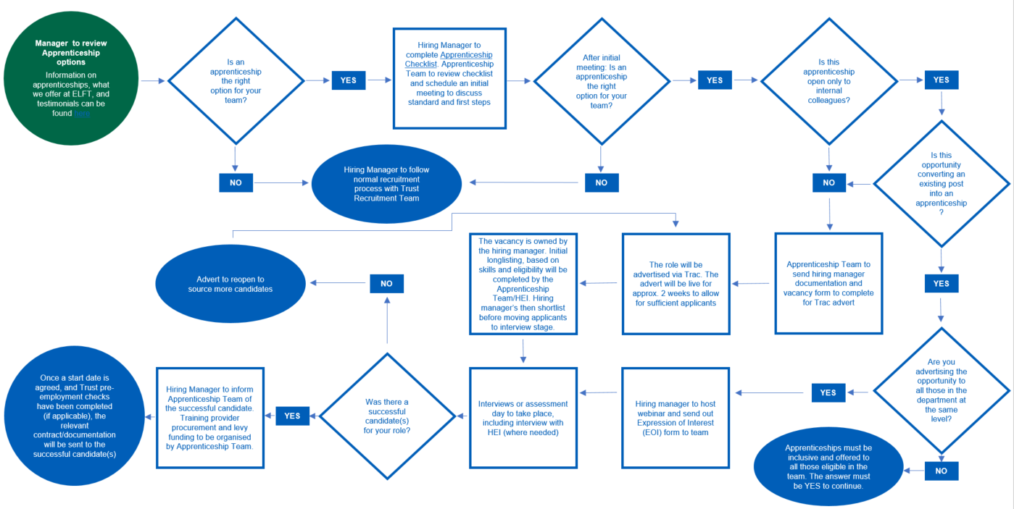

Appendix 2: Becoming an apprentice - process map
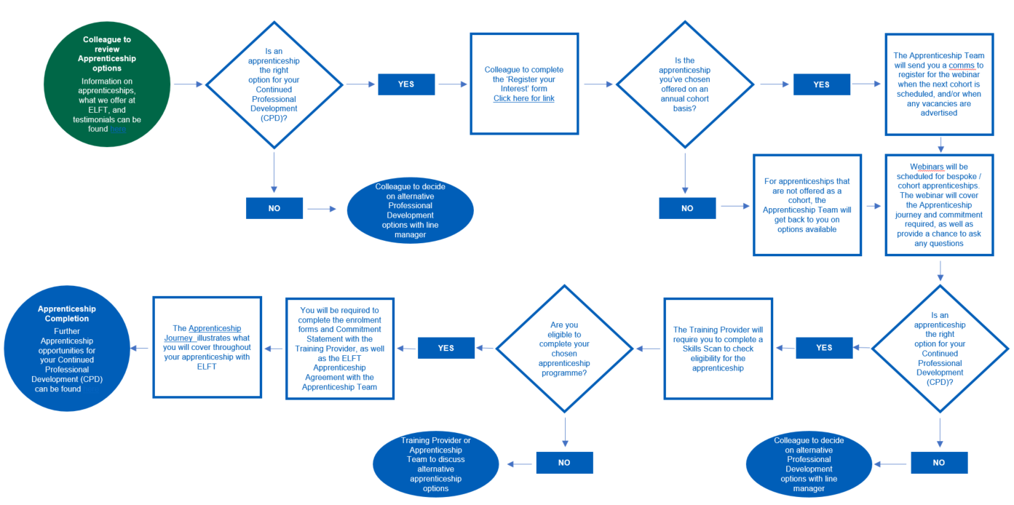

Appendix 3: Apprenticeship agreement

Appendix 4: Responsibility Matrix

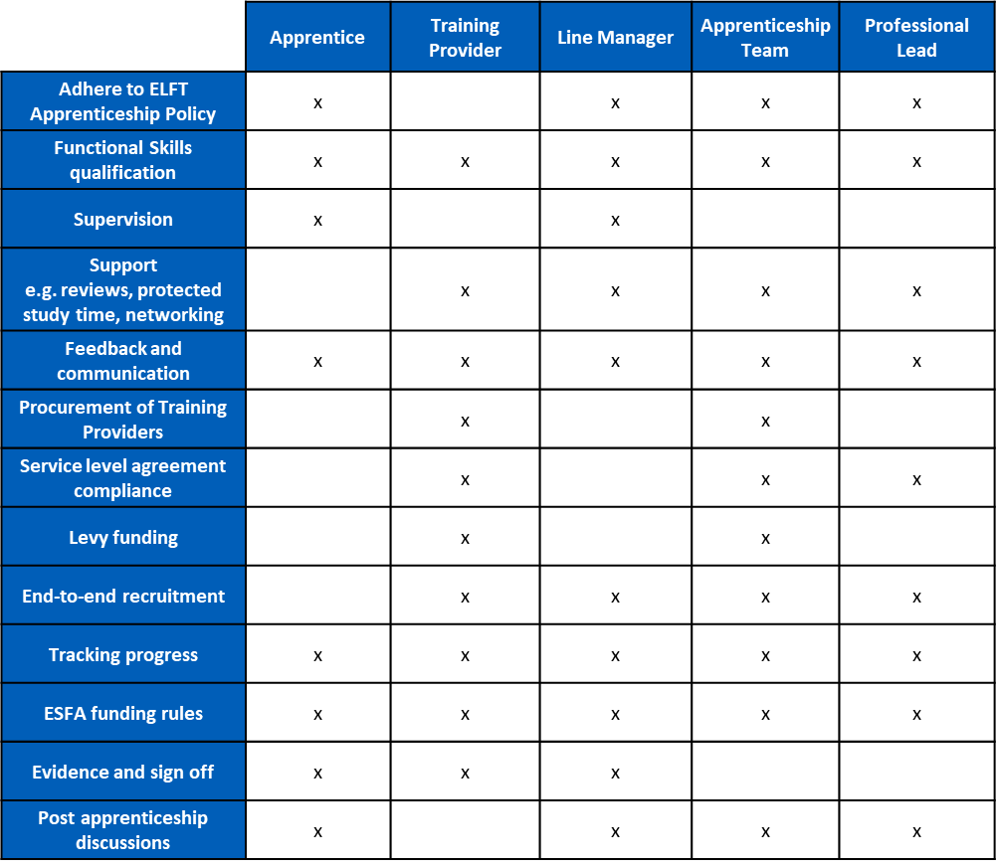

Appendix 5: ELFT apprenticeship journey
