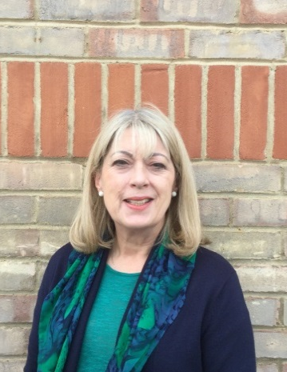
Bedfordshire AMHT
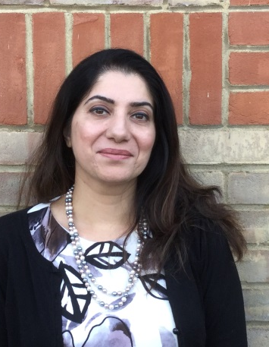
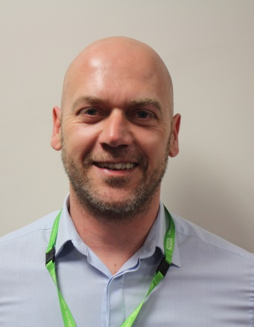

Matt Sparks Sobiz Naz Linda Johnstone
Professional Lead Child & Adolescent Systemic Psychotherapist
Mental Health Nurse Psychiatrist
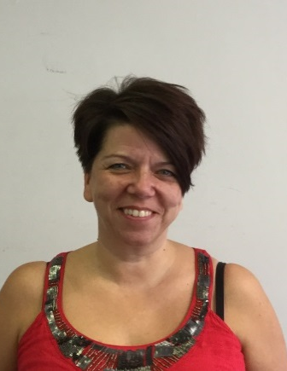
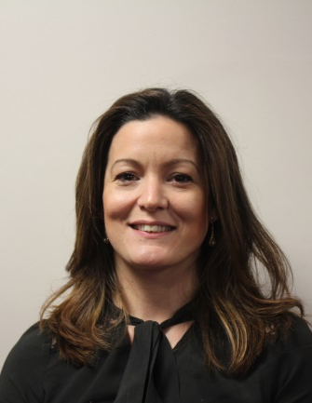
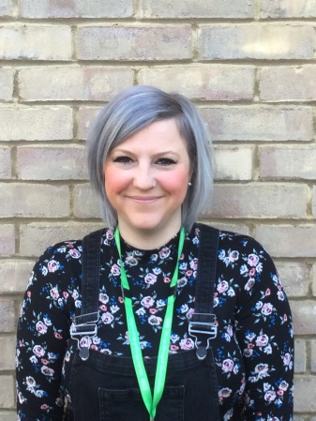

Helen Anderson Lisa Collings Amanda Wallace
Mental Health Nurse Mental Health Practitioner CBT Therapist
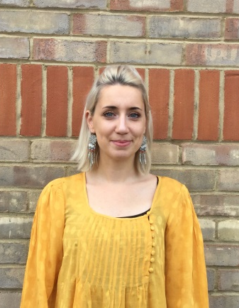
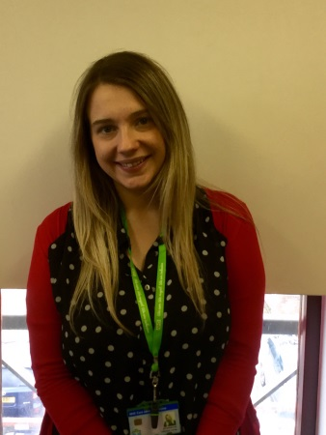

Steve Hartwell Chelsea Laing Gemma Douthwaite
A & E Liaison Practitioner A & E Liaison Nurse Support Worker
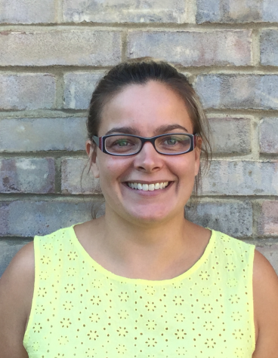
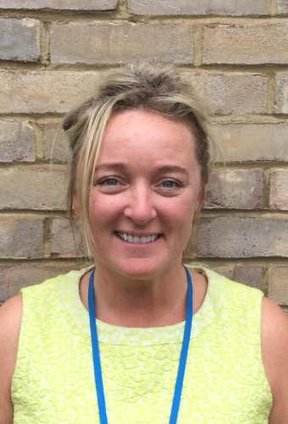

Marion Needs Niki Scott Jo Meehan
Team Administrator Service User Participation CAMHS General Manager
Lead
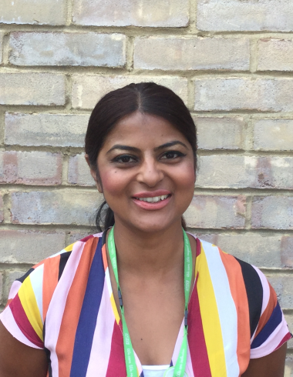

Annabelle Chang Shindy Powell
Mental Health Nurse A&E Liaison Nurse

