Pay Gap Report
East London NHS Foundation Trust
Contents
- What is the Gender Pay Gap Report?
- Exclusions
- Gender Pay Gap indicators
- East London NHS Foundation Trust workforce context
- Snapshot 31st March 2020
- Summary of results and initial assessment of implications/actions

- What is the Gender Pay Gap report?
Recent gender pay reporting legislation now requires employers with 250 or more employees to publish statutory calculations every year showing how large the pay gap is between their male and female employees. There are two sets of regulations. The first is mainly for the private and voluntary sectors (taking effect from 5 April 2019) and the second is mainly for the public sector (taking effect from 31 March 2019). For NHS Trusts this means providing a ‘snapshot’ of ordinary pay differences on 31st March 2019 and bonus payments made during the year.

The results must be published on the employer's website and a government website. They must, where applicable, be confirmed in a written statement by an appropriate person, such as a chief executive. While employers may already be taking steps to improve gender equality and reduce or eliminate their gender pay gap, this process will support and encourage action.

Gender pay reporting is different to equal pay; equal pay deals with the pay differences between men and women who carry out the same jobs, similar jobs or work of equal value. It is unlawful to pay people unequally because they are a man or a woman.

The gender pay gap shows the difference in the average pay between all men and women in a workforce. If a workforce has a particularly high gender pay gap, this can indicate there may a number of issues to deal with, and the individual calculations may help to identify what those issues are.

The NHS terms and conditions of service handbook contain the national agreements on pay and conditions of service for NHS staff other than very senior managers and medical staff.

Job evaluation enables jobs to be matched to national job profiles or allows trusts to evaluate jobs locally, to determine in which Agenda for Change pay band a post should sit.

- Exclusions

We have excluded the following from our calculations:
Elements related to: Salary sacrifice
Arrears
Overtime
Staff on reduced pay due to long term sickness, maternity/paternity
Hours worked and paid whilst ‘on call’ (on call allowance is included)
Career Break, maternity Leave, Inactive,

- The Gender Pay Gap Indicators

An employer must publish six calculations showing:

i. Average gender pay gap as a mean average
ii. Average gender pay gap as a median average
iii. Average bonus gender pay gap as a mean average
iv. Average bonus gender pay gap as a median average
v. Proportion of males receiving a bonus payment and proportion of females receiving a bonus payment
vi. Proportion of males and females when divided into four groups ordered from lowest to highest pay

- East London NHS Foundation Trust Workforce
Trust | Mean | Median | Lower | Lower Middle | Upper Middle | Upper | Mean Bonus Gap | Median Bonus Gap | % Women Receiving Bonus | % Men Receiving Bonus | Employer Size
West London Mental Health (NHS) Trust
South West London & St George's Mental Health NHS Trust
Central North West London NHS foundation trust
Norfolk And Suffolk NHS Foundation Trust
East London NHS Foundation Trust (2019)
Oxleas NHS Foundation Trust
Guy's & St Thomas' NHS Foundation Trust
Royal Free London NHS Foundation
Barts Health NHS Trust
Cambridgeshire Community Services NHS Trust
Barking, Havering & Redbridge University Hospitals NHS Trust
North East London NHS Foundation Trust

= Report has not been uploaded to government website for this year

Band | Apprentice | Band 2 | Band 3 | Band 4 | Band 5 | Band 6 | Band 7 | Band 8a | Band 8b | Band 8c | Band 8d | Band 9 | Trust Board | Medical
Female | 30 | 3 | 802 | 652 | 669 | 854 | 676 | 334 | 95 | 63 | 20 | 6 | 4 | 214
Male | 15 | 3 | 378 | 168 | 241 | 260 | 229 | 122 | 42 | 25 | 17 | 4 | 10 | 172
Female% | 66.67% | 50.00% | 67.97% | 79.51% | 73.52% | 76.66% | 74.70% | 73.25% | 69.34% | 71.59% | 54.05% | 60.00% | 28.57% | 55.44%
Male% | 33.33% | 50.00% | 32.03% | 20.49% | 26.48% | 23.34% | 25.30% | 26.75% | 30.66% | 28.41% | 45.95% | 40.00% | 71.43% | 44.56%

The current gender split within the overall workforce is 72.40% Female and 27.60% Male.

- Snapshot 31st March 2020

Pay Gap %

Pay Gap %
Gender | Avg. Hourly Rate | Median Hourly Rate
Male | £22.01 | £19.05
Female | £19.37 | £17.88
Difference | £2.64 | £1.17
Pay Gap % | 12.01% | 6.14%

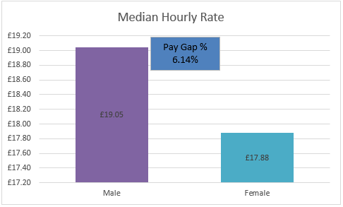
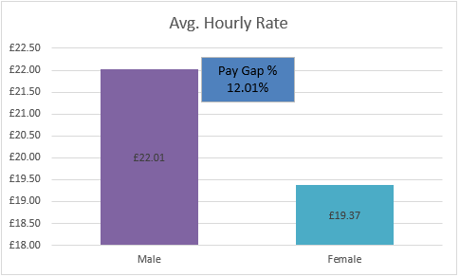

Bonus Gap %

Bonus Gap %
Gender | Avg. Bonus Pay | Median Bonus Rate
Male | £12,065.43 | £9,048.00
Female | £6,248.49 | £3,681.81
Difference | £5,816.94 | £5,366.20
Pay Gap % | 48.21% | 59.31%

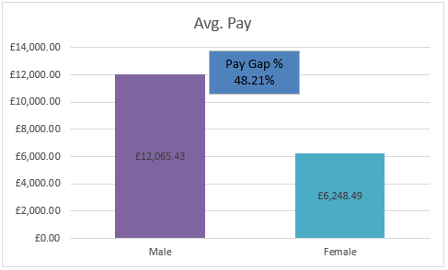
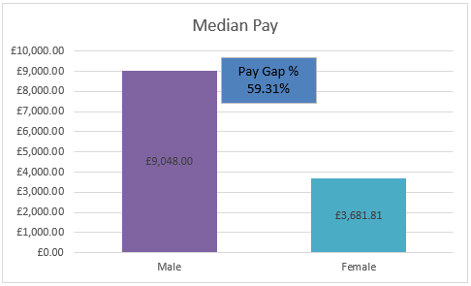

Bonus Gap %
Gender | Employees Paid Bonus | Total Relevant Employees | % Of Total Relevant Employees receiving Bonuses
Male | 51.00 | 2065.00 | 2.47
Female | 38.00 | 5230.00 | 0.73
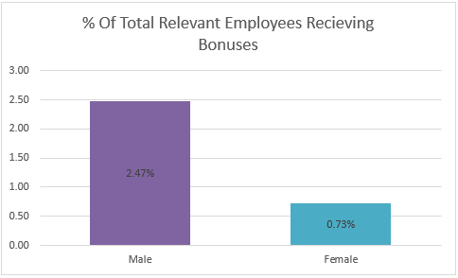

Quartiles

Quartiles
Quartile | Female | Male | Female % | Male %
1 | 1152 | 377 | 75.34% | 24.66%
2 | 1130 | 400 | 73.86% | 26.14%
3 | 1121 | 396 | 73.90% | 26.10%
4 | 1023 | 520 | 66.30% | 33.70%

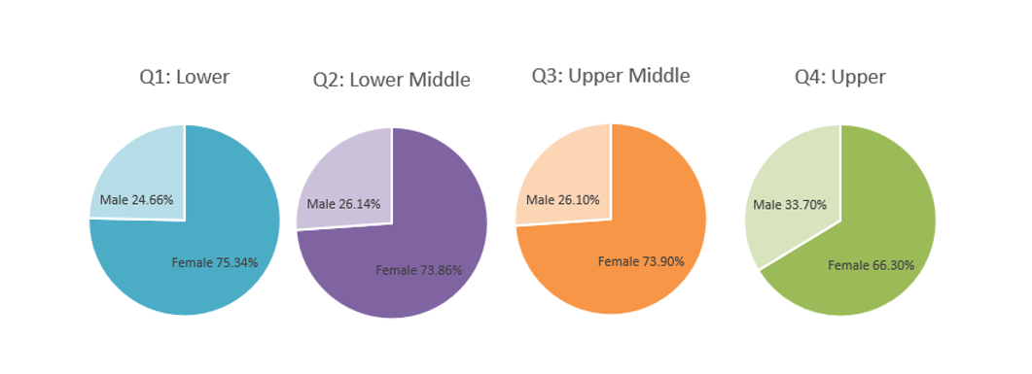

Gender Pay Gap % By Staff Group

Staff Group | Number Of Individuals | Male | Female | Difference | Pay Gap %
Add Prof Scientific and Technic | 752 | £24.91 | £24.33 | £0.58 | 2.33%
Additional Clinical Services | 1475 | £13.83 | £13.28 | £0.55 | 3.98%
Administrative and Clerical | 1359 | £21.61 | £16.57 | £5.04 | 23.32%
Allied Health Professionals | 464 | £22.37 | £20.94 | £1.43 | 6.39%
Estates and Ancillary | 22 | £12.18 | £11.07 | £1.11 | 9.11%
Medical and Dental | 385 | £41.63 | £38.43 | £3.20 | 7.69%
Nursing and Midwifery Registered | 1658 | £21.41 | £20.35 | £1.06 | 4.95%

Gender Pay Gap % By Pay Band

Band | Number Of Individuals | Male | Female | Difference | Pay Gap %
Band 2 | £9.90 | £9.55 | £10.24 | -£0.69 | -7.23%
Band 3 | £12.83 | £13.35 | £12.59 | £0.76 | 5.69%
Band 4 | £13.13 | £13.64 | £13.00 | £0.64 | 4.69%
Band 5 | £16.37 | £16.80 | £16.22 | £0.58 | 3.45%
Band 6 | £19.59 | £20.16 | £19.42 | £0.74 | 3.67%
Band 7 | £22.86 | £23.39 | £22.68 | £0.71 | 3.04%
Band 8a | £26.62 | £26.85 | £26.54 | £0.31 | 1.15%
Band 8b | £31.50 | £31.58 | £31.47 | £0.11 | 0.35%
Band 8c | £36.21 | £36.01 | £36.29 | -£0.28 | -0.78%
Band 8d | £43.04 | £42.83 | £43.22 | -£0.39 | -0.91%
Band 9 | £54.84 | £54.90 | £54.80 | £0.10 | 0.18%

- Summary of results and initial assessment of implications/actions

Metric | Analysis | Implications/Actions

