Appendix 17
Enteral Feeding Workbook
For gastrostomy devices

Name:_____________________________________________ Date__________

Section 1: Understanding of reasons for enteral feeding- Label the organs
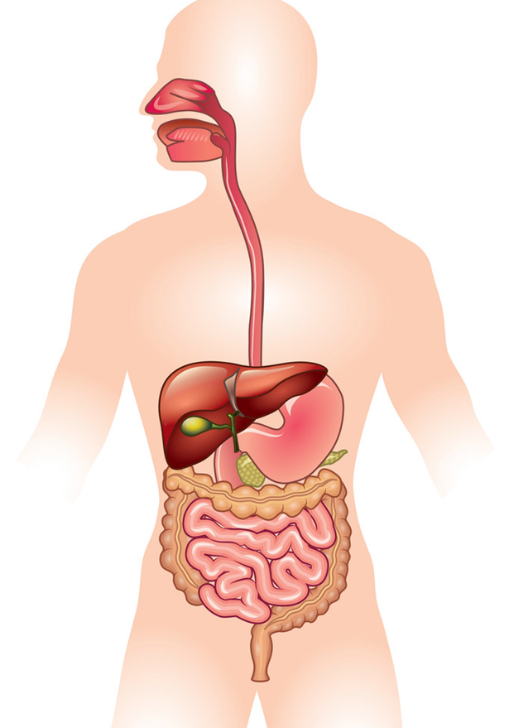
Organs
Oesophagus
Liver
Stomach
Anus/rectum
Mouth/oral cavity
Nose/nasal cavity
Large intestine
Small intestine
4
3
8
7
6
5
1
2

1) ______________________________ 5) ______________________________
2) ______________________________ 6) ______________________________
3) ______________________________ 7) ______________________________
4) ______________________________ 8) ______________________________
Match the organ with the function
Makes and excretes Bile when food enters bowel. Bile contains acids which are critical for the digestion and absorption of fats.

……………………………………………………

The beginning of the digestive tract. Chewing ensures food is digested easier while saliva begins the process of breaking food down ready to be absorbed.

……………………………………………………
Consists of the duodenum, jejunum and ileum. Food is neutralised so nutrients can be extracted and absorbed into the blood stream, waste continues on.

……………………………………………………
Stool is expelled.

……………………………………………………

……………………………………………………
Contains acids and enzymes to break up food. Ph 1.5-2.0

Route for air into the body. Warms, moistens and filters the air breathed in.
Water absorption takes place and waste product is compacted into stool.

……………………………………………………

……………………………………………………
A long thin tube that connects the pharynx (throat) to the stomach. Passage for food and liquids that have been swallowed into the pharynx to reach the stomach.

……………………………………………………

Give 3 reasons why a child may have an enteral feeding tube.
1) ______________________________________________________________________ _________________________________________________________________________
2) ______________________________________________________________________ _________________________________________________________________________
3) _______________________________________________________________________ _________________________________________________________________________

Describe the following in simple terms:
What is a gastrostomy? __________________________________________________________________________________________________________________________________________________
What is a percutaneous endoscopic gastrostomy/ jejunostomy (PEG-J)? __________________________________________________________________________________________________________________________________________________
What is a jejunostomy __________________________________________________________________________________________________________________________________________________
List two types of gastrostomy
1) _______________________________________________________________________
2) _______________________________________________________________________

Section 2: Understanding the safety aspects of enteral feeding

Hand washing is one of the most important safety aspects when feeding a child.
When do you need to wash your hands when feeding a child? (Please underline appropriate answers)
- Prior to feeding the child
- After feeding the child
- Prior to contact with the child.
- All of the above

Should you wear gloves when feeding a child?
Yes No
Give a reason for your answer __________________________________________________________________________________________________________________________________________________

When can you use alcohol hand rub? (Please underline appropriate)
- Every time you need to clean your hands (instead of using soap and water)
- After feeding the child
- On visibly clean hands only
- You should not use it at all

Should pre-packed feeds be stored in fridge? (Circle your answer)
Yes No

Should freshly mixed feeds be stored in fridge? (Circle your answer)
Yes No

Should you give a feed taken straight from the fridge? Please explain your reasoning.
___________________________________________________________________________________________________________________________________________________________________________________________________________________________
How long can pre-packed feeds be used?
2hours 4hours 8hours 12hours 24hours

If a feed has been opened how long before you need to discard at room temperature?
2hours 4hours 8hours 12hours 24hours

If a feed has been opened and placed in the fridge, how long before you need to discard it?
2hours 4hours 8hours 12hours 24hours

List four checks (in relation to the milk) that are essential prior to a feed being used
1) _______________________________________________________________________
2) _______________________________________________________________________
3) _______________________________________________________________________
4) _______________________________________________________________________

What position should children be in whilst receiving an enteral feed and why? _________________________________________________________________________
_________________________________________________________________________

Section 3: Understanding the importance of checking tube position
Prior to feeding a child, the gastrostomy/jejunostomy site needs to be checked. Please identify whether the following statements are true or false.

- The tube should be tight on the child’s abdomen. True False

- The tube should be flush with the abdomen with True False
approximately 5mm gap between the tube and skin.
- The tube should be 2cm away from the abdomen. True False

- The tube should easily rotate. True False

What problems might you observe around the stoma site? ___________________________________________________________________________________________________________________________________________________________________________________________________________________________
How would you manage this? ___________________________________________________________________________________________________________________________________________________________________________________________________________________________

List two ways that might suggest the feeding tube is dislodged.
1) _______________________________________________________________________
2) _______________________________________________________________________

Section 4: Competence using equipment

List all equipment you will require for enteral feeding
1) ______________________________ 4) ______________________________
2) ______________________________ 5) ______________________________
3) ______________________________ 6) ______________________________
4) ______________________________ 8) ______________________________

What does ‘priming’ mean? __________________________________________________________________________________________________________________________________________________

What 2 pieces of equipment do we prime?
1) _______________________________________________________________________
2) _______________________________________________________________________

What is a ‘flush’ and why is it important to use a ‘flush’? __________________________________________________________________________________________________________________________________________________

What type of water is used for a flush?
Under 1 year old: _________________________________________________________
Over 1 year old: __________________________________________________________
Why might you use sterile water for a child >1 year? ______________________________
________________________________________________________________________

Give a short description of gravity feeding and how it works?
__________________________________________________________________________________________________________________________________________________

Section 5 Daily cares for a child with an enteral feeding tube.

Can children with an enteral feeding tube have oral food and drink? (Circle your answer)
Yes No Depends on the child

Where would you find this information?
__________________________________________________________________________________________________________________________________________________

Should gastrostomy sites be cleaned? (Circle your answer)
Yes No
If yes:
How often? _______________________________________________________________
What would you use? _______________________________________________________

As a general rule, should a gastrostomy be covered with a dressing? (Circle your answer)

Yes No

Is it important for children to clean their mouths? (Circle your answer)

Yes No

If yes, how often should it be performed? (Circle your answer)

Once daily Twice daily 3 times daily

Section 6: Weekly care of the gastrostomy balloon device

What is inserted into the balloon to keep the balloon inflated? ________________________

How much is inserted?
- 5mls
- 10mls
- 20mls
- Dependant on child

Where would you gain this information? __________________________________________________________________________________________________________________________________________________

What would happen if there was too little in the balloon?
_________________________________________________________________________

What would happen if there was too much in the balloon?
_________________________________________________________________________

Why do we check the amount in the balloon?
1) _______________________________________________________________________
2) _______________________________________________________________________

How often is this carried out?
_________________________________________________________________________

Who is responsible for checking this?
_________________________________________________________________________

Section 7: Awareness of potential problems and solutions

How would you recognise if the tube is blocked? __________________________________________________________________________________________________________________________________________________

How can blockages in the tube be kept to a minimum? __________________________________________________________________________________________________________________________________________________

Explain what you would do if you suspected that the tube was blocked
1) _______________________________________________________________________
2) _______________________________________________________________________
3) _______________________________________________________________________

What would you do if you could not unblock the tube?
_________________________________________________________________________

Explain what you would do if the tube came out.

Balloon Gastrostomy ___________________________________________________________________________________________________________________________________________________________________________________________________________________________PEG/PEG-J (inserted > 6 weeks ago) ___________________________________________________________________________________________________________________________________________________________________________________________________________________________
PEG/PEG-J (inserted < 6 weeks ago) ___________________________________________________________________________________________________________________________________________________________________________________________________________________________

How long before a gastrostomy opening (stoma) will start to close after the tube is removed? (Circle your answer)
10 minutes 1 hour 2 hours 10 hours

Describe what you would do if a child developed vomiting, diarrhoea or abdominal pain during feeding?
1) _______________________________________________________________________
2) _______________________________________________________________________
3) _______________________________________________________________________

List four things that may cause vomiting, diarrhoea or abdominal pain.
1) _______________________________________________________________________
2) _______________________________________________________________________
3) _______________________________________________________________________
4) _______________________________________________________________________

Section 8: Understanding the psychological impact of enteral feeding.

Is it important that the child joins the family at meal times? (Circle your answer)
Yes No

Give a reason for your answer. __________________________________________________________________________________________________________________________________________________

List 5 ways you think enteral feeding may impact on a family
1) ______________________________________________________________________
2) ______________________________________________________________________
3) ______________________________________________________________________
4) ______________________________________________________________________
5) ______________________________________________________________________

Workbook Assessment Details:
Note – this workbook must be assessed by the registered nurse conducting enteral feeding training.
This document does not mean you are competent to feed a child unsupervised. An accompanying competency document must be completed by a registered nurse before you can feed independently.
Workbook completed by _______________________________________________________
Workbook assessed by ____________________________________ Sign_______________
Job title _________________________________________________ Date _______________

