Anorexia - an illness of contradictions...

The popular misconception of anorexia is that it is a willful lifestyle choice, a faddy vanity-fueled diet, that simply requires a decision to “just eat” in order to recover. I would have saved myself years of pain and grief and time lost in inpatient care if it were really that simple. To me, anorexia has been an illness of paradox and tangled contradictions, which traps me in a labyrinth of back-to-front thinking. At times, not consuming food has been an all-consuming preoccupation. In the doctrine of anorexia ‘need’ is redefined as ‘greed’, appetite becomes denied, displaced and demonised. Anorexia made me desperate to disappear and yet terrified of being abandoned or ignored. I felt the drive to both achieve and self-destruct.

Anorexia laid down strict rules for me to obey, punitive standards to attain, but also kept moving the goalposts; nothing – quite literally – was ever good enough. At the height of my difficulties, going against the rules my eating disorder dictated, triggered overwhelming anxiety and panic. The fears my anorexia induced were irrational but crippling and deeply rooted, impossible to battle with reasoning or logic alone. When I tried to resist the demands of my illness anorexia would tell me I was losing control. Family would plead with me to ‘fight’ but in the grips of anorexia fighting felt like losing, winning felt like failing. I was filled with ambivalence about recovery.
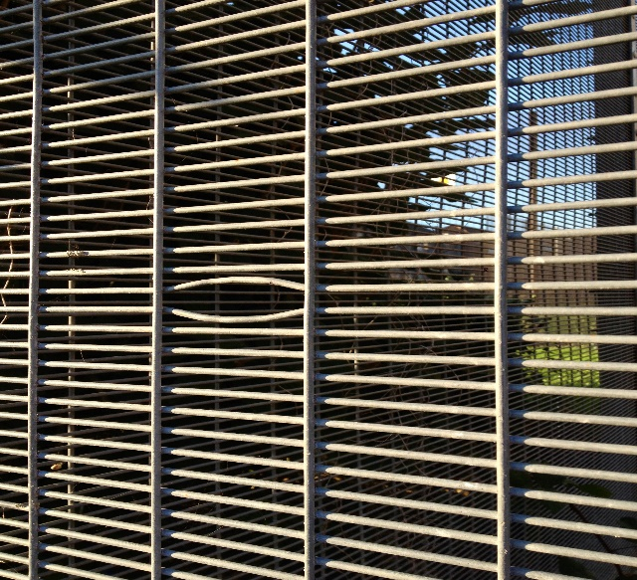
Photography by Katharine Lazenby, taken whilst an inpatient in 2014 receiving treatment for anorexia.

For the person struggling with disordered eating, of any kind, the behaviour serves some kind of purpose. It is an answer or solution to a problem, the clue to a buried inner conflict. Uncovering that problem or conflict is where the work needs to start. It is impossible to heal on the outside if the wounds inside are left untreated.

Retreating into my eating disorder numbed my emotions and fogged my mind: anorexia was the perversely literal solution to having ‘a lot on my plate’ and emotions that are impossible to swallow. My eating disorder steadily disconnected me from reality, turning down the volume on a deafening world and providing an escape from unwanted responsibilities and feelings of powerlessness. It gave me a language with which to communicate how I felt about myself, a channel through which to process how overwhelming I found life.

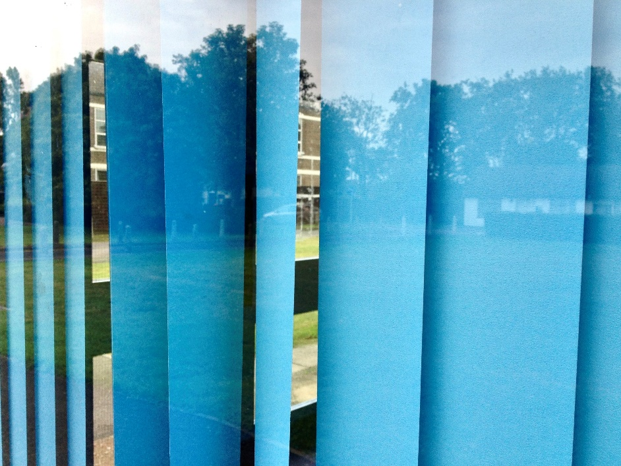
Photography by Katharine Lazenby, taken whilst an inpatient in 2014 receiving treatment for anorexia.

The upshot was that I lost myself to anorexia for many years. Recovery to me, and it is an ongoing process, has meant re-finding myself; finding my voice, my sense of self value, of purpose and identity. It has meant accepting that my path through my life is my own, and if it takes me a little longer than others to find my way, then that is OK. It has meant finding the spark within me that wanted to live and doing anything I could to keep that fire burning. It has meant recognising that whilst anorexia tried to protect me, that protection became a deadly constriction that threatened to suffocate the life out of me. Now I am ready to grow beyond it.

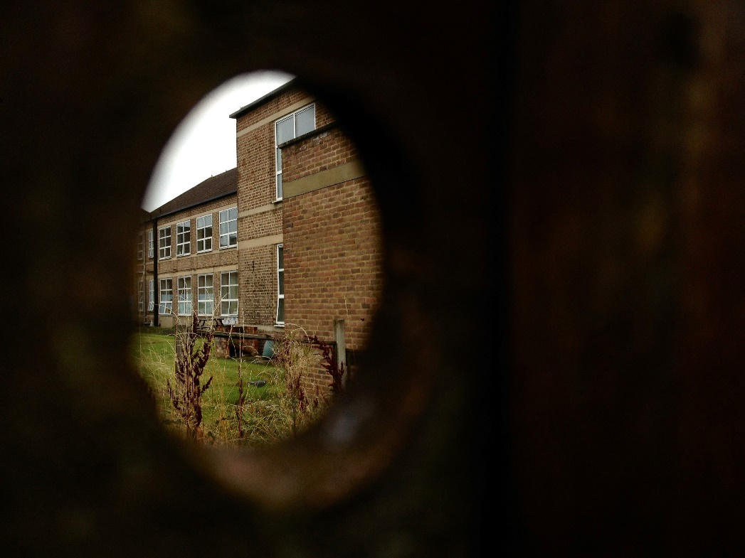
Photography by Katharine Lazenby, taken whilst an inpatient in 2014 receiving treatment for anorexia.

‘And the day came, when the risk it took to remain tight in a bud was greater than the risk it took to blossom’ – AnaÏs Nin

Katharine Lazenby, People Participation Worker for disordered eating

