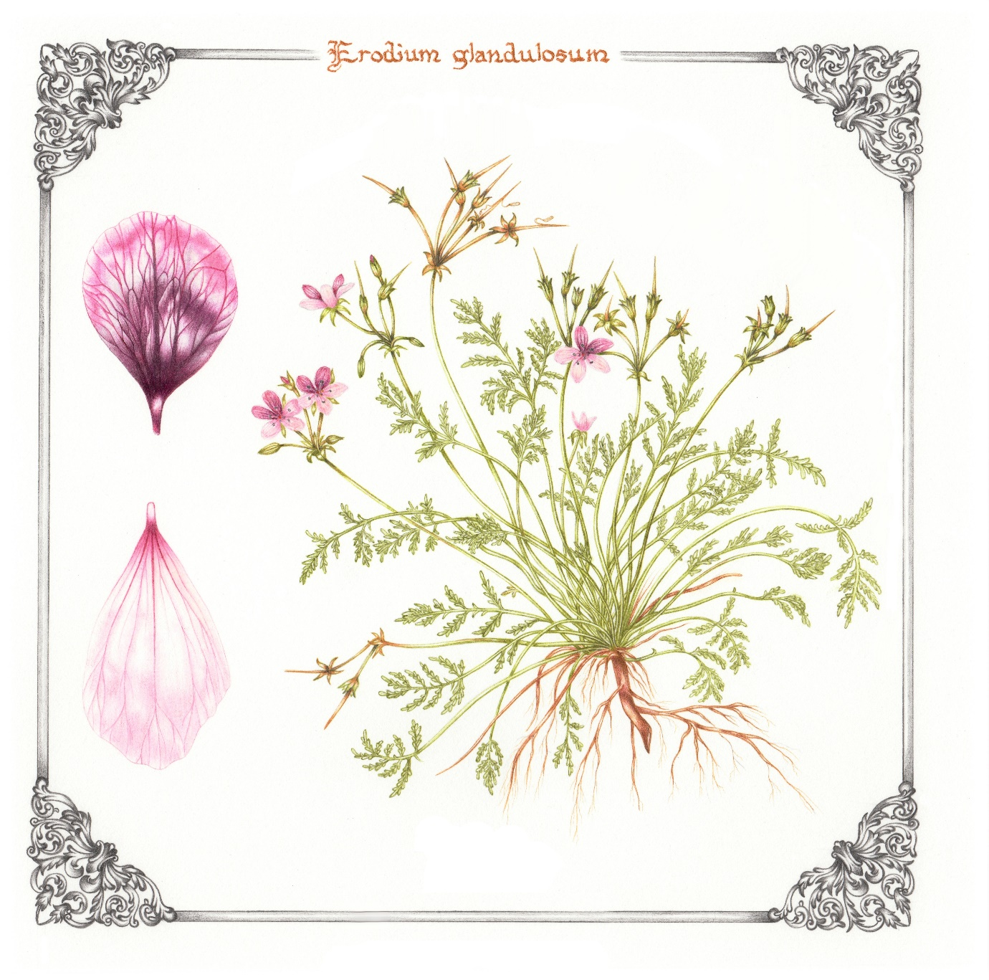

A picture speaks a thousand words…
Erodium glandulosum, also known as Black Eyed Heronsbill, one of the hardiest Heronsbill species. This watercolour is one of a series of five paintings of geraniums from the country of my birth, South Africa. The story of these paintings runs parallel to the course of my eating disorder, lying behind it is the challenge of recovery.

I started a botanical painting course in 2015, but the early years of my studies were a dark and difficult time and became largely defined by my eating disorder. It became increasingly hard to create and concentrate on my paintings; my eating disorder drew all my focus and energy. I was fortunate however, to have incredibly supportive tutors who made it possible for me to complete the course in my own time and this gave me the space to move forwards at my own pace.

Lockdown gave me the space I needed to think, and I started to work towards not only completing the course but also getting help for my eating disorder. I recognised that I had become comfortable with the uncomfortable; my controlling rituals and behaviours were such a familiar part of my identity but they got in the way of my life and had become a heavy weight on my shoulders. I had to accept that letting go was necessary.

As I worked towards completing the course and finishing my paintings I started to work with Colette, ELFT’s dietician for disordered eating. She was exactly what I needed, clearly and calmly talking me through my difficulties and helping me to find ways to cope with issues that had plagued me for years.

Six years after starting, I finished the painting course last year, whilst I was taking steps forward to manage my eating disorder. The letting go of the course, and of the eating disorder too, for me marks both an achievement and a loss. I have more space for thinking, which is liberating, but for someone prone to anxiety it can also be a real challenge. I have a sense of freedom but also the fear of losing control and an uncertainty about where to turn next.

When I look at this painting I see the story behind it; I see how far I have come but also recognise that there is still a way to go.

Anonymous, Tower Hamlets

