One step at a time
These are some photos I have taken over my years of eating disorder recovery. They capture some of my walks to treatment, times where I felt strong enough to go out and socialise, and my appreciation of nature when I was out and about. Getting outside is something that I consistently struggle with, due to my body anxiety, so any evidence of getting out is really important to me. The reason feet are important is that I haven't been able to have a picture taken of myself for years, so the photos also reflect the difficulty in being able to look at your physical self when you have an eating disorder.
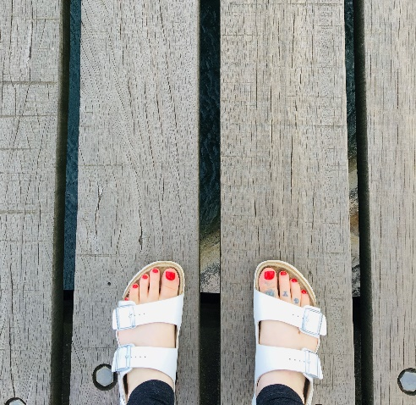
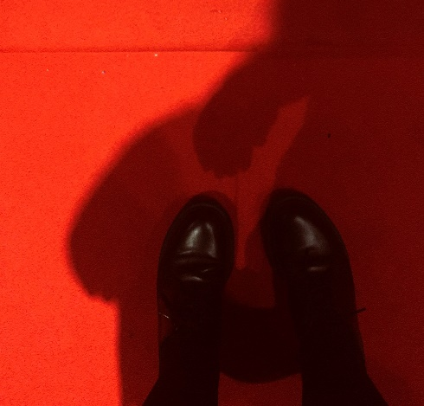
Sarah, Tower Hamlets
