Overcoming a dominant narrative

I overcame a dominant narrative and food was my nemesis.

In my twenties I tried to be the protagonist of my story; the hero who drives to overcome the white male dominated field of tailoring; the ‘invisible hand’ that wanted to write history. Ignoring the contribution of my parents made me defend my parents’ lesser-told story.

I was born in Yorkshire to parents who came from Pakistan in 1950. My father rose to the challenge of being self-made after years of being a mill worker.

Food became my nemesis, the inescapable agent to my breakdown, or breakthrough as I like to think of it, to realising what is real to me, my value, and values.

I turned vegetarian after my first encounter with power dominance on my first day at school. I cried with the pain of not being understood and being forced to eat meat by a teacher. I didn’t tell my parents.

This was my first experience of cultural insensitivity and made the world seem an unsafe place. I had English as a second language and was brought up on rules and taboos, most of which I didn’t understand. My relationships were skewed by not being understood and being sold the narrative of ‘if you work hard, you will gain triumph as opposed to being defeated.’ This was meant to be a salve from the pain of not knowing the rules. Why was I different? I was socialised by my parents as a Muslim but experienced violence and cultural clashes.

I decided to regain my power. I worked on overcoming narratives of being a threat as a person who was different. I overcame limited expectations of me at school and reclaimed my role as the writer of my story. But I also tried to fit in. I didn’t see myself reflected in the popular media, which instead taught me I could not be me.

Here is where food came into the arena again. This time I enjoyed treats but got the message that I was gaining weight. I was now running a business at the age of 18, like father like daughter. I had studied tailoring and now I was making clothes for people. I was inspired by two sisters who came in and asked me to design for them. They were thin and to me embodied triumph. My nemesis – anorexia - took hold for quite a few years, as well as the drive to carry on my family’s narrative.

My parents had intergenerational traumas of their own, mixed with racism and cultural inequalities, and I was a product of a society that puts labels on people. This promoted the message that expectations of who I was were limited. I internalised that as my story.
Over time I became the protagonist I had dreamt of being. I set out to achieve my goal of being a tailor to the great and the good, in a white male dominated society. I wanted to dress people so that they felt good. I had overcome my nemesis of disordered eating, which had been a coping strategy to the labels and traumas. I overcame barriers that were both hidden and visible. I tried to work hard because the story we were told was that if you work hard you can overcome obstacles.
I gained success and recognition for my work but still felt dominated, and came to realise that success could become another trap. The label of ‘success’ meant being perceived as not feeling pain or unable to connect with the suffering of your fellow human beings.
I became the problem instead of the ‘problem’ being the problem. I drifted into despair, similar to the negative impacts of early incidents when I was a child. ‘You are powerless’, again became my running story.
I had created clothes and freedom from the hierarchy of an economy that says one size fits all and that size should look a certain way. I had been a tailor and university lecturer, but still felt like the powerless child to the dominant narrative.

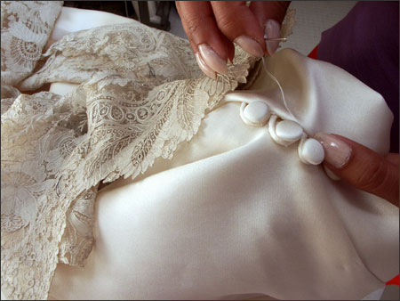

I had climbed the ladder to success, but had come to realise this was not my own intrinsic goal but an external goal to be valued. I sunk to anxiety and depression, seeing that the status quo was still in place and the power imbalance was not changing. Food was controlling my impulses to feel connected, and yet I was in the field of separateness and aloneness, an empty void.

It was not until I came across narrative therapy and began to develop self-compassion that I was able to start externalising the problem. My story led me to studying counselling and now I use these experiences to teach, so that others can see themselves free of being the problems in their lives and recognise that coping strategies can be healthy once you reclaim your story.

Imtaz Khaliq, Peer Tutor Lead, Tower Hamlets Recovery College

