A letter to the parent of a child with an eating disorder…

This letter is for you to read when you’re in pain, suffering and in fear and trepidation of the unknown, the horror of what you’re dealing with. When you are scared of the ground beneath you crumbling, with nowhere to turn. Know that there are other parents who have been where you are, they are here to support you.

I’m writing as your future self, the nurturing, caring and strong parent that knows you’ll get through. You brought their life into the world, to nurture and care for them, to feed and grow them. Now you are faced with the utmost challenge: your child is refusing to be nurtured, refusing to grow, wanting to die, you must sit alongside them, steering them as best you can, weathering the storm of the eating disorder.

You never asked for this to happen to your child, your family or to yourself. You didn’t cause this, no matter what other people say, or what your inner voice says. It is not your fault, and it is not your child’s fault. This is the fight of your life and you are the best person to take it on.

Know that if your child could behave another way, they would. No one wants to live in fear and horror of the monster inside their head pretending to be their friend, when in reality that monster will never be satisfied. It promises that they will be happy once they are thinner and thinner still. It cuts off all their support, all those who care. This is what is so hard to bear. Your child needs to know that you are a match for this monster, slowly and surely you will learn how to get them back.

You will have many challenges ahead, as your child is overwhelmed by this monster, you have to be their guide despite the fights. You might have struggles with so many things: NHS care and social services, benefits, school, work, family, friends, it will be overwhelming. It will seem like it is up to you to fix everything, the lonely, shamed parent. Those who are there to help will also challenge you, they may let you down, remember they don’t always have the answers. Experts can only advise, it’s up to you to bear it every day. You are the expert too.

When you are at your lowest ebb, stop for a few moments, remind yourself that you will be better able to care for your child when you are cared for yourself. These are not just empty words, if you feel there is no one to help, you must do it yourself. By taking a breath and pausing, you will see a way through. Keep your strength up, feed yourself, no matter how sick you feel, take those few moments to breathe, you will get through this, no matter how terrible the moment, time moves on.

You are not alone in this, even if it feels that way. You can also seek care and support from others. Just as you care for your family, you can seek care from them. If you have no family or friends to support you, know that there is always someone else who has been through what you are going through. Help comes from the compassion and wisdom of strangers who have been parents in your position, not just from professionals. Don’t seek help from those who don’t understand, seek out other people who have been through the same experiences. (They can be found on Facebook groups for parents and carers).

We fear the unknown but being able to step into the unknown is a skill you will develop; it comes with time. Everything you do is an opportunity to learn, if you fail at something, or today didn’t go so well, there is always tomorrow, time moves on regardless. Nothing lasts forever, and you will emerge stronger, wiser, and able to face the future whatever it brings.

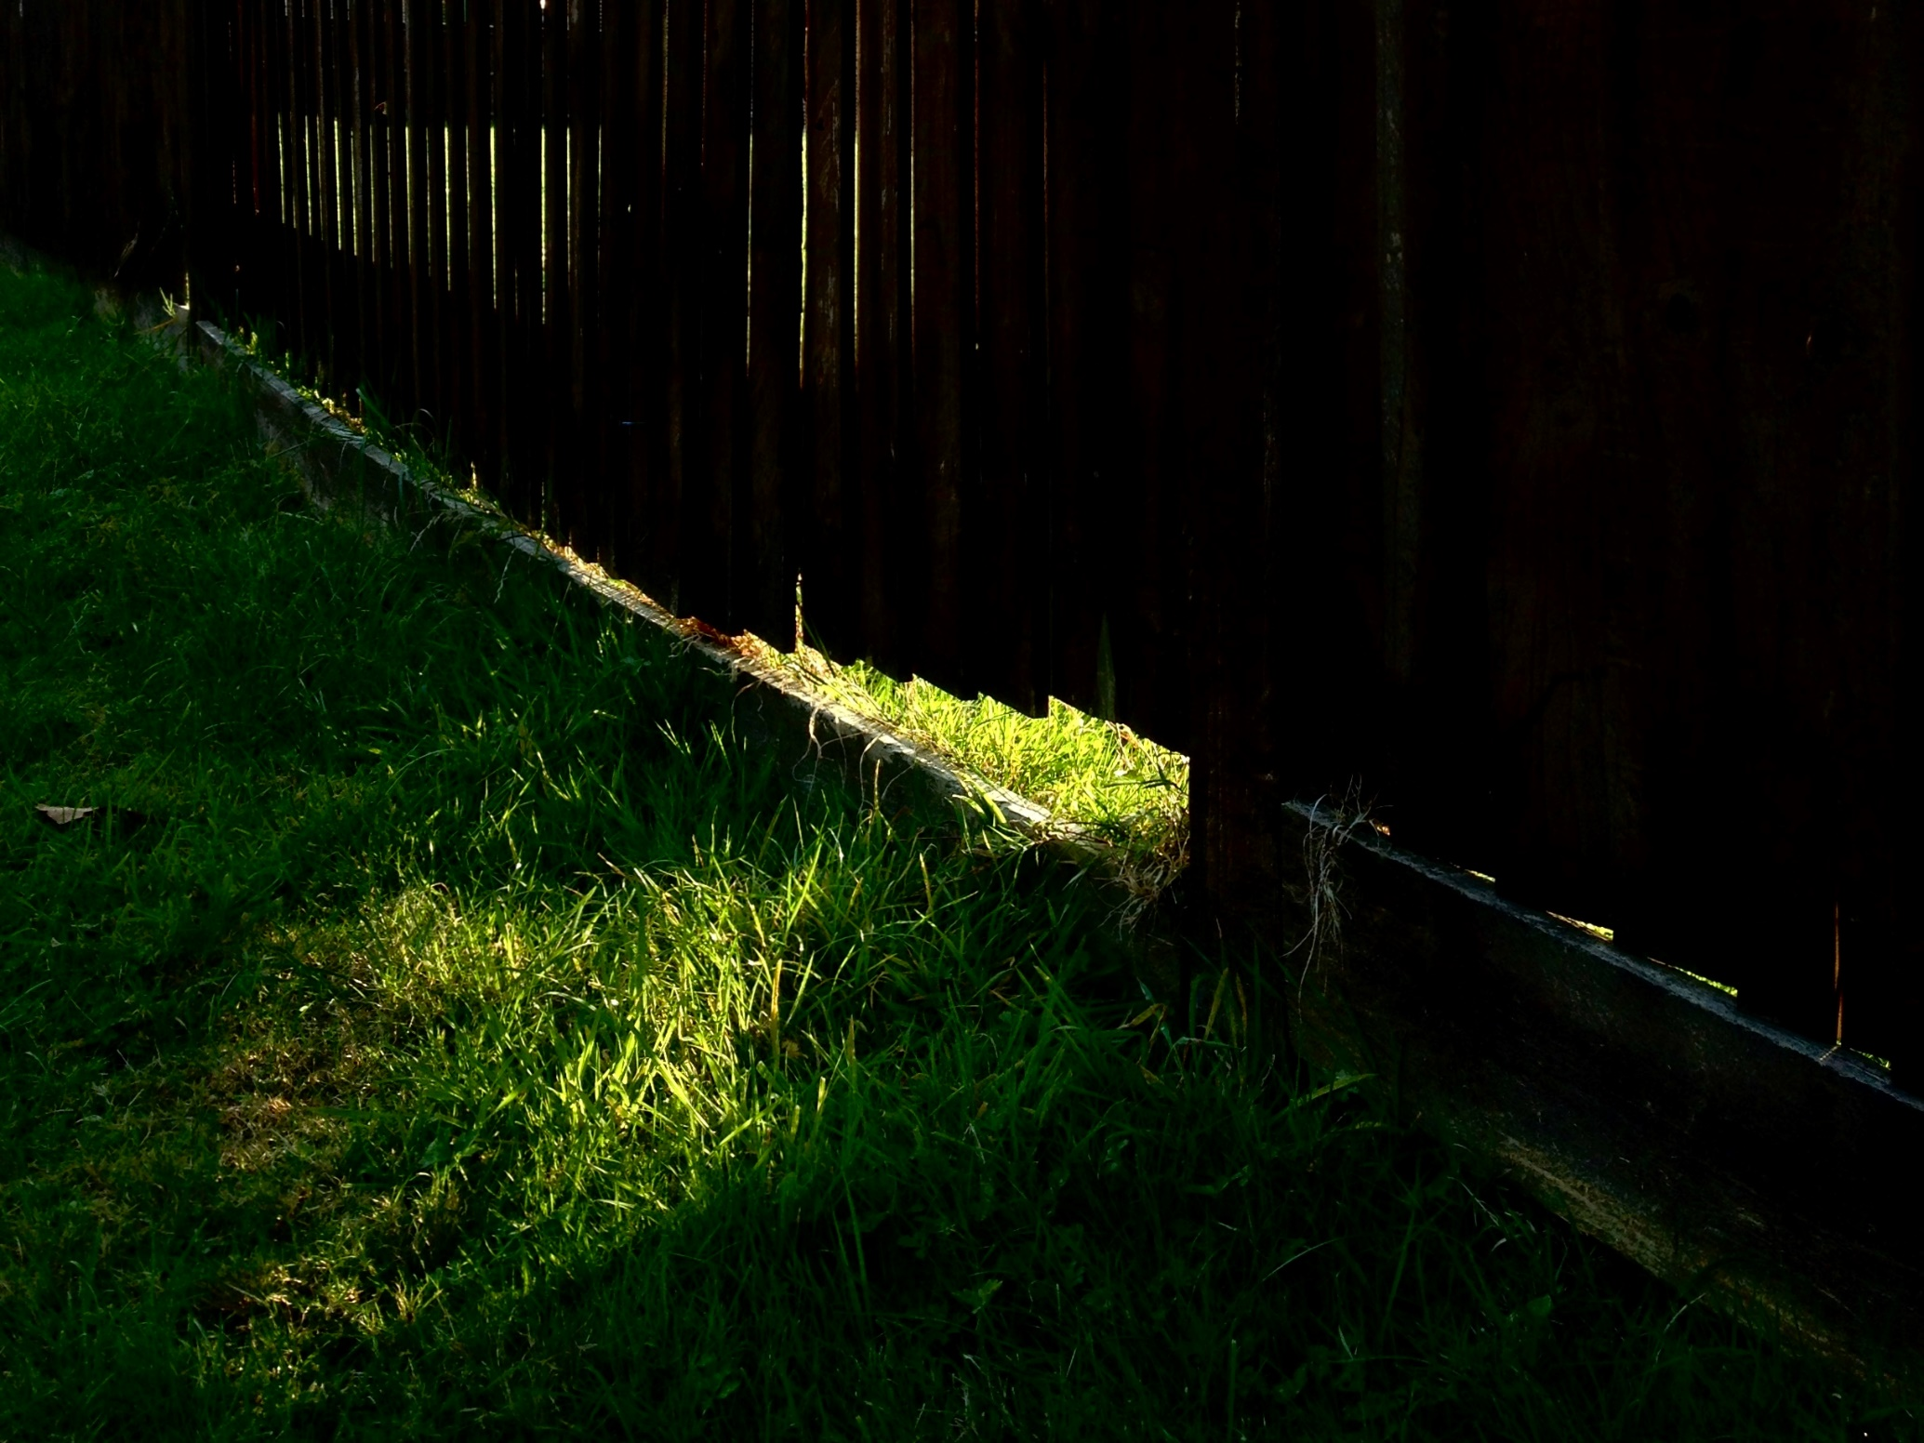
Photograph by Katharine Lazenby, taken whilst an inpatient in 2014 receiving treatment for anorexia.

Carer, Newham

