Why I only have one 2022 resolution - working towards recovery

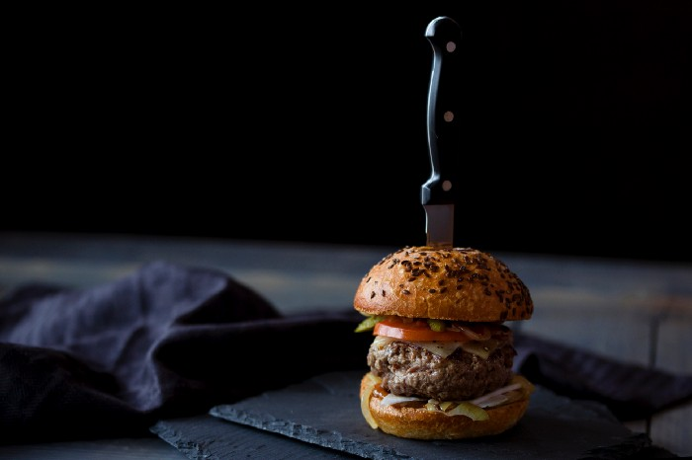

I hate this time of year. Adverts shouting about a ‘New Year, New You’. Magazines littered with ‘healthy’ recipes and tips to ‘get yourself back into shape’. Inboxes full of offers for the latest fad diet. Not only that, if you have the audacity to go out for a meal, you’re likely to hear someone at the next table talking about how they’re ‘being good’ and will just have the salad. Alternatively, and maybe more depressingly, ‘being naughty’ by sharing a pudding.
I’ve had a difficult relationship with food for as long as I can remember.

I’m not sure exactly when it started or how it developed. I do know that I put a great deal of value in food. When I was a child I would select the best bits and want to keep them for myself. I still want to — but now I’m 33 and constrained by social conventions. Some of this was probably a simple case of wanting to make sure that whatever I had was better than what my little brother had…

Would you like this broken biscuit or this whole biscuit that I’ve licked?

Classic older sister power play at work. Sadly, these days he would beat me at my own game and insist on having the licked one — even if just to spite me!

I’m sure lots of kids are also familiar with needing to fend-off their dad when showing the slightest sign they might be finished eating. For some reason, my cold, ketchup-soaked Alphabites seemed to be particularly tempting to him!

These things alone are not significant. But feeling the need to hoard food, to eat in secret and, eventually, to start making myself sick to try and keep things under control. This is where the trouble started.

The NHS website classifies eating disorders into four main categories: anorexia nervosa; bulimia; binge eating disorder (BED); and other specified feeding or eating disorder (OSFED). I fit squarely into the category of bulimia. Although there have been times when I’ve made a concerted effort to eat as little as possible, a key difference between anorexia and bulimia is about weight. While low weight for your age, or low BMI, is a symptom of anorexia, many people with bulimia will be average or even slightly overweight.

I have never been underweight. Ever.

In fact, for much of my life I’ve been in the ‘healthy’ BMI category for my height. Not only that, the times I was most complimented on how healthy I looked coincided with the times my symptoms were at their worst.

For people who are well, bulimia is a baffling concept. Why on earth would someone purposefully make themselves sick — not once, but repeatedly? Why would a person take pills to give themselves crippling stomach cramps, sitting on the toilet feeling as if their insides are leaving along with any small amount of food left in their stomach? Why would someone exercise to the point of near exhaustion?

Why would anyone do that? Why would I do that?
The answer…To be thin. To regain control.

A big part of many mental health problems can be a feeling of losing control. It might be control of thoughts, weight, the world around us. Once this control starts to slip you will do anything to regain it. For me, this is true of my anxiety. It is also true of my eating disorder. The problem is it is only ever a semblance of control.

2022 is the year it stops.

Just before the first lockdown, I completed a series of CBT based therapy sessions specifically focussed on bulimia and binge eating disorder. This is not the first time I’ve sought treatment, but I am hopeful that it will be the last. Although I finished the group sessions that was by no means the end of my recovery. It hasn’t been easy. I don’t think any treatment for a mental health condition is ‘easy’ since the majority of effective treatment requires the patient to deal with all the ‘shit’ they’ve been hiding under a rock (I believe this is the technical term?).

I can’t say things are fixed. While I have managed to change a lot of the eating disorder behaviours (despite food hoarding during lockdown being extremely triggering), that is by no means the end of my journey. I’d love to say how now when I look at my body, I can be kinder to myself, but I’m not quite there yet. While I still have some work to do, I can honestly say that I’m feeling the most positive I have in years.

It will take work, but my resolution for 2022 and beyond is recovery — and never going on a diet again!

Hannah, Tower Hamlets

