Case for Change Engagement Report
21 October 2021

Title | Case for change Engagement Report
Author | Richard Fradgley

Purpose of the Report
This report provides the details and outcomes of the case for change engagement programme commissioned by East London NHS Foundation Trust and Bedfordshire, Luton and Milton Keynes Clinical Commissioning Group (BLMK).

- Objective

  - To clearly articulate our future vision for inpatient mental healthcare and gauge support for the vision and gather questions not yet addressed to help inform our future considerations within the modernising inpatient mental health care programme.

- Case for change

2.1 East London NHS Foundation Trust (ELFT) and Bedfordshire, Luton and Milton Keynes Clinical Commissioning Group (BLMK) produced a case for change document outlining a partnership vision to modernise inpatient mental health care in Bedford Borough, Central Bedfordshire and Luton.
2.2 The case for change was produced to explain why NHS partners believe proposed changes would improve care for the communities we serve across Bedford Borough, Central Bedfordshire and Luton.
2.3 The case for change was co- produced and in partnership with clinical colleagues and service users and carers.
2.4 The document has been used as the basis for a six-week pre-engagement programme with service users, carers, NHS colleagues, stakeholders and partner organisations, neighbours and other interested members of the public.
2.5 The case for change was co- produced with clinical colleagues, service users and carers to explain why we believed the proposed changes would improve care for the communities we serve across Bedford Borough, Central Bedfordshire and Luton.
3.0 Timeline
3.1 The case for change engagement programme ran from Tuesday August 31, 2021 to Friday October 15, 2021.

4.0 Engagement process
4.1 The case for change was produced as a printed document and as a digital PDF document and available on request in different languages, audio, large print and braille. A case for change email address was created to provide a single point of contact for queries from all stakeholders
4.2 A case for change video was co-produced and included clinicians and service users and was published on YouTube to provide a summary of the modernisation vision.
4.3 A dedicated case for change webpage was published on the ELFT website and included a digital copy of the case for change, programme summary frequently asked questions (FAQs), email portal for any questions and the case for change video. The video was accessed by over 600 people.
4.4 Case for change slides were shared with BLMK CCG to display on TV screens in all primary care practices in Bedfordshire and Luton
4.5 Details of the engagement programme were shared with the media as a press release, with coverage also from BB3CR, Luton Today, Bedford Today, leighjton Buzzard Observer and Biggleswade Today.
4.6 Letters with details of the case for change programme were posted to all Bedford Health Village neighbours
4.7 Three digital public engagement meetings were organised and two ELFT staff engagement meetings organised.
4.8 Email messaging was used to inform stakeholders of the start of the engagement process, to remind stakeholders of the engagement sessions and to advise of the end of the engagement programme
4.9 The programme was supported with a rolling social media awareness campaign, with the Twitter hashtag #BedsForBedfordshire used.

5.0 Engagement structure
5.1 All stakeholders were invited to complete a case for change survey which recorded quantitative and qualitative data.
5.2 All stakeholders were asked the following questions:
Do you agree with our proposals?
Is there anything you don’t agree with?
Are there any areas of the proposals you would like to understand more about?
Is there anything missing from our proposals that you would like to see included?
5.3 Attendees at all engagement events were asked the same questions with responses recorded via Mentimeter software.
6.0 Participation
6.1 A total of 273 stakeholders participated in the engagement process.
6.2 Engagement sessions had a total of 145 attendees
6.3 The online survey was completed by 128 individuals.
6.4 We identified the respondents by place
6.5 We collected the ethnicity of respondents

7.0 Outcomes of the Engagement

7.1 Question 1: Do you agree with our proposals?

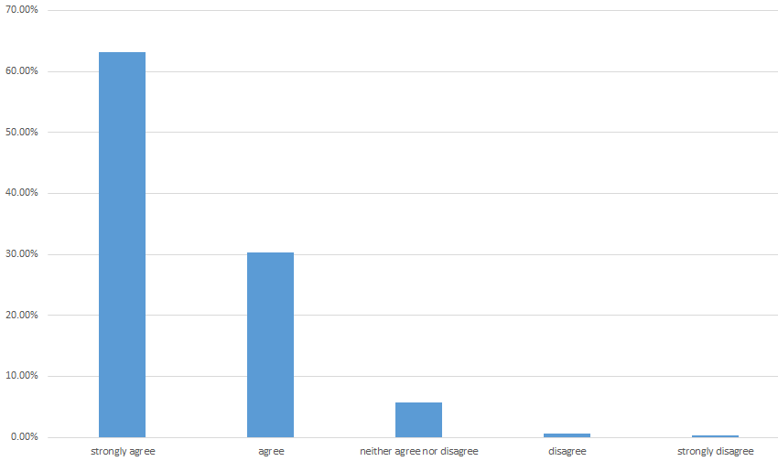

7.2 Question 2: Are there any areas of the proposals you would like to understand more about?

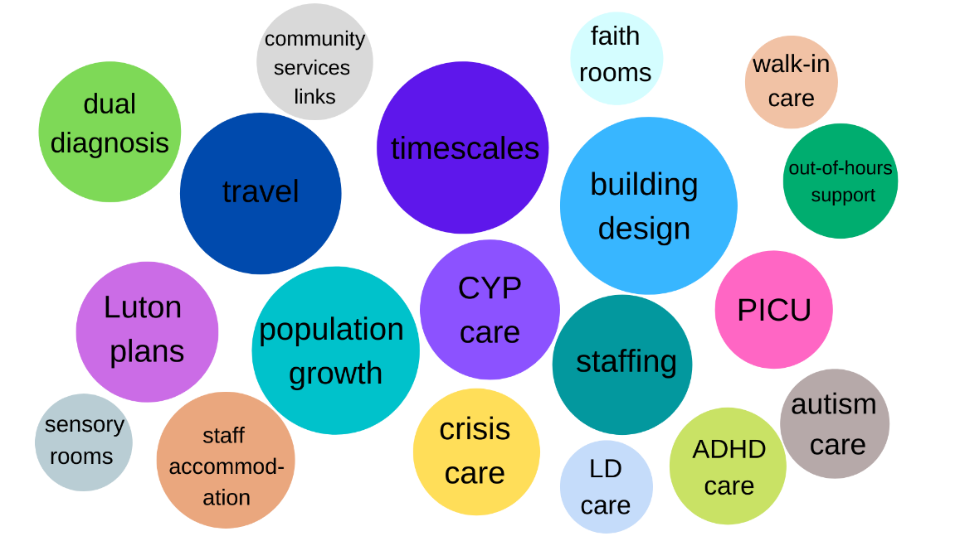

7.3 Question 3: Is there anything missing from our proposals that you would like to see included?
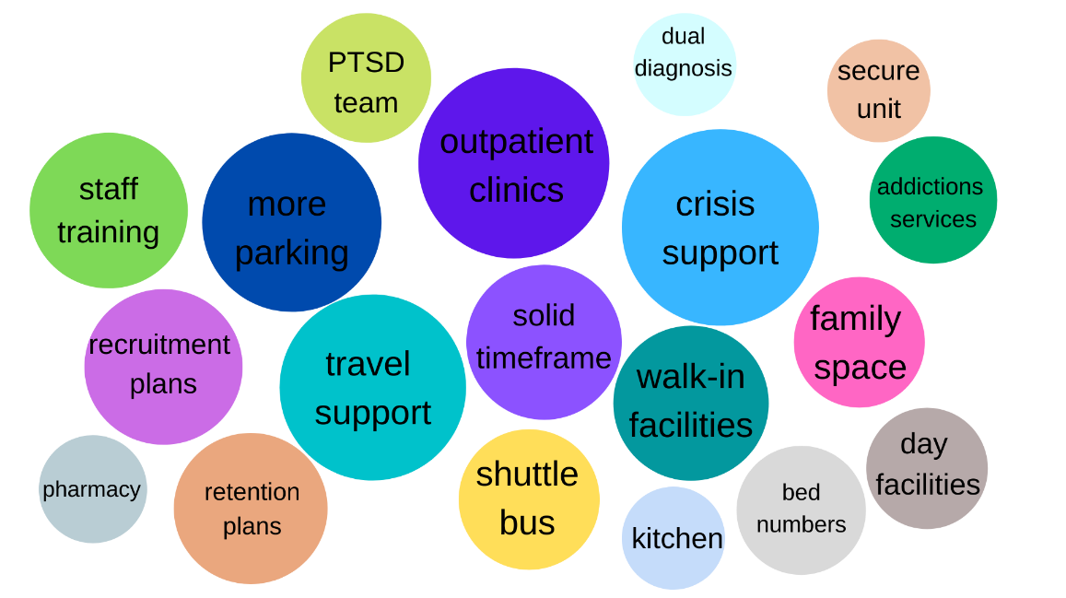

7.4 Question 4: Is there anything you don't agree with?
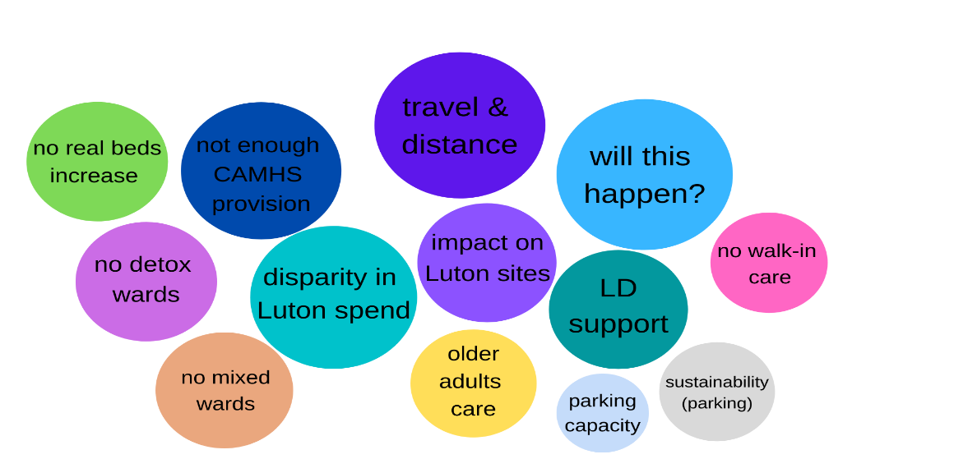

8.0 Conclusion
8.1 This pre-engagement programme has been invaluable in gathering questions for consideration in the development of a pre-consultation business case.
8.2 As can be seen from the engagement feedback, the majority of stakeholders involved with the engagement programme are in support of the vision, over 93% Strongly Agree or Agree with the proposal.
8.3 The majority of respondents were from Bedford Borough (over 70%), there were fewer respondents from Central Bedfordshire and Luton. The majority of respondents ethnicity was classified as white (over 80%), there were fewer respondents from a Black, Asian and minority ethnic background. Over 70% of respondents were female.
8.4 Key themes raised which need to be considered further include travel and transport, the environment of any modernised sites, further details of the vision to modernise Luton services, how integrated care would be provided, the possible provision of substance misuse/detox care at the Bedford Health Village site and the recruitment, retention and continuous professional development of staff.

9.0 Next steps
As this development moves into its next phase we will now explore in more depth the feedback from the case for change engagement process and the emerging themes.
In terms of the themes arising from Question 2 and 3; Are there any areas of the proposals you would like to understand more about? Is there anything missing from our proposals that you would like to see included? Work is already underway in a number of areas (see below) and this feedback will be directed to those specific work streams to progress. Where we have not identified a work stream to take forward a particular theme, we will develop a focused piece of work for these specific areas to examine the potential for their future arrangements.
A specific transport analysis has been commissioned and will identify the current travel times to our current 3 sites for inpatient care across the county and the impact of the proposed new development on the cost and time of travel. It will also identity in terms of accessibility those sites and services that are in closer proximity in terms of travel including the new development.
The clinical pathway workstream, a co-produced group with clinicians services users and carers representatives will be examining the principles of the new care pathway and this will include how integrated care would be provided, including crisis care, the potential for walk in services, specific care and support for people experiencing a dual diagnosis, substance misuse/detox, and also the care for people who have a mental health and learning disability and also those with ADHD care.
The clinical design workstream has developed a quality checklist and will be undertaking visits to other recently commissioned mental health inpatient facilities either virtually or in person (subject to COVID-19 and restriction on visits and when safe to do so) to understand the key principles of each development, taking the very best ideas and approaches in design to inform what excellence will look like in the proposed new facility.
Our vision is not only to create the best environments for inpatient care it is also to couple this with a cultural shift in the way that we support people with mental health conditions in hospitals. The service user and carer focus work stream have developed a survey to understand the experience of people within our current inpatient facilities, this ‘bottom up’ approach will both inform the clinical pathway and clinical design work streams. This will enable an improved approach and a cultural shift to bring about the required systemic change, directly informed by the people who have used our services. The clinical pathways and models of care will be adapted to address the pinch points within the current system; arrangements for admission, care and support whilst in hospital, access to therapy, safe and quiet places, privacy and dignity and preparation for discharge from hospitals, crisis support and where to get help.
In terms of the respondents and their representation the feedback has been mainly from Bedford Borough (over 70%), white in terms of ethnicity (over 80%), with over 70% of respondents being female. Our newly appointed People Participation Lead has in addition started a direct engagement with those people who are using our inpatient services and will be gathering further feedback from the diverse nature and background of people using services, including those make and female patients admitted into our wards.
In terms of those areas in Question 4: Is there anything you don't agree with? We will consider the specific commentary and feedback received to incorporate in our overall plans.
We will continue to communicate our plans and the development of these areas through the respective workstreams of this project through our website, emaiI and will continue to listen to stakeholders, service users, carers, NHS colleagues, stakeholders and partner organisations, neighbours and other interested members of the public, whilst we begin developing our pre consultation business case.

