Changes to the RiO Observations and Measurements form to make it NEWS2 Compatible

The Observations and Measurements form in RiO will shortly be updated in line with the NEWS2 standards. The form will remain in the same place and be accessed in the same way and staff will see the changes when completing a new form. The changes are largely self-explanatory and staff should follow the instructions on the form. The two key changes are illustrated below with before and after screenshots.

Change to oxygen saturation recording
A second oxygen scale has been added which should be used under specific circumstances, such as hypercapnic respiratory failure, where the target saturations are lower.

Old form
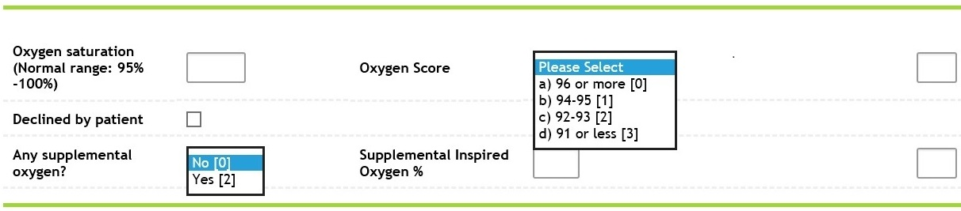

New form
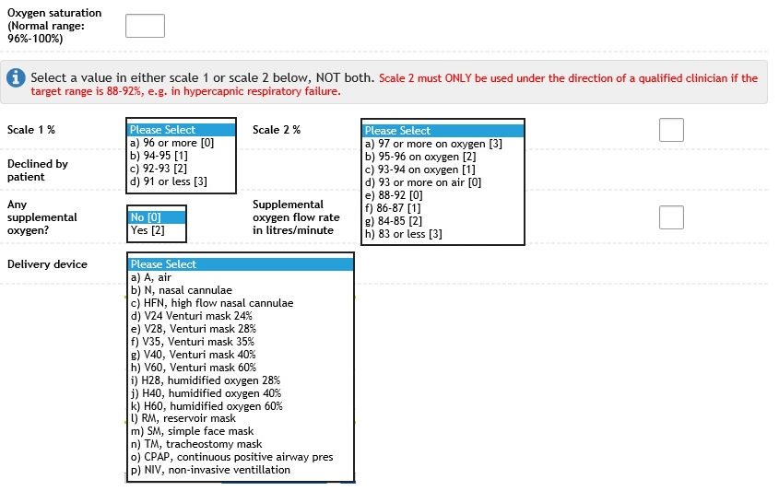

Changes to level of consciousness recording
An additional item “Confusion” has been added to the Level of consciousness picklist.

Old form
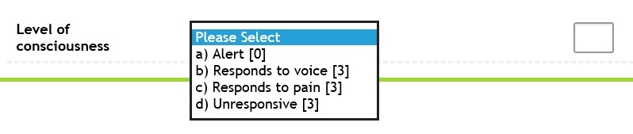

New form
