EMIS – Adding a New Referral

The Purpose of this document is how a new referral is added on EMIS

1. Adding a New Referral

From the Quick Launch Menu, Quick Access Toolbar or EMIS button click on ‘Patient Administration’:
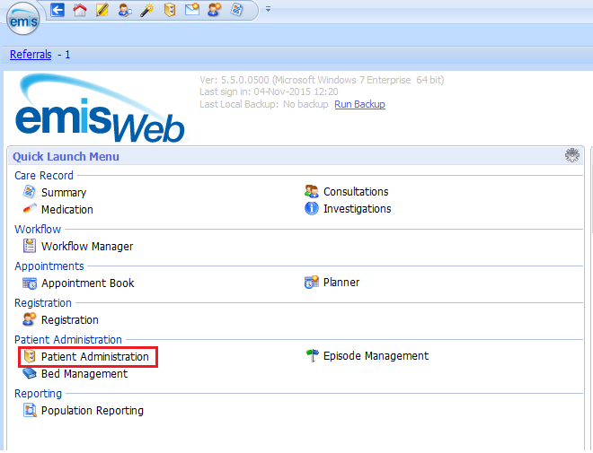

Click on Service View and select your service’s Single Point of Access (SPA) or Inbound Referral folder/list:
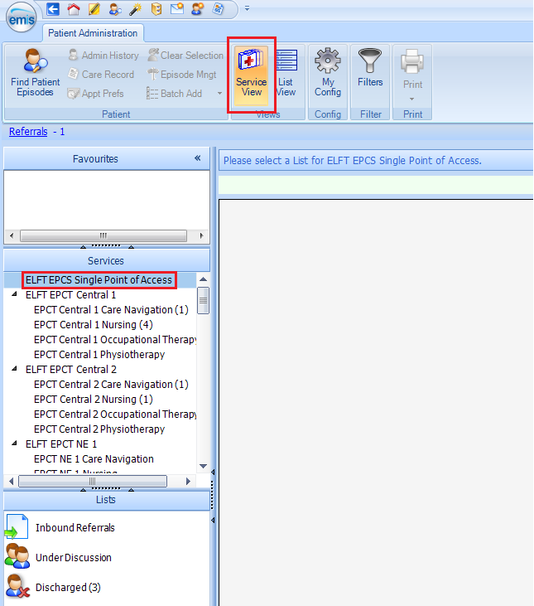

Select Inbound Referrals and click on New Referral:
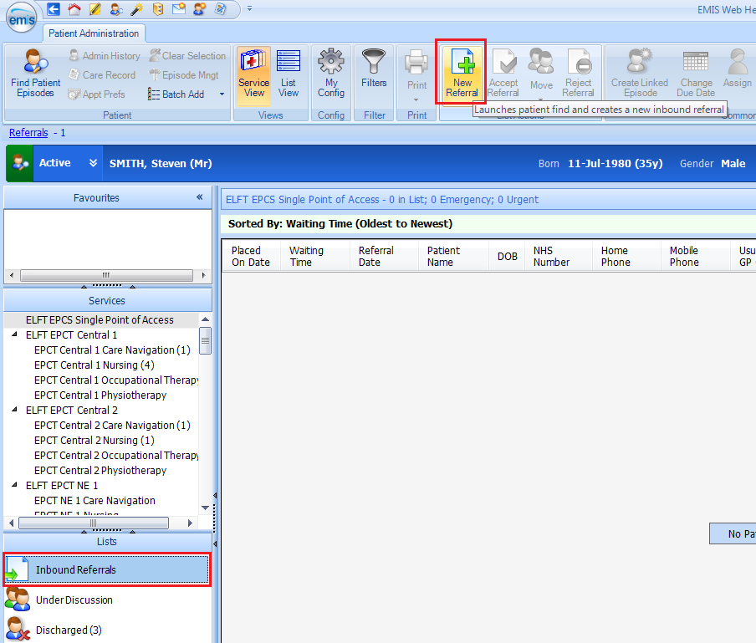

The ‘Patient Trace’ box appears – enter NHS number of patient:
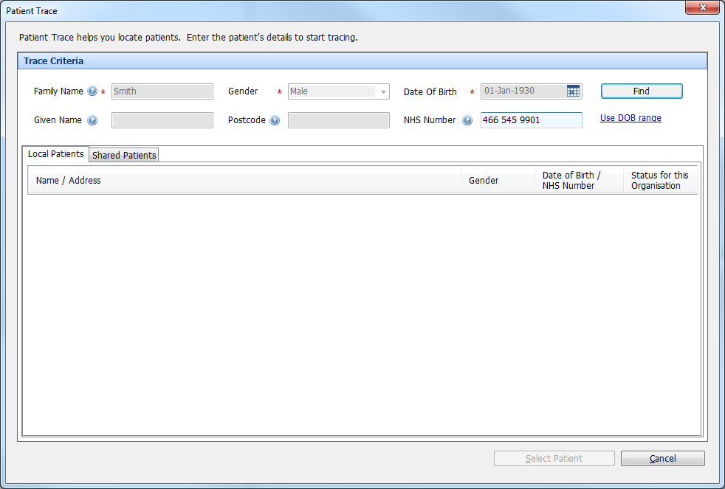

Select the Patient by double clicking or click on Select Patient

The ‘Inbound Referral’ box for the patient appears: Source and Target:

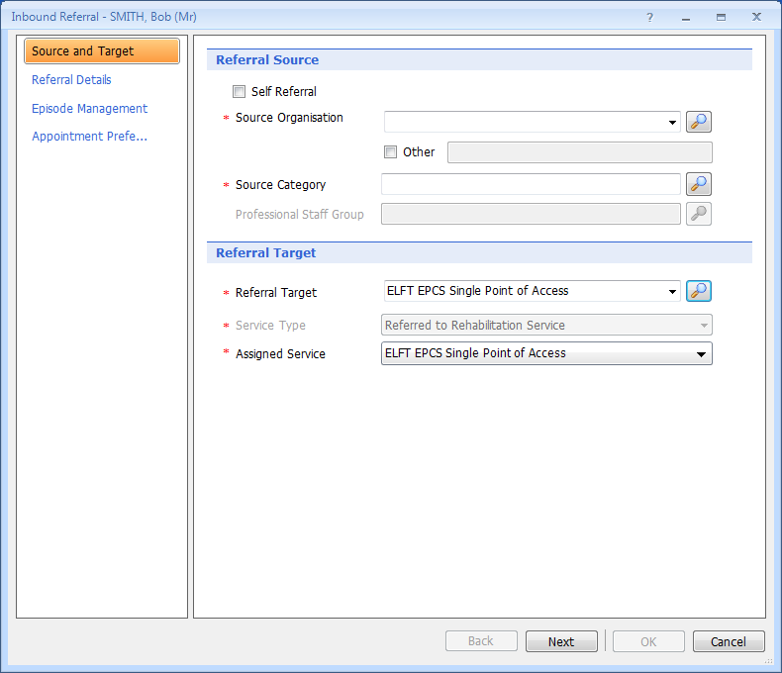
*Note:

- Source Organisation i.e. GP Practice name
- Source category i.e. General Medical Practitioner
- Professional Staff Group i.e. General Medical Practitioner
- Referral Target should be the team the referral is going to, or if unknown Single Point of Access
- Assigned Service should be Single Point of Access

Complete fields and click on Next

Referral Details:
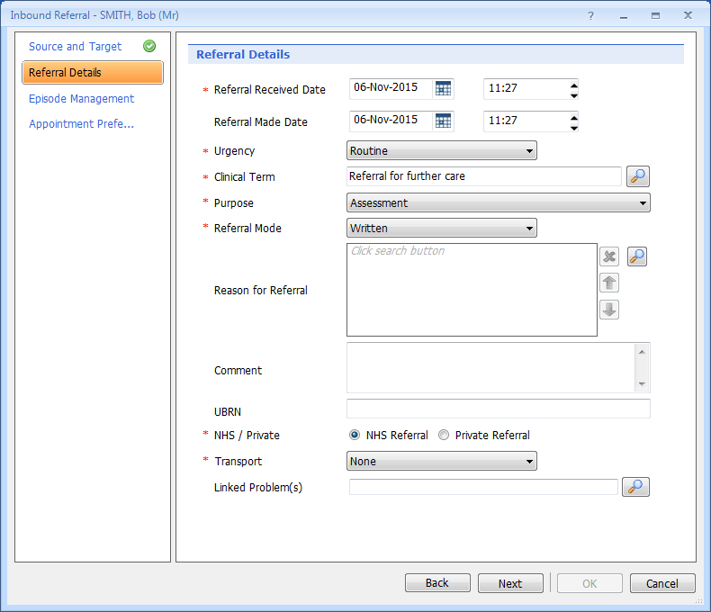
*Note:

- Enter Referral Received and Made date and time
- Urgency: Routine or Urgent
- Clinical Term Enter your Services Clinical Term found in your local Standard Operating Procedure (SOP)
- Select appropriate Purpose
- Referral Mode should be either Verbal or Written
- Referral Reason should be left if not known or refer to your local Standard Operating Procedure (SOP)

Complete fields and click on Next

Episode Management:
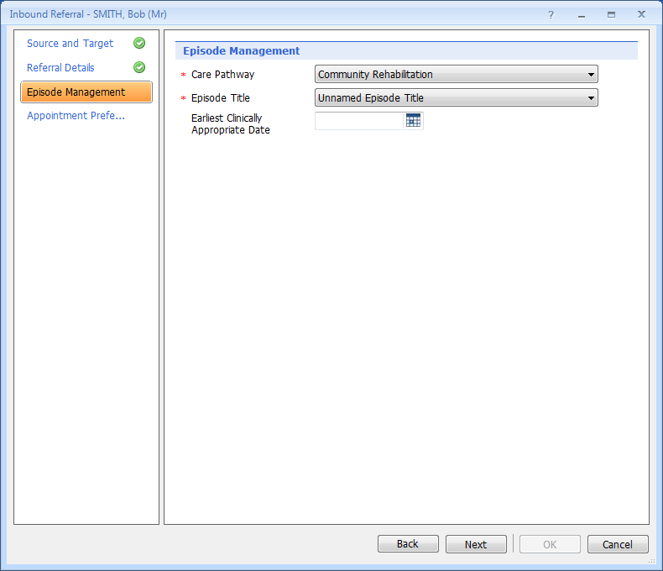
*Note:

- Care Pathway Select your services Care Pathway
- Episode Title Select your services episode title or if not known refer to your local Standard Operating Procedure (SOP)
- Earliest Clinically Appropriate Date should be left blank

Complete fields and click on Next

Appointment Preferences:
Leave all fields blank and click on OK
