Health Visitor Admin
Standard Operating Procedures
April 2017

Version: | 1.1
Ratified by: | Children & Young People and Sexual Health Governance Group
Date ratified: | 24th May 2017
Name of originator / author: | Nasim Patel
Name of responsible committee / individual: | Children & Young People and Sexual Health Governance Group
Circulated to: | Administrators, C&YP Managers and LBN School Health Service
Date issued: | May 2017
Review date: | May 2020
Target audience: | C&YPS admin team and health visiting service

Version Control Summary

Version | Date | Author | Status | Comment
1 | 2/5/2017 | Nasim Patel and Sarah Rolfe | Draft | New document to support the local admin tasks following the launch of NELFT CHIS hub
1.1 | 4/7/2017 | Sarah Rolfe and Tatenda Chigodora |  | Corrections to point 4.4 and 5.0 (not picked up during extensive consultation for v1.

CONTENTS | PAGE NO
- INTRODUCTION | 5
2. RiO  2.1 How to search for a client  2.2 The Monthly Team Planner  2.3 Progress notes  2.4 Uploading of clinical documentation  2.5 Viewing documents | 6-8
3. DATA WAREHOUSE  3.1 How to access data reports via link  3.2 RiO reports  3.3 Exporting to excel | 8-9
4. ANTENATAL REFERRALS  4.1 RiO  4.2 EPR  4.3 EPR snapshots  4.4 Antenatal mail merge procedure for batch printing | 10-12
5. MIDWIFERY & HEALTH VISITORS LIAISON REFERRALS | 12-13
6. BIRTH NOTIFICATION  6.1 RiO  6.2 Birth notification application (Failsafe)  6.3 Weekly new birth report | 13-16
7. NEONATAL & MATERNAL DISCHARGE SUMMARY  7.1 Mother’s discharge summary  7.2 Babies discharge summary  7.3 Receipt of maternal discharges not for Newham  resident mothers | 17-19
8. REGISTRAR  8.1 Current Procedure | 19
9. BLOODSPOT SCREENING  9.1 Results to be recorded on RiO within 14 days  9.2 Results to parents  9.3 Missing or incomplete screening test  9.4 Results where condition is suspected  9.5 Babies born abroad  9.6 Notifying GPs that screening has been declined  9.7 Health visitor undertaking new-born bloodspot testing  9.8 Health Visitors undertaking New-born Blood Spot testing | 19-25
10. NORTHGATE | 25-26
11. NEWBORN INFANT PHYSICAL EXAMINATION (NIPE) | 26-28
12. NEW BORN HEARING | 28-29
13. PROCESS FOR 6-8 WEEK HEALTH REVIEW | 29-30
14. HEALTH REVIEW  14.1 Preparation for 1 yr. and 2 yr. reviews (failsafe)  14.2 One Year Health Review  14.3 Year Ages and Stages Health Review (ASQ-3) | 30-33
15. A&E REFERRAL  15.1 Procedure for 0-5 years of age  15.2 Procedure for 0-5 years – overseas address  15.3 Procedure for 0-5 years out of area  15.4 Procedure for 5-19 years of age  15.5 Procedure for 6-19 years out of area  15.6 Step by step guide in accessing EMIS web | 33-35
16. CONSULTANT BASED HOSPITAL REPORT | 35
17. TRANSFER OF RECORDS  17.1 Universal Children Transfer in to Newham  17.2 Universal Children Transferred out of Newham  17.3 Child Protection – Record Transfer Out  17.4 Child Protection – Record Transfer In  17.5 Step by step process for transferring records  17.6 Process for sending data / request to the local authority  School Health Service | 35-40
18. DEATH NOTIFICATION  18.1 Procedure  18.2 Children Services notified if child had deceased and  Hub not aware  18.3 How to complete a Datix for reporting a child death  18.4 Step by step procedure on information to complete on  the Datix Form | 40-42
19. Neo-Natal Hepatitis B Programme  19.1 Purpose and Scope  19.2 Definitions and Abbreviations | 43
20. EDUCATIONAL HEALTH CARE PLAN | 44-47
21. SUBJECT ACCESS PROCEDURE | 47-48
22. HOW TO WINZIP FOLDERS | 49-50
23. UPDATING RIO WITH REVISED PUPIL CENSUS  INFORMATION | 50
24. ABBREVIATIONS | 51

- Introduction

In order to ensure CHIS services are safe and stable from now and throughout the subsequent transition of commissioning clinical services to the local authorities a CHIS improvement programme is in place.

From April 2017 58 child health datasets will be exchanged with a single child health platform so that the CHIS Hubs can collect, collate, analyse and report it to Newham clinical providers to track and failsafe every child. This data will begin to benefit parents and support the care system to begin tackle inequalities.
Information will feed from various sources into the London Platform. The London-wide CHIS platform will have the capability to identify health visiting service providers (based on the post code of residency of each child) and CCG by GP.
CSV files will be exported from CHIS hubs and sent to health visiting services based on local authority resident and responsible GP practice. The reporting frequency will be daily, weekly and monthly. As a minimum requirement, each csv file will be securely emailed using NHS.net email to chrdnewham@nhs.net .
Aims
The aims of the local administration team is to ensure that each child in Newham has an active care record, supporting delivery of the clinical services, including maternity data and neonatal information, health reviews, screening, immunisations, child health programme. Enable health promotion and failsafe activities and ensuring that clinical delivery is carried out in a timely manner in line with achieving key performance indicators (KPIs).
Purpose
This document outlines the standards for the delivery of administrative support to the health visiting service. This document is to be used in conjunction with the London Child Health Information System Reporting Protocol as well as other relevant service delivery policies. The health visitor administrators will provide essential functions ensuring the key demographic and clinical information is maintained for all children 0-5 years

- RiO

Standard for Registration of clients on RiO

All clients of the Specialist Service Children & Young People Service Newham must be registered on RiO for referrals to be created/actioned.

Staff must undertake a thorough search to ascertain if the client has an existing RiO record. These include:

- Local
- Simple PDS search
- Advanced PDS search

No client should be registered on RiO without these searches being undertaken.

All clients should have their local and national record synchronised with the national SPINE, this is the responsibility of all staff working with a client. If information is to be changed, staff should make every endeavour to authenticate information before changing it.

  - How to search for a client
- Click on the “Client Details’ icon  at the top left of the screen
- Click on ‘Demographic Details’ from the drop down list.
- Synchronise any information as requested
- If the desired client doesn’t appear
- Click on “Return to Search Criteria” hyperlink at the bottom of the screen
- Insert surname into the “Surname” field
- Insert forename if known. This is important as the system will only display a maximum number of records and if it is a popular surname the list may be very long.
- If the desired client is not on the list then search again increasing the amount of information, or indeed decreasing, if searching on part of the surname and/or forename if you are not sure of the spelling.
- When the desired client is found – click on the appropriate client to select their details.
- If the desired client is not found, search “National Records” using the hyperlink.
- This takes the administrator to the “Demographic Screen” to complete an advanced search. Not all the information is mandatory to collect. All the mandatory fields are purple coloured boxes.
- It is important to take notice of any messages that some onto the screen advising that there are other clients with similar details. If it becomes apparent that the client is already on the system there will be opportunities to discontinue the registration.

2.2 The Monthly Team Planner

The Monthly Team Planner (MTP) facilitates communication between Health Visiting Admin
and the Health Visitors and FNP team and it is from where ‘Antenatal’, ‘New birth’, “Transfer in’, ‘Bloodspot for babies over 28 days’ and for information for concern ‘A&E attendance’ will be notified.

The MTP will allow Health Visiting Admin to allocate clients to a team. All members of that team can see all clients and to whom they are allocated within that team.

- Click on ‘Client details’
- Click on ‘Monthly team planner’ from the drop down menu
- Click on drop down box next to ’Team‘ and select the required team
- Drop down menu appears. Click on the Team to which you wish the client to be allocated
- The month and year fields will default to the current month and year
- Click on ‘Go’

To add a client to the MTP

- Select ‘Add Client’
- Select client to add
- Use the pick list to select the reason why the client is being added to the planner
- Use the comments box to add any information relevant to the client being added
- Select ‘Add Client’ to confirm

To remove a client from the MTP

- Click on the box ‘select‘ on the right hand side of the screen
- This highlights and changes the colour of the client field.
- Click on ‘Remove’. It will ask are you sure?
- Click on ‘Yes’ and the client is removed from the screen

2.3 Progress Notes

Progress notes should always be written contemporaneously.

- Click ‘Client Details’ and select ‘Case Record’
- Look up client or select client.
- Click on the ‘Progress Notes’ folder on the right hand side of the screen
- Click on ‘add new’
- Then enter all information as necessary.
- Click on ABC to spell check.
- Click on ‘Validate’.
- Click on ‘SAVE’.

2.4 Uploading Clinical Documents to RiO
- Click on the ‘Clinical Documents’ RiO icon located
- Select the client
- From the RiO Upload Screen click ‘Browse’ and a list of your documents will come
up – select the relevant drive/folder the document is saved in.
- Select the file.
- Click ‘Open’.
- Enter the document title.
- Select the date as the date the document is being uploaded
- Select relevant document type
- Mark the document as draft or final version.
- Select upload
- If the document is selected as a draft document you can upload more documents under the same title.

2.5 Viewing documents
- Click on ‘Clinical Documents’ and select ‘Document View’
- Select the client and the screen will show all documents listed to the left.
- Clicking on the document on the left will bring the scanned document on to the screen along with details of who uploaded the information and when.

3.0 Data Warehouse

3.1 How to access data reports via link
Desktop has the following link
http://dwprd/Reports 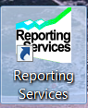
3.2 RiO Reports
- Via the specific URL you will be taken to the Data Warehouse homepage in which reports relevant to your work area are stored.
- All the reports in these directories have been written by the informatics team.
- Click on the icon for your service and you will see folders: i.e. daily ITM reports, late births, under 1 year without bloodspot results etc.

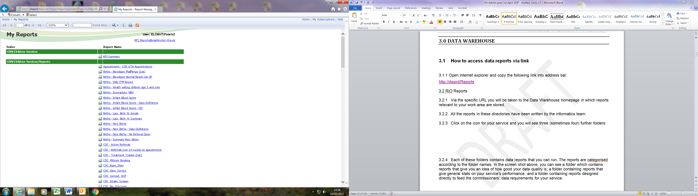
- Each of these folders contains data reports that you can run. The reports are categorised according to the folder names. In the screen shot above, you can see a folder which contains reports that give you an idea of how good your data quality is; a folder containing reports that given general stats on your service’s performance; and a folder containing reports designed directly to feed the commissioners’ data requirements for your service.

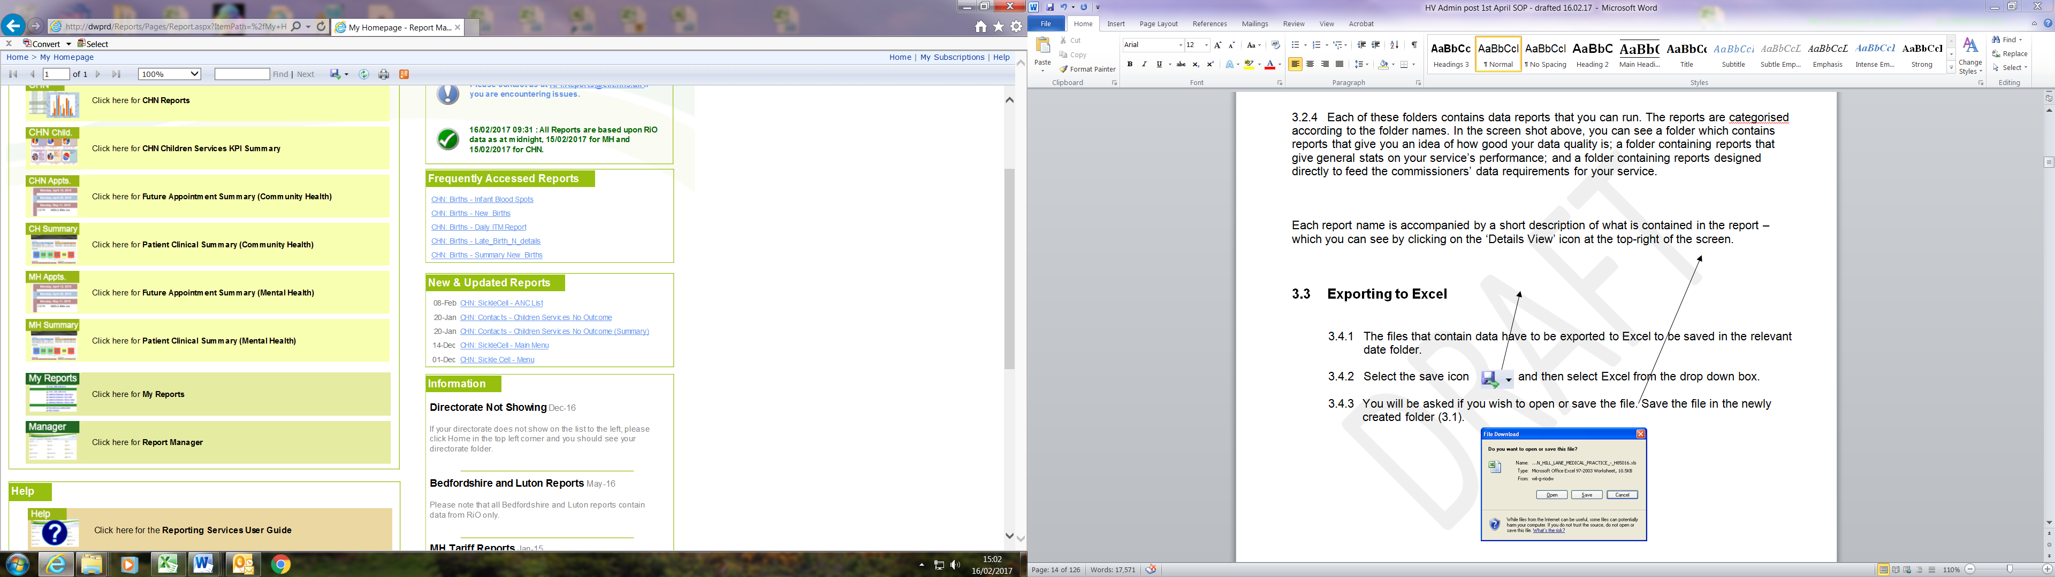

- Each report name is accompanied by a short description of what is contained in the report – which you can see by clicking on the ‘Details View’ icon at the top-right of the screen.

3.3 Exporting to Excel

- The files that contain data have to be exported to Excel to be saved in the relevant date folder.
- Select the save icon and then select Excel from the drop down box.
- You will be asked if you wish to open or save the file. Save the file in the newly created folder

4.0 Antenatal referrals:

All antenatal parents will be contacted by letter between 28 and 34 weeks of pregnancy to introduce them to the Health Visiting service and offered a contact/ visit as appropriate.

NELFT CHIS Hub will forward a daily feed of all women at 28 week gestation to the Informatics Team and then forwarded to the Health Visiting Admin

4.1 RiO

- From the list, check NHS number for each client on Rio and confirm address, if address is different: check the most up-to-date address and synchronise with that address.

- Make a Rio referral to the Health Visiting team by postcode area.

- Check client details for any “active referral” if no “active referral” details found then create a referral.

- Check on the antenatal list to ascertain whether the woman has had any previous history of miscarriage/s. If yes: add the client details onto the health visiting monthly team planner (MTP) stating clearly in the comment box ‘previous miscarriage/s.

- From the CSV spreadsheet clinical information will be recorded on the antenatal section.

- Click on Assessments – child and family – health visiting – mother and then click on the Antenatal Review and update information on the review form making sure that the EDD date is recorded for mail merge purposes for sending letters to parents.

4.2 EPR

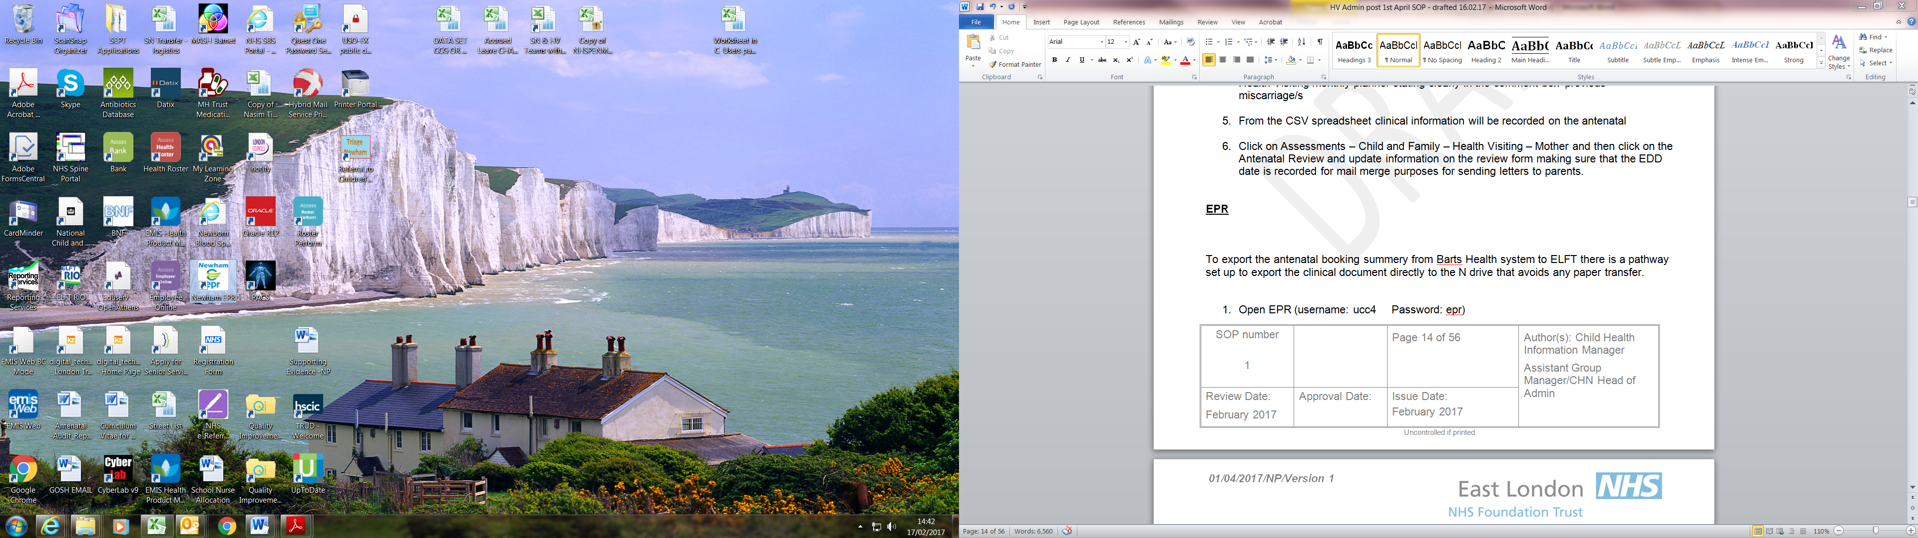

Admin Staff must export the antenatal booking summary from Bart’s Health system and upload the clinical document directly to the client RiO electronic records.

- Open EPR (username: ucc4 Password: epr)

- Search NHS number from the search page

- Clients details with clinical information will be viewed

- Pathway to export clinical document from EPR is as follows:

  - Step 1

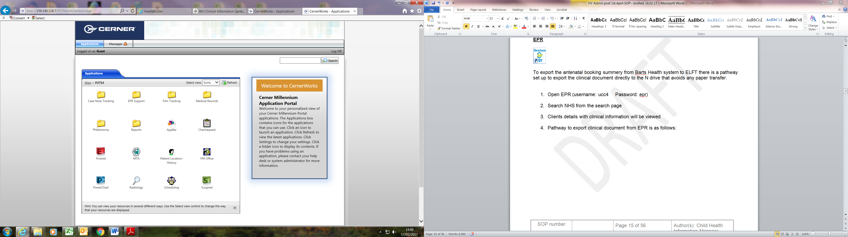 Choose the power chart icon
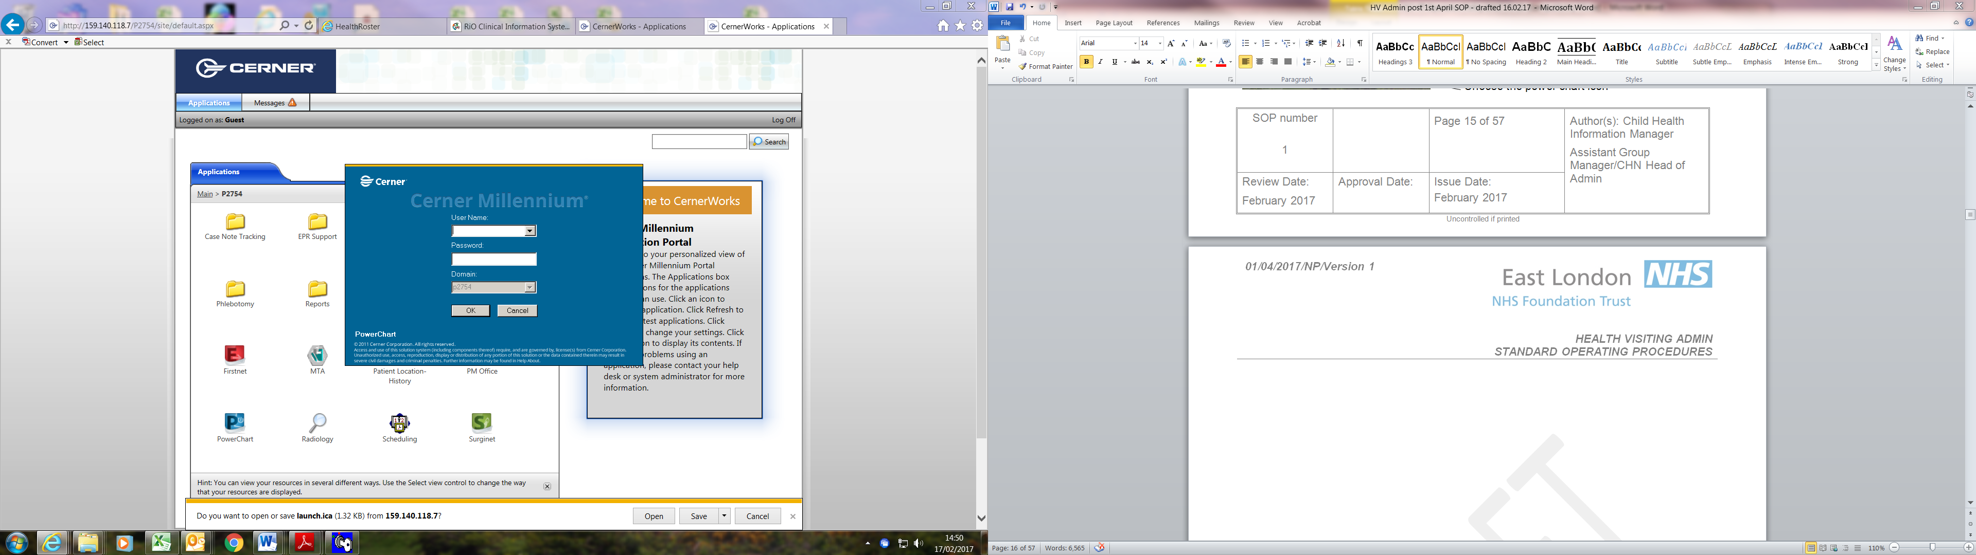 Step 2 add username and password and then ok
On the top right hand corner there is a magnifier – click on this as this is the search engine
Step 3
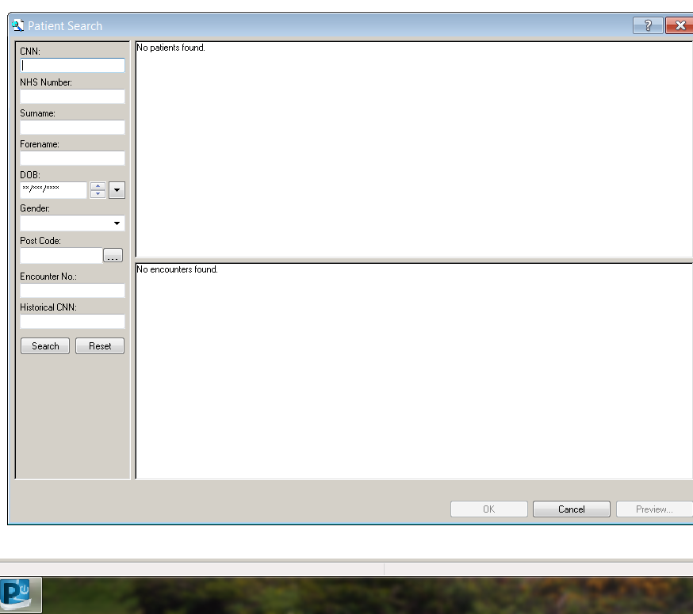 on the left hand corner search by clients NHS number that will be on the CSV list and the system will open the client’s record

Step 4
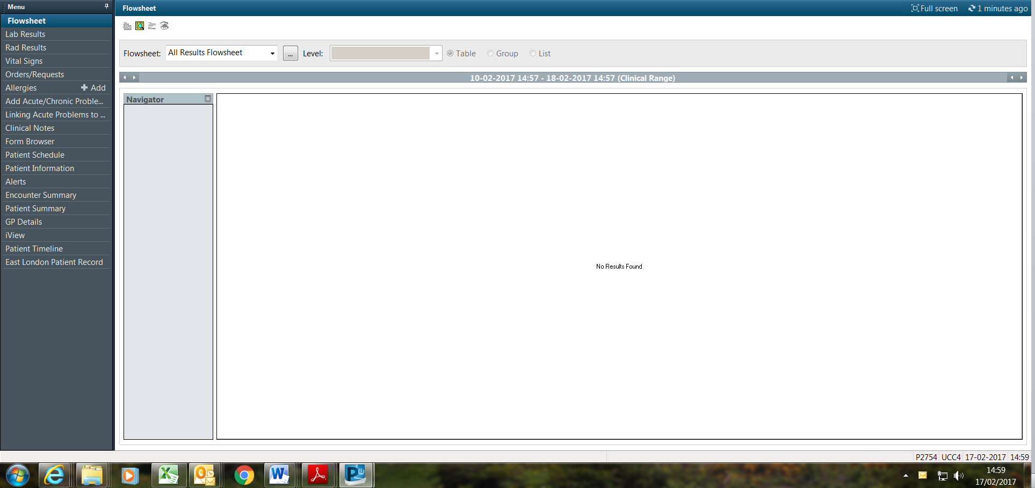
On the left hand side click on the clinical notes
Step 5
Double click on the folder which will expand the document that will be required to be exported named under ‘maternity booking summary’
Right click on the document and it will give next option.
Choose “export”
Follow procedure for uploading document on page 10
4.4 Antenatal letter mail merge procedure for batch printing.
(Please note: All pregnant women will be sent an antenatal letter at 28 weeks of pregnancy).
- Mail merge list must be checked for data quality to include:
- DOB, name, address, and for inaccuracy for example if the women had a miscarriage, termination. The health visitor administrator will check EPR the day before sending out the antenatal letter. This will however not capture any changes after the letter is printed / sent.
- No letters must be sent without all the checks above.

5.0 Midwifery & Health Visitors Liaison Referrals
Process
This process will remain the same; information will not flow through the hubs but will be emailed by Midwifes via the chrdnewham@nhs.net route from individual midwives and the Acorn Team within NUHT.
*note: no faxes must be accepted
Midwifery Service will complete Health Visitor Liaison form for all high risk women
and forward via email to chrdnewham@nhs.net

- Health visitor admin will save on the desktop folder – as School Nursing & Health Visiting Service - Midwifery & Health Visitors Liaison Forms
- Health visitor admin will upload the Liaison form to the mother’s RIO record, using the naming convention “Midwifery & health visitor liaison form”
- Health visitor admin will create a referral to the HV team
- Health visitor admin must make a note on the progress notes with the following information: “date liaison form received & uploaded, mother at risk”, and tick significant event box
- The allocated health visitor will make contact with the expectant mother at 28 weeks of pregnancy
- Health visitor admin will add the women on the appropriate HV UPP monthly team planner at 28 weeks and make a comment in the comments box stating “midwifery and health visitors liaison form is uploaded on RIO
- Health visitor admin must delete the information from desktop after task completed.
- The health visitor admin will send out antenatal letter to the women

Note: if the mother is not registered on RIO and is a Newham resident the health visitor admin will check the national spine and synchronise to the local data before completing the above process

Please note: The naming convention to upload the document must state “Midwifery & Health Visitors Liaison Form”

6.0 Birth notification
Daily CSV file will be forwarded by the new CHIS HUB to chrdnewham@nhs.net
Health visitor admin will record new birth details on RiO manually (until the data upload
tool is developed)

6.1 RiO
- Admin staff must identify the health visiting team by postcode that the baby will be allocated to
- Search NHS number on the Child Health Information System (RIO) and synchronise details from the national spine to local system
- Search mothers details and link mother and baby and record the necessary information on the birth page
- Create a referral identifying the HV team via postcode and add to the monthly team planner
- If the mother is 20 years or younger and has an FNP referral on RIO refer to the Family Nursing Partnership team, add child’s details onto the FNP monthly team planner.
- Upload birth notification from birth notification application (BNA)
- Check on the mothers RIO record and contact the mother to confirm details e.g. address, telephone number, etc. for a new birth visit and record onto progress notes - all staff must be cautious when congratulating a client on the birth of their new-born in case of an unreported neonatal death.
- If there is a concern identified the woman will be referred to the appropriate team under UPP referral pathway and added on the UPP monthly planner. It is the responsibility of the health visiting team to allocate a named HV who will make contact within 2 working days and liaise with midwifery services as appropriate. The new birth visit will be completed between days 10 – 14.
- Labels are printed by HVAs and sent out to HV teams via the courier. Birth packs are prepared by the clinic reception staff.

Failsafe solution

6.2 Birth Notification Application (via smartcard & then SCR) 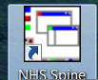

Step 1
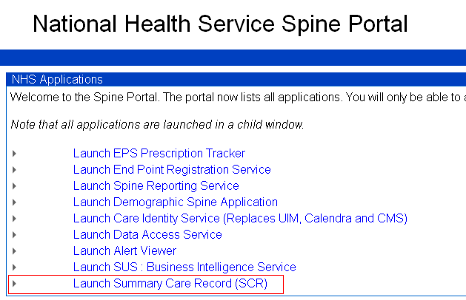
Step 2
Log onto Birth Notification Application (BNA)

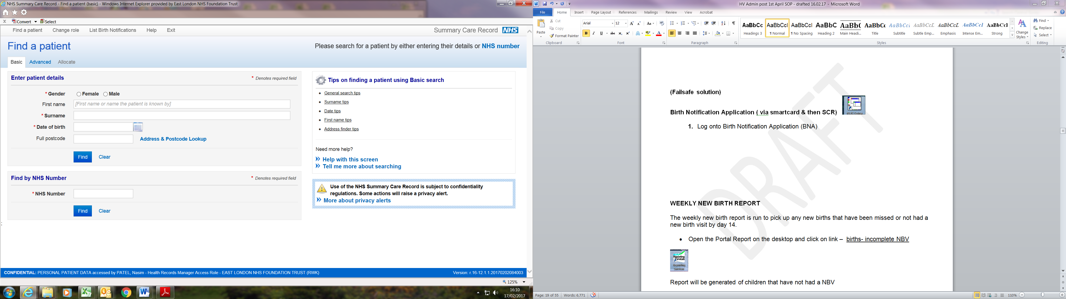
Choose from the top bar ‘list birth notification’

Step 3
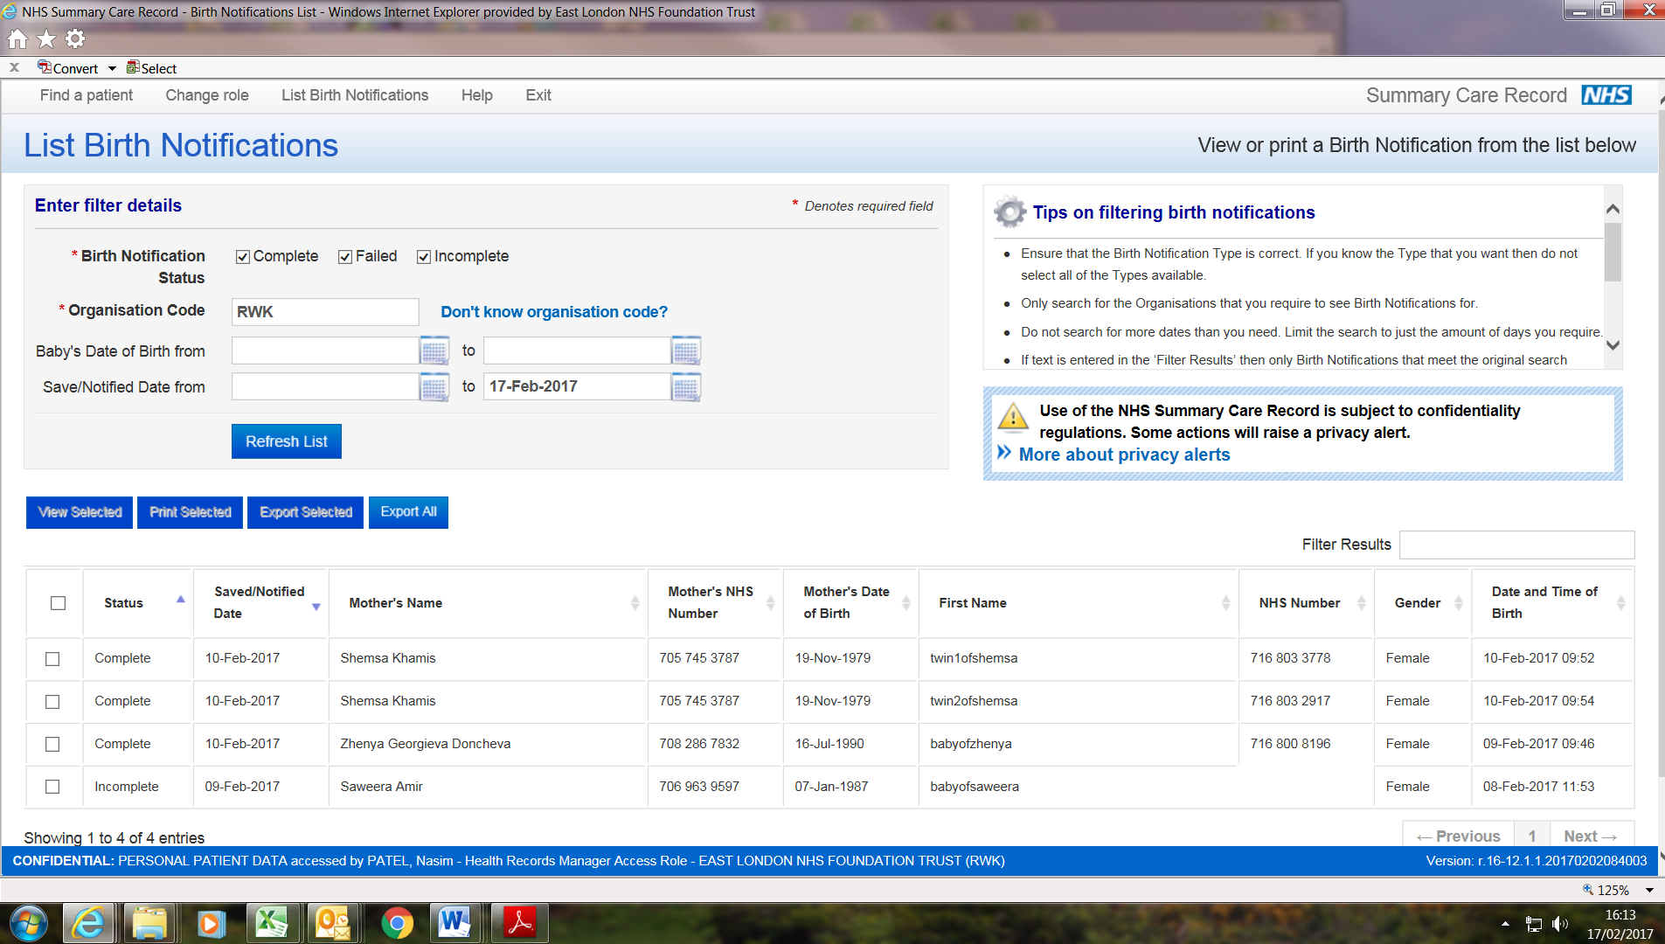

Enter the birth date under ‘baby’s date of birth from……. to ………

Refresh list
On the left side click on the blank box with a tick and double click

Step 4
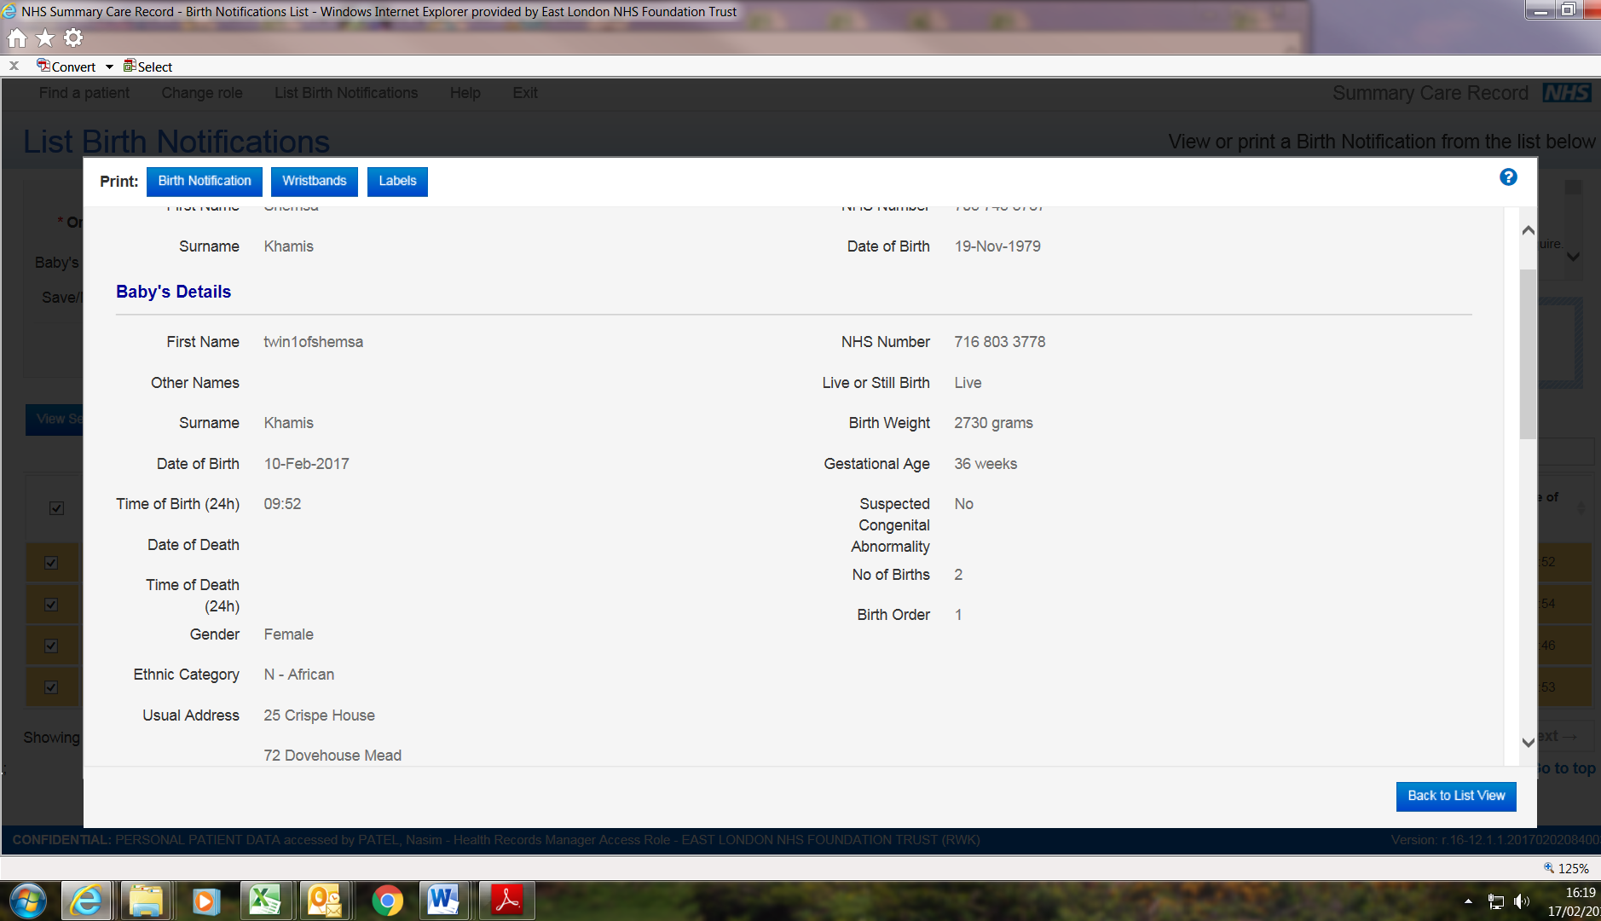

On the left hand side on the top blue bar click ‘birth notification’

A birth notification/s will be generated

6.3 Weekly new birth report
The daily new birth report is run to pick up any new births that have been missed or not had a new birth visit by day 14.
- Open the Portal Report on the desktop and click on link – births incomplete NBV

Report will be generated of children that have not had a NBV
Search if a birth notification has been received by the health visiting team by making checks if birth notification is uploaded and the health visitor’s admin have recorded any information on the progress notes and if a contact has been made with the mother.
If there is no birth notification or information in the progress notes then admin must search on BNA:
(follow the guidance on how to search and download birth notification)
Admin staff must inform the health visitors immediately, write information in the progress notes and upload birth notification.
Admin staff must contact mother to confirm address and inform her that the health visitor will contact them within 10-14 days.
7.0 Neonatal & Maternal Discharge Summary
Obstetrics consist of Maternal Postnatal Transfer Summary and the New-born Discharge Summary; both contain information of mother and new-born baby.

The Health Visitors Admin will receive a daily CSV excel sheet from Bart’s Health.
Some outer borough maternity will send the discharges by paper format.
CHIS hubs will not be responsible for forwarding the discharges.
7.1 Mothers’ Discharge Summary
Check if the mother has Hep B status positive and update the mother’s Rio record
- Check chrdnewham@nhs.net email daily
- Search for an email that is named as ‘ daily child health report’
- Password to open the report is childhealth
- Go through the list received from Bart’s Health and highlight each client completed in green
- Export clinical document from EPR – follow steps from page 10,11 & 12
- Search for the mother on Rio
- On the client view page click on ‘Child & Family’
- Click on “Health Visiting – Mother hyperlink”
- Click on Maternal Antenatal and Delivery Form link’
- On the ‘maternal Antenatal & Delivery Form’ input order of birth
- Hepatitis B status
- Date of test
- Upload document

7.2 Babies Neonatal Discharge Summary
CHIS hubs will not be responsible in forwarding the discharges.
- This process will be completed by the Health Visitor Admin
- Check chrdnewham@nhs.net email daily
- Search for an email that is named as ‘daily child health report’
- Password to open the report is childhealth
- When searching for the mother to check the child’s NHS number and export the new-born discharge summary from EPR and upload onto the child’s record
- To cross check against mother if mother is Hep B positive
- If mother is Hep B positive, check if baby has received Hep B vaccine
- If baby has received vaccine, record this in the immunisation page of the child’s RiO record

Step by step guide for recording Hep B
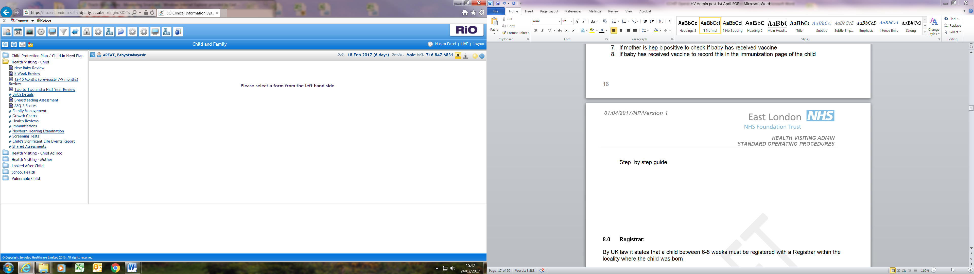

- Click on the immunisation hyperlink
- Link will take you to the create new immunisation page
- Select ‘Hep B primary course’ from the immunisation drop down list
- On the comment box add a note in capitals ‘ HIGH RISK’
- It is important to complete the neonatal dose from maternity to schedule other 4 doses
- Health visitor admin will be responsible for entering the neonatal vaccination the other doses will be uploaded automatically by informatics.

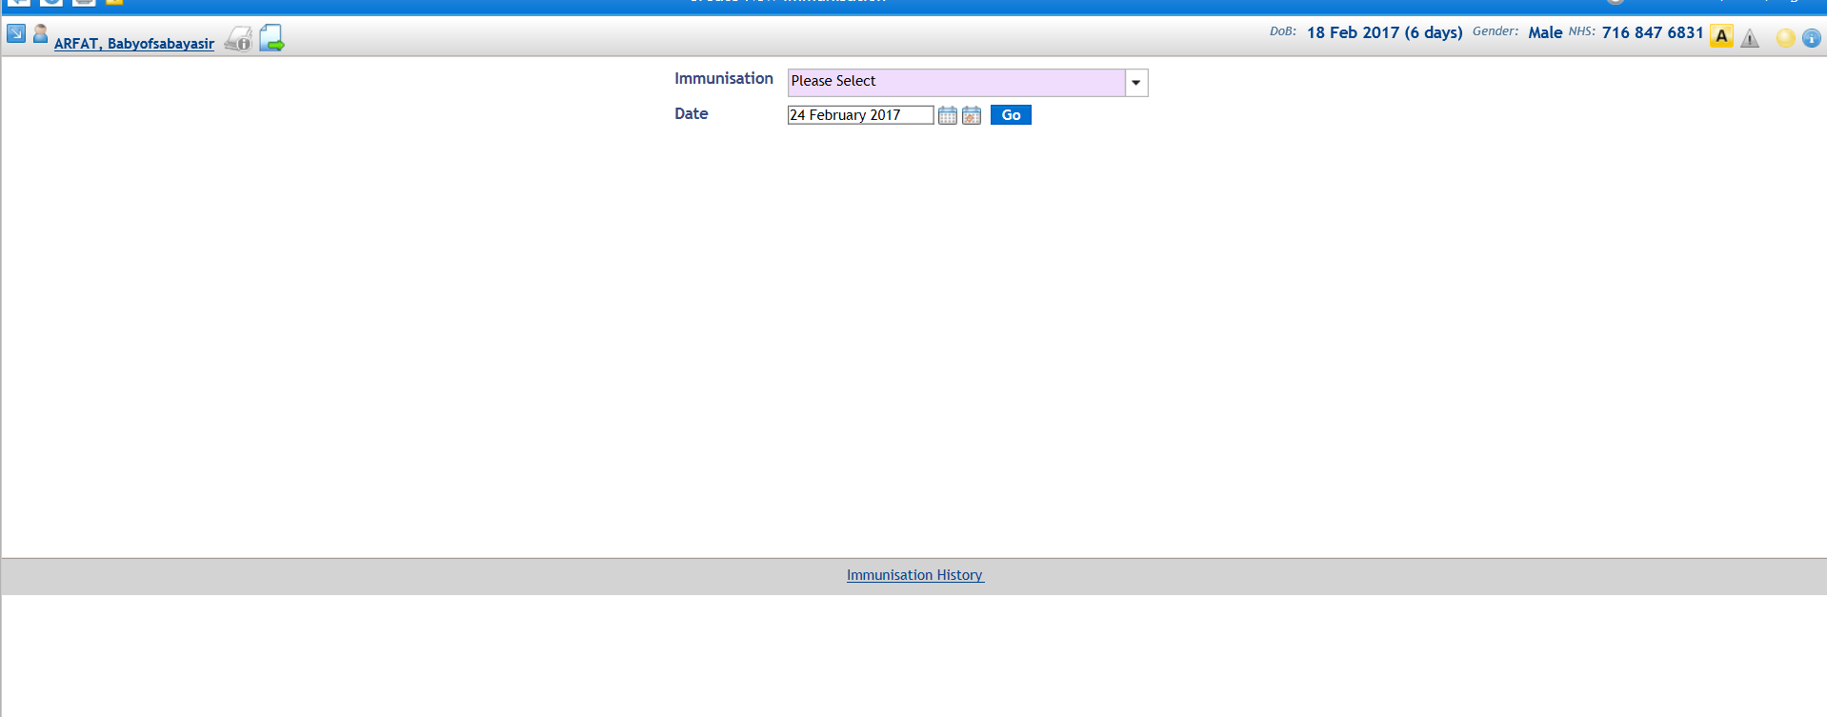

Immunisation page, point 3.
7.3 Receipt of maternal discharges not for Newham resident mothers
- Return to NELFT CHIS hub at nem-tr.nelchishub@nhs.net
- Also forward to the appropriate out of borough HV team

1. nem-tr.0-19universalredbridge@nhs.net - Redbridge
2. nem-tr.BDChildrenSPA@nhs.net - Barking & Dagenham
3. nem-tr.haveringhv@nhs.net - Havering
4. nem-tr.0-19universalspawf@nhs.net - Waltham Forest
5. thgpcg.hvrecordsandreferrals@nhs.net - GP Care Confederation (Tower Hamlets)
6. CLCHT.ChildhealthinformationHub@nhs.net (Barnet)
7. Beh-tr.EnfieldChildHealth@nhs.net (Enfield)
8. whh-tr.whittingtonchildhealth@nhs.net (Haringey & Islington)
9. huh-tr.chishv@nhs.net (City & Hackney)
10. cnw-tr.goodallcommunityreporting@nhs.net – Camden
11. LNWH-tr.CHRDHarrow@nhs.net (Harrow)
8.0 Registrar:
UK law states that every a child must be registered with a Registrar within the locality where the child was born between 6-8 weeks
8.1 Current practices must be followed:
- Each week a registrar’s return will be forwarded by email to nominated staff and a senior manager for all children that have reached 6-8 weeks with a new registered name, child deaths, and still births
- Open each document
- Search via NHS number
- Check address
- Edit demographic page to update the name
- Cross-check address and update if necessary
- If the child needs to be moved across to a different team due to internal demographic change, transfer referral and move the child from the current monthly team planner to the correct team by postcode. Go to screening page and check if the bloodspot results have been recorded
- Go to screening page and check if the bloodspot results have been recorded
- If screening is not recorded the admin staff must alert the health visitors who are trained to complete bloodspot screening
- Check the child is on the monthly team planner for the relevant team it has been referred to.
- On the still birth attachment, check on RiO that the child has the black diamond, and then it has been registered deceased. If not then inform manager. If address is out of borough, inform the hub by email for continuity of care.
- On the death’s attachment, check on RiO that the child has a black diamond then it has been registered as deceased. Check there is a Form A in the uploaded documents. If not then inform manager. If address is out of borough then inform the Hub by email for continuity of care.

9.0 New-born bloodspot screening
Parents of all new-born babies are offered blood spot screening, which identifies babies who may have rare but serious conditions.
Phenylketonuria (PKU): a rare inherited condition that can cause severe learning difficulties. Early treatment with a special diet can prevent disability and allow babies to lead a normal life.
Congenital Hypothyroidism (CHT): a condition caused by the thyroid gland not developing properly. Early treatment will prevent serious disability and allow babies to develop normally.
Sickle Cell disease (SCD): an inherited blood condition. Treating babies will help prevent serious illness and allow them to live a healthier life
Cystic Fibrosis (CF): an inherited condition that affects the internal organs, especially the lungs and digestive system. Early treatment is thought to help babies lead longer and healthier lives.
Medium-Chain Acyl-CoA Dehydrogenase deficiency (MCADD): a rare and serious inherited condition where the body cannot break down fat as well as usual. Babies with MCADD develop normally but recognizing the condition early enables parents to make sure they avoid serious illness.
The 4 newly added inherited metabolic diseases are:
Maple syrup urine disease (MSUD)
Maple syrup urine disease is an inherited disorder in which the body is unable to process certain protein building blocks (amino acids) properly. The condition gets its name from the distinctive sweet odour of affected infants' urine and is also characterized by poor feeding, vomiting, lack of energy (lethargy), and developmental delay. If untreated, maple syrup urine disease can lead to seizures, coma, and death.
Isovaleric acidaemia (IVA)
Isovaleric acidemia is a rare disorder in which the body is unable to process certain proteins properly. It is classified as an organic acid disorder, which is a condition that leads to an abnormal build-up of particular acids known as organic acids. Abnormal levels of organic acids in the blood (organic acidemia), urine (organic aciduria), and tissues can be toxic and can cause serious health problems.
Normally, the body breaks down proteins from food into smaller parts called amino acids. Amino acids can be further processed to provide energy for growth and development. People with Isovaleric acidemia have inadequate levels of an enzyme that helps break down a particular amino acid called leucine.
Glutaric aciduria type 1 (GA1)
Glutaric acidemia type I is an inherited disorder in which the body is unable to process certain proteins properly. People with this disorder have inadequate levels of an enzyme that helps break down the amino acids lysine, hydroxylysine, and tryptophan, which are building blocks of protein. Excessive levels of these amino acids and their intermediate breakdown products can accumulate and cause damage to the brain, particularly the basal ganglia, which are regions that help control movement. Intellectual disability may also occur.
Homocystinuria (pyridoxine unresponsive) (HCU)
Homocystinuria is an inherited disorder in which the body is unable to process certain building blocks of proteins (amino acids) properly. There are multiple forms of Homocystinuria, which are distinguished by their signs and symptoms and genetic cause. The most common form of Homocystinuria is characterized by near sightedness (myopia), dislocation of the lens at the front of the eye, an increased risk of abnormal blood clotting, and brittle bones that are prone to fracture (osteoporosis) or other skeletal abnormalities. Some affected individuals also have developmental delay and learning problems.
Less common forms of Homocystinuria can cause intellectual disability, failure to grow and gain weight at the expected rate (failure to thrive), seizures, problems with movement, and a blood disorder called megaloblastic anaemia. Megaloblastic anaemia occurs when a person has a low number of red blood cells (anaemia), and the remaining red blood cells are larger than normal (megaloblastic).
The signs and symptoms of Homocystinuria typically develop within the first year of life, although some people with a mild form of the disease may not develop features until later in childhood or adulthood.
9.1 New-born Blood Spot screening tests will be received via the interoperability
Model

Daily lists will be received as a CSV file by the health visitor admin of all babies that have not received the results by 14 days, and results that will need to be manually entered onto the system
The NHS target for results to be recorded on RiO is 14 days.
For babies born in the area, where there is no record of results by 14 days of age, the admin staff will notify the local screening midwife at munewham@nhs.net to:
- Check screening status
- Ensure rapid request for sample to be taken within 48-72 hours of request
- Ensure an audit trail to enable tracking of the failsafe system
The health visitor will contact the admin staff if no results available when NBV completed.
For babies who are movers-in, where there is no record of results by 14 days of age, the admin staff will inform the named health visitor to:
- Check screening status (including new born hearing test)
- Ensure rapid request for sample to be taken within 48-72 hours of request
- Ensure an audit trail to enable tracking of the failsafe system

9.2 Generation of results letter for parents (within the new CHIS model it will be the hubs that will send letters to parents for normal results within 6-8 weeks)

1. The health visitor will be able access the Blood Spot results for a baby prior to conducting the new birth visit as an additional failsafe as well as to the e-redbook that the parent will have access to.

2. Any discrepancies should be directed to the Health Visitors for investigation
3. All abnormal results will be given to parents by a trained health professional, preferably face-to-face, following local protocols that meet recommended NHS NBS Programme standards

9.3 Missing or incomplete screening test report

This report is run daily as a failsafe to ensure all clients have bloodspot results recorded.

From the data warehouse portal report: select the ‘Children under 1 year without bloodspot result folder’,

Choose the disc icon report & export to excel.

All outstanding results need to be checked via Northgate and weekly report sent by the CHIS hub

If results are found they will need to be uploaded manually to RiO

If results cannot be found every effort needs to be made to trace them. To identify which hospital the baby was born, perform a national search in Northgate, admin must contact appropriate laboratory to establish if they hold the results. In the event that there is no trace of the results the appropriate health visiting team should be contacted and asked to follow up with the parent and / or community midwives.

9.4 Recording results (manual recording)
Results to be recorded are accessed from the CHIS hub and as an additional failsafe -Northgate
- Using the client search function look up client via Demographic Details, select: Screening Tests
- The following screen will appear. Select on “Add Screening History” at bottom of screen.
- Under Screening Test, select each of the conditions Cystic Fibrosis, Hypothyroidism, MCADD, Phenylketonuria and Sickle Cell, Maple syrup urine disease (MSUD), Isovaleric acidaemia (IVA), Glutaric aciduria type 1 (GA1), Homocystinuria (pyridoxine unresponsive) (HCU).
- Under Part number select “1” from the drop down menu for each test.

- In the reference number box type the name of the hospital where the report has come from (this only needs to be done in one of the boxes).
- Under admin date, enter date the specimen was taken.
- From drop down menu: choose hospital site for location for each test (or appropriate alternative).
- Finally choose from pick list or the number and select or automatically display the result as coded on the report. i.e. 4 for ‘Condition Not Suspected’ 3.4 “Insufficient sample”.

For repeat/further sample required this should be recorded with the appropriate comment i.e. If the report details the reason for the repeat as premature baby, this should be coded correctly from the screening test history page.
For example:

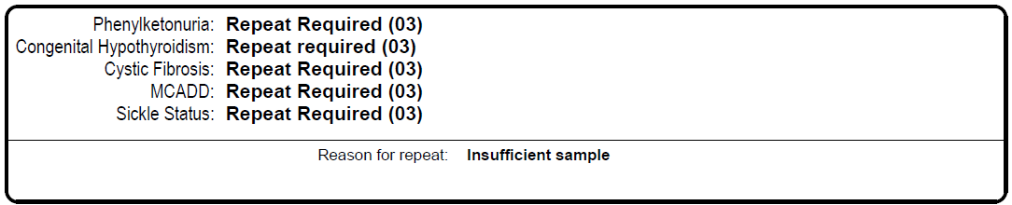
This should be coded as
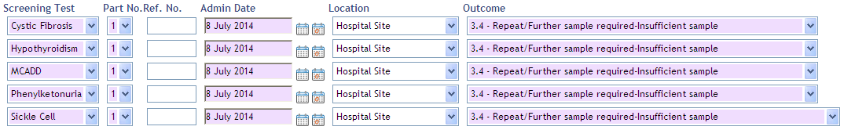
- Click “Save” to update the details.
9.5 Results where a condition is suspected
- The health visitor must contact the GP to confirm that the parents have been notified of the results. The health visitor must not discuss the results with the parents until they have been seen by a GP.
- After the results have been communicated to the parents, the health visitor must refer the child to an enhanced caseload and set a medical alert with the condition details.
- The health visitor must provide the family with ongoing support to manage the child’s condition, signposting as appropriate and liaising with the relevant Health care professionals.

9.6 Babies born abroad
Where babies are identified as having been born abroad it is required by NHS England and Public Health England that we offer a Bloodspot retest. This is because the UK is the only country testing for all of these 9 conditions and PHE are also unwilling to accept the quality assurance of any tests done abroad.
Repeat blood spot tests for babies that are 29 days to 364 days old are undertaken by health visitors trained to undertake new-born blood spot screening
- Ensure the child is linked with the family to include the parent’s details: name, DOB, NHS no. & telephone no. If not, liaise with GP to obtain the information and link the parent to the child on Rio.
- If an appointment is offered and the client DNA’s, health visitors will record DNA information on the progress notes and arranges a second appointment. The results should be recorded as ‘declined’ and a note put on Rio saying ‘DNA bloodspot repeat appointment, recorded as declined’.
- Health visitors undertaking a transfer in visit from abroad for a child 0 - 1 year, must check at the transfer-in visit that the parents have made an informed choice as to whether or not to have a test.
- If at the transfer in visit the health visitor ascertains that the parent does not want UK screening this must be recorded on Rio

9.7 Notifying GPs that screening has been declined
- HV must discuss additional testing with the parents and records in progress notes if testing is completed or declined.
- If testing is declined HV must inform health visiting admin who update screening results as declined

9.8 Health Visitors undertaking New-born Blood Spot testing
- This is an extended role for the health visitor and requires additional training and an assessment of competencies. Newham will identify health visitors who are able to perform effective blood spot testing.
- All health visitors carrying out this test are required to complete a half day e-learning training and a half day observation of practice with a competent practitioner
- The e-learning training is as follows:
http://cpd.screening.nhs.uk/bloodspot-elearning
http://cpd.screening.nhs.uk/bloodspot-elearning#fileList

Modules required to be completed:
New-born blood spot e-learning modules
1. Improving blood spot quality e-learning
2. Expanded new-born blood spot screening e-learning
3. Timeline for implementation of expanded screening
4. Files

All health visitors undertaking the screening are required to follow the NHS Screening Programme Guidelines for New-born Blood Spot Sampling.
10 Checking Northgate
- You will require log-in details and a password to access Northgate.
- Once you are logged in select Child Health option from the drop down menu.

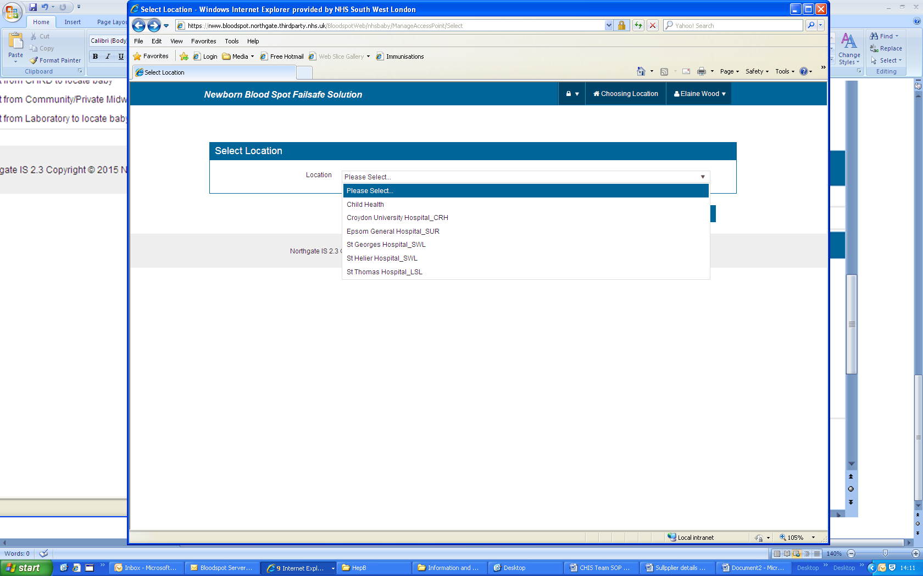

- In the next screen tick the box “any state” and enter either the NHS number or surname in the relevant drop-down box, click on “Filter” to search for the child.
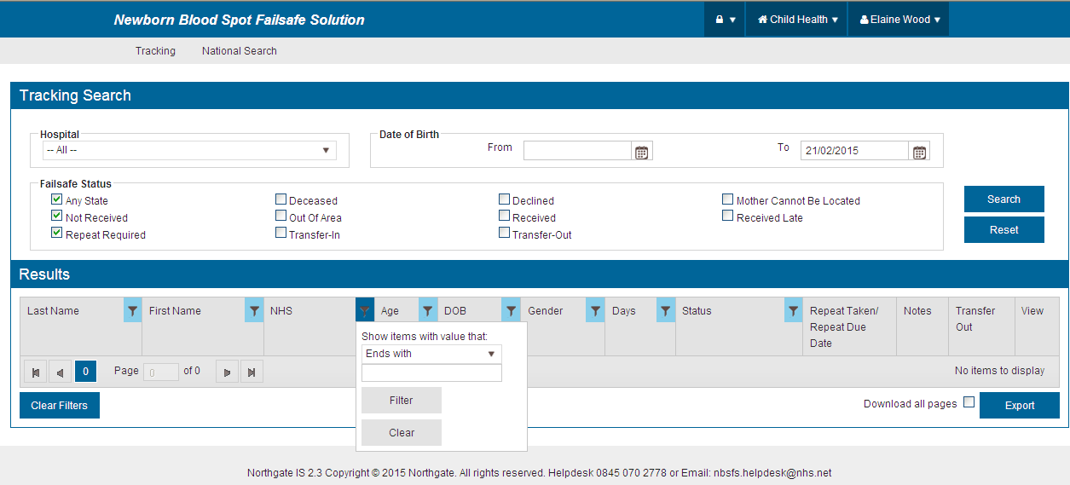

- The search will hopefully list the child you are searching, in which case, you can click on the spy glass under ‘view’ to display the results which will need to be input manually into Rio (4.4).

- If no results are found click on the ‘National Search’ at the top of the screen, then choose an appropriate option from the drop down menu for ‘reason note’

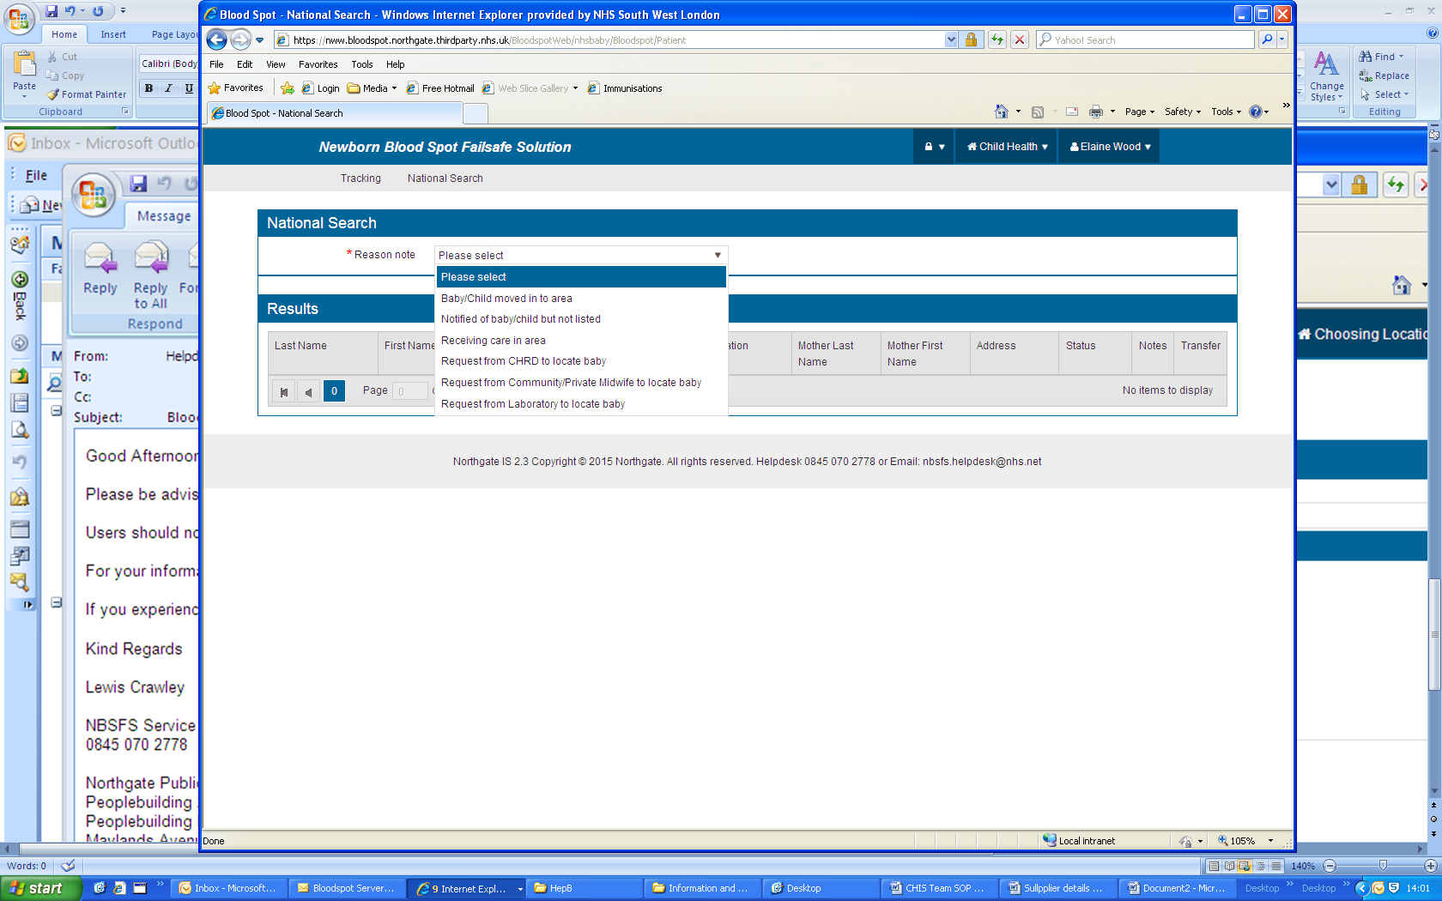
- Enter the NHS number and click “filter”. You will not be able to see the results, but by clicking in the notes you should be able to ascertain where the baby was delivered and contact the relevant child health or new-born screening lab.
Other failsafe status available to view
Deceased Transfer-out
Out of area Mother cannot be located
Declined Received late
Received Babies in NICU/SCBU or other Tertiary centres

Contacts:
Great Ormond Street
gos-tr.Enquiriesgosnbs@nhs.net

11 New-born Infant Physical Examination (NIPE)

Purpose and scope

11.1 The new born and infant physical examination screening programme (NIPE) is one of the antenatal and new born NHS population screening programmes
NIPE screens new-born babies within 72 hours of birth, and then once again between 6 to 8 weeks for conditions relating to their:-
- heart
- hips
- eyes
- testes
The 6 to 8 week screen is necessary as some conditions appear later in a child’s development.
NIPE data will be forwarded from Maternity to the London Platform and then the CHIS Hubs will forward a CSV file (spreadsheet) to the health visiting admin to manually input onto Rio until data upload tool is developed.
Follow the process below:
Check on the spread sheet list individual child and follow below:
- Click “Client Details” icon on the menu bar
- Select: “Demographic Details” Search for/select appropriate child
- Click “Health Reviews” hyperlink (at the bottom of the screen)
The Health Review History screen will appear
- Click “Add Health Review”
- Select “New born physical exam” from health review list to open health review screen
- Enter examination date in the date box.
You do not need to enter a comment
- Click “Save” which takes you to the “Health Review History screen
- Click on the “Outcome” columns of the New-born physical exam schedule as below
The Health Review screen appears entitled New-born Physical exam and Scheduled/Added Date is shown

12 New-born hearing

Purpose and scope

- National Health Screening Providers are responsible for ensuring that the hearing results are sent to the London Platform. The results of all children resident in Newham will be forwarded to NELFT CHIS hub. Once data is analysed this will be forwarded to the health visiting service for manual data entry onto Rio by health visiting admin on a day to day basis depending how often the information will flow from the London Platform.
Process – New-born hearing step by step guide for entering results onto RiO

Daily CSV file will be received in excel format.

- Open NHS mail look for email titled New-born Hearing Screening and open Excel document.
- Enter the password in capital letters- NHSPRIO to open the spreadsheet
- Look for the heading Postcode and using your postcode borough finder https://www.gov.uk/find-local-council go through the spreadsheet and highlight any rows that are not the borough of Newham
- Open Rio and find New-born Hearing Examination under the first ABC icon
- Copy the NHS number from the spreadsheet and enter it in Rio, in the space marked NHS Number and press GO
- If results have been recorded already a lilac strip will appear with details of whom and when the assessment was completed- click on the strip and update result, if they are different following the step below.
- A pop-up box may appear – seek approved name from manager
- New-born Hearing Examination page will be displayed- Double check that you have the correct baby.

- Complete the first field- Date/time of completion of assessment by clicking the second calendar box which display Today Date
- Open NHS mail look for email titled New-born Hearing Screening and open Excel document.
- Enter the password in capital letters- NHSPRIO to open the spreadsheet
- Look for the heading Postcode and using your postcode borough finder https://www.gov.uk/find-local-council go through the spreadsheet and highlight any rows that are not the borough of Newham
- Open Rio and find New-born Hearing Examination under the first ABC icon
- Copy the NHS number from the spreadsheet and enter it in Rio, in the space marked NHS Number and press GO
- If results have been recorded already a lilac strip will appear with details of whom and when the assessment was completed- click on the strip and update result, if they are different following the step below.
- A pop-up box may appear – seek approved name from manager
- New-born Hearing Examination page will be displayed- Double check that you have the correct baby.
- Complete the first field – Date/time of completion of assessment by clicking the second.
Keys: CR – Clear Response, NCR – No Clear Response, NC – Baby Unsettled
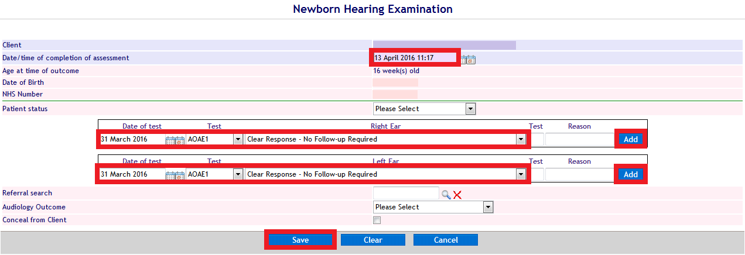
13 Process for 6-8 week GP health review
Step by step process to upload onto RiO
- Received from GP
- Go to RiO
- Click on first icon – go to registration
- Enter NHS No
- If NHS no is not available enter DOB, name, gender
- Search for child
- Go to demographic details – go to health reviews
- Add health review
- Select 6-8 weeks
- Enter today’s date – click go > save
- On health review history click on outcome
- Fill in details from SPUN form:
Health review form looks like this on RiO system
- Outcome is coded according to SPUN form
S = Satisfactory, P = Problem, O = Observation, R = Referral, N = Not observed
- Location is GP premises
- Surveillance outcome is completed
- In comments box record review done by GP at GP (name of surgery)
- If you cannot read the doctor’s writing, scan and upload SPUN form and record in comments box that you have uploaded SPUN form
- Under referral on information, select health visiting and click on >>
- On follow up, click on Health Review 1 click on >>
- Save

If SPUN form has an address which is not a Newham address, scan and send it to NELFT CHIS hub at nem-tr.nelchishub@nhs.net

14 Health Reviews

14.1 Preparation for 1 yr. and 2 yr. reviews (failsafe)

- Contact Tanya Pandilovska (Tanya.Pandilovska@elft.nhs.uk) senior information assistant of the Informatics Team requesting for 1 year and 2nd year health review for the following month.(Email the request at the end of the current month to get the report for the beginning of the new month.)
- Create a folder in your H drive or desktop for health reviews, once you receive the report save it into this folder.
- The report will contain information of all the children due to have their one year and two year health review (approximately 500 for both 1st year and 2nd year health review.)
- Log into RIO, open the report start with the 1st year health review, then once finished go onto the 2nd year review.
- Check for the following for each child using both the report and RIO, Synchronise RIO :
- Child first name
- Child surname
- Child date of birth
- Child Address
- Child Health Visiting Team, universal /UP/UPP
- Use the following key to colour code the report while checking the information with RIO:

Green if all the information on both the report and RIO are correct

Yellow if the child has moved address but within Newham, change the address on the report.

Red for the children who have moved out of borough
Purple for the children with referral for CDS MDT
Light green if the child has a referral for UP or UPP
Orange for another team referral or for children with NO TEAM (FNP, East Ham, New born blood spot)

- Once the report has been synchronised you need to split the report, select all the data and filter the report using the filter icon under the data tab.
- Open a new excel sheet, go to the report, filter the out of borough using the colour, and move them to the new spread sheet, save the spreadsheet as out of borough.
- Open a new Excel sheet, in this spread sheet create a tab for each health visiting clinic, go back to the main report filter out all the children with UP and UPP referrals using the colour as a filter copy and paste them to the correct UP / UPP health visiting clinic tab.
- On the same spreadsheet create more tabs for CDS MDT and other CLINIC and a tab for children with other move the children with these referrals to the correct tab. Save this report as UP / UPP.
- Go back to the main report; children that have been highlight in yellow check their referrals they may have changed due to move of address. Using the street list which can be found at N:\Departmental Shared\Childrens Services\School Nursing & Health Visiting Service, check the addresses against the street list if the clinic has change then on the child RIO account transfer the referral to the new health visiting clinic. On the report change the clinic and highlight that child to green if there is no change of clinic leave the referral highlight the child green on the report.
- Go to N:\Departmental Shared\Childrens Services\School Nursing & Health Visiting Service\Central Admin Team (Boleyn)\Health Review Initial Appointments; here create a folder for the health review month you are working on.
- Inside the folder create 2 sub folders for the 1 year and 2 year health review
- Inside these sub folders create folders for each health visiting clinic.
- Go to the original report and filter the children with universal health review
- Open a new excel sheet for each health visiting clinic and copy and paste the children with universals referrals for that health visiting clinic into the excel sheet and save under the sub folder created for that clinic, do this for all 8 clinics (Appleby, Balaam Park, Centre Manor Park, Joyce Campbell, Lord Lister, Royal Docks, Shrewsbury and West Ham Lane).
- Email the admin team to let them know the health review list is ready for them to book the appointments.
- Go back to the saved out of boroughs split the report according to rota for new births and send them to be transferred out:
- Lord Lister, Joyce Campbell, Shrewsbury out of borough to be sent to Nalini Mistry: Nalini.Mistry@elft.nhs.uk
- Balaam Park, The Centre Manor Park and West Ham Lane out of borough to be sent to Sue Abbott : Susan.Abbott@elft.nhs.uk
- Appleby and Royal docks out of borough to be sent to Helen Phillips: Helen.Phillips@elft.nhs.uk
- Go to the UP/ UPP report , open an new excel sheet and copy and paste the referrals and send this according to health visiting clinic, this is to be sent to the CTL and Band 7 of the health visiting clinic you are working on, they will book the health review for the child.
- Every health visiting clinic for UP and UPP must be done on a new spreadsheet.
- Open a new excel spreadsheet copy and paste the CDS MDT child referral here and send this to Sophie Njiri Sophia.Njiri@elft.nhs.uk The CDS team will book the health review.
- Open a new excel spreadsheet copy and paste the FNP child referral here and send this to Adeana Roberts Adeana.Roberts@elft.nhs.uk
- Open a new excel spreadsheet copy and paste the children with referrals for east ham and send to Edgar Bloye Edgar.Bloye@elft.nhs.uk
- Open a new excel spreadsheet copy and paste the children with no referral health visiting team here and send to admin team for them to allocate a health visiting team and book the child for health review
14.2 One Year Health Review
- Information Department will extract for the health visitor admin a list of children that are due for a health review
- Each health visitor admin will be assigned to each team to book appointments
- Cross-check for data quality i.e. DOB, NHS no; gender; address and if the child has been given a previous appointment by a HCP
- Go to clinic plan- select clinic date nearest child’s birth date
- To book an appointment select the slot and click on new appointment

(Making sure that 12 months health reviews are booked on the 12 month health review stream only within RIO) avoid booking clients on the 24-30 month slots

- Send an appointment letter to the parent by post (the letter includes a sentence asking the parent to contact the admin team if the appointment is not convenient)
- Save the letter onto RIO – naming convention – 12 month health review
- Make an note on the Progress note
- Post the letter
- If parent calls to re-schedule 1 year health review appointment, the admin team are to offer alternative slots within the 12 month health review stream only.

- If there are no more slots available which are convenient for the parent within the month that their child is 1 year old, give the parent the clinical team leader’s telephone number and they will organise an appointment with the parent.

14.3 Year Ages and Stages Health Review (ASQ-3)
ASQ-3 is an assessment tool that consists of a set of questionnaires about children’s development. It has been researched and used for more 30 years to ensure children are developing and doing well in important areas such as communication, fine and gross motor, personal-social and problem solving skills. ASQ can help identify a child’s strength as well as any area where the child may need support
- Information Department will extract for the health visitor admin a list of children that are due for a health review
- Each Health Visitor admin will be assigned to each team to book appointments
- Cross-check for data quality i.e. DOB, NHS no, gender, address and if the child has been given a previous appointment by a HCP
- Go to clinic plan – select clinic date nearest child’s date of birth
- To book an appointment select the slot and click on a new appointment
(Making sure that 24-30 month health reviews are booked)

- Send an appointment letter to the parent by post (the letter includes a sentence asking the parent to contact the admin team if the appointment is not convenient)
- Save the letter onto RiO – naming convention – 2 year health review
- Make a note on the progress note
- With the appointment letter attach the ASQ form (do not attach the scoring sheet)
- Post the letter
- If parent calls to reschedule 2 year ASQ health review appointment, the admin team are to offer alternative slots within the 24-30 month health review stream only
- If there are no more slots available which are convenient for the parent within the month that their child is 2 years old, give the parent the clinical team leader’s telephone number and they will organise an appointment with the parent.

15 A&E referral

A daily report can be generated from EPR

CHIS hub will not be responsible in forwarding daily reports, but will be requesting
for reporting purposes the figures each month of A&E attendance.

15.1 Procedure for 0-5 years of age

- Notes: A & E referrals must be uploaded on RiO within 48 hours of receipt

- From the list search the child on RiO
- Make necessary searches. i.e. demographics and if not on the system admin must synchronise on the local RiO system.
- Export clinical document from EPR ( follow page 12-14 how to export from EPR)
- Upload A & E referral onto RiO
- Make a note on progress note i.e. date (a) A & E attended. (b) reason for attendance
- Significant event must be ticked once recorded on progress note

15.2 Procedure for 0-5 years – overseas address
- Check the national spine on RiO for confirmation for UK address, if none, check on EPR
- If no UK address found, contact Lesley Bell ED Manager for ED attendance Tel: 020 7363 8644

UCC attendance – George Botchey – Administrator ED Manager for ED ATTENDANCE 020 7363 9200
15.3 Procedure for 0-5 years out of area
1. Inform the out of area health visiting team and forward the A&E document
2. Safeguarding concerns must be forwarded to the out of area Safeguarding Team
15.4 Procedure for 5-19 years of age
- From the list search the child on RiO
- Make necessary searches. i.e. demographics and if not on the system to synchronise on the local RiO system.
- Export clinical document from EPR ( follow page 12-14 how to export from EPR)
- Upload A & E referral onto RiO
- Make a note on progress note i.e. date (a) A & E attended. (b) reason for attendance
- Significant event must be ticked once recorded on progress note

- Upload A&E slip onto RiO within 48 hours of receiving the document. If it has been identified that the chid has attended A&E 3 times within the 6 months then admin must flag it up with the appropriate HCP and place the notification on the monthly team planner for appropriate team. Make a note on the Progress Note: date of A & E attended & reason for attendance i.e. injury/fall/fever etc. Significant event must be ticked following an entry in RIO progress note.
- If a child attends A & E more than once during the same week, alert the safeguarding, HV & SN team
- Children with a concern must be recorded on the health visitors team planner and for a school age child inform the LBN school nurse service via schoolhealth@newham.gov.uk.
- The School Health Service is split into Team A, B and C so allocate according to the school that the child attends.

15.5 Procedure for 6-19 years out of area

- Inform the school nursing team admin
- School nursing team to follow process of perusal and transfer of records

15.6 Step by step guide in accessing EMIS web
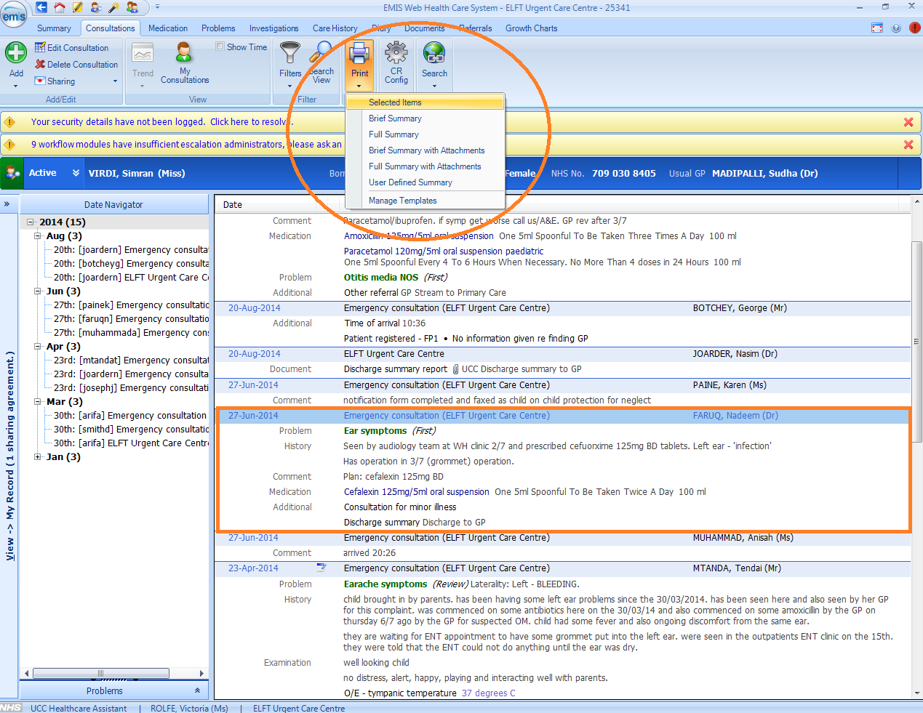

The above print icon will generate a basic report with the client’s details and the notes for this attendance.
If a child has no address or an Overseas Address on their Discharge Summary in EPR, find a UK address by looking under “Patient Summary”.
16 Consultant Based Hospital Report
Process
Hospital letters are received as local arrangements via NUHT emailing once each week. These hospital letters are sent where a child has been referred and seen by a specialist consultant or clinician and a report has been completed. The information is forwarded to upload to each child’s Rio record.

- Reports are forwarded and attached on a word document
- Save each report on the desktop
- Upload report on the child’s RiO record and check the document view to make sure the document is uploaded
- Make a note on the progress notes “consultant report uploaded and date when the child was seen”
- Delete the information from desktop after completion of the task.

17. Transfer of Records

17.1 Universal Children Transfer in to Newham

To ease administration burden and a way forward as part of the CHIS Digital Strategy interoperability and centralised service NELFT CHIS hub will forward a weekly report of all children that have transferred into Newham , health visiting service will receive an excel spreadsheet with information of Local authority and postcode responsibility, information; this will also include screening results.

*Paper record will not be sent by CHIS hubs* this will be a local arrangement by clinical providers

Paper record & electronic record

- Search child on RiO
- If the child has a different address to the local data, synchronise to update the demographic detail
- Make a referral by identifying the team by postcode ensuring it is clearly stating ‘transfer in’
(This can be searched via the street list on the n drive)
- Information included on the CHIS Hubs list will need to be updated, this will include the movers in record i.e. bloodspot, immunisation, concerns etc.
- On the progress notes clearly state where the child had previously moved from and date moved to Newham
- Add child onto the appropriate monthly team planner
- Scan paper records onto child’s records and upload onto RiO.
- If only a discharge summary is received, without the full child’s record, the administrator must make a note on the RiO progress notes to record this fact, identifying which provider organisation transferred the records to Newham. This will ensure if at any future date the full record is required, we can refer back to the organisation which holds the child’s record up to the date it was transferred to Newham.

17.2 Universal Children Transferred out of Newham

*Paper record will not be sent by CHIS Hubs* this will be a local arrangement

Electronic record procedure

- CHIS hub will forward a weekly list of children moved out of Newham to another borough within London or within the UK
- (Please note hubs will not take any responsibility of any paper records and it will be the health visiting team that will send paper records to areas outside London who do not have a facility to receive electronic information).
- Health visitor admin must forward the movers out report to health visitor by caseload
- Health visitor will peruse RiO record and discharge the child from the caseload referral.
- Health visitor must complete a discharge summary in the progress note.
- Health visitor must email the health visitor admin and confirm that records have been perused
- Health visitor admin will print from the maternity Discharge Summary (movers out) on births, bloodspot, immunisation, Hep B, new-born hearing, NIPE and a separate print out for progress notes
- The teams (health visitors and administrators) will have 10 working days to peruse the record discharge the referral and forward the record to the health visiting team out of borough

- For school age children the health visitor admin will forward the list to other services relevant to caseload i.e. therapist, CDS etc. See pathway for sending requests and data to the local authority school health service.
17.3 Child Protection – Record Transfer Out

- Health visitor admin must alert the safeguarding administrator by email that record for a child protection plan are for transfer out and attach a HQ4 form
- Safeguarding team will email the health visitors admin when records are ready for transfer (this is within 10 working days in total)
- Email the movers out report and progress notes via NHS.net to the appropriate outer borough Health Visiting Team.
- If the outer borough health visiting team do not have a secure email address to transport the records this must be sent as a hard copy and a note made on the progress notes i.e. where the record has been sent and the date it was sent.
- If the record is sent as a hard copy it must be sent by “recorded delivery”
- Administrator must make a note on RiO progress notes to confirm CP record transferred.

17.4 Child Protection – Record Transfer In

- If the records are sent by email save the records on the n drive under the ‘child health folder’
- Search for the child on RiO
- Synchronise the child’s demographic details over the local RiO system
- Record child’s bloodspot, births, immunisation status manually
- Make a referral indicating as a UPP caseload
- Add to the appropriate health visiting team under UPP caseload
- Forward the electronic record to the safeguarding administrator to alert the safeguarding team
- Make a note on ‘progress notes’ of the actions taken
- Upload the electronic record to the child’s RiO record under the naming convention ‘outer borough transfer in’
- Once the document has been uploaded it must be deleted from the desktop immediately

17.5 Step by Step Process for Transferring Records

Transfer Out Process

- Search Child
- Check that referral has been discharged - if not then discharge giving the reason ‘moved out of area’ and enter the new address and put the health visitor that perused the record as the HCP
- Enter on progress notes that records have been sent to new child health department
- ‘Records sent to …………………. Child Health Department’
- Check clients documents, everything that is on the clients documents needs to be saved (they will either be in PDF or word format) – these can be saved to a folder on the desktop which can be easier
- Click on 1st ABC button and click on Child Health Discharge Summary
Find child
Click Add Report
Click blue arrow on right hand side of top coloured line
Click Create Document
Click Save
Click blue arrow on same coloured line as before
Click Authorise
Click Authorise again
Click blue arrow on same coloured line
Click Print
This will come up as a word document where you have the option to save.
- Go to 2nd TV screen
Click Progress Notes Print Out
Find child
Start date use child’s DOB
End date use date of producing print out
Copy and paste onto word document – go to bottom of notes & highlight all to the top – Right click & copy – Go to word – Right click Word Document – change to Landscape – Paste document. Save into folder on desktop
- EDM Record – This will be for school age children 2009 and before:
On child’s case record, there may be a button which shows next to the hyperlinked name – top left hand side – if the button that has an exclamation mark is available then there are records there that also need to be printed off. Click on the exclamation mark which will bring up the records that are available, these need to be saved one by one – click on the save button at the end of each under options – when the document opens there will be a disk button at the top right hand side if you press this then the document will give you the option to save.
- Go to folder icon (10th icon from left)
Click on Document View
Search for child – You should see a list of documents for child – these will be in 2 formats Word and PDF.
Click on first document
If PDF: Hover near top of document this will bring up the option to save/print etc. Click Disk icon, which will bring up the Save As folder, find the folder that you are working with and save the document using the same name as on Rio (e.g. A&E attendance / Health Review appointment)
If document is WORD: When document is selected, a screen will appear asking if you want to open or save, click the Save as option – this will then take you to the Save as screen – following instructions as above.
- Check mother’s record just in case any documents are on her records as well.
- Go to NHS.net

Add all documents saved in the folder you created on desktop – Click first document – Shift – Click last document - Insert
Send to appropriate child health department and save the sent email in a designated folder.
- Delete folder on desktop.
Transfer In Process:
- Record received from previous child health
- Search child on RiO
You may need to pull over from National to Local data
- Put on the appropriate team referral.
- If record received electronically
Upload document
Author – Put name of child health record come from e.g. Tower Hamlets Child Health Department
Title – Out of borough Transfer In
Date: Date record received
Type – Other correspondence
- Add the Bloodspot result
- Bloodspot names: Cystic Fibrosis, Sickle Cell, Phenylketonuria, Maple Syrup Urine Disease, MCADD, Isovaleric Acidaemia, Hypothyroidism, Screening for Homocystinuria, Glutaric Aciduria type 1
All results are Part – 1
Admin date – Date of test
Ref number- Batch number /Card number (if on record this can be entered)
Outcome – find appropriate result – need to check these very carefully
Comment – date record was put on system – Transfer In DD/MM/YYY (needs to be in this format)
- Write in progress notes
- Records received from …………. Uploaded onto RiO
- Put into Monthly Team Planner.
- Email HV to inform that record has been uploaded ready for their perusal and action
Transfer In for Safeguarding / LAC
- If paper records are received give to Surjeet for CP team to peruse.
- If electronic records received upload to child and inform Surjeet by email.
- Once it’s been perused in send an email to appropriate HV.
Transfer Out for Safeguarding / LAC
- Email request form (HQ4) to Surjeet for safeguarding to peruse.
- Once perused by safeguarding they will inform you that the record can now be sent to the new Child Health department.
17.6 Process for sending data / request to the local authority school health
Service

17.6.1 Transfer of hard copy PID Informatio to LBN School Health Service

- Scan all the letters / reports into 1 file on the N drive, recording date, in case need to review/cross reference. Delete file after 2 weeks.
- Send letters / reports in 1 envelope via courier to SHS administrators with attached letter, stating sent by ELFT HV admin team.
- Paper records for SHS children, record names / DOB of these records in a file on N drive + date sent to LBN SHS (excel spread sheet)
- Daile deliveries by the courier as necessary starting on Monday 10th April 2017.
- Courier must handover to SHS admin. and not leave in Dockside reception. Courier obtains signed receipt for delivery.
17.6.2 Transfer of over 5 electronic information from ELFT to LBN
Emails between elft.nhs.uk and newham.gov.uk are secure.
- Electronic information received into chrdnewham@nhs.net
- Download onto desktop
- Attach to email _CCHIT@elft.nhs.uk with read receipt
- Send to schoolhealth@newham.gov.uk
- Delete information from desk top.
- Save sent emails for 2 weeks

18.0 Death notification
NELFT CHIS hub will inform the health visiting team of any child death that has been notified by various sources.

18.1 Procedure
- Information will come through either Informatics or directly to chrdnewham@nhs.net
- On receipt of the death notification
- Within 24 hours register the death on RiO
4.. Email the RiO Helpdesk (electronicsystems.help@elft.nhs.uk). Give them the information
about the child death so that
they are able to update the local record (Black Diamond)
5. Complete the next stage on RiO that will prompt the front end user to confirm the date
of death
6. Once the date of death is confirmed the system will automatically cancel all
appointments
7. Make a note on progress notes “death notification uploaded”

18.2 Children Services notified if child had deceased and Hub not aware
- Register death on Rio
- Inform NELFT Hub of child death via hub generic email nem-tr.nelchishub@nhs.net
- Informatics will forward a daily feed to hub
- Follow local procedure for the notification and dissemination of information regarding a child death (up to 18 years of age). Do not wait to receive information back from the hub.

18.3 How to complete a Datix for reporting a child death
Step 1

Search on the intranet “Datix”

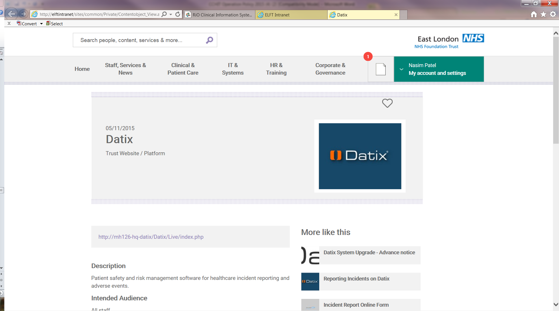

Click on the hyperlink
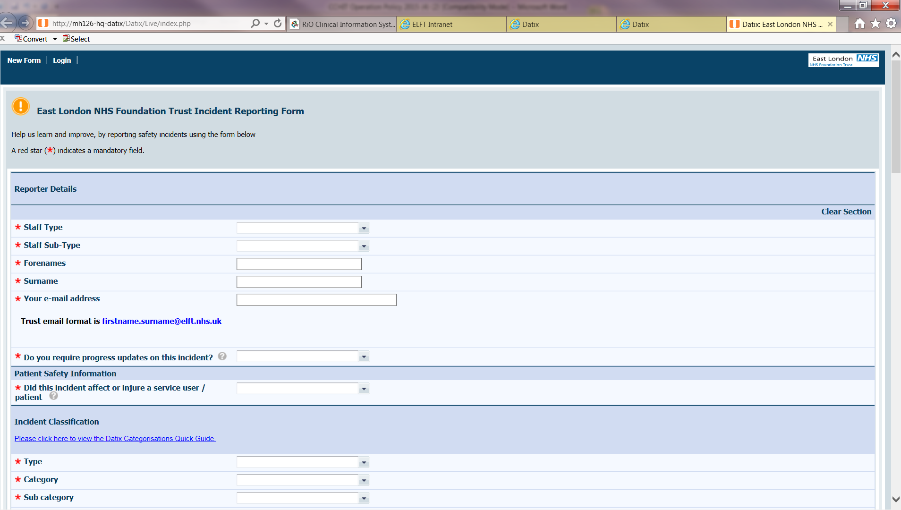
Complete the necessary fields
18.4 Step by step procedure on information to complete on the Datix Form
- Staff type: support staff (clinical & administration)
- Staff sub-type: administration/clerical/reception staff
- Forename: person completing the form
- Surname: person completing the form
- Email address: person completing the form
- Progress update: yes
- Did the incident affect or injure service use/patient: this depend on the incident
- Type: Death
- Category: Death of a child
- Sub category: depending on the situation but the most used is unexpected – cause known
- Outcome: Death
- Person harm: Expected death but this depend on the situation
- Date of the incident
- Time of the incident
- Directorate: Specialist Services and CHN Children’s Services
- Service Type: Community Health – Children & Young People
- Service: Child Health Admin Team
- Site of the incident:
- Exact Location:
- Events leading up to the incident: this will be from the death notification
- Does the incident have safeguarding adult implications: No
- Does the incident have safeguarding children implications: Yes
- Complete child details in the contacts section
- Choose the reporting Manager
- Save and submit

Other mandatory information must be completed within the form but the above are the main crucial points.

19.0 Neo-Natal Hepatitis B Programme

19.1 Purpose and scope
To ensure that appropriate receipt, and follow up of information received from maternity units and London Health Protection Team for all antenatal hepatitis B positive women are transported to the London Platform and fed into the hubs. This data will be forwarded to the health visitor admin team for uploading onto RiO. using the data upload tool. Also it is to ensure that immunisation follow up with GP practices for new born babies within Newham is maintained by the hub.

19.2 Definitions and abbreviations

Hepatitis B is a virus that infects the liver. Many people with hepatitis B will show no sign of illness, but can be carriers and may infect others. The virus is spread by having sex with an infected person without using a condom, and by direct contact with infected blood. If a person has hepatitis B or are infected during pregnancy, they can pass the infection on to their baby at birth.
All pregnant women are offered a blood test for hepatitis B as part of their antenatal care. Babies who are at risk should be given the hepatitis B immunisation at birth to prevent infection and serious liver disease later on in life. Immunisation at birth is 90-95% effective in preventing babies developing long-term hepatitis B infection. The first dose is given within 24 hours of birth. Two more doses are given at one and two months, with a booster dose at 12 months. A few babies may also need an injection of antibodies called immunoglobulin soon after birth.

The London Health Protection Team receives quarterly reports from the London Field Epidemiology Team which draws information from the Enhanced Surveillance of Antenatal Hepatitis B programme (ESAHB). ESAHB data is submitted by the antenatal screening coordinators from each London maternity unit.

Since August 2016 Vaccination UK is the provider to ensure that Hep B dose 2, 3, pre-booster 4 and Serology is completed by their clinicians. This responsibility will be transferred to Primary Care and GP’s will be responsible in ensuring that ELFT informatics receives the information to upload onto RiO so that the hubs are able to request information and act as a failsafe.

Neonatal dose 1 is the responsibility of the Screening Team within Maternity and this should be completed within 24 hours of babies’ birth.

It is the responsibility of the health visiting team / admin to ensure that the 1st dose is recorded onto the system and that the health visitors are aware of the mother and baby status.

*Please refer to page 10, 11 and 12 on how to record neonatal Hep B on mother and baby*

20.0 Education Health Care Plan (EHCP)
Stage 1 – Initial request (4 week timeframe)

Administrator receives the first request i.e.
letter 1 & form 1 from the local authority email (newham.gov.uk) to the generic EHCP email address (ehc@elft.nhs.uk)

If any papers are received by post, the EHC administrator should email the caseworker noted on the papers and request that only electronic papers are used as part of this process. Papers received by post will no longer be accepted.

Administrator to check on RiO for both open referrals and those closed within the last year. The check should cover any team e.g. CDS/ S&L/ Diana/ Physio/OT/LD/CAMHS.

CHILD IS KNOWN

If the child is known, the administrator should forward a copy of letter 1 & form 1 to each of the relevant dedicated/ generic email addresses for those teams and cc the local authority APC (Assessment and Placement Caseworker).

EHC administrator to add relevant lines to request 1 on the EHCP spreadsheet and this will create a ‘4 weeks waiting time alert’ from when the request was received to when a response has to be forwarded to the caseworker.

The clinicians should complete and return the part 1 form within 5 working days. EHC will monitor EHC log for timescales and prompt team and Team Lead, if necessary.

The EHC administrator will forward part 1 form(s) and reports (within the last 12 months) to the caseworker (edu@newham.gov.uk) . Date to be added to the EHC log, to close part one request.

CHILD NOT KNOWN

EHC administrator will complete part 1 advising that child is not known to services.

Date to be added to the EHC log, to close part one request.
Stage 2 – Assessment (6 week timeframe)

LBN will forward an update email to ehc@elft.nhs.uk

If an assessment is not required the case will be closed on the spreadsheet.

If confirmation is received that an assessment should be processed the EHC administrator will receive letter 2 & form 2

CHILD IS KNOWN

EHC administrator will forward letter 2 & form 2 to the relevant teams at the dedicated/ generic email addresses and cc the local authority APC (edu@newham.gov.uk) , adding this to the EHC log.

This will create a ‘6 weeks waiting time alert’ from when the request was received to when a response has to be returned to the caseworker.

- Clinicians to complete the assessment that is included on RiO under editable letters and return typed report to the EHC administrator.
- EHC administrator to upload report to the RiO record
- EHC administrator to add date to the EHC log and close request.

CHILD NOT KNOWN

If the child is not known/or has not been seen within 1 year, then the EHC administrator will create a new referral on RiO for Child Health Doctors and appointment the child into the next available clinic.
- venue to be arranged for children to be seen and to contact the parent to confirm availability for the appointed date
- Select clinic appointment on RiO and under the drop down list choose either: CHD: special needs clinic – Appleby or Lord Lister or West ham Lane
- EHC administrator to appoint at an available slot on RiO referring to the doctor’s rota
- EHC administrator to inform the doctor of the appointed children
- EHC administrator to send the appointment letter to the parent

Part 1 – Request for information timeline: four weeks

Upon receipt of any paper request, EHC administrator should email caseworker to advise that only electronic requests accepted.
EHC Administrator picks up SEN EHC request from ehc@elft.nhs.uk

Is the child known to any service (either current open referral or referral discharged within 12 months).

Yes No

Administrator to respond to SEN stating child not known.
Administrator to send part 1 to service(s) nhs.net accounts (cc the caseworker) and request completion within 5 working days. Request added on EHC log.

Administrator to add to EHC log and close off request.
Clinician to complete part 1 and return to administrator (ehc@elft.nhs.uk)

Administrator to forward completed part 1 and all available reports to SEN caseworker. If child not yet assessed/report available, part 1 form(s) only to be returned.

Completed part 1 to be uploaded to RiO

Administrator to log/close of request on EHC log.

Part 2 - Request for assessment timeline: six weeks

Upon receipt of any paper request, EHC administrator should email caseworker to advise that only electronic requests accepted.
EHC Administrator picks up SEN EHC request from ehc@elft.nhs.uk

Is the child known to any service (either current open referral or referral discharged within 12 months).
No

Administrator to send part 2 to service(s) nhs.net accounts (cc the caseworker) and request completion within 10 working days. Request added on EHC log.
Child will need to be seen by a Community Paediatrician

Yes

Referral to be opened on RiO – Child Health Doctors. Child to be booked for appointment on next available slot.

Clinician to complete part 2 (outcomes) and return to administrator (ehc@elft.nhs.uk)

Appointment letter to be sent by EHC administrator

Paediatrician to complete EHC form (paediatrician version) at appointment and return to EHC administrator
Administrator to forward completed part 2 SEN caseworker.

Part 2 to be uploaded to RiO.
EHC administrator to return form to SEN caseworker

Administrator to log/close of request on EHC log.
Administrator to log/close of request on EHC log.

Ad-hoc requests/letters

Requests received by post
We do not accept any paper requests. The caseworker (details on the letter), should be emailed and advised that only electronic requests are accepted. Duplicate papers should not be sent as we are a paperless service.

Review letter/Conversion of statement to EHC
EHC administrator to upload letter to RiO and email all teams involved in care of the child/YP to notify them of details.

Completed Report
Upload (scan and upload) to RiO.
Email all teams involved in care of the child/YP to notify them of completion.

21. Subject Access procedure:

- Request for access to medical records’ is sent to Information Governance by Solicitor, Parent or Social Care
- Information Governance will send the appropriate request to the ‘Access to Records Lead’ to co-ordinate the process and ensure the disclosure is made within the relevant timescale (21 days of receipt of request)
- Proof of identify, authority and consent must be obtained prior to disclosing copies of records. The consent must have been provided and signed within the last 3 months with proof of address within the last 3 months.
- If there is no consent, proof within the last 3 months, or ID , contact the requester and request for the appropriate ID proof and forward a copy of ELFT ‘request for access to person identifiable records form (the clock does not start until identification has been confirmed)
- Inform the Solicitor that they will incurred a £50 payment before release of records (no payment for parent or social care)
- Inform Information Governance and make a note on the spreadsheet tracker to avoid breaching.
- Once all relevant documents have been provided make an appointment with a Lead Clinician to peruse the record. (Sarah Rolfe, Evangelia Theochari-Boateng or Agnes Adentan

- Access to Records Lead will print all documents requested removing third party documents and attach the completed ‘request for access form signed by requester.
- Lead clinician will hand the perused record and signed form to the Access Record Lead, who will post the records via recorded delivery.
- Contact the requester that the record has been posted and upload the original request letter on RiO and make a note on the progress note date the record was delivered.
- Update spreadsheet and save (currently will be on the N drive but move to the K drive under ‘Subject Access’
- File the requester original letter and copy of the signed consent form in the red folder kept in room 17
- Every quarter Information Governance Lead will request figures for all requests for Children Service records.

Intended Litigation:

- Solicitors must confirm if litigation is intended against the Trust.
- Head of Information Governance must always be notified be ‘Access Record Lead’.
- Head of Information Governance must be notified within 5 days of receipt of request and before any documents are released.

Important information:

- All requests must be in writing.
- Appropriate consent and ID must be obtained prior to releasing records.
- ‘Access to Record Lead’ must co-ordinate the subject access process.
- The Responsible Clinician must make the decision to refuse access to records. This must be clearly documented in the records.
- Care must be taken that third party information is not inadvertently released.

Fees:

Request made via e.g. Solicitors, insurance companies are charged £50
Records must not be released until payment has been received.
Note: clock stops between the date an applicant is advised of the charge and the date payment is received

No charges:
Request made whilst a parent or young person is pursuing a complaint through the NHS Complaints Procedure
Personal representatives accessing records of deceased people.

22. How to winzip folders

Stage 1

Create the clients folder(s) and download the relevant documentations from RiO into the
appropriate folder.

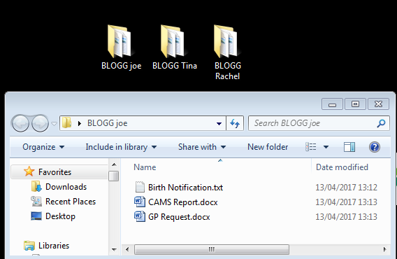

Stage 2
Right click and create a new WINZIP folder
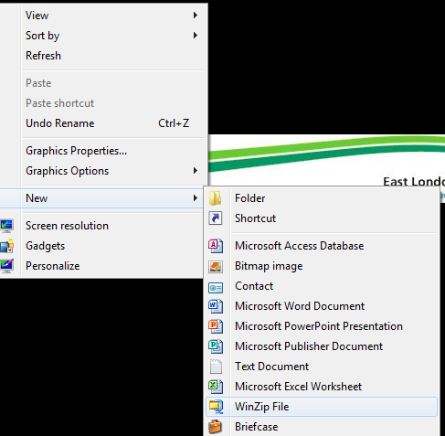

Stage 3
Name the folder accordingly
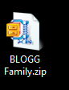
Stage 4
Copy and paste the folders in the WINZIP

Stage 5

Email the WINZIP to the relevant HCP

23. Updating RiO with revised Pupil Census information

- Each term the London Borough of Newham makes updated information available on which pupils are attending which schools in Newham
- The report is sent to ELFT in the form of a spreadsheet which includes all children at Newham schools
- The report is available from Faizel.Ahmed@newham.gov.uk and is uploaded to a USO account (staff in the Child Health Information Team have a USO account)
- When Faizel has uploaded the report he will send an access code to a mobile phone number. He will confirm the phone number with the recipient beforehand
- The nominated recipient will access their USO account and download the spreadsheet
- Once saved on the ELFT network, forward to XXXXXXXXXXXX for upload to RiO

24. Abbreviations:

MTP - monthly team planner
FNP - family nursing partnership
A &E - accident & emergency
URL - uniform resource locator (addresses various resources on the internet)
EPR - electronic patient record
SCR - summary care record (electronic patient record)
UPP - universal partnership plus
NBV - new birth visit
Hep B - hepatitis B
CHIS - child health information service
LA - local authority
CSV - comma separated value (simple file format used to store tabular data such
as a spreadsheet and expand from other programs)
PDS - personal demographic service (national electronic database of NHS patient
details)
HUB – historically underutilized business

