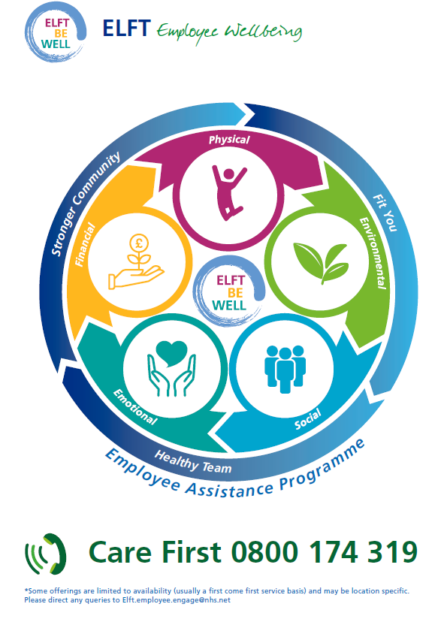

ELFT WELLBEING SUPPORT RESOURCES
ELFT’s Employee Assistance Programme is an anonymous call line directed to external registered counsellors and advisors who are available 24/7. The service is not only for emergency counselling, it can be used to gain advice on almost any aspect of life, from landlord issues to holiday bookings. Please reach out for confidential assistance on 0800 174 319 or by logging in online www.carefirst-lifestyle.co.uk : Username: ELFT; Password: employee
Emotional Wellbeing
Internal Support | ELFT’s Emotional Support Call-Back Service - can be accessed by emailing elft.communications@nhs.net
KeepingwellNEL & Keepingwell BLMK - Need to talk to someone or access help/support during the Pandemic?
If you work in London, you can visit - https://keepingwellnel.nhs.uk wellbeing platform for real-time support, signposting and fast-tracked referral where requested, to other support services. The service is provided by ELFT & NELFT. Visit the website to find out more about how the service could help you.

If you work in Luton and Bedfordshire, there is free fast psychological support for staff. Keeping Well BLMK is a confidential psychological support service run by care professionals for care professionals in Bedfordshire, Luton and Milton Keynes. You can get help quickly by phone: 01908 724227 or online: – https://keepingwellblmk.nhs.uk
 | Occupational Health - can be contacted on 01327 810777 or email: elft@teamprevent.co.uk
 | IAPT/Talking Therapies Services - staff who refer themselves to IAPT services run by ELFT will be given priority so make it known that you are a member of staff.
Bullying & Harassment Advisors -have you ever felt the need to talk to someone about how a colleague or manager is treating you? Do you feel you are undermined at work? Do you dread going to work because of how someone treats you? Do you find yourself trying to cope with unwanted behaviour? For further information please click on link:
https://elftintranet/sites/common/Private/Contentobject_View.aspx?id=29918
Freedom to Speak up - the freedom to speak up team is here to listen speaking up about any concern you have at work is really important. in fact, it’s vital because it will help us to keep improving our services for all patients as well as the working environment for our staff. For further information please click on link:
https://elftintranet/sites/common/Private/Contentobject_View.aspx?id=62168
External Support | Download the Woebot App to help reduce stress, combat isolation and offer supportive techniques
 | Silver Cloud is free to access for all staff to a CBT online platform by using the access code: NHS2020 https://www.silvercloudhealth.com/uk
 | Suicide Support (National Suicide Prevention Helpline UK) - offers a supportive listening service to anyone with thoughts of suicide. You can call the National Suicide Prevention Helpline UK on 0800 689 5652 (open 24/7)
NHS England & Improvement staff support line - NHSEI has a confidential staff support line, operated by the Samaritans and free to access from 7:00am – 11:00pm, seven days a week.
This support line is here for when staff have had a tough day, are feeling worried or overwhelmed. Whatever your worries, trained advisers can help with signposting and confidential listening.
Call: 08000696222
Alternatively, you can text FRONTLINE to 85258 for support24/7 via text
NHS England & Improvement bereavement support line - NHSEI has a confidential bereavement support line, operated by Hospice UK and free to access 8.00am and 8.00pm, seven days a week.
A team of fully qualified and trained bereavement specialists are available to support with bereavement and wellbeing issues relating to loss experienced through work. Call: 03003034434
Bright Sky App - Providing support and information for anyone who may be in an abusive relationship or those concerned about someone they know.
The app is also available to use in Polish, Punjabi and Urdu.
For more information, please see details and advice about using the app in your app store:
Bright Sky in Apple Store
Bright Sky in Google Play
 | Domestic abuse support - please contact a helpline such as Refuge: 0808 2000 247 or visit https://www.refuge.org.uk/
 | Headspace - provides mindfulness and mediation tools. Free for NHS staff. www.headspace.com/nhs (free access has been extended to 31/12/22)
 | Sleepio - is a personalised sleep improvement programme. Free for NHS staff https://www.nhs.uk/apps-library/sleepio/
 | NHS in Mind - is a free platform containing interventions to help combat high anxiety, panic and fatigue https://www.nhsinmind.co.uk/
 | Together In Mind - are podcasts and resources that support wellbeing of NHS staff during this difficult time https://togetherinmind.nhs.uk/
 | Ten Percent Happier - is free for six-months and offers meditation and mindfulness guidance https://www.tenpercent.com/care
 | Samaritans - Samaritans works to make sure there’s always someone there for anyone who needs someone. If you would like to contact a Samaritan, please call 116 123 for free 24/7 emotional support, there is also a free web chat service which can be accessed on www.samaritans.org
 | ​The “Going Home Checklist” - from Mind can help staff switch off from work https://people.nhs.uk/clinical/going-home-checklist/
 | Good Thinking - provides free wellbeing support and has been updated in response to COVID-19 https://www.good-thinking.uk/
Financial Wellbeing
Internal Support | ELFT Hardship Fund - provides financial support to help when it is most needed details can be found on the Trust intranet: http://elftintranet/sites/common/Private/Contentobject_View.aspx?id=62266
 | Salad Money Mind - if you’re struggling with managing your finances and you need some support, salad money mind is the place to go. Please click link for further information: https://elftintranet/sites/common/Private/Contentobject_View.aspx?id=65931
Home Technology Benefits Scheme - The Trust has introduced a scheme to enable you to spread the cost of technological purchases by deducting monthly amounts from your salary, details can be found on the Trust intranet:
http://elftintranet/sites/common/Private/Contentobject_View.aspx?id=60257

 | Holiday Play Schemes - The Trust offers a 40% subsidy towards the cost of Holiday Play Schemes during school holidays, please application form below:
 | The Credit Union is a long established savings and loans co-operative that encourages people to save rather than borrow. Thousands of employees across London and surrounding region already take advantage of a payroll savings scheme which allows you to have your savings, or loan repayments, deducted directly from your salary. Further information can be found on the Trust intranet. http://elftintranet/sites/common/Private/Contentobject_View.aspx?id=41101
 | ELFT has joined the ‘Working with’ Cavell Nurses’ Trust membership programme. The Cavell Nurses’ Trust supports UK nurses, midwives and healthcare assistants both working and retired when they’re suffering personal or financial hardship, often due to illness, disability, older age and domestic abuse. Further information can be found on the Trust intranet. http://elftintranet/sites/common/Private/Contentobject_View.aspx?id=58572
Busy Bees Childcare - offers care for children age 4 and over with free registration for NHS staff https://www.busybeeschildcare.co.uk/
(This offer depends on each nursery and whether they accept the NHS Blue Light Card so please ask the nursery near you).
 | SearchChildcare - offers information, advice and support on registered childminders https://searchchildcare.org.uk
 | London Koru Kids - provides help to find part time and after school nannies. www.korukids.co.uk
Physical Wellbeing
Internal Support | ELFT’s wellbeing winter fitness platform provides a weekly programme where sessions are held via zoom for further information please see document attached:
 | Flu Vaccines - if you’re looking to get a flu jab please contact elft.fluleadquries2021@nhs.net
 | Cycle to work scheme - allows you to purchase a bike through salary deduction making savings on Tax & NI contributions, for further details please visit www.vivup.co.uk
 | Eye Care vouchers - further information can be found on the Trust intranet http://elftintranet/sites/common/Private/Contentobject_View.aspx?id=28741
 | Menopause guidance - for further information on how we approach the Menopause, please see attached guidance:
Smoking cessation - Are you getting serious about giving up smoking? You may notice the trust’s new no smoking posters are in position. these are being complemented by leaflets which are available in all areas, if you would like to quit then please contact
o.anokwuru1@nhs.net for further information.
 | MOT Health Checks – these checks take place throughout the year in each directorate, we will aim to run more clinics in 2022, so please do look out for the adverts in the ELFT bulletins.
External Support | Gym Membership – All NHS staff are entitled to an NHS corporate discount when you show your NHS ID badge to any local leisure centre/gym
Yoga classes are run every Monday at 5:30 pm via Zoom. https://elftintranet/sites/common/Private/Contentobject_View.aspx?id=65990
If you have any questions regarding content please email ailon@lotus-exchange.com
Social Wellbeing
Internal Support | ELFT Networks - If you are interested in finding out further information regarding the following networks, BAME, ELFT Ability, Intergenerational, LGBTQ or Women’s network please make contact with the relevant leads:
 | COVID Support Social Group - We warmly welcome staff to join. This session is for staff who were shielding during the pandemic and anyone else who wishes to join us. We offer space for a safe evening of sharing stories and experiences, and to learn from each other. Monthly COVID Support Socials take place on the 4th Wednesday of each Month from 5.00pm to 6.00pm. For more information, please contact Mohit Venkataram mohit.venkataram@nhs.net
Long-Covid Support Groups – at ELFT there are various support groups available to our staff affected by Long-Covid. There is a monthly support group that meets on the first Friday of each month at 9:30am on Zoom, an informal Weekly catch up each Monday at 10am and a NELFT/ELFT Doctors Support Group that meets bi-weekly Friday at 4pm on Zoom.
Contact Donna Willis on d.willis1@nhs.net for the invites for the groups.
 | ELFT in1Voice is chance for you to be part of the Trust Choir, further information can be found on the Trust intranet http://elftintranet/sites/common/Private/Contentobject_View.aspx?id=59558
Annual Staff Awards – Would you like to see what the staff awards event looks like, which will hopefully encourage you to nominate and individual or team or even book tickets for next year’s event in 2022, if so please click link below:
https://elftintranet/sites/common/Private/Contentobject_View.aspx?id=65743
External Support | There are many methods to stay connected with others such as Zoom, which is a free and easy to use video chat https://zoom.us/download
 | Spotify can help you create collaborative playlists with friends and listening to podcasts just download the app https://www.spotify.com/
Environment Wellbeing
Internal Support | War on Waste – make a difference and turn it off to support the war on waste campaign http://elftintranet/sites/common/Private/Contentobject_View.aspx?id=48315
 | Display Screen Equipment Risk Assessments - further information can be found on the Trust intranet http://elftintranet/sites/common/Private/Contentobject_View.aspx?id=28633
 | The Green Travel Plan initiative - As part of the Trust’s ambition to operate more sustainably with the Green ELFT Campaign, a Green Travel Plan has been created. This will play a large part in helping the Trust achieve its carbon commitments of 80% co2 reduction by 2050. http://elftintranet/sites/common/Private/Contentobject_View.aspx?id=60562
*Covid risk assessments

