How to add users to Active Directory which allows access to the Hybrid Mail Service.
Click on start then computer
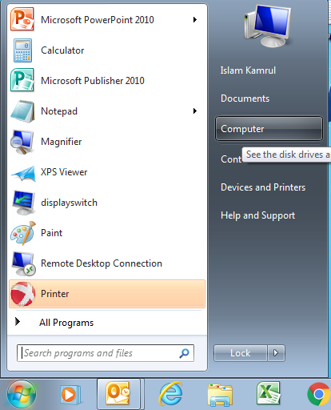
Click on network
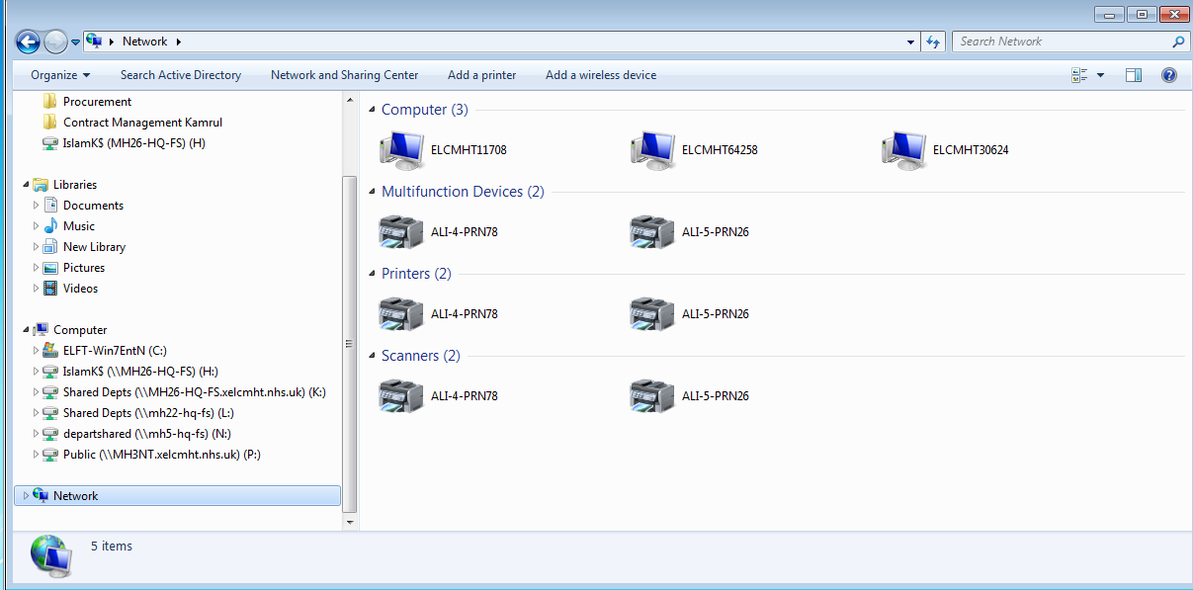
Click on ‘search active directory’
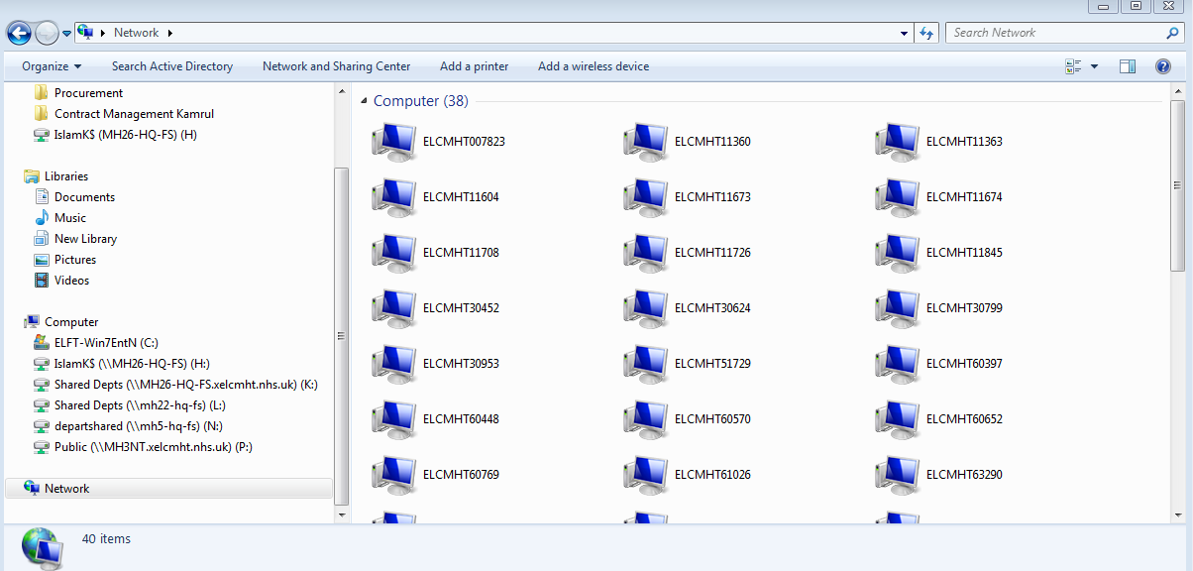

Search Software_Install_Xerox_Funasset, double click on the searched item
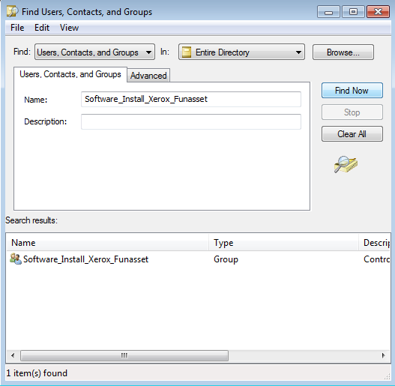
Click on Add
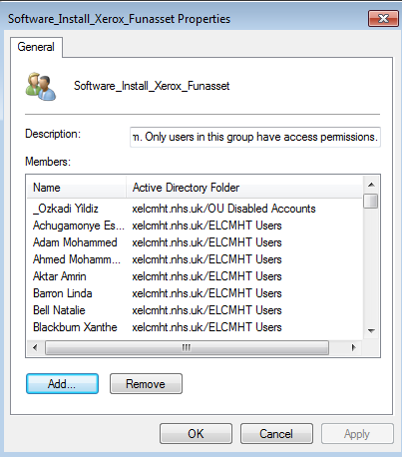
Type the users last name and click ok
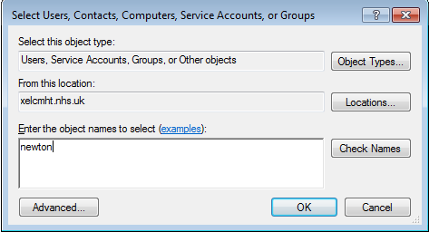

Find the user, highlight and click ok
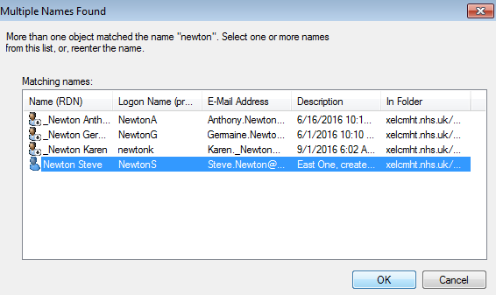

How to add users to group and how to create new group
Go to Hybridmail web portal http://10.142.160.201/Login.aspx
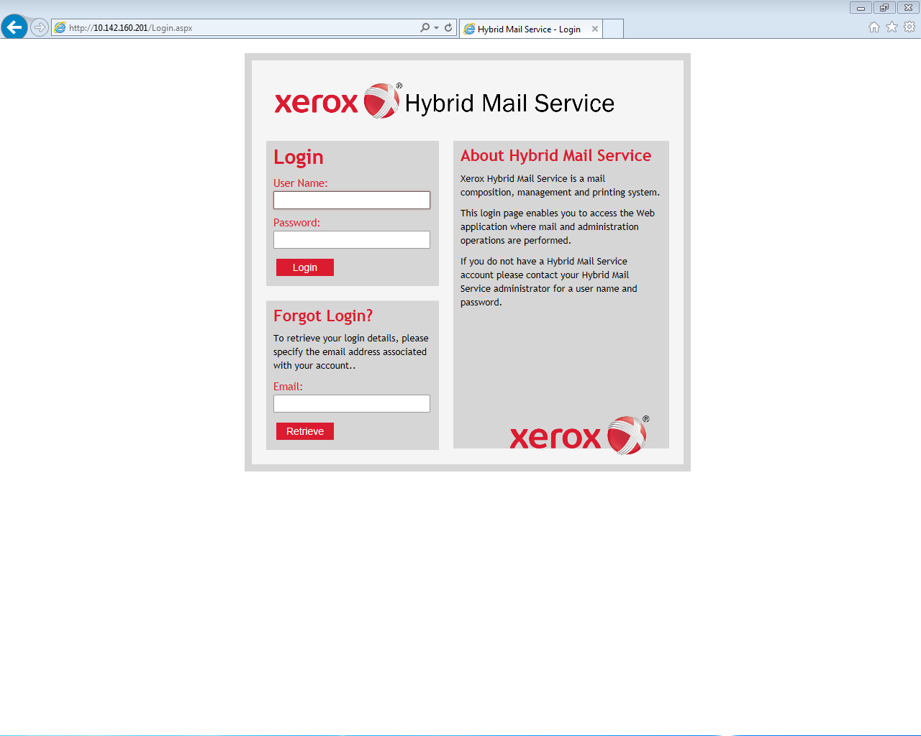
Once logged in by clicking on login, click on the admin tab and scroll down to groups
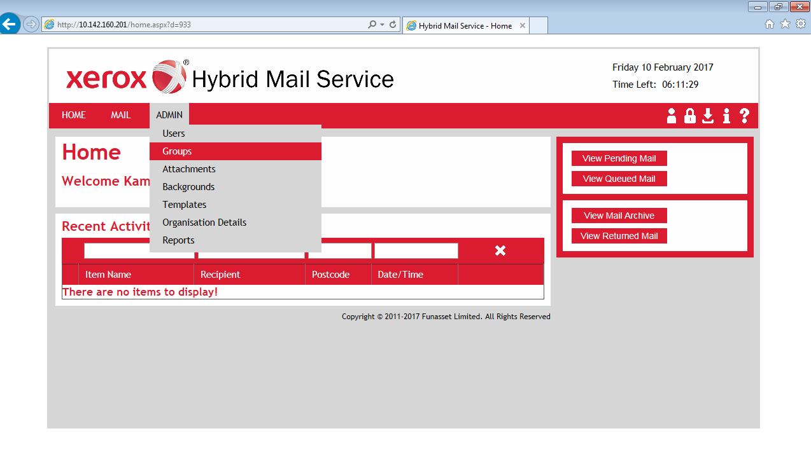
Click on ‘add new group’
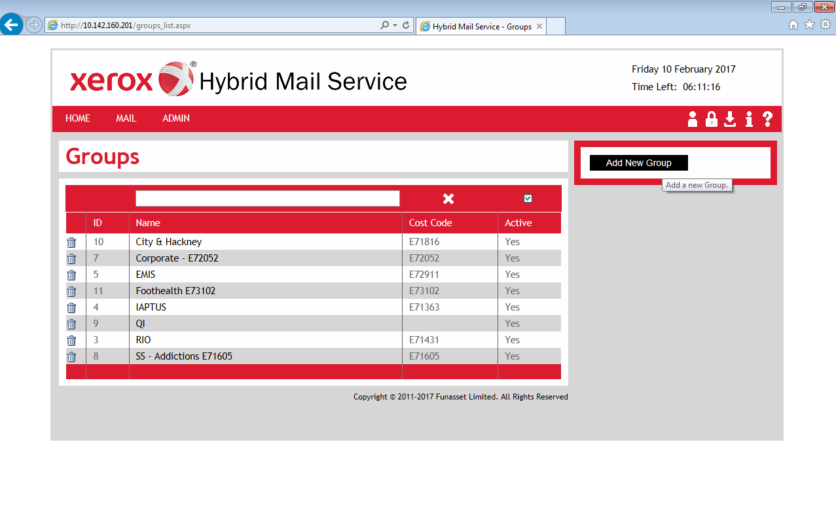
Type the relevant details such as service name and cost code and click save:
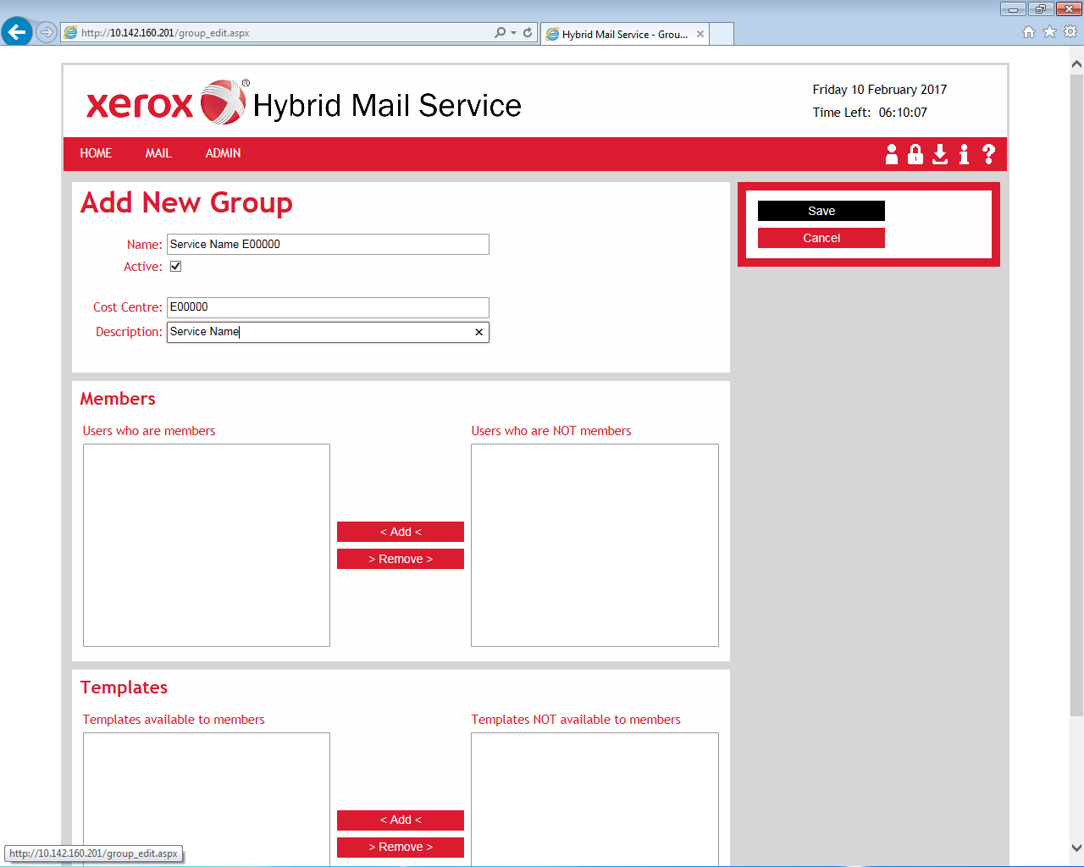
You will be able to see the group in the list below:
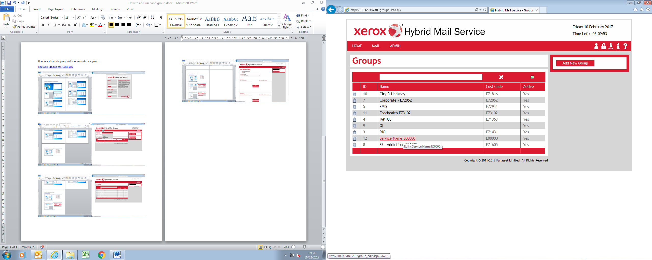

To add users to the group:
Click on the group you want to add users to:
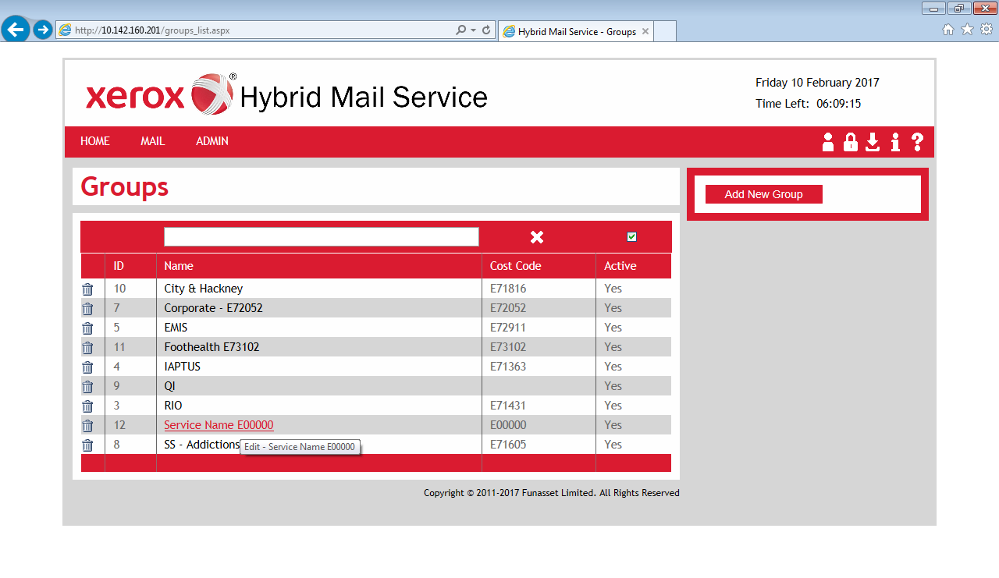
Find the user in the ‘users who are NOT members’ list
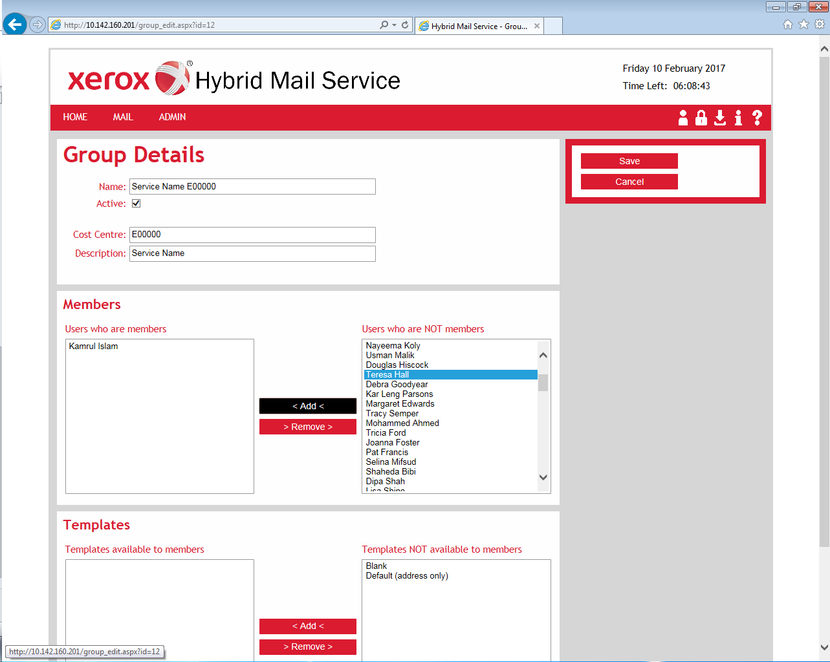

Click on the user, click on add and then click on save:
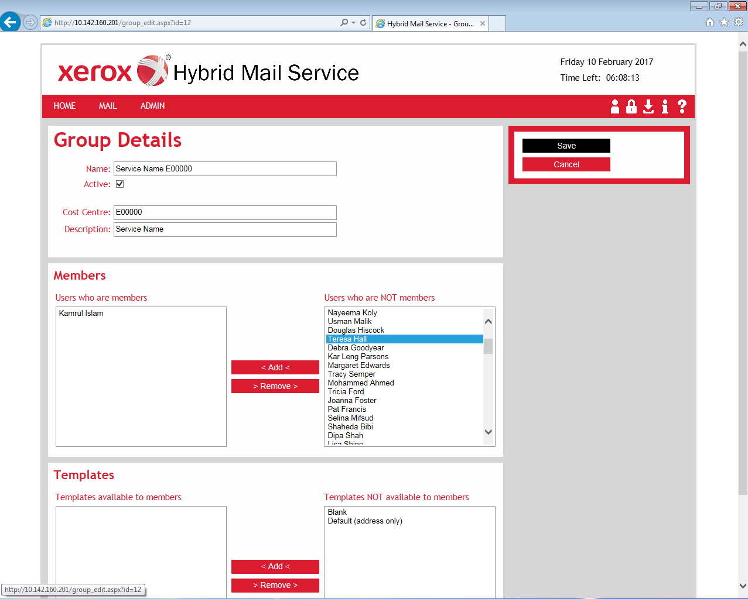
1
2
3

