ORDERING CODES | 7TH JUNE 2020
Medical Emergency green bag content list (pictures)
ITEM : | QTY: | IMAGE : | LOCATION:
Automated External Defibrillator and Pads  X | 1 | 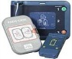 | Front Pouch
Spare Defibrillator Pads 11101-000021 | 1
Spare Battery NHS supplies & Oracle FDJ8195 | 1
Blood Pressure Monitor  NHS supplies & Oracle FFE572  X | 1 | 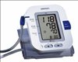 | Front Pouch
Blood Glucose Monitor = caresens  Supplied by Sprit Healthcare  Telephone = 0800 881 5423  Test strips & Test liquids from ELFT Pharmacy  X | 1 | 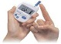 | Front Pouch
Finger Tip Pulse Oximeter  NHS supplies & Oracle FBC323  X | 1 | 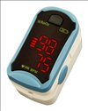 | Front Pouch
Stethoscope  NHS supplies & Oracle FFE1013  X | 1 | 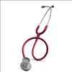 | Front Pouch
Oxygen CD Cylinder  Order from BOC  Telephone number is on each bottle  X | 1 | 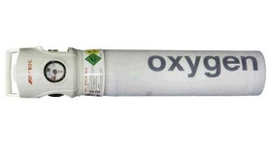 | Bottom compartment
Bag Valve Mask (Adult) with oxygen tubing  NHS supplies & Oracle FDE379 | 1 | 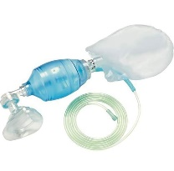 | Bottom Compartment
Non Re-breathe oxygen mask (adult) with tubing  NHS supplies only ask Balbir to add to Oracle catalogue FDQ 3513 | 1 | 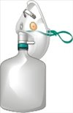 | Bottom Compartment
Pocket Mask (Adult)  NHS supplies & Oracle IHD9475 | 1 | 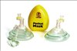 | Airway Compartment
Nebuliser Mask (Adult) with nebule pot and tubing  NHS supplies & Oracle FDE305 | 1 | 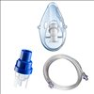 | Bottom Compartment
Compact portable suction  MEDISAVE = £128.12 (not on oracle or NHS supplies )  X | 1 | 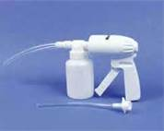 | Airway Compartment
Rigid adult suction catheter Yankauer)FSQ  NHS supplies | 1 | 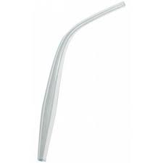 | Airway Compartment
Oropharyngeal Airway (Guedel) Size 2 green  NHS supplies & Oracle FDB567  Or NHS supplies & Oracle FDB316 | 1 | 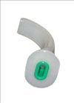 | Airway Compartment
Oropharyngeal Airway (Guedel) Size 3 orange  NHS supplies only ask Balbir to add to Oracle catalogue  FDB568  Or NHS supplies & Oracle FDB317 | 1 | 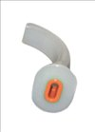 | Airway Compartment
Oropharyngeal Airway (Guedel) Size 4 red  NHS supplies only ask Balbir to add to Oracle catalogue  FDB569  Or NHS supplies & Oracle FDB318 | 1 | 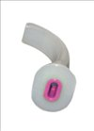 | Airway Compartment
Nasopharyngeal Airway Size 6  NHS supplies only ask Balbir to add to Oracle catalogue  FDB590 | 1 | 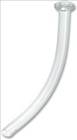 | Airway Compartment
Nasopharyngeal Airway Size 7  NHS supplies only ask Balbir to add to Oracle catalogue  FDB592 | 1 |  | Airway Compartment
i-gel (supraglottic airway) size 3  NHS supplies & Oracle FDD984 | 1 | 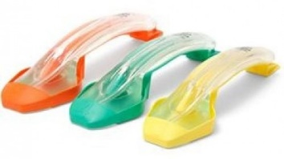 | Airway Compartment
i-gel (supraglottic airway) size 4  NHS supplies & Oracle FDD985 | 1 |  | Airway Compartment
i-gel (supraglottic airway) size 5  NHS supplies & Oracle FDD1057 | 1 |  | Airway Compartment
Lubricant for i-gel  Pharmacy? | 1 | 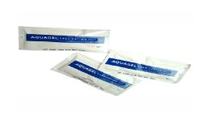 | Airway Compartment
McGills Forceps  Medisave = instrapac instrapac magills forceps adult 9.8 disposable (7992) £5.71 | 1 | 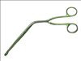 | Airway Compartment
Intravenous Cannula size 18G (green)  NHS supplies & Oracle FSP2152 | 2 | 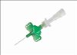 | Circulation Compartment
Intravenous Cannula size 16G (grey)  NHS supplies & Oracle FSP2151 | 2 | 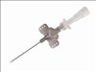 | Circulation Compartment
Intravenous Cannula size 14G (orange)  NHS supplies & Oracle FSP2150 | 2 | 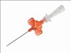 | Circulation Compartment
3 way tap with extension  NHS supplies & Oracle FVK840 | 2 | 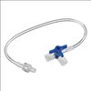 | Circulation Compartment
Intravenous Cannula Dressing  NHS supplies & Oracle EVX155 | 2 | 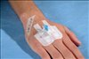 | Bottom Compartment
Micropore Tape  NHS supplies & Oracle EHU111  X | 1 | 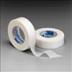 | Bottom Compartment
Large Bore Intravenous Giving Set  NHS supplies & Oracle FKA348 | 2 | 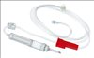 | Circulation Compartment
10ml syringe  NHS supplies & Oracle FCB13852 | 4 | 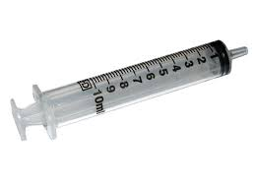 | Circulation Compartment
Prefilled syringe 10ml normal saline 0.9% flush  NHS supplies & Oracle FWC130 | 4 | 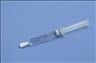 | Circulation Compartment
Tourniquet  Medisave – 2x20 £39.90  THESE MUST BE SINGLE USE ONLY  X | 1 | 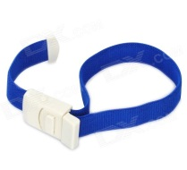 | Circulation Compartment
Chlorhexidine swabs  NHS supplies & Oracle VJT169  X | 10 | 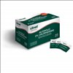 | Bottom Compartment
Normal Saline 0.9% - 1000ml bag  Order from ELFT Pharmacy  X | 1 | 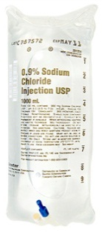 | Circulation Compart-ment
Tuff Cut Shears  Order from Farnell  X | 1 |  | Bottom Compartment
Ligature Cutters  Order from Farnell  X | 2 | 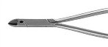 | Office
Ligature Cutters LC1  Order from Farnell  X | 2 | 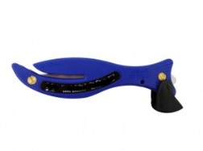 | Emergency Grab Bag
Gauze Swabs (pack of 10) sterile  NHS supplies & Oracle EMI283 | 1 | 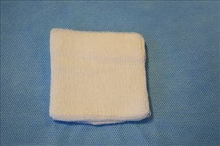 | Bottom Compartment
Medium sized wound dressing  Oracle | 1 | 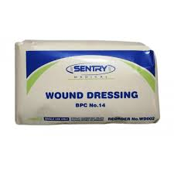 | Bottom Compartment
Burns dressing  NHS supplies & Oracle ELE059 | 1 | 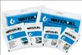 | Bottom Compartment
Non Sterile Gloves  NHS supplies & Oracle FTG026 (Medium)  NHS supplies & Oracle FTG027 (Large)  x | 6 pairs | 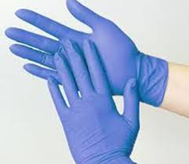 | Bottom Compartment
Non sterile Aprons  NHS supplies & Oracle KNB677  X | 6 | 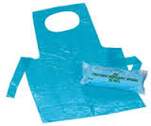 | Bottom Compartment
Goggles  NHS supplies only ask Balbir to add to Oracle catalogue ILH513  NHS supplies & Oracle ILH410 (not as good)  X | 6 | 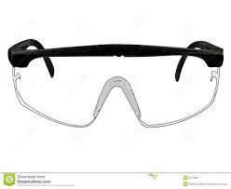 | Bottom Compartment
Red Metro Grab bagtag  Purchase from Metalcraft with PO (we have an account with them) £60 for a bag. | 1 | 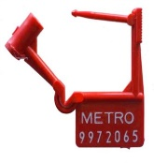 | Outside of bag

The tubing NHS Supply code has changed to FWP426 and I will ask for it to be added to the Oracle online catalogue but this can take a bit of time. It is possible to purchase 1 at £6.29 each, it is in stock

FDR147 Suction Liner Canisters 1 litre Blue lid for use with Laerdal Suction Unit on NHS supplies is in stock
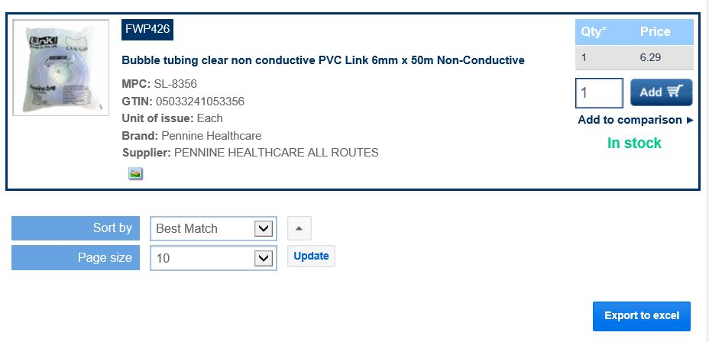
Receptor liner used with Laerdal suction inside of the cannister –
Liners Soft with Lids 1 litre standard Oval (for individual or cascade use) - FSE013

Suction Machine Checks

Suction Machine Checks
Equipment  Available | Date  Tested | Feedback/  Action | Staff signature

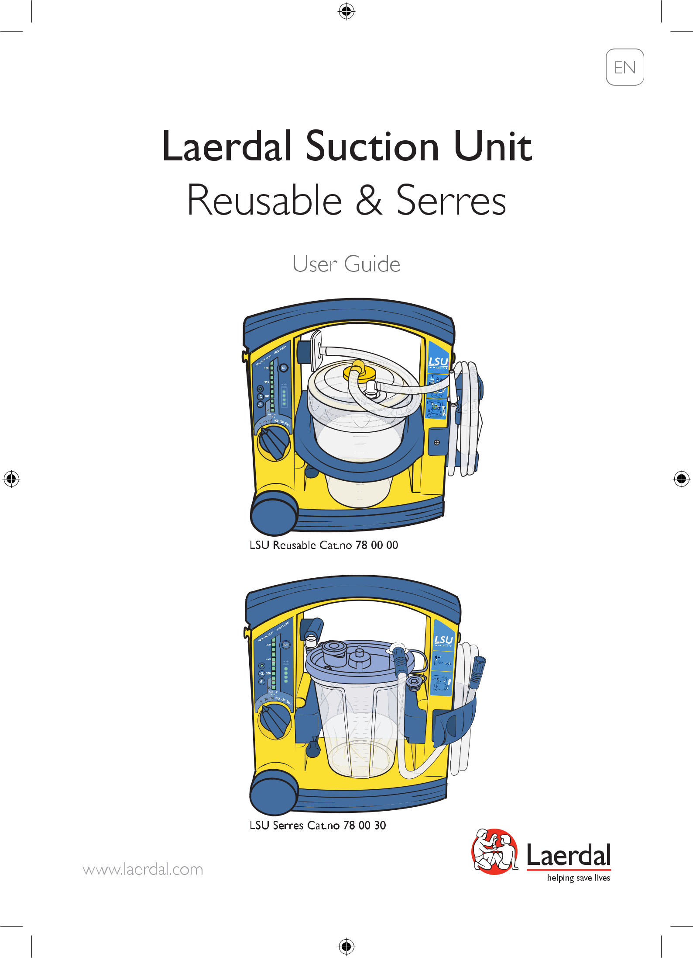

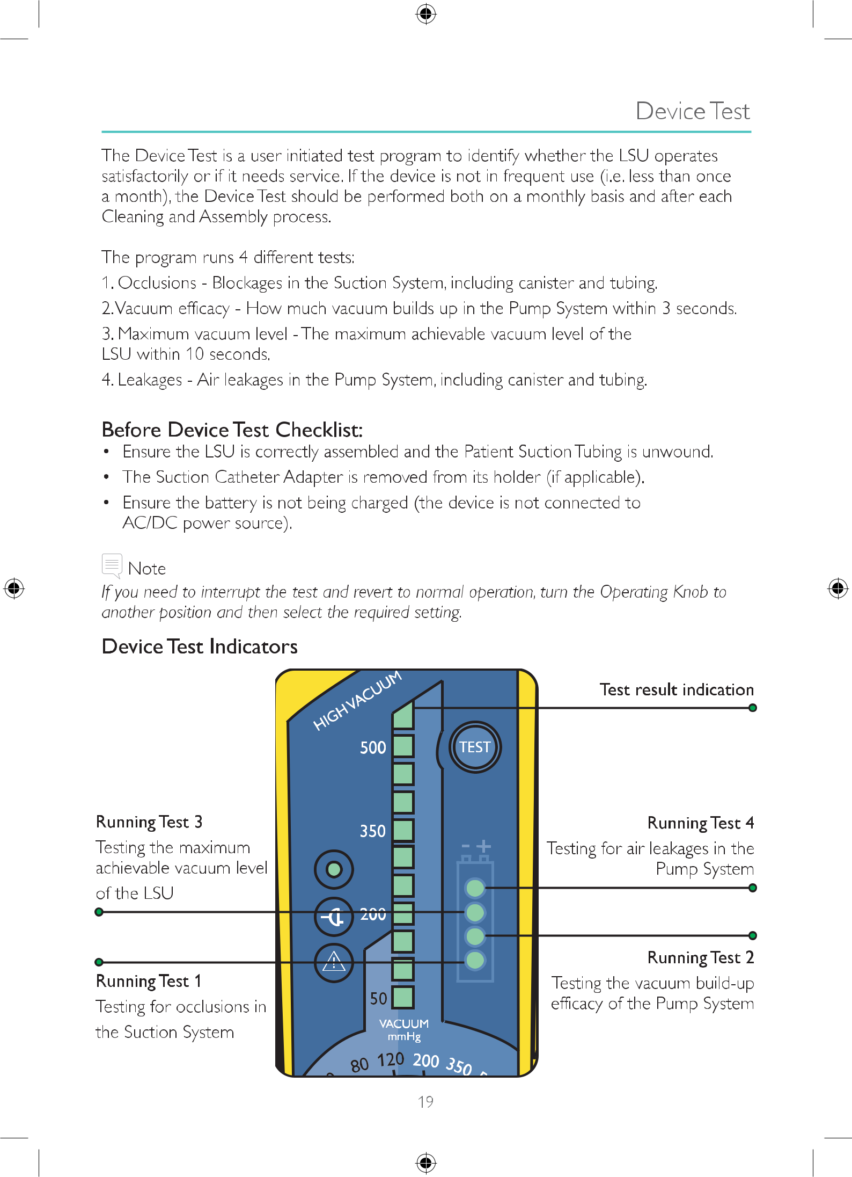

Device Test Guide
