https://drive.google.com/uc?id=0B15omt9LQpW5cFNQWVVhb3dsalU&export=download[](https://www.elft.nhs.uk/)

**Intensive Support Team**

**Drop In**

Services for People with a Learning Disability

**We have missed you!**

 **We are back!**

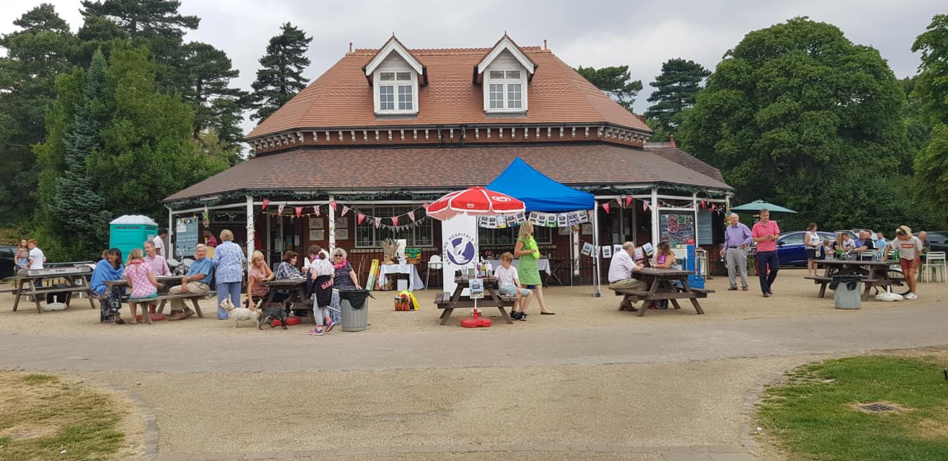

**Karaoke**

**Treasure Hunt**

**Chit chat**

**Snacks**

**Join us at The Pavilion**

**In Bedford Park**

**Thursday the 5th of May 5.30pm-7.30pm**

**Park Avenue, Bedford, MK41 7SS**

**For Further information, please contact**

**The Intensive Support Team on 01234 310538**

[cid:image005.png@01D2FA50.7DE1BF80](http://www.elft.nhs.uk/)