Nicotine Replacement Guidelines
(Guidelines on the prescribing, supply and administration of smoking cessation and nicotine replacement pharmacotherapy for patients and staff)

Version: | 3.0
Ratified by: | ELFT Medicines Committee
Date ratified: | January 2016 (version 3)
Name of originator/author: | James Innes, Deputy Chief Pharmacist  Shameem Mir, Chief Pharmacist  Veena Shivnath, Clinical Lead Pharmacist  Yvonne Wilson, Medicines Management Technician  Jennifer Melville, Deputy Chief Pharmacist
Name of responsible committee/individual: | ELFT Medicines Committee
Circulated to: | ELFT Medicines Committee  ELFT Smoke-free Implementation Group
Date issued: | May 2007 (version 1)  June 2010 (version 2)  January 2016 (version 3)
Next review date: | January 2019
Target audience: | ELFT staff

Version Control Summary

Version | Date | Author | Status | Comment
1.0 | May 2007 | James Innes | Final | -
2.0 | June 2010 | Veena Shivnath | Final | Nicotine patch strengths updated Nasal spray added as a treatment option. Updated to include combining NRT preparations and pre-loading.
3.0 | January 2016 | Jennifer Melville | Final | Update to:  Roles and responsibilities  Access to advisors  NRT what is available  Special patient groups  Access to NRT for patients and staff  Addition of nicotine oral spray  Supply of NRT under PGD – OT and training

Contents
Paragraph |  | Page
1 | Executive summary  Introduction
2 | Purpose
3 | Responsibilities
4 | Smoking cessation advisors
5 | Nicotine replacement therapy (NRT)
6 | Special patient groups
7 | Access to smoking cessation pharmacotherapy for patients and staff
8 | Effect of smoking cessation on drug metabolism
9 | Choice of NRT
10 | Supply of NRT
11 | Guidance on the use of Buproprion
12 | Guidance on the use of Varencicline
13 | Smoking cessation therapy on discharge
14 | References
Appendices
Appendix 1 | Supply of NRT to ELFT staff working on smokefree wards
Appendix 2 | Psychotropic drugs affected by smoking status (Maudsley, 12th Ed, page 688)

- Introduction

  - In 2006, the Health Act legislated that all enclosed public spaces become smokefree. Mental health trusts were to be compliant with the act by July 2008. ELFT complied with requirements; however service users as inpatients were still supported to smoke with smoking breaks and dedicated external garden areas.
  - ELFT will become a smokefree organisation by April 2017.
  - The ELFT smokefree nicotine management policy should be used alongside this guideline. This policy will include service users, visitors and members of staff.
  - Pharmacotherapy plays a vital role in enabling patients to maintain abstinence from tobacco products. These guidelines have been developed in line with NICE guidance and the following treatments may be used for the purposes of smoking cessation or nicotine maintenance therapy;
    - Nicotine Replacement Therapy - patches, inhalators, nasal spray, lozenges, film tab, and mouth spray.
    - Nicotine gum is not included because of security and health and safety risks
    - The use of e-cigarettes is bound by local policy, seek advice from your ward manager and/or borough lead nurse.
  - This guideline will not discuss the use of e-cigarettes. E-cigarettes will not be prescribed or supplied by ELFT. Directorates will have local procedures in place for Service users who use e-cigarettes.

- Purpose

  - This guideline covers the prescribing, supply and administration of NRT and smoking cessation pharmacotherapy
  - To ensure the safe and effective use of smoking cessation pharmacotherapy and nicotine maintenance in smokers.
  - To establish how smoking cessation pharmacotherapy and products for nicotine maintenance should be prescribed, issued and administered to patients on inpatient wards, under patient group direction (PGD) or at admission by prescriber.
  - To highlight the specific risks when stopping smoking cigarettes when prescribed certain psychiatric medicines and to explain how to manage this risk.

- Responsibilities

  - Doctors and non-medical prescribers
    - Prescribing NRT, buproprion and varenicline for service users for maintaining nicotine levels in inpatients and for those wanting to quit.
    - Reviewing and monitoring patients prescribed NRT including plasma level drug monitoring where appropriate
  - PGD authorised professionals (nurses, pharmacists and occupational therapists)
    - Authorising and administering NRT products under the Nicotine replacement therapy PGD.
  - Ward/team managers
      - Managing the NRT PGD for the ward/team
      - Managing the process for staff access to NRT on inpatient wards (appendix 1)

- Smoking cessation advisors

  - There are 3 levels of smoking cessation advisors. The trust will has access to level 1 and level 2 advisors.
  - Level 1 – All staff. This enables staff to provide advice and referral. Training is available from local smokefree services as face to face training or via the trust OLM e-learning site.
  - Level 2 – identified individuals. This training enables staff to provide specific smoking cessation support to inpatients. Training for level two is different in different directorates; contact your borough lead nurse/team leader.
  - National on-line training and information is available at http://www.ncsct.co.uk/

- Nicotine Replacement Therapy (NRT)

  - Nicotine replacement therapy (NRT) is an effective aid to smoking cessation for those smoking more than 10 cigarettes a day. It is regarded as the pharmacological treatment of choice in the management of smoking cessation.
  - NRT is also used where service users may not be motivated to quit, but who are not able to smoke due to being detained on a smoke free ward.
  - NRT is also used where service users continue to smoke, in order to reduce smoking rate (harm reduction).
  - Available formulations that may be used on inpatient wards in ELFT are:
    - Patches, inhalator, lozenges, microtabs, mouth spray, film tab, nasal spray and oral spray
    - Nicotine gum will not be used due to security and health and safety

- Special patient groups
  - Pregnant or breast feeding (NICE guidance ph26)
    - All pregnant or breast feeding women should be referred to smoking cessation clinics.
    - Discuss risks vs benefit and document include discussion on passive smoking see summary http://www.nhs.uk/conditions/pregnancy-and-baby/pages/smoking-pregnant.aspx
    - Try smoking cessation/smokefree without NRT initially, otherwise NRT can be prescribed during pregnancy as the option of least harm
    - Advise pregnant women using patches to remove prior to bed
    - Pregnant women are advised to avoid liquorice flavoured nicotine products
    - Do not use varencicline or buproprion
  - Cardiovascular event or hospitalisation for a cardiovascular complaint in the previous four weeks or uncontrolled hypertension
    - Caution is advised due to limited evidence in patient group
    - Should be encouraged to stop smoking with non-pharmacological interventions such as counselling, however NRT products are less harmful than smoking and can be used

- Access to smoking cessation pharmacotherapy for patients and staff

  - All localities will have access to smoking cessation pharmacotherapy
  - In many cases, a patient’s first exposure to NRT may not be for the purposes of smoking cessation but to maintain plasma nicotine levels when the patient is unable to smoke.
  - Therefore, on admission, it is essential that patients’ smoking status is confirmed by the admitting doctor. Patients who are smokers should be prescribed appropriate NRT to maintain nicotine plasma levels when they cannot smoke.
  - How patients and staff will access NRT:
    - Inpatients
      - Prescribed by ELFT medical doctor or non-medical prescriber
      - Supplied under PGD by an authorised professional
    - Community
      - By referral to their GP or community stop smoking services in locality (GP, community pharmacy, dedicated service)
    - Staff
      - Refer to local policy
      - Appendix 1 is available for use according to local policy

- Effects of smoking cessation on drug metabolism

  - Smoking cessation may alter the metabolism of a number of commonly prescribed psychotropic medicines, for a list of medicines that are affected and what to do see appendix 2.
  - The effect is unrelated to nicotine and is caused by polycyclic aromatic hydrocarbons (PAHs) present in tobacco smoke. PAHs increase the activity of liver enzymes (P450) that is responsible for metabolising some psychotropics.
  - Following smoking cessation the patient is no longer exposed to PAHs and therefore the metabolism of medicines decreases, resulting in increased plasma levels. Plasma levels will rise regardless of whether the patient is using NRT, buproprion or varencicline.
  - When prescribing smoking cessation therapy, prescribers must consider the patients other medicines and monitor for signs of increase plasma levels (eg side effects). In some cases, ie those prescribed clozapine, it may be necessary to check plasma levels.
  - Extreme caution must be taken in those patients taking theophylline. Smoking cessation may cause plasma levels of this narrow therapeutic index drug to rise. Those taking theophylline should be supplied with NRT as appropriate but the advisor must inform the patient’s doctor.

- Choice of NRT
  - All NRT formulations should be explained and offered to the service user for them to choose the most appropriate product for them taking into account previous treatments, contraindications, cautions and adverse drug reactions.
  - For people who show a high level of dependence to nicotine or people who found single forms of NRT inadequate in the past, consider offering a combination of the nicotine patch and another form of NRT (for example inhalator, lozenge, or nasal spray).
  - For those wanting to smoke during unescorted leave off the ward, consider intermittent dose forms (such as inhalator or lozenges) for temporary abstinence
  - Side Effects and Adverse Reactions
      - These are usually transient but may include the following, some of which are consequences of stopping smoking:
      - Nausea, dizziness, headache, cold and flu like symptoms, palpitations, dyspepsia and other gastro-intestinal disturbances, hiccups, insomnia and vivid dreams, myalgia, chest pain, blood pressure changes, anxiety and irritability, somnolence and impaired concentration and dysmenorrhoea.
  - Nicotine Patches

Formulation | Dose | How to use | Notes
10mg/16h  15mg/16h  25mg/16h | Initially 25mg patch daily for 8 weeks. If abstinence maintained, then 15mg patch daily for 2 weeks, then 10mg patch daily for 2 weeks, then stop | Apply on waking to dry, non-hairy skin on hip, chest or upper arm and remove 16 hours later, usually before bedtime. | The 24hour patch maybe more appropriate for those patients who require a cigarette within 30mins of waking in the morning
7mg/24h  14mg/24h  21mg/24h | Initially 21mg patch daily for 3 to 6 weeks. If abstinence maintained, then 14mg patch for 2 weeks, then 7mg patch for 2 weeks. Review treatment if abstinence not achieved within 9 months. | Apply on waking to dry, non-hairy skin on hip, chest or upper arm and remove 24 hours later, prior to applying the next patch.

    - Specific advice to client:
- The patch should be applied once a day, normally in the morning, to a clean, dry, non-hairy area of the skin.
- Apply to the skin, hold in place for 10-20 seconds.
- Patches should not be applied to broken or inflamed skin.
- Patches may cause skin irritation/redness. Therefore, patients should allow several days before replacing the patch on the previously used area. If skin irritation/redness is severe, then the product should be changed.
- Once the patch is spent it should be folded in half and disposed of carefully. Clients should not try to alter the dose by cutting it up.
    - Nicotine patches should be prescribed on the regular prescriptions section of the medication drug chart. The strength and duration of the patch (i.e. 16 or 24 hours) needs to be specified. Figure 1 is provided as an example of how to write such a prescription.
Figure 1: Example of How to Write a Prescription for a Nicotine Patch
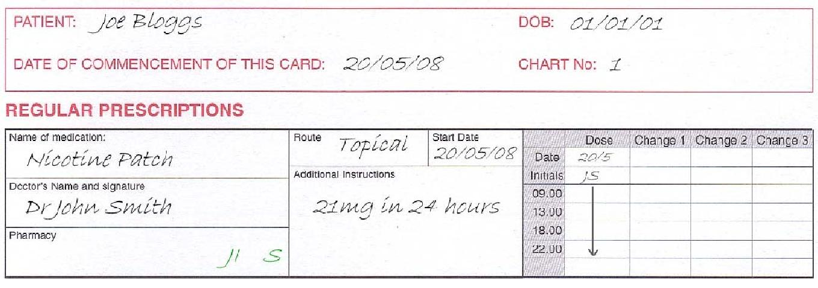

  - Nicotine sublingual (SL) tablets (microtabs)

Formulation | Dose | How to use | Notes
2mg SL tabs | For patients smoking ≤20 cigarettes daily; 2mg every hour, or increase to 4mg/hour in patietns who fail to stop smoking or who have significant withdrawal symptoms | SL tab should be placed under the tongue and allowed to dissolve slowly, and should be moved around under the tongue to prevent irritation | Give starter pack to patient

    - Specific advice to the service user
      - SL tablets may cause throat irritation, wind or hiccups. If any of these become intolerable, then therapy should be changed.
      - SL tablet should be placed under the tongue and allowed to dissolve slowly, and should be moved around under the tongue to prevent irritation.
    - Nicotine SL tablets should be prescribed on the PRN (as required) section of the drug chart. The maximum dose in 24 hours needs to be specified according to BNF. Figure 2 is provided as an example of how to write the prescription.

Figure 2: Example of How to Write a PRN Prescription for a Nicotine SL tablet
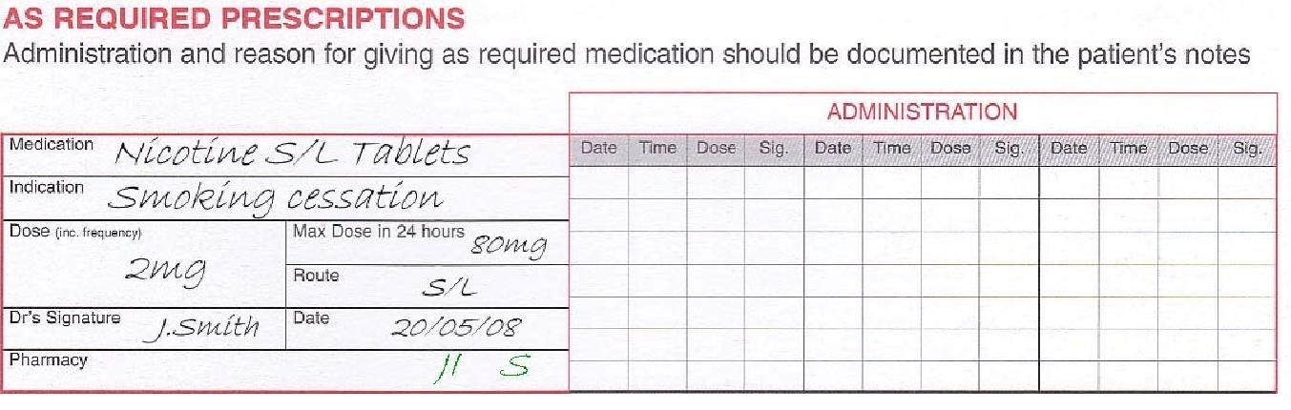

  - Nicotine Oral Spray

Formulation | Dose | How to use | Notes
1 mg/metered spray | 1–2 sprays in the mouth when the urge to smoke occurs or to prevent cravings. Individuals should not exceed 2 sprays per episode (up to 4 sprays every hour), and a maximum of 64 sprays daily. | Prime the spray before use by pressing the top of the spray with your index finger 3 times until a fine spray appears. After priming, point the spray nozzle as close to the open mouth as possible. Press the top of the dispenser and release one spray into your mouth, avoiding the lips. Do not inhale while spraying to avoid getting spray down your throat. | For best results, do not swallow for a few seconds after spraying.  The patient should not eat or drink when administering the oromucosal spray.
    - Specific advice to the client:
      - Prime the spray before use, do not point towards other adults, children or pets
      - Do not eat or drink during or immediately after use
      - During the first few days, treatment irritation to the mouth and throat may be experienced and hiccups are particularly common. Tolerance is normal with continued use.
    - Nicotine oral spray should be prescribed on the as required section of the drug chart. The maximum dose in 24 hours needs to be specified according to BNF criteria.
  - Nicotine Lozenges

Formulation | Dose | How to use | Notes
1mg, 2mg or 4mg lozenge | One lozenge should be used every 1 – 2 hours when the urge to smoke occurs.  Individuals who smoke ≤20 cigarettes each day usually use the lower strength lozenges  Do not exceed 15 lozenges daily | Suck lozenge until slightly dissolved and the taste is strong.  Periodically move the lozenge from one side of the mouth to the other. | Lozenges last 10 – 30 minutes
    - Specific advice to the service user
      - Lozenges may cause throat irritation or hiccups. In rare cases they may cause mouth ulceration and increase salivation. If any of these become intolerable, then switch therapy.
      - Lozenge should be sucked until the taste is strong and moved around the mouth
    - Nicotine lozenges should be prescribed on the as required section of the drug chart. The maximum dose in 24 hours needs to be specified according to BNF criteria. Figure 2 is provided as an example of how to write such a prescription.
  - Nicotine Inhalator
Formulation | Dose | How to use | Notes
15mg cartridges | The cartridges can be used when the urge to smoke occurs or to prevent cravings. Patients should not exceed 6 cartridges of the 15 mg strength daily. | Insert the cartridge into the device and draw in air through the mouthpiece; each session can last for approximately 5 minutes. A single 10 mg cartridge lasts for approximately 20 minutes of intense use; a single 15 mg cartridge lasts for approximately 40 minutes of intense use. | The amount of nicotine from 1 puff of the cartridge is less than that from a cigarette, therefore it is necessary to inhale more often than when smoking a cigarette.

    - Specific advice to the client:
- Inhalator may cause throat irritation, cough and rhinitis. If any of these become intolerable, then therapy should be changed.
- Air should be drawn into the mouth through the mouthpiece. Clients should be warned that the inhalator requires more effort to inhale than a cigarette and that less nicotine is delivered per inhalation. Therefore the client may need to inhale for longer than with a cigarette.
- The inhalator is best used at room temperature as nicotine delivery is affected by temperature. Used cartridges will contain residual nicotine and should be disposed of safely. Advise the client to dispose of used cartridges in a safe manner.
    - Nicotine inhalators should be prescribed on the as required section of the drug chart. The maximum dose in 24 hours needs to be specified according to BNF criteria. Figure 2 is provided as an example of how to write such a prescription.
Figure 4: Example of How to Write a PRN Prescription for a Nicotine Inhalator
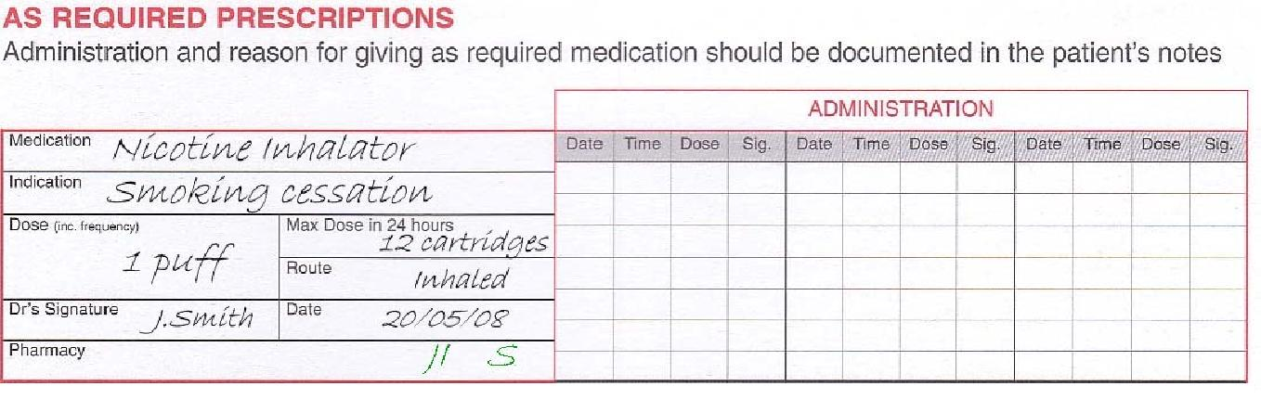

  - Nicotine Nasal Spray
Formulation | Dose | How to use | Notes
10mg/ml spray delivering 0.5mg of nicotine per spray | Spray once into both nostrils when urge to smoke occurs. This should be repeated up to twice every hour for 16 hours daily (maximum 64 sprays daily).  Initially 1 spray should be used in both nostrils but when withdrawing from therapy, the dose can be gradually reduced to 1 spray in 1 nostril. | Insert the spray tip into one nostril, pointing the top towards the back of the nose. Press firmly and quickly. Repeat this process for the other nostril. | Need to prime spray before use. Place the nozzle between first and second finger with the thumb on the bottom of the bottle. Press several times firmly and quickly until a fine spray appears (up to 7-8 strokes).  Point the spray safely away when priming it. Do not prime it near children or pets.

    - Specific advice to the client:
  - Nasal irritation, sneezing, running nose, watering eyes and cough occur in nearly all patients using this nicotine preparation for the first two days. However, these side effects are transient and are likely to decrease with continued use.
  - On first use of the nasal spray, the device will need to be primed. This is done by pressing the nozzle up to 8 times until a fine spray appears. The device is then ready for use.

    - Nicotine nasal spray should be prescribed on the as required section of the drug chart. The maximum dose in 24 hours needs to be specified according to BNF criteria. Figure 2 is provided as an example of how to write such a prescription.
Figure 5: Example of How to Write a PRN Prescription for a Nicotine Nasal Spray
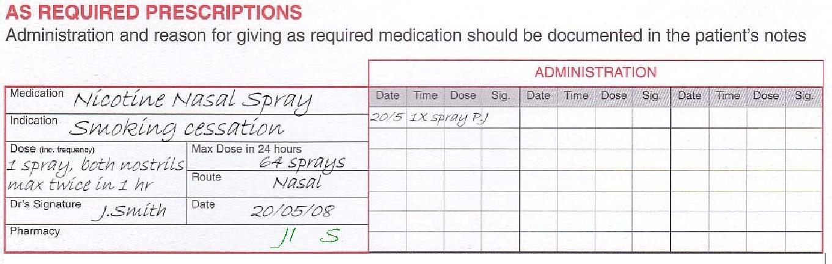

- Supply of NRT
  - NRT may be supplied to a service user either against a prescription written by a ELFT prescriber or against the ELFT NRT Patient Group Direction (PGD)
  - Authorised nurses, pharmacists and occupational therapists are eligible to supply NRT to inpatients via the NRT PGD. They must fit the following criteria
    - completed level 1 smoking cessation training
    - undertaken NRT PGD pharmacy training
    - been deemed competent by the ward/team manager
    - signed the PGD
  - The NRT PGD is designed to ensure inpatients will have access to NRT in a timely fashion at admission. Please refer to the PGD for conditions under which this can happen and how to document supply
  - When supplying patients NRT against a prescription, supply enough to keep on their person (eg 1 starter pack) and the total quantity of supply should be documented
  - Further supplies of as required nicotine replacement therapy may be given to the patient as long as the total quantity received during the day does not exceed the maximum dose stated on the prescription.

Figure 3: Example of How to Record PRN supply for a Nicotine Inhalator

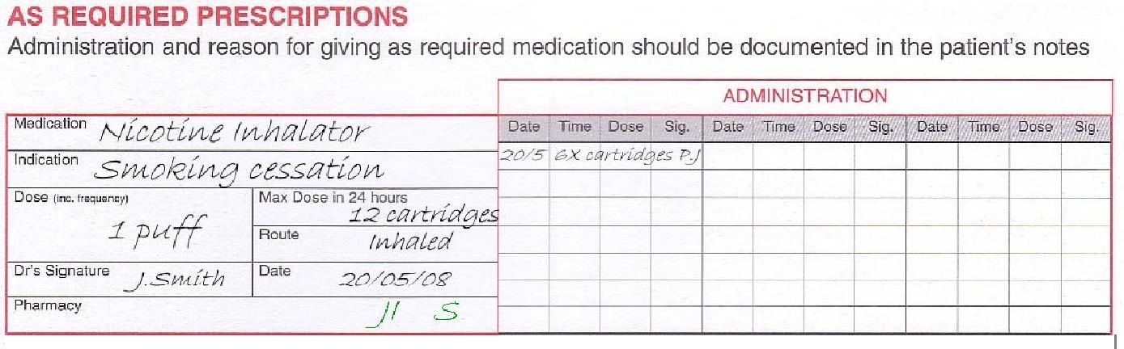

- Guidance for the Use of Bupropion
  - The NICE advocate the use of bupropion as a treatment option in those patients who require smoking cessation therapy ².
  - It should only be prescribed in combination with a programme of behavioural support.
  - The use of bupropion should be restricted to specialists in the smoking cessation area and preferably be prescribed in conjunction with the smoking cessation service.
  - Bupropion should only be prescribed as part of an abstinent-contingent treatment in which the smoker makes a commitment to stop smoking on or before a particular date.
  - When prescribed, these treatments should be prescribed exclusively and not in combination with any other form of smoking cessation pharmacotherapy.
  - Criteria for inclusion
  - Tobacco users identified as sufficiently motivated to quit i.e. willing to set a quit date and receive weekly support for the first four weeks.
  - Criteria for Exclusion
    - Bupropion is not recommended for those under 18 years of age and is contraindicated in those who are pregnant or breastfeeding.
    - Bupropion is contraindicated in those with a history of bipolar disorder.
    - Bupropion should not be prescribed if the patient is already being treated with varenicline or NRT.
    - The Committee on Safety of Medicines (CSM) has issued a reminder that bupropion is contraindicated in patients with a history of seizures or of eating disorders, a CNS tumour, or who are experiencing acute symptoms of alcohol or benzodiazepine withdrawal.
    - Bupropion should not be prescribed to patients with other risk factors for seizures unless the potential benefit of smoking cessation clearly outweighs the risk.
    - Factors that increase the risk of seizures include concomitant administration of drugs that can lower seizure threshold e.g. antidepressants, antimalarials, antipsychotics, quinolones, sedating antihistamines, systemic corticosteroids, theophyline, tramadol, alcohol abuse, history of head trauma and the use of stimulants and anorectics.

  - Prescribing of Bupropion
drug | Tablets strengths | Dose and instructions
Bupropion  (Zyban®) | 150mg MR | Start 1 – 2 weeks before target stop date  Initially 150mg OD for 6 days, then 150mg BD for a treatment period of 7 – 9 weeks. Max dose 150mg OD in the elderly and patients with risk factors
    - Bupropion must be prescribed on the regular prescriptions section of the inpatient medication chart. Treatment needs to be initiated a minimum of 1 week before the target stop date and the dose needs to be titrated over this first week.
    - The initial prescription for bupropion should not be for more than 3-4 weeks after which it should only be prescribed to those who continue to attempt to quit. Refer to the British National Formulary for full dosing schedule.
  - Side Effects and Adverse Drug Reactions
    - These may include the following, some of which are consequences of stopping smoking:
    - Dry mouth, gastro-intestinal disturbances, insomnia (reduced by avoiding dose at bed time), tremor, impaired concentration, headache, dizziness, depression, agitation, anxiety, fever, rash, pruritis and sweating.
    - Although uncommon, bupropion can cause hypertension, tachycardia and chest pains. It is recommended that blood pressure is monitored before and during treatment in all patients.
    - Any serious side effects should be discussed with the client’s adviser in the first instance. In addition a doctor or pharmacist using the ‘Yellow Card Reporting Scheme’ should inform the Medicines and Healthcare Products Regulatory authority.
    - Advisers should seek appropriate advice about any suspected adverse drug reactions from the stop smoking services (contact details on page 3) and offer this advice to the patient. The adviser should also record details of the adverse drug reaction and an incident form (IR1) completed.
  - Supply of Bupropion
    - All strengths of this treatment will be available from pharmacy. It should be ordered through the pharmacy service via the normal procedure.
  - Administration of Bupropion
    - Both preparations should be administered in an identical fashion to all other prescribed medicines on the drug chart.
- Guidance for the Use of Varenicline
  - NICE advocate the use of varenicline as a treatment option in those patients who require smoking cessation therapy.
  - It should only be prescribed in combination with a programme of behavioural support.
  - The use of varenicline should be restricted to specialists in the smoking cessation area and preferably be prescribed in conjunction with the smoking cessation service.
  - Varenicline should only be prescribed as part of an abstinent-contingent treatment in which the smoker makes a commitment to stop smoking on or before a particular date.
  - When prescribed, these treatments should be prescribed exclusively and not in combination with any other form of smoking cessation pharmacotherapy.
  - Criteria for inclusion
    - Tobacco users identified as sufficiently motivated to quit i.e. willing to set a quit date and receive weekly support for the first four weeks.
  - Criteria for Exclusion
    - Varenicline is not recommended for use in those under 18 years of age and is contraindicated in those who are pregnant.
    - Varenicline should not be prescribed if the patient is already being treated with bupropion or NRT.
  - Prescribing of Varenicline
drug | Tablets strengths | Dose and instructions
Varenicline  (Champix®) | 500microgram, 1mg | Start 1 – 2 weeks before target stop date  Initially 500micrograms OD for 3 days then increased to 500micrograms BD for 4 days, then 1mg BD for 11 weeks (maintenance dose)  May be decreased to 500micrograms BD if not tolerated  Treatment can be continued in those who remain abstinent to reduce the risk of relapse
    - Varenicline must be prescribed on the regular prescriptions section of the inpatient medication chart. Treatment needs to be initiated a minimum of 1 week before the target stop date and the dose needs to be titrated over this first week.
    - The initial prescription for varenicline should not be for more than 3-4 weeks after which it should only be prescribed to those who continue to attempt to quit. See the British National Formulary for the full dosing schedule.
  - Side Effects and Adverse Drug Reactions
    - These may include the following, some of which are consequences of stopping smoking:
    - Gastro-intestinal disturbances, appetite changes, dry mouth, taste disturbance, headache, drowsiness, dizziness, sleep disorders and abnormal dreams.
    - The Medicines Healthcare and Regulatory Agency (MHRA) have issued new advice regarding the use of varenicline in patients with underlying psychiatric illness, including depression. Varenicline has been associated with symptoms of depression and suicidal ideation in small numbers of patients. Patients on varenicline who develop suicidal thoughts should discontinue this treatment immediately.
  - Any serious side effects should be discussed with the client’s adviser in the first instance. In addition a doctor or pharmacist using the ‘Yellow Card Reporting Scheme’ should inform the Medicines and Healthcare Products Regulatory authority.
  - Advisers should seek appropriate advice about any suspected adverse drug reactions from the stop smoking services and offer this advice to the patient. The adviser should also record details of the adverse drug reaction and an incident form completed.
  - Supply of Varenicline
    - All strengths of this treatment will be available from pharmacy. This treatment should be ordered through the pharmacy service via the normal procedure.
  - Administration of Varenicline
    - Both preparations should be administered in an identical fashion to all other prescribed medicines on the drug chart.

- Smoking Cessation on discharge
  - Where a patient wants to continue smoking cessation they should be discharged with up to two weeks supply of smoking cessation pharmacotherapy along with their regular prescription.
  - Patients must be informed about smoking cessation services in the community.
  - A referral can be made to either their GP, a local community pharmacy or local clinic of their choice.

- References
- East London NHS Foundation Trust. Smoke Free Policy. 2008
- National Institute for Health and Clinical Excellence. Smoking Cessation Services. NICE Public Health Guidance
- February 2008 NICE guidance (PH48) , Smoking Cessation in Secondary Care , Acue,Maternity and Mental Health Services, available at https://www.nice.org.uk/guidance/ph48, accessed 11.10.2015
- Desai HD et al. Smoking in patients receiving psychotropic medications: a pharmacokinetic perspective. CNS Drugs 2001;15:469-94
- Miller LG. Recent developments in the study of the effects of cigarette smoking on clinical pharmacokinetics and clinical pharmacodynamics. Clin Pharmacokinet 1989;17:90-108
- Desai HD et al. Smoking in patients receiving psychotropic medications: a pharmacokinetic perspective. CNS Drugs 2001;15:469-94
- Goff DC et al. Cigarette smoking in schizophrenia: relationship to psychopathology and medication side effects. Am J Psychiatry 1992;149:1189-94
- Miller LG. Recent developments in the study of the effects of cigarette smoking on clinical pharmacokinetics and clinical pharmacodynamics. Clin Pharmacokinet 1989;17:90-108
- Haring C et al. Influence of patient-related variables on clozapine plasma levels. Am J psychiatry 1990;147:1471-5
- Haring C et al. Dose-related plasma levels of clozapine: influence of smoking behaviour, sex and age. Psychopharmacology 1989;99 (Suppl):S38-S40
- Ereshefsky L et al. Effects of smoking on fluphenazine clearance in psychiatric inpatients. Biol Psychiatry 1985;20:329-32
- Spigset O et al. Effect of cigarette smoking on fluvoxamine pharmacokinetics in humans. Clin Pharmacol Ther 1995;58:399-403
- Jann MW et al. Effects of smoking on haloperidol and reduced haloperidol plasma concentrations and haloperidol clearance. Psychopharmacology 1986;90:468-70
- Shimoda K et al. Lower plasma levels of haloperidol in smoking than in non-smoking schizophrenic patients. Ther Drug Monit 1999;21:293-6
- Bazire S. Psychotropic Drug directory 2007.
- Carrilo JA et al. Role of smoking-induced cytochrome P450 (CYP)1A2 and polymorphic CYP2D6 in steady-state concentration of olanzapine. J Clin Psychopharmacol 2003;23:119-27
- Gex-Fabry M et al. Therapeutic drug monitoring of olanzapine: the combined effect of age, gender, smoking, and co medication. Ther Drug Monit 2003;25:46-53
- Bazire S. Psychotropic Drug directory 2007.
- Desai HD et al. Smoking in patients receiving psychotropic medications: a pharmacokinetic perspective. CNS Drugs 2001;15:469-94
- Miller LG. Recent developments in the study of the effects of cigarette smoking on clinical pharmacokinetics and clinical pharmacodynamics. Clin Pharmacokinet 1989;17:90-108
- Desai HD et al. Smoking in patients receiving psychotropic medications: a pharmacokinetic perspective. CNS Drugs 2001;15:469-94
- Eli Lilly and company limited. Cymbalta. http://emc.medicines.org.uk/ 2006
- Goff DC et al. Cigarette smoking in schizophrenia: relationship to psychopharmacology and medication side effects. Am J Psychiatry 1992;149:1189-94
- Grasmader K et al. Population pharmacokinetic analysis of mirtazapine. Eur J Clin Pharmacol 2004;60:473-80
- Jorgensen A et al. Zuclopenthixol decanoate in schizophrenia: serum levels and clinical state. Psychopharmacology 1985;87:364-7
- Jann MW et al. Clinical pharmacokinetics of the depot antipsychotics. Clin Pharmacokinet 1985;10:315-33
- Committee for Safety of Medicines. Advice on Bupropion. May 2001
- British National Formulary. 2015;69: 341
- British National Formulary. 2015;69: 34406
- Medicines and Healthcare products Regulatory Agency. Drug Safety Update. 2008;1 (7) 3-4
- Stead LF, Lancaster T. Interventions to reduce harm from continued tobacco use (Review). The Cochrane Library 2009, Issue 1.

Appendix 1: Supply of NRT to ELFT staff working on smokefree wards

- ELFT staff may have access to all available NRT formulations.
- Staff who require NRT must request from the senior nurse in charge on the ward and this must be signed out using the log below
- Information must be retained on the ward

Date | NRT product supplied  (strength, formulation, amount) | Staff member receiving | Staff member supplying signature

Appendix 2 Psychotropic drugs affected by smoking status (Maudsley, 12th Ed, page 688)

Drug | Effect of Smoking | Action on stopping smoking | Action on restarting smoking
Agomelatine | Plasma levels reduced | Monitor closely. Dose may need to be reduced | Consider re-introducing previous smoking dose
Benzodiazepines | Plasma levels reduced by 0 – 50% (depends on drug and smoking status) | Monitor closely. Consider reducing dose by up to 25% over one week | Monitor closely. Consider restarting ‘normal’ smoking dose
Carbamazepine | Unclear, but smoking may reduce carbamazepine plasma levels to a small extent | Monitor for changes in severity of adverse effects | Monitor plasma levels
Chlorpromazine | Plasma levels reduced. Varied estimates of exact effect | Monitor closely, consider dose reduction. | Monitor closely. Consider restarting previous smoking dose.
Clozapine | Reduces plasma levels by up to 50%. Plasma level reduction may be greater in those receiving valproate | Take plasma level before stopping. On stopping, reduce dose gradually (over a week) until around 75% dose reached (ie reduce by 25%). Repeat plasma level one week after stopping. Anticipate further dose reductions. | Take plasma level before re-starting. Increase dose to previous smoking dose over one week. Repeat plasma level.
Duloxetine | Plasma levels may be reduced by up to 50% | Monitor closely. Dose may need to be reduced | Consider re-introducing previous smoking dose
Fluphenazine | Reduces plasma levels by up to 50% | On stopping, reduce dose by 25%. Monitor carefully over following 4-8 weeks. Consider further dose reductions. | On restarting, increase dose to previous smoking dose.
Fluvoxamine | Plasma levels decreased by around one-third | Monitor closely. Dose may need to be reduced | Dose may need to be increased to previous level
Haloperidol | Reduces plasma levels by around 20% | Reduce dose by around 10%. Monitor carefully. Consider further dose reductions. | On restarting, increase dose to previous smoking dose.
Lithium  Patients with ‘heavy’ caffeine consumption | Smoking induces metabolism of caffeine, therefore theoretically smoking can reduce xanthine levels, which could reduce lithium excretion (↑ plasma level) | Take plasma level before stopping. Repeat plasma level one week after stopping and consider need for dose increase. | Take plasma level before restarting. Repeat plasma level  one week after stopping and consider need for dose reduction.
Mirtazapine | Unclear, but effect probably minimal | Monitor | Monitor
Olanzapine | Reduces plasma levels by up to 50% | Take plasma level before stopping. On stopping, reduce dose by 25%. After one week, repeat plasma level. Consider further dose reductions. | Take plasma level before restarting. Increase dose to previous smoking dose over one week. Repeat plasma level.
Tricyclic antidepressants | Plasma levels reduced by 25-50% | Monitor closely. Consider reducing dose by 10-25% over one week. Consider further dose reductions. | Monitor closely, consider restarting previous smoking dose.
Zuclopenthixol | Unclear but effect probably minimal | Monitor | Monitor

