**Q3 Antimicrobial Prescribing Audit Report 2021/22**

**Introduction:**

This audit report summarises the key findings of the antimicrobial prescribing audit conducted in November 2021 and it is used to monitor antimicrobial prescribing trends and quality indicators as part of the Trust wide Antimicrobial Stewardship initiatives

**Method and Standards:**

The ELFT pharmacy team collect data across all sites every quarter during a two weeks period. For each antimicrobial prescription found during the audit period, the clinical notes and medication charts are reviewed and compared against antimicrobial guidelines and/or microbiology advice provided. For each prescription, compliance is measured against standards, which are derived from the ELFT Antimicrobial Stewardship Policy. This policy defines the processes, which ensure that antimicrobial prescribing within ELFT is safe, effective and appropriate. The audit standards are as follows:

1. **Appropriate treatment choice:** All antimicrobials prescribed should be in accordance with the recommendations in the relevant local or national guidelines or microbiology advice.
2. **Completion of the allergy box:** 100% of antimicrobial prescriptions should also have a clearly documented allergy status for the patient on the prescription chart.
3. **Documentation:** All antimicrobial prescriptions should have the clinical indication clearly documented in the patient medical record or on the prescription chart
4. **Course length:** All antimicrobial prescriptions should have a clearly documented duration (or review date) which is appropriate for the indication and is in accordance with recommendations in the relevant local or national guideline or microbiology advice.

The RAG rating parameters are set as follows:

|  |  |
| --- | --- |
| **RAG Rating** | **Required parameter** |
| Red – Poor Compliance | Below 50% total compliance |
| Amber – Good Compliance, improvement needed | Total compliance between 50%- 89% |
| Green – Excellent Compliance | Above 90% total compliance (100% for allergy status documentation) |
| No colour | Insufficient forms to RAG rate |

**Key Findings:**

A total of 20 antibiotic prescriptions were audited across all sites in November 2021 and findings for Q3 are summarised in table 1 below.

Also a comparison chart was developed for Q4, Q1, Q2 and Q3 in table 2 below:

**Table 1: Compliance scores Q3**

|  |  |  |  |  |
| --- | --- | --- | --- | --- |
| Site | n | Appropriate Treatment Choice | Documentation in Systm1 progress notes and medication chart | |
| Indication | Course Length/Review Date |
| Bedfordshire & Luton | 10 | **100%** | **100%** | **100%** |
| Tower Hamlets | 7 | **100%** | **100%** | **86%** |
| Newham | 0 | **-** | **-** | **-** |
| City & Hackney | 2 | **100%** | **100%** | **100%** |
| CAMHS | 0 | **-** | **-** | **-** |
| Forensics | 1 | **100%** | **100%** | **100%** |
| CHN Adults | 0 | **-** | **-** | **-** |
| TOTAL | 20 | **100%** | **100%** | **90%** |

**Table 2: Compliance scores summary Q4, Q1, Q2 and Q3**









**Bedfordshire & Luton, City & Hackney and Forensics**: Overall results showed excellent compliance with audit standards

**Tower Hamlets:** This service has demonstrated good compliance with most audit standards this quarter. Compliance with the appropriate course length audit standard in Q3 was 86%, this was due to 1 audit form which was non-compliant

**Newham, CAMHS and CHN Adults**: No patients on antimicrobials at the time of the audit

**Top TEN Wards Prescribing Antimicrobials**

As per attached graphic, the top 10 wards prescribing Antimicrobials were:

1. **Lea ward (MEH):**

Details of antimicrobials prescribed: Amoxicillin 500mg capsules, Co-Amoxiclav 500/125mg tablets, Ciprofloxacin 500mg tablets, Co-Trimoxazole 480mg tablets, Dolutegravir 50mg tablets, Doxycycline 100mg capsules, Emtricitabine 200mg/Tenofovir 245mg tablets, Eviplera tablets, Evotaz tablets, Flucloxacillin 500mg capsules)

1. **Conolly (C&H):**

Details of antimicrobials prescribed: Amoxicillin 500mg capsules, Biktarvy 50mg/200mg/25mg tablets, Co-Trimoxazole 480mg tablets, Emtricitabine 200mg/Tenofovir 25mg tablets, Dolutegravir 50mg tablets)

1. **Ruby TR (NCMH)**

Details of antimicrobials prescribed: Darunavir 800mg tablets, Emtricitabine 200mg/Tenofovir 10mg tablets, Doxycycline 100mg capsules, Nitrofurantoin 50mg tablets, Phenoxymethylpenicillin 250mg tablets, Ritonavir 100mg tablets, Terbinafine 1% cream)

1. **Leadenhall (MEH)**

Details of antimicrobials prescribed: Azithromycin 500mg tablets, Cefalexin 250mg capsules, Ciprofloxacin 500mg tablets, Co-Amoxiclav 500/125mg tablets, Flucloxacillin 500mg capsules, Nitrofurantoin 50mg tablets, Nitrofurantoin 100mg MR capsules, Symtuza 800mg/150mg/200mg/10mg tablets, Quinine Sulfate 200mg tablets)

1. **Globe (MEH)**

Details of antimicrobials prescribed: Clarithromycin 500mg tablets, Co-Amoxiclav 500/125mg tablets, Emtricitabine 200mg/Tenofovir 245mg tablets, Eviplera tablets, Dolutegravir 50mg tablets, Rezolsta tablets)

1. **Coral (LTN)**

Details of antimicrobials prescribed: Aciclovir 400mg dispersible tablets, Amoxicillin 500mg capsules, Clarithromycin 500mg tablets, Co-Amoxiclav 500/125mg tablets, Emtricitabine 200mg/Tenofovir 245mg tablets, Emtricitabine 200mg/Tenofovir 25mg tablets, Flucloxacillin 500mg capsules, Fluconazole 150mg capsules, Raltegravir 400mg tablets, Rezolsta tablets)

1. **ASH (LTN)**

Details of antimicrobials prescribed: Aciclovir 400mg dispersible tablets, Amoxicillin 500mg capsules, Co-Amoxiclav 500/125mg tablets, Doxycycline 100mg capsules, Flucloxacillin 500mg capsules, Fluconazole 150mg capsules, Quinine Sulfate 200mg tablets)

1. **Luton Crystal (LTN)**

Details of antimicrobials prescribed: Biktarvy 50mg/200mg/25mg tablets, Clindamycin 150mg capsules, Co-Amoxiclav 500/125mg tablets, Co-Trimoxazole 480mg tablets, Metronidazole 200mg/5ml suspension, Nitrofurantoin 50mg tablets, Nitrofurantoin 100mg MR capsules)

1. **Cazaubon (EHCC)**

Details of antimicrobials prescribed: Ciprofloxacin 250mg and 500mg tablets, Co-Amoxiclav 500/125mg tablets, Doxycycline 100mg capsules, Flucloxacillin 250mg/5ml SF liquid, Nitrofurantoin 100mg MR capsules, Pivmecillinam 200mg tablets)

1. **Emerald (NCMH)**

Details of antimicrobials prescribed: Atazanavir 300mg tablets, Cefalexin 250mg capsules, Co-Amoxiclav 500/125mg tablets, Doxycycline 100mg capsules, Emtricitabine 200mg/Tenofovir 245mg tablets, Ritonavir 100mg tablets)

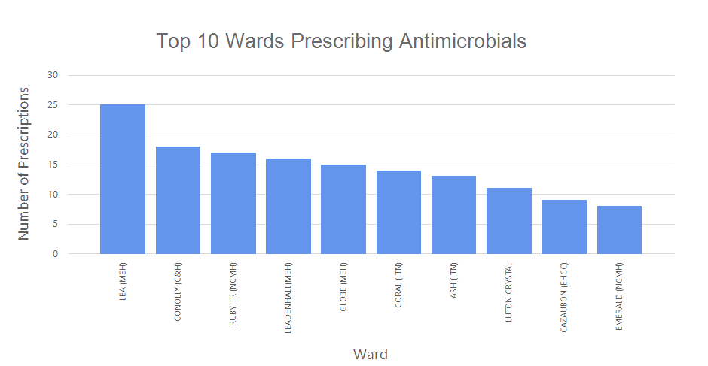

**Action Plan**

The following action plan has been formulated to address areas of non-compliance and concern as well as some overarching antimicrobial stewardship objectives in order to improve use of antimicrobials.

|  |  |  |
| --- | --- | --- |
| Action No | Action | By When |
| 1 | Circulate report to all Pharmacists, Prescribers, and Divisional Medical Directors to discuss at respective quality and governance meetings. Present findings of the audit to each divisional IPC subgroup and IPC Committee. | Feb 2022 |
| 2 | Services with good to poor compliance (RAG rated as amber or red) will be asked to develop local action plans to improve antimicrobial prescribing. This will involve close working between local prescribers, pharmacy teams and the antimicrobial pharmacist. | Feb 2022 |
| 3 | Review audit report/tool to ensure it captures key antimicrobial data as part of antimicrobial stewardship policy | Mar 2022 |