Guidance for

Prescribing and Administering

Influenza Vaccine

to eligible In-Patients across

East London NHS Foundation Trust (ELFT)

during the 2022/23 Flu programme

Version number | 5.0
Author | Roberta Contino  Lead Pharmacist Vaccinations and Antimicrobials
Circulated to | Ruth Bradley, Director of Nursing, Integrated Care  Claire McKenna, Director of Nursing  Andrea Okoloekwe, Interim Chief Pharmacist  Dupe Fagbenro and Amy Kings, Deputy Chief Pharmacists  ELFT Flu Leads  All Pharmacy Leads and Senior Pharmacy Managers group
Name of Responsible Committee | Medicines Committee
Approved and Ratified by | Medicines Committee
Date ratified | June 2022
Review date | June 2023
Target Audience | All Prescribers working within all services in ELFT, ELFT staff trained as vaccinators, ward managers, Clinical leads, pharmacists, and Infection prevention and control team, ELFT Flu Campaign group

Version Control Summary
Version | Date | Author | Reason/description of changes
1.0 | Oct. 2018 | Jennifer Melville
2.0 | Oct. 2019 | Charity Okoli | Updated with new information from PHE/NHSE for 2019/20 flu season programme.  Changed title from “Summary Guidance for Prescribing and Administering Influenza Vaccine  to ELFT inpatients” to “Summary Guidance for Prescribing and Administering Influenza Vaccine to eligible Service Users across all East London NHS Foundation Trust (ELFT) Services during the 2019/20 Flu season”.  Added “Introduction – section 1”  Changed section 1 to 2 and updated the eligibility criteria section.  The Information links and references updated.  Changed Section 2 to 3 and updated the section. Also added link for available vaccines this 2019/20 season.  Changed sect.3 to 4  Changed sect.4 to 5  Changed sect. 5 to 6; and changed the heading “Obtaining supply for eligible ELFT inpatients” “to “Prescribing/administering flu vaccines to patients”. Section 6 was also updated e.g., with advice on prescribing and administering the vaccine, advice and link for Green Book etc.  Changed the sub-heading 6.1 “QIV – for in -patients 18 – 64 years’ old” to “QIV – for patients 18 – 64 years’ old”  Added “this can be enabled on the e-prescribing platform (EPMA) where this has been rolled out”  6.2 changed “in-patients” to “patients”. removed “If the patient is short stay and able to obtain the vaccine from their GP this is the preferred option”  Added link for information leaflets for patients  6.3 Advice issued from NHS England.  Added sect. 7 “Reporting template” and what the vaccinators need to do.
3.0 | September 2020 | Charity Okoli | Updated the information on cover page, sections 1, 2, 3.2, 5, and 6. Section 7 (added information on infection control in view of Covid-19). The references also updated. Added appendix 2- Summary table of influenza vaccines being offered by NHS England in 2020/21 programme. In section 6 added information to assist in avoiding risk of administering extra flu vaccines.  Added Appendix 3, which is SOP to guide staff avoid the risk of extra dosing of influenza vaccine administration to patients.  Added links to excel spread sheets for all GP surgeries/Flu leads/PCN pharmacists in Newham Tower Hamlets and City & Hackney to enable easy access for ELFT pharmacy staff to communicate with GP practices and PCN pharmacist where available to provide quick information on discharge for patients vaccinated in ELFT. Section 6.3- added links for some useful information leaflets. Appendix 4 added, this has the record template for collation of patients vaccinated in in patient wards  Added supporting information on flu vaccination for people with learning disability on page 5
4.0 | September 21 | Charity Okoli | Page 5 –Updated the introduction section with information from Flu letters for 2021/22 season; in section 2, the extended eligibility criteria updated. Section 3 and appendix 2 updated to reflect the Flu vaccines products for 2021/22 season. References and all links updated.  Page 7- updated information on flu vaccination for Learning disability.  Section 8 changed, incorporating the information on how vaccination administered will be collated in 2021/22 programme. All data to be uploaded on NIVS. Explanation on the process, staff responsible, and detail of information required specified.
5.0 | June 2022 | Roberta Contino | All guidance reviewed against DHSC/UKHSA/NHSE: The national flu immunisation programme 2022/23 letter dated 22nd April 2022.  Added supported information on how to record the influenza vaccine on NIVS

Contents

1. Introduction 5
2. Eligibility for vaccination: 5
3. Influenza vaccine products for 2022/23 7
4. Contraindications and precautions with the vaccine 9
5. Interactions with the vaccine 10
6. Prescribing and administering flu vaccines to patients 11
7. Infection prevention and control when administering vaccines 13
References and Further Information 15
Appendix 1: Groups included in the national influenza immunisation programme………….16
Appendix 2: How to prescribe the influenza vaccine in EPMA …….18
Appendix 3: How to record the influenza vaccine on NIVS …………………………………….….......20

Introduction

Seasonal influenza is an unpredictable but recurring issue we face every year, which tend to add pressure to NHS every winter. In 2021/22, the flu vaccination programme was extended, and more groups were eligible to receive flu vaccine than in previous years.
As a result of non-pharmaceutical interventions in place for Covid-19 (such as mask-wearing, reduced social interventions and international travel), influenza activity levels were extremely low globally in 2020/21 and at present continue to be low. A late increase in activity cannot be ruled out this season. As social contact returns to pre-pandemic norms, there is likely to be a resurgence in influenza activity in winter 2022 to 2023 to levels similar to or higher than before the pandemic. The potential for co-circulation of influenza, Covid-19 and other respiratory viruses could add substantially pressure on NHS services in 2022/23, by addition or by prolongation of the overall period for which respiratory viruses circulate in sequence.
East London NHS Foundation Trust (ELFT) like other providers as expected by the government will focus on achieving high vaccine uptake levels in eligible groups, as they are most at risk of from flu.

Eligibility for vaccination:

Groups eligible for influenza vaccination are based on the advice of the Joint Committee on Vaccination and Immunisation (JCVI). The programme aims to provide direct protection to those who are at higher risk of influenza associated morbidity and mortality and to reduce transmission to all age groups through the vaccination of children.
The 2 March 2022 letter confirmed that those eligible for the NHS influenza programme are the cohorts offered vaccine prior to the pandemic:
- all children aged 2 or 3 years on 31 August 2022
- all primary school aged children (from reception to Year 6)
- those aged 6 months to under 65 years in clinical risk groups
- pregnant women
- those aged 65 years and over
- those in long-stay residential care homes
- carers
- close contacts of immunocompromised individuals
- frontline staff employed by the following types of social care providers without employer led occupational health schemes:
  - a registered residential care or nursing home
  - registered domiciliary care provider
  - a voluntary managed hospice provider
  - Direct Payment (personal budgets) or Personal Health Budgets, such as Personal Assistants

Cohorts that were eligible in the 2021 to 2022 season but that are not included in the cohorts for 2022 to 2023 are:
- those aged 50 to 64 years
- secondary school children in Years 7 to 11 (between 11 and 15 years of age on 31 August 2022)

The influenza chapter in ‘Immunisation against infectious disease’ (the ‘Green Book’), which is updated periodically, gives detailed descriptions of the groups outlined above and in Appendix 1
Inpatients
All inpatients admitted to an inpatient ward in ELFT who have not had a flu vaccination at their GP or community pharmacy and where this has been confirmed via medicines reconciliation should be offered a flu vaccine if they fall into any of the categories outlined in the flu letter mentioned above. In particular, these groups:
- CAMHS inpatients - All children aged 2 to 3 years on 31 August 2021 and all primary school aged children (from reception to year 6)
- Older people’s mental health, forensics and CHS inpatients - People aged 65 years or over (including those becoming age 65 years by 31 March 2023)
- Adult mental health inpatients - Those aged less than 65 years of age, in a clinical risk group such as those with:
  - chronic (long-term) respiratory disease, such as severe asthma (requires continuous or repeated use of inhaled or systemic steroids or with previous exacerbations requiring hospital admission), chronic obstructive pulmonary disease (COPD) or bronchitis
  - chronic heart disease, such as heart failure
  - chronic kidney disease at stage 3, 4 or 5
  - chronic liver disease
  - chronic neurological disease, such as Parkinson’s disease or motor neurone disease
  - learning disability
  - diabetes
  - splenic dysfunction or asplenia
  - a weakened immune system due to disease (such as HIV/AIDS) or treatment (such as cancer treatment)
  - morbidly obese (defined as BMI of 40kg/m² and above)

- Mother and Baby Unit inpatients - All pregnant women (including those women who become pregnant during the influenza season)
The list above is not exhaustive, and the healthcare practitioner should apply clinical judgement to take into account the risk of flu exacerbating any underlying disease that a patient may have, as well as the risk of serious illness from flu itself. Flu vaccine should be offered in such cases even if the individual is not in the clinical risk groups specified above. Capacity assessments should be considered where appropriate.
The aim of the influenza programme for 2022 to 2023 is to demonstrate a 100% offer and to achieve at least the uptake levels of 2021 to 2022 for each cohort, and ideally exceed them. For instance, influenza vaccine uptake 2021 to 2022 for aged 65 years and over was 82.3%, DHSC/UKHSA want to build on the momentum of this achievement and want an improved uptake for other clinical groups such as pregnant women, which only saw 37.9% vaccine uptake in 2021 to 2022.

NB: Frontline health and social care workers will be provided with flu vaccination by their ELFT teams. ELFT flu vaccinators in directorates will be providing opportunities for staff to be vaccinated in order to protect staff and patients from flu. See information on the intranet about flu campaign and vaccination this season. A written instruction has also been authorised by ELFT organisation to be used for the peer-to-peer vaccination of staff during 2022/23 flu immunisation programme.

There is also a trust Flu PGD and patient specific directions agreed with GPs for vaccination of our service users in the community by trained nurses where agreement has been reached locally.

- Support for people with Learning Disability (LD) to enhance uptake
It has been observed that despite the fact that from 2014 people with learning disabilities were eligible to have a free flu vaccination there has not been an appreciable rise in the numbers receiving the flu vaccine. It is highly important that people with learning disability be supported by healthcare professionals by putting some reasonable adjustments in place, to ensure that people with LD have their flu immunisation. This is because many studies/reports such as the CIPOLD report have shown that respiratory problems are a major cause of death of people with learning disabilities. Some of the adjustments that may be made for this group include:
- Consider the use of the nasal spray flu vaccine as an alternative adjustment that is less invasive when the LD patient is anxious about needles.
- The live intranasal influenza vaccine is given as a single spray squirted up each nostril. Note, this is not licensed for adults but can be used “off-label” for patients with LD who become seriously distressed with needles.
- The person seeing the patient may need to assess the patient’s capacity to decide to have the flu injection. If they do not have capacity for this decision, then this should not be a barrier to the flu injection being given; there would need to be a decision taken by the health professional that this is in their best interests.
- Healthcare professionals should inform people with learning disabilities, their family, carers and paid supporters that they are entitled to a free flu vaccination.
- Case coordinators, during the patient’s annual health check or CPA meetings should inform the patient and families/carers the reason it is important that they have a flu vaccination and provide information leaflets if possible.
Click the link below for more supporting information resources for Flu vaccinations for people with learning disability.
https://www.gov.uk/government/publications/flu-vaccinations-for-people-with-learning-disabilities/flu-vaccinations-supporting-people-with-learning-disabilities

Influenza vaccine products for 2022/23 programme

Influenza viruses change continuously and the World Health Organization (WHO) monitors the epidemiology of influenza viruses throughout the world, making recommendations about the strains to be included in vaccines, with recommendations now confirmed for 2022 to 2023. This process has been far more difficult and potentially less precise since early 2020 due to far fewer influenza viruses isolated and analysed worldwide.
All but one of the influenza vaccines available in the UK are inactivated and do not contain live viruses. One vaccine (Fluenz Tetra®) contains live viruses that have been attenuated (weakened) and adapted to cold so that they cannot replicate efficiently at body temperature. None of the influenza vaccines can therefore cause clinical influenza in those that can be vaccinated, although mild coryzal symptoms can occur with the live vaccine.
The live vaccine (Fluenz Tetra®) is administered by nasal spray, and the inactivated vaccines are all administered by intramuscular injection. There are very few individuals who cannot receive any influenza vaccine. When there is doubt, appropriate advice should be sought promptly from a specialist.
For more information on available influenza vaccines during the 2022/23 programme, the detailed information can be accessed in Appendix C (influenza vaccines for the adult’s programme) and Appendix D (influenza vaccines of the children’s programme) of the DHSC/UKHSA publication of 22nd April 2022 and summary table below:
Eligible group | Type of Influenza vaccine
At risk children aged from 6 months to less than 2 years | Offer QIVe (egg- grown Quadrivalent influenza vaccine – inactivated)  For egg-allergic children under 2 years it is advised that QIVc is offered off-label  NOTE: LAIV (Live Attenuated Influenza Vaccine) and QIVc (adjuvanted Quadrivalent influenza vaccine – cell cultured, inactivated) are not licenced for children under 2 years of age.
At risk children aged 2 to under 18 years | Offer LAIV  If LAIV is contraindicated or otherwise unsuitable offer QIVc  (QIVe is suitable to offer as a second option but has not been procured by UKHSA for this age group)
Aged 2 and 3 years on 31 August 2022.  All primary school aged children (aged 4 to 10 on 31 August 2022)  Secondary school aged children | Offer LAIV  If child is in a clinical risk group and is contraindicated to LAIV (or it is otherwise unsuitable) offer QIVc  (QIVe is suitable to offer as a second option but has not been procured by UKHSA for this age group)
At risks adults, including pregnant women, aged 18 to less than 65 years | Offer QIVc or QIVr (the recombinant quadrivalent influenza vaccine)  If QIVc or QIVr are not available, offer QIVe
Those aged 65 years and over | Offer aQIV/ QIVr  If aQIV or QIVr are not available, offer QIVc  (aQIV may be offered ‘off-label’ to those who become 65 years of age before 31 March 2023)

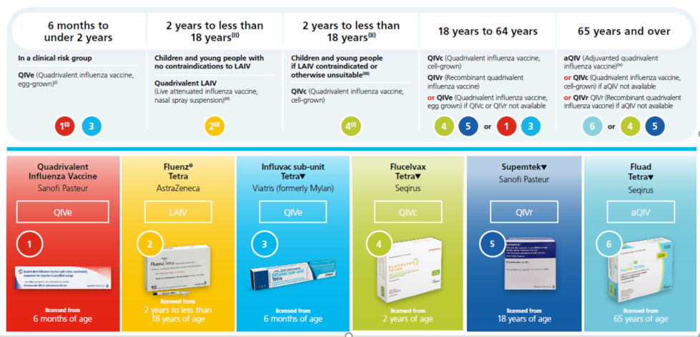

For up to date advice the Green Book https://www.gov.uk/government/publications/influenza-the-green-book-chapter-19
ELFT have ordered the QIVc vaccine (Flucelvax Tetra® – Seqirus) for routine vaccinations of inpatients under 65yrs old. Please see product SPC here:
https://www.medicines.org.uk/emc/product/9753/smpc#gref

4. Contraindications and precautions with the vaccine
None of the influenza vaccines should be given to those who have had:
- a confirmed anaphylactic reaction to a previous dose of the vaccine, or
- a confirmed anaphylactic reaction to any component of the vaccine.

Anaphylaxis kits must be available in case of an allergic reaction.
4.1 Egg allergy - Adult patients can also be immunised in any setting using an inactivated influenza vaccine with an ovalbumin content less than 0.12 μg/ml (equivalent to 0.06 μg for 0.5 ml dose), except those with severe anaphylaxis to egg which has previously required intensive care who should be referred to specialists for immunisation in hospital.
See Ovalbumin content for 2022/23 vaccines here: https://www.gov.uk/government/publications/influenza-vaccines-marketed-in-the-uk/all-influenza-vaccines-marketed-in-the-uk-for-the-2022-to-2023-season
4.2 Current illness or fever - Minor illnesses without fever or systemic upset are not valid reasons to postpone immunisation. If an individual is acutely unwell, immunisation may be postponed until they have fully recovered. This is to avoid confusing the differential diagnosis of any acute illness by wrongly attributing any signs or symptoms to the adverse effects of the vaccine.
4.3 IM administration - All seasonal influenza vaccines supplied by ELFT to the ward settings are licensed for Intramuscular administration. The preferred sites for intramuscular injection are the anterolateral aspect of the thigh (or the deltoid muscle if muscle mass is adequate) in children 6 months through 35 months of age, or the deltoid muscle in children from 36 months of age.
4.4 Injections and anticoagulants - It is important to closely monitor the patients taking coumarins and related anticoagulants closely. Caution is always advised when giving intramuscular injection to patients with bleeding disorders in order to reduce the risk of bleeding.
Individuals on stable anticoagulation therapy, including individuals on warfarin who are up to date with their scheduled INR testing and whose latest INR was below the upper threshold of their therapeutic range, can receive intramuscular vaccination. A fine needle (equal to 23 gauge or finer calibre such as 25 gauge) should be used for the vaccination, followed by firm pressure applied to the site (without rubbing) for at least 2 minutes. If in any doubt, consult with the clinician responsible for prescribing or monitoring the individual’s anticoagulant therapy.
Individuals with bleeding disorders may be vaccinated intramuscularly if, in the opinion of a doctor familiar with the individual's bleeding risk, vaccines or similar small volume intramuscular injections can be administered with reasonable safety by this route. If the individual receives medication/treatment to reduce bleeding, for example treatment for haemophilia, intramuscular vaccination can be scheduled shortly after such medication/treatment is administered. A fine needle (equal to 23 gauge or finer calibre such as 25 gauge) should be used for the vaccination, followed by firm pressure applied to the site (without rubbing) for at least 2 minutes. The individual/parent/carer should be informed about the risk of haematoma from the injection.

5. Interactions with the vaccine
There are a number of medications including phenytoin, carbamazepine, phenobarbital and theophylline which have reported interactions with influenza vaccines leading to changes, mainly increases in plasma levels of these medications. However, the majority of these interactions are limited to isolated case reports, mainly without any observed clinical changes and therefore the interactions are not thought to be clinically significant. As the influenza vaccine is administered as a single vaccine any changes in plasma levels of these medicines is likely to be short lived and therefore the benefits of the vaccine in most cases will outweigh any risks. However, as changes in the plasma, levels of these medicines can lead to changes in effects or adverse effects it would be prudent to advise the patient to monitor for any increase in adverse effects or loss of symptom control and to consider plasma monitoring of these medicines should this occur.
For medicines, queries related to the vaccines, such as interactions, contact your local pharmacy team for advice.

6. Prescribing and administering flu vaccines to patients

6.1 Medicines reconciliation at admission
Caution to avoid accidental double dosing of flu vaccination
It is also important to specifically check on admission whether the patient has already had the flu vaccination from another provider e.g. the GP, community chemist etc.
The process in place in order to avoid this risk comprise the following two steps:
- Robust check on admission of patients to ELFT to see if vaccine had been given prior admission (as part of the medicines reconciliation process)
- Proper communication to the Primary Care (GPs) on discharge of patients from ELFT to notify Flu vaccine had been administered while under the care of ELFT
On admission of patients to ELFT
- During working hours Monday to Friday 9am to 5pm: Pharmacists will as part of medicines reconciliation check for prior administration of flu vaccine at GP or community pharmacy, this may consist of the following actions:
  - Ask the patient where possible or check with family/carers
  - Check with the patient’s GP
  - Contact the patients named community pharmacist
  - Check on Summary Care Record (SCR) if up to date
  - Contact the PCN/GP practice-based Pharmacist
- Out of hours, this responsibility falls to the clerking prescriber.
- Document on patient’s electronic notes in RIO

6.2 Prescribing flu vaccine for inpatients
The prescribers and ELFT vaccinators must discuss the flu vaccines with eligible patients to ensure informed consent. Capacity assessments should be considered where appropriate. Where the patient lacks capacity to consent, staff could seek advice of the ELFT Mental Health office on what is appropriate.
Paper charts - the vaccine should be prescribed in the “once only” section of the inpatient administration chart as ‘Inactivated Quadrivalent Influenza Vaccine’ IM Injection.
EPMA - See Appendix 2 for EPMA influenza vaccine prescribing.
The vaccines will be provided by ELFT pharmacy for all inpatients who are eligible to be vaccinated during the 2022/23 flu vaccination programme; contact your local pharmacy staff for supplies.

6.3 Administration
Following vaccination of each patient, a record of the type of flu vaccine, batch number and expiry date of the vaccine as well as the route and site of administration must be documented in the patient’s electronic notes in RIO.
In order to adequately provide data for all ELFT service users vaccinated during the 2022/23 flu immunisation programme, arrangement have been made to capture the data using the National Immunisation & Vaccination System (NIVS).
The data will be uploaded on NIVS at point of administration of the vaccine by the allocated site flu lead vaccinator or deputy/designated administrator (see Appendix 3 for details)
This is because NIVS links information to GP system and NHS app for easy access, so it is important the data be shared promptly.
The details of information required for NIVS documentation are:
- Patient’s name
- Date of Birth
- NHS number
- EMIS/SystmOne or RIO number
- Type of Influenza (Flu) vaccine administered to patient
- Batch number of the flu vaccine administered
- Date administered

6.4 At discharge
Prescriber will add vaccine information to the notification of discharge (NODF) or other electronic records e.g. EMIS and SystmOne for the patients in community.
Ward pharmacist will check the NODF against the JAC record for vaccine administration and ensure the vaccine information has been added prior to validation.
- Prescribers must add information on flu vaccination to the discharge notification letter.
- Pharmacists will check this information prior to validation of the Discharge Liaison Form (DLF or NODF).

Trained ELFT vaccinators are to deliver and administer the vaccine in line with the Green book. Always use the latest updated online version of the Green book. See link below:
https://www.gov.uk/government/publications/influenza-the-green-book-chapter-19

6.5 Useful Information leaflets and posters

- Follow the link below for Information leaflets for patients on who should have the flu vaccine, which is available in different languages. https://www.gov.uk/government/publications/flu-vaccination-who-should-have-it-this-winter-and-why

- See link below for posters for visitors to hospitals and care homes:
https://www.gov.uk/government/publications/flu-poster-for-visitors-to-hospitals-and-care-homes

- For manufacturers written Patient Information Leaflet (PIL) for QIVc – Flucelvax Tetra® (for under 65yrs) click link below:
https://www.medicines.org.uk/emc/product/9753/pil

- For manufacturers written Patient Information Leaflet (PIL) for aQIV – Fluad Tetra® (for 65yrs and over) click link below:
https://www.medicines.org.uk/emc/product/11679/pil

7. Infection prevention and control when administering vaccines

Premises that are administering the flu vaccine should follow the recommended infection prevention and control (IPC) guidance.

People who are displaying COVID-19 symptoms or are self-isolating because they are confirmed COVID-19 cases, or contacts of suspected or confirmed COVID-19 cases, should not attend until they have recovered and completed the required isolation period.

Healthcare professionals who administer the vaccine are required to wear the recommended personal protective equipment (PPE) in line with the government’s guidance.
www.gov.uk/government/publications/wuhan-novel-coronavirus-infection-prevention-and-control/covid-19-personal-protective-equipment-ppe
The IPC principles in this guidance apply to all health and care settings, including acute, mental health and learning disabilities, primary care (including community services) and care homes.

Further information on IPC measures is provided in the Information for Healthcare Practitioner documents, which will be updated prior to and during the season as required.

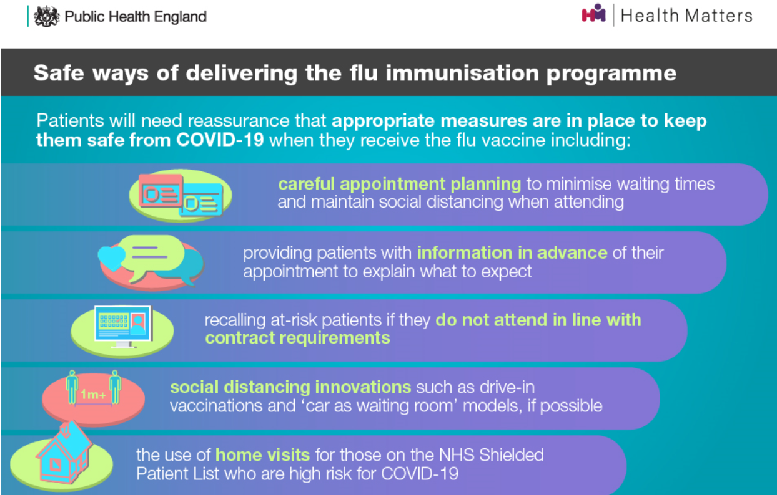

References and Further Information

- The summary of product characteristics should be consulted to guide the prescribing and administration of the vaccine. Summary of Product Characteristics are available from:
  - SmPC https://www.medicines.org.uk/emc/
  - SmPC Live Attenuated Influenza vaccine (Fluenz Tetra® nasal spray suspension)
https://www.medicines.org.uk/emc/product/3296

- Chapter 19 of the ‘The Green Book’ provides detailed recommendations for the use of the vaccine https://www.gov.uk/government/publications/influenza-the-green-book-chapter-19 Only use the updated on-line version
- Covid-19: Infection Prevention and control guidance www.gov.uk/government/publications/wuhan-novel-coronavirus-infection-prevention-and-control/covid-19-personal-protective-equipment-ppe
- DHSC/UKHSA/NHSE: The national flu immunisation programme 2022/23 letter dated 22nd April 2022
https://www.gov.uk/government/publications/national-flu-immunisation-programme-plan

- DHSC/UKHSA/NHSE: The statement of amendments to annual flu letter – 21st July 2022 https://www.gov.uk/government/publications/national-flu-immunisation-programme-plan/statement-of-amendments-to-annual-flu-letter-21-july-2022

- UKHSA: Inactivated Influenza vaccine : PGD template, updated 12.08.2022
https://www.gov.uk/government/publications/intramuscular-inactivated-influenza-vaccine-patient-group-direction-pgd-template

- Public Health England (2020). Health matters: delivering the flu immunisation programme during the COVID-19 pandemic. Available: https://www.gov.uk/government/publications/health-matters-flu-immunisation-programme-and-covid-19/health-matters-delivering-the-flu-immunisation-programme-during-the-covid-19-pandemic
- Guidance information on Flu vaccinations: Supporting people with learning disability
https://www.gov.uk/government/publications/flu-vaccinations-for-people-with-learning-disabilities

- Summary of Product Characteristics for Quadrivalent influenza vaccine, cell-grown, inactivated (QIVc) – Flucelvax Tetra®
https://www.medicines.org.uk/emc/product/9753

- Summary of Product Characteristics for Adjuvanted quadrivalent influenza vaccine (aQIV) – Fluad Tetra®
https://www.medicines.org.uk/emc/product/11679

Appendix 1 – Groups included in the national influenza immunisation programme
For the 2022 to 2023 influenza season, vaccinations will be offered under the NHS influenza immunisation programme to the following groups:
- all children aged 2 to 3 years on 31 August 2022
- all primary school aged children (from Reception to year 6)
- people aged 65 years or over (including those becoming age 65 years by 31 March 2023)
- those aged from 6 months to less than 65 years of age in a clinical risk group such as those with:
  - chronic (long-term) respiratory disease, such as asthma (requires continuous or repeated use of inhaled or systemic steroids or with previous exacerbations requiring hospital admission), chronic obstructive pulmonary disease (COPD) or bronchitis
  - chronic heart disease, such as heart failure
  - chronic kidney disease at stage 3, 4 or 5
  - chronic liver disease
  - chronic neurological disease, such as Parkinson’s disease or motor neurone disease
  - learning disability
  - diabetes
  - splenic dysfunction or asplenia
  - a weakened immune system due to disease (such as HIV/AIDS) or treatment (such as cancer treatment)
  - morbidly obese (defined as BMI of 40 and above)

- all pregnant women (including those women who become pregnant during the influenza season)
- household contacts of immunocompromised individuals, specifically individuals who expect to share living accommodation on most days over the winter and, therefore, for whom continuing close contact is unavoidable
- people living in long-stay residential care homes or other long-stay care facilities where rapid spread is likely to follow introduction of infection and cause high morbidity and mortality. This does not include, for instance, prisons, young offender institutions, university halls of residence, or boarding schools (except where children are of primary school age)
- those who are in receipt of a carer’s allowance, or who are the main carer of an older or disabled person whose welfare may be at risk if the carer falls ill
- frontline staff without employer led occupational health schemes, employed by a registered residential care or nursing home or registered domiciliary care provider, who are directly involved in the care of vulnerable patients or clients who are at increased risk from exposure to influenza
- frontline staff without employer led occupational health schemes, employed by a voluntary managed hospice provider, who are directly involved in the care of vulnerable patients or clients who are at increased risk from exposure to influenza
- frontline staff without employer led occupational health schemes employed through Direct Payments (personal budgets) and/or Personal Health Budgets, such as Personal Assistants, to deliver domiciliary care to patients and service users
Organisations should vaccinate all frontline health care workers and social care workers, in order to meet their responsibility to protect their staff and patients and ensure the overall safe running of services. There are limited circumstances where social care workers without access to an employer led occupational health scheme can access the vaccine on the NHS.
The list above is not exhaustive, and the healthcare professional should apply clinical judgement to take into account the risk of influenza exacerbating any underlying disease that a patient may have, as well as the risk of serious illness from influenza itself.
Healthcare practitioners should refer to the influenza chapter in ‘Immunisation against infectious disease’ (the ‘Green Book’) for further detail about clinical risk groups advised to receive influenza immunisation and for full details on advice concerning contraindications and precautions for the influenza vaccines.

Appendix 2: How to prescribe the influenza vaccine on EPMA

Step 1: Prescriber searches for influenza vaccine like any other drug. It is important to note that there are 2 influenza vaccines available: one for patients aged under 65 and one for patients aged 65 and over. Ensure you select the correct one based on the patient’s age.

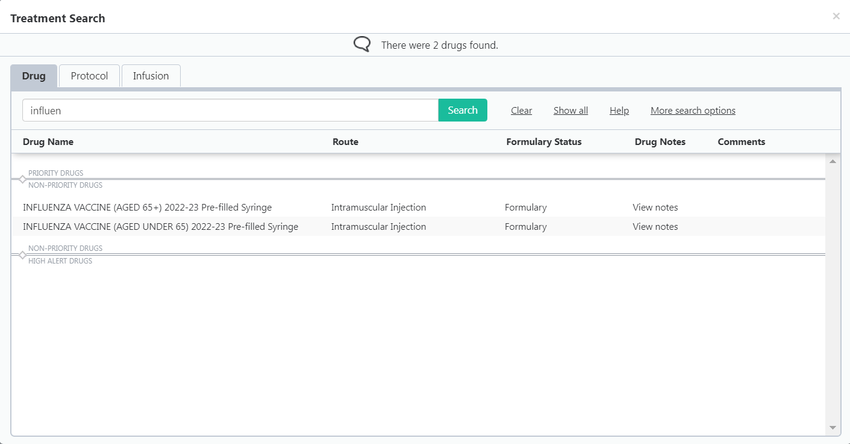

Step 2: Once the appropriate vaccine has been selected, a ‘drug note’ will appear with guidance. It is essential that this note is read thoroughly, and all guidance is followed. It is a mandatory requirement that the requested information is recorded as a progress note in RIO and the vaccination is also recorded in NIVS (see appendix 3 below for info on NIVS).

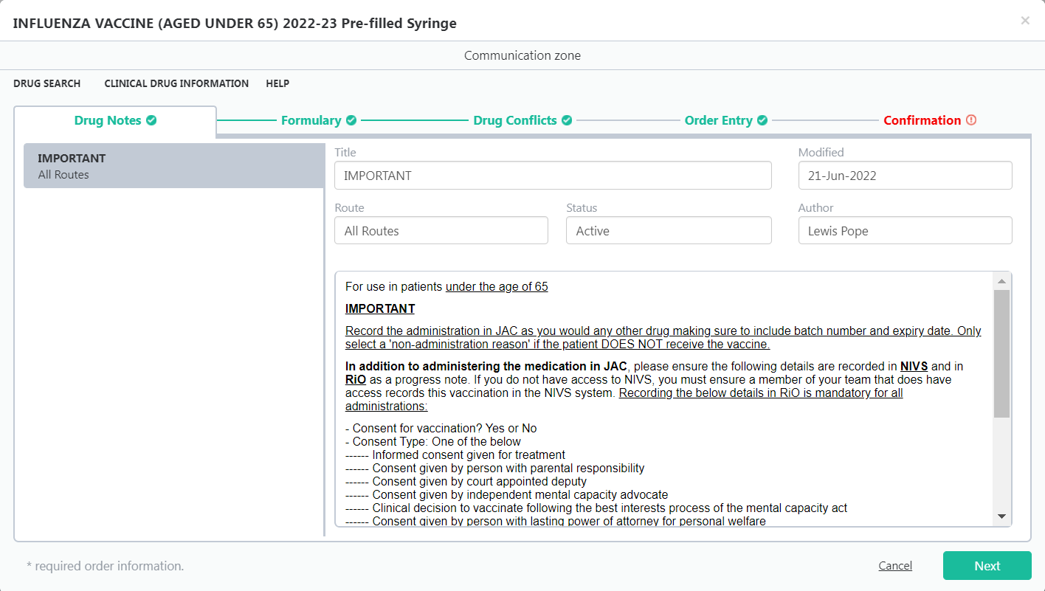

Step 3: The vaccine will default to be a 'STAT Order'. This STAT order will default to be given at the date and time of prescribing. This can be changed and set to a future date/time e.g. if the prescriber wants the vaccine given tomorrow or next week. It is important to take supply of the vaccine into account when prescribing.

Important Information

The screenshot below shows the vaccine having been administered at 16:46 on 7th Nov 2019. It will remain in the 'Inpatient Rx' tab until the end of the day (i.e. 23:59) after which it will go to the 'Discontinued Rx' tab. If the prescriber tries to prescribe the influenza vaccine again on the same day, a warning alert will pop up saying the patient has already received this medication. The prescriber will not get a warning alert if the vaccine is prescribed on the following day after receiving the first dose and thereafter.

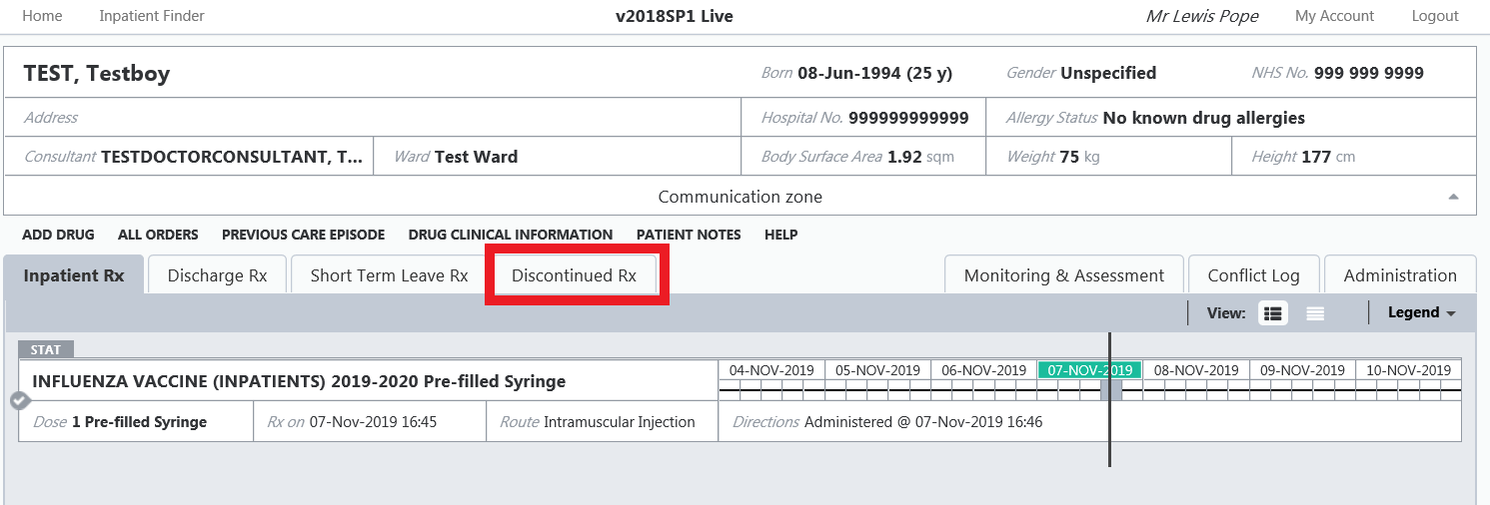

Therefore, it is strongly recommended that the prescriber checks the 'Discontinued Rx' tab in order to check whether the patient has already received the influenza vaccine before prescribing.

It is important that the supply of the vaccine to the ward is taken into account when prescribing i.e. if the vaccine needs to be ordered by pharmacy and will arrive on the ward the following day, ensure the dose is prescribed to be administered on that day or after.

Appendix 3: How to record the influenza vaccine on NIVS

Step 1: Sign in with your NHS.net email and your password
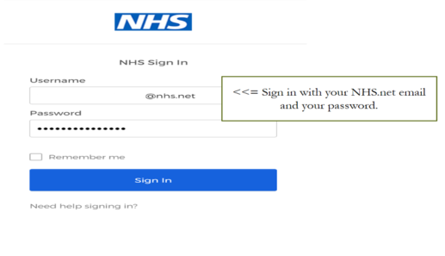
Step 2: Select the “Vaccinator location” icon
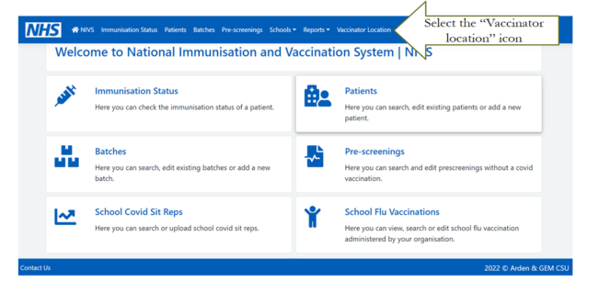
Step 3: Type in/select East London NHS Trust from the drop down
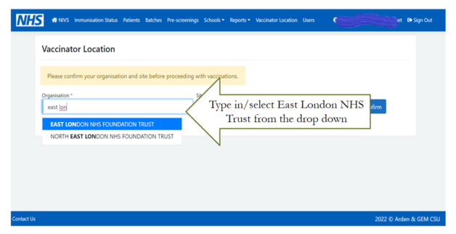

Step 4: Select your vaccination site. This is dependent on the selected organisation

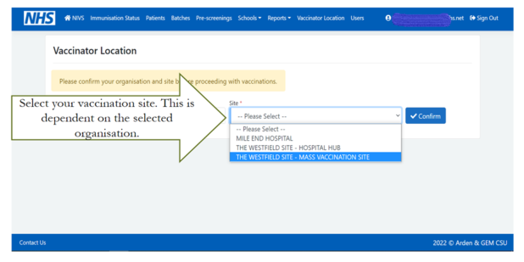

Step 5: Search Patients. Type NHS number and click “search” – circle in red. If no NHS number available, then fill with patient name, DOB, postcode and click “search” – circle in red.
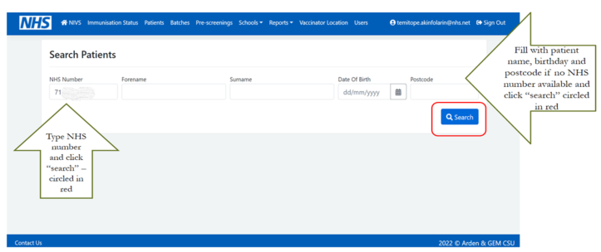

Step 6: If the search returns with no patient information, then select “New Patient”. Click the “Edit” option highlighted in blue

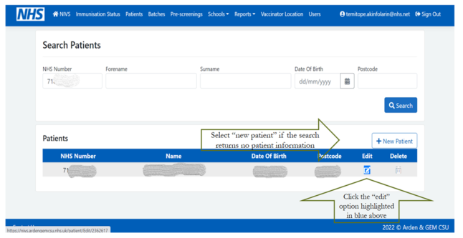
Step 7: If adding new patient with NHS numbers, type NHS number in the bar and click the “search” option circled in red. Confirm the information returned in your search or fill in the required information, scroll down and click “save”

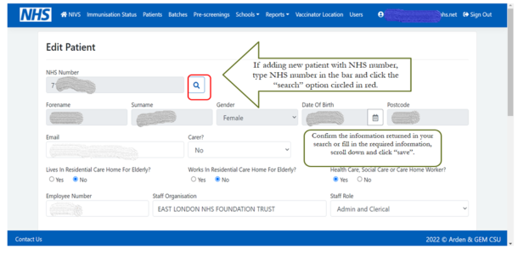

Step 8: Confirm the information returned in your search or fill in the required information, scroll down and click “save”. Then select the “New Flu Vaccination” tab

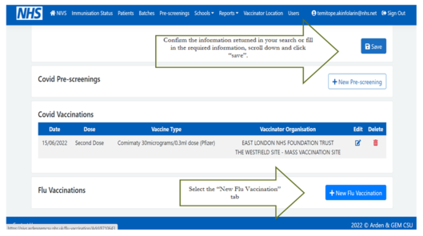

Step 9: Confirm patient’s consent and “consent type” and provide responses to the YES/NO questions. Fill in vaccinator name/surname – as required

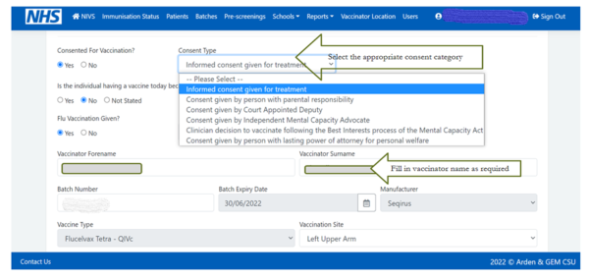
Step 10: Select the appropriate date and provide responses to the YES/NO questions.
Then select the correct batch number from the drop down menu. This will automatically populate the expiry date, manufacturer fields and vaccine type – as applicable.

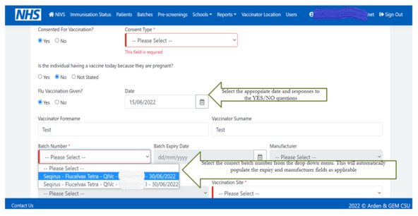

Step 11: Select the vaccination site

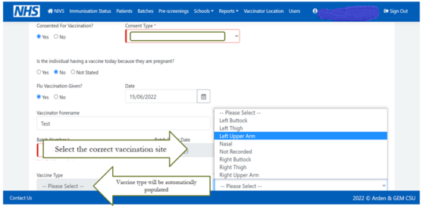

Step 12: Cross check the information and click “save”, if correct

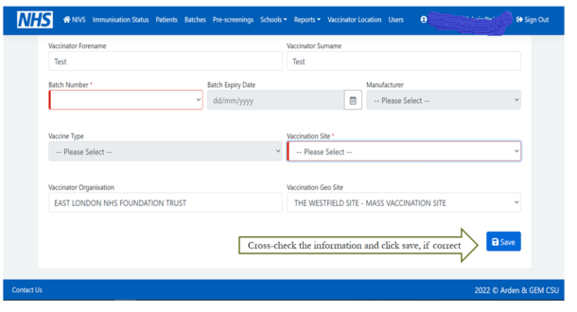

Step 13: Once you click “Save”, you should be returned to this page with the flu vaccination displaying as below



