Community Health Newham Directorate
Referral and Assessment Team (R.A.T) Standard Operational Policy

Version number : | 1.0
Consultation Groups | CHN Extended Primary Care Services  Discharge Co-ordinators,  BARTS Health, Newham University Hospital  Specialist Nursing Teams Specialist Therapies Team Director, CHN Services NUHT Director of operations Telehealth Team  GP Federation
Approved by (Sponsor Group) | Directorate Management Team, Community Health Newham (CHN) Directorate
Ratified by: | Quality Committee
Date ratified: | October 2022
Name of originator/author: | Ugomma Wright, Clinical Lead
Executive Director lead :
Implementation Date : | October 2022
Last Review Date | October 2022
Next Review date: | October 2025

Services | Applicable
Trustwide
Mental Health and LD
Community Health Services | X

Version Control Summary

Version | Date | Author | Status | Comment
1 | 14/09/2022 | Ugomma Wright | final

Contents

Contents 5
- Introduction 7
  - Key Principles 7
  - Operational Model 8
- Referral and Admission 8
  - The Referral Process and contacting the RAT 9
- Referral and Assessment Team (R.A.T) 9
  - Inbound Referrals 9
  - Clinical Triage 9
  - Initial holistic Assessment 10
  - Documentation and Care Planning 10
  - Informal Carers 11
  - Pressure Ulcer Prevention and Management Documentation 11
  - Handover 12
  - Discharge 12
    - Mechanism for Discharge from the Referral and Assessment Team 12 3.9 Access Issues 12
- Roles and Responsibilities 13
  - Clinical Lead 13
  - AHP and RN Leads 13
  - Senior Community Nurses/Occupational Therapists/Physiotherapists 13
- Location of Services and operating hours 13
  - Operating hours 13
- Services Eligibility Criteria 14
- Staffing Structure and operational management 14
- Conduct and professional responsibility 14
  - Conduct for staff working in Peoples’ homes 14
  - Conduct between professionals 15
- Communication 15
  - Key principle 15
  - Communication within the multi-disciplinary team 15
  - Communication with professions outside of the RAT and Planned Care Service 16
- Electronic EMIS Record 16
- Provision of equipment 17
  - Key principle 17
- Safeguarding and Mental Capacity 18
  - Principle 18
  - Mental Capacity Assessment (MCA) 18
- Performance Data Recording Capture 19
  - Key Principle 19
- Surge and Business Continuity Planning 19
- Clinical Governance 19
  - Key Principle 19
  - Clinical Governance 19
21. APPENDICES 20
Appendix A 20
Appendix C 22

- Introduction
The key function of the Referral and Assessment Team (R.A.T.) is to provide a holistic initial assessment of all new episodes of care referred to the Extended Primary Care Teams (EPCT) – Planned Care. The R.A.T will ensure thorough and holistic assessments are undertaken, identify care needs, complete required actions such as equipment ordering, onward referrals and completing a detailed care plan for all patients who will require ongoing care. The R.A.T will care for patients within the community, in their own residence including residential homes and will escalate to the Rapid Response (Unplanned care) where it is required to prevent a hospital admission where appropriate. The R.A.T will also fulfil the clinical triage component for all referrals to the EPCT Services.
The aim of the R.A.T, is to provide outstanding care, creating a seamless patient journey/experience. This will be achieved through effective multidisciplinary team working, comprising of registered & unregistered Nurses, Occupational therapists and Physiotherapists.
The R.A.T will work collaboratively with wider health & social care organisations, service users and careers.
This Procedure covers the general principles pertaining to the operation of the R.A.T.

Key Principles

The R.A.T team will coordinate short episodes of care, working collaboratively with community partners utilising population health, health promotion & education.
The R.A.T is a multidisciplinary lead team with each member performing distinct roles with discipline specific responsibilities. This will include facilitating holistic assessments with patients / family & careers to identify and anticipate future care needs, including onward referrals.
Each professional will follow and adhere to their respective professional code of conduct, e.g., Nursing & Midwifery Council (NMC), Health and Care Professionals council (HCPC) including upholding the Trust policies, values and guidelines.

Operational Model

The R.A.T is responsible for completing initial holistic assessments for all new episodes of care referred to the EPCT teams. This includes contacting all patients discharged under the Discharge to Access Pathway (D2A) in line with R.A.T scope of practice within 24 hours (Welfare check). The welfare check will ensure the patient is safe at home following hospital discharge including that patients have provisions i.e. food to remain safe and well at home.
Following the initial holistic assessment, patients’ needs will be identified, care plans will be created and onward referrals will be completed. Linked episodes of care will be created as the patient is handed over to the care of one of the four Extended Primary Care Teams (EPCT) that forms the Planned Care Service.
This model of delivery is based on the principle of “right care, right time and right place”. It reflects the philosophy that providing the right kind of care and support to help people manage their existing long-term conditions from the onset and provide support to help them through any exacerbation of that condition is the surest way to avoid them being admitted into hospital – Appendix A – Flow Chart linking patients flow through the EPCT Services.

Referral and Admission

All referrals to the EPCT are processed by the Single Point of Access (SPA). The referrals are screened and assigned for an assessment within 24 hours based on their clinical need by the RAT, as a component of the Integrated Discharge Hub (IDH).
The RAT will complete the initial holistic assessment, onward referrals and all relevant documentation completed on EMIS including care plans, handheld records left in the patients’ residence within 24 hours of contact with patient. This will include ordering all required equipment. The case will then be handed to the Planned Care Team who will plan and arrange subsequent visits.
The RAT will not routinely deal with referrals for the Unplanned Care Service.

Referrals to Rapid Response (RR) & Fast Falls (FF) will be through the Single Point of Access (SPA) with calls being transferred to a clinician for triage within the RR & FS. However, where clinically required to prevent a hospital admission the triage function with IDH and RAT will refer patients to RR & FS Service as appropriate.

The Referral Process and contacting the RAT
There is a single telephone number for SPA 0208 709 5555. The line is managed by dedicated administrators between 0800 and 2000. The telephone line is automatically diverted to the Clinical Lead on call between 2000 to 0800 hours (for telephone advice/signposting). All contact with staff will be through the number as well.
All non-acute hospital referrals to the EPCT teams are processed through the SPA. Referrals are received by emails on epct.spa@nhs.net

Referral and Assessment Team (R.A.T)

Inbound Referrals
SPA administrative staff are responsible for checking that all relevant information is recorded on the referral, including NHS number, GP, full address, access to the patient and mobility status (housebound, temporarily housebound, mobile/ambulant), as well as any known risks.
Administrative staff will cross-reference for existing episode of care (referral) within any of the planned care service (EPCT). If this is the case, the administrative staff will create a linked episode referral and send a task to the relevant team. For example, a referral has been received for a patient needing nursing care from the DN team however, they are open to the Physio team. The admin will in this case, create a linked episode of care and send a task to the DN team to review and assess the patient as a new episode of care.
If there is no open episode of care to the EPCT Planned Care Service, administrative staff will send the referral to the inbound referrals folder for clinical triage.

Clinical Triage
The RAT are responsible for clinical triage, which is seated within the IDH service based in Newham University Hospital (NUH). The clinical triage component will clinically triage all referrals from primary care, acute hospitals, self-referrals and inter-team referrals from within the Trust. The role of the clinical triage is to ensure that all clinical information that is required for a holistic initial assessment are provided in the referral. They will also confirm all demographics as screened by the SPA are accurate and where information is missing, will liaise with primary and secondary care to complete. The

clinical reasoning and decisions making process will be documented in the patient’s electronic records. Where referrals are rejected, the reasoning for rejection will always, be documented and the electronic patient record and referrer will be informed. The clinical triage function will allocate all patients to be seen by the clinicians within the RAT as appropriate to do so.

Initial holistic Assessment
All patients will have their initial (1st) assessment completed by the RAT with a completed patient handheld record being left in the patient’s residence
The team will complete a detailed initial holistic assessment for all new referrals which will be followed by appropriate assessment templates and care plans being completed within 24 hours of the assessment taking place. Patients who require ongoing care the RAT team will liaise with the relevant service to create a seamless pathway of care. The RAT will ensure that all required care plans, prescriptions, referrals and equipment will be provided before the relevant team continue care. Relevant templates / referrals are to be completed before any patients are handed over to the relevant professionals and teams.

Documentation and Care Planning
All record keeping should be in accordance with Trust Policy and Professional Codes. All records will be written within 24 hours of the event – for all direct and non-direct contacts.
All members of the R.A.T will be provided a computer tablet equipped with EMIS mobile. This will ensure that real time assessments are documented on the patient’s records as they happen.
The initial assessment template will always be used. All mandatory fields of the initial assessment template must be adequately completed. Special attention should be paid to the risk assessment and plans should be made if risks are identified in order to protect both staff and patients. The focus is holistic, and is based on the clinical judgment of the practitioner using assessment data collected from the initial assessment.
Upon completion of the patient’s visits all documentation, care plans, schedules prescriptions and equipment orders MUST be completed within 24 hours and ready for

handover the following day. Although flexibility will occur dependant on case complexity and patient need.
Formal Carers and Shared Care Agreement

Where formal carers subcontracted by London Borough of Newham will be engaged although RAT may not provide ongoing support. While the RAT are still having input they will ensure any ongoing services adhere to the shared care agreement, which includes
- Implementation of the Shared Care Agreement (copy in patients hand held record): Carrying out training such as monitoring skin for pressure areas and escalating any concerns
- Proactively obtaining progress updates or information from formal carers about patients
- Giving advice on care activities

Informal Carers

Where the patient, their family or friends wish to provide care for patients under the care of the RAT and subsequently the Planned Care Extended Primary Care Services, the service acknowledges a responsibility to ensure that there is effective liaison. This includes
- Monitoring that care activities carried out are of sufficient standard to always safeguard the well-being and safety of the patient
- Carrying out training i.e., monitoring skin for pressure areas and escalating any concerns
- Carrying out training for specific care
- Obtaining contact details for those carers that do not live on the same premises as the patient
- Proactively obtaining progress updates or information from formal carers about patients

Pressure Ulcer Prevention and Management Documentation

Please refer to the Integrated Pressure Ulcer Action Plan.

Any assessment that meets the criteria will be referred to the PUIF by the visiting clinician of the R.A.T

Handover
The RAT will conduct daily face-to-face handovers with all the four teams that make up the Planned Care Service. This handover will occur at 09.00am every day inclusive of weekends. Prior to handover, the handover template must be completed on EMIS for each patient by the visiting clinician.
The handover will take place using the SBAR method and is expected to be concise lasting no more than 45 to 60 minutes.
Attendance of the handover will be compulsory with two representatives of the R.A.T (ideally a nurse and an AHP) and the charge Nurse and AHP representatives of each locality that make up the Planned Care Service.

Discharge
The RAT will keep patients on their caseload as clinically required, up to a maximum of 48 hours from the date of the initial assessment, unless as noted previously the case has complexity or patient need that may require a delay in discharge

Mechanism for Discharge from the Referral and Assessment Team
From the commencement of treatment on the RAT and throughout the course of the team’s intervention, the MDT will assess and discuss the likely point at which discharge will take place; this will be documented on the patient’s record.
Discharge planning takes into consideration the need for referral to other statutory and voluntary services. Staff must be proficient in identifying specific individual client needs and be committed to ensuring high quality arrangements with other local services.
In the circumstance whereby the patient is not transferred to EPCT Planned Care Services but is discharged from the RAT back to the care of their GP, discharge arrangements will be according to the Community Health Newham Discharge and Transfer Policy, whereby a discharge letter is sent within 24 hours to the GP and the patient is issued with a copy.

Access Issues

Where care activities cannot be carried out as scheduled because members of the RAT cannot gain access, they will follow the No Access Action Protocol (Appendix C).

Roles and Responsibilities

Clinical Lead
The clinical lead is clinically and operationally responsible for ensuring the efficient day- to-day running of them team which includes allocation of patients and resource management. The Deputy Lead Nurse (Planned care) will support the clinical lead in fulfilling their role. The clinical lead where clinically required will attend joint visits and support in the management of complexes cases on the teams. The Clinical Lead will monitor allocation of work done by the band 7 leads and ensure that work is allocated with equity and fairness as required and appropriate.

AHP and RN Leads
The Lead RN and AHP within the team are responsible for the caseload, and allocation of clinical task – please reference the EPCT Review and Caseload management guidance.

Senior Community Nurses/Occupational Therapists/Physiotherapists
The band 6 Clinicians are responsible for visiting all allocated new patients and completing all assessments as is required of their role within RAT.
The band 6 clinicians will provide support to the band 7 team leads as required. They will also be rostered into the Triage shifts at IDH and co-ordinating the shifts.
A shift coordinator must complete allocation of visits at the ned of every shift

Location of Services and operating hours

The RAT are based on the second floor of East Ham Care Centre (EHCC). The IDH are based at Newham University Hospital, BARTS Health.

Operating hours

The RAT will operate a 7 day, 365 days a year service within the hours of 0800 – 2000. There are 2 shift patterns: 0800 – 1600 and 1200 – 2000. There will be however, the option of extended hours in line with the Trust Work Life Balance Policy. Approval for extended working hours will be at the discretion of the Clinical Lead.
Between the hours of 2000 and 0800, there is a clinical lead on call - 7 days a week.

Services Eligibility Criteria

The RAT will accept referrals for all Newham residents registered with a Newham GP. Residents must be 18 years old and above.
For Planned Care, urgent referrals will receive a response within 24 hours; non-urgent referrals will be contacted within 72hours or when the clinical input is due.
All RAT Staff will be contacted via the SPA on 0208 709 5555.

District Nursing is usually reserved for individuals who are over 18 years, are Newham residents and housebound – that is they can only leave the house by ambulance, or there should be some other reason why a home visit is deemed necessary. District Nurses cannot carry out ‘welfare check’ visits; the RAT will do this for patients under the D2A pathway. All referred patients must have a recognised nursing need. For referrals to Therapists, the patient would not necessarily be housebound, however, must have rehabilitation potential and is motivated to participate in rehabilitation programmes.
RAT will not usually offer specific appointment times, but a time band may be offered to patients. Time bands will be either am/mornings (0800 – 1200), pm/afternoons (1200
– 1600) or evenings 1600 – 2000) PM.

RAT is not an emergency service. Clinicians of the RAT will not collect prescriptions or delivery of equipment; this should be done by family/carers or delivered by pharmacists and equipment store as appropriate. Except in exceptional circumstances such as end of life patients without a family member.

Staffing Structure and operational management

See appendix B

Conduct and professional responsibility

Conduct for staff working in Peoples’ homes

Staff will wear badges indicating their name and role at all times when carrying out duties for Community Health Newham Directorate.
All clinical staff will be in uniform in line with the CHN Uniform policy/guidance at all times and for all roles including clinical triage. A professional presentation will be maintained all times in line with existing policy on dress code in community settings.

ALL staff will be expected to act in line with the Trust policies and their individual Professional codes and standards at all times.
Staff will ensure home based visits are planned in advance, in agreement with the patients and their carers. Where visits are cancelled for any reason, staff will, unless good grounds for exception exist, provide clear notice to patients and other professionals and this will be documented in the Electronic Patient Record.

Conduct between professionals

Relationships at all times within the multi-disciplinary team will be directed toward meeting the key objectives of the service and needs of patients at all times.
Formal multi-disciplinary team meetings and handover meetings will provide a formal arena for clinical problem solving, sharing best practice, assessment and discharge. All staff will conduct themselves in line with the Trust polices and their professional codes of conducts at all times.

Communication

Key principle

Communication between staff employed in the RAT, and other professionals working in collaboration with each of the multi-disciplinary teams will be central to its success.
This will equally apply where inclusion of other statutory, voluntary and private sector providers becomes a pre-requisite in ensuring long term care and support goals are met beyond the period of acute phase of interventions previously delivered through EPCT or secondary care.

Communication within the multi-disciplinary team

RAT is an MDT lead team with key care decisions for assessment and onward referral being made through MDT discussion. The views of each professional discipline will be sought in identifying the appropriate package of care and any potential ‘step up’ to RR
/ FF or other specialist service. These clinical discussions and decisions will always be documented on EMIS and in the patient’s records.
Handover is a significant element of care delivery; all patient information will be handed over in a timely manner using SBAR. Where care is being transferred between teams e.g., when a patient is in crisis, being cared for by Planned Care and RR & FS service,

there will be a verbal handover also being documented in the patients electronic records.

Communication with professions outside of the RAT and Planned Care Service
Community Health Newham recognises that the success and the broader sustainability of the Extended Primary Care Services will be co-dependent on the input and support of other organisations and agencies.
Key agencies central to the successful delivery of the service will include though not exclusively:
- London Borough of Newham Adult Services
- Newham GPs and PCN members
- Clinical Commissioning Group Clusters
- BARTS Health Trust
- Other directorates in ELFT
- Enabled Living
- Newham Voluntary Sector
- Other Community Health Newham specialist service providers
All members of the RAT will work collaboratively with other professionals and agencies to ensure appropriate support is offered and delivered to clients, their families and carers. Responsibility will rest with the Clinical Lead and other team members to identify key individuals responsible for maintaining these links, working relationships and problem resolution for each of its key partners from within their operation field of responsibility.

Electronic EMIS Record

The electronic EMIS record is the health care record used for all patients admitted to the Extended Primary Care Services. All visits and care interventions will be documented in the EMIS record on either the same day but no later than 24 hours, all healthcare records need to be comprehensive enough to facilitate appropriate care by all EPCT services team members as well as other CHN services.
Where temporary staff have carried out care and do not have access to EMIS, the Team Leader will ensure that such staff are buddied up with a team member with EMIS access

and ensure that a healthcare record is completed for each care episode carried out by the temporary member of staff.
All direct and non-direct encounters with patients, their carers or family member will be documented in the patient’s record on EMIS.

Provision of equipment

Key principle

The provision of supplementary services for the provision of medication, diagnostics, pharmaceutical supplies and equipment is critical to developing a sustainable model of delivery for clinical interventions enabled through the Extended Primary Care Services. Each plays an essential role in supporting these interventions from within the multi- disciplinary teams and the broader goal of reducing the need for a hospital bed.
The central provider of equipment to the RAT will be the Enabled Living.

Equipment will be ordered where there is a clear clinical need. For patients discharged from the Acute Hospital this will be done prior to discharge or at initial assessment by the RAT. In the course of care provision, if an equipment is required the orders will be placed on the electronic system within 24 hours of the need being identified though the Equipment officers or AHPs who have access to the equipment ordering system as appropriate.
Where specialised equipment is not available, the practitioner will identify what alternative equipment can be safely used in the interim and ensure that additional care interventions are documented on the care plan. In addition, that this is escalated to the Clinical Lead and other related teams and services such as the Tissue Viability Team.
Once installed, relevant members of the Extended Primary Care Team Services have a duty to ensure that the equipment is fully functional and evaluated that the patient’s needs are met as set out in the care plan, including explaining and demonstrating how to safely use any equipment. Where this is not the case, a new assessment will be made, and alternative solutions identified.
Staff from the Extended Primary Care Service should check that equipment is functioning on each visit and any fault should be reported to Enabled Living.

Equipment lent to the patient will be ordered from Enabled Living Service via the electronic ordering system ELMS or purchased by the patient if a patient does not meet the necessary criteria for a loan. Where there is no longer a clinical need for equipment it will be collected by the Enabled Living Service, either through patients and carers contacting the service directly or through members of the multi-disciplinary team entering a request on ELMS. This should be done in a timely fashion in order for it to be available for re-use.

Safeguarding and Mental Capacity

Principle

The need for Referral and Assessment Team staff to have awareness of the vulnerability of patients to become the victims of abuse and neglect.
The Trust Safeguarding Vulnerable Adults at Risk Policy provides guidance for staff. Where abuse or neglect is identified or suspected, this must be immediately reported on the Datix incident database and a Safeguarding Adults Alert (SA01) completed and forwarded to the London Borough of Newham, a copy of the submitted forms must be saved on the patient’s electronic record. Patients may need to be moved to safety or arrangements put in place that create a safe environment and safeguards their physical and emotional wellbeing.

Mental Capacity Assessment (MCA)

The Trust’s Consent to Treatment Policy provides guidance on when a patient’s ability to make decisions needs to be assessed. It must be remembered that a person should always be assumed to have capacity until proven otherwise. Making an unwise decision does not demonstrate a lack of capacity. If a lack of Capacity is suspected a Mental Capacity assessment should be performed.
Where a MCA has been performed and the patient has capacity, the clinician needs to proceed as described above and explore alternative solutions. All MCA will be completed using the MCA template on the patients’ electronic records (EMIS).
Where the mental capacity assessment shows that the patient does not have capacity to make the particular decision regarding their care and/ or, the Consent to Treatment Policy must to be followed to ensure that the patient’s interests are maintained. The trust has a mental health law team who are available to provide further expert advice

and support regarding the use of the mental capacity act in clinical practice. They can be contacted on 02076554046

Performance Data Recording Capture

Key Principle

KPI’s and CQUINS are reviewed yearly. Performance data will be collected from the electronic systems. All staff should provide information as required. Clinical Leads should be aware of the KPI’s.

Surge and Business Continuity Planning

See EPCT Business Continuity Plan.

Clinical Governance

Key Principle

The Extended Primary Care Services recognises that in order to deliver safe and effective care and support continuous service improvement, both the Extended Primary Care Services will fully engage with the Trust’s Clinical Governance Strategy and the Trust’s Quality Improvement Initiative.

Clinical Governance

The RAT will participate with Trust wide audits, develop, and implement remedial action plans where shortfalls have been identified.
The RAT will develop an annual local audit calendar that is tailored to specific activities or issues identified within the Extended Primary Care Services and implement remedial action plans where shortfalls have been identified.
The Clinical Lead will lead on audits, action plans and facilitate service improvements.

The Clinical Lead will be leading on evaluating patient feedback (PROMS and PREMs) with their teams, identify, and implement remedial actions.
The Locality General Manager will gain assurance from the Clinical Lead that action plans have been implemented.

21. APPENDICES

Appendix A
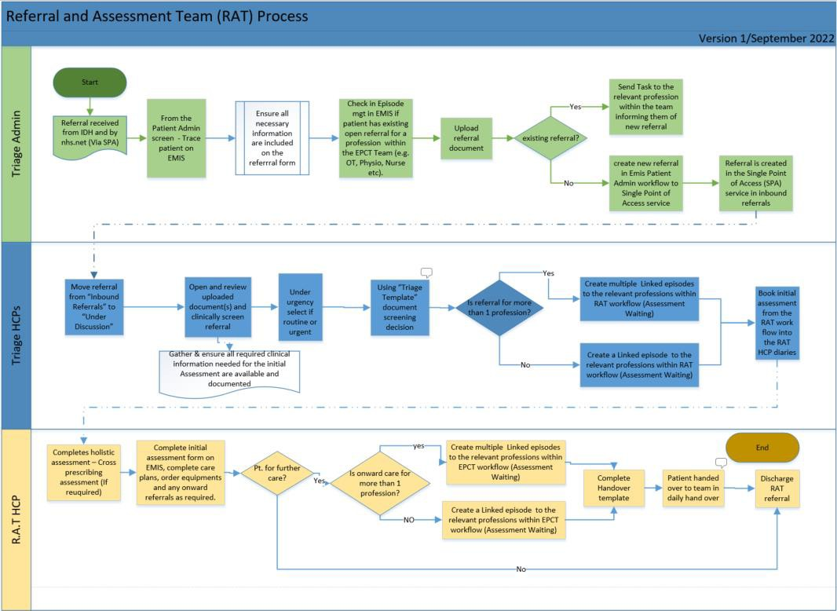

Appendix B
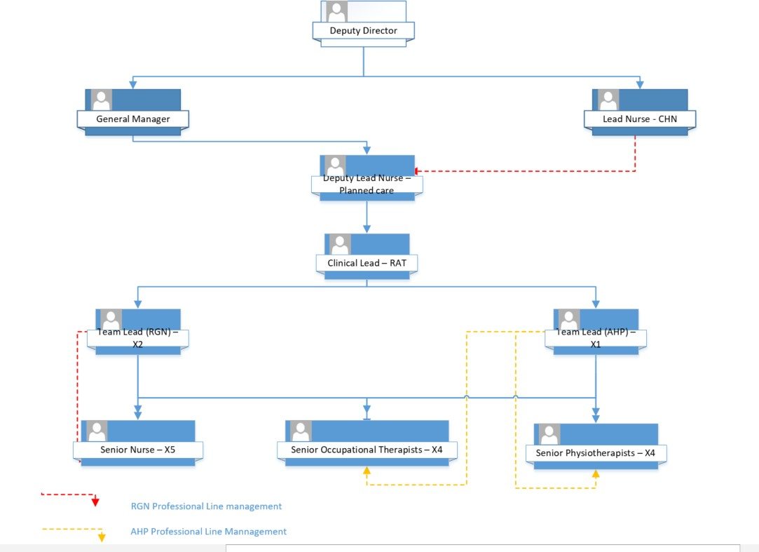

Ascertain whether there are any signs of presence of somebody by looking through windows/letterbox, speak to warden/next of kin/neighbours. Check whether post/milk/papers have been colected

Inform Team Leader and Clinical Lead

Ascertain information on patient's whereabouts: GP/next of kin/hospital etc

Contact Police and request a safety check

W
i t h i n 2
h o u r s

Appendix C

Unexpected Access Problems Protocol
Arranged visit - no response, unable to access
W
i t h i n 1
h o u r

T
o t a l

3

H
o u r s

