How to create accessible PDFs in Microsoft Word

Introduction
This document will show you how to make Accessible PDFs in Microsoft Word. The Accessibility Regulation (2018) places a lawful duty on Public Sector bodies, which includes our Trust, to produce accessible content for our website and intranet.
We must now make sure that any documents uploaded to our website and intranet complies with WCAG 2.1 AA accessibility standards. This guide is to help ensure they meet the new accessibility regulation.
But first, can you publish in an alternative format to Microsoft Word? For example:
- On a web page
- Open doc format
If you think your content can be published on to web page instead, please do so. Contact the Communications and Engagement Department for more advice and they will guide you through the process.

Basics: the title
Every document you create should have the correct properties (title, tags, author) filled in. This helps screen readers identify documents and also for search purposes on our website or intranet.
- A user-friendly title
- tags for headings and tables
- alternative ‘alt’ text on images

Add document title, author and keywords

Choose file from the menu. On the right you will see a content area similar to the one below.
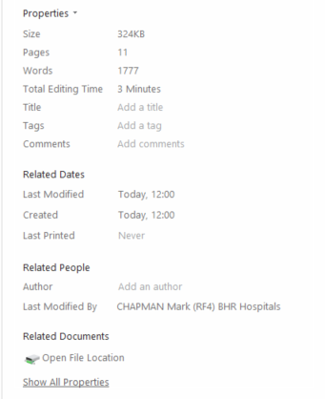

- Fill in the title of the document in the Title box.
- If there is a name in the author box, right click it and select ‘Remove Person’. Enter “Barking Havering and Redbridge University Hospitals NHS Trust”.
- Add around five related keywords to the Tags box, all separated by a comma. Include your department name.
- Click Save on the left hand menu to save your file.

Accessible layout in Word

Use heading tags
Heading tags set out document structure. This means those with visual impairments can use a screen reader and tab their way through documents. It also ensures that the tables of contents function properly. Avoid using bold or larger font text to create headers, this means screen readers cannot use a document’s structure to navigate the file.

Below are the BHRUT styles for our heading types:
Title
Arial Narrow Bold, 30pt

Heading 1
Calibri Bold, 18pt

Heading 2
Calibri Bold, 14pt

Heading 3
Calibri Bold, 12pt

To set up your heading tags, complete these steps:
- Highlight the sample heading copy.
- Right-click the matching heading in the Styles toolbar (pictured below).
- Select ‘Update to match selection’.
- Repeat for the other headings. Your Styles toolbar should look similar to the graphic below.

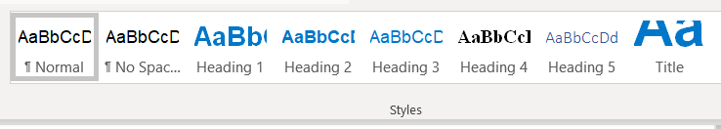

Use headings in copy
To turn a line of copy into a heading, simply highlight it and click the heading you want it to be.
Headings should follow a structure order:
- Use Title for the title of your document
- Use H1 for a section title
- Use H2 for a sub-section title under an H1
- Use H3 for a sub-section title under an H2

An example: Large Box Policy
In this example, Large Box Policy is tagged with Title as it is the title of the page.

Prices and sizes
Prices and sizes is tagged H1 as it is a section title

Prices
Prices is tagged H2 as it is a section under Prices and sizes

Small
Small is tagged H3 as it is a section under Prices.

Label your pages with contents and page numbers
Using heading tags will make it easier to create a table of contents. A contents list is important to make a document more user-friendly and clear. The reader will be able to see at a glance the titles of all the sections, and navigate to the one they need.
If you have used heading tags, complete the following steps to create a contents list. Do this once you have finished your document:

- Click References in the toolbar
- Select Table of Contents
- Choose Automatic Table 1
Your table should automatically format. You can make amends to it manually.

Use alt text for images and scans
Your document may include images and scans that improve a reader’s understanding of the content.

Examples of appropriate images are:

- A car park permit
- A scan of King George Hospital map
- A walking route map around Queen’s Hospital
If you have an image on your document, please add alternative text to it so that its contents can be shared with people who are visually impaired.
To add alt text, complete the following steps:

- Right click the image
- Select Format picture, then choose Alt text and type in the text field. You do not need
- to type ‘Picture of’ or ‘Image of’ at the start
- Aim to make your alt text short and clear

Good Alt text for the above examples are:

- A blue Annual Parking permit with an arrow pointing to the expiry date.
- A map of King George Hospital with the boundaries marked out
- A circular walking route around Queen’s Hospital
Do not use pictures that have text on them. The text will not be read by screen readers.

Creating whitespace
If you tend to hit "Tab" or "Enter" over and over again to create formatting you want - kick the habit. This makes the content you create inaccessible. White space is identified by a screen reader as “blank”. This might give users with impairments the impression that the document has ended if they hear this repeatedly.

Instead, use document formatting. Choose indentations, line spacing, and Styles to create the effect you want.

Tables
Tables are great for data, but when they’re read by a screen reader, they can confuse. Keep that in mind. All tables need to be set up so they are accessible using screen readers. There are three things you can do to achieve this.

Check Header Rows are ticked
When you insert a table, look to the top right corner of the Table tools/Design panel and check that the Header Row box is ticked.
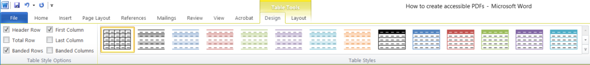

Repeat your column headings if your table is on multiple pages
Right-click your table and select Table Properties, Row, then tick Repeat as header row at top of each page. Untick the Allow row to break across pages box.
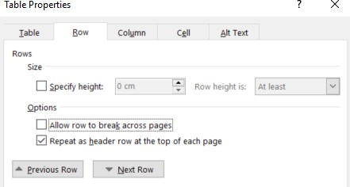

Add Alt text to describe your table
When you have created your table, right-click and select Table Properties. Add a title and a description of the content of the table.
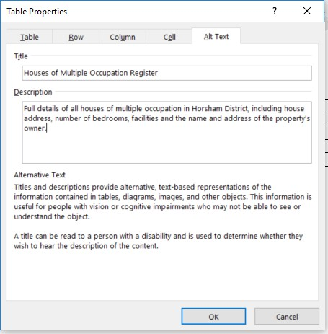

Adding alt text
All images in a document must have alternative text on them so that the images can be recognised by screen readers and read out if need be.
There are two options for images in documents:

- If the image is essential to understanding the document, add alt text. To do this, right click the image and select ‘Edit Alt Text’. Add a sentence explaining what is in the image. This makes sense for diagrams that indicate design features or images of products.
- If the image adds visual interest to the document but nothing more, you can mark it as decorative. To do this, right click the image and select ‘Edit Alt Text’. Tick the Mark as decorative box. This makes sense for images that are used purely to break up copy, such as images at the start of a chapter.

Enable accessibility settings when you generate the final PDF
Follow the steps below to turn your Word document into an accessible PDF:

- Select File, Export
- Click Create PDF
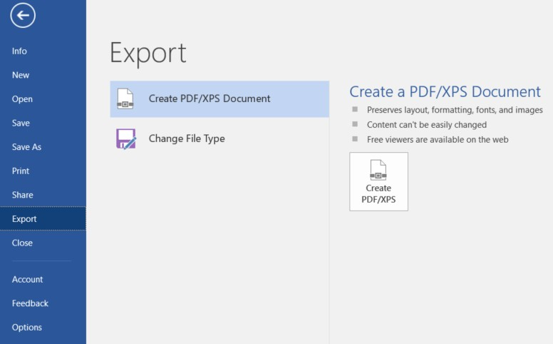

- The save screen will appear. Click the Options button.

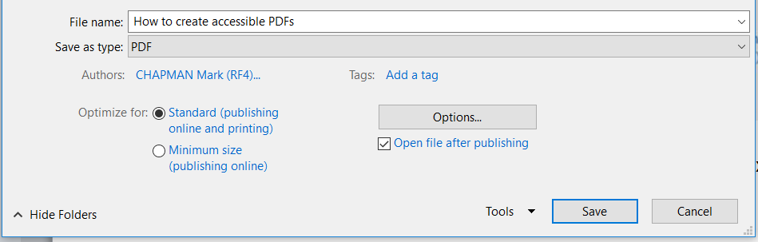

- Make sure both ‘Create bookmarks using headings’ box and ‘Document structure tags for accessibility’ box are both ticked.

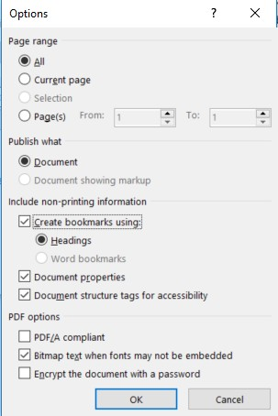

- Select OK and create your PDF.

