REPORT TO THE TRUST BOARD IN PUBLIC
24 November 2022

Title | Developing our Patient Safety Plan
Author | Dr Deborah Dover, Director of Patient Safety
Accountable Executive Director | Dr David Bridle, Interim Chief Medical Officer

Purpose of the report
To provide a first draft and invite board engagement with our new draft Patient Safety Plan, which aims to improve safety of patients and our workforce, via improvements in our safety systems and culture.

Committees/meetings where this item has been considered
Date | Committee/Meeting
07/11/22 | Quality Assurance Committee

Key messages
This plan outlines the main components that are envisaged as being part of our long-term Patient Safety Plan going forwards. These are grounded in the evidence-base around providing safer healthcare and take account of work already undertaken to improve safety within the trust. The plan is aligned with the NHS Patient Safety Strategy 2019 and the Trust strategy and incorporates recommendations from East London NHS Foundation Trust (ELFT) Safety review (2019) and learning from the international evidence base, patients, staff and stakeholders.

As well as outlining a longer-term plan, we propose three priorities for 2023-2024:
- Developing our safety insight, involvement and improvement by transitioning to the new Patient Safety Incident Response Framework (PSIRF);
- Engaging in national learning from Safety systems via transition to Learn From Patient Safety Events (LFPSE);
- Embedding of the NHS Patient Safety Syllabus.

Further co-design work with staff, patients and system partners is planned for the new year before a final version is agreed that combines the elements of safety that matter most to our people in combination with the latest evidence-base in the safety field.

Strategic priorities this paper supports
Improved population health outcomes | x | This is one of the primary drivers within the strategy and will have focus in years 2-3 onwards.
Improved experience of care | x | Safety and experience are strongly linked. Patient experience of safety is a key outcome for this plan.
Improved staff experience | x | Staff experience of safety is a key outcome for this plan.
Improved value | x | Safer care can bring significant reduction in costs to the organisation and individuals, which can be redirected to provide enhanced care for all.

Implications
Equality Analysis
Risk and Assurance | Enhanced focus on proactive risk identification, monitoring and response.
Service User/ Carer/Staff | Positive implications for staff and patients in delivering safer systems, services and culture of safety.
Financial | As above – significant cost savings by providing safer care.
Quality | Aims to improve quality by sustained and enhanced focus on safer care.

- Background/Introduction

  - Continuously improving safety is a central element of providing excellent patient care at ELFT and underpins delivery of our trust strategy.

  - Patient safety science has evolved over the last 20 years and there is now a clear evidence base regarding the elements that support safer care. Key elements include the safety culture(s), leadership, systems for learning & continuous improvement, application of reliability & systems thinking, just culture principles and human factors understanding.

  - This paper follows on from previous reports by the Chief Medical Officer, entitled Patient Safety - Going Forward, and presents an ambitious Patient Safety Plan for ELFT, which takes into account learning from the international and national evidence base.

  - Work done to date

  - Since 2013, the Chief Quality Officer at ELFT has led on the adoption of a systematic approach to understanding and solving complex safety issues, supported through our partnership with the Institute of Healthcare Improvement (IHI).

  - This work has led to greater involvement of staff, service users, carers and stakeholders in the identification of safety issues and application on Quality Improvement (QI) methodology to improvement.

  - Almost 5000 people have learnt skills in understanding and improving complex systems since 2014, and this programme continues to equip everyone with the skills and competencies to improve safety and quality. Safety improvement work has taken place in many high priority areas including violence reduction, pressure ulcer reduction and medicines safety.

  - Teams are now applying their improvement knowledge to other key areas such as improving therapeutic engagement, observation and physical health of those within in-patient settings.

  - Internal and external reviews of ELFT patient safety in 2018-2020, underpinned by the international evidence-base, have provided assurance of the current state of safety and also a clear picture of improvements that could be made.

  - The NHS Patient Safety Strategy

1.10.1 In 2019, the new NHS Patient Safety Strategy was launched, to support the NHS achieve its vision of continuously improving safety by building a strong patient safety culture and patient safety system.

1.10.2 The Trust has commenced work to deliver on the expectations of the strategy including the establishment of patient safety specialist roles within the organisation and promotion of core learning modules in Patient Safety.

1.10.3 Since 2021, national expectations have grown and the Trust is now mandated to deliver on four further core components:

- Adaptation of our reporting systems to align with and feed into the new national Learning from Patient Safety Events system;
- Transition to the Patient Safety Incident Response Framework (PSIRF);
- Delivery of the Patient Safety Syllabus;
- Engagement of dedicated patient role in safety, known as Patient Safety Partners.

1.11 A Safety Plan for ELFT

1.11.1 This draft Safety Plan for ELFT has been developed to deliver on the expectations of the NHS Patient Safety Strategy, and goes further to include evidence-based areas for improvement that are not included in the strategy.

1.11.2 In developing this plan, we are consulting with a wide range of staff, stakeholders and patients to understand what safety means to our people, the current status of safety, the gaps in our safety profile and the improvements they think are needed.

1.11.3 To supplement the extensive staff engagement work undertaken in 2018-2020, a further staff survey and exploration exercise plus a large patient focus group and survey have been commenced, exploring what matters to patients and staff in relation their safety and the improvements they think are needed. The data from both exercises has been used to inform this plan. Further stakeholder engagement is planned for the months ahead.

1.12 Patient Focus Group answers to “what safety means to me?”

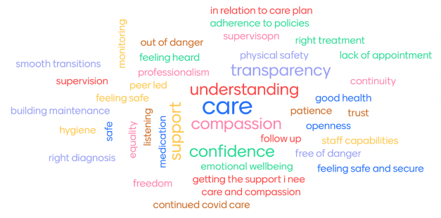

1.13 A Mission & Vision for Safety

1.13.1 Our Safety vision is to:
To become an organisation which provides the safest possible care for all our people, with a positive and equitable safety culture and where safety is everyone’s primary concern, underpinned by strong leadership, people participation and proactive learning, monitoring and improvement.

1.13.2 Our working mission is:
To provide the safest possible care for our patients, safest conditions for our staff and safest lives for those communities we serve.

1.13.3 We see these three factors as intrinsically interlinked and mutually dependent. Over the next few months, we will be refining this mission to ensure safety is defined by those we serve.

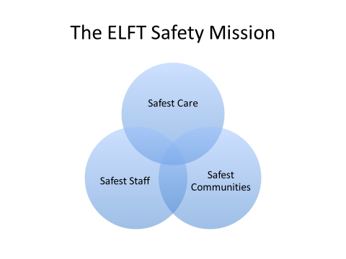

1.13.4 We have identified six primary drivers to achieve this mission.
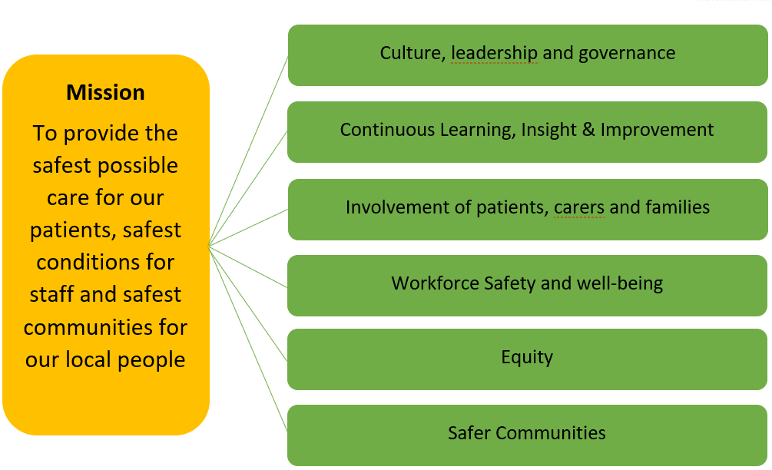

1.13.5 A further detailed driver diagram and implementation plan with key change ideas can be seen in appendix 1 and 2. The plan will undergo further refinement, iteration and co-creation by the people leading in each area as we go forwards.

2.0 Long Term Safety Plan Objectives

2.1 Culture, leadership & Governance

2.1.1 ELFT will:

- Use culture metrics like those in the NHS Staff Survey to understand the safety culture and focus on staff perceptions of the fairness and effectiveness of incident management
- Focus on the development and maintenance of a just culture by adopting the NHS Just Culture Guide or equivalent
- Embed the principles of a safety culture within and across the organisation, and align those efforts with work to ensure the organisation adheres to the well-led framework and its eight key lines of enquiry.
- Implement the patient safety syllabus to promote the right culture and behaviours – using the syllabus to help staff understand the systems approach to patient safety, learning from incidents, human factors and safety management, and creating safe systems
- Implement the national toolkit to address incivility toolkit [and the forthcoming safety culture guide].
- Implement the patient safety incident response framework to promote a restorative just culture that is fair and respectful for staff and patients
- Work with those responsible for quality, diversity and inclusion to ensure alignment to enhance the restorative just culture.

2.2 Continuous Learning & Improvement

2.2.1 ELFT will:

- Adopt and promote key safety measurement principles and use culture metrics to better understand how safe care is
- Support the trust to transition from the National Reporting and Learning System to the Learning from Patient Safety Events Service
- Introduce the Patient Safety Incident Response Framework to improve the response to, and investigation of incidents
- Engage with the medical examiner system to scrutinise deaths
- Improve the response to new and emerging risks, supported by the new National Patient Safety Alerts Committee
- Promote patient safety insight as an approach that incorporates understanding all sources of patient safety intelligence, including from incidents, risk assessments, investigations, litigation, mortality and morbidity reviews, inquests, research, clinical audits, GIRFT reviews, positive experience, compliments and complaints, litigation, patient and staff surveys, in line with the measurement principles set out in the NHS Patient Safety Strategy.
- Work with the existing informatics and business intelligence/analytics function to develop systems for patient safety insight. Ensure information and intelligence from these sources is used as the basis for prioritising local patient safety development and ensuring proposed improvement approaches are based on an understanding of underlying causes.
- Support the effective collation, analysis and presentation of qualitative and quantitative patient safety data and provide regular and tailored reports to all relevant committees, the organisation’s Board and external agencies as required, integrating these data sources to give a comprehensive and patient-centred picture of patient safety challenges, improvement opportunities and achievements

- Communicate patient safety issues at executive/board level, to a wide range of stakeholders both statutory and non-statutory across both ICBs and at a national level with patient safety specialist networks to low engagement and contribution to the national patient safety agenda.
- Contribute to multi-professional responses to patient safety incidents, tailoring the different approaches required for new or under-recognised issues and wider patient safety challenges needing long-term improvement, ensuring adherence to national policies and enabling timely and good quality reporting.
- Support the systems for the response to National Patient Safety Alerts, including systems for identification of clinical leaders for the coordinated cross-organisational delivery of each alert designated ‘complex’, and robust systems for Executive authorisation of “actions completed”.

2.3 Involvement of Patients, Carers and families

2.3.1 ELFT will:

- Establish principles and expectations for the involvement of patients, families, carers and other lay people in providing safer care
- Create patient safety partner roles (PSPs) to ensure the role of patients, their families and carers is a key part of the patient safety strategy; providing strategic advice, support risk, governance and quality oversight, help with service or pathway design and management, be involved in incident reporting and incident investigation
- Support the implementation of the patient safety syllabus, training and education framework for the trust
- Ensure people are equipped to learn from what goes well as well as to respond appropriately to things going wrong
- Ensure the whole healthcare system is involved in the safety agenda.

2.4 Improvement Focus

2.4.1 ELFT will continue to support the application of quality improvement in these areas building on work that has already taken place over many years:

- Continue to support the application of quality improvement and work with system partners to support safety improvement in priority areas, including Medicines Safety, Restrictive Practice and sexual safety, and building on the work that has taken place in these areas over many years.
- Work to ensure research and innovation support safety improvement.
- Oversee and support patient safety improvement, by engaging the ELFT approach to quality improvement. This will address complex patient safety issues and ensure that systems thinking, human factors understanding and just culture principles are embedded in patient safety processes.
- Support an approach to patient safety that drives improvement across the patient pathway beyond the organisation’s boundaries, including facilitating multi-agency reviews where required
- Lead the implementation of continuous improvement of quality and impact of incident investigations, currently through the new Patient Safety Incident Response Framework (PSIRF).
- Have an understanding of research principles and how these could be used to improve areas of patient safety.
- Build a patient safety system within the organisation that has an international evidence base.

- Ensure mechanisms/policies are in place so that insights lead to actionable recommendations/improvements that can be evidenced, measured and monitored across the organisation from all internal and external organisational reviews, high level enquiries and reports relating to patient safety.
- Make informed decisions based on highly complex and sensitive information available from multiple sources, including patient safety incident data.
- Support and ensure that patient safety improvement programmes sit within the Trust’s quality improvement programme and utilise our established approach to coproduction and quality improvement.

2.5 Workforce Safety

2.5.1 ELFT will:

- Prioritise the physical, mental and sexual safety of the workforce
- Take a trauma-informed approach to supporting those staff affected by safety incidents.
- Focus on staff well-being at an organisational level by undertaking improvement work to enhance joy in work and reduce burnout.
- Promote safer staffing by addressing issues of retention, turnover and staffing levels.

2.6 Equity

- Ensure an equity focus for all safety learning reviews and in safety data metrics and dashboards.
- Aim for equitable engagement and involvement of people in their own safe care and in organisation safety work.

2.7 Safer Communities

- Actively contribute to system-level patient safety reviews.
- Include a population-health focus for safety priority areas.
- Contribute to whole system upstream approaches to safety, aiming to address social determinants of safety and taking a prevention approach.
- *This driver will require further development in years 2-3.

2.8 Safety Plan Year 1 Priorities

2.8.1 Transition to the NHS Patient Safety Incident Response Framework (PSIRF)

2.8.1.1 PSIRF is the new NHS approach to responsing to patient safety incidents, for the purpose of learning and improving patient safety. It was published in 2022 and replaces the Serious Incident Framework and makes no distinction between “patients safety incidents” and “serious incidents”. Secondary care NHS services are manadated to trannsition to PSIRF within 12 months of September 2022.

2.8.1.2 PSIRF is a significant transformation towards a data-driven and coordinated approach to patient safety. Advocating for compassionate engagement with those affected and also embedding incident response within a systems and improvement focussed approach.

2.8.1.3 PSIRF is a contractual requirement for NHS acute, mental health, community healthcare providers. It is not yet a requirement for primary care, but primary care is invited to adopt the approach if they wish.

2.9 NHSE PSIRF Transition Preparation Phases

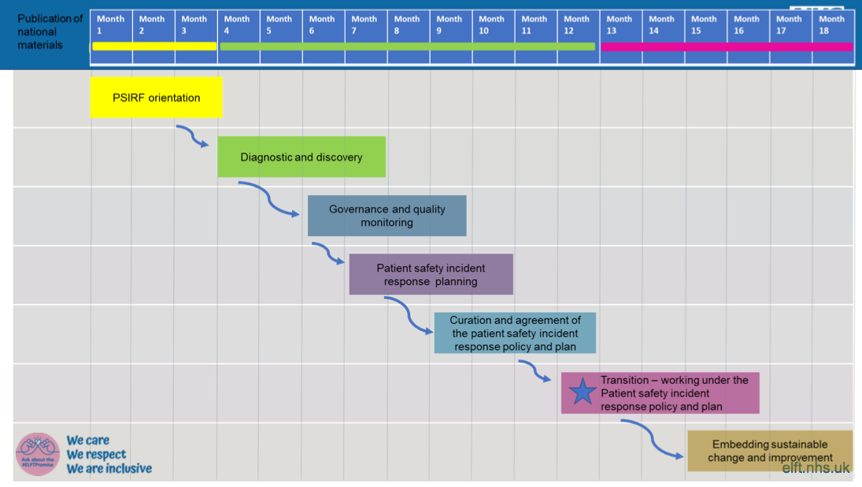
2.9.1 The full draft ELFT PSIRF implementation plan and progress can be seen in Appendix 3.

2.9.2 ELFT PSIRF orientation steps taken so far include:

2.9.3.1 We have commenced the orientation phase with the following work undertaken:

- Senior Responsible Officer (SRO) and Deputy SRO appointed;
- Establishment of PSIRF Implementation Team;
- Stakeholder mapping completed;
- Connections established with both both local Integrated Care Boards and other local NHS provider partners to share learning, coordinate approach and gain support for discovery phase and beyond;
- Cascaded internal communications commenced;
- Coroners engagement process commenced, led by our Chief Medical Officer;
- Oversight leads have commenced HSIB Level 2 “Systems Approach to Incident Review” training programme, and have started booking onto Engagement of Patients” training day.

2.9.4 PSIRF Next steps:

- 3 months initiative to clear Serious Incident Backlog to free up capacity to focus on PSIRF;
- Ongoing implementation team meetings;
- Engagement with staff and stakeholders;
- Commissioning of suitable training package for PSIRF learning and patient engagement leads;
- Establishment of Safety Network to grow wider engagement;
- Safety Plan Launch/Learning event.

3.0 Adoption of the NHS Learning from Patient Safety Events System (LFPSE)

3.1 The Trust currently exports all patient safety incidents to the NRLS (in line with the national NHS Contract). Information is extracted directly from the Datix Incident Form, manually uploaded by the Risk and Datix Team following approval by managers and review by the Incident Team and other key specialist leads.

3.2 From 1st April 2023, all Trusts must implement NHSEs’ replacement system LFPSE, (with the new option of delayed transition by 30th September 2023). The new system will result in a predefined list of mandatory questions to be included within the Trust’s Incident Reporting Form, to facilitate this the existing Datix system will be upgraded. The mandated questions will apply to all healthcare providers including the acute sector and independent contractors providing a national data set aiming to introduce improved capabilities for the analysis of patient safety events occurring across healthcare, using the latest technology, to offer a greater depth of insight and learning that are more relevant to the current NHS environment.

3.3 An implementation plan has been drafted and will continue to be developed as more information becomes available. This will be further supported by the LFPSE Steering Group (to be established), membership will include end users and key leads from across the Trust.

4.0 Engagement with the National Patient Safety Syllabus

4.1 ELFT have recently launched the NHSE e-learning modules which support implementation of the NHS Safety strategy. Module one is aimed at all staff (with a supplementary module aimed at boards and senior leaders) and module two is for those staff in roles where more in-depth knowledge is required. Over the next year these modules are anticipated to become mandatory.

4.2 In the year ahead we will be working with colleagues in learning and development and communications to promote and support staff to engage with these modules. We will support this work by launch of dedicated Patient Safety communications.

5.0 Recommendations

5.1 The success of this plan depends on engagement at all levels and visible sponsorship and support by the board and executive leadership team. The board is asked for feedback including areas for improvement and/or strengthening, and also their active involvement in championing and supporting this plan over the years ahead.

- Action Being Requested

6.1 The Board is asked to:

  - RECEIVE and NOTE the report.
Appendix 1: ELFT Safety Plan Driver Diagram
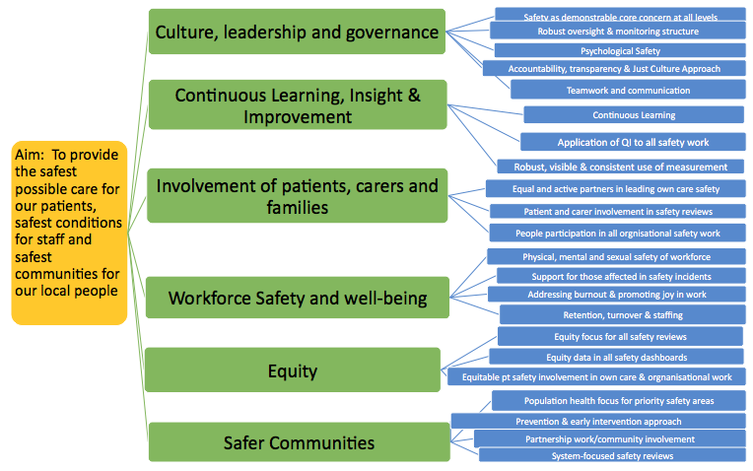
Appendix 2: ELFT Patient Safety Long-Term Plan
Primary Driver | Secondary Driver | Idea | Notes/ Resource Implications | Time Frame
Leadership, Gov & Culture | Everybodys Core concern | Vision & Principles – develop and share using co-creation workshops | OD support | Y1
 | Everybodys Core concern | Define Safety Priorities (using systematic review of board papers, incident themes and improvement work) & in co-creation with senior leaders. Review every 2y. | Part of PSIRF prep. | Y1
 | Everybodys Core concern | Develop Safety Commitments for each Priority – what care looks like when goes right. Review, test, revise regularly |  | Y2
 | Leadership & Gov | Improve safety reporting to focus on analysis and improvement & reduce information burden | PSIRF | Y1
 | Everybodys Core concern | Core set of “Brilliant Basics” Safety Behaviours - Develop and publish |  | Y2
 | Leadership & Gov | Integrated pt safety team with safety advisors |  | Y2
 | Leadership & Gov | Board level Safety Role |  | Y3
 | Leadership & Gov | Directorate Safety specialists - linked to core team to create network |  | Y2
 | Leadership & Gov | Shift focus to risk monitoring with dedicated safety risk monitoring work group to develop information escalation framework, make use of information on harms, operations, anticipation and learning, development of risk visualisation and monitoring framework with owners for each risk. Test risks ?Use BARS map
 | Leadership & Gov | Introduce competency-based training to support all in safety leadership roles
 | Leadership & Gov | Independent Safety Advisory Panel reporting to Board |  | Y3+
 | Leadership & Gov | Develop expertise and capacity re Human Factors, safety analysis and evaluation methods
 | Leadership & Gov | Framework for safety escalation
 | Accountability | Framework of safety skills & responsibilities defined for every role & support staff to attain these |  | Y3-4
 | Psychological Safety/Just Culture | Introduce & Implement Just Culture Policy including separate line management & performance from safety improvement | PSIRF | Y1
 | Psychological Safety/Just Culture | Just Culture Simulation Exercises led by all managers 6 monthly | PSIRF+ | Y3
 | Psychological Safety/Just Culture | Work with colleagues in quality, diversity and inclusion to ensure alignment to enhance the restorative just culture approach |  | Y3
 | Psychological Safety | Introduce routine monitoring of safety culture & tools for teams to self-assess and improve | PSIRF | Y2+
 | Transparency | Regularly publish/share Key Safety Performance Data |  | Y2
 | Teamwork & Communication | Incorporate training on human factors, use of safety communication tools such as SBAR, critical language teamwork and communication into existing training packages, eg., PocketQI. | ?via Pocket QI | Y3+
 | Teamwork & communication | Embed Incivility Toolkit |  | Y3+
Learning, Insight & Improvement | Continuous Learning | Move from RCA to Systems approach to learning from incidents | PSIRF | Y1
 | Continuous Learning | Transition to new National Learning from Patient Safety Events System (LFPSE) | NHS Strategy. By April 2023 | Y1
 | Continuous Learning | Create trust safety shared learning network and link these with local, national and international learning networks. | Launch Jan 2023 | Y1
 | Continuous Learning | Introduce suite of new learning from safety methods, eg., After Action Review, Swarm Huddles, Ward Observations & shift safety resources to include learning from everyday work, and towards the frontline | PSIRF | Y1 onwards
 | Continuous Learning | Embed learning from excellence system | NHS Strategy | Y2-3
 | Continuous Learning | Introduce Safety education and training for all staff, including NHS Safety Syllabus | NHS Strategy  Commenced | Y1-Y3
 | Continuous Learning | Establish system for cascading & sharing learning from all safety learning forums | Partial establishment | Y1 onwards
 | Continuous Learning | Develop Safety intranet platform & learning library | Commenced | Y1
 | Continuous Learning | Develop safety analysis using Bow Tie methodology | Gain support McCrae
 | Continuous Learning | Improve the response to new and emerging risks, supported by the new National Patient Safety Alerts Committee | NHS strategy
 | Application of QI | Continue to apply quality improvement methodology and work with system partners to support improvement in key safety priority areas |  | Ongoing
 | Application of QI | Apply QI to Incident Review work and actions | PSIRF | Y1
 | Application of QI | Safety Action teams with use of QI to address specific priority areas/issues | PSIRF | Y1
 | Application of QI | Oversight structure for all Safety Improvement work (Patient Safety Forum) with QI reporting template | Partially established
 | Application of QI | Dedicated QI lead role for Safety |  | Y3+
 | Application of QI | QI competencies and training for all in Safety leadership roles | Existing QI Programme | Y3+
 | Application of QI | Rewards and Celebrations for involvement in Safety Improvement
 | Measurement | Work with informatics and analytics to develop system for optimising safety insight, incoporating all sources of patient safety intelligence | NHS Strategy
 | Measurement | Develop Safety Monitoring & Continuous Improvement Dashboard | PowerBI | Y2
 | Measurement | Use of visual data display at all levels to support safety
 | Reliability | Promote and enhance simplification and standardisation of core operational processes
 | Reliability | Safety leads to participate in all key operational forums (sensitivity to operations) |  | Y3+
Involvement of patients, carers and families |  | Establish competencies, principles, expectations and training for all staff in engagement of patients, carers and families in safety | NHS Strategy. Embed in PocketQI?
 |  | Introduce dedicated people participation roles within core safety team and for each directorate. | NHS Strategy | Y1-2
 |  | Involve patients/carers in codesign of safety mission, principles & strategy | Already started – focus group held | Y1 onwards
 |  | Include patients and carers in safety reviews | PSIRF
 |  | Include patients and carers in all safety governance and improvement forums. | PSIRF  Commenced
 |  | Provide compassionate support for patients and carers affected by patient safety events | PSIRF | Y2
 |  | Develop methods for patients & carers to lead safety of own care, eg., via education, tools, systems |  | Y3-4
Workforce Safety & well-being |  | Continue to apply a QI approach to improving holistic workforce safety co-created with workforce with clear aims and priorities
 |  | Robust support system for staff involved in safety incidents | Part of PSIRF
 |  | Compassionate engagement approach to involving staff in incident reviews | Part of PSIRF
 |  | Continue to address burnout and well-being via Joy in Work approach, incorporating a trauma-informed approach to well-being | In progress
 |  | Safer Staffing QI work focused on retention, reduction of temporary staff and safe staffing levels for all areas | In progress?
 |  | Support the ELFT People plan with focus on looking after our people, new ways of working, planning for future and belonging in the NHS | Led by Tanya Carter
Equity |  | Equity data in all patient safety monitoring dashboards
 |  | Equity focus and aim for safety reviews | PSIRF will help this | Y2-3
 |  | Equitable patient and carer involvement in own care and organisational safety work
Safer Communities |  | Population health focus for safety priority areas with community partnership work |  | Y3+
 |  | Prevention work on priority areas and social determinants of safe care |  | Y3+
 |  | System-level safety reviews | PSIRF | Y2
 |  | *Needs more work to define this area in Year 3 |  | Y3+

Appendix 3: ELFT PSIRF Implementation Plan
Phase | Actions | Implementation Status | Notes/Resource implications
Orientation  (September – November 2022) | Create Implementation Team | Complete | SRO and Deputy appointed
 | Allocate Time for reading and Reflection | Complete
 | Identify knowledge and support needs for getting started | Complete
 | Create Stakeholder list and plan engagement | Complete | Stakeholder list complete
 | Agree structure and processes for project management | For discussion | Project manager role required
 | Set ambition for PSIRF implementation | In progress | Need Exec approval and QAC sign-off
 | Training – source provider and commence training and training log | Commenced | Oversight leads & Learning reviewer training commenced
 | Targeted SI backlog clearance work | Commenced
Diagnostic and Discovery  (Dec-Mar 2023) | Assess status of open and transparent reporting
 | Assess engagement and involvement of patient safety incidents
 | Assess status of developing a Just Culture | In progress
 | Assess incident response capacity and training needs
 | Assess alignment of incident repsonse and improvement
 | Identify where improvement is needed based on above assessments
Governance and Quality Monitoring (Feb-Apr 2023) | Develop processes for incident response decision-making
 | Define how system effectiveness will be monitored
 | Develop processes for reporting cross-system issues
 | Define how PSIRF will be monitored
Patient Safety Response Planning (Mar-June 2023) | Map our services
 | Examine patient safety incident records and safety data
 | Describe safety issues revealed by the data
 | Identify work underway to address to address contributory factors
 | Agree how we intend to respond to issues listed in our patient safety profile
Curation and agreement of policy and plan (June-Sept 2023) | Populate policy and plan templates and share these with stakeholders
 | Respond to stakeholders feedback on the draft policy and plan
 | Agree how to manage transition
 | Ensure commitment to delivering required improvement
 | Seek policy and plan approval/sign-off and agree transition date
Transition (Sept 2023) | Apply new learning repsonse methods
 | Reflect on agreed plan with internal and external stakeholders and conside adaptations needed
 | Continue to develop diagnostic and discovery work
 | Continue collating insight, collecting data to support quality monitoring and supporting and collaborating with others.

