ICT Housekeeping and Monitoring Policy

Version number : | 1.3
Consultation Groups | Digital Management Team, Information Governance Steering Group
Approved by (Sponsor Group) | Information Governance Steering Group
Ratified by: | Quality Committee
Date ratified: | 3rd May 2023
Name of originator/author: | Chief Information Security Officer
Executive Director lead : | Chief Executive
Implementation Date : | April 2023
Last Review Date | April 2023
Next Review date: | April 2026

Services | Applicable
Trust wide | x
Mental Health and LD
Community Health Services

Version Control Summary

Version | Date | Author | Status | Comment
1.0 | 07/01/2013 | Daniel Woodruffe | Final | Revisions
1.1 | 22/03/2016 | Asim Mir | Final | Revisions
1.2 | 23/09/2019 | Usman Malik | Final | Revisions
1.3 | 18/04/2023 | Chief Information Security Officer | Final | Revisions

Contents

Page

Executive summary 4

- Introduction 4
- Purpose 4
- Procedure 4
- Monitoring 4

Appendices
Appendix A Housekeeping and Monitoring Procedure Spreadsheet 5

Executive Summary

The following document outlines the process for monitoring the security and other procedures and processes in place in the Digital Department are effectively being carried out on a regular basis. This is to minimize risk to the Trust’s data and reputation, and to ensure that disruption from system failures is kept to a minimum.

1.0 Introduction

The Trust uses a number of systems to monitor the various software and hardware devices in use to ensure that they are secure, and that only authorized users are accessing them. Also, these systems are used to monitor performance and help avoid or detect problems when or before they occur.

2.0 Purpose

The purpose of this document is to describe the procedures, systems, frequency and methods of monitoring specific applications and devices on our Trust network to maintain it’s integrity.

3.0 Procedure

The procedure is described at Appendix A attached. The Infrastructure Manager will ensure the procedure is followed, and the audit sheet regularly updated. Any issues will be escalated to the DCIO.

4.0 Monitoring

The Infrastructure Manager will report monthly to the DCIO on the audit programme. The report will be reviewed by the DCIO and submitted to the IM&T Quarterly and Performance Review meeting. Any urgent exceptions should be reported to the DCIO as they occur, and any minor exceptions reported at the monthly meeting.

Progress on resolution of any exceptions will be monitored via the monthly meetings within the IT department.

Appendix A

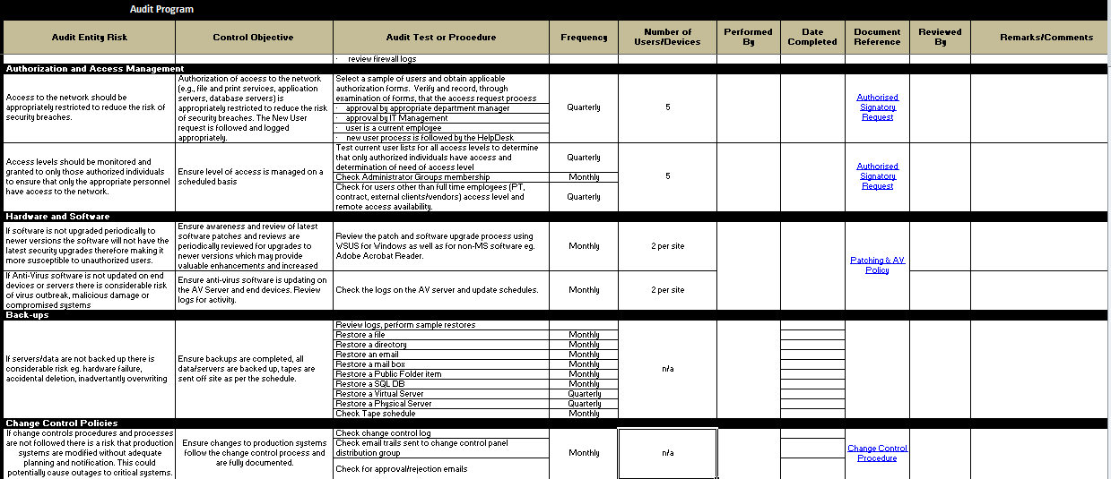

(Original of this spreadsheet can be located on SharePoint.)

