Guidelines for the Safe Administration of Low Molecular Weight Heparins (LMWH) in Adults Transferred to ELFT Community Health Services

Version number : | 1.0
Consultation Groups | CHS Clinical Policies Alignment Group
Approved by (Sponsor Group) | Medicine Committee
Ratified by: | Medicines Committee
Date ratified: | 10th May 2023
Name of originator/author: | Lead Pharmacist Tower Hamlets Community Health Service  Locality Manager, Beds  Professional Development Lead Nurse
Executive Director lead : | Chief Nurse
Implementation Date : | May 2023
Last Review Date | May 2023
Next Review date: | May 2026

Services | Applicable
Trustwide
Mental Health and LD
Community Health Services | √

Version Control Summary
Version | Date | Author | Status | Comment
BCHS Procedural guideline | August 2015 | Kikelomo Pinheiro, Lead Pharmacist, Bedfordshire CHS (until Dec 2019) | Archived | Original document authored by Lead Pharmacist for BCHS as procedural guidelines and approved for local use by BCHS Quality Assurance Group from August 2015 – July 2022.
1 | Jan 2023 | Fatima Hafesji, Lead Pharmacist Tower Hamlets Community Health Services | Final | Incorporated and reviewed as a trust wide CHS guideline by Fatima Hafesji, Lead Pharmacist Tower Hamlets CHS. MDT policy review in collaboration with ELFT CHS Policies Alignment Group January 2023.  - Document title changed from Procedural Guidelines for the Safe Administration of Low Molecular Weight Heparins (LMWH) in Patients Transferred to the Care of Bedfordshire Community Health Services (CHS) to Guidelines for the Safe Administration of Low Molecular Weight Heparins (LMWH) in Patients Transferred to ELFT Adult Community Health Services  - Section 1, definitions updated to include MAR chart.  - Purpose & scope updated in relation to application as a trust wide CHS guidance.  - Section 3 – New addition of associated policies  - Section 6 – checking for contra-indications updated.  - Section 9 – ‘Amending the time of administration (dose-time)’ updated.  - Section 10 – ‘What to do after amending the time of administration’ updated to include process in systematic order  - Section 11 – New addition ‘Accountability’  - Section 12 – New addition ‘Incident reporting’  - Section 13 – New addition ‘ Audit & Monitoring’  - Section 14 – ‘References’ updated  - Appendix 1 – Table ‘Treatment doses of low molecular weight heparins’ reviewed and updated  - Appendix 2 – Title ‘Rationale for amending the dose-time of low molecular weight heparins, changed to ‘Flow chart for amending the dose-time of low molecular weight heparins in ELFT Adult Community Health Services’. Flow chart steps reviewed and updated to reflect process to be followed.

Members of the Community Health Services Clinical Polices Alignment Group:

Name | Position
Caroline Ogunsola | QN - Professional Development Lead Nurse - Convener
Dupe Fagbenro | Deputy Chief Pharmacist – Bedfordshire
Nike Bademosi | QN - Lead Nurse, Tower Hamlets CHS
Rashida Goswami | Team Lead, Tower Hamlets CHS
Chantal Riviera | Clinical Lead Newham CHS
Gavin Shields | Lead Nurse, Newham CHS
Caroline White | QN - Deputy Lead Nurse, Bedfordshire CHS
Sarah O’Hare | QN – Locality Manager, Bedfordshire CHS
Fatima Hafesji | Lead Pharmacist, Tower Hamlets CHS
Victoria Stone | Locality Manager, Beds CHS
Saema Arain | Lead Pharmacist, Beds CHS
Edward Phillips | QN – Practice Development Nurse, Bedfordshire CHS
Georgina Amparado-Molina | Clinical Lead Tower Hamlets CHS
Charity Okoli | Lead Pharmacist, Tower Hamlets CHS
Dawn McMahon | Lead Pharmacist, Newham CHS
Emma Robinson | QN – Deputy Lead Nurse, Tower Hamlets CHS
Sharon Eplett | QN – Head of Quality & Performance Beds CHS
Megan Collins | Quality & Performance Lead Beds CHS
Davinder Kaur | Clinical Lead - Tower Hamlets CHS

Contents
- Definitions………………………………………………………………………………………...5
- Purpose and scope 5
3.0 Assosicated Policies 5
4.0 Responsibilities………………………………………………………………………………….. 5
5.0 Clinical Risks 6
6.0 Checking for Contra-Indications 6
7.0 Prophylactic Doses of LMWH 6
8.0 Checking Treatment Doses of LMWHs: 6
9.0 Amending the time of administration (dose-time) 7
9.1 Amending the Dose-time for Tinzaparin 7
9.2 Amending the Dose-time for Enoxaparin and Dalteparin 7
10.0 What to do after amending the time of administration 8
11.0 Accountability 8
12.0 Incident Reporting………………………………………………………………………………8
13.0 Audit & Monitoring……………………………………………………………………………...9
14.0 References……………………………………………………………………………………..10
Appendix 1 Treatment doses of low molecular weight heparins 11
Appendix 2 Rationale for amending the dose-time of low molecular weight heparins…......13

1.0 Definitions

Term | Meaning
LMWH | Low Molecular Weight Heparin
Dose-time | The time of day the LMWH is scheduled to be administered
MAR chart | Medicines Administration Record chart
VTE | Venous Thromboembolism
INR | International Normalised Ratio

2.0 Purpose & Scope

The purpose of these guidelines is to ensure that doses of Low Molecular Weight Heparins (LMWHs) are not omitted or delayed because of the time of day the doses are scheduled for patients whose care is transferred to adult Community Health Services in East London Foundation Trust.

It aims to empower nurses to check the treatment dose, check for contraindications and change the time of administration (dose-time) where applicable, thereby reducing the risk of delayed or omitted doses.

The LMWHs that these guidelines apply to are:

- Dalteparin (Fragmin®)
- Tinzaparin (Innohep®)
- Enoxaparin (Clexane®)

3.0 Associated Policies

- Procedural Guidelines for the Administration of Medicines by Staff in Community Health Services
- Policy for Transcribing Medication Administration Records in ELFT Community Health Services
- ELFT Medicines Policy
- ELFT Incident Policy

4.0 Responsibilities

The Trust: to recognise the need for this guideline and accept liability for changes made to dose-time of LMWHs.

Community Nurse: to follow these guidelines when there is need to change dose-time to reduce risk of omitted or delayed doses, and to check for contra-indications to LMWHs when patients are referred for continuing care.

5.0 Clinical Risks

Changing the timing of treatment doses of LMWH is outside the product licences of all licensed products available in the UK

There are theoretical risks that if a LMWH treatment dose is given excessively early, a patient’s risk of bleeding may increase or if a dose is delayed excessively, a VTE may extend or re-form. This is however difficult to prove, due to an absence of evidence.

6.0 Checking for Contra-Indications

Staff administering treatment doses of LMWHs should be aware of pharmacological or clinical contraindications to their use.

Circumstances when the use of LMWHs may be contraindicated can include but are not limited to:

- Active bleeding
- Acquired bleeding disorder such as acute liver failure
- Concurrent use of anticoagulants known to increase risk of bleeding, (however, these may be used together during warfarin induction phase of treatment, until INR reaches target range and will be under the recommendation of a prescriber)
- Concurrent use of antiplatelet and other interacting medicines
- Lumbar puncture/epidural/spinal anaesthesia within the previous four hours or expected within the next 12 hours.

The BNF and Summary of Product Characteristics (SPC) for the LMWH should be consulted for a full list of contraindications.

7.0 Prophylactic Doses of LMWH

There is no requirement to check prophylactic doses of LMWH as these are not based on body weight.

8.0 Checking Treatment Doses of LMWHs:

National Patient Safety Agency (NPSA) guidance¹ requires essential information such as dose, weight, renal function, indication and duration of treatment to be communicated at transfer of care (e.g. by discharge letter/summary) and used to ensure that future doses are safe.

On transfer of care for administration of treatment doses of LMWHs, hospitals are expected to provide information on the patient’s body weight and renal function used to determine the dosage.

Dose checks based on patient’s body weight and renal function are expected to be checked by healthcare professionals who review, dispense or administer treatment doses of LMWHs when this information is readily available to them.

Community nurses should check the following from discharge communication before administering a dose of LMWH:

- Indication – whether the LMWH is for prophylaxis or treatment
- Duration of therapy
- Weight of patient
- Renal function
- Strength of syringe required
- Volume of syringe required
- Check dose in international units (IU) and in millilitres (mL)
- Check dose against body weight
- Route and frequency of administration

If information on the patient’s body weight and renal function is not made available, reasonable steps should be taken to find out the information required.

A reference table of treatment doses for all the preparations is available in Appendix 1

9.0 Amending the time of administration (dose-time)

It is common practice in acute hospitals to initiate LMWH doses at 6pm (18:00 hours). This is to allow at least 12 hours before any invasive procedure is carried out.

Some nurses in the community setting have developed a culture of shifting the time of the dose, day-by-day using a perceived ‘window of safety’ to achieve an operationally achievable or convenient dose-time.

Dose times should be altered only when there are risk factors that increase the risks that doses may be delayed or omitted.

9.1 Amending the Dose-time for Tinzaparin

The “new” dose time should be 24 hours after the first injection, plus or minus six hours. All subsequent doses should be given at the “new” time until Tinzaparin is discontinued or the direction expires.

Example: A patient is discharged from hospital and has been having the dose of Tinzaparin at 18.00h. For future convenience a change in the time of dose administration is required. It has been decided the new dose will be given at 12.00h (i.e. 24 hours after the first injection minus six hours).

9.2 Amending the Dose-time for Enoxaparin and Dalteparin

Amendments can happen on a maximum of two occasions for a patient, by up to a maximum of two hours per occasion from the initial hospital administration time.

The two occasions may be on two consecutive days to achieve a total dose-time shift of 4 hours over 2 days.

Subsequent doses should be continued at the amended dose-time until the LMWH is discontinued or the direction expires

10.0 What to do after amending the time of administration

- Record the amendment(s), of dose-time on the MAR Chart to ensure that staff administering subsequent doses maintain continuity
- Ensure the change of dose time is clearly documented on the MAR chart, signed and dated.
- Void and cross out any pre-existing transcriptions on the MAR chart for the LMWH. Refer to the ELFT transcribing policy for further guidance if unclear.
- Administer the LMWH in accordance with trust policy.
- Record the administration on the MAR Chart.
- Record the amendment in the patient’s electronic clinical record e.g. EMIS or SystmOne and the reason for the amendment.
- Ensure that the amendment is also verbally communicated in the team handover so that all members of the nursing team are aware of the change and rationale.

11.0 Accountability

Nurses are deemed competent to administer medicines by virtue of their qualification. The safe administration of medicines is an essential competence for admission to the Nursing and Midwifery Council register.

All staff are accountable for their own actions in the administration of medicines. They must be prepared to exercise professional judgement in any situation and be able to substantiate their actions/inactions. They must: ⁵

- Be aware of the indications, action(s), usual dosage, usual route(s), side effects, interactions, contra-indications and correct storage of the medicines to be administered.
- Ensure they are competent to administer medicines, maintain competence and address any deficits in their knowledge/skills.
- Be aware of their limits and know when to refer for further advice

12.0 Incident Reporting

Patient safety incidents are any unintended or unexpected incident which could have, or did, lead to harm for one or more patients receiving healthcare. All Patient Safety Incidents should be reported on DATIX regardless of whether harm was caused to the patient or not.

- As part of the ongoing evaluation of the patient’s care and treatment, the effects of medicines on the patient must be observed and documented. The effects and side effects of the treatment and any variances to expected outcomes must be reported to the Prescriber/MDT and on DATIX.
- Where adverse drug reactions are experienced advice should be sought from the prescriber/ out of hours services/pharmacy or management.
- Details of the reaction should be documented in the patient’s electronic clinical records, reported on DATIX and through the MHRA Yellow Card system.
- Any error in the administration or supervision of medicines must be recorded in the patient’s electronic clinical records, reported immediately to the Prescriber and the Senior Nurse or Senior HCP on duty.
- Appropriate action must be taken to ensure patient safety.
- The patient/relative/carer must be advised of the error as part of Duty of Candour and the patient’s condition monitored and recorded as appropriate.

13.0 Audit & Monitoring

- Clinical records including MAR charts and documentation on electronic clinical systems such as EMIS & SystmONE must be completed at the time of the administration/refusal or as soon as possible thereafter and must be clear, legible and auditable.
- Transcribing of LMWHs is audited as part of the trust Medicines Management audit cycle.

14.0 References

- National Patient Safety Agency NPSA/2010/RRR014 Reducing treatment dose errors with low molecular weight heparins
- NHS England Patient Safety Alert NHS/PSA/W/2015/001 Harm from using Low Molecular Weight Heparins when contraindicated January 2015 (accessed July 2020) https://www.england.nhs.uk/wp-content/uploads/2015/01/psa-lmwhs.pdf
- Medicine Information Letter from Sanofi, 23/12/19. Reference: 00056109
- Medicine Information Letter from Leo Pharma,19/11/2019. Reference: Enquiry # UK2019-02959
- Medicine Information Letter from Pfizer, May 19 2017. Reference:GB17-004438
- Summaries of Product Characteristics Enoxaparin (Clexane ®) http://www.medicines.org.uk/emc/medicine/24345 (Accessed July 2022)
- Summaries of Product Characteristics Tinzaparin (Innohep®) https://www.medicines.org.uk/emc/tinzaparin (Accessed July 2022)

- Summaries of Product Characteristics Dalteparin (Fragmin®) https://www.medicines.org.uk/emc/dalteparin (Accessed July 2022)

- BNF Monograph Tinzaparin Sodium (Innohep ®) https://bnf.nice.org.uk/drugs/tinzaparin-sodium/ (Accessed July 2022)

- BNF Monograph Enoxaparin Sodium (Clexane ®) https://bnf.nice.org.uk/drugs/enoxaparin-sodium/ (Accessed July 2022)

- BNF Monograph Dalteparin Sodium (Fragmin ®) https://bnf.nice.org.uk/drugs/dalteparin-sodium/ (Accessed July 2022)

- What factors should be considered when using low molecular weight heparin (LMWH) to treat venous thromboembolism in patients with high body weight? Specialist (June 2020) Pharmacy Service NHS UK (Accessed July 2022)

- Low molecular weight heparins - should treatment doses be used in patients with renal impairment? (March 2020) Specialist Pharmacy Service NHS UK(Accessed July 2022)

- Yellow Card reporting https://yellowcard.mhra.gov.uk/

Appendix 1: Treatment doses of Low Molecular Weight Heparins (LMWHs)

Low Molecular Weight Heparin | Tinzaparin ⁽⁹⁾ | Dalteparin ⁽¹¹⁾ | Enoxaparin ⁽¹⁰⁾
Brand Name | Innohep® | Fragmin® | Clexane®
Dose to treat thrombosis in adults | 175 IU/kg bodyweight once daily  Weight in kg International units IU Injection Volume mls from 20,000 IU/ml solution  32-37 6,000 0.30  38-42 7,000 0.35  43-48 8,000 0.40  49-54 9,000 0.45  55-59 10,000 0.50  60-65 11,000 0.55  66-71 12,000 0.60  72-77 13,000 0.65  78-82 14,000 0.70  83-88 15,000 0.75  89-94 16,000 0.80  95-99 17,000 0.85  100-105 18,000 0.90 | 200 IU/kg total body weight once daily  Weight in kg Dose in IU  <46 7,500  46-56 10,000  57-68 12,500  69-82 15,000  83 and over 18,000  The single daily dose should not exceed 18,000 units  Maximum dose of 18,000 IU was used in patient weighing up to 132kg in the CLOT study  For patients with increased risk of bleeding 100 IU/kg body weight may be used. twice daily | 1•5 mg/kg (one point five mg/kg) until oral anticoagulation has been established.  1.5mg/Kg is equivalent to 150 International Units (IU)/kg  No dosage adjustments are recommended in obesity or low body weight  Enoxaparin sodium can be administered SC either as a once daily injection of 150 IU/kg (1.5 mg/kg) or as twice daily injections of 100 IU/kg (1 mg/kg).
Route of administration | Subcutaneously, once daily | Subcutaneously, once daily | Subcutaneously once daily preferred for community teams
Preparations | Pre-filled syringe 20,000 IU/ml:  0.4 ml (8,000 anti- Factor Xa IU)  0.5 ml (10,000 anti-Factor Xa IU)  0.6 ml (12,000 anti-Factor Xa IU)  0.7 ml (14,000 anti-Factor Xa IU)  0.8 ml (16,000 anti-Factor Xa IU)  0.9 ml (18,000 anti-Factor Xa IU)  Vials  20,000 IU/ml in 2 ml multidose glass vial  10,000 IU/ml in 2ml multidose glass vial | Pre-filled syringes:  2,500 IU/0.2ml  5,000 IU/0.2ml  7,500 IU/0.3ml  10,000 IU/0.4ml  12,500 IU/0.5ml  15,000 IU/0.6ml  18,000 IU/0.72ml  Ampoules/Vials  10,000 IU/1 ml Ampoule  10,000 IU/4ml Ampoule  100,000 IU/4ml Multidose-Vial  Graduated Syringe  10,000 IU/ml | Pre-filled syringes:  2,000 IU (20mg) in 0.2 mL  4,000 IU (40mg) in 0.4 mL  6,000 IU (60mg) in 0.6 mL  8,000 IU (80mg) in 0.8 mL  10,000 IU (100mg) in 1 mL  Forte Pre-filled Syringes  12,000 IU (120mg) in 0.8ml  15,000 IU (150mg) in 1ml  Vial  30,000 IU (300 mg/3ml) Multidose vial
Patients with renal impairment:  See SPC for most up-to-date information | Risk of bleeding may be increased; use with caution in elderly and avoid if age over 90 years; unfractionated heparin may be preferable.  Tinzaparin is not recommended in patients with severe renal impairment (CrCl<30 ml/min), as dosage in this population has not been established. | Dalteparin should be used with caution in patients with renal impairment as they have an increased risk of bleeding complications.  For patients with an increased risk of bleeding, it is recommended that dalteparin is administered according to the twice daily regimen. ¹³  Please refer to the SPC for further guidance. | Risk of bleeding increased; reduce dose if eGFR less than 30 mL/minute/1.73 m2.  Enoxaparin sodium is not recommended for patients with end stage renal disease (CrCl <15 ml/min) due to lack of data in this population. ¹³
Elderly Patients | No dose reduction is needed in elderly patients with normal renal function. Renal function should be assessed, to estimate creatinine clearance levels .The manufacturer recommends caution in elderly patients with renal impairment. | Fragmin® has been used safely in elderly patients without the need for dosage adjustment | For all indications except STEMI, no dose reduction is necessary in the elderly patients, unless kidney function is impaired

Appendix 2: Flow chart for amending the ‘dose-time’ of Low Molecular

Weight Heparins (LMWHs) in ELFT Adult Community Health Services

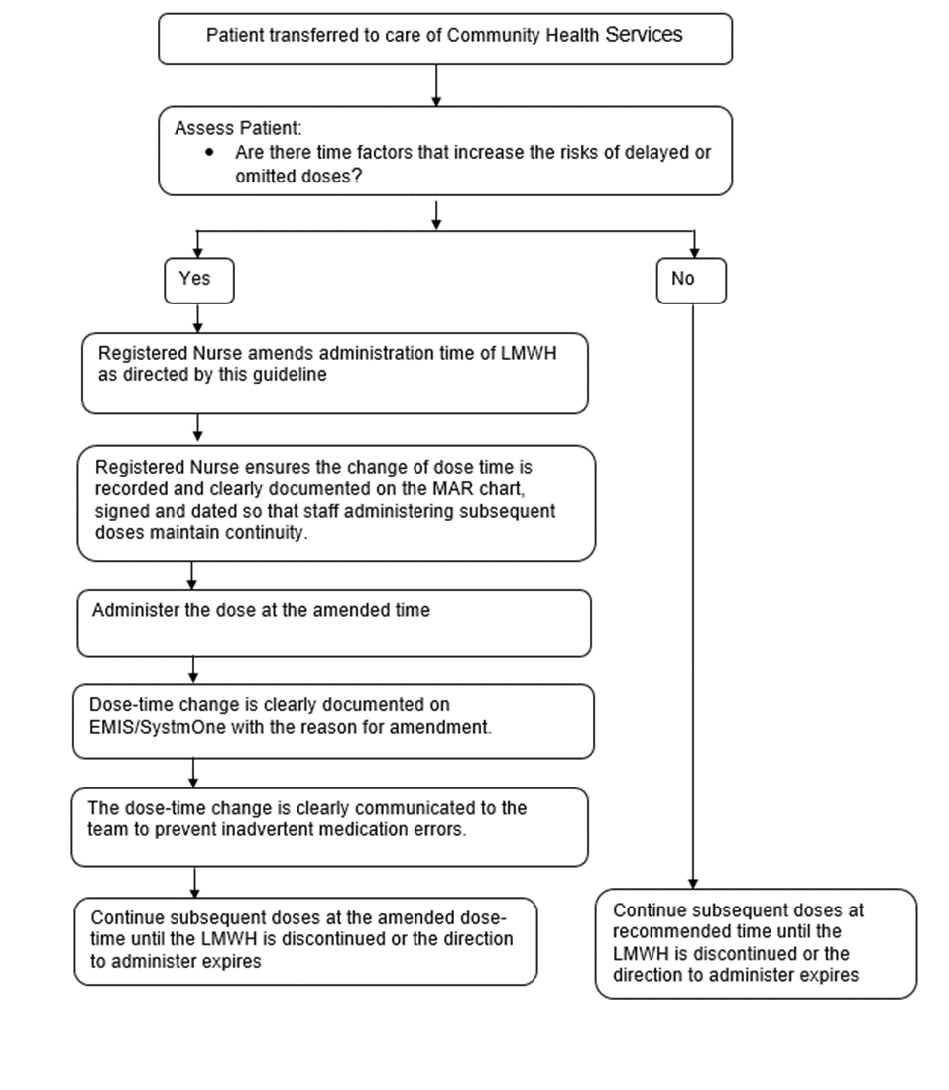
END OF DOCUMENT

