62Learning Disability – ELFT Management of Out of Area Placements
Last Updated 14th April 2022
Contents

1. Background 2
2. Recording Standard 3
3. How to Access the Virtual Ward 3
4. How to Admit someone 4
5. How to Discharge someone 5
6. How to view client ward history 6
7. Glossary of Bed Icons 6
8. How to Monitor OOA Admission and Discharges 7

Background

The service users with Learning Disability are sometimes placed far away from their home in public or private settings. In order to safely monitor and track those patients out of area, a virtual ward has been created on RiO to capture those people who are on LD community caseloads but are in out of area hospital placements. This is part of a national patient safety roll out following a Safeguarding Adults Review regarding the deaths of three people. The LD community services will need to use the virtual ward to capture and monitor any services users who are commissioned by local CCGs but placed in OOA setting.

Ruth Cooper
Operational and Strategic Lead for Learning Disability

Sanjay Nelson
Clinical Lead for Learning Disability

Recording Standard

This guidance document is intended to support the accurate recording of bed state in RiO. It is important that bed states are recorded as soon as possible to support real-time bed management and accurate reporting for Trust, statutory and financial purposes (where required).

The community services will need to ensure following activity is captured and RiO is updated with all the changes (prior to the end of the month).

- Date of Admission to the OOA inpatient setting
- ELFT consultant involved in LD community
- MHA section if known
- Admission source and method
- Date of Discharge from the OOA inpatient setting
- Discharge source and method

The service users that are not known will need a RiO record to be created. Every service user can only have one clinical record. Therefore, important that all details have been checked and confirmed to rule out any other aliases.

How to Access the Virtual Ward

The ward on RiO has been setup as “MH Out of Area Placement LD (Virtual)” with 12 beds capacity. The capacity can be changed by the ELFT Clinical Systems team.

How to Access
- Menu
- Inpatient Management
- Wards

Choose the ward from the drop down menu and click on the bed icon. This will display the current ward view.

How to Admit someone

To admit a client, click on an empty bed in Bay 1 and click on admit. If all beds in Bay 1 are occupied, use the “overbooking bay”.

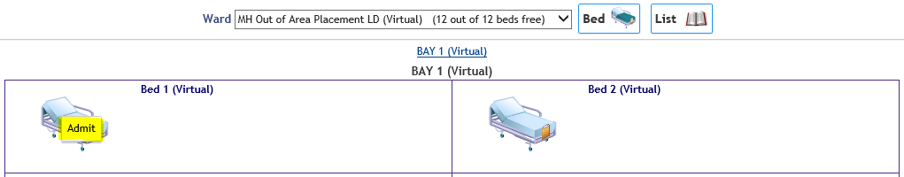

- Search for the client by name, date of birth and gender, or by the NHS, or RiO number. Please ensure you have checked and confirmed the details of the client.
- Once you have located / or registered the relevant client the admission page will open, select a Consultant, a Type of Stay and a Referral Source from the drop down menu list.

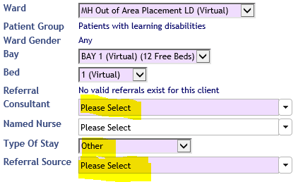

- You will notice additional fields will be visible as soon as you select the Consultant and Referral source.
- Complete all fields; accurately recording Admission Date and Time (an accurate date/time is key), Admission Source and Admission Method (this helps us to understand where the admission came from).
  - Client Classification can be Ordinary Admission
  - Legal Status on Admissions if known. Useful to capture this.
  - Psychiatric Patient Status can be not known
  - Administrative Category can be “NHS Patient, excluding overseas visitors”. Do not use any other options. Private patient indicate if the service is not eligible for the NHS free care and will be subject to invoice from the NHS provider.
- Click Save, the ward view is displayed and the bed will be occupied.

How to Discharge someone

To discharge a client, click on the on relevant bed. Select Discharge, then Discharge Patient.

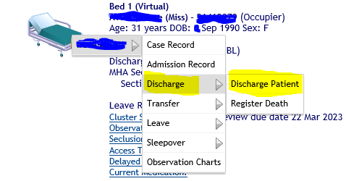

- Record Discharge Date & Time.

- Select Method and Destination from drop down (this helps us to understand where the client was discharged to).

- Click magnifying glass to enter the Destination Address.

- Select “No” for ‘Produce Final Discharge Summary’ and click ‘Save’.

- Please note, you can associate documents to Inpatient Discharge. At the bottom of the page, click on the + next to ‘No Document Associated’.

The services to ensure that the discharge data is captured on RiO as soon as possible after the decision to discharge has been taken.

How to view client ward history

To view any inpatient history (previous/current admissions) known to ELFT RiO.

- Go to the client record.
- Inpatient Management
- Admission History

This will display the list of client’s inpatient episodes. Click on the required episode to be viewed. To return to the case record click on the client name in the top left hand side of the screen

Glossary of Bed Icons

For LD virtual ward usage, you will most likely manage empty and occupied beds only.

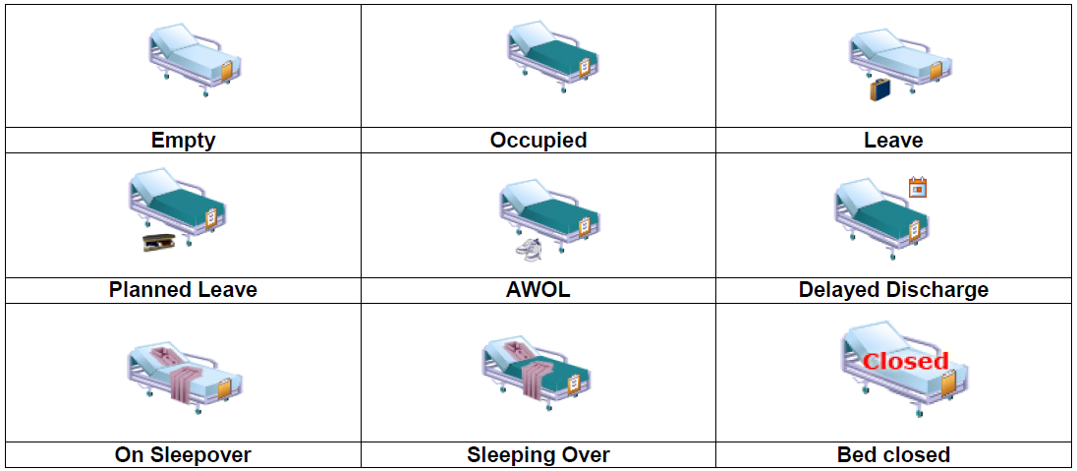

This guide should only be used to manage LD virtual ward for OOA placements. It was specifically developed by Yasar Choudhary – Head of Quality & Performance to support the LD teams with management of Out of Area placements. This guide is based on certain adaptations to meet the LD virtual needs only.

The original ELFT guidance for bed management can be found here;
https://elftintranet/sites/common/Private/Community_View.aspx?id=407&pageid=4647

How to Monitor OOA Admission and Discharges

You will need access to Reporting Services (RS) application. You can request RS access by logging a request through the IT Portal application. Following are direct links to reporting services reports.

Admission:
http://svr-dwprd/reports/report/Trustwide/Inpatient/Inpatient%20-%20Monthly_Weekly%20Admissions%20(Virtual%20Ward%20Only)

Discharges:
http://svr-dwprd/reports/report/Trustwide/Inpatient/Inpatient%20-%20Monthly_Weekly%20Discharges%20(Virtual%20Wards%20Only)

