Trust-wide Care Programme Approach (CPA) Policy

Version number : | 1.3
Consultation Groups | Directors, Managers and Clinical Staff involved in the provision of care under the Care Programme Approach
Approved by (Sponsor Group) | Lead Nurses group
Ratified by: | Quality Committee
Date ratified: | November 2021
Name of originator/author: | Borough Director - City & Hackney
Executive Director lead : | Chief Medical Officer
Implementation Date : | November 2021
Last Review Date | November 2021
Next Review date: | November 2024

Services | Applicable
Trust-wide | X
Mental Health and LD
Community Health Services

Version Control Summary

Version | Date | Author | Status | Comment
1.0 | 14 December 2016 | Trust Social Care Lead | Final | A revised Trust-wide CPA Policy was required in conjunction with the New CPA Process approved by the Service Delivery Board on the 14 December 2016. This policy replaces the Trust-wide Care Programme Approach Policy (Version 4.1 15/4/15)
1.1 | 22 March 2017 | Trust Social Care Lead | Final | A re-formatted version of the revised Trust-wide CPA Policy submitted for approval by the Trust’s Quality Committee.
1,2 |  | Trust Social Care Lead | Final | A revised version of the Trust wide CPA Policy (April 2017) - submitted for approval by the Trust’s Quality Committee.
1.3 |  |  |  | Extended via chairs action

Contents
1. Introduction 4
2. Purpose and Scope of the Policy 4
3. Roles and Responsibilities 5
4. Legal Framework 6
5. Categories of CPA 7
6. Completing the Assessment (including risk) 9
7. My Recovery Plan 11
8. My Safety Plan 11
9. Involving/Supporting others and sharing information 13
10. Refusal to Maintain Contact with Services 15
11. Loss of Contact with Services 16
12. Changes to CPA 17
13. Discharge from CPA 19
14. Section 117 Aftercare 20
15. Review of the need for compulsory powers at CPA (CTO, conditionally discharged patients, Guardianship orders, DoLS) 21
16. RiO CPA and Dialog+ processes 21
Appendix 1 CPA Standards and Timelines…………………………………………………22
Appendix 2 Recovery Care Pathway Documentation……………………………………23
Appendix 3 Operational Guidance for the Recovery Care Pathway Documentation (Including Ecpa)……………………………………………………………………………………25

Introduction

This document sets out the policy governing the operation of the Care Programme Approach (CPA) within East London NHS Foundation Trust (ELFT). This policy supersedes existing CPA policies within the Trust.

This policy is based on the following principles:

All CPA Planning and documentation should be done in collaboration with service users, focusing on strengths and ability.

Be based on principles of recovery, social inclusion and participation

Supports the Care Act (2014) principle of wellbeing and the eligibility outcomes set out in the Care and Support (Eligibility Criteria) Regulations 2014

Ensuring effective partnership with relatives, carers, advocates, and statutory and third sector agencies.

Recognises the role of carers, children and parents and their support needs.

Be based on integration of health and social services (or alternate local configuration of health and social services delivering holistic care).

Includes positive risk assessment, contingency and crisis planning.

Purpose and Scope of the Policy

This policy will describe how the Care Programme Approach is to operate in East London NHS Foundation Trust.

The process is based upon a Care Act compliant mental health assessment which promotes service user-led, recovery focused care. The mental health assessment is an holistic, health and social care assessment which will result in a recovery plan and safety plan.

Roles and Responsibilities

Chief Medical Officer

The Medical Director undertakes the role of Trust Executive Lead for the Care Programme Approach (CPA).

Service Directors

To ensure all teams operate the revised CPA in a way which delivers optimum care for service users.

All Clinicians

All clinicians working for the Trust will use the process of CPA to underpin all care delivered by the Trust. Therefore all service users should be assessed to establish whether they fall within the criteria for CPA. Service users who do not meet the criteria for CPA should still have access to recovery plans and regular review; however it will usually be a less detailed plan. This should cover how the Trust will work with the service user, who is the main person to contact in the Trust, how to contact them and who to contact in an emergency along with consideration of risk assessment, contingency and crisis issues.

Care Coordinators

To coordinate the on-going assessment of the service users mental and physical health, needs and risk, and respond accordingly.

To ensure service users and carers are central in planning and agreeing the care plan.

To consider any Advance Directives the service user may have made.

To ensure that the care plan is regularly reviewed.

In collaboration with the service user, identify who attends the CPA review Meetings and seek consent from the service user about who can be invited, ensure that invites are sent out to attendees who chair the meeting, who presents information about progress at reviews and decides what is discussed.

To act as a reference point for other professionals, relatives, carers and advocates.

To maintain contact with the service user wherever they are e.g. in hospital. To ensure dynamic risk assessment is undertaken and a crisis, relapse and contingency plan is established.

To record the assessment of the service users’ needs, My Recovery Care Plan, risk assessment and My Safety Plan including changes, decisions and goals on RiO, using DIALOG+ and the other appropriate RiO screens and templates.

The Care Coordinator needs to also ensure that the service users’ needs assessment and any care and support plan put in place to meet those needs are also recorded, as necessary, on the relevant Local Authority’s electronic information system

Care coordinators should ensure consistency in care during planned or unplanned absence by ensuring that there is a clear handover for the person covering (where possible), recovery plan / safety plan information is up to date and accessible on RiO. Arrange reviews for service users unless they are on an acute mental health ward, where the Primary Nurse will take responsibility.

A change of care coordinator must be agreed and the rationale recorded in the service user’s progress notes. The service user must also be informed, preferably well in advance and wherever possible, a handover period agreed to allow the service user to get to know their new care-coordinator

Team Managers/Operational Leads

To ensure all service users receiving care through their service are assessed to establish whether they meet the criteria for CPA. To ensure all service users who meet the criteria for CPA are allocated an appropriate care coordinator. To ensure service users under the care of their team are appropriately and regularly reviewed. To monitor training and support for care coordinators. To monitor the quality of care plans and CPA process for care coordinators in their team.

Responsible Consultant Psychiatrist

A Consultant Psychiatrist may be consulted by a Care Coordinator in relation to the care delivered to the service user. The Consultant Psychiatrist may not, however, be clinically responsible for all decisions taken by the Care Coordinator. Decisions regarding changing CPA level must be made with the Consultant Psychiatrist’s agreement. Overall responsibility for physical healthcare will remain with the service user’s GP.

Legal Framework

The Care Programme Approach is guidance not statute, and the Trust must work in accordance with the legislation relevant to mental health services. Relevant legislation and guidance includes:

Mental Health Act (1983/2007) –

https://www.legislation.gov.uk/ukpga/2007/12/contents

Refocusing the CPA: Policy and Positive Practice Guidance (2008) –

https://webarchive.nationalarchives.gov.uk/ukgwa/20130107105354/http:/www.dh.gov.uk/prod_consum_dh/groups/dh_digitalassets/@dh/@en/documents/digitalasset/dh_083649.pdf

Mental Capacity Act (2005) –

https://www.legislation.gov.uk/ukpga/2005/9/contents

Human Rights Act (1998) –

https://www.legislation.gov.uk/ukpga/1998/42/contents

Data Protection Act (1998) –

https://www.legislation.gov.uk/ukpga/1998/29/contents

Children Act (1989) –

https://www.legislation.gov.uk/ukpga/1989/41/contents

Care Act (2014) –

https://www.legislation.gov.uk/ukpga/2014/23/contents/enacted

Equality Act (2010) –

https://www.legislation.gov.uk/ukpga/2010/15/contents

Categories of CPA

The Best Practice Guidelines for CPA (2008) removed the category of standard CPA, so now service users will either be under CPA or non-CPA. However regardless of whether a service user is on CPA or non-CPA, the key principles guiding the care they receive from the Trust, continue to be:

Every person, accepted for assessment should receive a thorough, holistic and comprehensive assessment of their health and social care needs which is compliant with the Care Act (2014) and consideration needs to be given to whether or not there may be social care responsibilities to meet identified needs.

The assessment should include an accurate diagnosis using ICD10 coding, and cluster.

The assessment should include assessments of risk, crisis and contingency.

The assessment should address (and assess and record if appropriate) any capacity issues.

The development of a recovery care plan, in collaboration with the service user and carer which sets out how these needs will be met and by whom. It should promote recovery, social inclusion and choice.

The recovery plan should be written in accessible and clear language that the service user understands (including translation and large font where needed).

There should be regular reviews at agreed intervals, or sooner where needed.

The recovery plan should be given in writing to the service user

Service users and clinicians are encouraged to review and if necessary update the recovery plan at every contact and not simply at a formal review.

CPA

Some service users have complex needs which requires being on CPA. The guiding principles for a service user requiring CPA are those with complex characteristics whose needs are met from a number of services or who are most at risk and who need a higher level of engagement, co-ordination and support. Some clients should default to CPA because of parenting or significant caring responsibilities, unless a thorough assessment indicates otherwise, and those reasons should be clearly documented.

Wherever possible, the aim should be to support a move from CPA to non-CPA and back to primary care in line with the Trust’s commitment to recovery principles.

Criteria for a Service User being on CPA may include:

Severe mental disorder with high degree of clinical complexity

Current or potential risk(s) to self or others (including history of offending)

Relapse history requiring urgent response

Self-neglect/non concordance with treatment plan

Vulnerability / safeguarding concerns

Financial (or other social) difficulties related to mental illness, including experiencing disadvantage as a result of this

Disinhibition

Child protection issues

Current (or significant history of) significant distress/instability or disengagement

Co-morbidity such substance/alcohol/prescription drugs misuse, learning disability

Multiple service provision from different agencies

Currently or recently detained under Mental Health Act (including CTOs and Guardianship) or referred to crisis services

Own significant caring responsibilities

Significant impairment of function due to mental illness

Ethnicity, sexuality or gender issues.

Non-CPA Service Users

Service users require care and support from secondary care specialist mental health services, but do not meet the characteristics outlined above that would instigate care under the formal CPA process. This is usually a service user with straightforward mental health needs who requires single agency support and with an appropriate named Health Care Professional (HCP) facilitating their care.

The named HCP is responsible for overseeing the care provided by the secondary mental health service and ensuring that the process of assessment, care planning and review is done in collaboration with the service user (and carer where appropriate).

The HCP is responsible for identifying any carers involved and ensuring they are aware of their own right to an assessment of need.

The HCP will liaise as necessary with others involved in the service user’s care as well as ensure that transfer of care, in the event of any transfer of responsibility to another healthcare professional, or social services professional either within or outside of the Trust, is agreed and that all relevant information transferred is appropriate and timely.

Completing the Assessment (including risk)

When a service user has been accepted by any professional within secondary mental health services, the professional involved must, in collaboration with the service user, complete an assessment of need and risk. The outcome of this assessment should be shared with the referrer, other team members, and the service user (and carer if appropriate).

There may be a legal duty under to share the outcome of the assessment with the Carer, if needs are to be met by them in line with Section 13 of the Care Act (2014).

This assessment should, in line with the Care Act (2014) include strengths and needs in the following areas:

Mental state and behaviour

Past psychiatric history

Medication, side effects and compliance

Substance misuse

Physical health

Personal function and self-care

Social function and family relationships including:

Child care and parenting issues

Carer issues including young and older adult carers

Managing and maintaining nutrition

Personal hygiene needs

Toileting requirements

Dressing

Safety issues and safeguarding

Keeping home clean and safe

Relationships

Employment, volunteering and learning

Accessing local community

Financial circumstances

Accommodation

Daytime activity (including employment, training, education)

Degree of risk and dangerousness and safeguarding of children and adults

Identification of any precipitating factors to breakdown

These themes can be explored and assessed under the following DIALOG+ domains:

How satisfied are you with your mental health?

How satisfied are you with your physical health?

How satisfied are you with your job situation?

How satisfied are you with your accommodation?

How satisfied are you with your leisure activities?

How satisfied are you with your relationship with your partner/family?

How satisfied are you with your friendships?

How satisfied are you with your personal safety?

How satisfied are you with your medication?

How satisfied are you with the practical help you receive?

How satisfied are you with your meetings with mental health professionals?

How satisfied are you with your expression of identity (including religious, cultural, spiritual, and gender identity?)

How satisfied are you with your finances?

How satisfied are you with your substance / alcohol use?

The DIALOG+ Domains also align with the specified outcomes under the Care Act (2014). Consequently the DIALOG+ Assessment Tool can be used to determine whether or not there may be a social care responsibility to meet any of the identified needs.

When determining whether or not there are many eligible Social Care needs the HCP completing the assessment must consider whether:

The Adults needs arise from or are related to a physical or mental impairment or illness

As a result of the adults needs the adult is unable to achieve two or more of the specified outcomes

As a consequence of being unable to achieve these outcomes there is or is likely to be a significant impact on the Adults wellbeing.

An adult is only eligible where they meet all three of these conditions

The outcomes specified under the Care Act (2014) and listed in the Care and Support (Eligibility Criteria) Regulations 2014 are as follows:

Managing and maintaining nutrition

Maintaining personal hygiene

Managing toilet needs

Being appropriately clothed

Being able to make use of home safely

Maintaining habitable home environment

Developing and maintaining family and other personal relationships

Accessing and engaging in work, training, education or volunteering

Making use of necessary facilities or services in the local community including public transport and recreational services

Carrying out any caring responsibilities the Adult has for a child

Further specialist assessment by members of the multi-disciplinary team (MDT) should then be arranged, as required.

If there are other members of the MDT involved in the assessment, it is good practice to hold an assessment meeting to discuss the findings. If it is decided that the service user fulfils the criteria for CPA, the selection of an appropriate Care Coordinator must be considered.

My Recovery Plan

The plan includes sections to help the service user think about how they can meet personal goals and stay well. It is also an opportunity, to let others (professionals, friends, family etc.) know how to best support the service user and what matters most to the service user. The recovery plan should be about the service user’s own ideas and experiences, and the mental health professional should support the service user to develop their plan as far as possible. The recovery plan can be shared with others such as carers, friends or relatives and these people will be listed on the recovery plan. The Trust Permission to Share Information form should also have been completed and will outline any restrictions around information sharing.

My Safety Plan

Assessing Risk, Capacity and the ability of Service Users to Protect Themselves

When considering an assessment of risk please refer to the ELFT Clinical Risk Assessment and Management Policy

(https://www.elft.nhs.uk/uploads/files/1/Clinical%20Risk%20Assessment%20and%20Management%20Policy%205.0.pdf)

Decisions involving clinical risk always involve balancing the health and safety of service users and others with service users’ quality of life, their personal growth and their right to exercise choice and autonomy in the care they receive.

Service users assessed at any point in their contact with mental health services should have some form of risk assessment undertaken as part of their initial and subsequent assessments of health and social care need. Clear recording of risk assessment is essential to minimise risk and identify strengths.

Collaboration with the service user and those involved in the service user’s care should be intrinsic to the risk management process.

Risks are not static and therefore require regular review and assessment in response to the service user’s changing presentation and circumstances.

Risk information should be gathered from a wide range of sources, including and should be evaluated for its quality and relevance to the risk management process.

Assessment of risk to self, others and of self-neglect, requires a high quality of history taking, sharing of information between services and tracking down key past clinical information, which may indicate future potential risks.

Consideration of risk to a child if the service user is responsible for or in contact with children.

Where risk concerns are identified consideration must be given as to whether procedures for protecting children, adults at risk and the public should be triggered.

Please refer to relevant guidance:

Local Authority and Trust MAPPA guidance

https://www.elft.nhs.uk/uploads/files/1/Policies%20-%20Alisha/ELFT%20MAPPA%20policy%202019%20draft%20(2)%20to%20upload.pdf

MARAC guidance

https://bswccg.nhs.uk/for-clinicians/safeguarding/adult-safeguarding/235-toolkit-for-multi-agency-risk-assessment-conference-domestic-violence/file

Safeguarding adult guidance

https://www.elft.nhs.uk/uploads/files/1/Communications/16.04.2020%20Safeguarding%20Adults%20Policy%20Quality%20Commitee%20version%20-%20Final.pdf

Safeguarding children guidance

https://www.elft.nhs.uk/About-Us/Freedom-of-Information/Trust-Policies-and-Procedures/Safeguarding-Children-Policies

The period around hospital discharge following an admission for mental health needs is a time of particularly high risk of suicide. Therefore the need for proper assessment prior to discharge and effective follow-up afterwards is essential. Service users must be seen within 7 days of discharge.

Key clinical indicators for assessment of risk of violence could include:

Previous history of violence/documented incidents.

Problems of control of temper.

Alcohol and drug misuse associated with violence, or offending.

Domestic violence.

History of child abuse.

Poor concordance/relapse and associated factors relating to violence.

Poor engagement with services.

History of unsettled accommodation/frequent moves.

Altercations with the police.

Key relationships, which might present risks to the service user.

Key relationships where another person might be considered at risk, e.g. a carer experiencing carer stress or a child.

Key mental state indicators, with particular reference to hallucinatory voices which might be encouraging violent action or persecutory beliefs, particularly associated with increasingly unpredictable behaviour.

Recent changes in mental state and a reduced ability to engage in services as a result.

Involving/Supporting others and sharing information

Service users have a right to confidentiality, underpinned by the Data Protection Act (1998). This is clarified in the Trust Information Governance& IMT Policy)https://www.elft.nhs.uk/uploads/files/1/Information%20Governance%20and%20IMT%20Security%20Policy%205.8.pdf

The presumption made throughout this policy is that of:

Full disclosure of relevant clinical information to Trust professionals directly involved in a service user’s care;

Disclosure to relevant professionals in other organisations with which the Trust has an information sharing agreement; and

Disclosure is justified for the safety of the service user or others. This must be fully explained to the service user by the care coordinator

https://www.elft.nhs.uk/About-Us/Freedom-of-Information/Trust-Policies-and-Procedures/Information-Governance-Policies

The care coordinator should complete the Additional Personal Information section on RiO. Any objections raised by the service user regarding information sharing must be recorded on this form and observed in line with Data Protection guidance. Note that Data Protection guidance permits the sharing of information without consent for health and social care purposes under GDPR 9(2)(h)

If information may need to be shared and the service user has not consented please refer to the Trust Principles for Sharing Information

https://www.elft.nhs.uk/About-Us/Privacy-and-Your-Data

and adhere to the Caldicott principles, namely:

Principle 1 – Justify the purpose for using confidential information.

Principle 2 – Only use it when absolutely necessary.

Principle 3 – Use the minimum necessary confidential information

Principle 4 – Access should be on a strict need to know basis.

Principle 5 – Everyone with access to confidential information should be aware of their responsibilities.

Principle 6 – Understand and comply with the law.
Principle 7 - The duty to share information for individual care is as important as the duty to protect patient confidentiality
Principle 8 - Inform patients and service users about how their confidential information is used

Staff should also have knowledge regards to Section 133 of the Mental Health Act concerning the duty to give information to nearest relatives, and when a service user may restrict information sharing.

All letters written by Trust professionals to other professionals within or outside the Trust, for example a GP, should be copied to the service user except where: the letter contains personal data that would reveal information that relates to and identifies another person, unless the person has consented to the disclosure, or can be fully anonymised in the letter, or it is reasonable to provide the information without consent.

Refusal to Maintain Contact with Services

This is when a service user subject to CPA whose whereabouts and physical wellbeing is known and who has made it clear that they refuse to have contact with services or engage with the Care Coordinator, despite their best endeavours having been made to try and contact and engage with them.

Where there is a refusal of engagement, there must be a timely discussion within the Multi-Disciplinary Team (MDT) and with the GP. Consideration should be given to the risks that the service user presents to him/herself (including risks of self-neglect), or others. And appropriate action taken.

Please note: There is a duty under section 11(2) of the Care Act (2014) to continue to assess even with capacitated refusal of services if the person is in need of care and support and at risk of abuse and neglect.

Where there are serious concerns, consideration should be given to conducting a Mental Health Act assessment if indicated.

Where there are serious concerns regarding the safety of children, family members or the public, consideration should be made as to whether the police should be informed of the situation including via MAPPA or MARAC processes / Children’s or Adult safeguarding referral.

An action plan is required in all cases of refusal to maintain contact following discussion within the team and where appropriate family members and carers. The action plan should be clearly documented on RiO (in progress notes, correspondence to the GP and RiO risk assessment and management). This action plan is likely to include the following elements:

A documented multi-disciplinary review should take place following attempts to engage the service user in services. Timescales around this will depend on the strengths and risks involved in each case.

Prior to this review there should be a consultation of people involved in the service user’s care and support, which might include mental health team members, GP, carer/family members and other relevant agencies as appropriate e.g. housing officer, third sector agency.

A team decision on the minimum type of contact with the service user, for example, an attempt to visit, an offer of outpatient appointments once every three months, or support/monitoring via a third party such as a housing support worker will need to be agreed, documented and shared as appropriate.

Exceptionally service users may be discharged from CPA when there has been no contact for a period of time deemed by the multi-disciplinary team to be appropriate based on the safety plan and potential risks. This step should be fully discussed within the MDT and documented on RiO. The named HCP should ensure that the GP and carers are aware of this decision.

Loss of Contact with Services

If it becomes clear that contact with a service user has been lost, a meeting should be held by the MDT to discuss a new contingency plan. Every effort should be made to make contact with him/her, either directly, through the GP or family, if appropriate. Consideration should be given to contacting local A&E departments and other community services, and the police, if the person is felt to be a risk of harm to themselves or others. The care coordinator should take responsibility for co-ordinating this.

The MDT will decide the extent to which resources should be directed towards re-establishing contact, based on factors such as clinical complexity, risk and alternative support as well as the timescales involved. A decision to discharge should only be made after extensive discussions by the MDT and documented in the clinical notes.

For service users who are liable to compulsory powers under the Mental Health Act, account must be taken of the provisions of the Act. For those service users subject to Restriction Orders under the Mental Health Act (sections 41, 44, 45A or 49), or those that have been conditionally discharged from such Restriction Orders, decisions can only be made following discussion with the relevant case worker at the Ministry of Justice. Advice should also be sought from the local Mental Health Act Administration office and Local Authority solicitor.

Changes to CPA

Moving between CPA levels

Every formal CPA review meeting should consider whether the support provided by the CPA framework needs to be considered. In line with recovery principles, service users where possible, should be supported to move towards non-CPA.

A decision to move service users on CPA to non-CPA should be made after careful consideration at a CPA review meeting and the reasons why, recorded in the revised recovery plan and on RiO. The CPA must be attended by relevant members of the MDT and information about the decision shared with all relevant professionals and family members (subject to consent by the service user to share this information)

For service users on non-CPA, a decision to move on to CPA should be made by the MDT, after discussion with the service user and named HCP who had been involved in the treatment of the service user whilst on non-CPA.

Any service user who is admitted to a mental health inpatient setting, regardless of whether they were under CPA or not prior to admission, and is assessed as requiring inpatient care should be placed under CPA during the admission and a discharge CPA Meeting held with the representation from the relevant Community Team meeting held prior to discharge. Inpatient CPA, discharge planning and post discharge follow-up arrangements should be in accordance with the Trust Admission & Discharge Policy.

https://www.elft.nhs.uk/uploads/files/1/Policies%20and%20Procedures/Clinical%20Policies/Admission,%20Transfer%20and%20Discharge%20final%20version%2011.pdf

Transfer of responsibility for care

For all service users under CPA, all decisions regarding transfer to another team or service within the Trust, must be made at a formal CPA review, with the full involvement of the service user and explanation of the implications of the transfer. For seamless transfer from tertiary services to secondary care services, the locality team should allocate a care coordinator as early as possible before discharge. When a transfer of care co-ordination responsibility occurs within a team, the new care coordinator will inform the members of the MDT.

For CAMHS service users approaching eighteen years of age and identified as meeting the criteria for CPA, the transfer process would usually start six months before his/her eighteenth birthday and the transfer meeting should usually be arranged by the CAMHS team approximately one month before the young person’s eighteenth birthday. However, this process should be initiated at least six months before the eighteenth birthday. For those CAMHS service users approaching eighteen and identified as not meeting the criteria for CPA, the Adult CMHT will advise the CAMHS team of the appropriate consultant in Adult Psychiatry for onward referral where needed.

The accepting Adult Mental Health Team should also refer to Section 58 of the Care Act (2014) which sets out the assessment duty in relation to a child.

Transfer of care between Adult Mental Health Services for people of working age and Mental Health Care of Older People should involve discussion between the Adult and Older Adult Consultant Psychiatrists to agree the need for transfer.

Prior to the transfer, the current care coordinator must ensure that the following have been agreed:

The receiving team/service has identified a new care coordinator.

Appropriate services have been put into place by the receiving team to meet the service user’s needs, before the transfer takes place.

Effective communication has taken place and detailed information has been given to the receiving team/service.

For service users being transferred outside of the Trust, the referring team will retain responsibility for providing and co-ordinating their care until the transfer has been agreed and completed.

Discharge from CPA

At every CPA review meeting the care coordinator should consider the need for CPA. If the multi-disciplinary team agrees that CPA is no longer necessary then a conversation about this should take place with the service user and arrangements will be made for discharge.

A service user should not be discharged from CPA simply because his/her mental health appears stable. This may be, at least in part, the benefit of the extra support that CPA provides

A service user’s discharge could mean stepping down to non-CPA and being seen in outpatient clinic or it could mean discharge from secondary mental health services altogether and being referred back to primary care or Enhanced Primary Care.

Prior to any decision being agreed about discharge from CPA, the care coordinator should do a thorough risk assessment. Discussions about possible discharge should also be reflected in DIALOG+. Consideration should also be given to whether or not the service user continues to have eligible social care needs, under the care Act (2014). If this is the case then arrangements need to be put in place to ensure these needs continue to be appropriately met.

Once an agreement has been made to discharge the service user from CPA, and the up to date risk assessment completed, there should be a discharge CPA. This will include a recovery plan outlining the arrangements for any future support. An updated safety plan will need to reflect crisis and contingency arrangements including who to contact once the care coordinator is no longer involved.

The GP must be informed of the discharge and any other agencies / individuals who are involved in future care (in line with the service user’s wishes around permission to share information).

Section 117 Aftercare

Section 117 Aftercare may apply to service users who have been detained under any of the following sections of the Mental Health Act - 3, 37, 45A, 47 and 48.

The statutory definition of what s117 aftercare services encompass states that, this means services which have both of the following purposes:

Meeting a need arising from or related to the person’s mental disorder; and

Reducing the risk of a deterioration of the person’s mental condition (and, accordingly, reducing the risk of the person requiring admission to a hospital again for treatment for mental disorder).”

The Care Act (2014) lists general duties relevant to s117 aftercare, including:

s1 promoting individual well-being

s2 preventing needs for care and support

s3 promoting the integration of care and support with health services

Case law regarding s117 aftercare, has clarified that aftercare “would normally include social work, support in helping with problems of employment, accommodation or family relationships, the provision of domiciliary services and the use of day centre and residential facilities.” (Clunis v Camden and Islington Health Authority (1998) 1 CCLR) and "psychiatric treatment" is also considered aftercare (R. v Manchester City Council Ex p. Stennett [2002] UKHL 34)

The Trust’s Mental Health Act 117 Policy

https://www.elft.nhs.uk/uploads/files/1/Section%20117%20Policy%202.3.pdf

clearly sets out the legal duty to provide aftercare services for certain service users. See also the ADASS Protocol & Principles for Aftercare Services under Section 117:

https://londonadass.org.uk/wp-content/uploads/2018/01/Section-117-Protocol-reviewed-Dec-2018.pdf

S117 eligibility should be reviewed at the CPA review meeting. The review should specifically consider whether the service user continues to have a need for aftercare. If there continue to be needs which should be met under Section 117 aftercare then, it needs to be made clear which elements of the care plan form part of the duty under section 117 aftercare and whether or not there are other social care elements of the care plan, not covered by Section 117 aftercare (which may therefore potentially incur charges). If the Local Authority and Clinical Commissioning Group jointly decide that the service user no longer requires after-care under section 117, the local Mental Health Law office should be advised so they can amend the Section 117 register.

Review of the need for compulsory powers at CPA (CTO, conditionally discharged patients, Guardianship orders, DoLS)

Service users subject to compulsory powers in relation to their mental health, such as a CTO, Guardianship order, DoLS or conditional discharge such as s37/41 must have these powers reviewed regularly.

The CPA review is a good opportunity to review these powers and reflect any discussion in DIALOG+.

Service users should be provided with accessible information about any compulsory power(s) they are subject to, and any right to recourse. Information leaflets about the Mental Health Act can be accessed here: https://www.elft.nhs.uk/Professionals/Mental-Health-Act-Leaflets

Care coordinators should encourage discussions with advocates such as IMHAs and IMCAs, who can also attend the CPA review meeting with the service user’s consent. Reports sent to the Ministry of Justice should reflect CPA discussions around compulsory powers.

RiO CPA and Dialog+ processes

The Trust has developed a suite of new CPA Documentation in RiO for use when receiving external referrals, completing an assessment of need, developing and reviewing a care plan and communicating with external referrers such as GPs.

Where to find the new CPA documentation, how to use it and who should complete it is set out in the “CPA Operational Guidance” which is appended to this policy (Appendix 3).

Appendix 1 CPA Standards and Timelines

Process | Ref | Standard | Timescale
Referral | CPA 01 | Assess urgency of referral on day 1 of referral receipt:  - if urgent follow additional standards CPA 04 and CPA 05  - if non-urgent continue to Standard CPA 06 | Day 1
 | CPA 02 | Register/update client demographics on RiO within 1 working  day of referral receipt
 | CPA 03 | Enter referral on RiO within 1 working day of referral receipt
Referral (Urgent) | CPA 04 | Contact with client within 4 hours of referral receipt
 | CPA 05 | Formulation of initial care plan on day 1 of referral receipt
Screening | CPA 06 | Single Point of Entry multi-disciplinary team meeting screens  referral within 7 days of receipt | Day 1 – 7
 | CPA 07 | Allocation of named Health and Social Care Professional within  first 7 days
 | CPA 08 | Minimum of telephone contact to assess level of urgency and  offer appointment choices within 7 days of receipt of referral
 | CPA 09 | Formulation of initial care plan within 7 days of receipt of referral
Assessment | CPA 10 | Complete Needs Assessment within 28 days of referral receipt | Day 7- 28
 | CPA 11 | Decision on CPA support to be made on completion of Needs  Assessment
 | CPA 12 | Complete Permission to Share Information within 28 days of  referral receipt
 | CPA 13 | Allocation of Care Co-ordinator within 28 days of referral receipt
 | CPA 14 | Signed copy of Care Plan to be sent to Client
 | CPA 15 | Review of initial care plan within 28 days of referral receipt
Care Planning and CPA Reviews | CPA 16 | Medical review within 2 months of referral receipt | Month 1-3
 | CPA 17 | CPA Review within 3 months of referral receipt
 | CPA 18 | Care Co-ordinator, Consultant and / or Responsible Clinician (or  suitable deputising arrangements for them) to attend all CPA Review Meetings
 | CPA 19 | HoNOS (Health of the Nation Outcome Scale) to be completed  for each CPA Review and entered in RiO within one week
Monitoring and Review Cycle | CPA 20 | Minimum of 6 monthly CPA Review cycle | Ongoing
 | CPA 21 | Current CPA Care plan and Risk Assessment to be up to date  (within 6 months) and reviewed at each CPA meeting
 | CPA 22 | All Care plans and Risk Assessments to be attached in RiO
 | CPA 23 | CPA Compliance will be monitored through annual audit of the  approved documentation using the Trust CPA Audit Tool

Recovery Care Pathway Documentation
HCP

Doctor

- KEY

Admin

Document

Decision
Manual
Process
RiO
Process

End
HCP = Health Care Professional [Any Clinical User]
CPA = Care Programme Approach LA = Local Authority

CPA Process
Local Authority Care Package |  | Carers Assessment
City&Hackney Older Peoples | MOSAIC LBH System  - CC Request  - Authorising Mgr Allocate the Task to CC  - CC completes FACE Assessment  - CC & Authorising Mgr approval loop  - Authorising Mgr Allocates Support Plan Task  - CC completes Support Plan  - Indicative budget auto generated  - Sign off to PANEL  - CC Attend Town Hall  - PANEL decision | ELFT Word Template  - Identify Carer(s)  - Decision on Carers assessment [best practice to offer all]  - Carer can have independent eligible needs from patient  - Carers Assessment Word  - Attach to patient record/register in RiO/3rd party folder?  - Signpost link into groups  MOSAIC LBH System  - Purchasing Support, Respite Request, Grant  - LA Carers Assessment  - Funding request process?
Inpatients | PILOT ACTION  Map the inpatient CPA processes; Initiate CPA on admission, Discharge CPA, 7 Day Follow Up

Operational Guidance for the Recovery Care Pathway Documentation (Including Ecpa)

Version: | 1.0
Ratified by: | Operations Meeting
Date ratified: | 7th March 2018
Name of originator/author: | Trust Social Care Lead
Name of responsible committee/individual: | Trust Social Care Lead
Circulated to: | Directors, Managers and Clinical Staff involved in the provision of care under the Care Programme Approach
Date issued: | 8th March 2018
Review date: | April 2019
Target audience: | Directors, Managers and Clinical Staff involved in the provision of care under the Care Programme Approach

Services | Applicable
Trustwide | X
Mental Health and LD
Community Health Services

- Purpose and Overview

The purpose of this new Operational Guidance is to introduce the new Care Pathway Documentation on RIO which includes the new Recovery CPA documentation. The Guidance clarifies how and when to use it: who completes which document, when and for what purpose?

It is important for staff to have a broader knowledge of the functionality of RIO and the benefits of using these Care Pathway Documents and so this Guidance should be read in conjunction with the CPA Policy (which is available on Trust Intranet).

Clinical information that is held in these documents can be used to automatically generate editable letters that can be used for different reasons and improve both the quality and efficiency of communication.

This document is divided into four parts. This is the first.

The second details process: how the Care Pathway Documentation is used in different clinical setting. There are Process Boxes throughout this section which explain how and when to complete the various forms and editable letters:
  - Process – Screening
  - Process – Patients Seen in A&E
  - Process – Inpatient Admissions
  - Process- New Referral via Home Treatment Team
  - Process – Community Assessment
  - Process – Care Coordination /Care Planning
  - Process – CPA Review/ Meeting

The third part details how to complete the individual RiO forms. The fourth part details how to generate the editable letters.

- Processes

2.1 Screening Process.
Process – Screening
WHAT NEEDS TO BE COMPLETED
There are differing pathways for new referrals in different parts of the Trust e.g. CHAMHRAS in City & Hackney, Assessment Brief Treatment (ABT) in Newham and direct referrals to CMHTs/Recovery teams in Tower Hamlets, Luton and Bedfordshire. In Bedfordshire they also conduct a telephone triage. However, whatever the pathway, the process is recorded in the RiO Referral Screening & Triage form.

- Screening confirms the referral is appropriate.
- The Initial assessment is triage, and is recorded in this form.
- This form records the outcome of triage/screening.

WHEN
The Referral Screening & Triage form in RiO is to be used for all new external referrals and re-referrals from the community, whether GPs or other referrers.

- In the case of referrals from inpatient wards to community teams of patients who were not previously known to the service, the recipient of the referral fills in the screening and triage form.
- When an internal referral is made to another ELFT service the next service does not need to complete a new screening and triage form.
- Note: The outcome of the initial assessment may also be summarised in progress notes including any immediate plan.

WHO COMPLETES THIS FORM
- This may be different for each team. If Admin receive the referral then they complete the start of the form. The form can be completed in a referrals meeting and/or by the clinician who does the assessment.

OUTPUTS
- Response back to the Referrer

2.2 A&E Process
Process – Patients Seen in A&E
WHAT NEEDS TO BE COMPLETED
- As a minimum Mental Health Staff in A&E/RAID should complete the RiO Adult/CAMHS Risk Assessment form and complete the My Safety Plan on discharge from their service.

WHO COMPLETES THE FORMS
- Completed by the assessing Clinician.

OUTPUTS
- My Safety Plan ( a copy given to the Service User)

2.3 Inpatient Process
When a service user is admitted to the ward it is essential that the inpatient clinical team utilise the Recovery Care Pathway Documentation. This will ensure clinical information is held in the correct place and can be used to generate letters.

For patients who are known to the service they may already have completed forms and information available. However, for all patients, new forms must be created on each admission.

Process – Inpatient Admission
WHAT NEEDS TO BE COMPLETED

On Admission to Inpatient Care

- A new History and Context form must be created when the patient is admitted to the ward. This will pull the information through from the previous form and this can be updated throughout the inpatient stay as more information becomes available.
- A new Clinical assessment/ Review form must be completed on Admission.
- An Entry to be made in Progress Notes – which will include the initial plan.
- Dialog+ to be started on admission for new patients.
- For patients already known to services the Dialog+ should be updated.
- Commencing Dialog+ or updating for existing patients happens within 72 hours of admission.
- My Safety Plan – to be commenced or updated on admission and completed for the Discharge CPA.

On Discharge from Inpatient Care
- A discharge CPA should be arranged for each patient prior to discharge.
- For those patients who are being discharged on CPA. their ‘My Recovery Care Plan’ which includes my safety plan will be produced following their discharge CPA. A copy will be given to the patient
- My Recovery Care Plan’ uploaded on RIO as a CPAT.
- For patients who are discharged from the ward not on CPA ‘my safety plan’ must be completed, a copy given to the patient and the discharge plans recorded on RIO.

WHO COMPLETES THESE FORMS
- History and Context Screen - completed by the clerking in Doctor and Nurse.
- Clinical assessment/ Review - completed by the clerking in Doctor and Nurse.
- DIALOG+ - started by the admitting Nurse. Any member of the Ward MDT can input into the form.
- My Safety Plan - started by the admitting Nurse. Any member of the Ward MDT can input into the form.
- For patients being discharged on CPA The Dialog+ needs to be developed in time for the Discharge CPA, so that a new My Recovery Care Plan can be created for the CPA Meeting. This needs to be agreed with the Care Coordinator in the CPA Meeting.

OUTPUTS

On Discharge from Inpatient Care
- My Recovery Care Plan (for CPA patients only)
- My Safety Plan
- Discharge Liaison Form (NODF) sent to the GP - uploaded on RiO

2.4 New Referral via Home Treatment Team

Process: New Referral via Home Treatment Team
WHAT NEEDS TO BE COMPLETED

As Part of Initial Assessment
- A new History and Context form must be created when the patient is assessed. This will pull the information through from any previous forms.
- A new Clinical assessment/ Review form must be completed as part of the Assessment
- An Entry to be made in Progress Notes – which will include the initial plan.
- Risk Assessment form - to be completed or updated as part of all assessments
- My Safety Plan – to be commenced or updated

- WHO COMPLETES THESE FORMS
- The Health Care Professional who is completing the assessment or another relevant member of the MDT

OUTPUTS

On Transfer to another Service in the Trust

- Risk Form

- My Safety Plan

2.4 Community Assessment
Process – Assessment
WHEN
- When a patient has been discharged from the ward and been referred to a Community Team, accepted and allocated for assessment
- Or when a new referral has been accepted and allocated for assessment in a Community Team.

WHAT NEEDS TO BE COMPLETED
- Clinical Assessment/Review form
- History And Context form
- Dialog+ form
- Risk Assessment form - to be completed or updated as part of all assessments

Important Notes on Dialog+
- Dialog+ is a process, it is never finished.
- By the end of the 28 day assessment period enough of the Dialog+ will have been developed sufficiently to create a meaningful and relevant ‘My Recovery Care Plan’ if the service user is being placed on CPA.
- The ‘My Recovery Care Plan’ will continue to be updated and developed after the 28 day assessment period (for CPA patients).

WHO COMPLETES THESE FORMS
- The Health Care Professional who is completing the assessment or another relevant member of the MDT

OUTPUTS
- Risk Form
- My Recovery Care Plan
- My Safety Plan
- Editable letter or Case Summary to GP

2.5 Care Coordination and Care Planning
RiO Process – Care Coordination /Care Planning
Care Co-ordination/Care Planning
- It is anticipated that the Care Coordinator would continue to use Dialog+ as a therapeutic tool on an ongoing basis. There is no target, BUT TO BE COMPLETED NOT MORE THAN MONTHLY.
- Dialog+ could be used as a structure for future visits and ongoing interventions.
- Dialog+ needs to be completed as much as is relevant and as fully as possible for the patient by the first CPA meeting.
- As a minimum Dialog+ should be updated for every subsequent CPA or at points of significant change. A new Dialog+ form should be created at least for every CPA. This pulls the information through from the previous form and this information can then be updated. This ensures that a chronological record of previous Dialog+ forms is retained.
- My Safety Plan and the Risk Assessment form should be revised and updated after any significant incident and updated for CPA reviews.
- Service user receives My Recovery Care plan and My Safety Plan after the initial CPA meeting.

WHAT NEEDS TO BE COMPLETED
- Dialog+ (The relevant Domains need to be completed including Service User Goals and Action Plans so that a relevant My Recovery Care Plan can be created.)

WHO COMPLETES THESE FORMS
- Care Coordinator

OUTPUTS
- My Recovery Care Plan
- My Safety Plan
- Case Summary to GP

2.6 CPA Review Meeting

RiO Process – CPA Meeting
- Dialog+ to be completed before the meeting and should be discussed in the meeting where actions can be added or agreed before the My Recovery Care Plan is generated and given to the service user.
- Use the most up-to-date version of Dialog+ when preparing for the CPA meeting. To be revised not a new form started.
- My Recovery Care Plan should be given to the service user immediately after the CPA.
- Initial CPA Meeting should take place by 12 weeks after the referral.
- Other professionals can contribute to the Dialog+ outside CPA e.g. OT plans etc.
- Carer’s views should be captured.
- Following the CPA Meeting Care Coordinator uploads the My Recovery Plan as a CPAT on RiO and also sends it directly to GP with a Case Summary via eCorrespondence (where it is fully deployed).

Inpatient discharge CPAs
- Create a new dialog+ when patient is admitted to the hospital. (See RiO Process – Inpatient Admissions – above)
- Care co-ordinator is responsible for reviewing and updating the last Dialog+ before the patient leaves the ward, and generating the My Recovery Care Plan to give to the Service User.

WHAT NEEDS TO BE COMPLETED
- Dialog+
- My Safety Plan

WHO COMPLETES THESE FORMS
- Care Coordinator

OUTPUTS

Service User
- My Recovery Care Plan
- My Safety Plan

GP
- Case Summary - To be uploaded to RiO as CASE
- My Recovery Care Plan – To be uploaded to RiO as the CPAT

Note: It important that both these documents are uploaded to RiO on the completion of the CPA Meeting

- Detailed RiO Screens

Where to find the new documentation
Click on the ‘client record’ icon then ‘case record’

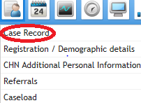

Search for the required client, once in the client record select the ‘Recovery Care Pathway Documentation’ folder from the ‘Case Record Menu’.
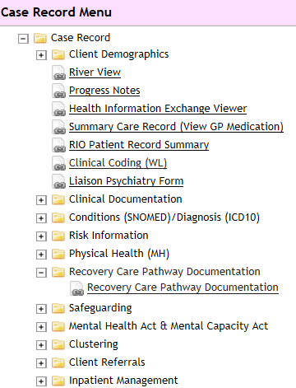

This will display the Recovery Care Pathway documentation (which includes the documents required for the new Recovery CPA), click on the relevant form

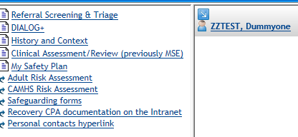

3.1 Referral Screening and Triage form
- Click on the ‘create new’ button at the base of the screen
- Enter the date and time of the initial screening
- Referral / Admission – you can link this to a specific referral or admission
- Upload and attach any relevant referral documentation e.g. GP letter, by clicking on the + sign in the box

Screening
- Screening – please outline the reason for the referral & screening decision e.g. GP has referred because of long standing anxiety and depression which is not being adequately managed in primary care and GP would like specialist assessment and consideration for psychology input. Duty worker has discussed the referral with the GP, checked previous notes on RiO and service user has agreed to assessment.

- Screening outcome – choose from the drop down menu. If the outcome is ‘signposted to another agency’ or ‘signposted to another ELFT service’ please state which service, who has signposted and evidence of this e.g. onward referral letter (this can also be attached via the referral documentation link above) in the screening decision comments box. If you have rejected the referral / returned to the referrer please clearly outline the reasons why.

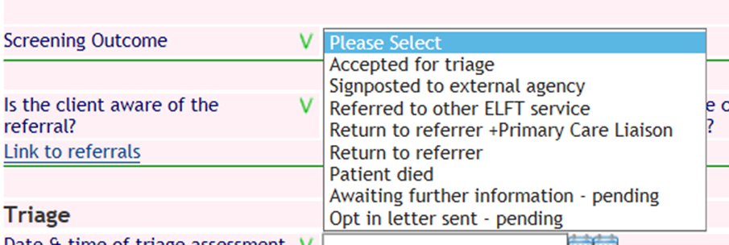

Once you have completed the screening section, the form can be saved or you can go on to the triage section.

Triage

- Complete all the fields in this section of the form
- Triage assessment & decision – complete the free text box to provide a brief summary of the assessment and any decisions taken / action plan agreed at the end of the assessment
- Triage outcome decision – choose the outcome from the drop down list. If you are signposting to another agency or another ELFT service please state which ones and ensure there is evidence of this e.g. letter uploaded, state who you spoke to on the phone from external agency etc. in the triage assessment & decision comments box.

The hyperlinks at the bottom of the screen will take you to the Progress notes, Clinical Assessment/Review form or the History and Context form

Once you have completed the form press ‘Save’.

3.2 DIALOG+

Select the DIALOG+ form and then click on the ‘create new’ button to create a new DIALOG+ assessment. The new form will auto-populate with the responses from the previously completed DIALOG+ form, unless this is the first DIALOG+ form being completed when it will be blank. You can delete or edit these responses depending on what is discussed at this assessment.

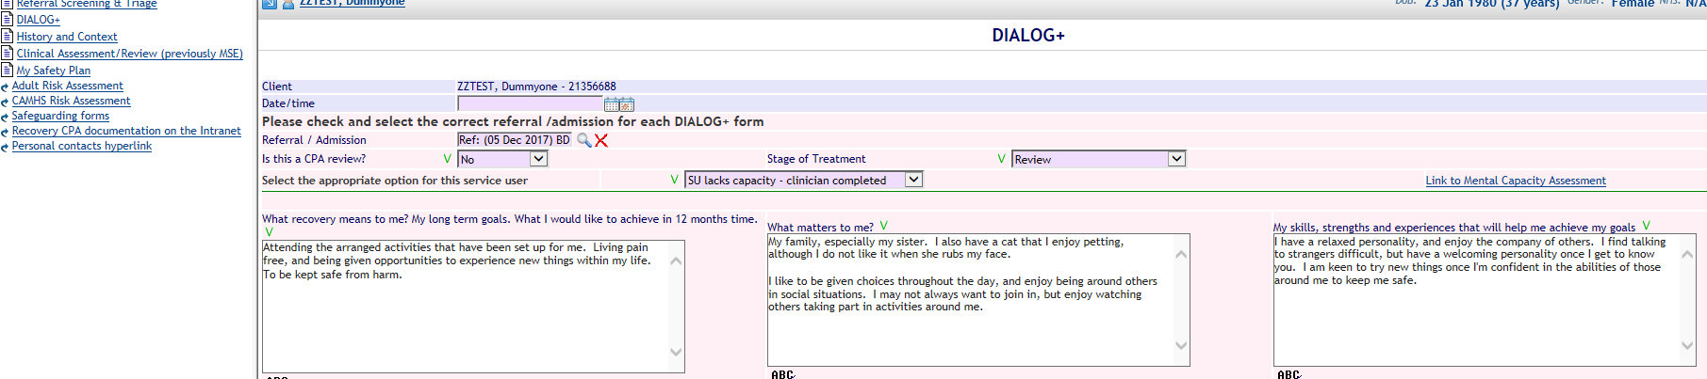

- This form must be completed at the point of entry into the service, at regular intervals throughout the clinical contact, and at discharge.

- Complete the date and time field using the date of assessment/review
- Referral / Admission – you can link this to a specific referral or admission
- Is this a CPA review? – choose yes or no from the drop down menu
- Stage of Treatment – choose assessment, review or discharge from the drop down menu

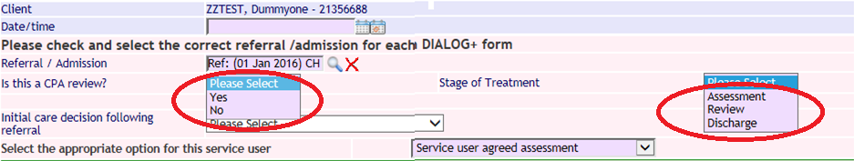

Assessment – for assessing a service user
Review – for reviews meetings (CPA/non CPA) or when a service user is discharged from a ward/service
Discharge – for when a service user is discharged from CPA / or from the Trust

Service user engagement with DIALOG+ - choose from the drop down menu ‘Select the appropriate option for this service user’
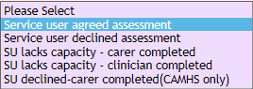

There is a link to the RiO mental capacity assessment form to the right of the screen, if you need to complete an assessment of capacity or refer to a previous assessment.

Complete the next three free text boxes using the service user’s own words and priorities

- What recovery means to me? My long term goals. What I would like to achieve in 12 months’ time

- What matters to me?

- My skills, strengths and experiences that will help me achieve my goals

You will now start the DIALOG+ questions.

Ask the service user to rate their satisfaction using the Likert Scale in the screenshot below:

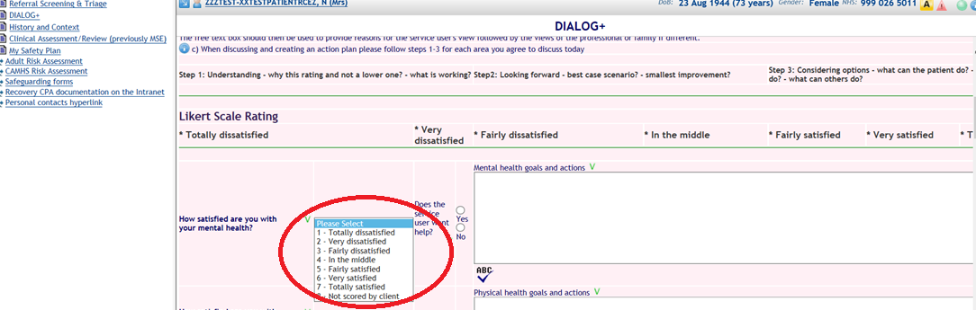

Moving through the list of questions, (apart from the first two domains - mental health and physical health - which are mandatory questions), you will ask the service user if s/he requires help in this area. If they do not and you also have no concerns you can select “no” on the Yes/No radio button and move onto the next area if there is no discussion or actions to reflect in the free text box.

If the service user reports they do not require help in a particular area but you have concerns you can select the “yes” on the Yes/No radio button and then reflect both perspectives and any agreement or disagreement.

You will then use the free text box next to each question to reflect the discussion, ensuring that you reflect
- the service user’s views and your understanding of why s/he has chosen this rating and not a lower one (i.e. what is working)
- best case scenario in this area and the smallest improvements to start working towards this
- Considering options – what the service user can do, what the clinician can do and what others can do?

Further explanation of the above can be found by clicking the question mark icon at the top left hand corner of the screen, when completing the DIALOG+ form

The ‘ABC’ icon below each of the free text boxes will allow you to spell check your text before saving.

At the base of each DIALOG+ screen, there is an option which will allow you to upload and attach (or attach a previously uploaded document) any relevant documentation including Local Authority funding agreements to a service user’s record. A list of associated documents will appear at the bottom of the screen. When you have completed the form click ‘save’. The clear button at the base of the screen will clear all fields.
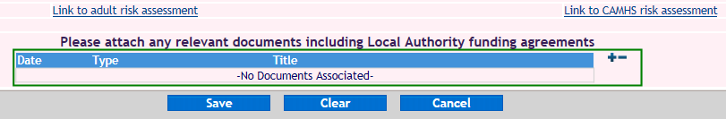
There are links to progress notes, adult risk assessment or CAMHS risk assessment forms, if you want to reflect extra information or changes in risk based on this discussion.

Is this a CPA review?
The DIALOG+ screen produces extra boxes to complete if you choose ‘yes’ to the ‘Is this a CPA review?’ field.

These appear at the bottom of the DIALOG+ screen to reflect, who has attended the CPA meeting and who has been sent a copy of the care plan.

During the CPA DIALOG+ screen if there is a disagreement regarding whether the service user needs help in a particular area you should reflect the discussion as outlined above and then at the bottom of the screen there is a prompt “Does the service user agree with this care plan?” If there has been any disagreement you should select the “no” on the Yes/No radio button and then reflect this in the free text box.

The Responsible Clinician (or their representative attending the CPA meeting) will need to tick the box ‘Does the Responsible Clinician agree to this care plan?’ if they agree to the plan. Where there is a disagreement, this should ideally be resolved in the meeting, or any issues clearly recorded in the DIALOG+ screen (in the relevant free text box).

Please tick the box if this review was unplanned; also complete the drop downs for the ‘care decision following review’ and ‘If this client is receiving a package of care, who is responsible for funding?’

If appropriate, the date the client was entitled to S117 and the end date for S117 are pulled through as read only fields. If this needs to be updated please contact your local MHA office. There is also a free text box to enter details of the S117 entitlements of this care plan

When you have completed the CPA review and My Safety Plan, these can be printed for the client and attached to RiO as a CPAT document, see section 4.1, My Recovery Care Plan.

3.3 History and Context

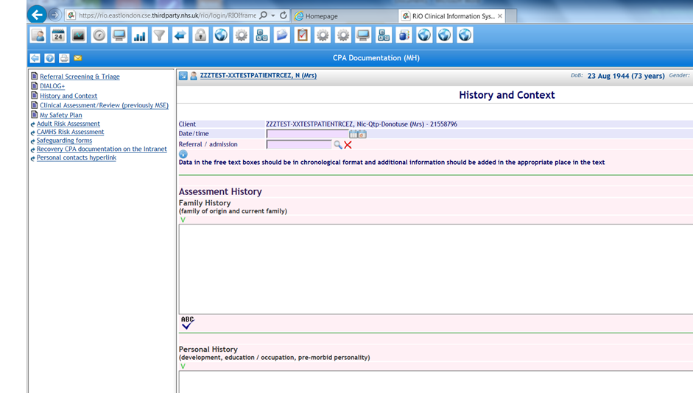

- Complete the date and time of assessment by using the left hand calendar icon next to the date/time field, to input an earlier date and/or time in the past, or the right hand calendar to input today’s date and current time
- Referral / Admission details – you can link this to a specific referral or admission
- Fill and complete the rest of the form as necessary
- Complete each of the free text boxes where you have information to record:

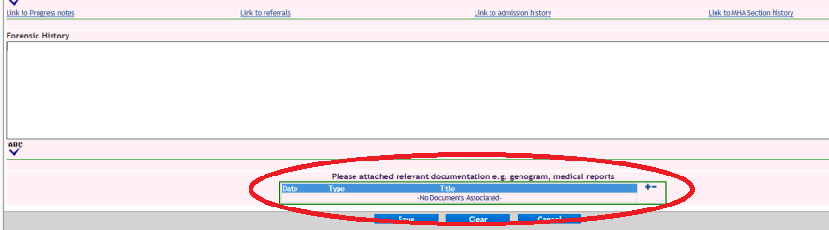

Upload any relevant documentation to a patient’s record e.g. GP summary.

Links to the medical physical health form, lifestyle assessment form, progress notes, referrals, admission history and MHA Section history can be found in the History & Context form. When you have fully completed the form, click on the save icon at the base of the screen, to save your work.

3.4 Clinical Assessment/Review

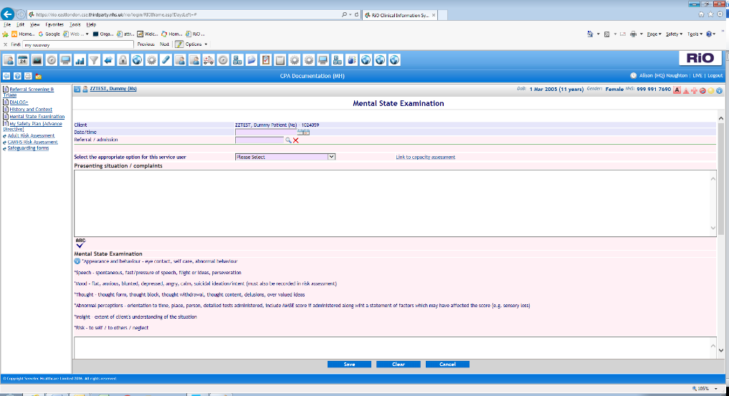
- The most appropriate clinician (care coordinator, psychologist or psychiatrist) should complete a clinical assessment including a mental state examination to reflect the service user’s current mental state. This is not recorded on the DIALOG+ screen in detail as DIALOG+ is a subjective discussion focusing on how satisfied the service user is with his/her mental health, whereas the clinical Assessment/Review form includes an objective assessment of the service user’s current mental state.
- Complete the date and time of assessment by using the left hand calendar icon next to the date/time field, to input an earlier date and/or time in the past, or the right hand calendar to input today’s date and current time.
- Referral / Admission details – you can link this to a specific referral or admission
- Fill and complete rest of form as necessary.

3.5 Adult/CAMHS Risk Assessment

There are hyperlinks to the Adult and CAMHS risk assessment forms in the ‘Recovery CPA Documentation’ folder.

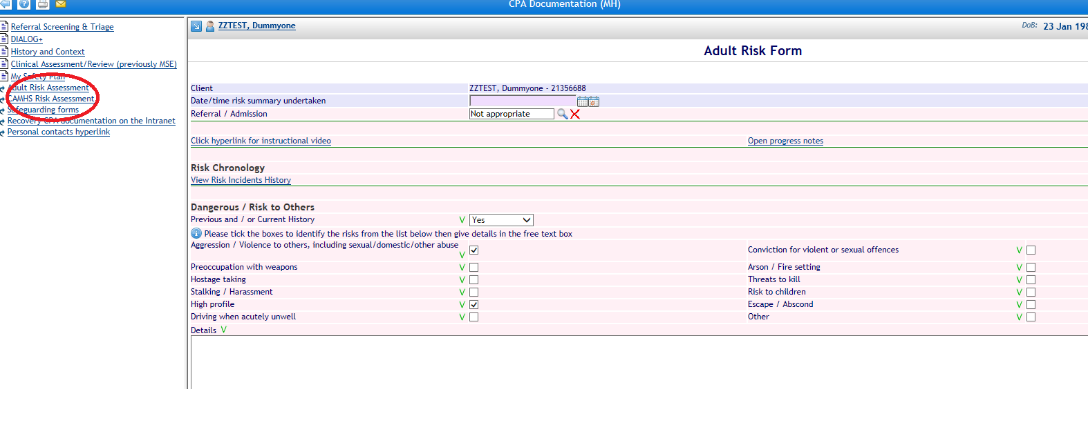

- Complete each section as required.
- This form has links to Risk Incidents History.
- Complete the date and time of assessment by using the left hand calendar icon next to the date/time field, to input an earlier date and/or time in the past, or the right hand calendar to input today’s date and current time.
- Referral / Admission details - you can link this to a specific referral or admission.
- Press save once you have completed the risk form.
3.6 My Safety Plan (Advance Directive)

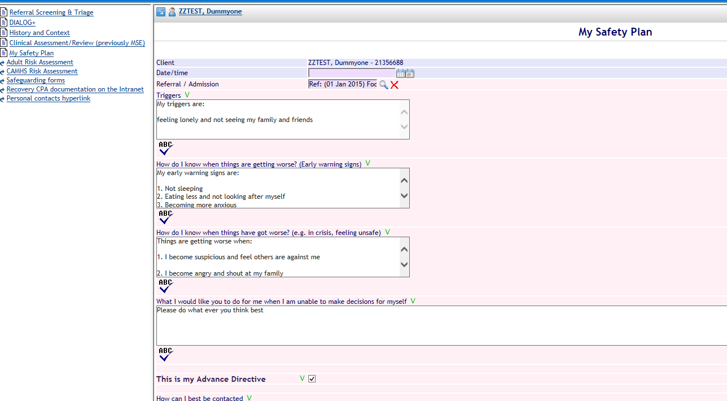

This screen should be completed for any service user who would benefit from having a crisis and contingency plan. This should be developed with the service user, and the clinician should encourage the service user to identify factors which contribute to risk and help in managing or minimising risk. There are four key areas to focus on with the service user

- Triggers
- Early Warning Signs
- When things are getting worse
- How will I know when I am out of crisis
- What I would like you to do for me when I am unable to make decisions for myself

An action plan for each point can then be identified. The discussion and plan will be written in the free text box.

If the service user agrees to this form being their Advance Directive then check the tick box.

The clinician will also discuss how to contact the service user and who else can be contacted and how. This information should not contradict what has been stated on the Permission to Share Information form (and if it does then the Permission to Share Information form should be updated to reflect the service user’s wishes regarding information sharing).

Wherever possible this should be a service user led plan and it is important that the service user agrees to the safety plan and the box at the bottom of the form is ticked.

The type of items which can be added here are, an individual’s mobile phone number, their point of contact in emergency’s, trigger points, early warning signs and other action plans.

The Safety Plan can be created and printed as a stand-alone document – this is useful for service users who are not on CPA and will not have a Recovery care plan.

There is a link here to the Adult risk form, CAMHS risk form and progress notes.

- Editable Letters.

The following table lists forms within the Recovery Pathway Folder and the Editable letters they populate.

RiO Form Completed | Editable letter Populated
DIALOG+ | My Recovery Care Plan  Adult Case Summary  Adult Case Summary (Plus full MSE)
My Safety Plan | My Safety Plan  My Recovery Care Plan
Clinical Assessment/Review (previously MSE) | Adult Case Summary (Plus full MSE)
History and Context | Adult Case Summary  Adult Case Summary (Plus full MSE)
Referral Screening & Triage | Adult Case Summary  Adult Case Summary (Plus full MSE)

4.1 My Recovery Care Plan

My Recovery Care Plan is a printout which pulls information from the DIALOG+ form and My Safety Plan.

To generate the document go to the ‘Clinical Documents’ icon at the top of the screen and select ‘Edit and Print Letters’

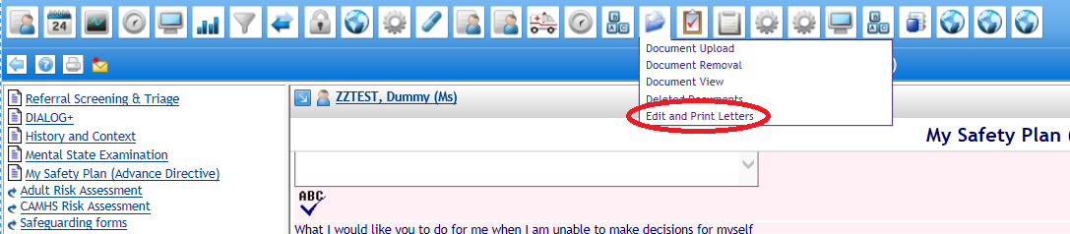

Search for the relevant client

In ‘Letter Type’ search for ‘My Recovery Care Plan’, then press the ‘Create’ button at the bottom of the screen

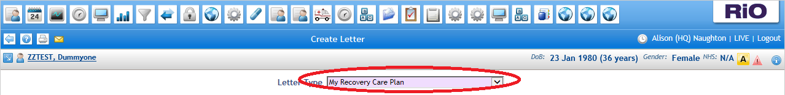

This displays the printable care plan as a Word document

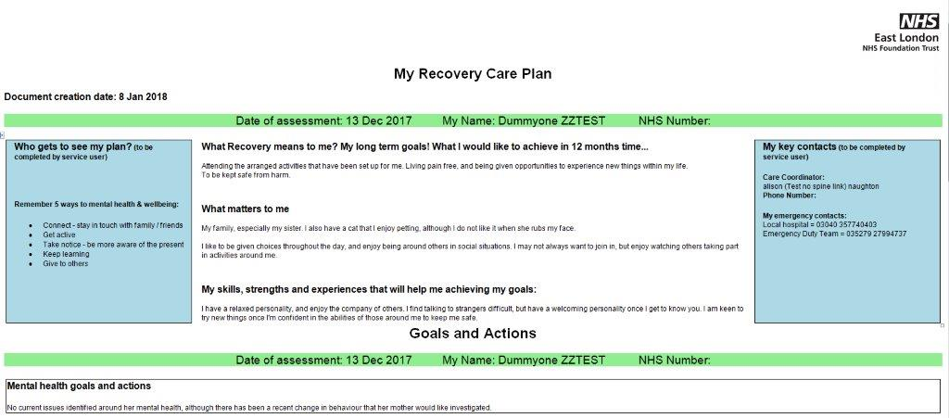

Select the ‘File’ option in Microsoft Word at the top of the screen and then ‘Print’ to produce paper copy to hand to the patient.

My Recovery Care Plan must be attached to RiO using document upload.

Within Microsoft Word select the ‘DropZone’ option then click ‘Send To RiO’

A pop up box will appear, complete all the fields:
- Enter CPAT in the ‘Title’ field
- The default will be ‘Final Version’ do not change this selection
- Enter My Recovery Care Plan in the ‘Description’ field
- ‘Document Date/Time’ field should be the date of the DIALOG+ review
- Select MH Care Plans in the “Type” picklist.
- Where eCorrespondence has been fully deployed, tick the “Send to GP” tick box to enable the My Recovery Care Plan to be sent to the GP. If eCorrespondence has not been deployed in your area, do not tick this box, the My Recovery Care Plan will be sent the conventional way.
- Click ‘OK’ and the document will be saved and can be viewed in the Document List View. Where eCorrespondence has been deployed, clicking ok with the “Send to GP” box ticked will simultaneously send the document to the GP.

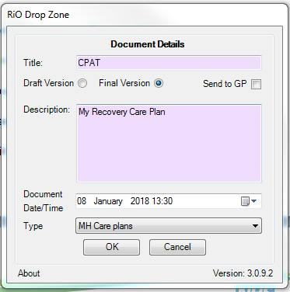

4.2 Case Summary

Case summary is an Editable letter that pulls information from the following areas of the Recovery Care Pathway documentation:
- DIALOG+
- My Safety Plan
- Clinical Assessment and Review
- History and Context
- Referral Screening and Triage.

It also includes information from other areas in RiO including Diagnosis ICD 10, Risk Assessment and Physical Health forms.

To generate the document go to the ‘Clinical Documents’ icon at the top of the screen and select ‘Edit and Print Letters’

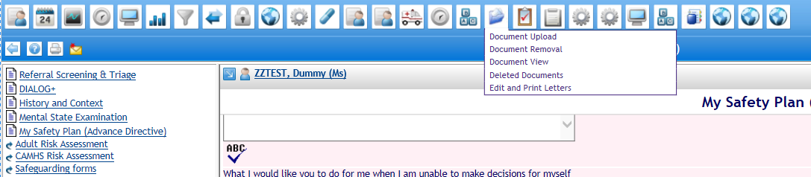

Search for the relevant client

In ‘Letter Type’ select ‘**Adult Case Summary (plus full MSE), then press the ‘Create’ button at the bottom of the screen

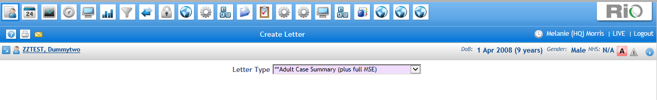

This displays the Adult Case Summary as shown below.

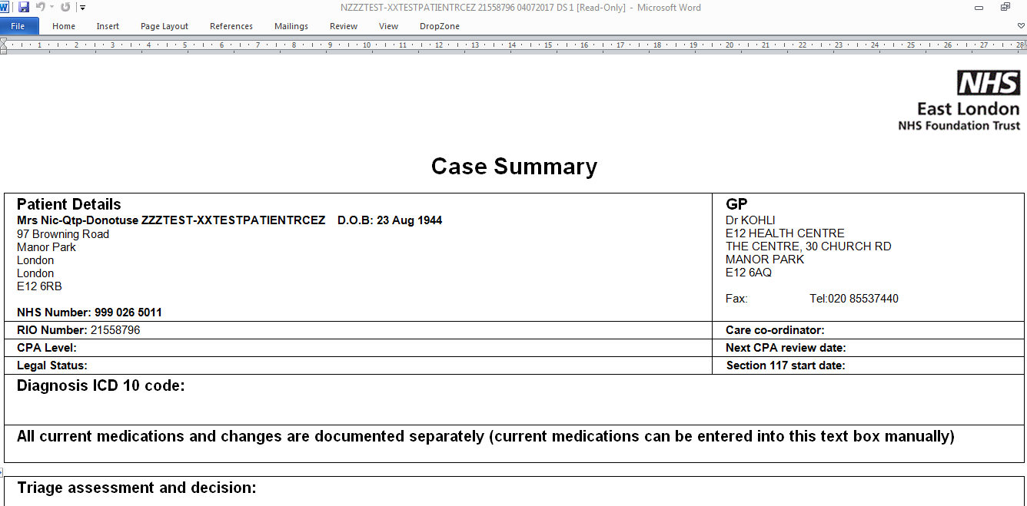

To upload the Adult Case Summary to the RiO record, select the ‘DropZone’ option then click ‘Send To RiO’

A pop up box will appear, complete all the fields:
- Enter CASE in the ‘Title’ field
- The default will be ‘Final Version’ do not change this selection
- Enter “Case Summary” in the ‘Description’ field
- ‘Document Date/Time’ field should be the date of the DIALOG+ review
- Select MH Reports/Assessments in the the ‘Type’ picklist.
- Where eCorrespondence has been fully deployed, tick the “Send to GP” tick box to enable the Case Summary to be sent to the GP. If eCorrespondence has not been deployed in your area, do not tick this box, the Case Summary will be sent the conventional way.
- Click ‘OK’ and the document will be saved and can be viewed in the Document List View. Where eCorrespondence has been deployed, clicking ok with the “Send to GP” box ticked will simultaneously send the document to the GP.

