RiO Section 117 Guidance for staff

Purpose of the Section 117 form
The dedicated Section 117 form in RiO allows staff to document Section 117 aftercare arrangements. This includes identifying Section 117 funding responsibilities between NHS Commissioners and Local Authorities, identifying responsible ELFT professionals or community teams in the delivery of care, financial splits between health and social care, outcomes of Section 117 reviews, and reasons for Section 117 disputes, if applicable.

How to access the Section 117 form on RiO
The Section 117 form can be accessed via the Case Record Menu in RiO.

- Case Record Menu:

Case Record Menu > Recovery Care Pathway Documentation > Section 117 Form
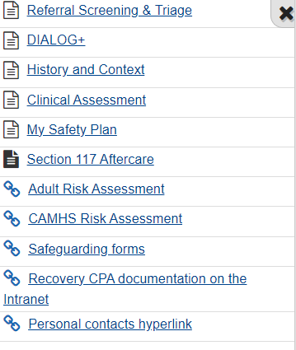
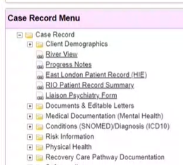

How to complete the Section 117 form on RiO
Click on the Section 117 form in RiO.

The first two questions require staff to identify the date when the patient was initially detained under an eligible section of the Mental Health Act (Section 3, 37 47, 48, 45a) and the most recent detention date under an eligible section. Staff can use the calendar feature to select the relevant date.

Once the relevant dates and times have been inputted, select “Go”.

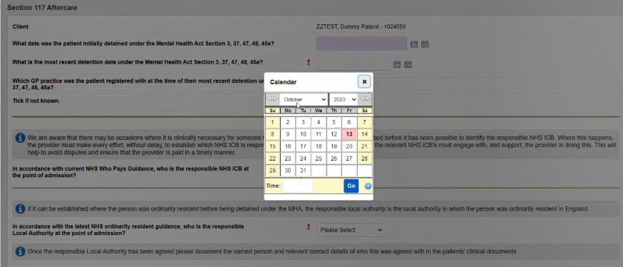

Once the initial and most recent detention dates have been identified, the form requires staff to identify where the patient was registered with a GP. There is a free text box to input this information. If this is not known, staff can select “Tick if not known”.

If the GP practice is not known, a follow-up question will appear, prompting staff will have to identify the patient’s address at the time of their most recent detention. If this is also not known, staff can select “Tick if not known”.

If both the GP practice and address at the time of their most recent detention are not known, then staff will be required to manually input where the patient was physically present at the time of their most recent detention.

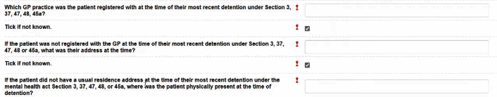

In accordance with the Who Pays Guidance, the responsible NHS ICB needs to be identified at the point of admission. We are aware that there may be occasions where it is clinically necessary for someone to be admitted before it has been possible to identify the responsible NHS ICB. Where this happens, the provider must make every effort, without delay to identify which NHS ICB is responsible for funding the patient's care. This will help to avoid disputes and ensure that the provider is paid in a timely manner.
Once the responsible ICB has been identified, staff can record the borough breakdown within this ICB.

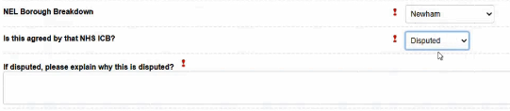
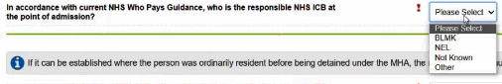

Staff will have to select from a drop-down of options to identify whether the responsible ICB is “Agreed”, “Disputed” or “TBC”. If the identifying ICB is disputed, staff will also have a free text box to explain why this is disputed, as highlighted above.
In accordance with the ‘ordinarily resident’ guidance, staff will also be required to identify the responsible Local Authority.
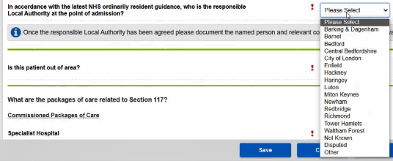

Similar to the questions requiring staff to identify the responsible ICB, staff will need to identify whether the identified Local Authority is “agreed”, “disputed” or “TBC”. Again, if the responsible Local Authority is “Disputed”, staff will have a free text box to explain this further.

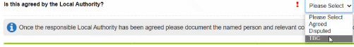

Staff will need to record whether the patient is out of area. This will ensure that the correct Community and/or HCP teams are identified that are responsible for providing care to the patient. If they are an ELFT patient, then staff will have to identify the responsible community teams and HCP within ELFT as shown below:

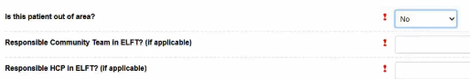

The following questions will require staff to identify the packages of care related to Section 117.
These have been broken down into “Commissioned Packages of Care” and “Routine Commissioned Packages of Care”. The questions are tick boxes and are designed to allow staff to select multiple, if relevant. There are also options to select “none” or “other” if the packages of care are not captured under the prescribed list:
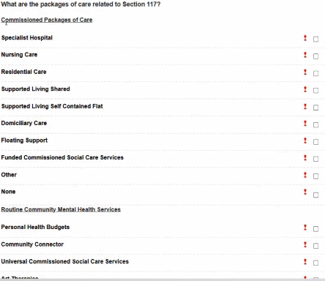

Once the relevant packages of care have been identified and selected, staff will have to identify the financial cost of these packages. This includes documenting to overall (health and social care combined) weekly cost of the care package, as well as the health care split and social care split. If this information is not known at the time of completing this form, staff can also select “Tick if not known” and input the information once this is made available

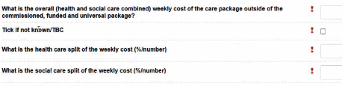
Staff will be required to identify whether this is a new Section 117 plan or a Section 117 review. If “117 Review” is selected, then you will be asked to document the outcome of the review and provide evidence and key rationale for any changes in the Section 117 form.

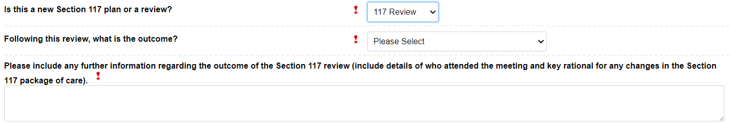

If “New Plan” is selected the form will then ask you to ensure the aftercare needs are updated and recorded in the Dialog care plan including provider information related to the funded packages of care including the provider umbrella name/local service name/address.
Please note, the same questions below appear if you also select “117 Review”. This encourages staff to ensure that all aftercare needs are updated and recorded in the Dialog care plan and relevant provider information at the time of review.
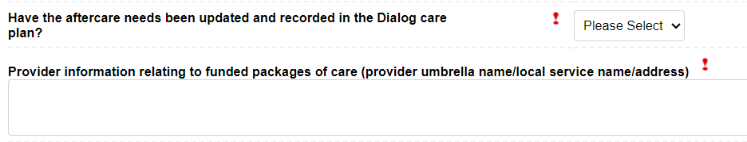
Once all of the relevant information has been identified, staff will have to select the date of the next review. This review should be done approximately every 12 months to ensure routine oversight of Section 117 packages of care.
Use the calendar icon to select the appropriate date.
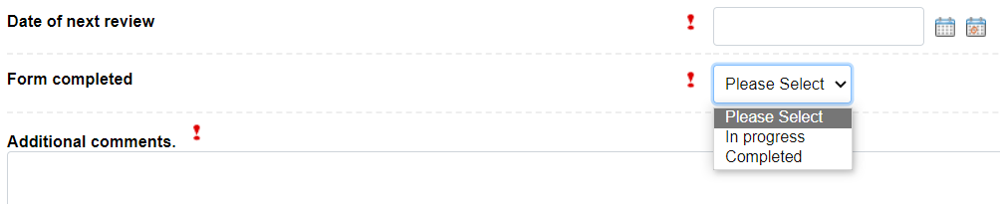

Once this has been inputted, staff can identify whether the form is “Completed” or “In progress”. If staff select “In progress” because information related to the Section 117 package of care, them staff can use the “Additional comments” box to highlight the progress they have made within the form and any outstanding items that require follow-up.
Once the information has been inputted, select “Save”.
The output of this document will be pulled together as part of the “My Recovery Care Plan” documentation.



