
COVID-19 – Infection Prevention and Control Policy

Version Number: | 11.0
Ratified by: | Infection Prevention & Control Committee
Date Ratified: | 24th February 2022
Name of Originator/Author: | - Infection Prevention & Control Department  - Estates & Facilities Department  - People & Culture Department
Name of Responsible Committee/Individual: | Infection Prevention & Control Team
Circulated to: | - Clinical & Operational COVID-19 Work stream  - Community Health Services COVID-19 Work stream  - People & Culture COVID-19 Work stream  - Infection Prevention & Control Committee  - Quality Committee
Implementation Date: | February 2022
Last Review Date: | February 2022
Next Review Date: | The emerging evidence base on COVID-19 is rapidly evolving. Further updates may be made to this policy as new guidance emerges.

Services | Applicable
Trust wide | X
Mental Health and LD
Community Health Services

Version Control Summary
Version | Date | Author | Status | Comment
01 | 5 May 2020 | Rana Begum | Final | New policy.
02 | 22 May 2020 | Rana Begum | Final | Update on case definition for COVID-19.
03 | 8 June 2020 | Rana Begum | Final | Changes on flowchart to incorporate compulsory isolation guidance.
04 | 17 June2020 | Rana Begum | Final | Changes include update on patient and staff exposure and contact tracing, NHS Test & Trace, face covering/mask guidance, outbreak management of healthcare acquired COVID-19 infection.
05 | 17 July 2020 | Rana Begum | Final | Update on COVID-19 waste management.
06 | 4 Aug 2020 | Rana Begum | Draft | Update on discharges and transfers, patient exposure to COVID-10 infection, management of healthcare staff with COVID-19 infection.
07 | Nov 2020 | Verity Honu | Draft for Approval | Updated in view of updated national guidance on 20 October 2020 COVID-19: Guidance for the remobilisation of services within health and care settings infection prevention and control recommendations and  COVID-19: management of staff and exposed patients and residents in health and social care settings – 28 September 2020.  The Pan London COVID-19 recovery: Infection Prevention & Control Guidance v4.
08 | January 2021 | Siobhan Fensom | Draft for Approval | COVID-19: Infection prevention and control for mental health and learning disability settings. 21 January 2021.  Guidance for step down of infection control precautions and discharging COVID-19 patients. 18 December 2020.  COVID-19: Guidance for maintaining services within health and care settings infection prevention and control recommendations.
09 | July  2021 | IPCT | Final | Incorporation of feedback from Directors, Microbiologist and addition of Lateral Flow testing appendix , Management of Patients-Service Users from Red-Amber List Country and Office Environment.
10 | September 2021 | Rana Begum | Final | Updated guidance on Track and Trace & point of care testing DNA-Nudge flow chart & Guidance when admitting new patients to wards with active COVID-19 case or outbreaks of COVID-19 (High risk areas)
11 | Jan 2022 | Siobhan Fensom  Rebecca Clancy  Verity Honu | Draft for Approval | Guidance on infection prevention and control for seasonal respiratory infections including SARS-CoV-2.  COVID-19: management of staff and exposed patients or residents in health and social care settings.  Stay at home: guidance for households with possible or confirmed coronavirus (COVID-19) infection.  Guidance for contacts of people with confirmed coronavirus (COVID-19) infection who do not live with the person.  Update on Health Care acquired infection processes and Root cause analysis

Table of Contents
No. | Content | Page No.
 | Background | 6
 | Introduction | 6
 | Purpose | 7
 | Mode of Transmission | 7
 | Diagnostic Investigations Required for COVID-19 including Documentation | 7
 | Management Pathway for COVID-19 Infection Risk | 8
 | Standard Infection Prevention Control Precautions (SICPs) | 10
 | Respiratory Cough Etiquette | 11
 | Personal Protective Equipment (PPE) Universal Masking | 11
 | Sessional Use of PPE | 15
 | Donning and Doffing of PPE | 15
 | Aerosol Generating Procedures (AGPs) | 15
 | Isolation & Cohort Nursing | 16
 | Staff Cohorting | 17
 | Transfer of Patients with COVID-19 - Moving Patients within ELFT Services | 17
 | De-isolation Pathway of COVID-19 Infection | 17
 | Discharge of Patients with COVID-19 to Home Environment Considerations | 18
 | Discharge to Care/Nursing Homes | 19
 | Environmental Cleaning – COVID-19 Wards/Areas | 19
 | Cleaning of Re-Usable Equipment | 20
 | Laundry and Linen Management | 21
 | Clinical Waste | 21
 | Waste Segregation | 22
 | Inpatient Sites and Community Clinics | 22
 | Community Nursing/District Nursing (Treatment at Domestic Properties) | 22
 | Office Environment | 22
 | Food Service in COVID-19 Areas | 23
 | Reporting to UKHSA (UK Health Protection Agency) | 23
 | Contact Details for Notification of COVID-19 | 23
 | Notifiable Diseases – Reporting to UK Health Security Agency (UKHSA) | 23
 | Managing Visitors | 24
 | Patients Returning from Leave | 24
 | Staff Uniform | 24
 | Fans | 25
 | Crockery & Cutlery | 25
 | Resuscitation | 25
 | Management of Patient’s Property | 25
 | Handling the Deceased | 25
 | Management of Healthcare Staff in conjunction with COVID19 | 26
 | Risk Assessment of Staff Exposures in the Workplace | 28
 | Isolation and guidance surrounding returning from foreign travel | 29
 | Management of Patients-Service Users from Red-Amber List Country | 29

 | List of Appendices | Page No.
1 | Diagnostic Investigations - How to take a specimen for COVID-19 | 32
2 | Management Pathway of COVID-19 Infection - Mental Health Inpatient Settings | 34
3 | Management Pathway COVID-19 Infection  Community Mental & Community Physical Health Services | 35
4 | SPACES to Care Approach for COVID-19 | 36
5 | Do’s & Don’ts for Suspected or Known COVID-19 | 37
6 | Personal Protection Equipment including AGP: All Inpatient and Community Mental/Physical Health Services PPE Requirements | 38
7 | Donning Personal Protective Equipment | 39
8 | Doffing Personal Protective Equipment | 40
9 | Donning AGP Personal Protective Equipment | 41
10 | Doffing AGP Personal Protective Equipment | 42
11 | Donning Coveralls Personal Protective Equipment | 43
12 | Doffing Coveralls Personal Protective Equipment | 44
13 | Environmental Cleaning | 46
14 | Patient Information Leaflet on COVID-19 | 50
15 | Waste Segregation | 51
16 | Recording of COVID-19 on RIO | 52
17 | Glossary | 53
18 | Severe Immunosuppression Definitions and shielding | 57
19 | Lateral Flow Testing | 58
20 | Decision Tree for Suspected or Confirmed Nosocomial Covid-19 Infections | 61
21 | Nosocomial Covid19 Infections on Inpatient Wards and transfers | 62
22 | Temperature taking of staff and visitors | 63
23 | Equality Analysis | 65
24 | Track & Trace - Contract tracing – Covid-19 Factsheet | 68
25 | Infection Prevention & Control DNA Nudge Testing | 72
26 | Guidance when admitting new patients to wards with active COVID-19 case or outbreaks of COVID-19 (High risk areas) | 73
27 | Staff Isolation Flowcharts | 75
28 | Self-Isolation Risk Assessment Form | 79
29 | Health care Acquired infections and Root cause analysis flowchart | 81
1.0 Background

1.1 On 31 December 2019, the World Health Organisation (WHO) was informed of a cluster of cases of pneumonia of unknown cause detected in Wuhan City, Hubei Province, China.

1.2 On 12 January 2020, it was announced that a novel coronavirus had been identified. This virus is referred to as SARS-CoV-2, and the associated disease as Coronavirus infectious disease (COVID-19). Current symptoms are:

- New continuous cough and/or;
- Fever ≥37.8°C;
- A loss of, or change in, your normal sense of taste or smell (anosmia).

1.3 The transmission of COVID-19 is thought to occur mainly through respiratory droplets generated by coughing and sneezing, and through contact with contaminated surfaces.

1.4 During Aerosol Generating Procedure (AGPs), there is an increased risk of aerosol spread of SARS-CoV-2 irrespective of the mode of transmission (contact, droplet), therefore, airborne precautions must be implemented when performing AGP on a suspected or confirmed case of COVID-19.

1.5 SARS-CoV-2 has been detected in blood, faeces, conjunctival secretions and urine of confirmed cases. As always, body fluids should be regarded as potentially infectious when handling.

1.6 Incubation & Infectious Period

1.6.1 The incubation period is from 1 to 14 days (median 5 days). In most cases, individuals are usually considered infectious while they have symptoms; how infectious individuals are depending on the severity of their symptoms and stage of their illness.

1.6.2 The median time from symptom onset to clinical recovery for mild cases is approximately 2 weeks, and is 3 to 6 weeks for severe or critical cases. The latter may need some time to recover as part of a rehabilitation programme.

1.6.3 As this is an emerging infection, further research is required to determine asymptomatic and pre-symptomatic infection, and associated transmission risk.

1.6.4 On the balance of current evidence, most people will have sufficiently reduced infectivity 7 days after the onset of symptoms.

2.0 Introduction

  - Policy outlines the Infection Prevention and Control (IPC) principles for the management of patient’s/service users in East London Foundation Trust (ELFT) in view of the current COVID-19 Pandemic. The policy is based on the following national guidance:

- Public Health England (PHE) COVID-19: Guidance for the remobilisation of services within health and care settings: Infection prevention and control recommendations - 20 October 2020;
- COVID-19: Management of staff and exposed patients and residents in health and social care settings
- The Pan London COVID-19 Recovery: Infection Prevention & Control Guidance v4.

2.2 UKHSA (formerly PHE) have now recommended the management of patients in healthcare setting to follow COVID-19: Guidance for health professionals. Updated 22 October 2021.

2.3 Screening and testing should be in place to identify COVID-19 symptomatic patients and isolate them to reduce the risk of transmission within healthcare environments.

2.4 Standard IPC precautions apply to all patients with suspected or confirmed cases of COVID-19. Lateral Flow Test (LFT are used in Bedford and city and Hackney to screen patients and PCR. DNA Nudge Point of Care Testing is used in Tower Hamlets and Newham Mental Health in patients

2.5 Lateral Flow Test (LFT) and Lamp Testing is also currently being utilised across the trust as part of a risk reduction measure to identify staff that may be asymptomatic but have Covid-19.

3.0 Purpose

3.1 The purpose of this policy is to:

- Eliminate the risk of nosocomial infection of COVID-19;
- Minimise the risk of exposure to COVID-19;
- Provide an environment that supports good IPC.

4.0 Mode of Transmission

4.1 Clinicians should consider testing inpatients with new respiratory symptoms or fever without another cause or worsening of a pre-existing respiratory condition. Clinicians should be alert to the possibility of atypical presentations in patients who are immune-compromised.

5.0 Diagnostic Investigations Required for COVID-19 Including Documentation

5.1 Clinicians must arrange diagnostic sampling for individuals meeting the case definition.
5.2 Influenza testing should be considered where SARS-CoV2 is negative in severe infections and immune-compromised patients, and in other cases where it is relevant for clinical management. This will assist with differential diagnosis of symptoms of either Influenza or Covid-19.

5.3 Patients must be triaged and tested on admission. A SARS-CoV-2 PCR test is required on admission; that is day 1, then on day 3 and day 5 to 7 of admission. This then continues weekly. Where possible and appropriate service users should be encouraged to wear a mask, separate from others pending results of admission testing or have symptoms.

5.4 All results to be documented on Designated RIO template for Mental Health Services as below Appendix 22. Community Health Services to continue documentation on Systm1 Electronic Record.

5.5 See appendix 1 on how to collect specimen sample to test for COVID-19 infection or where symptoms are recognized.

5.6 Within the trust LFD tests are carried out on admission, with a PCR follow up with the exception of Newnham and Tower Hamlets Mental Health who continue with DNA Nudge followed by a PCR test.

5.7 The patient can de-isolate on the result of the LFD & DNA test result.

6.0 Management Pathway for COVID-19 Infection Risk.

6.1 As of 19th March 2020, COVID19 is no longer considered a High Consequence Infectious Disease.

6.2 Implement Infection Prevention and control measures whilst awaiting any test results, this includes isolation and wearing correct PPE.

6.3 Assess the possible case individuals in a single occupancy room.

6.4 Ask the patient, if older than 3 years and can tolerate it to wear a fluid-resistant (Type IIR) surgical face mask (FRSM) if they are in a clinical or communal area or are being transported. This minimises the dispersal of respiratory secretions and reduce both direct transmission risk and environmental contamination.

6.5 Other clinical situations when SARS-CoV-2 testing are to be considered is as follows. There has been a wide variety of clinical systems associated with COVID19, therefore it is NOT a requirement that the patient meets the definition of a possible COVID-19 case.
Any patients with acute respiratory infection, influenza-like illness, clinical or radiological evidence of pneumonia, acute worsening of underlying respiratory illness, and fever without a cause should have a COVID 19 test.

6.6 A suspected Covid-19 case should be placed in respiratory isolation or within a specified cohort area, and the correct PPE (Under IPC precautions) should be worn by ANYONE entering that area. Potential contaminated areas and waste management are managed as per policy sections below.

6.7 Arrange a COVID-19 diagnostic sampling for individuals who require a test. Do not wait for results of local testing for other pathogens before sending samples for SARS-CoV-2 testing.

6.8 The local PHE health Protection Team should be informed about COVI-19 outbreaks and clusters in particular settings. This includes Hospitals and Healthcare settings. This is the responsibility of the Infection Prevention and Control Team within ELFT.

6.9 The Ward can begin to step-down infection prevention and control (IPC) measures once inpatients have self-isolated for 10 days. This is after the onset of symptoms or their 1st positive Covid-19 test if they do not have symptoms. De-isolations should be made on a case by case basis in discussion with the Infection Prevention and Control Team.
6.10 If a COVID-19 patient is clinically well and suitable for discharge during their 10-day isolation period they can be discharged after:

- Appropriate clinical assessment.

- Risk assessment of their home and provision of self-isolation advice. Isolation should be maintained until at least 10 days from their first positive test. If the patient is febrile on discharge they should extend their self-isolation until fever has resolved for a consecutive 48-hour period without medication.
Their household should be risk assess to identify and resident with an underlying health condition that puts them at higher risk of severe illness if they were infected with COVID-19.
- There must be arrangements in place to get them home. Public transport should not be used (including taxis). See section 6:11.

- They should be informed that they will not need to be retested for covid-19 for 90 days unless they develop new symptoms

- They should be informed that they must wait 28 days before having a Covid vaccine

Other patients that are identified at COVID 19 contact cases should:

- Monitored daily for 10 days for symptoms by ward staff supported by the IPC team.
- PCR test every 48 hours for all patients identified as contacts.
- If symptomatic test for Covid-19 infection & follow inpatient Covid-19 management pathway. See appendix.

If patient contacts are discharged to another care facility the receiving facility should be informed of the exposure. Please refer to test and trace guidance.

If the patient contact is to be discharged home refer to the stay at home guidance (note this guidance doesn’t apply to non-contacts) if less than 10 days has elapsed since their exposure (contacts who have been double vaccinated do not need to isolate once they have been discharged into the community

6.11 Transport home for patients can be arranged via a variety of routes. If they have their own car and are well enough they may drive home.

If transport is shared, their status and isolation needs should be communicated with transport staff (for example ambulance crews and relatives). Those transporting them should not be at a greater risk of infection themselves.

- It is also best practice to provide written instructions on ongoing isolation.

- The patient should wear a surgical facemask for the duration of the journey.

- The patient should sit in the back of the vehicle with as much distance from the driver.

- Windows should be left open for ventilation.

- Vehicles should be cleaned appropriately at the end of the journey.

6.12 Any COVID-19 patient who is being discharged to a care facility including nursing homes can be done when the clinical status is appropriate for discharge. Immunocompetent patients who have tested positive and have already completed their isolation should be exempt from testing by PCR prior to hospital discharge within 90 days from their initial test or onset of illness. Unless they develop new COVID-19 symptoms. However, if the test was more than 90 days ago the patient should be tested again 48 hours prior to discharge and the result of this test be relayed to the receiving organisation.

It is possible for severely immunocompromised patients to remain infectious for prolonged periods even if they are not displaying and symptoms of COVID 19. The isolation period for these patients whilst in hospital should be at least 14 days.
For definition of the severe immunocompromised please see the Green Book on:

https://assets.publishing.service.gov.uk/government/uploads/system/uploads/attachment_ data/file/655225/Greenbook_chapter_6.pdf

7.0 Standard Infection Prevention Control Precautions (SICPs)

7.1 SICPs are the basic IPC measures necessary to reduce the risk of transmitting infectious agents from both recognised and unrecognised sources of infection and are required across with ALL confirmed/suspected COVID-19 cases. SICPs must, therefore, be used by all staff, in all care settings, at all times and for all patients/individuals, whether infection is known or not, to ensure the safety of patients/individuals, staff and visitors.

7.2 The elements of SICPs are:

  - Patient placement and assessment for infection risk (screening/triaging) before and during admission;
  - Hand hygiene;
  - Respiratory and cough hygiene;
  - Personal protective equipment;
  - Safe management of the care environment;
  - Safe management of care equipment;
  - Safe management of healthcare linen;
  - Safe management of blood and body fluids;
  - Safe disposal of waste (including sharps);
  - Occupational safety: prevention and exposure management;
  - Maintaining social/physical distancing (new SICP due to COVID-19).

7.21 Healthcare workers should wear appropriate PPE for all cases of COVID-19. This is:

- Aprons, gloves, fluid repellent mask and eye protection whilst assessing and treating patients.
- Gowns/Coveralls, gloves, FFP2/FFP3 respirator and eye protection whilst performing aerosol generating procedures.

7.3 Patient Placement in inpatient setting

7.3.1 Following screening, triaging and testing, patients should be regularly reviewed for respiratory symptoms throughout their stay.

7.3.2 In the hospital setting where possible should be placed in a single room, ideally with en-suite facilities. A specialised isolation room is not required but where available should be used for aerosol generating procedures.

7.3.3 The transfer of patients outside their room should be limited to medically necessary activities where possible.

7.3.3 If a single/isolation room is not available, cohort patients with confirmed respiratory infection with other confirmed patients.

7.3.4 Physical distancing is recommended to remain at 2 metres where patients with suspected or confirmed respiratory infection are cared for and patients should be reminded to remain in their bed space.

7.3.5 Care homes. Individuals in care homes with suspected or confirmed should ideally be isolated in their own room with associated en-suite.

7.3.6 Where a treatment or appointment cannot be deferred, patients with symptoms should be triaged to a segregated waiting and assessment area with physical 2 metre distancing.

7.4 Hand Hygiene
7.4.1 Hand hygiene is one of the most important basic interventions to prevent cross transmission.

7.5 Staff

7.5.1 Staff must undertake hand hygiene as per the World Health Organisation (WHO) ‘5 moments of hand hygiene’, using either soap and water or an alcohol-based hand rub.

7.5.2 Hands must be dried with soft absorbent, disposable paper towels from a dispenser, located close to the hand wash sink and beyond risk of splash contamination.

7.5.3 Posters indicating ‘how to wash and dry hands’ must be clearly displayed in all public toilets and staff areas.

7.5.4 Refer to the sub-section of Hand Hygiene within the IPC manual.

7.5.5 Staff must be reminded of the importance of skin care. Hand moisturiser must be provided for staff use.

7.6 Patients

7.6.1 Patients should be instructed and encouraged to wash their hands or use alcohol gel hand rubs at entry points to the facility where hand-washing signage should be in place.

7.6.2 Inpatients who are unable to wash their hands should be provided with wipes so they are able to decontaminate their hands prior to eating and drinking, after toileting and attending to hygiene needs as required. Clinell hand wipes can be ordered for this purpose.

7.6.3 If wearing an apron, forearms may have been exposed to respiratory secretions (for example, cough droplets or other body fluids), hand washing should be extended to include both forearms. Wash the forearms first and then wash the hands using the 7 steps of hand hygiene.

8.0 Respiratory Cough Etiquette

8.1 Patients, staff and visitors should be encouraged to minimise potential COVID-19 transmission through good respiratory hygiene measures.

8.2 Disposable, single-use tissues should be used to cover the nose and mouth when sneezing, coughing or wiping and blowing the nose.

8.3 Used tissues should be disposed of promptly in the nearest waste bin and hand hygiene performed.

9.0 Personal Protective Equipment (PPE) Universal Masking

9.1 Universal masking with surgical face masks (Type II or IIR) to prevent the transmission of SARS-CoV2 and other respiratory infectious agents in health care settings, as a source of control measure.

9.1 PPE must be available at point of use and stored in a clean dry area.

9.2 All PPE is single patient use apart from the surgical mask which can be worn for up to 4 hours.

9.3 PPE posters showing how to don and doff should be available at entrances to the wards/clinical departments. (Appendix 7)

9.4 The use of PPE must always be in line with PHE Guidance and ELFT IPC manual.

9.5 All staff (clinical and non-clinical) must:

- Be trained and assessed as competent in the correct procedure for putting on (donning) and removing (doffing) PPE;
- Be fit tested for FFP3 mask for use when undertaking any aerosol generating procedure;
- Know what PPE they should wear for each setting and context;
- Have access to the PPE that protects them for the appropriate setting and context;
- Perform hand hygiene before and following removal of PPE.

9.6 PPE for Clinical/Patient Facing Staff

9.6.1 All staff working in clinical areas must routinely wear fluid resistant surgical masks (FRSM).

9.6.2 All staff providing direct patient care, within 2 metres of all patients must continue to wear disposable aprons, gloves, FRSM, and (based on risk assessment) eye/face protection when in the patients’ immediate care environment. The PPE should be removed and replaced between patient contacts.

9.6.4 If an infectious patient has an unexpected episode of violence and aggression where PPE has not been worn, the staff member should undertake a risk assessment to determine if they need to change their clothing. Within Covid-19 secure areas, scrubs can be provided to facilitate this. This incident may require investigation.

9.7 PPE Guidance for General Areas

9.7.1 Face mask for non-clinical areas:

9.7.1.1 Fluid-Resistant Surgical Masks (FRSM) are available at the entry of the care facilities and all staff (clinical and non-clinical) must wear a surgical mask on entry to the facility or other Trust buildings that are non-clinical.

9.7.1.2 Staff that do not share an office are not required to wear a facemask whilst alone, however, staff that share an office are required to wear a surgical facemask unless a formal risk assessment has been carried out and have been advised that this is not necessary.

9.7.1.3 Social distancing (2 meters) should be maintained during breaks and masks should not be placed on tables.

9.7.1.4 FRSM and alcohol gel should be made available at all entrances to buildings and offices along with a waste bin for disposal of masks.

9.7.1.5 Staff must wear a face mask at all times except at meal times. Social distance must be maintained during break times. Where this is not possible, it is recommended that eating and drinking times are kept to 15 minutes or less and face masks are immediately put on after eating and the rest of the break time.

9.7.1.6 Masks can be worn for a maximum of 4 hours or when it becomes damp, then they will need to be changed. Wash your hands with soap and water or use alcohol hand gel to decontaminate your hands before and after removal of facemask.

9.7.1.7 FRSMs provide barrier protection against respiratory droplets reaching the mucosa of the mouth and nose. FRSMs should be well fitted. Covering the nose and mouth. Not touched once on, and not dangle around the neck at any time.

9.7.1.8 Ensure fluid-resistant (blue side) side is facing outwards when wearing.

9.7.1.9 FRSM must be discarded:

- When damp;
- When damaged soiled (for example, with secretions, body fluids);
- When uncomfortable.

9.8 Surgical Facemasks for Patients

9.8.1 All patients should be encouraged to wear a surgical mask (if tolerated and does not compromise clinical care). The patient’s mask should be changed 4 hourly or when it becomes damp.

9.9 Face and Eye Protection

9.9.1 Eye and face protection provides protection against contamination to the eyes from respiratory droplets, aerosols arising from AGPs and from splashing of secretions (including respiratory secretions), blood, body fluids or excretions.

9.9.2 Eye and face protection can be achieved by the use of any one of the following:

- surgical mask with integrated visor;
- full face shield or visor;
- Polycarbonate safety spectacles or equivalent.

9.9.3 Regular corrective spectacles are not considered adequate eye protection. While performing AGPs, a full-face shield or visor is recommended.

9.9.4 Disposable, single-use, eye and face protection is recommended. See appendix 6.

9.9.5 However, re-usable eye and face protection is acceptable if decontaminated between use with disinfectant wipe.

9.9.6 It is important that the eye protection maintains its fit, function and remains tolerable for the user. Eye and face protection should be discarded and replaced if damaged, soiled (for example, with secretions, body fluids).

9.10 Disposable Aprons and Gowns

9.10.1 Disposable plastic aprons must be worn to protect staff uniform or clothes from contamination when providing direct patient care and during environmental and equipment decontamination.

9.10.2 For Aerosol Generation Procedures (AGP) long sleeved disposable fluid repellent gowns/coveralls must be worn when a disposable plastic apron provides inadequate cover of staff uniform / clothes for the procedure or task being performed and when there is a risk of splashing of body fluids such as during AGPs. If non-fluid-resistant gowns are used, a disposable plastic apron should be worn in addition.

9.10.3 Disposable aprons are subject to single use and must be disposed of immediately after completion of a procedure or task. Long sleeved disposable fluid repellent gowns are also for single use.

9.11 Disposable Gloves

9.11.1 Disposable gloves must be worn when providing direct patient care and when exposure to blood and or other body fluids is anticipated or likely, including during equipment and environmental decontamination. Disposable gloves are subject to single use and must be disposed of immediately after completion of a procedure or task and after each patient contact. This must be followed by completing hand hygiene.

9.12 Respiratory protective equipment (RPE)/Filtering Face Piece Class 3 (FFP3) Respirators or powered air purifying respirator (PAPR) hood

9.12.1 Filtering Face Piece Class 3 (FFP3) respirators are used to prevent inhalation of small airborne particles arising from Aerosol Generating Procedure (AGP). FFP3 must be worn when undertaking an AGP. See list of APG in session 14. All FFP3 respirators should be worn by staff when:

- Caring for patients with suspected or confirmed infection spread by the airborne route (during the infectious period).
- When performing AGP’s on a patient with suspected or confirmed infection spread by the droplet or airborne route.
- In light of the Omicron variant, FFP3 Masks can now be routinely worn not just when AGPs are being performed. They can be worn when caring for patients who have tested positive for covid-19. Refer to appendix for the flow chart which enables staff to risk assess the situation and whether FSRM or FFP3 should be used.

9.12.2 Where a risk assessment indicates, FFP3 should be available to staff. The risk assessment should indicate the evaluation of the ventilation in the area, operational capacity, and prevalence of infection/variants of concern in the local area.

Respirators can be single use or sessional use (disposable or reusable)
All tight fitting RPE, that is, FFP3 respirators must:

- Be fluid resistant
- Be tested on all health and care staff who may be required to wear a respirator to ensure an adequate seal/fit according to manufacturer’s guidance.

  - Be well fitted, covering both nose and mouth so that this does not interfere with the seal of the respiratory protection
  - Disposed of and replaced in breathing become difficult, the respiratory becomes damaged or distorted, or become obviously contaminated by respiratory secretions
  - Be compatible with other facial protection used (protective eye wear)
  - Not be touched once put on
  - Be removed outside the patient room or respirators can be single use or single and fluid-resistant.

9.12.2 The Health and Safety Executive (HSE) state that all staff who are required to wear an FFP3 respirator must be fit tested for the relevant model to ensure an adequate seal or fit (according to the manufacturers’ guidance). Fit checking (according to the manufacturers’ guidance) is necessary when a respirator is donned to ensure an adequate seal has been achieved.

9.12.5 The manufacturers’ guidance should be followed in regard to the maximum duration of use.

10.0 Sessional Use of PPE

10.1 Sessional use of single use PPE items only applies to the extended use of facemasks and eye or face protection for healthcare workers.

10.2 The exception of FRSM Type IIR of which can be worn for a sessional period of up to 4 hours but MUST be changed immediately if:

Becomes damp or moist;

Is damaged in any way;

Becomes poorly fitted.

Should skin care be mentioned here in relation to FFP3 masks and skin damage? I have attached relevant docs in email.

11.0 Donning and Doffing of PPE

11.1 All staff using personal protective equipment must be trained on how to safely don and doff their PPE including the correct order to avoid cross contamination and infecting yourself.

11.2 See appendix 7/8 for further details on donning and doffing of PPE.

12.0 Aerosol Generating Procedures

12.1 The highest risk of transmission of respiratory viruses is during AGPs of the respiratory tract, and use of enhanced respiratory protective equipment is indicated for healthcare workers performing or assisting in such procedures. The following procedures are considered to be potentially infectious AGPs:

- Intubation, extubation and related procedures e.g. manual ventilation and open suctioning of the respiratory tract (including the upper respiratory tract) *;
- Tracheotomy or tracheostomy procedures (insertion or open suctioning or removal);
- Non-invasive ventilation (NIV); Bi-level Positive Airway Pressure Ventilation (BiPAP) and Continuous Positive Airway Pressure Ventilation (CPAP);
- High Frequency Oscillatory Ventilation (HFOV);
- Induction of sputum (cough);
- High flow nasal oxygen (HFNO);
- Cardiopulmonary resuscitation (*Local policy for ELFT);
- Bronchoscopy and upper ENT airway procedures that involve suctioning;
- Upper Gastro-intestinal Endoscopy where there is open suctioning of the upper respiratory tract;
- Surgery and post mortem procedures involving high-speed devices;
- Some dental procedures (e.g., high-speed drilling).

See appendix 9-12 for further details on donning and doffing of PPE for AGP.

12.2 For patients with possible or confirmed COVID-19, any of these potentially infectious AGPs should only be carried out when essential.

12.3 Nebulisers and spiting are not considered an AGP. Staff should use appropriate hand hygiene when helping patients to remove nebulisers and oxygen masks.

13.0 Isolation & Cohort Nursing

13.1 A designated self-contained area (ward) or wing of the ward (exception for Forensic Services) should be used for the treatment and care of patients with confirmed COVID-19 cases. This area should:

- Include a reception area that is separate from the rest of the ward;
- There must be a separate entrance/exit;
- Not be used as a thoroughfare by other staff, including patients being transferred, staff going for meal breaks;
- Be separated from non-segregated areas by closed doors;
- Have signage displayed warning of the segregated area to control entry;
- Please contact IPC team for support and further advice in organising dedicated COVID-19 wards/ areas if required.

13.3 Outbreak Management Inpatient Settings

13.3.1 Where 2 or more cases of confirmed COVID-19 are identified connected in time and place, Outbreak Management must be followed. See IPC Policy and Outbreak Management Policy

13.3.2 The decision to declare an outbreak is made by the IPC team in collaboration with local Public Health Team.

13.3.3 When an outbreak has been declared by the IPC team, the ward must close to admissions and transfers. In exceptional circumstances where patient transfer/movement is required [based on risk assessment], this must be discussed with the IPC team and Medical Nursing Directors

13.3.4 A notice must be placed at the ward entrance alerting visitors to the outbreak, and visitor restrictions imposed [essential visitors only].

13.3.5 All patients are commenced on QDS National Early Warning Score (NEWS).

13.3.6 The duration of ward closures due to a COVID-19 outbreak is 10 days from the last Positive case. Following stand down from the outbreak status and completion of an Infectious clean, the ward can reopen to admissions and transfers. Following the reopening of the ward, IPC team will continue to advise and obtain updates on a daily basis.

13.3.7 Please refer to the Trust Infection Prevention & Control Policy manual - outbreak management section for further guidance. Please refer to Appendix 2 for Management of COVID 19 Patient.

13.3.8 Please refer to Trust Infection Prevention Control Outbreak policy for further Guidance on the management of Outbreaks.

13.3.9 In rare exceptional circumstances where admissions may need to take place to COVID19 ward who has an unknown status/Negative to COVID19 please see the Guidance for admitting non-Covid positive patients to wards with active outbreaks or isolating due to contact with COVID19 Infection. This needs to be in consultation with Lead IPC, Chief Nurse or nominated other. Appendix?

14.0 Staff Cohorting

14.1 Dedicated COVID-19 dedicated staff (staff or patient cohorting) should be used to provide care.

14.2 In the event that staffing cannot be increased to elevate rapid response teams responding to emergencies, it is advised that appropriate PPE is worn don & doffed correctly to ensure safety of staff and patients.

14.3 Staff who have had confirmed COVID-19 and recovered, or received the vaccine, should continue to follow all the infection control precautions, including the use of PPE. See Appendix re lateral flow testing.

15.0 Transfer of Patients with COVID-19 – Moving Patients within ELFT Services
15.1 The movement and transport of patients from their single room/cohort area should be limited to essential purposes only. Staff at the receiving destination must be informed that the patient is in falling into high, medium or low risk care pathway?

15.2 Where transport/movement is necessary, the patient should wear a surgical face mask during transportation to minimise the dispersal of respiratory droplets when this can be tolerated and providing this does not compromise clinical care.

15.3 Patients must be taken straight to and returned from clinical departments and must not wait in communal areas.

15.4 Patients should be placed at the end of clinical lists.

15.5 Equipment used during transportation will need to be cleaned and disinfected before being placed back into circulation for use.

15.6 Transferring ward should complete COVID-19 swab within 48 hours of transferring the patient to a new ward, unless confirmed COVID-19 and moving to a COVID-19 cohort area.

16.0 De-Isolation Pathway of COVID-19 Infection.
16.1 Patients within ELFT follow the following de-isolation guidance.

16.2 Clinical improvement criteria:

  - Clinical improvement with at least some respiratory recovery;
  - Absence of fever (> 37.8°C) for 48 hours without the use of medication;
  - No underlying severe immunosuppression.

16.3 A cough or a loss of, or change in, normal sense of smell or taste (anosmia) may persist in some individuals for several weeks and is not considered an indication of ongoing infection when other symptoms have resolved:
- Must complete 10 full days of isolation;
- Isolation date is calculated from the day of onset of symptoms as in isolation from symptom onset;
- If asymptomatic, isolation calculated from day the swab is taken if isolating, if not from the 1st day the patient is isolated;
- The patient can therefore be de-isolated if completed 10 days’ full isolation;
- Been asymptomatic for 48 hours without the use of paracetamol for temperature control;
- Not discharging to an environment where there are immunocompromised or clinically extremely vulnerable individuals.

16.4 For severely immunocompromised individuals, 1 negative test is acceptable for stepdown no earlier than 14 days. If repeat testing remains positive after 14 days, patient samples should be tested after a further 7 days if the patient remains in hospital, or at intervals of 2 weeks in the community (for example, at repeat hospital appointments if attending for another pressing indication. If a patient is positive it is not necessary to retest for 90 days and that a continuous positive swab is possible up to 21 days or more, however after 9 days it is not infectious.

16.5 For de-isolation of patients’/service user pathway of COVID-19 infection. Patients will not require re-testing for 90 days as continual persistent swab is likely however after nine days this is non-infectious.

17.0 Discharge of Patients with COVID-19 to Home Environment Considerations

17.1 This can be done when the patient’s clinical status is appropriate for discharge. Consider testing the patient 48 hours prior to discharge if:

- They will require repeated hospital day case or other care, especially if severely immunocompromised;
- A member of their household is clinically extremely vulnerable.

17.2 They should be given clear safety-netting advice for what to do if their symptoms worsen.

17.3 They should be given instruction as to when their isolation period ends.

17.4 Discharged patients should follow the Stay at home: guidance for households with possible or confirmed coronavirus (COVID-19) infection - GOV.UK households and self-isolate for at least 10 days’ from their first positive SARS-CoV-2 PCR test.

17.5 If patients are febrile on discharge, they should also continue to self-isolate until their fever has resolved for 48 hours consecutively without medication to reduce their fever (unless otherwise advised by a healthcare professional, for example, if another reason for persistent fever exists).

17.6 A cough or a loss of, or change in, normal sense of smell or taste (anosmia) may persist in some individuals for several weeks and is not currently considered an indication of ongoing infection when other symptoms have resolved.

17.7 For discharge of patients with COVID-19 infection, please refer to Appendix 14.

17.8 If the discharged patient is returning to a shared household less than 10 days after receiving their positive test result, other household members should complete their 10-day stay at home period. This period should start from the date of the individual’s first positive test result.

17.9 If there are any clinically extremely vulnerable individuals who live in the household and are currently not infected, it is highly advisable for patients to be discharged to a different home until they have finished their self-isolation period, if possible. If these individuals cannot be moved to a different household, ensure that the discharged patient is advised on strict infection prevention control measures as outlined in the Stay at home guidance.

18.0 Discharge to Care/Nursing Homes

18.1 All patients discharged to a care facility should be tested for COVID-19 48 hours prior to discharge and that result relayed to the receiving organisation.

18.2 Patients must be discharge to a single occupancy room in nursing and residential homes.

18.3 This can be done when the patient’s clinical status is appropriate for discharge. For example, once assessed, to have stable or recovering respiratory function, and any ongoing care needs can be met at the residential care facility.

18.4 Discharged patients should follow the care home guidance for settings with COVID-19 patients. A 10-day period of isolation from their first positive test is recommended and, after completion of the 10-day period if still febrile, until their fever has resolved for 48 hours consecutively without medication to reduce their fever (unless otherwise instructed by their acute care provider, for example, another reason for persistent fever exists).

18.5 A cough or a loss of, or change in, normal sense of smell or taste (anosmia) may persist in some individuals and is not an indication of ongoing infection when other symptoms have resolved.

18.6 Immunocompetent patients who have tested positive for SARS-CoV-2 by PCR and have already completed their 14-day isolation period should be exempt from testing prior to hospital discharge within 90 days from their initial illness onset or test, unless they develop new COVID-19 symptoms. In this case, a clinical assessment should be made to determine subsequent onward movement.

18.7 However, if the positive SARS-CoV-2 PCR test was more than 90 days ago, the patient should be tested again 48 hours prior to discharge and the result of this repeat test relayed to the receiving organisation.

18.8 For discharge of patients with COVID-19 infection, please refer to Appendix 14.

19.0 Environmental Cleaning – COVID-19 Ward Areas

19.1 There is evidence for other coronaviruses of the potential for widespread contamination of patient rooms or environments, so effective cleaning and decontamination is vital.

19.2 This type of virus has been shown to be susceptible to a broad range of disinfectants including chlorine and alcohol, and to thermal inactivation (1 hour at 58–600C, or 30 minutes at 750C). Survival of viruses outside the body is dependent on several factors. Survival on different surfaces is dependent on a number of environmental factors (type of surface, humidity, light, concentration of virus present, etc.). It can survive for several hours when dried onto surfaces such as doorknobs and worktops, and up to several days in body fluids such as blood at room temperature. However, it is easily inactivated at higher temperatures and by soap and water.

19.3 The care environment must be well maintained and in a good state of repair (in line with HBN 00-09 Infection control in the built environment).

19.4 The environment must be visibly clean and free from non-essential items and equipment to facilitate effective cleaning. The frequency of cleaning across all risk pathways will be increased during the pandemic to at least twice daily. Frequently touched sites / points to be cleaned between patients with the responsibility of clinical staff and domestic staff.

19.5 Cleaning and decontamination should only be performed by staff trained in the use of the appropriate PPE and Staff groups should be aware of their environmental cleaning schedules for their area and clear on their specific responsibilities. Please see Appendix 15 Chart of responsibilities.

19.6 Cleaning should be with a chlorine-based disinfectant in the form of a solution at a minimum strength of 1000ppm (0.1%) available chlorine. If an alternative disinfectant is used within the organisation, IPC team should be consulted on this to ensure that this is effective against enveloped viruses.

19.7 Blood and bodily fluid spills should be decontaminated promptly by clinical staff using spillage kits. Domestic staff will then provide a further clean.

19.8 There should be more frequent cleaning and disinfection of commonly used hand-touched surfaces and of anteroom or lobby areas (at least twice per day). See Appendix 15 for further details.

19.9 Cleaning frequencies of the care environment in COVID-19 care areas must be enhanced, and single rooms, cohort areas and clinical rooms (including rooms where PPE is removed) cleaned at least twice daily.

19.10 Clinical rooms should also be decontaminated after clinical sessions for patients on Medium/High Risk Pathways. See Appendix 15 for further details.

19.11 Cleaning of COVID-19 ward areas isolation areas should be undertaken separately to the cleaning of other areas of the ward, clinical areas (some boroughs/units may have Rapid response COVID-19 teams). Please liaise with local Facilities monitoring offices and Estates helpdesk for further information.

19.12 If there are clusters or outbreaks of COVID-19 (2 or more cases linked by time and place) with significant respiratory symptoms in communal settings this frequency should be increased to a minimum of twice daily.

19.13 The increased frequency of decontamination/cleaning should be incorporated into the environmental decontamination schedules for all COVID-19 areas, including where there may be higher environmental contamination rates. This includes, for example, toilets/commodes particularly if patients/individuals have diarrhoea, ‘frequently touched’ surfaces such as medical equipment, door/toilet handles, locker tops, patient call bells, over bed tables, bed rails, phones, lift buttons/communal touch points and communication devices (for example, mobile phones, tablets, desktops, keyboards) Where these are used by many people, they should be cleaned at least twice daily with solution of detergent and 1000ppm chlorine or an agreed alternative when known to be contaminated with secretions, excretions or body fluids. It is the responsibility of all staff, clinical included to use the Clinell wipes to decontaminate the environment.

19.14 Dedicated or disposable equipment (such as mop heads, cloths) must be used for environmental decontamination.

19.15 Single (isolation) rooms must be infectious cleaned as above following resolution of symptoms, discharge or transfer (this includes removal and laundering of all curtains and bed screens).

19.16 Please see Appendix 15 for cleaning definitions and terminology.

20.0 Cleaning of Reusable Equipment

20.1 Patient care equipment should be single-use items if possible. Reusable non-invasive equipment should as far as possible be allocated to the individual patient or cohort of patients as per Trust Decontamination Policy.

20.2 Reusable communal non-invasive equipment must be decontaminated:

- Between each patient and after patient use;
- After blood and body fluid contamination;
- At regular intervals as part of equipment cleaning decontamination of equipment must be performed using either:
- Disposable cloths/paper roll and a fresh solution of detergent, rinse, dry and follow with disinfectant solution at a dilution of 1000 parts per million available chlorine (ppm available chlorine (av.cl.); or
- A combined detergent/chlorine releasing solution with a solution with a concentration of 1000 ppm av cl, rinse and dry thoroughly.

20.3 An increased frequency of decontamination should be considered for reusable non-invasive care equipment when used in isolation/cohort areas using disinfectant wipes. Please refer to the Trust Infection Prevention & Control Policy manual - decontamination section for further guidance.

21.0 Linen and Laundry Management

21.1 All linen used in the direct care of patients with possible and confirmed COVID-19 should be managed as ‘infectious’ linen. Should be changed daily. Linen must be handled, transported and processed in a manner that prevents exposure to the skin and mucous membranes of staff, contamination of their clothing and the environment:

- Don PPE as donning guidance (gloves, apron, Fluid resistant surgical mask, visor/googles- if risk of splashing) when handling infectious linen;
- All linen should be handled inside the patient room/cohort area. A laundry receptacle should be available as close as possible to the point of use for immediate linen deposit.

21.2 When handling infectious linen:

- Do not rinse, shake or sort linen on removal from beds/trolleys;
- Do not place used/infectious linen on the floor or any other surfaces such as a locker/table top;
- Do not re-handle used/infectious linen once bagged;
- Do not overfill laundry receptacles;
- Do not place inappropriate items, such as used equipment/needles, in the laundry receptacle.

21.3 When managing infectious linen:

- place directly into a water-soluble/alginate bag/ red canvas bag and secure;
- place the water-soluble bag inside a clear polythene bag and secure;
- Place the polythene bag into in the appropriately coloured (as per local policy) linen bag.

21.4 All linen bags/receptacles must be tagged with hospital ward/care area and date. Store all used/infectious linen in a designated, safe, lockable area whilst awaiting uplift.

22.0 Clinical Waste

25.1 Disposal of all waste related to possible or confirmed cases medium and high risk pathways should be classified as infectious clinical waste suitable for alternative treatment.

25.2 Clinical waste from a possible / confirmed case must be disposed of as Category B waste in line with Health Technical Memorandum 07-01: Safe management of healthcare waste.

23.0 Waste Segregation

23.1 Where areas are COVID-19 secure, e.g., offices and food preparation areas, masks and face coverings can be discarded in the domestic waste stream if no longer required.

23.2 Masks and face coverings worn by patients, visitors and non-clinical staff who have entered a clinical area should be discarded in the offensive waste stream if no longer required. Bins for these should be located at the entrances and exits where masks are given to those who do not have them.

23.3 Clinical staff should dispose of surgical face masks in the offensive or infectious waste streams, depending on the procedures they undertook while wearing the mask.

23.4 Please see Appendix 21 for further Waste Segregation Table.

24.0 Inpatient Sites and Community Clinics

24.1 The handling and removal of waste remains the same within sites which already have a clinical waste removal setup in place. Clinical staff should dispose of surgical face masks in the offensive or infectious waste streams, depending on the procedures they undertook while wearing the mask.

24.2 Masks and face coverings worn by patients, visitors and non-clinical staff who have entered a clinical area should be discarded in the offensive waste stream if no longer required. Bins for these should be located at the entrances and exits where masks are given to those who do not have them.

25.0 Community Nursing/District Nursing (Treatment at Domestic Properties)

25.1 Where clinical staff are providing services in the home of a patient who has (or is suspected to have) COVID-19, then PPE can be left behind in a bag. This will be stored for 72 hours before being put into the person’s domestic waste stream. See RPS C5: PPE waste from home healthcare workers treating patients with COVID-19 for more information.

25.2 If clinical waste sacks were used, it would cause issues with domestic waste removal companies not collecting the waste.

25.3 Community teams advising relatives caring for patients in their own homes are advised to follow the same guidelines. Waste generated by the patient/relative will be stored for 72 hours before being put into the domestic waste stream in a standard black bag.

254 This treatment of COVID-19 clinical waste does not then supersede any process in place for the removal of infectious waste if the service user is known to have other infectious diseases (MRSA, C.diff., etc.).

26.0 Office Environments

26.1 Where areas are COVID-19 secure, e.g., offices and food preparation areas, masks and face coverings can be discarded in the domestic waste stream if no longer required.

27.0 Food Service in COVID-19 Areas

27.1 Food should be prepared in the same way and normal service maintained.

27.2 All food going into a contaminated area should be placed on paper disposables, covered and placed on a tray; the tray goes to the door of the contaminated area and is collected by staff behind the main barrier (wearing full PPE).

27.3 No contact is made person to person.

27.4 Food service within the contaminated area must be managed within this space. All paper plates and plastic cutlery used must be bagged up within the area and disposed of as contaminated waste; double bag, place within domestic waste after a period of time being stored in sluice room.

27.5 Trays wiped with Clinell wipe, stacked and collected from outside of the door by Housekeeper.

27.6 Units are provided with all disposable consumables and stocked with sufficient dry stores to enable service from behind the infected area.

28.0 Reporting to the UKHSA (UK Health Protection Agency)

28.1 During outbreaks, the local health protection team should be informed of confirmed COVID-19 cases of outbreak. Local Clinicians/Borough Lead Nurses/IPC nurses need to call or email their local coronavirus response cell when outbreak has been declared. A reference number is provided– please ensure this is shared with Infection Protection & Control Team.

29.0 Contact Details for Notification of COVID-19

Area | Contact Details
East London | London Coronavirus Response Cell (LCRC)  Phone: 03003030450  Email: LCRC@phe.gov.uk or phe.lcrc@nhs.net if contains PII. London also require reporting to:  NELCCG on nelondon.ipc@nhs.net and nelcsu.ipcteam@nhs.net Do we still need to report to both?
Luton & Bedfordshire | East of England Coronavirus Response Cell  EOE.CRC@phe.gov.uk

30.0 Notifiable Disease – Reporting to UK Health Security Agency (UK HSA)

30.1 COVID-19 is a notifiable disease and must be reported to UK HSA – local Health Protection Team (HPT).

30.2 Registered Medical Practitioners (RMPs) have a statutory duty to notify the ‘proper officer’ at their local HPT of suspected cases of certain infectious diseases.

31.0 Managing Visitors

31.1 Visitors from patient’s relatives and/or carers (informal/formal) should be encouraged and supported.

31.2 If visitors are attending a care area with infectious patients, they should be made aware of any infection risks and offered appropriate PPE. Gloves and aprons are not routinely required unless providing direct patient care.

31.3 Visitors should not be present during AGPs on infectious patients unless they are considered essential following risk assessment.

31.4 It may be considered appropriate to restrict visiting because of outbreaks in the health care setting. This is a local outbreak management team decision.

31.5 Visitors with respiratory symptoms should not be permitted to enter the care area. However, if the visit is considered essential for compassionate (end of life) or other care reasons a risk assessment should be undertaken and mitigations put in place.

32.0 Patients Returning from Leave
32.1 Patients will require to be re-tested on their return if they have un-escorted leave from the ward or away from the unit for over a 24-hour period.

32.2 Re-isolated on return and remaining in isolation until a negative swab has been obtained. They will then have to follow the same regime as a new admission with a further swab at Day 3, and a third swab again at Days 5-7. Then following weekly surveillance swabbing.

32.3 For shorter periods of leave, a risk assessment must be completed on the patient’s return. Unless assured of excellent compliance with social distancing and use of face coverings, returning patients must be treated as new admissions as outlined above.

33.0 Staff Uniform

33.1 The appropriate use of PPE will protect staff uniform/work clothing from contamination in most circumstances:

- Staff working in high risk areas can wear scrubs/uniform (polo t-shirt & trousers);
- Staff working in low risk areas can wear their work clothing in line with Trust’s Uniform policy;
- In services where scrubs have been arranged to be laundered within the local health care facility, scrubs need to be placed into a red bag and follow the Trust’s policy of ‘infectious linen’ management;
- Only change your scrubs on a shift basis unless they become soiled and please do not take them home or stockpile;
- All staff must change into personal clothes for travel to and from work whether they are wearing uniform or scrubs;
- Uniforms and scrubs must be transported home in a disposable plastic bag or a donated uniform bag that can be washed with the uniform. If using a plastic bag, then this should be disposed of into the household waste stream.

33.2 Uniforms/wear clothing should be laundered:
- Separately from other household linen;
- Do not load more than half the machine capacity;
- Washed at 60 degrees for 10 minutes - effective to kill COVID-19;
- For work wear, wash clothing at the maximum temperature the fabric can tolerate, then ironed or tumbled-dried.

34.0 Fans

34.1 Avoid the use of fans that re-circulate the air. Please refer to IPC policy manual on further guidance on fan use.

35.0 Crockery & Cutlery

35.1 There is no need to use disposable plates or cutlery. Crockery and cutlery can be washed in a dishwasher. If there is no access to dishwashing processing, disposable cutlery should be used.

36.0 Resuscitation

36.1 Cardiopulmonary resuscitation is considered an aerosol generating procedure and therefore staff must wear full PPE (long sleeve gown, apron, including FFP3 mask and visor to safely perform CPR). See Appendix 6 for PPE guidance chart.

36.2 For resuscitation, please refer to COVID-19 Cardiopulmonary Resuscitation Standard Operating procedure

37.0 Management of Patients’ Property

37.1 Patients clothing/fabric items to be washed in 60 degrees. Hard items to be cleaned with disinfectant wipe (Clinell). Items unable to clean or disinfect should be double bagged and stored for 72 hours and then discarded as domestic waste.

38.0 Handling the Deceased

38.1 Those handling bodies should be aware that there is likely to be a continuing risk of infection from the body fluids and tissues of cases where COVID-19 (SARS-CoV2) infection is confirmed.

38.2 Whilst deceased individuals remain in the care environment, FRSM, apron, gloves, and visor (if risk of splashing) should be used; this is due to the ongoing risk of infectious transmission via contact. No additional precautions are needed unless AGPs are being undertaken.

38.3 Where the deceased was known or possibly infected with COVID-19, there is no requirement for a body bag. However, body bags may be used at the request of funeral director. For handling the deceased, please refer to the Standard Operating Procedure Care after death with confirmed or suspected COVID-19.

39.0 Management of Healthcare Staff in conjunction with COVID-19

39.1 If a staff member develops COVID-19 symptoms

If a health or social care staff member develops any of the main symptoms of Covid-19 however mild they should:

They should follow the Stay at home guidance and arrange to have a PCR test either through the workplace arrangements of the NHS Test and Trace Service as soon as possible. Testing is most sensitive within 3 days of the development of symptoms.

If at home (off duty) they should not attend work whilst awaiting their PCR test result and should notify their line manager immediately.

If at work, they should inform their line manager and return home as soon as possible.

If they have already taken at LFD test and the result was positive they should follow the following:

39.2 Staff Member receives a positive LFD or PCR test result

If a staff member receives a positive LFD or PCR result they must complete a period of self-isolation. The isolation period includes the day the symptom started (or the day their test was taken if there were no symptoms), also known as day 0.

Staff members do not need to take a PCR test if they have already taken a LFD test and the result was positive unless:

They wish to claim the test and trace support payment

They have received an email or letter from the NHS because of a health condition
That means they are suitable for new COVID19 treatments

They are taking LFD tests as part of research or surveillance programmes

They have a positive day 2 LFD test after arriving in England after travel from another
Country.

Staff may be able to end their self-isolation period before the end of 10 days.

They can take an LFD test on the 5th day of their isolation period and another on the 6th day of isolation, 24 hours at least.

If both tests are negative, they may end their isolation immediately and return to work if they meet the below criteria:

The staff members’ symptoms have resolved, or their only symptom are cough or anosmia which can last for several weeks.

If the staff member works with patients who are especially vulnerable to COVID-19 a risk assessment should be completed and consideration given to re-deployment for the remainder of the 10-day isolation period.

Staff members should continue to undertake daily LFD tests for the remaining days of isolation.

If any of the LFD tests are positive the staff member should isolate and wait 24 hours before taking the next LFD test.

On days the staff member is working, the LFD test should be taken prior to the beginning of their shift.

The staff member must continue to comply with all relevant infection control precautions and PPE must be worn properly throughout the day.

The likelihood of a positive LFD in the absence of a high temperature after 10 days is low. If the staff members LFD test result is positive after the 10th Day, they should continue to take daily LFDs and can return to work after a single negative LFD test.

If the LFD is still positive on the 14th days, they can stop testing and return to work on day 15. If the staff member works with patients or are especially vulnerable to COVID-19 a risk assessment should be completed and consideration given to re-deployment.

39.3 If a staff member has a positive LFD or PCR and was asymptomatic
When the test was taken

Staff who test positive for COVID 19 (either by LFD or PCR test) and who were
Asymptomatic at the time of the test can return to work after their isolation period has ended

If they develop any symptoms of COVID-19 during their self-isolation period, they DO NOT need to start a new period of self-isolation.

39.4 If a staff member is identified as a contact of COVID 19 case

If a staff member is providing care to or is in close contact with an individual with COVID 19 and is wearing the correct PPE appropriately in accordance with the UK infection Prevention and control (IPC) guidance, the will not be considered as a contact for the purpose of contact tracing and isolation. This applies regardless of the staff member’s vaccination status.

In non-patient facing areas, IPC precautions may unintentionally be less stringently adhered to- If IPC precautions have been compromised, or PPE has been worn incorrectly the staff member should follow advice below:

If there has been a breach of the recommended PPE during the care episode, then the staff member would be considered a contact and should follow the below advice:

39.5 Exemptions from self-isolation if a staff member is fully vaccinated and is identified as a contact case:

Staff members that are a contact of a COVID19 care are not required to self-isolate if they are fully vaccinated. Your line manager should be informed immediately if they are required to work within the 10 days following their last contact with COVID-19 case.

If the staff member develops symptoms of COVID19 during this period, follow the guidance: Staff member develops symptoms of COVID19.

Fully vaccinated staff continuing in their role will apply the following guidance returning to work:

- Staff member should not have any of the main COVID-19 symptoms
- Should not have any travel related isolation requirements
- Staff member should arrange for a PCR test and should be negative prior to returning to work
- Following the PCR test the staff member should undertake a LFD test every day for the 10 days following their last contact with the case (including days they are not working)
- If the staff member has had COVID-19 infection in the last 90 days they should not have a PCR test and should only undertake daily LFD testing for this purpose
- On days the staff member is working the test should be taken prior to the commencement of their shift.
- Staff member should comply with all relevant Infection Control Precautions and PPE should be worn correctly throughout the day.
- If the staff member works with vulnerable patients to COVID-19 a risk assessment should be completed and consideration given to re-deployment during the 10 days.

39.6 If an unvaccinated or partially vaccinated staff member is identified as a contact of COVID-19 case
If an unvaccinated or partially vaccinated member of staff is notified as a contact of a COVID-19 case either by NHS test and Trace or their workplace, they must self-isolate unless they are exempt (because they are under 18, unable to be vaccinated due to medical reasons or taking part in a clinical trial for COVID-19 vaccine) and follow the stay at home guidance.

If you are legally required to self-isolate, your isolation period includes the date of your last contact with the person who has a positive LFD or PCR test result for COVID-19, and the next 10 full days. This means that if, for example, your last contact with them was at any time on the 15th of the month your isolation period ends at 23:59 on the 25th.

If the staff member is unvaccinated and exempt from self-isolation in the community they should not attend work, or should be re-deployed for the period of time they would be required to self-isolate.

If they develop symptoms of COVID19 during this period, they should follow the section: If a staff member develops COVID19 symptoms.

40.0 Risk Assessment of Staff Exposures in the Workplace

40.1 If a healthcare staff has come into close contact with a confirmed COVID-19 patient or service-user or patient/service-user suspected of having COVID-19 while not wearing PPE, or had a breach in their PPE while providing personal care to a patient /service user with confirmed or suspected COVID-19, then the staff member should inform their line manager.

40.2 In assessing whether a healthcare worker has had a breach of PPE, a risk assessment should be undertaken in conjunction with local infection prevention and control department. Take into consideration:
    - The severity of symptoms the patient has;
    - The length of exposure;
    - The proximity to the patient;
    - The activities that took place when the worker was in proximity (such as aerosol-generating procedures (AGPs), monitoring, personal care);
    - Whether the healthcare worker had their eyes, nose or mouth exposed.

40.3 If the risk assessment concludes there has been a significant breach or close contact without PPE, the worker should remain off work for 10 days.

40.4 A contact tracing form should be completed and sent to Occupational Team Prevent on: ohteamprevent.elft@nhs.net

40.5 Copy of the Contact Tracing can be found on the Intranet:

40.6 Please refer to Appendix 20 for further information.

41.0 Isolation and guidance surrounding returning from foreign travel

41.1 If staff are returning from any foreign travel they would be expected to follow the guidance set by Public Health England on the Government Website where the travel corridors are listed as these will be updated regularly.

https://www.gov.uk/guidance/how-to-quarantine-when-you-arrive-in-england

42.0 Management of patient/ service-user from Amber list country
42.1 Patients/ Services users arriving from red or amber list countries presents a high risk given the levels of the Coronavirus variants and the increased transmission rates in countries on the amber and red list.

Given how strict the 10-day isolation period is for the public returning from countries on the red list, within East London Foundation Trust will need to uphold this. We must do all we can to minimise risk and protect other patients/staff and visitors on the ward from any potential risk.

Should there be any patients/ service user arriving to our inpatient services from red/ amber countries. Please contact the Infection Prevention & Control department immediately for further support. Please Note from 19th July 2021 people returning from amber list countries who have been fully vaccinated with COVD-19 vaccine, will not need to quarantine on arrival in England. (Note: research has shown that the AstraZeneca vaccine protection is around 60-70% whilst Pfizer is probably higher at around 85%).

Please also implement the following procedures:
Upon arrival to Ward
- During transfer the patient/service user should be offered a fluid resistant surgical mask. This should be worn during transfer & admission to ward until the patient is in allocated bedroom.
- On entry to ward they must be immediately isolated to room with en-suite facilities (shower and toilet).
- Even if patient/service user is fully vaccinated, ALL patients will still require the PCR testing on admission, day 3, day 5, day 6 or 7.
- Patient/ service user must be compliant with isolation nursing. If there is difficulty with isolation nursing, consider one-to-one nursing or compulsory isolation.
- Patient must remain isolated in bedroom with a bathroom dedicated to personal use only. This bathroom should be next to the bedroom to prevent patient/service users entering corridors. Other patients must not use this bathroom.
- Patient bedroom & bathroom should be cleaned on a daily basis using chlorine based disinfectant/ disinfectant wipes (book via Facilities helpdesk).
- Should patient want fresh air, they should be allowed access to this. Patient should be offered a fluid resistant surgical mask and advice to clean hands with hand gel/ soap and water on leaving and entering the ward.
- If COVID-19 PCR swabs are negative from day 1, day 3, day 5 & day 7 swabs. The patient/ service-user will still need to complete the full 10 days of quarantine, from the date of arrival to United Kingdom.
- The day of arrival into England counts as day 0, therefore ten days of quarantine should be from this date.
- If the patient develops symptoms or test positive at any point – the isolation period will need to restart and should continue for 10 days.
- Staff should uphold stringent IPC standards; maintain correct PPE use and meticulous hand hygiene. They should change their PPE and replace with new PPE after being in contact with the patient.
- Any equipment used should ideally be single use however in terms of observations, please do not bring the patient to the clinical room to check them. Please bring the dynamap to the patient, and then ensure it is thoroughly cleaned afterwards with clinell universal wipes/ disinfectant wipe.
- Visits to clinical/ treatment room should be last on the list. Any equipment used should be cleaned with clinell universal wipes/ disinfectant wipe.

42.2 Transfers to other wards/ other health and social care providers
If patient needs to be stepped down/transferred to another ward at some point – we would have to ensure the receiving ward can accommodate the personal bathroom requirement. Please inform the Infection Prevention & Control department, when these plans are being made.

Should the patient/ service user require transfer to another health & social care provider. Please inform them of the 10-day quarantine period. We must do all we can to minimise risk and protect other patients/staff/ visitors and public from any potential risk.

42.3 Discharges

If the patient/ service user is deemed medically fit for discharge, then the patient can be discharged to the following setting

- Usual residence- advice should be provided for self-isolating at home. A risk assessment should also be conducted to ensure clinical vulnerable and at risk family members are not put at further risk.
- Social care setting- A risk assessment should be conducted to ensure clinical vulnerable households are not put at risk. The patient should also be able to have the personal bathroom requirement for the 10-day quarantine period.

References

      - https://assets.publishing.service.gov.uk/government/uploads/system/uploads/attachment_data/file/8814 89/COVID-19_Infection_prevention_and_control_guidance_complete.pdf
      - https://www.gov.uk/government/publications/wuhan-novel-coronavirus-infection-prevention-and- control/transmission-characteristics-and-principles-of-infection-prevention-and-control
      - https://www.gov.uk/government/publications/wuhan-novel-coronavirus-infection-prevention-and- control/reducing-the-risk-of-transmission-of-covid-19-in-the-hospital-setting
      - https://www.gov.uk/government/publications/wuhan-novel-coronavirus-infection-prevention-and- control/covid-19-personal-protective-equipment-ppe
      - https://www.gov.uk/government/publications/wuhan-novel-coronavirus-infection-prevention-and- control/phe-statement-regarding-nervtag-review-and-consensus-on-cardiopulmonary-resuscitation-as- an-aerosol-generating-procedure-agp
      - https://assets.publishing.service.gov.uk/government/uploads/system/uploads/attachment_data/file/8775 33/Routine_decontamination_of_reusable_noninvasive_equipment.pdf
      - https://assets.publishing.service.gov.uk/government/uploads/system/uploads/attachment_data/file/8775 31/Best_Practice_management_of_blood_body_fluid_spillages.pdf
      - https://www.gov.uk/government/publications/covid-19-management-of-exposed-healthcare-workers- and-patients-in-hospital-settings/covid-19-management-of-exposed-healthcare-workers-and-patients- in-hospital-settings
- https://assets.publishing.service.gov.uk/government/uploads/system/uploads/attachment_data/file/910885/COVID-19_Infection_prevention_and_control_guidance_FINAL_PDF_20082020.pdf
- https://www.gov.uk/government/publications/covid-19-guidance-for-stepdown-of-infection-control-precautions-within-hospitals-and-discharging-covid-19-patients-from-hospital-to-home-settings/guidance-for-stepdown-of-infection-control-precautions-and-discharging-covid-
- http://www.eastlondon.nhs.uk/about_us/equality_and_diversity.asp Equality Information including examples of Equality Analysis, East London Foundation Trust
- www.equalityhumanrights.com Equality and Human Rights Commission
- www.stonewall.og.uk Lesbian, Gay & Bisexual Information and Research, Stonewall

- www.ndti.org.uk; Achieving Age Equality in Local Mental Health Services, National Mental Health Development Unit

- https://www.gov.uk/government/publications/coronavirus-covid-19-travellers-exempt-from-uk-border-rules/coronavirus-covid-19-travellers-exempt-from-uk-border-rules

- https://www.gov.uk/government/publications/covid-19-stay-at-home-guidance/stay-at-home-guidance-for-households-with-possible-coronavirus-covid-19-infection

- https://www.gov.uk/government/publications/guidance-for-contacts-of-people-with-possible-or-confirmed-coronavirus-covid-19-infection-who-do-not-live-with-the-person/guidance-for-contacts-of-people-with-possible-or-confirmed-coronavirus-covid-19-infection-who-do-not-live-with-the-person
- https://www.gov.uk/government/publications/guidance-for-contacts-of-people-with-possible-or-confirmed-coronavirus-covid-19-infection-who-do-not-live-with-the-person/guidance-for-contacts-of-people-with-possible-or-confirmed-coronavirus-covid-19-infection-who-do-not-live-with-the-person
- https://www.gov.uk/government/publications/wuhan-novel-coronavirus-infection-prevention-and-control
- https://www.gov.uk/government/publications/wuhan-novel-coronavirus-initial-investigation-of-possible-cases
- https://www.gov.uk/government/publications/covid-19-investigation-and-management-of-suspected-sars-cov-2-reinfections
- https://www.gov.uk/government/publications/covid-19-guidance-for-stepdown-of-infection-control-precautions-within-hospitals-and-discharging-covid-19-patients-from-hospital-to-home-settings
- https://www.gov.uk/guidance/red-amber-and-green-list-rules-for-entering-england#history

Appendices

Appendix 1 – Diagnostic Investigations: How to take a specimen for COVID-19

For collection of nasopharyngeal swabs (for example, for COVID-19 diagnostic purposes) plastic aprons, FRSMs, eye protection and gloves should be used.

Samples required for initial diagnostic testing

Upper respiratory tract sample(s): single swab used for throat then nose into one pot of viral transport medium; a viral nose swab and a viral throat swab combined into one pot of viral transport medium, or a nasopharyngeal aspirate in a universal transport pot. Bacterial or charcoal swabs are not suitable. Lower respiratory tract sample (sputum) if obtainable, in universal container.

Important points about sample-labelling and request forms include:

- label each sample with ID, date of birth and type of sample
- use the specific form for requesting COVID-19 acute respiratory disease testing (E28), one form for each sample
- do not place paperwork (request forms) in the primary container for Category B transport
- request form must include a contact phone number for sharing of results
- samples without appropriate paperwork will not be tested or testing will be delayed

Sending samples to the testing laboratory

All samples for COVID-19 testing should be packaged and transported in accordance with Category B transportation regulations and labelled ‘Priority 10’. UN 3373 packaging must be used for sample transport. Red Transportation Boxes are available in all areas.

Further guidance is given on packaging and transport of samples in safe handling and processing for laboratories. PHE follows the World Health Organization (WHO) guidance on regulations for the transport of infectious substances 2019-2020.

Equipment for Specimens Collection:

Items for taking a COVID-19 swab
Virology swabs | 1 | 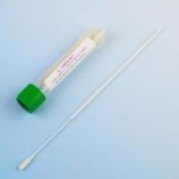
Pathology Bio Hazard plastic sample bag (Double bag specimen) | 2 | 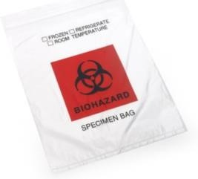
Specimen form | 1 | https://assets.publishing.service.gov.uk/g government/uploads/system/uploads/atta chment_data/file/875209/COVID19_E28_  form_V4_24-03-2020.pdf

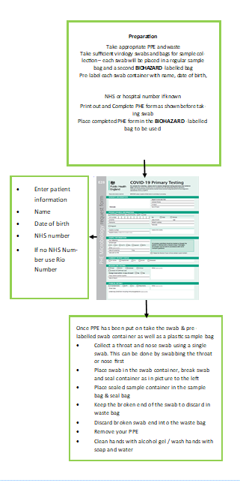

Appendix 2 – Management Pathway of COVID-19 Infection
in Mental Health Inpatient Settings.
Swab all patients on admission or patient with new continuous cough and/or fever >37.8ºC or a loss of, or change in, your normal sense of taste or smell (anosmia)

Give patient surgical mask if it’s safe to do so, ask to stay in the bedroom and keep door closed. Ideally, the patient should be placed in a room with en-suite facility, or have designated bathroom facilities.
In the event of non-compliance with isolation please refer to compulsory isolation guidance on ELFT Intranet. Will follow Medium Risk Amber Pathway.

Samples should be collected as per Collection of COVID-19 Lab Samples guidance.

Wear fluid repellent surgical mask (at all times) apron, gloves (Close contact care) & eye protection if blood/body fluids splashing.
PPE should be removed immediately on exiting the room/ward and placed in a foot pedal clinical waste bin.

Physical examination including observations should be performed as required. Use disposable equipment if possible or decontaminate with Green Clinell / disinfectant wipe. The patient should remain in the room with the door closed. Belongings and waste should be placed in paper bags only and should remain in the patient’s room.
Avoid patient movement/transfer.
If the patient is critically ill and requires urgent ambulance transfer to acute hospital, inform the ambulance call handler of the concerns about suspected/confirmed COVID-19 infection. Please also contact IPC team for further advice.
If Patient is COVID19 positive to be nursed in isolation for 10 days, until step down from isolation measures. Follow de-isolation pathway. Contact Infection Control Team for further advice.

Appendix 3 – Management Pathway COVID-19 Infection
Community Mental & Community Physical Health Services
Pre Home Visit Checklist

Phone call to the patient and ask the following:
- Has the Patient had a diagnosis of COVID19
- Do they have a new continuous cough?
- Do they have a high temperature?
- Do they have a loss of, or change in, your normal sense of taste or smell (anosmia)?
- Does anyone in the household have the above?
- Has the patient been discharged from an inpatient unit in the last 7 days?
No
- Complete visit with 1 nurse, 2 if the patient is a ‘double up’ visit.

- PPE to be worn – Gloves/aprons/face mask with visor or goggles. Goggles need to be thoroughly cleaned after each use with Green Clinell wipes, and allow to dry thoroughly before use.

- Waste must be double-bagged, then transported back to base and disposed of as clinical waste or left for 72 Hours and patient disposes of in household waste stream.

- DO NOT REUSE Gloves and Aprons. Change at each visit.

Remember to document on RIO/EMIS/S1 reminders that the patient is either ‘suspected’ or ‘confirmed positive’ so all staff are aware.
Complete Datix for confirmed COVID-19 Infection.
Yes
Consider: Clinical assessment can the visit be safely re-scheduled? If No follow below.
Ensure that all COVID-19 related care plans are implemented onto the patients’ records on RIO/EMIS/S1
Document visit as required on RIO/EMIS/S1
- Visit to be completed by 1 nurse
- PPE to be worn – Gloves/aprons/mask without visor/goggles if risk of splashing
- Waste disposed of as per waste management policy pre COVID19.
- DO NOT REUSE Gloves and Aprons. Change at each visit.
Appendix 4 – SPACES to care approach for COVID-19

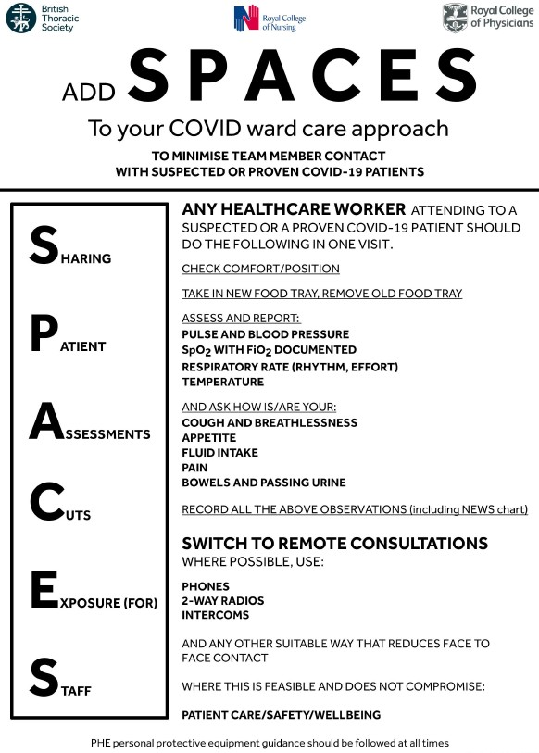
Appendix 5 – Do’s and Don’ts for Suspected or Known COVID-19
Do’s ✓ | Don'ts X
Wear the correct PPE every time you enter the room regardless of the reason or length of time you will be in the room?  (Gloves, Apron and Fluid Resistant Surgical  Face Mask (FRSFM) Unless undertaking an aerosol generating procedure) | Don’t come out of the room in your PPE – even just to collect something  (All PPE should be removed inside the room other than FFP3 Masks)
Undertake hand hygiene following removal of PPE (Even if your hands look clean) | Don’t take anything into the room that isn’t  essential equipment (Complete paperwork outside the room)
Remove wristwatches, Fitbits, stoned rings and expose forearms before undertaking hand hygiene (This is required even if hands are decontaminated with alcohol based  hand rub) | Don’t remove equipment from the room unless it has been cleaned with disinfectant wipes.
Treat all linen as contaminated (Place directly into in a water soluble/alginate bag; then into a clear plastic bag before placing  in the laundry receptacle) Mental Health use red bag | When wearing FRSFM/FFP3 don’t touch the front of the mask (The front of your mask will be at higher risk of being contaminated)
Wear visor if there is a risk of  splashing/spraying from patients coughing or sneezing | Don’t eat in the clinical area. Surfaces could be contaminated
Avoid touching surfaces in the patient’s room (Organisms can live on hard surfaces  and fabrics) | Don’t re-use single use equipment  Look for the single use symbol
Educate the patient on respiratory and cough etiquette. Provide tissues, disposable bag and hand hygiene advice.  (Catch it, bin it, kill it) | Don’t use Alcohol Based Hand Rub on your gloves. Gloves should be changed immediately after each patient and/or  following completion of a procedure or task
Use single use items if possible or  equipment is dedicated to patient while in isolation/cohort room | Don’t use disposable crockery, cutlery, trays  or water jugs Items can be processed as normal.
Remove all PPE inside the room other than  FFP3 Masks which must be removed outside the room. | Don’t hesitate to contact the IPCT with your questions. No question is too silly

Appendix 6 – Personal Protection Equipment including AGP: All Inpatient and Community Mental/Physical Health Services PPE Requirements

PPE to be worn as follows

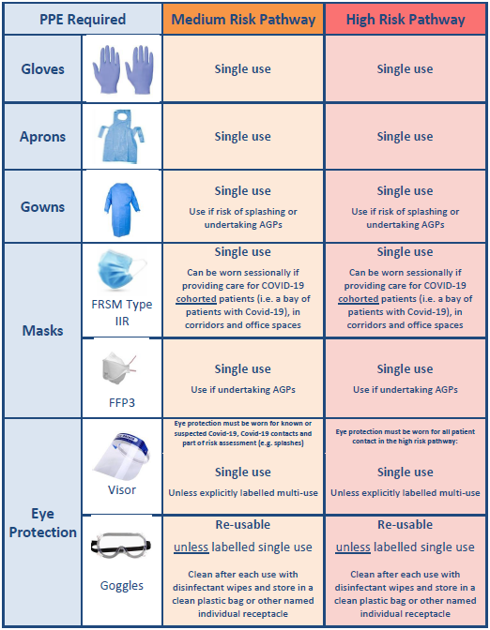
Information based on Public Health England: IPC_Highlights_Quick_Reference_Guide.pdf
Single use: use for an episode of care and then discard (only clean if re-usable)
Sessional use: can be worn for an extended period of time

Appendix 7 – Donning Personal Protective Equipment
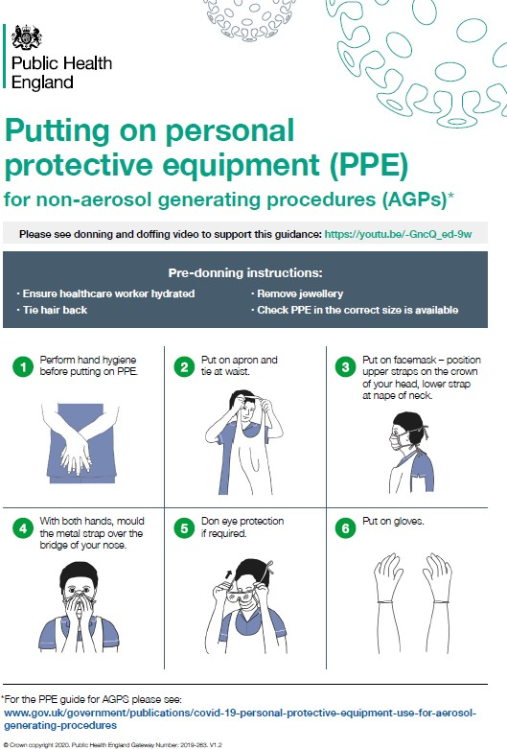

Appendix 8 – Doffing Personal Protective Equipment
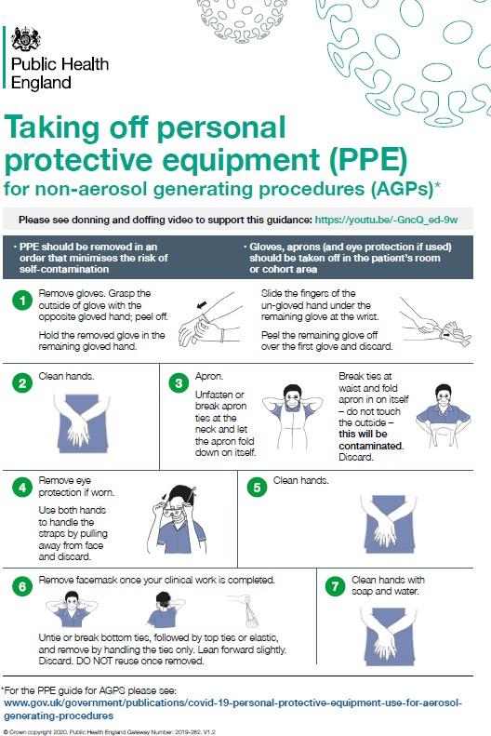
Appendix 9 – Donning AGP Personal Protective Equipment
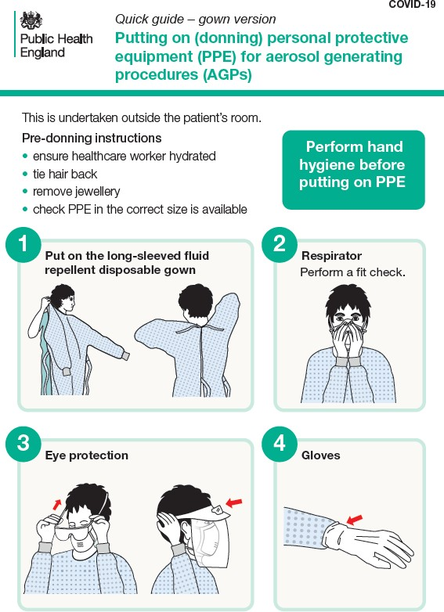
Appendix 10 – Doffing AGP Personal Protective Equipment
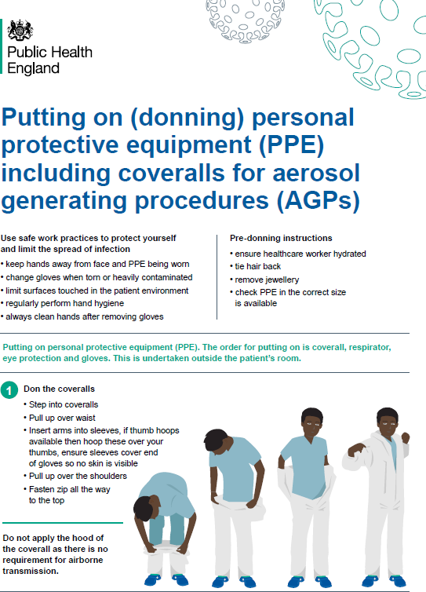

Appendix 11 – Donning Coveralls Personal Protective Equipment
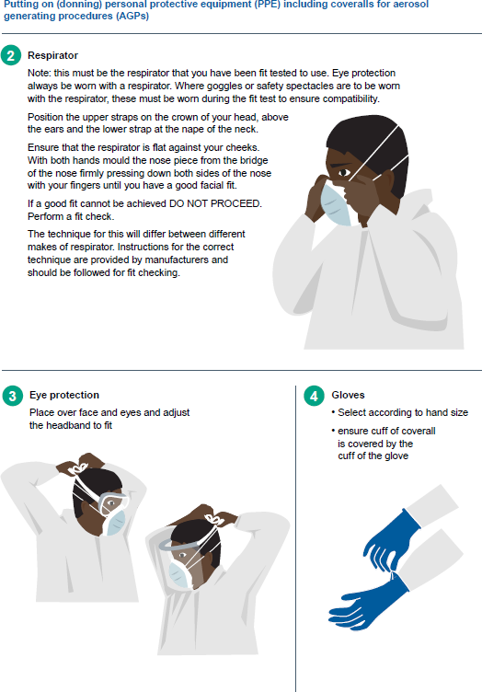

Appendix 12 – Doffing Coveralls Personal Protective Equipment
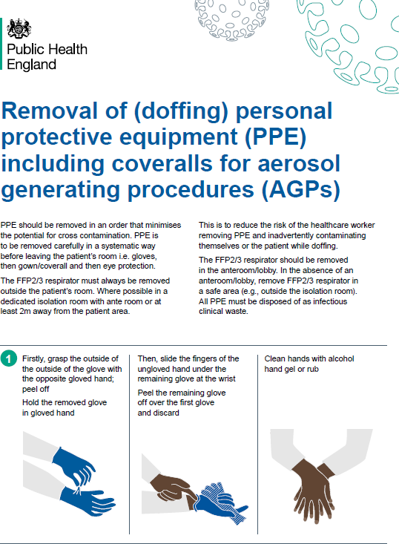

Appendix 12 Doffing Coveralls Personal Protective Equipment
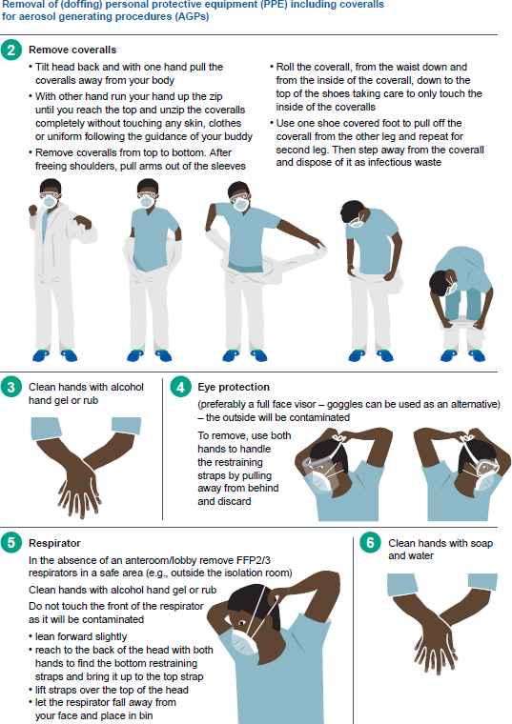

Appendix 13 – Environmental Cleaning
For COVID-19 wards or where there is an outbreak of COVID-19 the following cleaning of the environment will take place. For areas that are not identified as dedicated wards caring for COVID- 19 infections domestic cleaning will be provided as normal.

Cleaning products/solutions
Decontamination of equipment and the care environment must be performed using a combined detergent/disinfectant solution at a dilution of 1,000 parts per million (ppm) of chlorine.

Only cleaning (detergent) and disinfectant products supplied, are to be used. Products must be prepared and used according to the manufacturers’ instructions and recommended product ‘contact times’ must be followed. If alternative cleaning agents/disinfectants are to be used, they should only on the advice of the IPC Team and conform to EN standard 14476 for virucidal activity. The person responsible for undertaking the cleaning with detergent and disinfectant should be trained in the process.

Cleaning the room/ward/environment:

    - Before cleaning the environment, domestic staff to liaise with Ward nursing staff and exchange information on cleaning and any potential risk;
    - Domestic staffs to collect PPE form ward nursing staff;
    - Before entering the room, perform hand hygiene;
    - Don PPE as donning guidance (gloves, apron, Fluid resistant surgical mask, visor/googles- if risk of splashing);
    - Collect all cleaning equipment (should be single use where possible) and healthcare waste bags before entering the room;
    - The following staff will undertake cleaning duties shown in table 1 with a chlorine-based disinfectant at a minimum strength of 1,000ppm;
    - Equipment to be discard if not sent off to laundry;
    - Patient care equipment should be cleaned with disinfectant wipes;
    - Dedicated disposable equipment (such as mop heads, cloths) must be used for environmental cleaning and disposed as clinical waste;
    - Communal cleaning trollies should not enter the room;
    - Doff PPE as doffing guidance;
    - Wash hands including up to elbows with soap and water;
    - Cream hands.

Patient isolation rooms must be cleaned:
- Twice a day;
- During discharge;
- Transfer;
- After an AGP (this includes removal and laundering of all curtains).
Domestic/cleaning staff performing environmental decontamination should:
- Ideally be allocated to specific area(s) and not be moved between COVID-19 positive wards and non-COVID-19 care areas
- Be trained in which personal protective equipment (PPE) to use and the correct methods of wearing, removing and disposing of PPE.
The care environment should be kept clean and clutter free. In COVID-19 positive wards all non- essential items including toys, books, and games should be removed from reception, waiting areas, day rooms and lounges. When made available, these items should not be shared. All toys must be cleanable and should be cleaned regularly by nursing staff in line with the Trust Infection Prevention & Control Policy Manual.

Table 1: Cleaning duties of all staff disciplines

Clinical staff | Frequency | Domestic staff | Frequency
All hard surfaces in COVID-19 positive rooms | Twice | Corridors | Twice
Beds | Daily | Bathrooms | Twice
High touch surfaces- keyboard, phones, light switches, Fobs ,Keys | Daily- A minimum of 3 times a day with disinfectant wipe | High touch surfaces  Door Handles, rails | Daily- A minimum of 3 times.
Bed linen. Do not shake linen and avoid all necessary agitation | Daily | Toilets | Twice
Toilets – where soiling | Ad-hoc | Floors | Twice
Mattress | Daily | Staff toilets/ changing rooms | Daily
Cupboard  Tables Chairs | Twice | Showers | Twice
All re-usable medical equipment (BP cuffs, dynamaps, blood glucose machines, oxygen cylinders | Before /after patients use/In between patients with disinfectant wipe | Communal areas- dining room/ lounge | Twice
Toys, books, and games/ I-pads | Before /after patients use/In between patients with disinfectant wipe | Bedrooms | Twice
 |  | Collection of clinical waste  – as per local arrangements | Daily

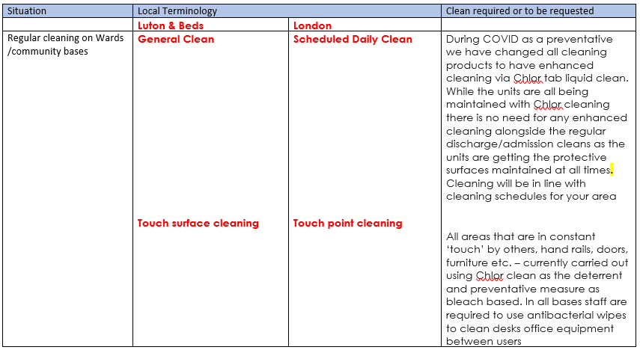

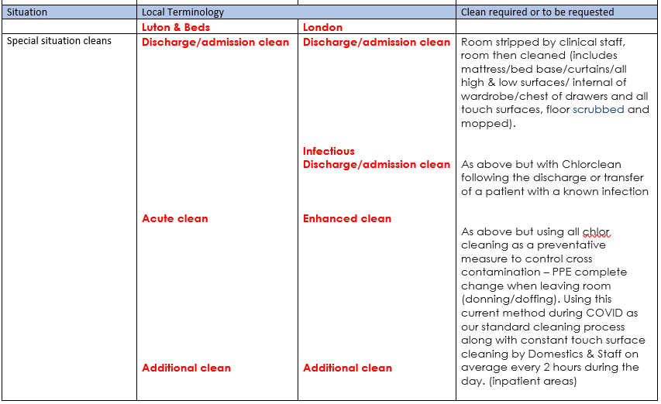

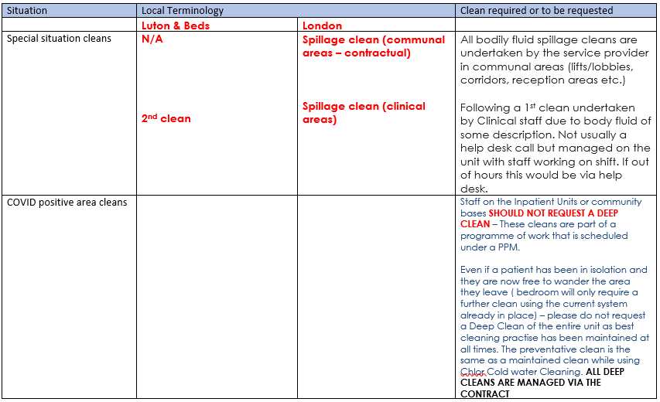

Appendix 14 – Patient Information Leaflet on COVID-19
- You have been identified as being a contact of a patient who has tested positive for COVID 19. What is COVID 19?

Coronavirus (COVID-19) is the illness caused by a new strain of coronavirus first identified in Wuhan City, China, it can cause a cough and or a fever/high temperature.

Coronavirus can cause more severe symptoms in people with weakened immune systems, older people and those with long term conditions like diabetes, cancer and chronic lung disease.

What are the symptoms of COVID 19?

The most common symptoms of COVID-19 are:

  - A new continuous cough;
  - And/or a fever/high temperature (37.8 C or greater);
  - You may feel warm, cold or shivery;
  - Some people will have more serious symptoms, including pneumonia or difficulty breathing which might require admission to hospital.

How does it spread?

Because it’s a new illness, we don’t know exactly how the virus spreads from person to person. Similar viruses spread by droplets in coughs and sneezes.

How can I prevent other people from getting COVID-19?

You can reduce spreading the infection by:

- Avoiding direct hand contact with your eyes, nose and mouth;
- Maintaining good hand washing;
- Avoiding direct contact with other patients or sharing personal items such as mobile phones;
- Covering your nose and mouth when coughing or sneezing with disposable tissues and disposing of them in the nearest waste bin after use.

Wash your hands regularly
Wash your hands with soap and water/ disinfectant wipe before eating and drinking, and after coughing, sneezing and going to the toilet.

How is it treated?

Currently, there is no vaccine and no specific treatment for the virus.

What happens if you are a contact of a patient diagnosed with COVID 19 while in hospital?

You will be monitored for any symptoms of COVID 19 for 10 days while you are in hospital
What happens if I am discharged before the 10 days are over?
You need to continue to monitor for symptoms (see symptoms section above) until the 10 days are up. You should be told when that will be by the ward staff on your discharge.
.

What about visitors? Are friends and family at risk?
It is recommended that you keep visitors to a minimum and discourage any family members who may be at risk due to underlying health conditions from visiting you
Appendix 15 Waste Segregation
COVID-19 Waste Segregation

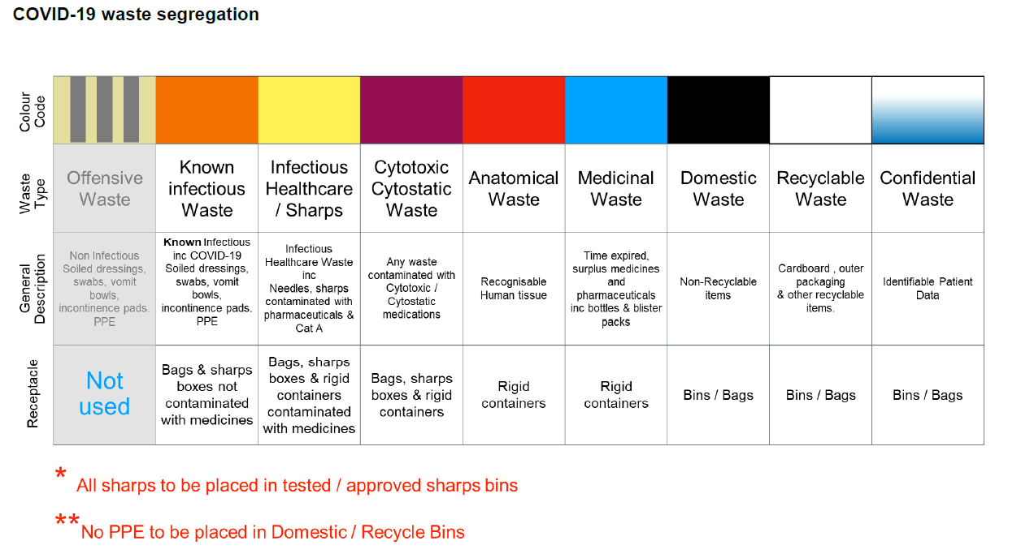

Non-clinical/staff-only areas waste segregation
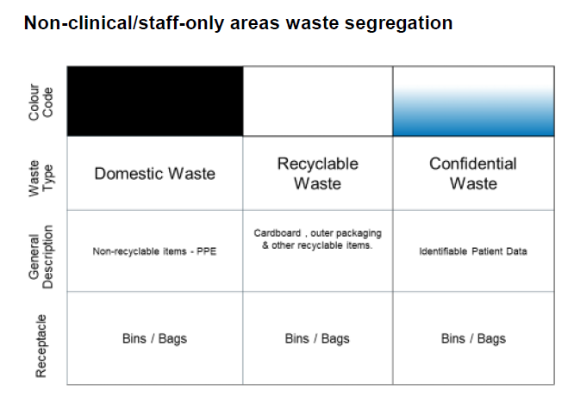

Non-clinical public area waste segregation
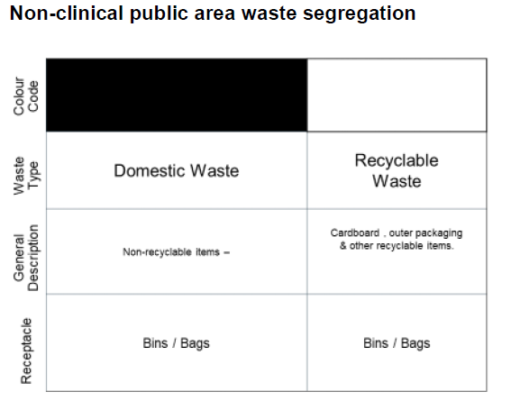
Entrances and exits waste segregation
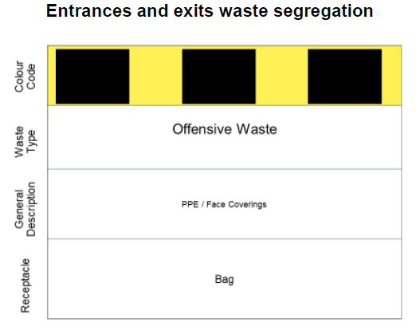
Appendix 16 Recording COVID-19 on RIO

- Under Physical Health, click Infection Screening Form
- Find COVID-19 Swab Request Form
- Complete Swab Status
- Complete Swab Type
- Complete Result
- Therefore, accurate recording will allow a RIO report to be completed and identify what COVID-19 swabs are due to be collected

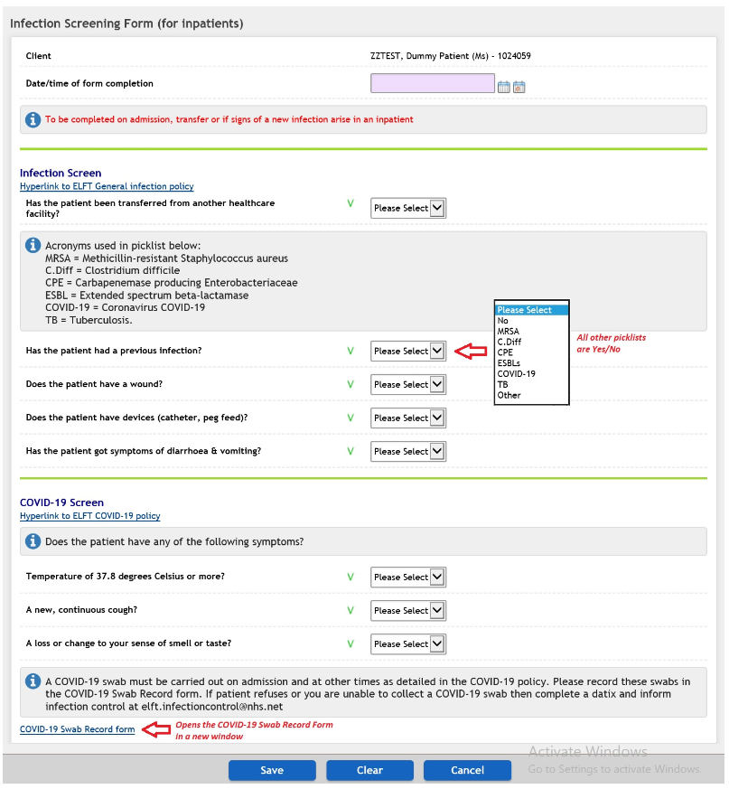
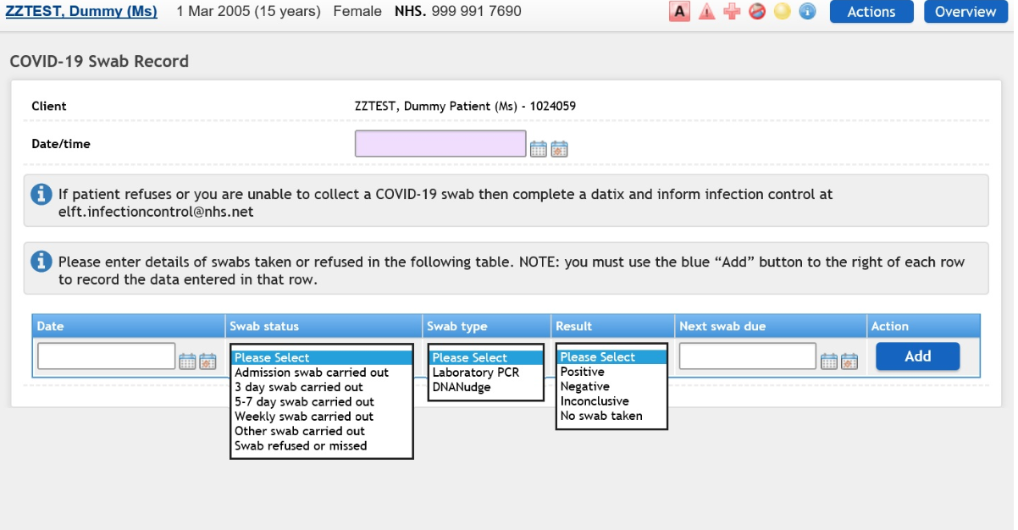
Appendix 17 - Glossary

Aerosol-Generating Procedures (AGPs)

Certain medical and patient care activities that can result in the release of airborne particles
(Aerosols). AGPs can create a risk of airborne transmission of infections that are usually only spread by droplet transmission.

Airborne Transmission

The spread of infection from one person to another by airborne particles (aerosols) containing infectious agents.

Airborne Particles

Very small particles that may contain infectious agents. They can remain in the air for long periods of time and can be carried over long distances by air currents. Airborne particles can be released when a person coughs or sneezes, and during aerosol generating procedures (AGPs). ‘Droplet nuclei’ are aerosols formed from the evaporation of larger droplet particles (see droplet transmission). Aerosols formed from droplet particles in this way behave as other aerosols.

Airborne Precautions

Measures used to prevent and control infection spread without necessarily having close patient contact via aerosols (less than or equal to 5μm) from the respiratory tract of one individual directly onto a mucosal surface or conjunctivae of another individual. Aerosols can penetrate the respiratory system to the alveolar level.

BS/EN Standards

Mandatory technical specifications created by either the British Standards Institute (BS) or European Standardisation Organisations (EN) in collaboration with government bodies, industry experts and trade associations. They aim to ensure the quality and safety of products, services and systems.

Cohort Area

An area (room, bay, ward) in which 2 or more patients (a cohort) with the same confirmed infection are placed. A cohort area should be physically separate from other patients.

Contact Precautions

Measures used to prevent and control infections that spread via direct contact with the patient or indirectly from the patient’s immediate care environment (including care equipment). This is the most common route of infection transmission.

Contact Transmission

Contact transmission is the most common route of transmission, and consists of two distinct types: direct contact and indirect contact. Direct transmission occurs when microorganisms are transmitted directly from an infectious individual to another individual without the involvement of another contaminated person or object (fomite). Indirect transmission occurs when microorganisms are transmitted from an infectious individual to another individual through a contaminated object or person (fomite) or person

COVID-19

COVID-19 is an infectious respiratory disease caused by a novel coronavirus. The disease was discovered in China in December 2019 and has since spread around the world.

Droplet Precautions

Measures used to prevent and control infections spread over short distances (at least 1 metre or 3 feet) via droplets (greater than 5μm) from the respiratory tract of one individual directly onto a mucosal surface or conjunctivae of another individual. Droplets penetrate the respiratory system to above the alveolar level.

Droplet Transmission

The spread of infection from one person to another by droplets containing infectious agents.

Eye or Face Protection

Worn when there is a risk from splashing of secretion (including respiratory secretions). Eye or face protection can be achieved by the use of any one of the following:

- A surgical mask with integrated visor;
- A full face visor or shield;
- Polycarbonate safety spectacles or equivalent.

Fluid-Resistant (TYPE IIR) Surgical Face Mask (FRSM)

A disposable fluid-resistant mask worn over the nose and mouth to protect the mucous membranes of the wearer’s nose and mouth from splashes and infectious droplets. FRSMs can also be used to protect patients. When recommended for infection control purposes a ‘surgical face mask’ typically denotes a fluid-resistant (Type IIR) surgical mask.

Fluid-Resistant

A term applied to fabrics that resist liquid penetration, often used interchangeably with ‘fluid-repellent’ when describing the properties of protective clothing or equipment.

Frequently Touched Surfaces

Surfaces of the environment which are commonly touched or come into contact with human hands.

Healthcare or Clinical Waste

Waste produced as a result of healthcare activities for example soiled dressings, sharps.

High-Flow Nasal Cannula (HFNC) Therapy

HFNC is an oxygen supply system capable of delivering up to 100% humidified and heated oxygen at a flow rate of up to 60 litres per minute.

Incubation Period

The period between the infection of an individual by a pathogen and the manifestation of the illness or disease it causes.

Induction of Sputum

Induction of sputum typically involves the administration of nebulised saline to moisten and loosen respiratory secretions (this may be accompanied by chest physiotherapy (percussion and vibration)) to induce forceful coughing.

Infectious Linen

Linen that has been used by a patient who is known or suspected to be infectious and or linen that is contaminated with blood and or other body fluids, for example faeces.

Long-Term Health Condition

This covers:

- Chronic obstructive pulmonary disease, bronchitis, emphysema or asthma;
- Heart disease;
- Kidney disease;
- Liver disease;
- Stroke or a transient ischaemic attack (TIA);
- Diabetes;
- Lowered immunity as a result of disease or medical treatment, such as steroid medication or cancer treatment;
- A neurological condition, such as Parkinson’s disease, motor neurone disease, multiple sclerosis (MS), cerebral palsy, or a learning disability;
- Any problem with the spleen, including sickle cell disease, or had spleen removed
- A BMI of 40 or above (obese).

Personal Protective Equipment (PPE)

Equipment a person wears to protect themselves from risks to their health or safety, including exposure to infection agents. The level of PPE required depends on the:

- Suspected or known infectious agent;
- Severity of the illness caused;
- Transmission route of the infectious agent;
- Procedure or task being undertaken.

Respiratory Droplets
A small droplet, such as a particle of moisture released from the mouth during coughing, sneezing, or speaking.

Respiratory Protective Equipment
Respiratory protection that is worn over the nose and mouth designed to protect the wearer from inhaling hazardous substances, including airborne particles (aerosols). There are 2 types of respiratory protection that can be used, tight-fitting disposable FFP respirators and loose-fitting powered hoods (TH2).
FFP stands for filtering face piece. There are three categories of FFP respirator: FFP1, FFP2 and FFP3. FFP3 and loose fitting powered hoods provide the highest level of protection and are recommended when caring for patients in areas where high risk aerosol generating procedures (AGPs) are being performed. Where the risk assessment shows an FFP2 respirator is suitable, they are recommended as a safe alternative. N95 respirators are tested against different standards but are broadly equivalent to a FFP2.

Respiratory Symptoms

Respiratory symptoms include:

- Rhinorrhoea (runny nose);
- Sore throat;
- Cough;
- Difficulty breathing or shortness of breath.

Segregation

Physically separating or isolating from other people.

SARS-CoV-2

Severe acute respiratory syndrome coronavirus 2, the virus responsible for the 2019 outbreak of COVID-19 disease.

Standard Infection Control Precautions (SICPs)

SICPs are the basic infection prevention and control measures necessary to reduce the risk of transmission of an infectious agent from both recognised and unrecognised sources of infection.

Single Room

A room with space for one patient and usually contains (as a minimum) a bed, a locker or wardrobe and a clinical wash-hand basin.

Staff Cohorting

When staff care for one specific group of patients and do not move between different patient cohorts. Patient cohorts may include for example ‘symptomatic’, ‘asymptomatic and exposed’, or ‘asymptomatic and unexposed’ patient groups.

Transmission Based Precautions

Additional precautions to be used in addition to SICPs when caring for patients with a known or suspected infection or colonisation.

Appendix 18
Severe Immunosuppression Definitions and shielding

Severe immunosuppression is defined in the Green Book on Immunisation as:

- Immunosuppression due to acute and chronic leukaemias and lymphoma (including Hodgkin’s lymphoma);
- Severe immunosuppression due to HIV/AIDS (British HIV Association advice);
- Cellular immune deficiencies (such as severe combined immunodeficiency, Wiskott-Aldrich syndrome, 22q11 deficiency/DiGeorge syndrome);
- Being under follow up for a chronic lymphoproliferative disorder including hematological malignancies such as indolent lymphoma, chronic lymphoid leukaemia, myeloma and other plasma cell dyscrasias;
- Having received an allogenic (cells from a donor) stem cell transplant in the past 24 months and only then if they are demonstrated not to have ongoing immunosuppression or graft versus host disease (GVHD);
- Having received an autologous (using their own stem cells) haematopoietic stem cell transplant in the past 24 months and only then if they are in remission;
- Those who are receiving, or have received in the past 6 months, immunosuppressive chemotherapy or radiotherapy for malignant disease or non-malignant disorders;
- Those who are receiving, or have received in the past 6 months, immunosuppressive therapy for a solid organ transplant (with exceptions, depending upon the type of transplant and the immune status of the patient);
- Those who are receiving or have received in the past 12 months’ immunosuppressive biological therapy (such as monoclonal antibodies), unless otherwise directed by a specialist;
- Those who are receiving or have received in the past 3 months’ immunosuppressive therapy including:
  - Adults and children on high-dose corticosteroids (>40mg prednisolone per day or 2mg/ kg/day in children under 20kg) for more than 1 week;
  - Adults and children on lower dose corticosteroids (>20mg prednisolone per day or 1mg/kg/day in children under 20kg) for more than 14 days;
  - Adults on non-biological oral immune modulating drugs, for example, methotrexate >25mg per week, azathioprine >3.0mg/kg/day or 6-mercaptopurine >1.5mg/kg/day;
  - Children on high doses of non-biological oral immune modulating drugs.

Appendix 19 Lateral Flow Testing.
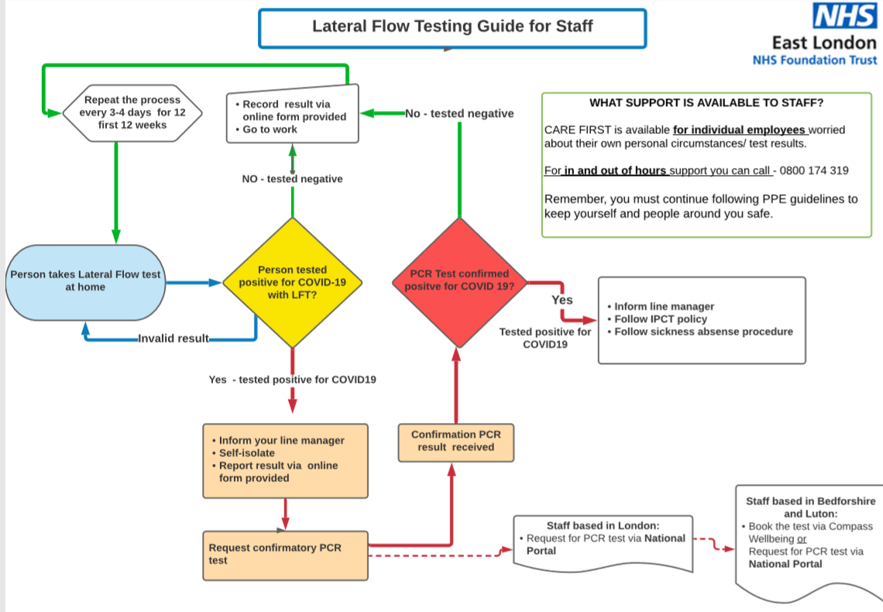

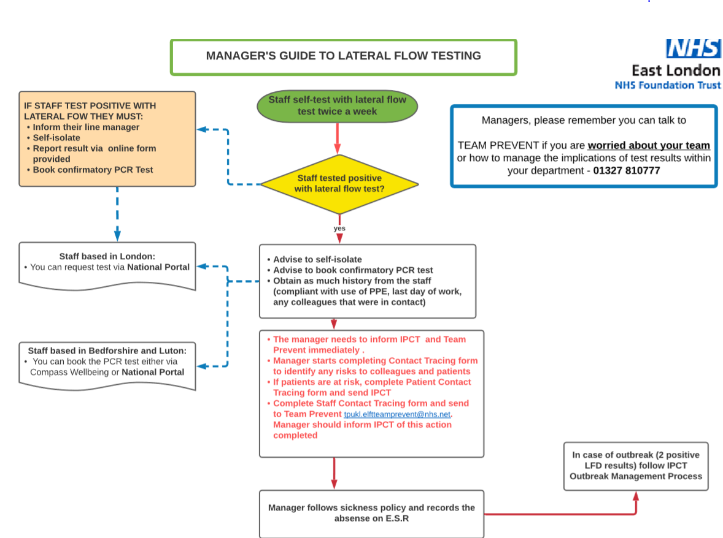

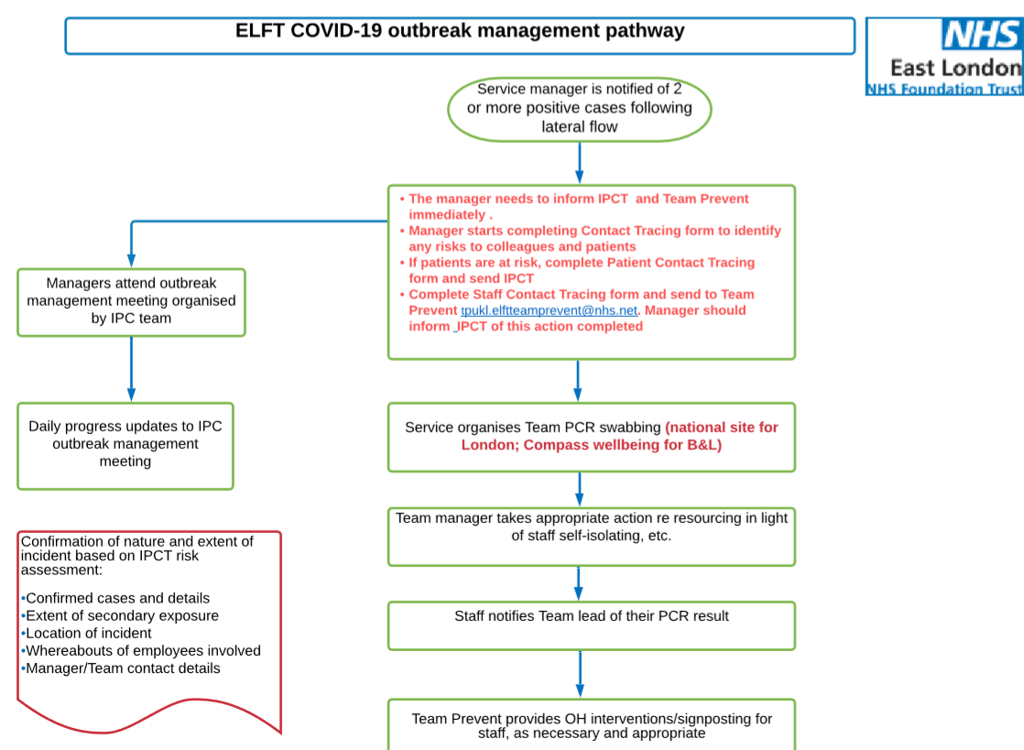

Appendix 20 - 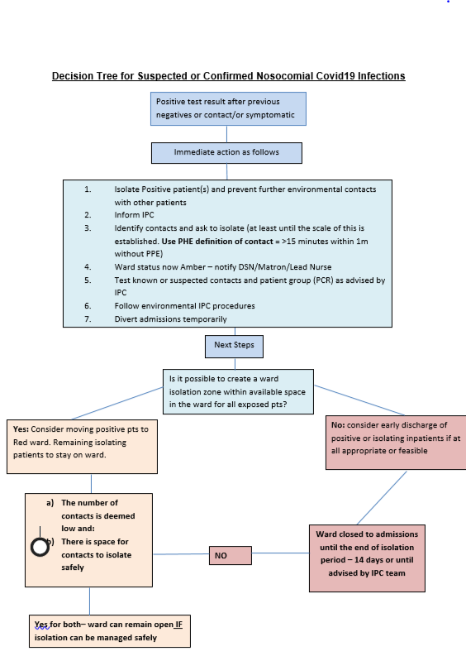

Appendix 21
Nosocomial Covid19 Infections on Inpatient Wards and Transfers
- If a positive test result occurs at or beyond the 7day test it is reasonable to assume that the infection is likely to be nosocomial or the infection has been caught on a period of leave from the ward.
- Due to the very broad range of presentations within our services, it can be very challenging to safely manage the risk of transmission in hospital wards – especially during the first days of hospitalisation and/or where leave from hospital is being utilised.
- Early detection of the virus is essential to cohort patients but when a nosocomial infection is suspected; any furthering of the chain of transmission must be curtailed as far as is practical. We must suspect that there will be further positive results in the ward population and that asymptomatic transmission has occurred.
- Patients who test positive in this context should not be transferred to a Covid ward until the rest of the patient group and ward staff have been tested.
- If there are nosocomial cases on the ward (>2), it should be closed to admissions with leave and visiting stopped and safe alternative arrangements initiated. This changes the status of the ward to Red.
- Discharges of asymptomatic patients may continue and national isolation guidelines followed. There may be some prolongation of admission for those in shared or supported accommodation where the risk of onward transmission is higher.
- The IPC team will advise when the outbreak has concluded. For planning, this is likely to take at least 14 days but may be longer as cases emerge on the ward.
- If there is more than one ward with nosocomial infections and the volume of positive cases is stable (no further positive cases for 5 days) then then the current positive patients can be merged on one ward for the duration of the outbreak.
- When Patients are being transferred all infection prevention and control precautions need to be in place and adhered to in line with Trust Covid policy. Any vehicles used for transport should have a terminal clean with Chlorine based product before reuse.

Appendix 22 Staff and Visitors temperature taking procedure
There are many reasons for a high temperature, and we are aware that a high temperature (37.8 degrees or above) is one of the symptoms of COVID-19 infection.
Taking temperatures of staff on arrival to our buildings is part of staff assessment and dialogue about general fitness in the workplace, to reduce the spread of COVID-19 infection.
Physically vulnerable service users are more likely to suffer serious effects of COVID-19 infection if infected by the virus, we therefore should take every precaution to minimise the risk of transmission.
Staff temperature testing – Clinical areas
All clinical areas where face to face contact with physically vulnerable individuals will take place will need to create a local auditable system for checking staff and visitor’s temperatures separate from the track and trace system, the system needs to indicate that a temperature has been taken but does not need to indicate the reading.
To include areas such as inpatient units, staff working with service users with learning difficulties, older people and SCYPS or other services where vulnerable service users are being seen, where groups of staff work as a base to visit vulnerable service users in their homes. In these locations all staff should take their temperature daily when coming into one of these sites this includes non-patient facing staff as non-clinical staff are likely to interact with staff who care for vulnerable people.
Temperature taking should wherever possible occur before entry into a clinical area and must occur before any direct service user contact. Consideration should be given to sites with multiple entry points and how this can be mitigated to consistently support temperature taking on arrival to the care facility.
There is growing evidence that ear (tympanic) temperature is the most consistently reliable method for temperature taking, therefore this method should be used in the clinical context outlined above.
Staff temperature testing - Community based or working from home clinical staff (direct care service users)
Where people are initiating service user visits from a home staff are required to review their general physical wellbeing, taking their temperature at home may assist in this assessment.
Staff temperature checking – Non clinical ELFT premises
Areas where there are many staff circulating temperature taking can be a useful tool to reduce the spread of infection amongst the staff group. Therefore, these sites can choose to have temperature taking facilities available. In these circumstances there is not the necessity to have an auditable record of temperatures.
Where temperature is taken by wall mounted or hand held devise the readings are only indicative and less conclusive than when taken by tympanic means, therefore would only be indicative and should form part of a self-assessment of wellness
Action if high temperature is detected
If any COVID- 19 symptoms (loss of taste, loss of smell, new cough, temperature above 37.8 degrees) are noted the staff member should inform their line manager or designated other and their inability to undertake the visit their duties and self-isolate for 10 days.
- Where a staff member’s temperature is above 37.8 degree they should not enter a clinical area, or area where other staff are circulating. They should be advised to self-isolate for 10 days and access staff testing sites to receive a COVID- 19 test.
- Staff should be supported in considering options for safe passage home avoiding public transport wherever possible.
- They should also give their line manager an account of their whereabouts and contacts in the last 48 hours, including whether compliance with PPE (fluid resistant surgical mask) has been robust during this period, to support the track and trace process.
- All staff in contact with the individual should maintain PPE wearing throughout the contact and hard surfaces should be cleaned with disinfectant wipes (Clinell, PDI) on leaving the area.
Visitor Temperature taking
Visitors are people outside of the core staff group who work in the building or care facility. Visitors would include contractors, such as maintenance and domestic staff, people visiting inpatient wards, visiting care professionals or agency’s to name but a few.
Visitor temperature taking should match the requirements for staff testing as outlined above. If a visitor refuses to have their temperature taken where required admission should be denied.
Where a visitor is found to have a high temperature (above 37.8 degrees) they should not enter staff premises and be supported to consider how they will organise safe passage home, and be informed how to access the government site for COVID-19 testing.
Procurement / Maintenance of thermometers
Hand held or wall mounted thermometers should be cleaned with disinfect wipes. All surrounding surfaces areas must be thoroughly cleaned. Tympanic thermometers require cleaning with disinfect wipes between every use. Thermometers that are going to be used to take service users temperatures or Tympanic thermometers need to be procured through NHS supply’s, or come from ELFT procurement, and be registered as a medical devise...A maintenance programme is required to ensure they are in good working order.

Appendix 23 - Equality Analysis

Equality Analysis Template

Part 1: Equality Analysis Details

Title of ‘Proposal’ | COVID-19 Infection Prevention & Control Policy
Name of Directorate | Corporate
Name of Manager Undertaking the Equality Analysis | Bernadette Kinsella DDIPC
Consultation Date/s with Staff | To be confirmed
Consultation Date/s with Service Users | To be confirmed
Date Equality Analysis Completed | 10 February 2022
Review Date  (Review at least once every 3 years) | The emerging evidence base on COVID-19 is rapidly evolving. Further updates may be made to this policy as new guidance emerges

Part 2: Proposal Details

- What are the aims of the proposal? Indicate if this is a new proposal or the review of an existing one.

(The term ‘proposal’ covers activities such as policy development, policy review, service redesign and internal re-organisation or restructuring processes)

Part 3: Equality Analysis of Staff

Protected Groups  - Identify the impact or potential impact on each of the following protected groups, with due regard to the 3 aims of the Public Sector Equality Duty (PSED) | Impact – Positive or Negative?  Or  No Impact? | Please describe the process of your analysis with reference to the following:  - Results of consultation;  - Data or research on the protected groups that you have considered;  - Implications for the protected groups.
Age: | No impact
Disability: (Consider a range of impairments, including sensory, mental, physical and learning disability) | No impact
Sex: | No impact
Religion or Belief: (including no belief) | No impact
Sexual Orientation: | No impact
Race: including ethnicity and nationality | No impact
Gender Reassignment: | No impact
Pregnancy and Maternity: | No impact
Marriage and Civil Partnership: | No impact

Part 4: Equality Analysis of Service Users/Patients

Protected Groups  (Equality Strands)  - Identify the impact or potential impact on each of the following protected groups, with due regard to the 3 aims of the Public Sector Equality Duty (PSED) | Impact – Positive or Negative?  Or  No Impact? | Please describe the process of your analysis with reference to the following:  - Results of consultation;  - Data or research on the protected groups that you have considered;  - Implications for the protected groups.
Age: | No impact
Disability: (Consider a range of impairments, including sensory, mental, physical and learning disability) | No impact
Sex: | No impact
Religion or Belief: (including no belief) | No impact
Sexual Orientation: | No impact
Race: including ethnicity and nationality | No impact
Gender Reassignment: | No impact
Pregnancy and Maternity: | No impact
Marriage and Civil Partnership: | No impact

Part 5: Findings from the Equality Analysis

Use this space provided below to elaborate on your decision based on the findings of the equality analysis

- Accept the proposal – no evidence of discrimination; appropriate opportunities have been taken to advance equality and foster good relations.

No impact – Not applicable.

- Adjust the proposal – take steps to remove barriers to advance equality. It may involve introducing actions to mitigate the potential effect or to look at how to deliver the proposal in a different way. It is lawful under Equality Law to treat people differently in some circumstances, for instance developing single sex provision where required.

No impact – Not applicable.

- Continue the proposal – despite adverse effects or taking opportunities to advance equality provided the proposals do not unlawfully discriminate and can be objectively justified. (To identify whether a proposal may unlawfully discriminate due regard should be given to discrimination on the basis of the protected characteristics)

No impact – Not applicable.

- Stop the proposal – the policy shows unlawful discrimination and adverse effects that cannot be mitigated.

Not applicable.

Part 6: Equality Analysis Action Plan

Adverse Impact – Staff | No impact – N/A

Adverse Impact – Service Users | No impact – N/A

This analysis has been checked and approved by:

Name: Bernadette Kinsell a

Title: Deputy Director IPC

Date: 3rd September 2021

Once completed, the document should be sent to the Trust’s Risk & Datix Manager to support the policy development and review process: joanne.sims3@nhs.net

Appendix 24 –

COVID-19 Track & Trace -Contact tracing- Factsheet with charts


- What is contract tracing?

Contact tracing attempts to find all contacts of a confirmed case, in order to test or monitor them for symptoms. The goal is to stop the spread of a disease by finding and isolating cases.

Contact tracing is a core public health intervention that plays an important role in the control of COVID-19 infection. The aim of contact tracing is to rapidly identify potentially newly infected persons who may have come into contact with existing cases, in order to reduce further onward transmission.

2. How does contact tracing work?

Contact tracing consists of three steps:

- Contact identification: to identify persons who may have been exposed to SARS-Cov-2 virus as a result of being in contact with an infected person.

- Contact listing: to trace and communicate with the identified contacts, and to provide information about suitable infection control measures, symptom monitoring and other precautionary measures such as the need for self-isolation.Contact follow-up: to monitor the contacts regularly for symptoms.

3. What the process of contact tracing?

A clinician will speak to suspected individual, to gather details of places they visited and the people they’ve been in contact with since they became unwell. This information is used to build up a detailed picture of the people we need to get in touch with, such as colleagues and patients.

- Contact tracing for patients/ services users is provided by the Infection Prevention and Control department elft.infectioncontrol@nhs.net

- Contact tracing for healthcare staff is provided by Occupational Health Department –Team Prevent. STAFF contact tracing forms to Team prevent as instructed to ohteamprevent.elft@nhs.net

- For staff Covid-19 issues please contact Team Prevent Occupational Health Service as below: Care first for individual employees worried about their own personal circumstances/ test results in and out of hours - 0800 174 319
- Team prevent for managers worried about their team or how to manage the implications of test results within their department - 01327 810777

4. What is a close contact?

When we talk about “close contact” it’s important to point out that we’re not looking for people the person may have passed in a building, as the risk in these situations is very low. A close contact involves either face to face contact or spending more than 15 minutes within 2 metres of an infected person and without appropriate PPE. Once we have recorded the close contacts, we can categorise them into high or low risk exposure, then contact them to provide advice on what they should do.

- What’s the difference between a high risk exposure and a low risk exposure?

High-risk exposure are contacts who have spent 15 minutes or more in close proximity to (2 metres or less) or in a closed environment with a case without appropriate PPE. A low-risk exposure contacts who are still at risk but who have not been exposed to a case for as long.

- I am a staff member and have been contacted by NHS Test and Trace, as a contact whilst at work, what should I do?

If you have been contacted by the NHS Test and Trace service, and identified as a contact, whilst at work please contact. Care first for individual employees worried about their own personal circumstances/ test results in and out of hours - 0800 174 319 A risk assessment would be required to ascertain if personal protective equipment was worn or if there were any breaches in personal protective equipment use. Advice will then be provided on whether to self-isolate or continue working.

- I am a staff member and have been contact by NHS Test and Trace, as a contact whilst not at work, what should I do?

Staff who have been notified through the NHS Test and Trace service that they are a contact of a confirmed case of COVID-19 in the community (outside their place of work) they should inform their line manager and complete the return to work risk assessment form (place link here)

- What is the process of contact tracing for patients?

If a patient has been identified as a contact of a confirmed COVID-19 cases, the service/department staff will inform the Infection Prevention and Control department. IPC will gather further information to support with risk assess. A contact trace listing form will be sent to the manager of the service/department to complete that would enable easy identification of contacts.

This form is completed and sent to the Infection Prevention and Control department– elft.infectioncontrol@nhs.net
The contacts are contacted on a daily basis, for 10 days, to monitor for symptoms and if symptomatic to follow management pathway for covid-19 infection. In patients are isolated and monitored for 10 days as per UKHSA guidance. For further information, please refer to COVID-19 IPC policy.

Contact tracing of COVID-19 infection- Service User /Patients
https://www.gov.uk/government/publications/wuhan-novel-coronavirus-infection-prevention-and-control/covid-19-guidance-for-maintaining-services-within-health-and-care-settings-infection-prevention-and-control-recommendations

If asymptomatic after 10-days contact discharged from contact tracing list/Infection Control department. No further actions required.
Contacts monitored daily for 10 days for symptoms by ward staff supported by IPC team. If symptomatic test for COVID-19 infection & follow inpatient COVID-19 management pathway. Test every 48hrs. See COVID-19 Infection Control policy.
Discharge to another health & social care facility
Discharge home
Contract trace listing form to be sent to elft.infectioncontrol@nhs.net
Contact Infection Prevention & Control department elft.infectioncontrol@nhs.net for risk assessment
Community patient exposure
Inpatient service-user /patient exposure
Patient will be followed up by PHE in line with the Test & Trace guidance. No further action required.
Inform facility of exposure and refer to the Test & Trace guidance.
Refer to the stay at home guidance if less than 10 days has elapsed since their exposure.
Patient/Service User
Contact tracing of Covid-19 - Healthcare Workers Identified as contacts

No
Yes
Has staff member been notified by NHS Test and Trace services as contact of COVID-19 infection, whilst at work?

Has staff member been notified by NHS Test and Trace services as contact of COVID-19 outside of work?

Yes

Discuss with line manager. Is staff fully vaccinated?

Inform line manager and contact Occupational Health Ohteamprevent.elft@nhs.net for advice on completing risk assessment.

Yes

Team Prevent to conduct risk assessment including:
- the severity of symptoms if any
- the length of exposure
- the proximity to the patients
- the activities that took place when the staff member was in proximity (such as aerosol-generating procedures (AGPs), monitoring, personal care)
- whether the staff had their eyes, nose or mouth exposed
- whether Personal protective equipment was worn appropriately

Is there a high risk of exposure?
Refer to The criteria for exemption from self-isolation below

Yes
No

If unvaccinated or vaccinated but the risk assessment concludes there has been a significant breach or close contact without PPE, the staff should remain off work for 10 days & monitor for symptoms of COVID-19 infection. If symptomatic, staff must have a PCR test for COVID-19 infection

Refer to Occupational Health –Team Prevent for contact tracing and follow-up. Please also complete Datix if high risk of exposure is identified at work.
No

Continue to work

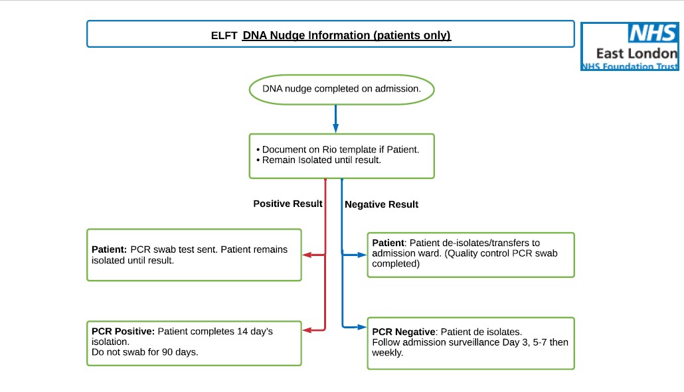*If DNA Nudge swab is negative and PCR swab is positive for COVID-19. Patient to be isolated. Please Control Infection Prevention & Control team as soon as possible elft.infectioncontrol@nhs.net
Appendix 25 – IPC & DNA Nudge Testing


Appendix 26 –
Guidance when admitting new patients to wards with an active COVID-19 case or outbreaks of COVID-19 (High risk areas)
Wards that are closed due to the present of patient/s with infection (High risk areas) do pose infection risk to new patients if admitted into such environment. Ideally these closed wards should not be opened to admitting new patient however there are times when the Trust has unmet external bed demand that involves high patient risk (e.g. patient in the community deemed very unwell) or reputational risk/system wide NHS capacity risk (e.g. patient in an emergency department or significantly delaying medical bed admission).

In these circumstances a clinical decision to admit a new patient into these risk environments must be made by the admitting consultant, balancing the risks and benefits for the patient, and must be agreed by the following: In hours:
- The service’s Clinical Director
- Infection Prevention and Control (IPC) team.
- Borough Service Director/Lead should also be involved in the decision making
The Omicron variant of the Coronavirus is highly transmissible and prevalent in our inpatient wards. This means that the need to admit to a ward with Covid+ patients is much more likely due to the spread of infection across wards.
Before considering admission or transfer to a ward with infections (a RED ward) please clarify (via the DSN) if there are any available Green beds in an ELFT borough (including those in NELFT and available beds in the Priory Hospitals).
Criteria to consider when admitting patients to these areas:
1) The clinical risk is such that delaying admission would be likely to cause avoidable harm whether the patient is in the community, ED or acute hospital bed.
2) This is a clinical decision and must be made by the admitting consultant/Doctor, balancing the risks and benefits for the patient, and if the balance of risks needs further discussion, in consultation with the service’s Clinical Director and Borough Lead Nurse or nominated deputies as required (Out of hours on-call consultant and DSN). IPC advice is available 9am to 5 pm Monday – Friday. Each Borough Lead Nurse will need to keep record of each patient admitted using the SOP which is on the daily DSN report.
Please e mail elft.infectioncontrol@nhs.net, for all patient admitted using the SOP. This email should be sent by the Borough Lead Nurse, Duty Senior Nurse and/or Ward Manager.
Prior to admission the following requirements must be met and clearly recorded in the patient’s Rio note:
- Open and transparent discussion about the risks with the patient and family:
- The patient and relatives/carer must be informed of the ward status regarding the positive case or outbreak prior to admission, and must agree to the admission.
- This discussion must take place at the point of assessment/decision to admit, and must be recorded in patient’s Rio note.
- If not possible to achieve this discussion and agreement with the patient and family, then best interest principles must be applied by the clinical decision maker (out of hours this is the on-call consultant) and the outcome recorded in patient’s note.
Risk assessment
- Patient must be assessed on individual case by case basis.
- Risk assessment must consider any underlying health conditions and comorbidities (chronic and acute) of the patient being admitted to ensure they are not clinically or clinically extremely vulnerable (Refer to PHE definition) https://www.nhs.uk/conditions/coronavirus-covid-19/people-at-higher-risk/who-is-at-high-risk-from-coronavirus-clinically-extremely-vulnerable (please attempt to prioritise vulnerable, unvaccinated patients for GREEN ward admission).
- The vaccination status of the patient being admitted should also be taken into consideration. Whilst this may be considered in the risk assessment, it is important to note that under the current NHS advice, there is a chance people might still get or spread COVID-19 even if they have had two doses of vaccines as the vaccine does not offer 100% protection. All the IPC precautions must still be followed regardless.
- The health status of patients on admitting ward i.e. acuity, number of confirmed cases, and their cooperation with isolation.
- Environmental limitations (availability of ensuite facilities, equipment, etc.)
- Staffing levels and competency.
- Risk of delaying the admission
- If risk assessment determines that admission to the outbreak ward is not recommended and not in the patient’s best interest, but they still require a bed then use the formal escalation procedure via the on-call manager.
Admission agreed;
If the outcome of the risk assessment determines that admission to the outbreak/affected (high risk) ward is in the patient’s best interest and outweighs the risk of exposure to infection, the following must be considered to help minimise the risk;
- The new patients should be admitted into an ensuite bedroom (please note Hackney do not have ensuite rooms but may have beds – please discuss this with the DSN and local Senior Nurses) and isolated as per current COVID-19 Trust policy. Admission swabs (both point of care and PCR) must be obtained.
- They are to remain isolated until their COVID-19 PCR results are available. If negative, a decision should be made on whether to step down or prolong their isolation base on the ward status at this time. Please discuss with IPC.
- If a decision is made to step down isolation, the patient should not mix with the other patients who are positive or contacts and are still in their incubation period.
- Should the patient need to leave their room, staff should attempt to ensure they are wearing surgical face masks and perform hand hygiene before leaving and returning to their rooms. All IPC precautions including hand hygiene, appropriate use of PPE and environmental decontamination as per the Trust COVID-19 policy applies
- This guidance must be used in conjunction with the principles of in COVID-19 policy
Once a decision to admit has occurred then a message confirming the decision needs to go to the IPC email address: elft.infectioncontrol@nhs.net with the patients name and RiO number and the admission ward. These admissions will be reviewed at Silver weekly group.

Appendix 27 – Staff Isolation Flowcharts
Staff Testing

All staff are expected to undergo LFD testing twice weekly

Negative LFD result – Staff member to continue to work

Positive LFD result – Staff member must inform management & follow self-isolation procedure. A follow-up PCR test is no longer required unless staff are specifically asked to do so.

If a Staff member develops symptoms – at any point, they must inform management, follow self-isolation procedure and take a PCR test

Positive PCR result – Staff member to continue and complete self-isolation as below.

Negative PCR result – Staff member to return to work if well enough.

Isolation Procedure

The advice on ending isolation for staff who develop COVID-19 symptoms or who have tested positive on a lateral flow device (LFD) test or polymerase chain reaction (PCR) test has changed. They can now end their isolation on the sixth day, provided they have 2 consecutive negative LFD tests.

All staff, regardless of vaccination status who receive a positive LFD / PCR test must adhere to self-isolation procedures as per Government guidance updated on the 17/01/22.

https://www.gov.uk/government/publications/covid-19-management-of-exposed-healthcare-workers-and-patients-in-hospital-settings/covid-19-management-of-exposed-healthcare-workers-and-patients-in-hospital-settings

Self-Isolation for Positive staff

Ending Self-isolation early using LFD Tests

Action
Day of Isolation

0
Self-Isolation begins from the day of the positive result, swabbing or initial symptoms
Self-Isolate

Self-Isolate
If staff continue to have positive results
14+
10+
5-10
1-4
Self-Isolate
Day 14+
If staff are positive on day 14 they should stop testing & management are to carry out a risk assessment and/or refer staff to Team Prevent

If staff continue to test positive on Day 10, they should:
- Continue to isolate
- Undertake daily LFD Testing until a single negative result.
- Then to return to work

Self-Isolate &
Undertake LFD Testing

Day 5 LFD Test is Day 5 LFD Test is
Negative Positive

Continue to isolate Continue to isolate
& take another LFD & undertake daily
Test on Day 6 LFD Tests, 24
hours apart until
2 Consecutive
Day 6 LFD Test is results are received. Negative

Self-isolation ends
& staff should return
To work. Once at work,
Staff must continue LFD
Testing until 10 days.
Self-Isolate
Self-Isolate
Risk assessment for early return to work

Risk Assessment for early return:

- If the first LFD test result was negative on the fifth day, and the second LFD test result is negative on the sixth day, the staff member can return to work but should continue to take LFD tests on days 7, 8, 9 and 10.

- Staff who were asymptomatic at the time of the test can return to work after their isolation period has ended if they do not develop symptoms.

- Please note that if asymptomatic staff do develop symptoms during their self-isolation period, they are no longer required to restart a new isolation period. They can return to work if well enough.

- Symptomatic staff can return to work after their isolation period has ended provided their symptoms have improved i.e. they have been afebrile (not feverish) for 48 hours without the use of medication to control fever, and are medically fit to return.

- Staff may still return to work if they still have any of the other symptoms and are fit enough to do so, as these may persist for some time after the infection has resolved. Adhere to IPC precautions on shift including appropriate use of PPE & and hand Hygiene at all times.

- If working with clinically vulnerable service users, a local risk assessment must be carried out with line manager.

https://www.gov.uk/government/publications/covid-19-management-of-exposed-healthcare-workers-and-patients-in-hospital-settings/covid-19-management-of-exposed-healthcare-workers-and-patients-in-hospital-settings

Criteria for exemption from self-isolation for fully vaccinated staff
The majority of fully vaccinated health and social care staff will be able to continue in their usual role:
The following must apply:

- The staff member should not have any COVID-19 symptoms.

- The staff member should not have any travel related isolation requirements.

- The staff member should immediately arrange for a PCR test, either through their workplace arrangements or via the NHS Test and Trace service, and the result of this PCR test should be negative prior to returning to work.

- Following the negative PCR result, the staff member should undertake an LFD antigen test every day for the 10 days following their last contact with the case (even on days they are not at work).

- If a staff member has had a positive PCR in the past 90 days, they should not have a PCR test and should only undertake daily LFD antigen tests for this purpose.

- On days the staff member is working, the LFD antigen test should be taken before starting their shift, and the result should be negative.

- The staff member should comply with all relevant infection control precautions and PPE should be worn properly throughout the day.

- If the staff member works with patients or residents who are especially vulnerable to COVID-19 (as determined by the organisation), a risk assessment should be undertaken, and consideration given to redeployment during the 10 days following their last contact with the case.

Appendix 28 – Self Isolation Risk Assessment Form

COVID-19 SELF- ISOLATION RISK ASSESSMENT FORM-
STAFF MEMBERS WHO ARE DOUBLE VACCINATED RETUNING TO WORK

Section 1-Staff members details
Staff name: |  | Directorate: |  | Team/Ward: |  |  |  |  |  | NHS Track & Trace call or text |  | NHS Covid-19 App notification
Date of call/text or notification: |  | Date of Exposure: |  | Date of end of isolation:
Vaccination Status: |  | Pfizer/Astra Zeneca/Other |  | 1st dose - Date |  |  |  |  |  | 2nd dose - Date |  | Not vaccinated
If staff member has not had both vaccinations with a 14-day gap from 2nd dose of vaccine, then staff member is required to isolate for 10 days in line with national guidance.

Section 2-Risk assessment
Is a member of the household the index case? (circle yes or no) |  |  |  |  |  | YES |  |  |  |  |  |  | NO
 |  |  |  |  |  | Staff member must not come to work. May work from home if appropriate |  |  |  |  |  |  | Risk assessment for exposure can continue.
Questions |  |  |  |  | Comments
Was appropriate PPE worn at identified venues and on public transport where face masks are usually required e.g., shops, work?
Was there any breach in PPE at identified venues and on public transport where face masks are usually required?
Was appropriate PPE (face mask) worn at identified venues where face masks are NOT usually required e.g., pubs, restaurants, gyms
Section 3- Outcome of Risk Assessment
Staff member can return to work with mitigations described below in place |  |  |  |  |  |  |  | Staff member CANNOT return to work. May work from home if appropriate
Section 4
Mitigations (staff member to be informed of the below mitigations during telephone call)
In order to mitigate the increased risk associated with attending work, the following precautions must be implemented:
- The staff member should be fully vaccinated, defined as having received both doses of an MHRA approved vaccination, with 14 days having elapsed since the final dose.
- The staff member should undertake a PCR test and should self-isolate until they receive the result. They should only attend work if this result is negative.
- If staff member has had a COVID-19 infection in the past 90 days and has had a positive contact, they should only undertake daily Lateral Flow testing for 10 consecutive days. A PCR test is not required.
- Staff member should undertake daily Lateral flow testing for 10 days, prior to starting work each day. Test results should be reported to NHS Test and Trace via the web portal and to their duty manager. If you have a positive Lateral Flow Test during this period, you should not attend work and should arrange a PCR test as soon as possible.
- If the staff member develops any COVID symptoms, they should stay at home and immediately arrange a PCR test.
- Staff working during this 10-day period should comply with all relevant infection control measures (including hand hygiene, social distancing, & adequate ventilation) and PPE should be properly worn throughout the day. Any breaches should be reported immediately to their line manager.
- The staff member should not work with clinically extremely vulnerable patients.

Working environment | Yes | No | Comments
Is staff member working in high risk environment (older adults/ Learning disabilities)
Does role involve working with extremely clinical vulnerable patients?
If yes, can working duties be restricted so not working directly with extremely clinical vulnerable patients?
Has this been approved by the Clinical/Service director

Section 5-Form Completion details
Additional notes/any other action required/taken:
If the result of the risk assessment is that the staff member can return to work, the staff member has been informed of all the required mitigations and has agreed to implement these.
Date of  Completion: |  |  | Line Manager signature |  |  |  |  |  | Staff member signature

Criteria for exemption from self-isolation for fully vaccinated staff

https://www.gov.uk/government/publications/covid-19-management-of-exposed-healthcare-workers-and-patients-in-hospital-settings/covid-19-management-of-exposed-healthcare-workers-and-patients-in-hospital-settings

Appendix 29 – Health care Acquired infections and Root cause analysis flowchart

HOSPITAL ONSET COVID-19 INFECTIONS (HOCI) DEFINITIONS:

All COVID-19 positive cases that are identified on or after day 8 post admission are classed as HOSPITAL ONSET COVID-19 INFECTIONS (HOCI). There are 2 cause groups:

Hospital onset probable healthcare associated (HOPA) - cases identified between days 8-14

Hospital onset definite healthcare associated (HODA) - cases identified on day 15+

Any case identified before day 8 of admission is classed as community onset.

NHSE/I requires that NHS providers review all HOCI cases and learn from how they occur and if they are preventable. Within ELFT, root course analysis (RCA) is the agreed review process.

The infection Prevention and Control (IPC) Team is available to support the department leads to complete the RCA process. A template has been designed to help support this process.

A completed RCA process is required for all HOCI individual cases. However, where a HOCI resulted in an outbreak or cluster of cases, one review can be conducted for the outbreak or cluster, starting from the index case and then reviewing other factors that may have contributed to further transmission.

Where a community onset case also resulted in an outbreak, one review for the outbreak is required to understand what factors had contributed to further transmission from the index case to others.

Learning from HOCI
This will be captured at the organisational level from the RCA process:
• Standardise the learning and provide consistency by using the approved template
• Identify trends and establish a preventative approach to the root course and contributing factors
• Identify opportunities across the organisation to share the learning
• Communicate learning with NEL ICS (and beyond) as appropriate
• Approach the review as a multidisciplinary team (MDT)

Reviewing HOCI cases that resulted in death or severe harm

In addition to the IPC RCA process above, a case record review (e.g. Structured Judgement Review or similar) is required for any case that resulted in death. A sampling approach may be appropriate if impractical to review every case due to high numbers.

For cases that results in severe harm, individual case review is required if it is a ‘definite’ nosocomial infection (day 15+). For local determination if it is a ‘probable’ nosocomial infection (day 8-14).

Notes from IPC RCA can be incorporated into any case record review.

Reporting- All HOCI must be reported on local Risk management system i.e. Datix

Governance and Trust Board Oversight

Trusts should have clear governance processes for reporting of COVID-19 deaths including an executive lead. There should be a clear process for reporting to Trust Boards, escalation of risk and sharing the learning.

This process sits within the existing Trust mortality governance processes chaired by the medical director. Recommendation from this meeting form part of the SI process and include IPC as required

Ref- Learning from hospital-onset COVID-19 -guidance note collated by the NHS England and NHS Improvement (NHSEI) national patient safety team in consultation with NHSEI nursing directorate and regional teams- July 2021
Agree on how and where the lessons will be shared
Base on the issues identified and lessons learned, formulate a SMART action plan
All to review and update the draft RCA form during the meeting and identify root course and contributing factors etc.
Ward to send the completed RCA draft form to IPC at least 2 days prior to the meeting date
Ward complete a draft RCA form with as much information from the patient’s case note and any relevant documents (aim to cover 14 days prior to the date of positive swab. Also include information of audits carried out around this time as evidence and for assurance.

IPC Admin will support the wards by sending a diary invite for the RCA meeting, either as part of an outbreak meeting (if outbreak) or as a separate meeting, whichever works best

IPC nurse to send a notification email to department (ward manger, matron and borough lead nurse) and request a date for RCA meeting. Attached the RCA template to this email. RCA to be completed within 2 weeks of notification
Ward to report all HOCI cases on Datix and Datix No.to be added to the RCA form
COVID-19 positive case is identified on a ward (check date of admission and specimen date to determine if HOCI definition is met as below

