ELFT Medicines Shortage Standard Operating Procedure

Version number | 3.0
Consultation Groups | Medicines Committee
Approved by (Sponsor Group) | Medicines Committee
Ratified by: | Medicines Committee
Date ratified: | May 2024
Name and Job Title of last author: | Lead Procurement Technician  Medicines Safety Officers  EPMA Lead Pharmacist
Executive Director lead | Chief Medical Officer
Implementation Date | May 2024
Last Review Date | May 2024
Next Review date: | May 2027

Services | Applicable to
Trust wide | √
Mental Health and LD

Community Health Services

Version Control Summary

Version | Date | Author | Status | Comment
1 | March 2019 | Jennifer Melville  (Chief Pharmacist) | Ratified March 2019 by Medicines Committee | New SOP
2 | TBC | Indreet Anand  (Medicines Safety Officer)  Lewis Pope (EPMA Lead Pharmacist)  Jenny Clifford (Lead Procurement Technician) | Ratified March 2021 by Medicines Committee | Section 3 Responsibilities updated:  - Information incorporated on regular review of medicines shortages spreadsheet (available on the intranet)  - Activating and de-activating ‘supply shortage alerts’ onto the EPMA system  - Updated Responsibilities of the ‘Medicines Committee’, ‘Designated Pharmacist’ and Tower Hamlets: Lead Procurement Technician, Lead Dispensary Technician and Lead Pharmacist  Section 7 [NEW SECTION]:  - Pharmacy Procurement Team - Role in Escalating and Investigating supply issues identified locally within the Trust (included in alignment with NHS/DHSC guide)  Appendix C [NEW APPENDIX]:  - Pharmacy Procurement Team - Role in Escalating and Investigating supply issues identified locally within the Trust (included in alignment with NHS/DHSC guide)
3 | April 2024 | Jenny Clifford  (Lead Procurement Technician)  Indreet Anand  (Medicines Safety Officer)  Lewis Pope (EPMA Lead Pharmacist) |  | Main Review with regards to procurement specific aspects  Second reviewer with regards to more general aspects  Review of EPMA relevant aspects

Contents
Paragraph
1 | Introduction
2 | Purpose
3 | Responsibilities
4 | Working Collaboratively
5 | Procedure
6 | De-Escalating a medicines shortage
7 | Pharmacy Procurement Team - Role in Escalating and Investigating supply issues identified locally within the Trust
8 | References
Appendices
Appendix A | Example email notification – for amendment according to each shortage scenario
Appendix B | Example Supply Shortage Communication Template - Memo
Appendix C | Checklist for use by NHS Trust Pharmacy Procurement Team (adopted from DHSC/NHS A Guide to Managing Medicines Supply and Shortages (V1, Nov 2019):
Appendix D | How to create and deactivate a medicine shortage ‘drug note’ in JAC EPMA

Introduction

Shortages of medicines have become increasingly common, often occurring without advance notice. It is important that pharmacy have a co-ordinated and rationale approach to appropriately manage and communicate such shortage(s) in order to minimise the impact of patient care and safety.

Purpose
This SOP outlines the responsibilities of the Trust’s pharmacy team for deciding a critical medicine shortage management (contingency) plan where a critical shortage is identified and the communication pathway for ensuring all relevant staff members are made aware. The Pharmacy procurement team should use this local SOP in conjunction with the national guidance (DHSC/NHS A Guide to Managing Medicines Supply and Shortages (V1, Nov 2019)For the purpose of this document, a critical medicine shortage is defined as:
An East London NHS Foundation Trust formulary approved medicine where supplies are at high risk of becoming (or have already become) exhausted and there is no direct therapeutic alternative (including unlicensed or off-label use). In addition, an interruption of supply would be considered by any one of the teams described below to compromise therapeutic care of a patient.

Responsibilities
Chief Pharmacist
To ensure there are processes in place to identify, manage and communicate medicines shortages.
Tower Hamlets: Lead Procurement Technician, Lead Dispensary Technician and Lead Pharmacist
The responsibilities stated below have been assigned to the Lead Procurement Technician/Procurement Technician. However, the Tower Hamlets Leads Dispensary Technician and Lead Pharmacist must have oversight over the tasks below and in the case of any absence within the procurement team, must make sure relevant tasks are delegated to appropriate trained staff.
Must be familiar with the national DHSC/NHS A Guide to Managing Medicines Supply and Shortages (Version 1 , November 2019) and roles and responsibilities of the NHS procurement team as outline in the guidance
To monitor and track medicines shortages and assign a Designated Pharmacist (see below) for those shortages they deem to be critical.
Lead Procurement Technician/Procurement Technician to review and update the medicines shortages spreadsheet, which tracks all shortages and relevant information (uploaded onto the intranet medicines shortages page) on at least a two weekly basis (or sooner if notified of a shortage).
Lead Procurement Technician/Procurement Technician to activate ‘Supply Shortage Alerts’ on any relevant drug files within the EPMA system and de-activate these when no longer relevant.
Lead Procurement Technician/Procurement Technician in liaison with the Designated Pharmacist, consider suitable therapeutic alternative(s) if existing stock, is or is likely to be exhausted before the shortage is resolved. Where a non-formulary, off-label or unlicensed medicine(s) are considered the only alternative, seek the relevant formulary and/or medicines committee approvals.
Designated Pharmacist in liaison with directorate Tower Hamlets lead pharmacists to review and where appropriate disseminate Medicines Supply Shortage memos to the relevant pharmacy and dispensary teams. This message will detail instructions to be followed by relevant team members.
Where a supply shortage requires Trust-wide communication, the designated pharmacist will lead on this in collaboration with the Medicines Safety Officer and Chief/Deputy Chief Pharmacist with final approval from the Chief Medical Officer.
Respond to any national shortage communications received from the Commercial Medicines Unit (CMU) and liaise with the CMU on any emerging national medicine shortages.
Designated Pharmacist (DP)
For the purposes of this SOP, the Designated Medicine Shortage Pharmacist is the pharmacist taking the lead for co-ordinating and communicating a response from the relevant clinical area(s) regarding the preferred option for managing a critical medicine shortage and liaising with the lead procurement technician, lead technician, TH lead pharmacist and deputy chief/Chief pharmacist. This will include identifying and managing any risks associated with the shortage particularly where alternative agents are used.
They will be supported where necessary by other professional clinical specialists where necessary. E.g. lead physical health nurse, diabetes specialist nurse, infection control lead nurse.
To appropriately act upon instructions from any medicines supply shortage communications received. To check the Specialist Pharmacy Service website for further information including any tailor clinical advice and act upon this accordingly. Designated Pharmacist in liaison with directorate lead pharmacists to review and where appropriate disseminate Medicines Supply Shortage memos to the relevant clinical wards/areas via e-mail message (appendix 1) and/or hard copy dissemination. This message will detail instructions to be followed by relevant team members.
Any trust-wide communication, will require review from the Chief/Deputy Chief Pharmacist(s) with final approval from the Chief Medical Officer
Pharmacy Procurement Team
The pharmacy procurement team are responsible for investigating and providing procurement information on critical medicine shortages and purchasing alternatives as follows:
- Gathering advance intelligence on risks to interruptions of medicines supply.
- Liaising with the Designated Pharmacist, lead dispensary technician and TH lead pharmacist to determine the potential medicines affected by a shortages that could become critical
- Maintaining an up-to-date list of all medicine shortages, highlighting medicine shortages that are considered critical.
- To review and update the medicines shortages spreadsheet, which tracks all shortages and relevant information (uploaded onto the intranet medicines shortages page) on at least a two weekly basis (or sooner if notified of a shortage).
- Providing data/figures on trust-wide usage of medicines where there is a critical supply shortage.
- Sourcing and purchasing alternative medicines as advised by the Designated Pharmacist and others where required.
- Providing usage data and current stock levels in pharmacy and at ward level.
- Monitoring for when normal supplies are expected resume.
- Advising when the critical stock shortage can be de-escalated i.e. when normal supply has resumed and stock levels are replenished and updating the medicines shortages spreadsheet (available on the intranet medicines shortages page) accordingly.
- Informing the Commercial Medicines Unit of any critical supply shortages
- Identifying any pack size changes and informing pharmacy stores and Ward Medicines Management teams to make relevant adjustments to stock levels where necessary (which takes into account any changes in pack size)
Where stock has been exhausted and there is an immediate need to supply, the procurement team will arrange an urgent supply from a reputable wholesaler or local Trust.
Dispensary
The dispensary leads are responsible for informing their dispensary teams of the contingency plan for managing medicines shortages as detailed in the critical supply notification email message. If required, the dispensary leads will arrange for paper copies of memos to be disseminated to affected ward/clinical areas.
Where a member of an inpatient or outpatient dispensary team identifies a stock shortage, they should contact the procurement team to notify them of the shortage and obtain advice.
Pharmacy Stores and Ward Medicines Management teams
Where the contingency plan includes conserving stock of the medicine affected by the shortage, the pharmacy stores team and or Ward Medicines Management teams will be responsible for concentrating stock to identified clinical areas or to pharmacy as per instructions provided by the procurement team. This may include taking account of any changes in pack sizes and adjusting quantity of whole packs stocked in clinical areas accordingly.
Once normal supplies resume, reverse previous stock adjustments are made in response to the shortage. The stores team will be responsible for replenishing stock to normal levels.
EPMA (Digital Medicines) Team
Will make any amendments required where feasible to the EPMA system to assist with the management and communication of a critical medicine shortage. EPMA system can communicate medicine shortages through the use of ‘drug notes’ which automatically appear at the point of prescribing. Option available to have ‘drug note’ also appear at the point of administration. These ‘drug notes’ will be co-managed by the Pharmacy Procurement Team and second checked by the EPMA Pharmacist, Medicines Safety Officer or Directorate Lead Pharmacist. Second checker should decide whether ‘drug note’ should also appear at the point of medicine administration. See Appendix D for guidance on how to create a medicines shortage ‘drug note’ in the EPMA system.
Pharmacy Procurement Team should stipulate the status of any EPMA drug notes on medicines shortages spreadsheet (available on the intranet) . Once shortage has been de-escalated, the ‘drug note’ can be deactivated and the medicines shortages spreadsheet should be updated by the pharmacy procurement team. Please see Appendix D for guidance.
A EPMA drug note will NOT be appropriate for every medicines shortage. It would be appropriate for this drug shortages deemed critical or may have a trust wide relevance/impact or may have been issued via the Central Alerting System. Activating an EPMA drug note should be with mutual agreement of; the designated pharmacist, lead pharmacist(s), EPMA pharmacist and Lead Procurement Technician.
Medicines Committee
Responsible for oversight of shortages, contingency plans and therapeutic alternatives.
Approve use of non-formulary, off-label or unlicensed medicine(s) when these are considered the only alternative in the case of supply shortage.

Working Collaboratively across the system
- Other Mental Health and Acute trusts and Primary care
Trusts should seek to work on a collaborative basis across the system to avoid duplication of work on risk assessments, procurement alternatives and production of clinical advice etc. NHS Trust Chief Pharmacists should work collaboratively to ensure that such medicines as are available during a shortage, are used for patients with the greatest clinical need. ELFT will work as part of the Mental Health Chief Pharmacist Network to do this.
Depending on the nature of the drug and drug shortage, consider whether it would be appropriate to notify partner ICBs Medicines Optimisation Team of actions the Trust has taken and any memo(s) devised. Discuss with the Chief/Deputy Chief Pharmacist if this is not clear.

Procedure

- Identifying a critical medicine shortage
The procurement team will monitor and track all medicine shortages known to them by reviewing the stock shortage report and attending central procurement meetings. Where a shortage has been identified and not included in the report, the procurement team should be contacted to investigate.
Where staff become aware of information regarding a potential supply shortage received from primary care and/or ELFT staff and/or service user , the individual should contact their ELFT pharmacy team who will inform the lead procurement technician. They will then investigate further and respond accordingly.
A medicine shortage will be deemed critical where procurement team and the lead dispensary technician, TH lead pharmacist and deputy chief/Chief pharmacist agree (in conjunction with the relevant clinical pharmacy team) that a contingency plan (see below) needs to be instigated. The existing stockholding, usage data, available alternative agents and indication(s) the medicine is used to treat will inform these teams on whether the shortage is critical.
Where medicines shortage is deemed to be critical, a Designated Pharmacist (DP) will be assigned to co-ordinate a contingency plan (see below).
Primary care shortages

The following link provides information from the PSNC about supply chain and shortages in community. It provides a central resource about price concessions and NCSO, branded medicines shortages, manufacturer contingency arrangements and distribution issues.

https://psnc.org.uk/dispensing-supply/supply-chain/

2. Agreement of a critical medicine shortage management (contingency) plan
Once a critical medicine shortage is identified, the procurement team are to provide the team and Designated Pharmacist and the Medicines Safety Officer (where appropriate) with:
- a usage report which identifies the areas that the affected medicine is supplied to and quantity supplied over a given timeframe (usually 1 year)
- usage data with expected timeline until all current stock in pharmacy is exhausted
- stock holding at ward level
- expected timeframe of the stock shortage
- provide details of suggested alternative options and availability where appropriate (e.g. alternative presentations, strengths, vial sizes of the same drug and unlicensed options)
- appraisal of other Mental health trust status of shortage
Risk assessment:
- The estimated duration of the shortage
- Usage figures
- The availability of suitable alternative products
- The potential risk to patients
Based on the risk assessment, the Designated Pharmacist and Medicine Safety Pharmacist, clinical nurse specialist and/or consultant (where appropriate), will make a decision to either:
- manage stock shortage with existing stock levels
- substitute with an alternative licensed formulary medicine
- substitute with an alternative licensed non-formulary medicine
- substitute with an alternative unlicensed/off-label formulary medicine
- substitute with an alternative unlicensed/off-label non-formulary medicine

The designated pharmacist will co-ordinate the required approvals (e.g. Quality Assurance, medicines committee approval for unlicensed use and where necessary, facilitate electronic profiling of new medicines (e.g. JAC).
As the medicines committee sits every two months, chairman’s action can be sought in emergency/urgent situations via email to Chief Medical Officer and Deputy/Chief Pharmacist.
The Medicines committee may be called to meet more regularly, this will be at the request of the Chief Medical Officer/Chief Pharmacist
3. Communication Pathway for Management of Critical Medicine Shortage
Once a critical medicine shortage has been identified as requiring a contingency plan, the communication pathway for informing relevant teams will depend on the impact of the shortage and the chosen strategy to manage it. In liaison with procurement, dispensary and clinical teams, the Designated Pharmacist will work with Trust communications team to notify the trust of the stock shortage according to one of the following assigned levels of communication:

Level | Description | Communication from: | Communication to
1 | Pharmacy Only  no impact on clinical practice  e.g. Short-term, limited supply problem managed by conserving stock levels. | Designated Pharmacist/Lead Pharmacists | Pharmacy Department: internal memo
2 | Discrete Clinical Areas  Minimal impact on clinical practice/administration (e.g. change of product or packaging). | Designated Pharmacist/Lead Pharmacists | Affected Clinical Leads or clinic nurses; internal memo to affected clinical area(s)
3 | Discrete Clinical Areas – Significant impact on clinical practice/administration  e.g. change to total amount of drug per vial, change to strength of liquid | Designated Pharmacist/Lead Pharmacists | Affected Clinical Leads: Memo required detailing contingency plan  The designated/lead pharmacists must have assurance that the message has been received and clearly understood and if they deem necessary, paper copies of the memo to be distributed to the affected clinical areas. Where any changes to EPMA prescription profiles are necessary, the EPMA team/ Lead Procurement Technician must be contacted.
4 | Trust-wide  e.g. change of therapy for a commonly used medicine such as hyoscine for clozapine induced hypersalivation, or discontinuation of an antipsychotic | Designated Pharmacist | Pharmacy Department  Trust Wide Memo/Clinical Alert detailing contingency plan supported by medicines committee  To send via the Chief pharmacist, Chief Medical Officer and / or Chief nurse  Consider involvement of primary care for information and collaboration

Level 2 and 3 communication will need review and approval by the lead dispensary technician, TH lead pharmacist and Deputy /Chief Pharmacist
Level 4 communication will require approval from the Chief Medical Officer.
*see Appendix: The medicine supply shortage email notification message should as a minimum, include:
- Clear subject heading of the medicine affected
- Main areas affected
- Course of action to be followed and who is responsible
- Where a memo is attached, to request it is brought to the attention of relevant staff that may not routinely have access to email
- Expected date of return of stock
- That a follow up message will be sent once there is confirmation that stock levels have been replenished
- Additional measures to be put in place to mitigate against any identified risks.
- Where appropriate, advise that Clinical Pharmacists or Pharmacy Technicians covering any affected ward speak directly with the nurse in charge of the relevant ward for additional confirmation that they are aware of the shortage and contingency plan.
**clinical leads will be dependent on the number of areas affected. For level 2, this will usually need to include the ward manager and matron and for level 3 shortages, Heads of Nursing and Clinical Directors may also need to be included.
Where stock is required to be mobilised, the procurement team will liaise with the relevant teams (Pharmacy Stores, Dispensary) and where supply is for a critical medicine that has been exhausted, the procurement team will liaise with the wholesaler or external Trust to arrange an urgent delivery. If the delivery is expected to be out of hours, this is to be handed over to the on call pharmacist on duty.
Any stock shortages expected to impact on supplies out of hours, the Designated Pharmacist is to remind the weekend teams and on call pharmacists.
The procurement team are to inform the lead dispensary technician, TH lead pharmacist and Deputy /Chief pharmacist and Designated Pharmacist when the shortage has been resolved and stock levels has been replenished.
- De-escalating a critical medicine shortage
Once a contingency plan has been invoked, it will be reviewed by the senior pharmacy team and procurement team periodically until there is confidence that the supply will not be interrupted for at least 8 weeks. At this stage, the contingency plan is to be de-escalated. This is to be achieved by the relevant teams involved in managing the shortage, reversing any measures that were implemented as part of the contingency plan. This will be co-ordinated and communicated by the Designated Pharmacist and the lead dispensary technician, TH lead pharmacist and deputy/Chief pharmacist who will advise of the required actions that are to be taken. This will include how to use any surplus supplies of a substitute procured as a result of the shortage to avoid wastage.
- Pharmacy Procurement Team - Role in Escalating and Investigating supply issues identified locally within the Trust
When a medicine supply disruption is identified by an NHS Trust Pharmacy Procurement Team for a product that is procured and managed by the Collaborative Purchasing Organisation, the team contact the Collaborative Purchasing Organisation in the first instance.
For all other identified medicines supply issues, the NHS Trust Pharmacy Procurement Team should first check all known sources, such as wholesalers and suppliers, for information about current supply issues and should undertake steps to manage the shortage locally. As part of this process, Pharmacy Procurement Teams should consult:
- The medicines shortages update documents from the DHSC Medicines Supply Team;
- The NHSE&I Commercial Medicines Unit supply issues fortnightly spreadsheet;
- The Rx-Info Define® and Exend® medicines shortage system;
- All other recent communications on medicines shortages from national teams;
- The Specialist Pharmacy Service website.
For more information on the Pharmacy Procurement Teams local processes for managing supply disruptions locally, see Annex B: Checklist for use by NHS Trust Pharmacy Procurement Teams (adopted from DHSC/NHS A Guide to Managing Medicines Supply and Shortages (Version 1 , November 2019): https://filestore.medicineslearningportal.org/docs/RPS%20managing-medicines-shortages-in-secondary-care.pdf)

Image/Information: DHSC/NHS A Guide to Managing Medicines Supply and Shortages (Version 1 , November 2019):

https://www.england.nhs.uk/wp-content/uploads/2019/11/a-guide-to-managing-medicines-supply-and-shortages-2.pdf

References/Resources
DHSC/NHS A Guide to Managing Medicines Supply and Shortages (Version 1 , November 2019): https://www.england.nhs.uk/publication/a-guide-to-managing-medicines-supply-and-shortages/
https://www.england.nhs.uk/wp-content/uploads/2019/11/a-guide-to-managing-medicines-supply-and-shortages-2.pdf
Specialist Pharmacy Service: Best Practice Standards for managing medicines shortages in NHS hospitals (updated Nov 2018): https://www.sps.nhs.uk/articles/best-practice-standards-for-managing-medicines-shortages-in-nhs-hospitals
Pharmaceutical Journal: Managing risks arising from shortages of medicines in NHS hospitals (August 2012): http://www.pharmaceutical-journal.com/download?ac=1066420
Medicines Learning Portal. Managing medicines: Shortage of medicines (updated July 2018): https://www.medicineslearningportal.org/2016/02/managing-medicines-shortages-of.html
Royal Pharmaceutical Society: Best Practice Standards for managing medicines shortages in secondary care England: https://filestore.medicineslearningportal.org/docs/RPS%20managing-medicines-shortages-in-secondary-care.pdf
PSNC (Pharmaceutical Services Negotiating Committee): Supply chain and shortages: https://psnc.org.uk/dispensing-supply/supply-chain/

Appendix A: Example email notification – for amendment according to each shortage scenario
Level of Shortage | Subject heading
1 | Medicine Supply Shortage of [Name of Medicine] – for information
2 & 3 | Medicine Supply Shortage of [Name of Medicine] – Memo attached
4 | Please read: Medicine Supply Shortage of [name of medicine] - Memo attached
Dear All,
There is a shortage in the supply of [name of medicine], where supplies of medicines are expected to be affected until [insert month/year].
Level 1 (delete): This email notification is for information only. Arrangements have been made to conserve stock until normal supplies are expected to resume. The main clinical areas affected are:
Level 2&3 (delete): Please find attached a memo detailing actions to be taken to manage the shortage until normal supplies have resumed. The main clinical areas affected are:
Please forward ensure that staff who do not routinely have access to emails and need to be aware of the shortage are informed.
A confirmation email will be sent once normal stock levels of the affected medicine have been replenished.
In the meantime, please do not hesitate in contacting me for further advice
Kind regards,

[name, designation and contact details]

Appendix B: Example Supply Shortage Communication Template

Memo

[Directorate]
To: xxx
From: xxx
Date: xx
Re: Supply Shortage of Medicine XXX

Author:
Date:
Approved by:
Pharmacy contact email/telephone ext:

Appendix C – Adopted from DHSC/NHS A Guide to Managing Medicines Supply and Shortages (V1, Nov 2019):

Appendix D – How to create and deactivate a medicine shortage ‘drug note’ in JAC EPMA

- Access DNOTE on JAC Medicines Management
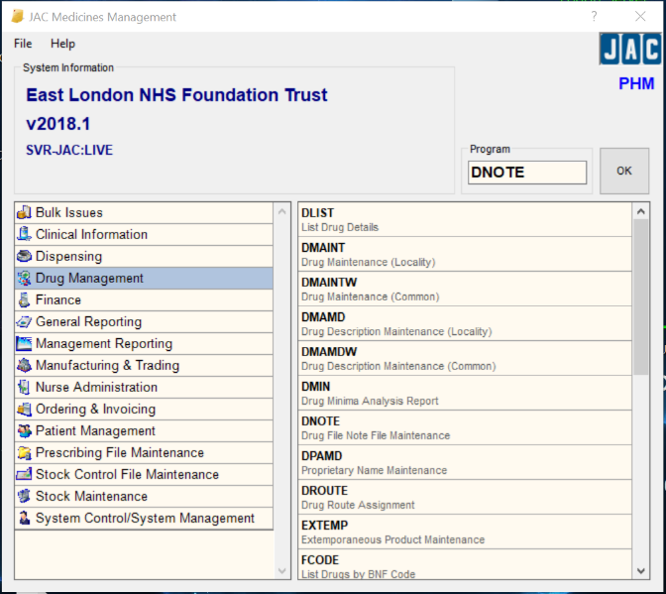
- Select ‘Individual’ and the click ‘Select Drug’
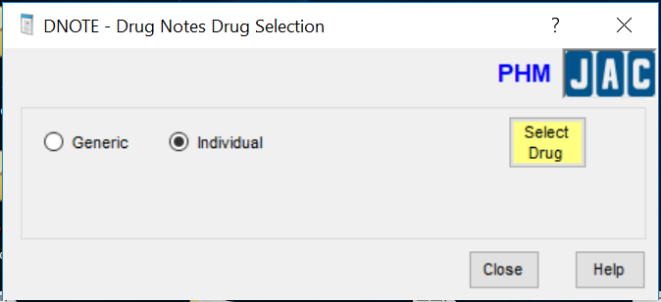
- Search for the relevant drug and select ‘Ok’

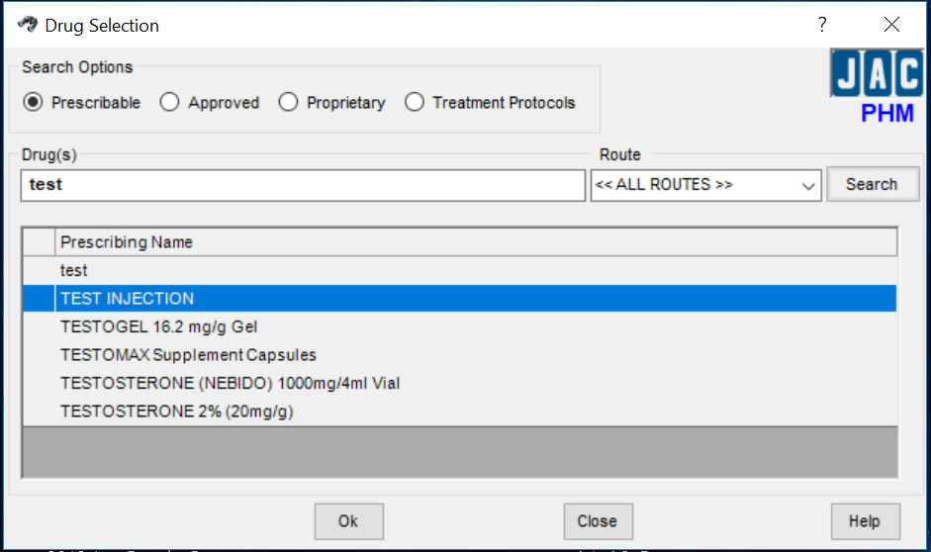

- Select ‘Add Note’

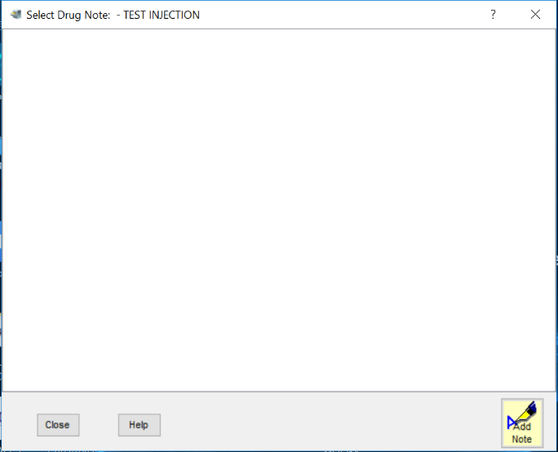

- In the Drug Note window, input ‘Supply Shortage Alert’ as the Drug Note Title. Select ‘<< ALL ROUTES >>’ as route. Use the below example to ensure all the relevant information is recorded in the alert – “current supply shortage”, record whether the medicine is restricted to a particular ward or team and “Contact Ward Pharmacist for further advice”. This note will appear to the prescriber at the point of prescribing. Tick “Available in Charting” for the alert to appear at the point of medicine administration (NB: this will appear every time the medicine is due to be administered). Tick “Available in Dispensing” for the alert to appear at the point of dispensing. Once complete, select the save icon
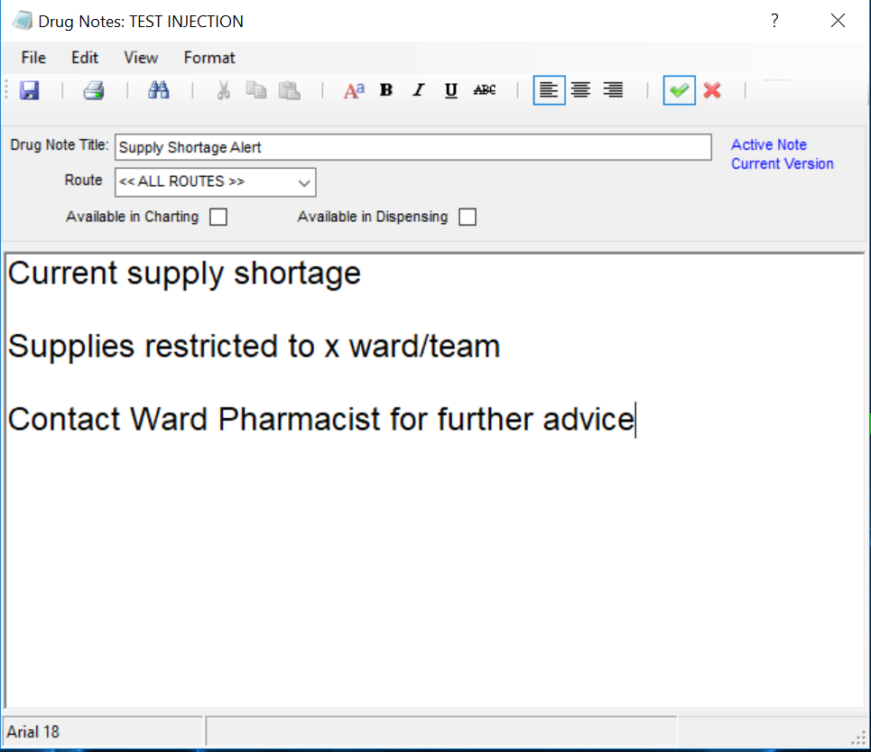
The above wording to be tailored depending on the nature of the medicines shortage and what additional instruction are required.

- Once saved, the below window will appear showing the saved drug note
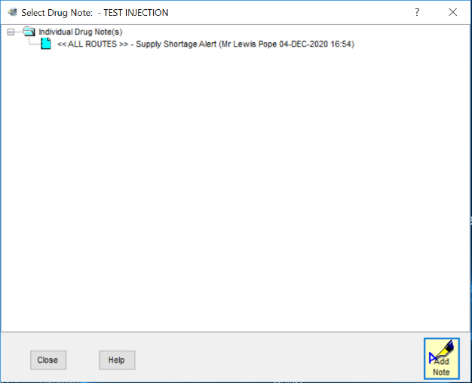
- To remove a drug note, select the appropriate note from the above screenshot. The below window will appear. Select the red cross in the top right of the window to deactivate. This will produce a red ‘inactive note’ message like in the below screenshot.
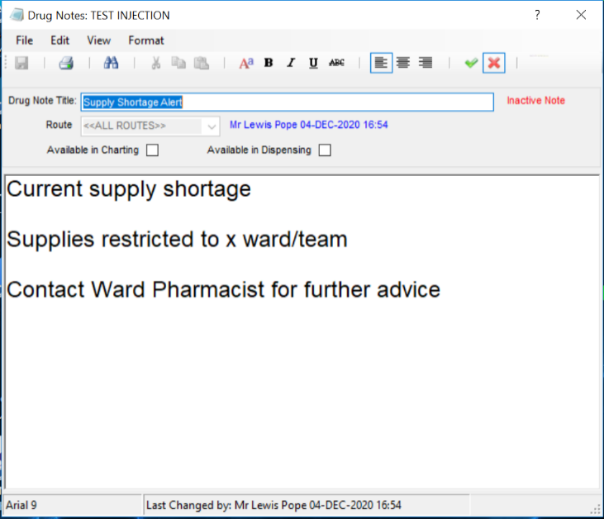
- Once inactive, the drug note will have a red stop sign to indicate it has been deactivated. To link in with pharmacist to ensure deactivation has been completed.
