
REPORT TO THE COMMISSIONERS
19/07/2024

Title | Mental Health Services Contract - Performance Report
Author | John Morrell, Principal Information Analyst
Accountable Executive Director | Amar Shah, Chief Quality Officer

Purpose of the Report:
This report provides narrative, detailed performance, quality Indicators (QI) and activity schedules as stipulated in the 2024/25 contract to the Commissioners for the period 1st to 30th June 2024.

  - Mandated NHS Improvement targets
  - Reporting Key Performance Indicators (KPIs) as agreed for the 2024-25 Mental Health service contract.
  - Red, Amber and Green ratings for Quality Indicators with targets set. These are generally applied as follows: 10% adverse variance = RED; Less than 10% adverse variance = AMBER; Otherwise = GREEN.

Current formats were developed/agreed via Mental Health Technical Support Group (MHTSG) discussions. The agreed template for this financial year has been used for this month’s report.

Summary of key issues
Of the 45 indicators with targets (at Trust level) in the contract report, 14 are rated red. There are 3 consecutive ambers.

Contents

1.0 | Performance Summary . . . . . . . . . . . . . . . . . . . . . . . . . . . . . . . . . . . . . . . . . . . . . . . . . . . . . | 3
2.0 | Priority Area of Focus . . . . . . . . . . . . . . . . . . . . . . . . . . . . . . . . . . . . . . . . . . . . . . . . . . . . . . | 5
3.0 | Inpatients Key Priority . . . . . . . . . . . . . . . . . . . . . . . . . . . . . . . . . . . . . . . . . . . . . . . . . . . . . | 27
4.0 | 2023/24 QUALITY INDICATORS (QIs) - DMT LEVEL VARIANCE REPORTS . . . . . . . . . . . . . | 28

APPENDICES
A02 EL Schedule 4 – LTP -Cluster 10 2024-25 M03 HIDE QUARTERLY ONES
A03 EL CAMHS Commissioners Report 2024-25 M03
A04 PTS Dashboard 2024-25 M03
A05 CH PTA alliance dashboard 2024-25 M03
A06 TH Autism Contract Report 2024-25 Q1
A07a IAPT Dashboard Newham 2024-25 M03
A07b IAPT Dashboard Tower Hamlets 2024-25 M03
A08 IAPT CCG Report Tower Hamlets 2024-25 Q1
A09 Dementia Contract Report 2024-25 M03
A10 TH CLDS Contract Report 2024-25 Q1

1.0 Performance Summary

This report provides the NHS East London Commissioning Consortium with:

- A summary of performance covering the period 1st to 30th June 2024.
- Of the 45* indicators with targets (at Trust level) in the contract report, 14* are rated red, and there were 3 consecutive ambers.
The red rated indicators include:

Schedule 4

- Metric ELAIS06: Cardio metabolic Assessment - % of assessments completed – Adult Inpatients (36.1% against a target of 90%)

- Metric ELAIS07: Discharge notification sent to GP within 24 hours of adult patient's discharge (38.5% against a target of 95%)

- Metric ELOAI03: Older Adult Inpatient Services - Older adult Clinically Ready for Discharge (CRFD) (67.6% against a target of 7.5%)

- Metric ELOAI05: Cardio metabolic Assessment - % of assessments completed – older adult inpatients (28.2% against a target of 90%)

- Metric ELOAI06: Discharge notification sent to GP within 24 hours of patient's discharge. (16.7% against a target of 95%)

- Metric ELPLS02: Proportion of A&E patients seen by HPM/Psych Liaison within 1 hour of referral to HPM/Psych Liaison team. (83.8% against a target of 95%)

- Metric ELPLS06: National 4-hour A&E breach target performance (73.3% against a target of 95%)

- Metric ELEIP03: Cardio metabolic Assessment - % of assessments completed (EIS) (50.4% against a target of 90%)

- Metric ELPCN01: Percentage of CMHT/PCN service users seen within 28 days for assessments within new care model (69.8% against a target of 95%)

- Metric ELMEC02: Memory Clinic: Percentage of patients contacted within 6 weeks (Referral to Treatment) to include F2F, Tel and Video. (52.7% against a target of 90%)

- Metric ELMEC03: Memory Clinic: Percentage of patients diagnosed within 18 weeks (Referral - Diagnosis) (59.4% against a target of 90%)

Cluster 10

- Metric ELC1002: Percentage of cases with a HONOS (75.9% against a target of 95%)

Learning Disabilities

- M3: Waiting time from assessment (triage to treatment) (77.8% against a target of 100%)

Dementia

- Metric CHDQ2d: RISK STRATIFICATION & SUPPORT PLAN: Percentage of those seen within 6 weeks who have a risk stratification with support plan created (52.6% against a target of 95%)

- Commentary on adverse variances, with supporting action plans to return performance to target where appropriate.

2.0 Priority Area of Focus

SPC charts are provided only for the monthly metrics with targets, showing two years of history (i.e., 24 data points): the figures for these metrics are all to be found in the Schedule 4 and LTP tabs of appendix A02. SPC charts are not provided for targeted metrics with under 15 data points as this is an insufficient number of to produce reliable chart.

Rated RED in June 2024

Schedule 4

Metric ELAIS06: Cardio metabolic Assessment - % of assessments completed – Adult Inpatients (Target 90%)

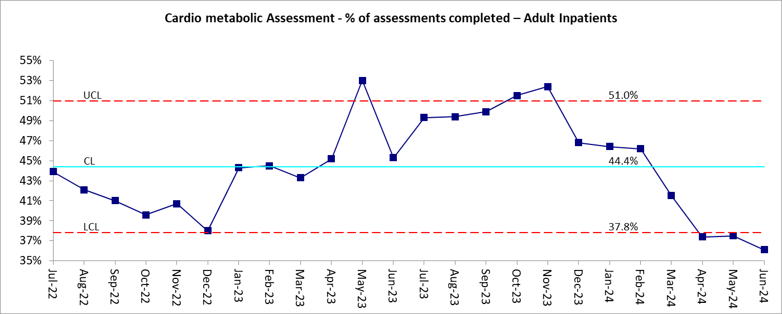

CH | 21.7% | The high occupancy rate of the inpatient unit (98%) has meant staff have been focussed on facilitating bed management across the unit.  - 97% have Blood Pressure checked.  - 84% have had BMI checked (highest in at least 6 months)  - 92% have had Lifestyle forms completed (highest in at least 6 months)  - 29% have had bloods recorded. This does not mean that blood testing has not been completed, only that it has not been recorded in the correct field on RiO. An ELFT digital group is currently looking at the interoperability of blood testing and RiO systems.  Case note audits are being completed weekly and review at Senior nurses’ meetings. It was identified that blood investigation forms are being completed but not including Lipids and Glucose results which this metric is looking at.  It will be fed back to the new rotation of Junior doctors from August 2024 to ensure they specifically include Lipids and Glucose levels when requesting blood testing.  In May and June Inpatient ACD and Performance lead started meeting with ward doctors and managers to discuss RiO recording, including blood results recording. Recording issues regarding lifestyle forms, NoDF completion and Blood recording were highlighted during these discussions and Lifestyle form completion performance has improved from between 70-80% in 2023 to between 90-100% in 2024.
NH | 54.5% | Compliance against this metric has fallen over the last couple of months and remains below target. The primary challenge is the recording of blood test results which we continue to explore with the doctors. One particular difficulty is that the forms are currently filled out manually causing additional work and room for error - the Trust is exploring ways for this to be automated but there is no current solution. Additionally, doctor capacity has been limited in June with the strikes and the doctors approaching the end of their rotation.  Work continues to further improve compliance, cardio-metabolic assessment compliance is monitored and raised with wards on a weekly basis. Each ward has dedicated time for reviewing missing information each week, and we are exploring further ways to create space for entering this information. There is also some work to review the reports available for teams, to improve the availability of information for wards. It is hoped this will improve the process for monitoring where this information has been missed live in the ward environment. Each ward now has large screens in their offices to show live reporting which is hoped will allow easier tracking of missing information.  One area highlighted that continues to cause difficulty in recording is blood test results for service users with a short admission, often the service user is discharged before the blood results have been received which can lead to them failing this metric. We will explore ways to mitigate the impact of this in reporting.  The Trust continues to review the forms used to record this data to improve the experience and improve compliance. There is a cohort of service users that refuse observations and blood tests - whilst these service users are encouraged to engage at every opportunity, we are also working to make sure the refusal is recorded accurately in order for it to be reflected in reporting.
TH | 31.5% | 35 patients out of 111 had all checks completed. Cardio-metabolic assessment compliance is monitored and raised with wards on a bi-weekly basis by Performance. There is a long term and, as yet, unresolved difficulty in requesting, receiving and recording investigation results in Mental Health. Results have to be manually entered onto a RIO form to be extractable for this report. Instead, they are often put it in progress notes where it can be accessed quickly in ward rounds/huddles etc. by clinicians. The RIO form has no clinical value and takes time to access. The data is also available on HIE, but the report does not pull from HIE.  Wards are still adapting to visibility of their performance on the ward, this needs to be encouraged and the benefits shown to the ward teams regularly to embed new behaviour.  The digital working group is looking into an automotive solution for the blood results rather than doctors having to enter this manually which takes a lot of time and has no clinical value. There are conversations underway into whether we need a central group with all stakeholders across all ELFT Directorates to come together similar to what we have with the NODF as we recognise this is a Trust-wide issue which requires the current systems to be smarter and more automotive to help facilitate the process. This may be ongoing for several months.  The in-patient unit has launched an ambitious physical health quality improvement project. There will be a number of streams covering improving physical health assessments, emergency simulations and new ward based physical health clinics. These clinics aim to work on reducing health inequalities for our in-patients with a focus on education and health promotion. This will not address the data input issues.

Metric ELAIS07: Discharge notification sent to GP within 24 hours of adult inpatient's discharge (Target of 95%)

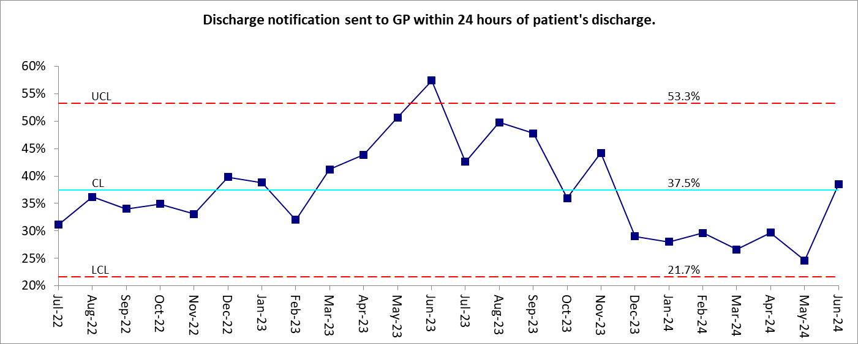

CH | 53.5% | This is the highest performance in 12 months. There continues to be High Occupancy and Acuity - Ward occupancy levels remain high at 98% with more patients on leave effecting NoDF completion within 24 hours.  These figures will be shared with the teams in both the Inpatient management Meeting and Junior/ Senior medical meeting and the ACD for Inpatients has contacted the consultants individually to discuss their team performance.  In May and June, the ACD and Performance lead started regular walkaround meetings with inpatient doctors to discuss RiO recording, including NoDF completion.  Training has been arranged to educate the new rotation of Junior Doctors starting in August.
NH | 45.7% | Completion of NODFS within 24 hours of discharges continues to present a significant challenge for the unit. Although compliance improved within June, the average time for a NODF to be sent in was just over 3 days which is higher than desirable. Reasons for low compliance include stretched medical teams on the ward and challenges completing paperwork following discharge.  There are regular meetings in place and steps taken to address when NODFs are outstanding for longer than 24 hours, along with reports that are available to allow monitoring by ward staff.  Doctor capacity remains the biggest barrier to completion of the NODF. A QI project is ongoing to explore these barriers, and how we mitigate against limited doctor capacity. The group is testing ways of working to move towards a goal of service users leaving the ward with a NODF completed, rather than focusing on completion post discharge. We are hoping to test different ways of using the patient system to improve this further - a ward round template has been designed and we are working with other areas to look at testing this on different sites. This template will allow for a smoother generation of a NODF, and allow us to explore other members of the MDT generating the NODF if the doctor is unavailable.
TH | 11.6% | The average time from discharge to NODF completion has reduced significantly since starting the NODF improvement project at the end of 2022 when discharge to NODF completion was at over 400 hours average and we had a large backlog of missing NODFs. For the last 6 months the average has been under 100 hours from discharge to NODF completion. In the last 6 months due to doctors strikes, there was reduced capacity to complete the NODFs and this increased the time from discharge to NODF completion as a result. Some of breaches are caused by a Friday discharge when there limited numbers of pharmacists to complete this until the following Monday. This is very much a job between junior doctors and pharmacist and as in all of our work relationships are important to get things done in time and we are building on the collaboration of these groups. Clinical leaders have reinforced the process and are championing the completion of this with quality and punctuality. There are some digital issues with meeting this target that the central digital team is working on. We are using two systems that makes the process fragmented. A system solution integration engine is expected to take several months, and this will continue to add lag to the process and will impact on the time taken for completion. In order to reduce fragmentation doctors have recommended that the system should send an automatic email to pharmacy stating that the medication validation is required rather than manually doing this. The Rio team is working on this change. Doctors and Pharmacy have now created a poster process flow map, and this helps ensure that roles and actions are clear. Daily reminders are being sent to Pharmacy and Junior Doctors which is helping with visibility and reducing time taken to complete the NODF. These reminders have been welcomed by Doctors and Pharmacy who find these helpful. Discussions are ongoing with Pharmacy and Junior Doctors as well as other staff such as admin and ward managers to see what other ideas can be tested or what processes can be simplified or given additional focus. Performance has visited the wards and provided training sessions. Performance has also demonstrated and will continue to demonstrate Power Bi over the coming months to improve digital capability and usage. Performance, ward staff, IT and Informatics are also working on getting the ward TV screens running and providing training on how these screens could help with ward huddles. There are talks underway to have this functionality on all wards. There has also been useful stakeholder feedback gathered that has been shared and we are looking at ways to incorporate this feedback to improve our processes. These measures outlined above will continue for the next few months.

Metric ELOAI03: Older adult Clinically Ready for Discharge (CRFD) (Target of 7.5%)

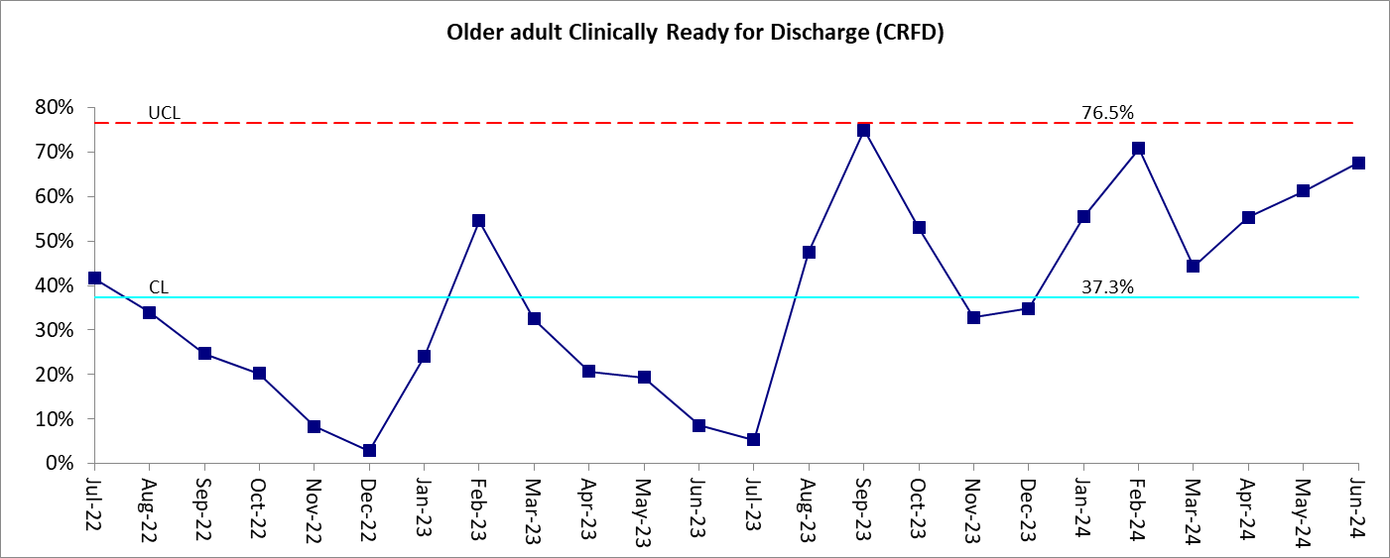

TH | 67.6% | There are 19 CRFDs. 6 have now been discharged. Of the 19 CRFDs  - 17 are attributable to social care,  - 1 attributable to both,  - 1 is responsibility of NHS.  - 3 patients are under the responsible borough of Hackney,  - 12 for Newham,  - and 4 for Tower Hamlets.  - 12 have a delay description of awaiting residential home placement,  - and 1 has a delay description of awaiting public funding,  - 3 are awaiting care-coordinator allocation,  - 2 are awaiting care package in own home,  - and 1 is awaiting supported accommodation.

Metric ELOAI05: Cardio metabolic Assessment - % of assessments completed – older adult inpatients (Target of 90%)

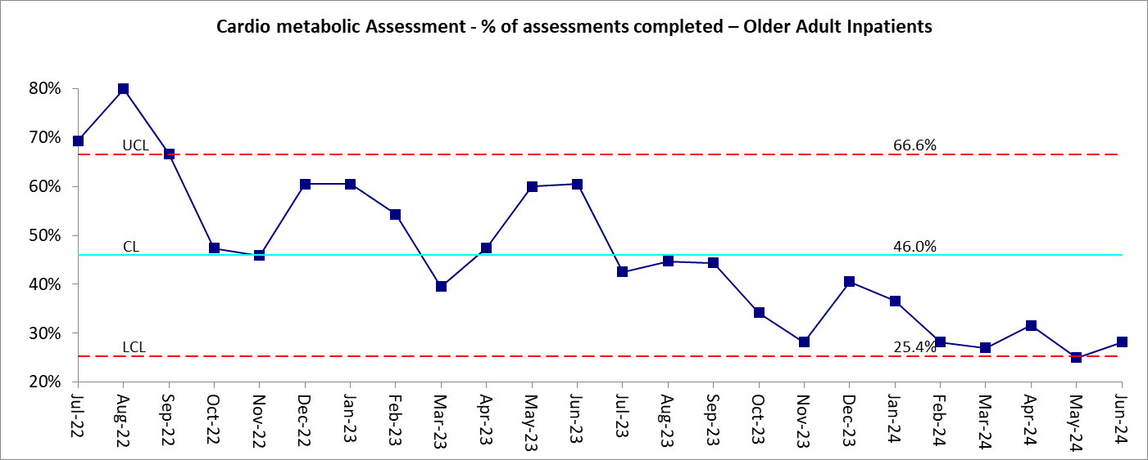

TH | 28.2% | 11 out of 39 had all checks completed. Cardio-metabolic assessment compliance is monitored and raised with wards on a weekly basis by Performance. There is a long term and, as yet, unresolved difficulty in requesting, receiving and recording investigation results in Mental Health. Results have to be manually entered onto a RIO form to be extractable for this report. Instead, they are often put it in progress notes where it can be accessed quickly in ward rounds/huddles etc. by clinicians. The RIO form has no clinical value and takes time to access. The data is also available on HIE, but the report does not pull from HIE.  Wards are still adapting to visibility of their performance on the ward, this needs to be encouraged and the benefits shown to the ward teams regularly to embed new behaviour.  The digital working group is looking into an automotive solution for the blood results rather than doctors having to enter this manually which takes a lot of time and has no clinical value. There are conversations underway into whether we need a central group with all stakeholders across all ELFT Directorates to come together similar to what we have with the NODF as we recognise this is a Trust-wide issue which requires the current systems to be smarter and more automotive to help facilitate the process. This may be ongoing for several months.  The in-patient unit has launched an ambitious physical health quality improvement project. There will be a number of streams covering improving physical health assessments, emergency simulations and new ward based physical health clinics. These clinics aim to work on reducing health inequalities for our in-patients with a focus on education and health promotion. This will not address the data input issues.

Metric ELOAI06: Discharge notification sent to GP within 24 hours of patient's discharge (Target of 95%)

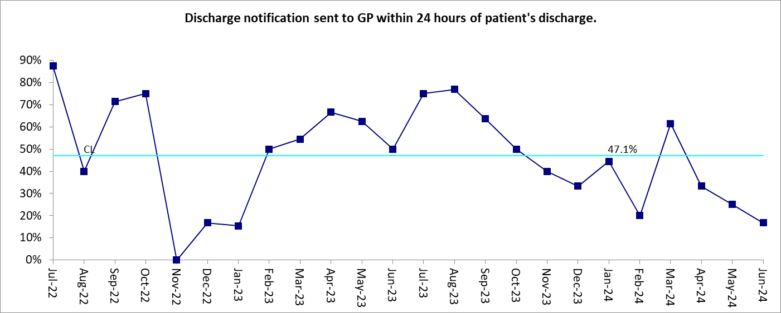

TH | 16.7% | There were 10 breaches in month. The average time from discharge to NODF completion has reduced significantly since starting the NODF improvement project at the end of 2022 when discharge to NODF completion was at over 400 hours average and we had a large backlog of missing NODFs. For the last 6 months the average has been under 100 hours from discharge to NODF completion. In the last 6 months due to doctors strikes, there was reduced capacity to complete the NODFs and this increased the time from discharge to NODF completion as a result. Some of breaches are caused by a Friday discharge when there limited numbers of pharmacists to complete this until the following Monday. This is very much a job between junior doctors and pharmacist and as in all of our work relationships are important to get things done in time and we are building on the collaboration of these groups. Clinical leaders have reinforced the process and are championing the completion of this with quality and punctuality. There are some digital issues with meeting this target that the central digital team is working on. We are using two systems that makes the process fragmented. A system solution integration engine is expected to take several months, and this will continue to add lag to the process and will impact on the time taken for completion. In order to reduce fragmentation doctors have recommended that the system should send an automatic email to pharmacy stating that the medication validation is required rather than manually doing this. The Rio team is working on this change. Doctors and Pharmacy have now created a poster process flow map, and this helps ensure that roles and actions are clear. Daily reminders are being sent to Pharmacy and Junior Doctors which is helping with visibility and reducing time taken to complete the NODF. These reminders have been welcomed by Doctors and Pharmacy who find these helpful. Discussions are ongoing with Pharmacy and Junior Doctors as well as other staff such as admin and ward managers to see what other ideas can be tested or what processes can be simplified or given additional focus. Performance has visited the wards and provided training sessions. Performance has also demonstrated and will continue to demonstrate Power Bi over the coming months to improve digital capability and usage. Performance, ward staff, IT and Informatics are also working on getting the ward TV screens running and providing training on how these screens could help with ward huddles. There are talks underway to have this functionality on all wards. There has also been useful stakeholder feedback gathered that has been shared and we are looking at ways to incorporate this feedback to improve our processes. These measures outlined above will continue for the next few months.

Metric ELPLS02: Proportion of A&E patients seen by HPM/Psych Liaison within 1 hour of referral to HPM/Psych Liaison team. (Target of 95%)

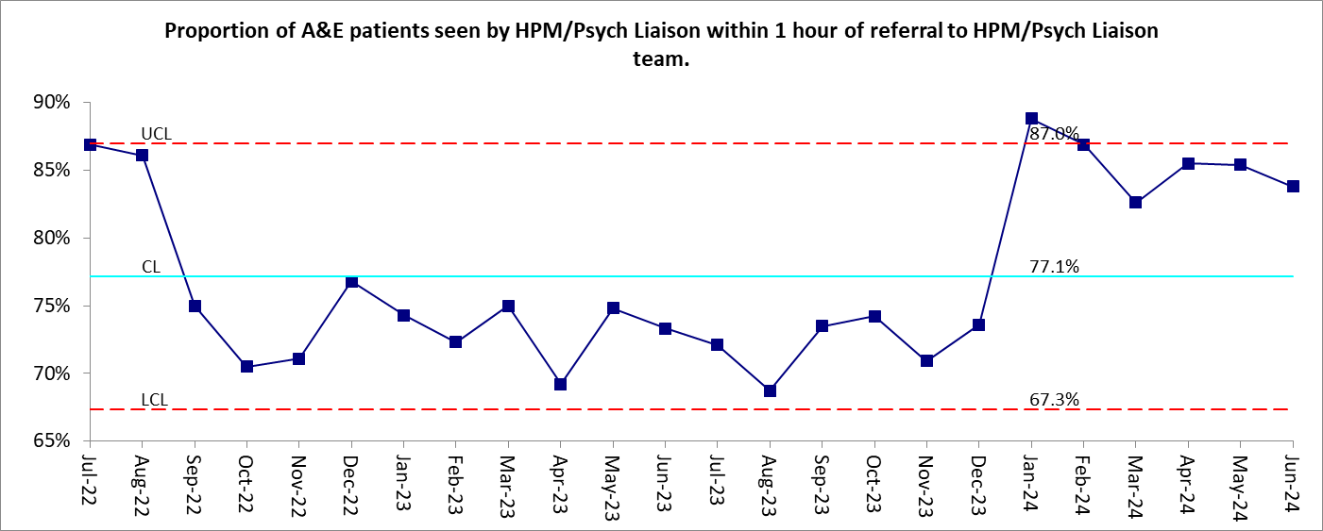

CH | 76.8% | The team have a sustained increase of 11% more referrals over the last 12 months (24% in two years). There are also continued inpatient bed pressures meaning people are remaining in the A&E department longer than usual while waiting to be admitted either within ELFT or elsewhere.  Bed pressures are showing signs of reducing which, if they continue will help with the flow of patients through A&E.  The Performance manager met with the Operational Lead in July to discuss the monthly data extract from Homerton University Hospital to ELFT in detail. It was noted that there are some data inaccuracies regarding data inputting from staff (recording dates and times manually) which have an impact on performance accuracy. The operational lead will be covering this is the next team business meeting to request more care and attention in data recording.  A directorate wide focus on community team provision has a longer term aim of reducing the number of attendances to the A&E department.
TH | 81.5% | There were 318 A&E Referrals. A&E Liaison service continues to experience an increase in referrals since January 2022. The actual level of Referrals is higher than reflected on the Royal London Barts system due to under-reporting. Some of the breaches may be data quality issues which may be due a few notes have been transposed from Rio to CRS without the time being adjusted accordingly and this is being investigated further by the service. This activity only reflects presentations to the A&E whereas the service also responds to 100 referrals (on average) from the acute hospital wards which can impact capacity. Reasons for the breaches include busy department with high workload compared to number of staff available, acuity, long bed delays, transport delays and multiple patients waiting over 12+ hours for beds which did have an impact on being able to see new referrals. These are similar reasons that are recurrent in the department.

Metric ELPLS06: National 4-hour A&E breach target performance. (Target of 95%)

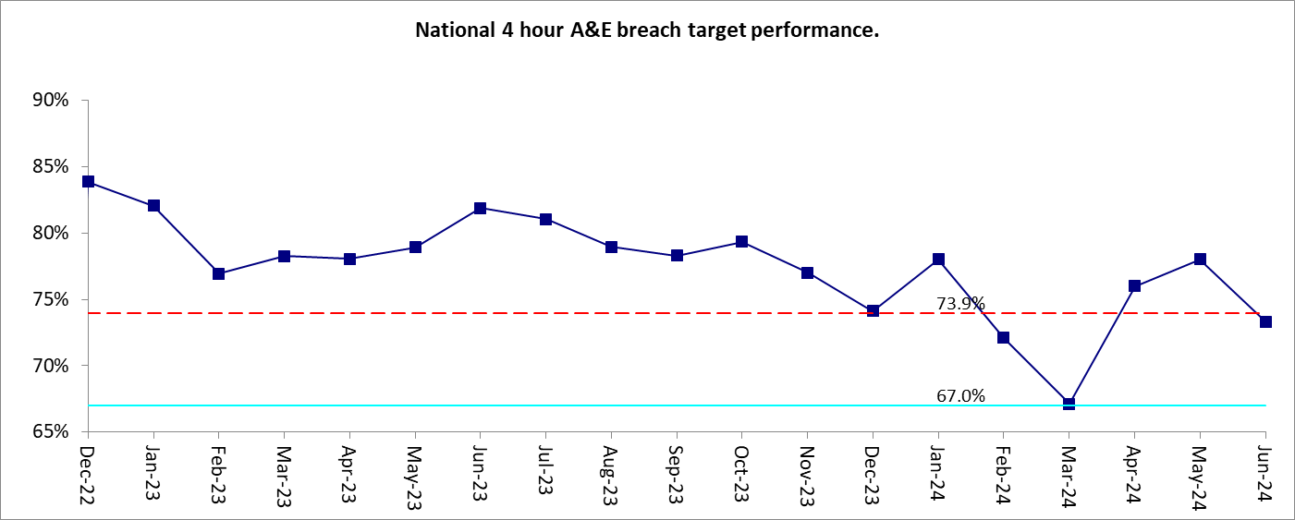

CH | 68.5% | This was due to 228 out of 333 cases being completed within 4 hours.  The average number of monthly referrals in 2023 was 383 per month compared to the previous year figure of 344. Showing a 11% increase in attendances. 24% in the last 2 years.  Inpatient bed pressures have increased the time A&E patients are in the department waiting for beds to be identified either in other NHS units or if necessary in Private sector hospitals.  Bed pressures are showing signs of reducing which, if they continue will help with the flow of patients through A&E.  A directorate wide focus on community team provision has a longer term aim of reducing the number of attendances to the A&E department.  For 12hr breaches, majority of the breaches are due to no beds, and then there's intoxicated/overdosed patients who can take longer than 12 hours to sober/wake up for assessment. Then more recently we're reducing our overnight admissions, with a view to making a concerted effort to discharge them during the day. There have been quite a few examples of this working well, which is a priority during this extended bed crisis. Our team is presenting a QI to panel on 16/7, "Reducing Average Length of Stay in Homerton Emergency Department". This will feature many change ideas, but overall we're hoping this will reduce 12 hour breaches as well.
NH | 80.9% | There were 43 breaches in June which is a reduction from May but still exceptionally high. Pressure within the system remains at an incredibly high level. This is due to very low inpatient bed capacity and therefore service users often have to wait in A&E for longer periods before admission. The psychiatric liaison team continue to have very high rates of assessment within 1 hour, meaning service users are seeing a mental health professional very quickly. The directorate also has a clear plan for making sure that service users are well cared for and supervised while they wait for admission to a mental health bed. There are a number of streams of work to alleviate bed pressures, including the commissioning of a number of step-up and step-down beds and the introduction of a team to work with service users admitting to Newham Centre for Mental Health from areas outside of the Trust. The directorate now has a dedicated team to work with service users placed outside the Trust to ensure oversight of care, and clear discharge planning if repatriation to ELFT is not possible.  For 12 hour breaches, numbers also reduced in June. This is primarily due to slightly less pressure in the inpatient services which has meant service users can be admitted to a bed and not have to wait within A&E for as long. However, there is still significant ongoing work around this to reduce the breaches further.
TH | 73.0% | There were 86 breaches in month 4 hour performance is at 73%. Reasons for the breaches include:  - Bed pressures, which lead to delays in MH Act assessments, delays with medical staff and busy department remain as factors for breaches.  - Complexity of assessments and social issues are among the contributing factors.  - Delays also due to high referral numbers on certain peak days and times  - There has been a number of out of area presentations which have taken a significant amount of time to find beds for and the private sector have refused referrals due to the complexity of the presentation. March was a significantly busy month with much more referrals than previous months and the last 12 months average and this impacted on being able to meet the 4 hour target. Additionally, there were doctors strikes in June which impacted the service capacity.  For 12hr breaches, decreased as there have been beds available for us to move patients into quicker. The overall number of breaches hasn't changed much but we are having less patients in the department for over 12 hours. Hopefully this will continue into July and beyond.

Metric ELEIP03: Cardio metabolic Assessment - Percentage of assessments completed (EIS) (Target of 90%)

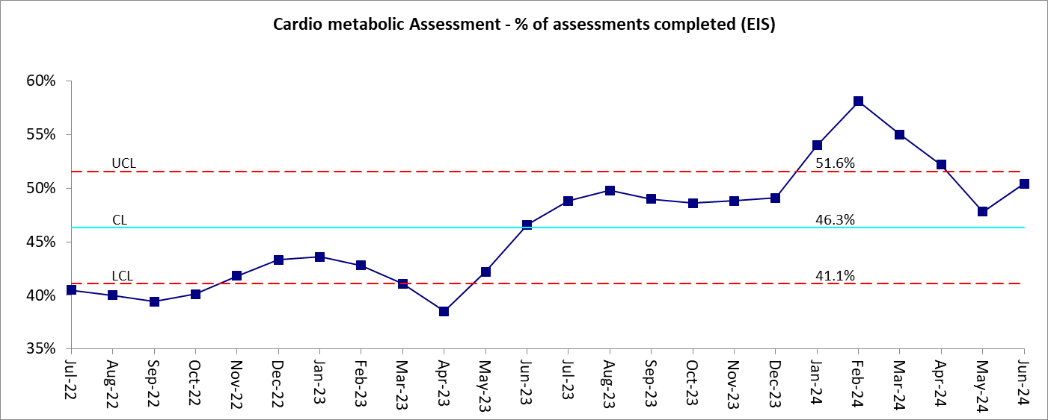

CH | 16.4% | The performance represents activity from ELFT RiO only. The evidence can be held in three different systems GP EMIS, ELFT RiO and HIE. But there have been digital challenges in obtaining a one version of the truth. In addition, being a system target, the NHSE evidence is obtained through GP EMIS, and this is one of the reasons that concentrated efforts are being made to update EMIS. EQUIP patients are encouraged to visit the Physical Health practitioner when they have appointments and this practitioner record on EMIS.  The following provides breakdown of various forms and their completion levels on ELFT RiO  - 83% have had their Blood Pressure checked.  - 75% have had Lifestyle forms completed. (4 months of improvement, highest in at least 12 months)  - 79% have had BMI checked.  - 17% have had their blood results recorded. This does not mean that blood testing has not been completed, only that it has not been recorded in the correct field on RiO.  In City and Hackney, the ICB LTP dashboard showed that in 2023/24 C&H achieved 80% of SMI Physical Health checks being completed against a target of 70%.  An ELFT digital group is currently looking at the interoperability of blood testing and RiO systems. We will like more support from our corporate services to address the digital challenges.  Care Coordinators are being asked to ensure RiO is being updated prior to their CPA reviews meetings on a 6 monthly basis.  The team are encouraging all clinicians to use power BI as a tool to identify patients on the caseload requiring Cardio Metabolic checks to be completed on a regular basis.
NH | 73.6% | Cardio metabolic assessment compliance has been variable in recent months although remained the same in June. While variable, compliance does remain at an improved level than 12 months ago. There continues to be significant focus on this in the team. There is still further work needed to reach the service users most difficult to engage around physical health checks. This will continue to be a focus of the team. The Trust continues to review the forms used to record this data to improve the experience and improve compliance. In particular blood forms are currently filled out manually causing additional work and room for error.
TH | 61.2% | 139 out of 227 patients had all checks completed. The service achieved 61% compliance for June, and this is the highest level of compliance to date. This indicates due to the sustained consistent increase each month in compliance that the QI project initiatives from the team are beginning to embed and we are seeing the benefit of these change ideas. Additionally other measures that are helping are staff have received additional training on ECG & bloods. We've recruited an additional support worker to increase capacity for groups; planning to commence a healthy eating/ cooking and exercise group in the coming months. The service also has an additional health care assistant that can help with increased capacity available now for the health checks. Cardio-metabolic assessment compliance is monitored and raised with EIS on a weekly basis by Performance. Physical health KPI's to be raised in monthly supervision for all care coordinators- clear focus and time frames to achieve data collection. We also have a physical heath admin afternoon once a month for care coordinators to use to achieve data collection. There is a long term and, as yet, unresolved difficulty in requesting, receiving and recording investigation results in Mental Health. Results have to be manually entered onto a RIO form to be extractable for this report. Instead, they are often put it in progress notes where it can be accessed quickly in sessions by clinicians. The RIO form has no clinical value and takes time to access. The data is also available on HIE, but the report does not pull from HIE.  The digital working group is looking into an automotive solution for the blood results rather than doctors having to enter this manually which takes a lot of time and has no clinical value. There are conversations underway into whether we need a central group with all stakeholders across all ELFT Directorates to come together similar to what we have with the NODF as we recognise this is a Trust-wide issue which requires the current systems to be smarter and more automotive to help facilitate the process. This may be ongoing for several months.

Metric ELPCN01: Percentage of adult CMHT/PCN service users seen within 28 days for assessments within new care model (Target of 95%)

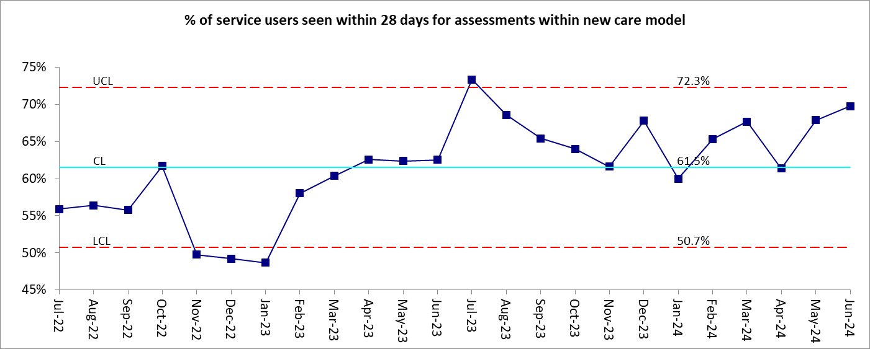

CH | 54.3% | Highest performance in 6 months. Waiting lists of community teams are discussed regularly as part of the weekly DMT Flow meetings and at the monthly DMT Operations meeting.  A review of the backlog of cases has been completed and appointments booked for all waiters. The waiting list for the Neighbourhoods has reduced by nearly 50% in the 8 months since October 2023.  The QI project continues to meet fortnightly looking at improving 28 day performance. Its main focus is improving provision and engagement of medical appointments as currently 50% are being cancelled buy the trust or not attended. Previous QI projects on waiting time reductions have been reviewed and previous learning reimplemented. Demand & Capacity work being initiated in the neighbourhoods - looking at the numbers of appointments needing to be offered when including current DNA and cancellation rates. The Borough Director, Clinical Director, Associate Clinical Director for Neighbourhoods, Administration lead and Performance Lead met in early June to look at current medical clinic provision and expectation. They intend to meet again in July to further define expectations for medical staff in the Neighbourhoods.  Performance and Administration leads reviewed the current appointment booking process and are currently changing it to a more to a consistent, centralised system which avoids individual secretary's having responsibility/ lone visibility of holding waiting lists. Part of this work involves getting agreement of consistent working processes across the 8 Medical teams. A new process for requesting Outpatient appointments was implemented in September to ensure only appropriate requests for doctors’ appointments are processed. These requests must be discussed with either a team senior or the consultant before administrators can book appointments. This has increased the availability of doctors’ appointments for appropriate referrals.  Meetings have been implemented by the ACD and Service Lead to facilitate stronger operational and clinical oversight management and accountability. These are held every two months and data over time is being presented and discussed in order to share good practice across the Neighbourhood teams.  A new psychology team is being implement on RiO to further identify Psychology and Neighbourhood patients. At the moment, patients are waiting in the Neighbourhoods to be allocated to Psychologists and appointments are recorded against Psychology Teams. The Administration Lead and Performance Lead met in June to further map out a new system pathway and this was presented to Psychology leads in early July and signed off. This will allow better oversight of current waiting lists and blockages within the service. Psychology staff are also contacting patients as referrals are received in order to better triage cases earlier.
NH | 81.6% | The number of service users seen within 28 days remains at an improved level whilst remaining below target. In the last two months significant efforts have been put into ensuring the service users waiting for the longest time, have appointments booked and are seen, which means that compliance may remain under target while those service users are seen in the next couple of months.  There has also been a focus on understanding long waits within the teams which has led to significant improvements in the compliance of this metric, however challenges with capacity have made it difficult to maintain the high levels of compliance, in particular with regards to demand for doctor appointments. The teams continue to explore the flow of referrals to doctors for first appointments to see if this is always the most clinically appropriate option.
TH | 60.6% | The performance has remained fairly consistent in the last 6 months and overall waiters have been have decreased significantly Dec-22 to Dec-23 and have remained consistent on size since then. There are a number of reasons for breaches within the new care model: recording of appointments is not robust enough which is being reviewed with teams; staffing capacity is limited in the teams and capacity and demand work has been undertaken so we have an understanding of this and can articulate this for business cases and general workforce planning - the services are getting an increased demand for medical reviews which require doctor input. We have formulated working groups in each area that has more waiters, and this group is reviewing waiters and breaches as well as process and adherence to for instance the DNA policy - One NMHT has capacity issues and is under resourced and therefore makes up the majority of the breaches and waiters. This service will be receiving more support from the DMT, and an interim service manager has been put in place. Working with performance we will be focusing on reducing the breaches over the coming months. We have established a weekly meeting to focus on this, in addition to weekly reports on waiters. All other areas are either at or close to their optimum waiting list size for their demand. The areas with the larger number of waiters have had high staff turnover which is being reviewed by OD and P&C to see what we can learn to improve on retention in the future. The recent doctor strikes have led to more appointments being cancelled which has increased the number of breaches. Business cases have also been recently prepared to potentially recruit more staff due to increase population in Tower Hamlets, increased GP list sizes, increased referrals and increased caseloads where we now have significantly more demand in 2023 and 2024 than in previous years for NMHTs. The latest funding review is ongoing as to whether the new proposed increase in staffing will be agreed. There is an EOI that's has been submitted to trial a new form of service with the Trieste model. We will know the outcome of this soon and have started preparations for this. We already have selected a site and are working through outcomes, governance, clinical model and how it will function day to day. We hope with this model that we can eliminate waiting lists in the future.
Metric ELMEC02: Memory Clinic: Percentage of patients contacted within 6 weeks (Referral to Treatment) to include F2F, Tel and Video. (Target of 90%)

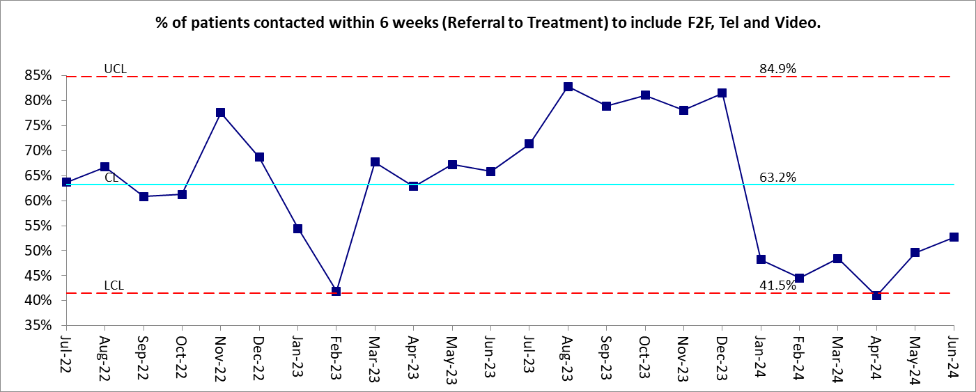

CH | 43.8% | This is due to 21 people seen within 6 weeks out of 48 people seen in June. This was the highest number of referrals seen in month in the last 8 months. The waiting list dropped by 16% (20 people) down to 101 people in June.  The Team, Service lead and Performance team met in early July and reviewed the KPI's and performance. A review of contact per staff member is being conducted to ensure consistency across the service.  Diagnostic memory service is a consultant assessment led service. The performance is due to lack of adequate medical capacity which continue to impact the assessments completed. This will continue to be the case for a while. The Homerton consultant is not taking any assessments since August 2023 despite Homerton getting paid for his sessions. The service lead is reviewing the contractual agreement with Homerton University Hospital to ensure clear expectations on service provision are included in a new contract.  The local ELFT doctor who is currently covering sick leave in service's medical post had to cancel assessments in February to cover inpatient wards during junior doctor's strike. All of this has a huge impact on the assessment completed by doctors.  Admin teams are calling patients more consistently to arrange appointments to avoid DNAs and cancellations. Breaches are anticipated to occur for the next few months as the team continue to work through the current waiting list.
NH | 66.7% | The memory clinic is a small team and has been struggling with medical and psychology capacity in recent months. This has led to delays in assessment and feedback to service users, increasing the waits both for initial assessment and diagnosis. The team has been looking at ways to mitigate the lack of capacity including agency doctor time to support the team.
TH | 53.7% | 29 out of 54 service users were seen within 6 weeks. Factors impacting on the service to meet the current demand.  - The service continues receive a high number of referrals – see data. Waiters have reduced for the sixth consecutive month and breaches of service users waiting (Incomplete pathway) have significantly reduced.  - Over the last six months approximately 37% of the referrals received by the service have been declined (with management advice offered) – the majority of declined referrals primarily include a mood disorder presentation. As all referrals require full screening and triaging, declined referrals continue to impact on the service capacity.  - The complexity of the post-pandemic presentations in relation to cognition, social care needs and physical comorbidities continue to result in protracted assessments when attempting to determine the cause of organic cognitive decline.  Recent Local service improvements that have been implemented to manage the demand. The QI project change ideas and measures are currently being formulated and we will be able to add these in the coming months and monitor progress.

Metric ELMEC03: Memory Clinic: Percentage of patients diagnosed within 18 weeks (Referral - Diagnosis) (Target of 90%)

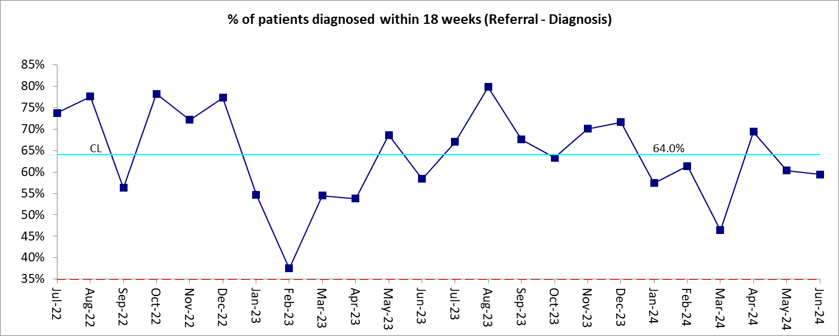

CH | 76.7% | The Team, Service lead and Performance team met in early July and reviewed the KPI's and performance. A review of contact per staff member is being conducted to ensure consistency across the service.  Diagnostic memory service is a consultant assessment led service. The performance is due to lack of adequate medical capacity which continue to impact the assessments completed. This will continue to be the case for a while. The Homerton consultant is not taking any assessments since August 2023 despite Homerton getting paid for his sessions. The service lead is reviewing the contractual agreement with Homerton University Hospital to ensure clear expectations on service provision are included in a new contract.  The local ELFT doctor who is currently covering sick leave in service's medical post had to cancel assessments in February to cover inpatient wards during junior doctor's strike. All of this has a huge impact on the assessment completed by doctors.  Admin teams are calling patients more consistently to arrange appointments to avoid DNAs and cancellations. Breaches are anticipated to occur for the next few months as the team continue to work through the current waiting list.
NH | 61.5% | The memory clinic is a small team and has been struggling with medical and psychology capacity in recent months. This has led to delays in assessment and feedback to service users, increasing the waits both for initial assessment and diagnosis. The team has been looking at ways to mitigate the lack of capacity including agency doctor time to support the team.
TH | 38.5% | 10 out of 26 people were diagnosed within 18 weeks. Factors impacting on the service to meet the current demand.  Recent Local service improvements that have been implemented to manage the demand.  - The service has established a ‘Diagnosis in a day clinic’ where service users can receive a full diagnostic assessment from the MDT and receive their diagnosis on the same day. This currently operates as a specialist psychiatry & cognitive neurology clinic, which includes the provision to diagnosis complex presentations with a neurological component. The clinic, however, is not currently able to operate as ‘one stop shop’ for the diagnosis of all dementia type presentations.  - The service continues to maintain a collaborative partnership with the RLH imaging dept. Through the partnership we have implemented a number of change ideas to improve and create a more efficient imaging referral pathway between the services. Of note, RLH have implemented a local wait times improvement project and we have seen a notably reduction in the waiting times for Memory clinic referrals to the imaging dept. We are now in a stronger position to revisit negotiations to create a neuroimaging SLA with RLH. There may be some honorary contracts provided in relation to this and we will know if this has been granted next month.  - Future Service improvement ideas to manage the demand. The service has commenced a Quality Improvement project looking at improving the waiting times for Memory Clinic service users.  - The service is currently reviewing the service name/ branding and considering changing the service name to the ‘Dementia Diagnostic Clinic’. We have considered that the rebrand may better informing referrers and service users when considering a referral to the clinic.  - The service Operational lead will formally review the feasibility of establishing an ‘out of hours’ weekend assessment clinic.  - The service will explore the feasibility of expanding the ‘diagnosis in a day clinic’. In spite of these challenges Tower Hamlets continues to outperform the National and London-wide average for Dementia Diagnostic Rates (75% against a target of 67%)

Cluster 10

Metric ELC1002: Percentage of cases with a HONOS. (Target of 95%).

Insufficient data points to generate the control chart.

95.0% | 78.6% | This is due to 52 out of 243 people not having a HoNOS. Performance has increased 5% over May figures.  The team have had staffing establishment issues in February and March. They have had two new staff join the team in May which will help alleviate activity pressures after they have completed their induction period.  The Performance manager discussed with the Operational lead and clarified that completing a cluster is no longer required, but the completion of HoNOS is. The group will meet on a monthly basis to review operational and performance figures.
95.0% | 84.7% | This metric is usually consistently met. There have been some struggles with doctor capacity in EIS which has led to updating of HONOS scores taking longer than usual. This will be addressed within the team.
95.0% | 65.1% | A recent change was made to the business rules to bring this metric in line with the automatic MHSDS submission and this now means that the whole cohort are included when previously some service users who had not been clustered did not appear in the denominator. The impact of this has been shared with the team and the team will mitigate this over the next few months to enter the information on RIO in the correct forms. There has been a shortage of doctors in the team, and this has resulted in less capacity available to update HONOS.

Learning Disabilities

Metric M3: Waiting time from assessment (triage to treatment) (Target of 100%).

Insufficient data points to generate the control chart.

NH | 77.8% | There were 4 breaches in June. 2 breaches were due to initial appointments not being recorded; this will be picked up with the team to ensure staff understand importance. One breach was due to the team waiting for social care to arrange a joint assessment for the service user. The final breach was due to capacity within the psychiatry team and was booked in week 19.

Dementia

Metric CHDQ2d: RISK STRATIFICATION & SUPPORT PLAN: Percentage of those seen within 6 weeks who have a risk stratification with support plan created (Target of 95%)

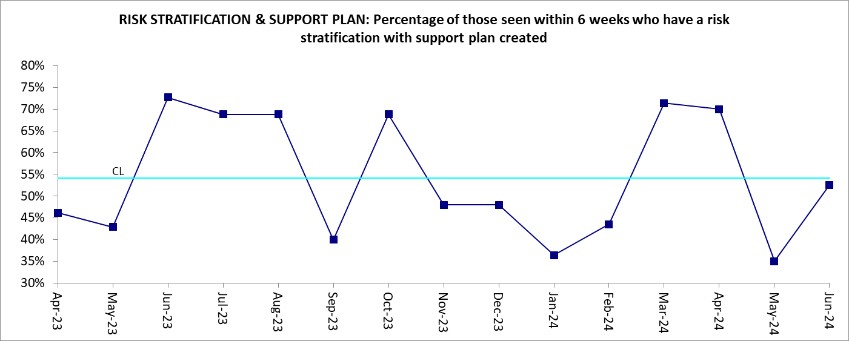

CH | 52.6% | This is due to 9 out of 19 patients not having a Risk Stratification and Support plan completed within 6 weeks. However, 4 of these are still within the 6 weeks period from referral.  There have been Nursing and Dementia navigator resource issues with multiple staff off due to sickness and vacancies. 2 new staff members joined the team in May and now completed their induction period. They will both relieve some of the caseload pressure from June onwards.  The Service Lead, Operational Lead and Performance team met in July and the operational lead will highlight in their team business meeting, the importance of completing a Risk Stratification Plan immediately after seeing new patients.  This metric needs further discussion as cases showing as not having had a Risk Stratification and Support plan completed are still within the 6 week period. Currently it is counting people who had their first contact within June only.

Rated AMBER in June 2024 (Consecutive Month Ambers)

Schedule 4

Metric ELOPC01: Community Mental Health Teams /Primary Care Network services (older adults): Percentage of service users seen within 28 days for assessments within new care model (Target of 90%)

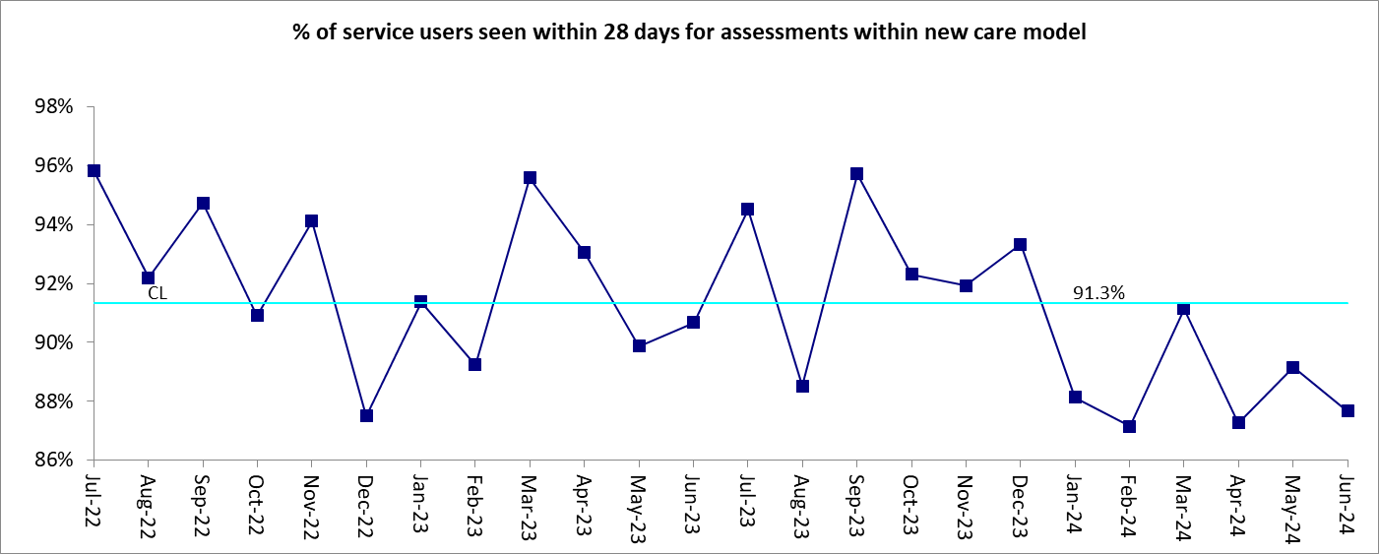

NH | 81.3% | There were 9 breaches reported in June. Five of the service users that breached were seen on day 30 - this is being explored with the team as there seems to have been a lack of understanding in the team regarding target timelines. One breach was due to contact not being recorded correctly. This continues to be a wider problem that is addressed with the team to monitor more closely and ensure that reporting reflects the level of contact and support that service users receive but this remains a challenge. The final 3 breaches were due to challenges engaging service users for assessment, although contact was made with families during this period.

LTP

Metric IAPT(ii.a): IAPT recovery rate: % of people that attended at least 2 treatment contacts and are moving to recovery (Target of 50%)
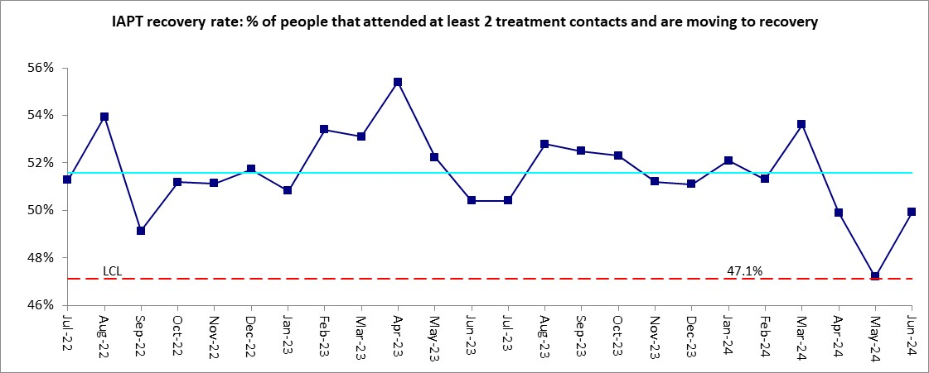
TH | 49.2% | Recovery is no longer considered a meaningful outcome indicator by the national Talking Therapies programme, has directed the use of Reliable Improvement (target 67%) and Reliable Recovery (target 48%) as the new preferred indicators. Services are adapting to target these new outcome measures and aim to be consistently meeting them by Q4.

Dementia

Metric CHDQ3b: CARE HOMES RESIDENTS REVIEWS: Percentage of people living in care homes with dementia on DNS caseload having regular face-to-face reviews every 6 months (Target of 100%)

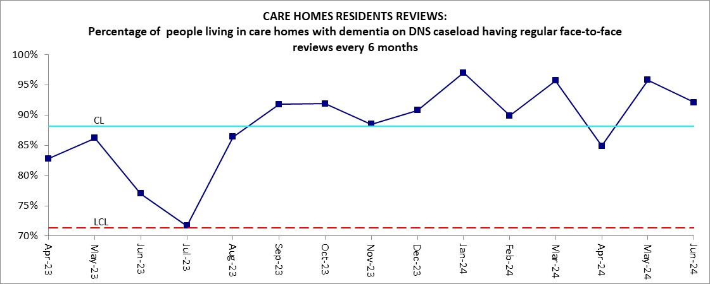

CH | 92.1% | This is due to 5 out of 76 care home patients not having both a DSRA form and a F2F contact within the last 6 months. 2 new staff members joined the team in May and now completed their induction period. They will both relieve some of the caseload pressure from June.  The Service Lead, Operational Lead and Performance team met in July and the operational lead will highlight in their team business meeting, the importance of completing a Risk Stratification Plan immediately after seeing new patients.

2.1 Infection Control
There were zero instances of MRSA infections and zero instances of C. Difficile infections reported by the Trust for Mental Health wards in June 2024.

2.2 Psychological Therapies Update
The monthly exception report and narrative for psychological therapies is provided in Appendix A04.

3.0 Inpatients Key Priority

3.1 Inpatient Re-admissions with 28 days – numbers by month (Ref ELAIS04)
In month re-admission numbers are provided in the additional table below.

Trust has achieved re-admissions score of 2.0% in June against target of 7.5% and below is the breakdown.

TABLE 1: Adult MH Services Readmission detail
Directorate | Apr | May | June | July | Aug | Sep | Oct | Nov | Dec | Jan | Feb | Mar | YTD
City and Hackney | 1 | 0 | 2 |  |  |  |  |  |  |  |  |  | 3
Newham | 5 | 11 | 4 |  |  |  |  |  |  |  |  |  | 20
Tower Hamlets | 4 | 5 | 2 |  |  |  |  |  |  |  |  |  | 11
TOTAL | 10 | 16 | 8 |  |  |  |  |  |  |  |  |  | 34

3.2 MHCOP Inpatient Delayed Transfers of Care (DTOC) (Ref ELOAI02)
In month numbers of delayed patient are provided in the additional table below.

TABLE 2: MHCOP Inpatient Delayed Transfers of Care (DTOC) detail of instances in each month
Directorate of Ward | Apr | May | June | July | Aug | Sep | Oct | Nov | Dec | Jan | Feb | Mar | YTD
City and Hackney | 0 | 0 | 0 |  |  |  |  |  |  |  |  |  | 0
Newham | 0 | 0 | 0 |  |  |  |  |  |  |  |  |  | 0
Tower Hamlets | 11 | 16 | 19 |  |  |  |  |  |  |  |  |  | 46
TOTAL | 11 | 16 | 19 |  |  |  |  |  |  |  |  |  | 46

Delay discharges shown above is the number of delayed patients occurring in month.

4.0 2021/22 QUALITY INDICATORS (QIs) - DMT LEVEL VARIANCE REPORTS

This section highlights significant local red or consecutive amber rated variances for indicators not listed in section 2.0 above. The variances relate to adult and older adult mental health services and are shown against agreed trajectories for this period plus details of action taken to achieve improvement. The commentary is from the stated directorates and the control charts show the East London wide position.

SPC charts are provided only for the monthly metrics with targets, showing 2 years of history: the figures for these metrics are all to be found in the Schedule 4 and LTP tabs of appendix A02. The metrics with targets elsewhere in the report, are all quarterly, and have only 8 data points which is an insufficient number of to produce an SPC chart. The charts in this section relate specifically to the directorates for which commentary is provided.

Schedule 4

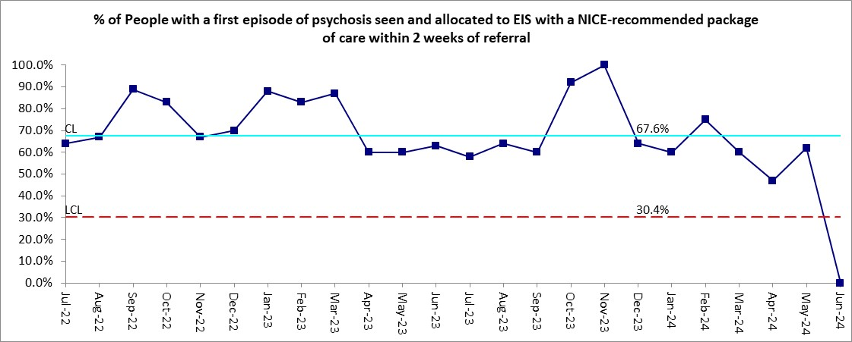

Directorate | KPI  Ref | Description | Target | Actual | DMT Comment and Recovery Plan
CH | ELEIP01 | % of People with a first episode of psychosis seen and allocated to EIS with a NICE-recommended package of care within 2 weeks of referral | 60.0% | 0.0% | This was due to 4 out of 4 people showing as not being contacted or allocated within 2 weeks of referral.  - 1 had 2 phone calls and agreed a home visit on day 17.  - 1 the patient had gone to stay with their mother out of London contact was made with patient and family and a home visit arranged on their return to London.  - 1 was an inpatient in a private hospital outside of London. The team were in contact with the hospital regularly and arranged a home visit at the earliest opportunity when they return to London.  - 1 was an inpatient in Hackney, the allocated Care Coordinator did visit the patient on the ward, but this was not recorded as an appointment on RiO.

Cluster 10

Insufficient data points to generate the control chart.

Directorate | KPI  Ref | Description | Target | Actual | DMT Comment and Recovery Plan
TH | ELC1004 | % of cases with accommodation status captured in MHSDS Report. | 95.0% | 94.9% | The target was almost met. The remaining outstanding service users (11) who do not have this completed will be updated by admin over the next month.

Insufficient data points to generate the control chart.

Directorate | KPI  Ref | Description | Target | Actual | DMT Comment and Recovery Plan
TH | ELC1005 | % of cases with employment status captured in MHSDS Report. | 95.0% | 94.9% | The target was almost met. The remaining outstanding service users (11) who do not have this completed will be updated by admin over the next month.

Insufficient data points to generate the control chart.

Directorate | KPI  Ref | Description | Target | Actual | DMT Comment and Recovery Plan
CH | ELC1006 | % of cases seen within 2 weeks and start a NICE concordant package of care. | 60.0% | 0.0% | This was due to 4 out of 4 people showing as not being contacted or allocated within 2 weeks of referral.  - 1 had 2 phone calls and agreed a home visit on day 17.  - 1 the patient had gone to stay with their mother out of London contact was made with patient and family and a home visit arranged on their return to London.  - 1 was an inpatient in a private hospital outside of London. The team were in contact with the hospital regularly and arranged a home visit at the earliest opportunity when they return to London.  - 1 was an inpatient in Hackney, the allocated Care Coordinator did visit the patient on the ward, but this was not recorded as an appointment on RiO.

Insufficient data points to generate the control chart.

Directorate | KPI  Ref | Description | Target | Actual | DMT Comment and Recovery Plan
CH | ELC1014 | % of cases reporting that they are satisfied with the "practical help received from the service" as per Q13 of the Dialog rating scale. | 70.0% | 62.5% | Out of 203 people, 3 were Totally dissatisfied, 3 were very dissatisfied, 1 fairly dissatisfied, 24 in the middle, 124 either fairly, very or totally satisfied and 48 were not scored by the service user. Meaning of those who responded, 80% were satisfied with the practical help they received from the service.

Insufficient data points to generate the control chart.

Directorate | KPI  Ref | Description | Target | Actual | DMT Comment and Recovery Plan
CH | ELC1015 | % of cases reporting that they are satisfied with the "meetings with the mental health professionals in the service" as per 14 of the DIALOG rating scale. | 75.0% | 72.2% | Out of 212 people, 3 were Totally dissatisfied, 5 were very dissatisfied, 3 fairly dissatisfied, 16 in the middle, 141 either fairly, very or totally satisfied and 44 were not scored by the service user. Meaning of those who responded, 83.9% were satisfied with the meetings with mental health professionals in the service.

LTP

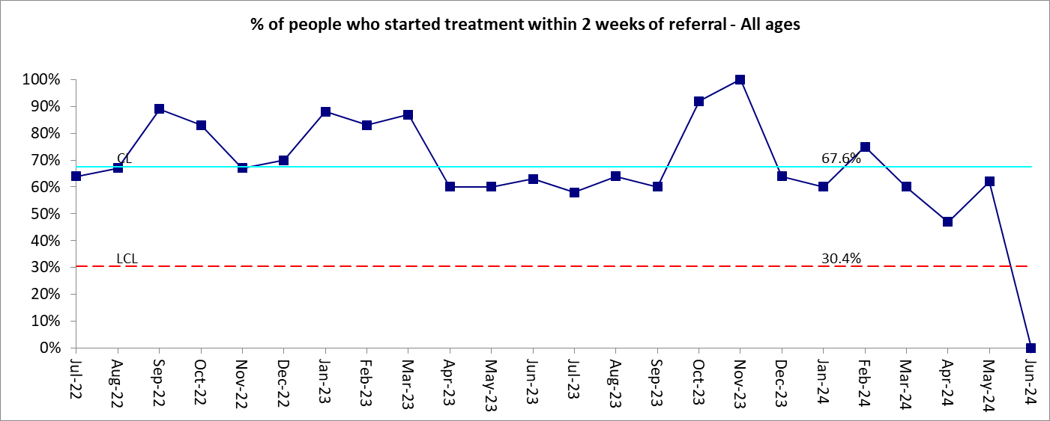

Directorate | KPI  Ref | Description | Target | Actual | DMT Comment and Recovery Plan
CH | EIP(i) | % of people who started treatment within 2 weeks of referral - All ages | 60.0% | 0.0% | This was due to 4 out of 4 people showing as not being contacted or allocated within 2 weeks of referral.  - 1 had 2 phone calls and agreed a home visit on day 17.  - 1 the patient had gone to stay with their mother out of London contact was made with patient and family and a home visit arranged on their return to London.  - 1 was an inpatient in a private hospital outside of London. The team were in contact with the hospital regularly and arranged a home visit at the earliest opportunity when they return to London.  - 1 was an inpatient in Hackney, the allocated Care Coordinator did visit the patient on the ward, but this was not recorded as an appointment on RiO.

