

An Information Governance round up on InPhase data security breaches

Remember to use bcc when emailing or sending invites to groups of service users

Several data security breaches on InPhase where group emails and invites were sent to service users using carbon copy (cc) instead of blind carbon copy (bcc). This has compromised their right to confidentiality as everyone can see their names and email addresses.

Please use bcc. Bcc sends a copy of your email to anyone in the bcc field but hides their email address from all other recipients. Bcc recipients won't be able to use the reply-all function. No one who receives the email can see bcc recipients, and bcc recipients can't see each other either.

In Outlook, open a new message or reply to a message. · From Options > Show fields, select Show Bcc. · Add the names of people you want on the Bcc line.

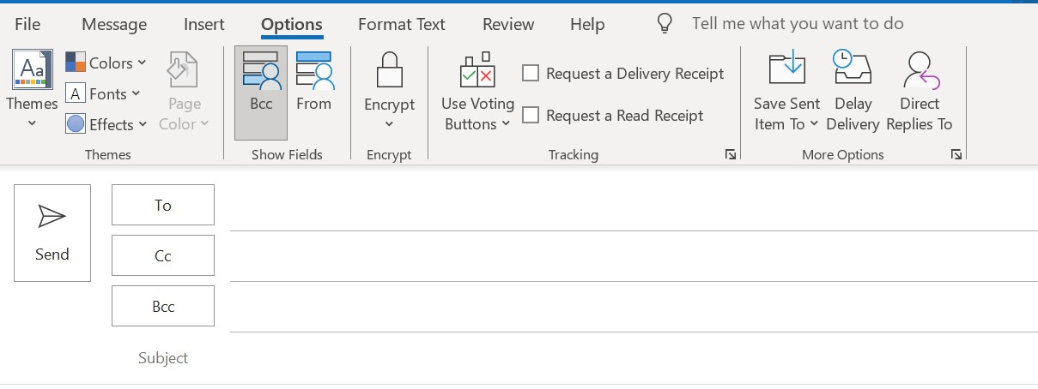

Single lost, stolen or broken phones, iPads and other IT kit

No need to report on InPhase. Just log a call on Service Now so the Digital team can block the device. If you need a new one you’ll need to have a budget code to order a new one, also via Service Now

Observations

When observations are missed don’t report as an information governance or digital incident on InPhase. These are patient safety incidents. Use Type ‘Care and treatment’, category ‘Observations’ and then select the relevant subcategory.

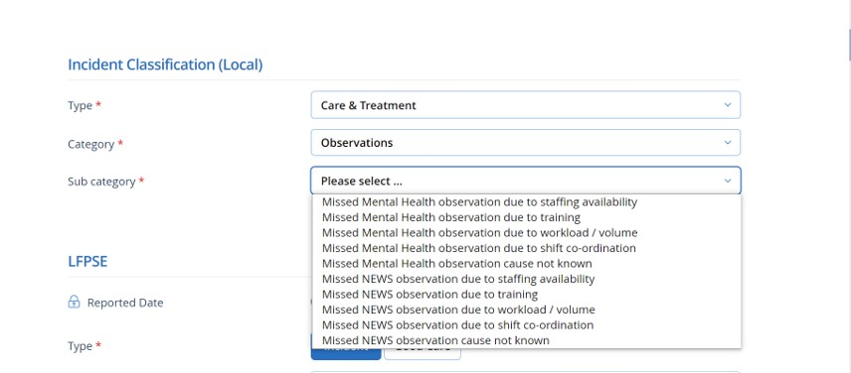

Emails sent to incorrect recipients

Make sure you don’t cause a date security breach by sending your email to the wrong recipient.

Most of the breaches occurred by selecting the wrong recipient from the drop down box in the ‘To’ field. Check before hitting the Send button! It’s even better to routinely clear the drop down box. From your emails select File/Options/Email/Empty Auto Complete/Are you sure?/Yes/OK.
Or just click on an incorrect address in the drop down and hit Delete.

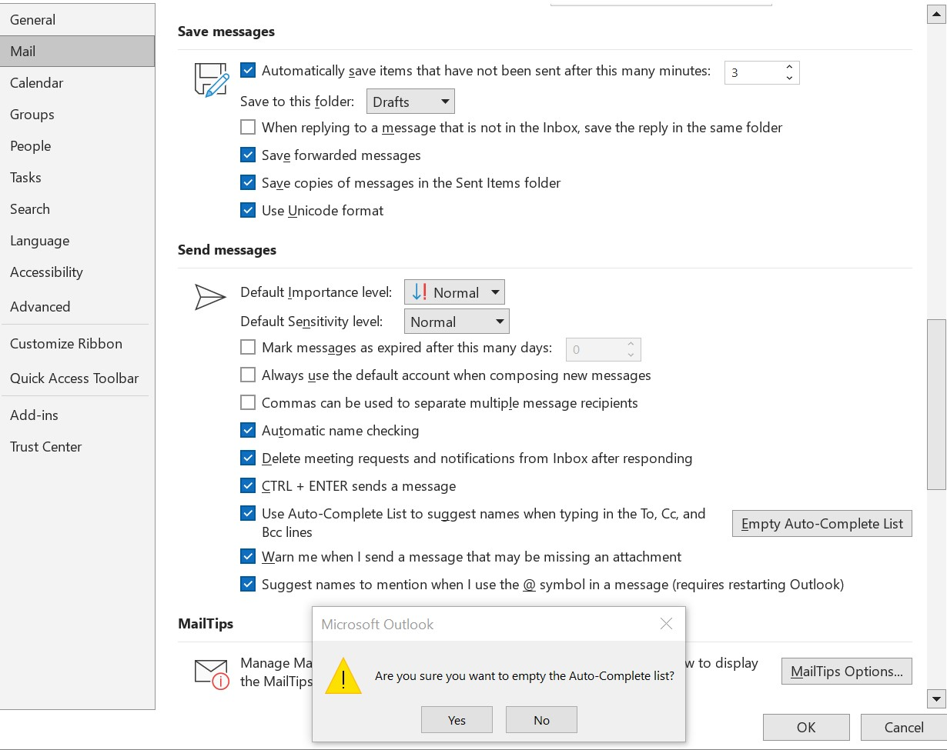

Contact us by Teams or email:

Chris Kitchener, Associate Director of Information Governance & DPO. Chris.kitchener@nhs.net

Nahida Rahman, Senior Information Governance Manager for Systems. Nahida.rahman3@nhs.net

Daniel Hill, Senior Information Governance Manager for Compliance. Daniel.hill17@nhs.net

Ade Adekunbi, Information Governance Manager for Luton & Bedfordshire Ademola.adekunbi@nhs.net

Ehi Osawe, Information Governance Manager for London Ehinoma.osawe@nhs.net

