Setting a Password to Access ESR and Payslip

Step 1 – Go to https://my.esr.nhs.uk then click login to ESR on the top right
- Step 2 - Select the Forgotten / Request username /Password / Unlock account
- Step 3 – Enter your NHS Mail email address & just your date of birth, Do NOT enter username, once this is done, you will receive an automated email with confirmation of your username and a password reset link from the ESR system.
- Step 4 – Make a note of your username from the email
- Step 5 – Click on the second link in the email to reset your password:-
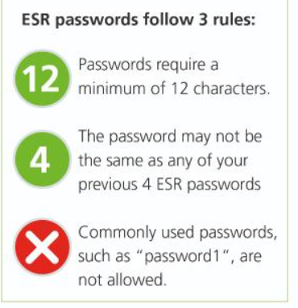
- Step 6 – Click on the Step 1 link in this email to be taken to the login page
- Step 7 – Log in with your username and new password

If you received the above message after completing the steps above to access ESR. Please email directly from your NHS email address and include your national insurance number to elft.hrelectronicforms@nhs.net

