

Lower Limb Ulcer Prevention and Management Procedural Document

Version number : | 7.0
Consultation Groups | Community nursing teams, Foot Health Service, Tissue Viability Services across ELFT, Nursing Development Steering Group
Approved by (Sponsor Group) | Policy Alignment Group
Date approved | 5th July 2024
Ratified at: | Quality Committee
Date ratified: | 25th September 2024
Name and Job Title of author: | Clinical Nurse Specialist Tissue Viability and  Clinical Lead Leg ulcer service
Executive Director lead : | Director of Nursing
Implementation Date : | September 2024
Last Review Date | June 2024
Next Review date: | June 2027

Services | Applicable to
Trust wide | √
Mental Health and LD

Community Health Services

Version Control Summary

Version | Date | Author | Status | Comment
2.0 | 2008 | Caroline Dowsett | Approved NDSG | This Document replaced the leg ulcer section in the wound management Guidelines
3.0 | July 2011 | C Dowsett | Approved NDSG | Revised and updated
4.0 | January 2015 | C Dowsett | Approved  NDSG | Revised and updated
5.0 | March 2018 | C Dowsett | Approved  NDSG | Revised and updated
6.0 | March 2021 | C Dowsett | Approved NDSG | Revised and updated to include National Wound Care Strategy Programme. Lower Limb Recommendations for Clinical Care
7.0 | June 2024 | C Dowsett | NDSG 13.06.24  Policy Alignment Group 05.07.24 | Revised and updated  Sections  9.7, 9.10, 11.2, 12.1, 12.2, 12.7

CONTENTS TABLE
Section Number | Section heading | Page Number
1.0 | Policy Summary | 6
2.0 | Overriding Duty of Care Statement | 6
3.0 | To whom this guideline applies | 6
4.0 | Background & Scope | 6
5.0 | Aims & Objectives | 6
6.0 | Quality Assurance & Audit | 6
7.0 | Dissemination | 7
8.0 | Definitions: Lower limb wounds | 8
9.0 | Assessment | 8
9.1 | Demographic Details | 8
9.2 | Current leg ulcer treatment | 9
9.3 | Medical History | 9
9.4 | Pain | 9
9.5 | Nutritional assessment | 9
9.6 | Ulcer History | 9
9.7 | Assessment of ulcer and surrounding skin | 9
9.8 | Condition of the legs | 10
9.9 | Opportunities for supported self-management | 10
9.10 | Investigations: Investigations: Ankle Brachial Pressure Index (ABPI) | 10
9.11 | Repeat ABPI measurements | 11
10.0 | On-going care and review | 11
10.1 | Repeat ABPI measurement | 11
11.0 | Wound & Skin Care | 12
11.1 | Wound Cleansing | 12
11.2 | Care Of Surrounding Skin | 12
11.3 | Contact sensitivities | 12
11.4 | Debridement | 12
11.5 | Infection | 13
11.6 | Dressings | 13
12.0 | Differential Diagnosis and Management | 14
612.1 | Venous Ulcer Aetiology | 14
162.2 | Venous Ulcer Management & compression systems | 14
12.3 | Arterial Ulcer Aetiology | 16
12.4 | Arterial Ulcer Management | 16
12.5 | Mixed Aetiology Ulceration | 16
12.6 | Mixed Aetiology Ulcer Management | 16
12.7 | Wounds on the foot | 16
12.8 | Malignant Ulceration | 16
12.9 | Management of Malignant Ulceration | 17
12.10 | Ulceration in people with Rheumatoid Arthritis | 17
12.11 | Vasculitic Ulcers | 17
12.12 | Management of Rheumatoid & Vasculitic Ulcers | 17
12.13 | Uncertain Diagnosis | 18
13.0 | Prevention of Venous Ulcer Recurrence | 18
13.1 | Compression Hosiery | 19
13.2 | Classification of compression hosiery | 19
13.3 | Advice on prescribing hosiery | 19
13.4 | Advice on fitting compression hosiery | 20
13.5 | Potential hazards of compression hosiery | 20
14.0 | Mobility and Exercises | 20
15.0 | Education and Training | 21
 | References | 22
 | APPENDICES
1 | National Wound Care Strategy Programme: Leg Ulcer Recommendations | 23
2 | ELFT Lower Limb Pathway | 25
3 | Lower Limb Assessment: Essential Criteria | 27
4 | Guidance for community nurses using MESI automated devices | 29
5 | Patient information Emollient Risk of Fire & Burns | 31

POLICY TRACKING TABLE
Title | Leg Ulcer Prevention & Management
Policy Number | V 7.0
Summary: | Contains guidance for clinical staff on the Assessment Management and Prevention of recurrence of patients with leg ulcers
Responsibility for Updating | Clinical Lead for leg ulcer service Tissue Viability Service
Date | June 2024
Review Date | June 2027
Equality Impact Assessment completed | Yes
Approved Via | Nursing Development Steering Group
Distribution | All Clinical Directorates. All Clinical staff via intranet. Available to the public Trust website.
Related Documents | Wound Management Guideline  Infection Control Policy
Further Information | Tissue Viability Service
This document replaces | Leg Ulcer Prevention and Management Guidelines 2021

1.0 Policy Summary

This document has been written by the Tissue Viability Service (TVS) and contains guidance for clinical staff on the assessment management and prevention of recurrence in patients with leg ulceration based on guidance from the National Wound Care Strategy Programme(NWCSP): Lower Limb recommendations for clinical care (2023)), NICE (2020) Leg ulcer infection: antimicrobial prescribing guidelines, SIGN (2010) Management of chronic venous leg ulcers: a national clinical guideline, National Institute for Clinical Excellence (NICE 2021, revised guidelines) and Best practice Statement on venous leg ulcer management (2016). It replaces previous local guidance published in 2021. These guidelines should be read in conjunction with National Guidance and the other Clinical Practice Guidelines in the Tissue Viability Service Portfolio (Newham and Bedfordshire/Accelerate CIC for Tower Hamlets).

2.0 Overriding Duty of Care Statement

Should the content or operation of these guidelines be challenged on any grounds whatsoever then the impact on the past, present or future duty of care to patients will be taken to be a primary factor in deciding the outcome of that challenge.

3.0 To whom this Guideline applies.

This document is aimed at practitioners who are responsible for the assessment, management, and prevention of recurrence of ulceration in patients with leg ulceration.

4.0 Background & Scope

Leg ulcers are wounds on the lower leg (originating on or above the malleolus and below the knee) that have not healed in 2 weeks. There are an estimated 739,000 leg ulcer in England with estimated associated healthcare costs of £3.1 billion per year (Guest et al, 2020). Leg ulcers have a significant impact on patients' quality of life causing pain, reduced mobility and negatively impacting their emotional and social well-being and their ability to cope with aspects of daily living. There are many causes of lower limb ulceration and unless the correct diagnosis is made early, patients may experience long delays in healing and poor outcomes.

This document is intended to provide a practical guide for the assessment, management, and prevention of recurrence of ulceration in patients with the most common causes of lower limb ulcers. It is not intended to replace national guidance and therefore, should be read in conjunction with full national guidance, best practice statements and subsequent research publications.

5.0 Aims & Objectives

- To provide a reference guide for assessing managing and preventing recurrence in patients with leg ulceration with a focus on the most common causes of leg ulcers, to include recommendations from the National Wound Care Strategy Programme (2023).
- To ensure an evidence-based, standardised approach to the management of patients with the more common causes of leg ulcers.
- To ensure standardised, evidence-based approach is taken to the prevention of recurrence of venous leg ulcers.
- To provide a framework to ensure that the quality of care for patients in this area can be monitored and improved in line with the Trusts quality improvement strategy.

6.0 Quality Assurance & Audit

The principles upon which this document is based are:
- An individualised holistic assessment should be undertaken, and evidence-based treatment plans commenced, which consider the underlying aetiology, patient’s circumstances, patient’s wishes, the overall goals of therapy, the practitioner’s clinical judgement, available resources, and knowledge of more recent research findings.
- The assessment, diagnosis and treatment plan should follow the recommendations from the National Wound Care Strategy Programme (2023), NICE (2020) incorporated into these local guidelines and pathways of care.
- Those who undertake assessment, planning, implementation, and evaluations of care should be trained/educated/competent in lower limb ulcer assessment, management, and prevention of recurrence. They should have attended the leg ulcer in-house training programmes, had supervised practice in the leg ulcer clinics/home care and be deemed competent by the caseload holder.
- The patient and their carers should be fully informed, have given consent and share in the decision-making process.
- The process should be clearly documented in the patient’s electronic records and made accessible to all those caring for the patient to ensure continuity of care.
- A collaborative, multi-disciplinary, inter agency approach is taken to meet all the needs of patients with or 'At risk' of lower limb ulcers developing.
- Patients, staff, and carers should have access to the equipment and resources necessary to deliver quality care.
- Monitoring of ulcer healing rates and recurrence rates as an indicator of quality care should be undertaken regularly.

7.0 Dissemination

This document is available to all staff on the Trust Intranet site. The recommendations have been incorporated into the educational programmes for leg ulcer care.

- DEFINITIONS: Lower limb wounds

Leg ulceration.

A wound on the leg is defined as a wound that originates on or above the malleolus. It should be noted that a "leg ulcer" is not a diagnosis but a manifestation of the underlying disease process, which requires diagnosis if the correct treatment pathway is to be selected. Seventy percent of lower limb ulcers are caused by venous disease, 10 per cent are caused by peripheral arterial disease and the remaining caused by other aetiologies such as mixed aetiology, trauma, lymphoedema, oedema, vasculitis, or immunological disorders.

Foot ulceration

A foot ulcer is a break of the skin of the foot (below the malleolus) that includes minimally the epidermis and part of the dermis. Foot ulceration is also an issue of concern. People with diabetes are 23 times more likely to have a leg, foot, or toe amputation than someone without diabetes, and both ulceration and amputation are associated with high mortality. The growing burden of diabetes and its complications has led to a national diabetes strategy with examples of significant regional service transformation. However, over half of all major amputations are in patients who do not have diabetes. Please refer to foot health service guidelines and advice and follow local, National, and international recommendations on best practice (NICE 2019, NWCSP 2023, IWGDF 2023).

- ASSESSMENT

All leg ulcers have an underlying cause, and an accurate diagnosis is essential to determine the appropriate treatment pathway. A full clinical history and physical examination should be conducted for a patient presenting with either their first or recurrent lower limb ulcer and assessment should be ongoing thereafter. The assessment should follow the leg ulcer recommendations from the NWCSP, which are summarised in Appendix 1

The National Wound Care Strategy Programme for leg ulcers recommends that on first contact the patient should be assessed for ‘red flag’ symptoms/conditions that would prompt immediate escalation, including.

- Acute infection (e.g. increasing unilateral erythema, swelling, pain, pus, heat)
- Symptoms of sepsis
- Acute or suspected chronic limb threatening ischaemia (e.g., PAD in combination with rest pain, gangrene, or lower limb ulceration >2 weeks duration).
- Suspected acute deep vein thrombosis16 (DVT).
- Suspected skin cancer.
- Bleeding varicose veins

Immediate and necessary care should be provided for those without red flag symptoms in line with the NWCSP (2023) recommendations and in line with the Trusts lower limb pathway Appendix 2. Patients without signs and symptoms of peripheral arterial disease and at low risk of pressure damage over bony prominences should be offered first line mild graduated compression (20mmHg or less at the ankle). Closely monitor for skin integrity and sign of vascular insufficiency if there is known or suspected impaired sensation.

A comprehensive assessment of the patient and diagnosis of the cause of ulceration should be undertaken by a health care professional trained in leg ulcer management within 14 days of referral and include the following information.

9.1 Demographic Details

- Date and time of initial assessment.
- Name, address, NHS number, contact telephone number, date of birth.
- District/Community/ Clinic nurses name, contact details.
- GP's name, address, telephone number

9.2 Current Leg ulcer treatments and investigation

- Allergies/skin sensitivities and medication
- Include any pathology test results.
- Results of investigations; Vital signs, BMI, recent blood results

9.3 Medical History

- Past & Current medical history: e.g. Diabetes mellitus.
- Anaemia
- Deep vein thrombosis (DVT) in the affected leg
- Phlebitis of the affected leg
- Number of pregnancies
- Obesity
- Past surgery: including past venous & arterial operations.
- Past fractures of the legs and lower limb orthopaedic operations
- Any prolonged periods of bed rest i.e. more than 4 days
- Smoking & alcohol history
- Nutritional and hydration level
- Family history including leg ulceration, varicose veins, heart disease, stroke, diabetes etc.
- Medications

9.4 Pain

- Patient reported pain using a 1-10 scale with 10 being the most pain.
- Constant or intermittent
- Day or night
- At dressing change
- What helps the patient?
- Impact of the ulcer on the patient’s quality of life

  - Nutritional Assessment

- All patients should be screened for 'risk of' or actual malnutrition and be given advice on a well-balanced diet in accordance with their wishes. Use of MUST tool recommended.
- Patients considered as 'malnourished', or 'at risk' of malnutrition should be managed according to local and national guidance.
- Nutritionally compromised patients who have wounds may have an increased dietary need and a referral to a Dietician should be considered for further assessment, advice, and supplementation.
- Weight, height, and body mass index (BMI) should be recorded at initial assessment and then regularly throughout the treatment phase.

  - Ulcer History

- How the ulcer(s) started
- Duration of ulcer(s) past and present
- Number of episodes of ulceration
- Time to healing in previous episodes.
- Ankle movement
- Measurement of ankle circumference

  - Assessment of the ulcer and surrounding skin

- Assess the ulcer in line with minimum data set outlined in Appendix 3
- Site of ulcer(s) - position on the leg. For example: medial, lateral, anterior, posterior, within the gaiter area, on the foot, over the malleolus etc.
- Size of ulcer(s) – record maximum length by maximum width in centimetres. This should be recorded on the Wound Assessment Form in the patient’s electronic notes and should be repeated and compared with previous measurements every 4 weeks.
- Photographs should be taken on initial assessment and every four weeks with the patient's consent. Verbal consent can be obtained for record keeping purposes. Please use the Trusts consent form for photographs that will be used for Product evaluations, teaching or publication purposes and upload the consent and photograph to the patients’ electronic records and delete from the camera. Refer to wound management guidelines for more information.
- Verbal consent can be obtained for photographs used for wound monitoring and evaluation, triage and for providing information to the Tissue viability team for virtual advice.
- Presence or absence of odour and exudate including colour and volume.
- Appearance of wound bed including colour i.e. black/grey/green/yellow/red/pink.
- Type of tissue i.e. necrotic, sloughy, purulent, granulating, epithelialising, infected.
- Clinical observations and changes to the ulcer bed and edges should be documented at each dressing change.

  - Condition of the Legs

- Shape of leg. For example: inverted champagne bottle, thin or normal shaped
- Presence of oedema. If yes, is it pitting? How far up the leg does the oedema extend? Is this caused by heart failure, prolonged limb dependency or lymphoedema?
- Varicose veins, superficial veins, ankle flare, atrophy blanche
- Temperature of skin along leg length including foot
- Skin condition. For example: dry skin, eczema, broken areas, brown staining, red and inflamed areas, lack of hair, shiny skin, capillary refill (more or less than 3 seconds), scars on the leg.
- Foot condition. For example: discolouration of toes or feet (white, bluish, red), number of toes, thickening of toenails.
- Foot pulses - present or absent, can they be felt or heard using Doppler ultrasound? How many pulse sounds can be heard? triphasic, biphasic or monophasic.
- Ankle movement - full/restricted movement or fixed ankle joint?
- Walking ability - full/restricted/with aids - is the movement heel to toe to move calf muscle pump?
- Ankle and calf measurements (cm)

  - Opportunities for supported self-management.

- Discuss and incorporate opportunities for supported self-management into the patient’s treatment plan in line with the individual’s and their carers’ capacity, capability and wishes (NHS England 2020)

9.10 Investigations: Ankle Brachial Pressure Index (ABPI)

Measurement ABPI using MESI, or a handheld Doppler ultrasound should be taken during the initial assessment.

ABPI assessment is not intended for the diagnosis of venous disease, but rather for exclusion of significant arterial disease and therefore confirmation of safe practice (i.e. to confirm that use of compression treatment is safe). Measuring ABPI provides an assessment of the patient’s peripheral arterial system.

- Patients do not need to rest before the procedure if using the MESI device but should lie still during the procedure.
- The MESI device will calculate the ABPI which will be displayed on the screen.
- All staff should be aware of the limitations of using MESI devices to measure ABPI and the risk of missing peripheral arterial disease (NICE2023, DG52) Appendix 4.
- If using a handheld Doppler the patient should have rested, as flat as possible, for at least 20 minutes. Inaccurate readings will occur if the patient sits up or the legs are dependent or very oedematous.
- Ankle systolic pressure: locate, obtain, and document pressure readings from all pulse points if possible and use the highest reading in each foot to calculate ABPI. Pulses to identify: Dorsalis Pedis and Posterior Tibial.
- Brachial systolic pressure - using the Doppler ultrasound to take readings from both arms and use the highest reading when calculating ABPI.

The ankle brachial pressure index (ABPI) provides an index of vessel competency by measuring the ratio of systolic blood pressure at the ankle to that in the arm, with a value of 1 being normal. Measurement of the ABPI should be undertaken by an experienced operator using validated equipment.

- ABPI ratio less than 0.5 suggests severe arterial disease. Refer the person to vascular services. Compression is contraindicated.
- ABPI greater than 0.5 to less than 0.8 suggests the presence of arterial disease or mixed/venous disease. Refer the person for vascular assessment. Reduced compression may be suitable but only under the supervision of the specialist team with strict supervision.
- ABPI between 0.8 and 1.3 suggests no evidence of significant arterial disease. Compression may be safely applied in most people.
- For people with cardiac failure, consider seeking specialist advice as there may be a risk of fluid overload if heart failure is not controlled.
- ABPI greater than 1.3 may suggest the presence of arterial calcification, such as in some people with diabetes, rheumatoid arthritis, systemic vasculitis, atherosclerotic diseases, and advanced chronic renal failure. Please seek advice from specialist services. Compression therapy should be used with caution in people with diabetes, who may have unreliable ABPIs due to arterial calcification as well as an underlying sensory neuropathy.
- ABPI values should always be interpreted in the context of signs and symptoms for example, if it is within the normal range but the person has symptoms of peripheral arterial disease (such as intermittent claudication or rest pain), consider vascular referral.
- When the ulcer has healed the patient should be reviewed 6 monthly for an assessment that includes peripheral vascular assessment, skin and lymphoedematous changes and assessment of sensation (NWCSP 2023)

NB: ABPI readings indicate strength of arterial blood flow to the foot. A common misunderstanding among inexperienced staff is that ABPI readings between 0.8 and 1 indicate the ulcer is venous in origin. This is incorrect. The range represents the arterial strength required to apply compression therapy if clinically indicated.

9.11 Repeat ABPI measurements

ABPI measurements should be repeated when.
- An ulcer is deteriorating.
- Patient presents with ulcer recurrence.
- Before commencing compression therapy
- Patient is to commence wearing compression hosiery as a preventive measure.
- There is a sudden increase in ulcer size.
- There is a sudden increase in ulcer pain.
- Foot colour and/or temperature of foot changes
- Ongoing assessment at 3, 6 or 12 months depending on initial and ongoing assessment outcomes, cardiovascular risk profile and patient needs (NICE 2020).

- On- going care and review

All patients should be re-assessed at each dressing change to review effectiveness of their treatment plan and escalate any concerns. Assess for ‘red flag’ symptoms and escalate to relevant specialist. Assess for a reduction in wound size and document using wound measurement and photography every 4 weeks. People with wound that show no significant progress towards healing at 12 weeks or are deteriorating should be escalated to the tissue viability service. Where possible, self-care should be encouraged and supported.

11.0 WOUND & SKIN CARE

11.1 Wound Cleansing

- Clean the ulcer, where necessary, with UCS cleansing and debridement wipes. These are available in a box of 10 sachets PIP code: 384-4271.If not available use warmed (body temperature) tap water or sterile 0.9% sodium chloride. In most cases tap water will be suitable but should be assessed on an individual basis. Consider: patient comfort, quality of tap water, environment, equipment available, the need to cleanse surrounding skin, volume needed, moving and handling of loads (buckets).
- If patients wish to shower Limbo Waterproof protectors can be prescribed. Please refer to the Local Wound Management Formulary.
- Other antiseptic cleansing solutions may be recommended for wounds with infection or at high risk from infection. However, these should not be used routinely. Please refer to the Trusts Wound Management Formulary 2024 and or seek advice from the tissue viability service.
- Use the No Touch Wound Dressing Technique to prevent cross infection. Universal precautions should be maintained. Hands should be washed before and after using gloves and between patients.

11.2 Care of the Skin surrounding the ulcer

- Dry skin should be moisturised with bland emollients. For example: 50:50 liquid paraffin and white soft paraffin, Zero-base or Epaderm. Please follow local guidelines on the Trusts emollient formulary and guidelines. The dryer the skin the more 'greasier' a preparation and more frequent application is required. Emollients containing petroleum should be used with caution due to the risk of fire. Information on Risk should be provided to patients (Appendix 5)
- Varicose eczema may benefit from the topical application of steroid ointment or cream, which may reduce inflammation and limit the spread of skin breakdown. It should be noted that topical steroid therapy should only be applied to eczematous skin and not the ulcer. Use a cream for wet eczema and an ointment for dry eczema. Apply amount according to size of surface area affected. For example: 1 fingertip unit to cover the surface area equivalent to that of two adult hands and use the appropriate potency for the severity of the eczema.
- The surrounding skin should be protected from wound exudate, which may cause excoriation and/or maceration by using dressings that absorb exudate and skin protectors. Please refer to the Local Wound Management Formulary.
- If skin problems persist, please consult the patients GP for onward referral to dermatology services in line with local agreement.

11.3 Contact Sensitivity

Patients can become sensitised to elements of their treatment at any time. The most common sensitizers include lanolin, perfumes, preservatives; natural rubber latex and topical antibiotics and these should be avoided. Patients with suspected sensitivity reactions should be referred to a dermatology specialist to identify the allergen. After patch testing, identified allergens must be documented; avoided and medical advice on treatment should be sought.

11.4 Debridement

Wounds may be covered by a combination of sloughy or necrotic tissue, fibrin, exudate and dressing residue, which can harbour bacteria, increase the risk of infection and can delay healing by prolonging the inflammatory response. Therefore, it is important to remove devitalised tissue and excess exudate to promote healing. This may be achieved through autolysis, chemical or enzymatic or mechanical debridement.

Debridement methods include:

- Autolysis debridement using dressings such as: hydrogels, hydrocolloids, hydrofibres and foams.
- Mechanical debridement: use of debridement wipes and pads e.g. debrisoft/Alprep pad
- Enzymatic debridement.
- Bio-surgery otherwise known as sterile larvae (maggots).
- Sharp debridement: using a blade or scalpel, but this must only be undertaken by a healthcare professional with specific training. Please seek advice from the tissue viability service
- Surgical excision: performed by a surgeon in sterile conditions.

NB: Decisions about debridement method should be made by a registered health professional that has undergone appropriate training and demonstrated competence.

11.5 Infection

NICE (2020) guidelines for leg ulcer infection: antimicrobial prescribing, recommend only giving antibiotics for adults with a leg ulcer when there are symptoms or signs of infection (for example, redness or swelling spreading beyond the ulcer, localised warmth, increased pain, or fever). First choice oral antibiotic is Flucloxacillin 500mg to 1g four times a day for 7 days. Please see NICE guidelines for those who are unsuitable for Flucloxacillin. Do not take a sample for microbiological testing from a leg ulcer at initial presentation – consider sending a sample (after cleaning) if symptoms or signs of the infection are worsening or have not improved as expected within 2-3 days of starting antibiotics. For treatment of local wound infection follow the recommended antimicrobial dressings in the localwound care formulary.

11.6 Dressings

There is little evidence to support that any individual dressing is more effective in healing leg ulcers. The underlying cause must be addressed. For example: venous hypertension, arterial insufficiency. However, the following principles should be considered when choosing a dressing:
- easy to apply and remove without causing trauma or pain.
- able to cope with various amounts of exudate.
- able to mask or minimise odour.
- hypo-allergenic.
- Low or non-adherent. Avoid adhesive dressings or tape on the skin. Tubular bandages (e.g. Actifast) or cotton bandages may be used to retain non-adhesive dressings in place without the need for adhesive tape.
- Be cost effective.
- Acceptable to the patient

NB: Antimicrobial dressings e.g. silver dressings should only be used when the wound is infected and should be used for no longer than 14 days (2-week challenge). If the problem has not resolved, please refer to the tissue viability service.

12.0 DIFFERENTIAL DIAGNOSIS, AETIOLOGY & MANAGEMENT

12.1 Venous Ulcer Aetiology

The major cause of leg ulcers in the UK is chronic venous hypertension. The following checklist can be used to identify patient risk factors and presenting signs and symptoms for venous leg ulceration.
Box 1. Checklist for patient risk factors that may contribute leg ulcer (NHS, 2016)
Checklist for patient risk factors that may contribute to developing a venous leg ulcer (NHS, 2016)

■ Obesity or being overweight – this increases the hydrostatic pressure in the veins of the lower limb and abdomen
■ Issues with mobility and/or walking – this compromises the activation of the calf muscle pump, which aids venous return
■ Previous deep vein thrombosis (DVT) – blood clots in the deep venous system can result in damage to the valves in the veins, which will affect venous return
■ Varicose veins – swollen and enlarged veins caused by malfunctioning valves
■ Previous injury to the leg, such as a broken or fractured bone, which may cause DVT or impair walking
■ Previous surgery to the leg, such as fractures or flap surgery, which can cause damage to the veins, lymphatics, ankle mobility and gait
■ Increasing age – people find it harder to move around as they get older, particularly if they suffer from arthritis
■ Chronic oedema – associated with inflammatory processes, and compromises skin and tissue condition
■ Familial history of VLUs
■ History of intravenous drug use

Venous ulcers are usually situated within the gaiter area of the leg and are more prevalent over the malleoli (ankle bones). Varicose veins may be apparent, and the skin may feel hard and indurated in texture. There may be red/brown staining of the skin due to leakage from red blood cells (hyper-pigmentation), ankle flare (distension of veins around the malleolus and foot), atrophy blanche (loss of pigment in the skin due to capillary infarction) and venous eczema. Patients with venous insufficiency should be referred to vascular services for assessment for venous surgical/endovenous interventions (NWCP 2023).

12.2 Venous Ulcer Management

- The first line treatment for uncomplicated venous ulcers is graduated compression therapy. Those without red flag symptoms and at low risk of pressure damage over bony prominences should be offered first line mild graduated compression (20mmHg or less at the ankle) as part of immediate and necessary care. Please follow the Trusts lower limb wound pathway (Appendix 2). Closely monitor for skin integrity and sign of vascular insufficiency if there is known or suspected impaired sensation. The following compression bandages are recommended for use in East London Foundation Trust.

- K2 compression bandage – multicomponent system
- 4-layer compression bandage
- Short stretch bandage
- Compression hosiery kits/Compression hosiery with a foam dressing
- Compression wraps

Compression Bandage Systems and Hosiery Kits/Wraps
Urgo K2 Multicomponent bandages | K-Tech  K-Press | Short stretch- gives 80% of the pressure.  Long stretch gives 20% of the pressure.  50% overlap for 40mgHg and use of pressure indicator to achieve correct pressure. Oval becomes a circle | Urgo KTwo
Four-Layer
1. Sub-compression wadding |  | Spiral  To protect bony prominences | Profore1
2. Crepe |  | Spiral  No stretch | Profore 2
3. Light compression | 17 mmHg | 50% overlap & 50% stretch  Figure 8 application | Profore3
4. Cohesive bandage | 23 mmHg | Elasticised bandage.  50% stretch & 50% overlap  Spiral | Profore 4
Short stretch bandages | Pressure when moving foot/calf muscle 40mmHg | Inelastic bandage  Use with sub-compression wadding | Actico
Compression hosiery kits | 25mmHg – 40mmHg | Liners or understocking  Overstocking | Mediven  Activa  Hosiery kits
Compression wraps | Up to 40mmHg | Colour coded Velcro overlap 50% | Activa Ready Wrap

- Chose a compression system that supports patient self-management when possible, such as hosiery kits and wraps. When oedema is present in the leg, or the patient is not suitable for kits/wraps use a multi-component compression bandage systems e.g. KTwo as first line intervention. Compression bandages should be changed once a week, however more frequent application may be required if the ulcer is exuding heavily, or infection is present. Graduated, multi-component, high compression systems aim to provide 40 mmHg of pressure at the ankle decreasing gradually to 20 mmHg at the knee if applied according to manufacturers’ instructions on a leg with a normal shape and regular size ankle (18-25cm).
- If the ankle circumference is < 18cms or > 25cms please use the recommended kits for reduced or increased ankle circumference.
- If no improvement is seen within two weeks with compression therapy (NICE 2021) refer to the Tissue Viability Service for re-assessment and advice. Further referral to the vascular team may be required.
- Ankle, Brachial Pressure Index (ABPI) readings must be taken on all patients prior to the application of compression therapy.
- The ABPI should be between 0.8 and 1.3 and the limb should be adequately padded to
prevent pressure damage. If the ABPI is less than (<) 0.8 but greater than (>) 0.7 reduced compression may be indicated, but only under the recommendation of the Vascular team/Tissue Viability and should be used with caution by experienced practitioners. Please refer to tissue viability for further advice.
- Patients/carers/practitioners are advised to observe for loss of colour, movement, sensation or increasing pain levels in compressed limbs. If observed the patient should be advised to remove the compression layer(s) and call for assistance from the nursing team.

NB: Decisions to use compression therapy should be made by a registered health professional that has undergone appropriate training and demonstrated competence. Healthcare professionals should have completed the Trust competency assessment and be deemed competent by team leaders in applying compression therapy.

12.3 Arterial Ulcer Aetiology

About 10 per cent of leg ulcers are caused by arterial occlusion, which causes deprivation of oxygen and essential nutrients to the skin. The prevalence of PAD increases with age and smoking exacerbates the condition; therefore, patients should be advised to stop smoking. Arterial ulcers can be found on the foot or the lower leg and are usually small (but may be larger) and are described as having a 'punched out' appearance and may contain sloughy or necrotic tissue. The leg may be cold and pale or deep red, blanching when elevated to approximately 45 degrees from level and slowly recovering its colour when lowered. Capillary refill time is more than three seconds when a toe is squeezed lightly. The patient may complain of pain when walking, which subsides with rest (intermittent claudication. Also, the patient may complain of pain when the limb is elevated, which resolves when lowered. Arterial ulcers are often more painful on elevation, and as a result these patients often sleep in a chair or get up frequently in the night to walk about. The skin on the leg may be shiny and hairless and the toenails may have become thickened, owing to lack of nutrient diffusion from poor blood supply.

12.4 Arterial Ulceration Management

- Patients who have critical limb ischaemia or ischaemia pain must not have compression therapy.
- Refer to a vascular service to establish the location and extent of the occlusion or the presence of small vessel disease and to advise on surgical intervention.
- If ABPI is less than 0.7 and the patient shows signs and symptoms of claudication, request an “URGENT” referral.

12.5 Mixed Aetiology Ulceration

A percentage of leg ulcers show signs and symptoms of both arterial and venous disease and are termed "mixed aetiology”. For example: signs of venous hypertension may be present, but the arterial blood supply may be lower than normal.

12.6 Mixed Aetiology Ulcer Management

- If ABPI is below (<) 0.8 but greater than (>) 0.7 and the patient does not show signs or symptoms of claudication, then reduced compression may be used cautiously under the supervision of the vascular team. This should only be applied by registered clinicians experienced in compression application and leg ulcer management, and with close observation for compromised circulation.
- If ABPI is less than (<) 0.7 and the ulcer is not healing, this indicates significant arterial disease and a referral to a vascular surgeon for assessment is indicated.
- If ABPI less than (<) 0.6 and the patient show signs and symptoms of arterial disease the referral should be marked as “URGENT”.

12.7 Wounds on the foot

Foot wounds can be due to different underlying causes, but amputation is a risk for many of these causes, especially in people with diabetes mellitus. People with foot wounds are at high risk of infection and other complications. A multi-disciplinary team (MDT) approach to care is essential. All foot ulcers should be referred to Foot Health services for assessment and identification of contributing causes. People with foot ulcers and diabetes should be referred to a specialist diabetic foot podiatrist and care provided in line with local, National, and International recommended best practice guidelines (NICE2019, NWCSP 2023, IWGDF 2023), for diabetic foot problems. The community nurse should liaise with the podiatrist and follow the recommended treatment plan. For foot ulceration of other and uncertain aetiology refer to appropriate service for an opinion depending on symptoms and local arrangements e.g., dermatology/rheumatology/vascular/endocrinology.

12.8 Malignant Ulceration

Malignancy is a rare cause of ulceration and more rarely a consequence of chronic ulceration, but the possibility should not be overlooked. Malignancies may include: - squamous cell carcinoma, basal cell carcinoma and malignant melanoma. Some characteristics of malignant ulcers are displayed in Table 2.

Table 2. Characteristics of malignant ulcers

Type | Characteristics | Presentation | Referral Pathway
Basal Cell Carcinoma | - common, slow growing  - locally invasive | - red/brown  - dome shaped nodule  - central ulceration  - raised rolled border  - Translucent pearly appearance | - refer to dermatologist for biopsy and diagnosis
Squamous Cell Carcinoma | - aggressive, malignant tumour  - rapid deterioration | - opaque, skin coloured  - fleshy papules, nodules or plaques  - scaly  - may have friable surface | - refer urgently to dermatologist for biopsy and diagnosis
Malignant Melanoma | - malignant growth of pigmented cells | - change in appearance of existing mole  - fragile  - inflamed border  - may bleed or discharge fluid | - refer urgently to dermatologist for biopsy and diagnosis

12.9 Management of Malignant Ulceration

All ulcers suspected to be in this group require urgent referral to Dermatology services for biopsy, diagnosis, and treatment in collaboration with the patients General Practitioner. Surgical excision is the mainstay of treating malignant lesion, but other non-surgical modalities may also be used.

12.10 Ulceration in People with Rheumatoid Arthritis

Leg ulceration is common among people with rheumatoid arthritis and this group is at very high risk of developing coronary arterial disease and peripheral vascular disease, even if they have never smoked. Therefore, they should be referred to a vascular consultant for assessment. The underlying aetiology in this group is thought to be a combination of:
- local vasculitis
- poor venous return due to immobility of the ankle joint
- Debilitating effect of prolonged steroid therapy on the skin.

The ulcers appear:
- deep and well demarcated
- punched out
- very slow to heal.
- Often situated on the calf or dorsum of the foot.

12.11 Vasculitic Ulcers

Ulcers caused by vasculitis tend to appear suddenly and deteriorate rapidly and are slow to heal. They may present as multiple, small, 'punched out', painful ulcers. Vasculitic ulcers are also associated with other, less common, inflammatory connective tissue disorders, or rarely may be caused by reactions to medications.

12.12 Management of Rheumatoid / Vasculitic Ulcers

The treatment is usually systemic steroid therapy, moist interactive wound dressing, and non- compression bandages. If Vasculitic ulcers are suspected, the patient should have a medical and vascular assessment as soon as possible, Vasculitic blood screen with potential wound biopsy.

12.13 Uncertain Diagnosis

If there is any doubt about the aetiology of an ulcer the patient should be referred to the GP for onward referral to the appropriate specialist.

- PREVENTION OF VENOUS ULCER RECURRENCE

Venous ulceration is associated with a high rate of recurrence unless the underlying venous disease can be improved surgically. Therefore, all patients whose venous ulcer has healed should have an individualised prevention of recurrence programme and referral back to their GP for onward referral to vascular services for investigations and suitability for surgery. They should be given a leg ulcer passport to support follow up care.
Programmes should include:

- Compression Hosiery - usually for the patient's lifetime unless surgical intervention resolves the problem.
- Regular ABPI readings to exclude arterial insufficiency: Three monthly for patients with: diabetes, immobility, previous ABPI of less than 0.9 and for those who develop symptoms of claudication. 6-12 monthly for mobile patients with no signs or symptoms of arterial disease.
- Limb measurements - use a disposable tape measure for each patient to prevent cross infection, these are available from NHS Logistics Authority catalogue. Record limb measurements in centimetres and document in the patient's notes.
- Ankle circumference - taken just above the malleolus at the narrowest point while the patient is standing or has their foot flat on the floor.
- Calf circumference - taken at the widest point while the patient is standing or has their foot flat on the floor.
- Foot length - taken from tip of great toe to heel, for closed toe hosiery and from the base of the toes to the heel for open toe hosiery. Measure while the patient is standing or has their foot flat on the floor. Open toed hosiery is recommended when the patient: requests them, wants to wear a sock on top, has arthritic or misshapen toes, needs to use certain application aids, (for example, a Chinese slipper), requires podiatrist care or has a fungal infection.
- Below knee length - taken from just below the back of the knee to the base of the heel, while the patient is standing or has their foot flat on the floor.
- Thigh circumference (for thigh length hosiery) - taken at the widest point while the patient is standing.
- Length of the leg (for thigh length hosiery) - taken while the patient is standing. Thigh length hosiery is usually advised where varicose veins extend above the knee, or when oedema accumulates above the knee joint or arthritic changes to the knee increase discomfort from below knee hosiery.
- All leg measurements should be taken after a period of elevation, directly on removal of compression bandaging and preferably just as the patient gets out of bed, before oedema can develop.
- Measure legs separately if compression hosiery is required for both legs.
- Patients should be advised to apply the hosiery before they put their feet to the floor in the morning before oedema can develop.
- If not already in use, patients with oedema may require treatment with compression bandages prior to measurement and fitting of compression hosiery.
- Condition of skin - the skin on the lower leg should be checked regularly by the patient or carer, for, dry skin, varicose eczema, ulcer recurrence, pressure damage from compression, oedema. Patients/carer should be shown how to maintain basic skin care such as washing with a soap substitute and using an emollient regularly to prevent dryness, itching and skin cracking. Patients/carers should be advised to apply creams or ointments in downward strokes to prevent the product accumulating at the base of the hair shaft, reducing the risk of folliculitis. Products containing perfumes, lanolin or preservatives should be avoided as these can cause sensitivities, irritation, or allergy. Oil-based emollients should be avoided as these can accumulate and damage the material.
- Condition of feet - a podiatrist or orthotist may be required if specialist footwear or nail care is indicated.
- Allergies or contact sensitivities - ask the patient about allergies to products such as natural rubber latex, nylon, Lycra, perfumes, emollients etc.
- As compression hosiery must be worn every day to be effective it is important to involve the patient in the decision-making process, this includes which stocking, style and colour they prefer. This may increase concordance.
- Depending on the patient/carers abilities the hosiery may be removed at night and reapplied in the morning or worn for a period of up to 7 days.
- Patient education - including skin care, how to apply and when to remove hosiery, how to launder hosiery, leg and foot exercises, mobility, leg elevation when not mobilising, when and who to contact at the first sign of ulcer recurrence and when the hosiery is damaged or due for replacement.

13.1 Compression Hosiery

Ready-made hosiery is available on FP10; however, for patients with limb sizes outside the ranges, hosiery can be made to measure and is also available on FP10.

13.2 Classification of Compression Hosiery

There are several classification systems for compression hosiery. RAL hosiery offers higher pressures and is the recommended first choice. However, some patients may not be able to tolerate higher pressures and therefore British class hosiery offers an alternative.

13.3 Advice on Prescribing Hosiery

- Article and brand name, for example: Medi compression hosiery Compression level: Class 1, 2 or 3.
- Length - below knee or thigh length
- Quantity - single or number of pairs, it is usual to have two stockings per leg, one to wash and one to wear.
- Size required - measure ankle, calf, and foot to select appropriate size from manufacturers measuring guide.
- Open or closed toe.
- Colour - ask the patient as this may improve compliance. See manufacturer’s guide.
- For made to measure hosiery: measure limb according to manufacturer’s instructions, fill in made to measure form, attach form to prescription sheet requesting made to measure hosiery from the named company.

13.4 Advice on Fitting Compression Hosiery

Compression hosiery is not put on like ordinary socks, stockings, or tights. If the compression stocking is gathered in the typical 'doughnut' fashion, the effect of the elastic material is multiplied, and it becomes hard to apply.
To apply correctly: -
- Insert a hand down the shaft of the stocking to the heel pocket only and turn stocking inside out.
- Position stocking over foot up to heel pocket position, pulling the garment as far along the foot as possible.
- Gradually unfold/peel the stocking up the leg from the top opening. The last piece of material to be fitted should be just below the knee or thigh.
- Hosiery should be applied with care to prevent skin trauma and damage to the hosiery. Using a tubular bandage as a liner may aid application e.g. Tubifast.
- The patient's ability to apply and remove the stockings should be assessed and application aids considered. For example, silk/nylon (Chinese/pixie) slipper, applicator frame (available from manufacturers).
- Patients unable to apply stockings will need assistance from a relative, friend or other carer who should be trained to apply the hosiery correctly.
- The patient/carer should be advised about how to care for the stockings and the information should be given verbally from the manufacturer’s instructions as well as leaving the instructions for them to read. For example, wash in warm soapy water, let the stockings dry naturally away from direct heat and not over a radiator or near a fire, ensure nails and hands are free from snags to prevent ladders.
- Once the patient has been fitted with hosiery, they should be followed up to check comfort, fit, skin condition and their ability to manage and level of compliance. It is also important to check that the hosiery is having the desired therapeutic effect.
- Patients should be advised to contact a named healthcare professional immediately if they have problems or concerns about the skin on their leg. Early intervention might prevent ulcer recurrence or deterioration.
- As a general guide, patients should be re-measured, re-Doppler and stockings replaced every 6-12 months (see manufacturer’s instructions for details).
- Patients/carers should be supplied with an educational leaflet to reinforce any advice given verbally.

13.5 Potential Hazards of Compression Hosiery

- Pressure damage due to undiagnosed arterial disease or badly fitting hosiery.
- Friction or pressure damage due to ill-fitting hosiery. Usually seen over the tips and joints of toes, mid foot, medial and lateral malleoli, tibial crest or the anterior bend in the ankle
- Tourniquet effect caused by badly applied hosiery.
- Skin irritation or allergies.
- Compression hosiery should be used with caution when treating patients with diabetes mellitus or rheumatoid arthritis because these patients are susceptible to small vessel disease and compression could cause further occlusion and pressure necrosis.

- Mobility and Exercises

Poor mobility and fear of falling are common problems for older patients with leg ulceration. An assessment of the patient's ability to walk should be performed and documented. The problems may be due to oedema, pain, joint stiffness and obesity etc. It is important that a patient’s mobility is maintained and improved, as this will aid venous return, by moving the calf muscle pump, in addition to reducing the risk of developing other problems associated with immobility (12). Patients should be advised to walk, where possible and, if able, perform ankle and foot exercises while sitting and standing. A referral to the physiotherapist may be indicated. When resting, those patients with venous disease and/or oedema should be advised to elevate their legs, with ankles slightly above hip level, rather than sitting with their legs hanging down. This may be more easily achieved by resting on a bed or sofa with pillows/cushions underneath the lower section of the leg. Foot stools are not recommended as they are generally not high enough to reverse venous hypertension and reduce oedema and they can increase pressure at the heel, which may increase the risk of pressure ulceration in this area for 'At Risk' patients.

15.0 Education and Training

Health care professionals involved in the care of patients with leg ulcers should have attended training in leg ulcer management and be knowledgeable and skilled in the following areas.
- Pathophysiology of leg ulceration
- Leg ulcer assessment & differential diagnosis skills.
- Use of Doppler ultrasound to measure ABPI.
- Normal and abnormal wound healing
- Compression therapy - theory, management, and application
- Dressing selection
- Skin care and management
- Health education
- Prevention of recurrence
- Criteria for referral for specialised assessment, including vascular services.

References

Best Practice Statement Holistic management of Venous Leg Ulceration (2016). London Wounds UK. Available at www.wounds-uk.com

Internal Working Group Diabetic Foot Guidelines (2023) available at www.iwgdfguidelines.org

The International Working Group on the Diabetic Foot (IWGDF) 2023 Guidelines
Available at www.IWGDFguidelines.org

National Wound Care Strategy Programme Lower limb Recommendations for Clinical Care (2023) available at www.ahsnnetwrok.com/about-academic-health-science-netwroks/national-programmes-priorities

National Wound Care Strategy Programme: (2023) Recommendations for Foot Ulcers.

NHS England Supported Self-Management (2020) available at www.england.nhs.uk/personalisedcare/supported-self-management

NICE. (2021) Clinical Practice Guidelines: The management of patients with venous leg ulcers. Updated January 2021. Available at www.nice.org.uk

NICE (2019) Diabetic foot problems: prevention and management. Updated 2019. Available at www.nice.org.uk

NICE Clinical Guideline (2018) Peripheral arterial disease: diagnosis and management (CG147). available at www.nice.org.uk/guidance/cg147

NICE (2020) Leg ulcer infection: antimicrobial prescribing available at www.nice.org.uk/guidance/ng

NICE (2023) Diagnostics guidance [DG52] Automated ankle brachial pressure index measurement devices to detect peripheral arterial disease in people with leg ulcers. Available at: www.nice.org.uk/guidance

SIGN (2010) Management of chronic venous leg ulcers. Guideline No 120. Available at www.sign.ac.uk/guidelines

RCN (2008) Clinical Practice Guidelines. The management of patient with venous leg ulcers. Audit protocol. Available at www.rcn.org.uk

APPENDIX 1

NATIONAL WOUND CARE STRATEGY PROGRAMME

Leg Ulcer recommendations 2023

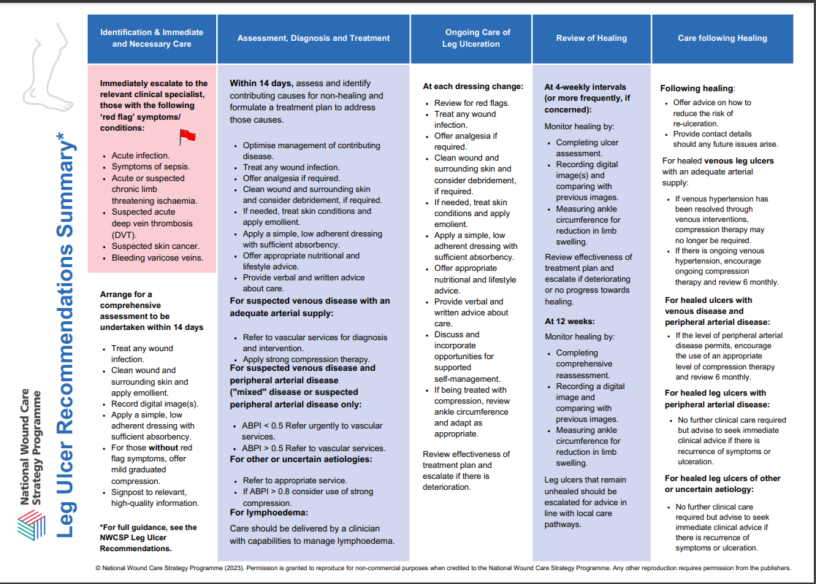

APPENDIX 2

LOWER LIMB WOUND PATHWAY

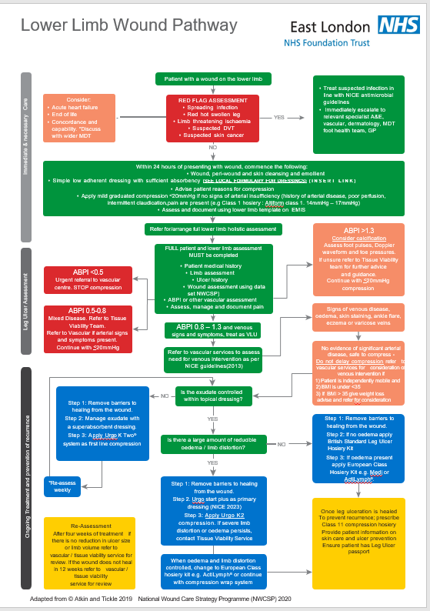

APPENDIX 3

LOWER LIMB ASSESSMENT ESSENTIAL CRITERIA

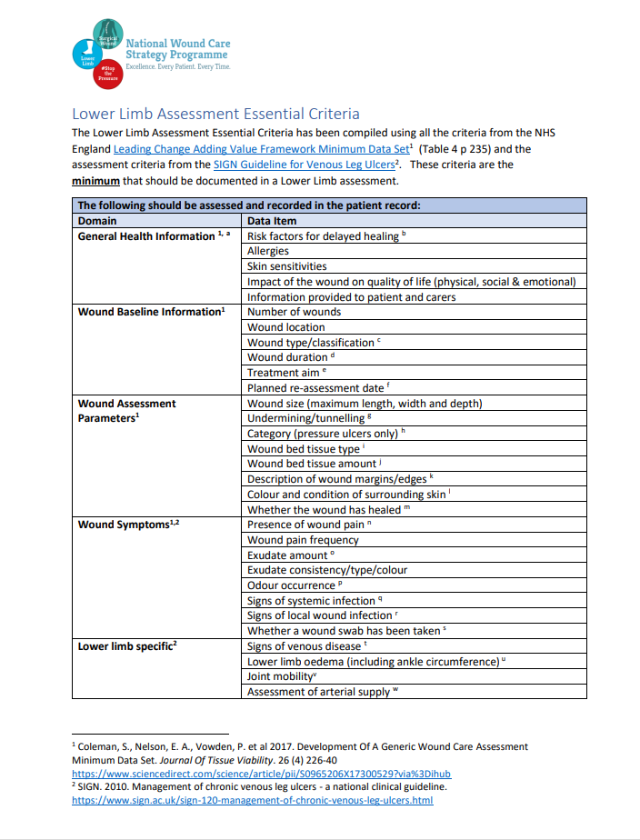

APPENDIX 4

GUIDANCE FOR COMMUNITY NURSES USING MESI Automated Devices

Guidance for Community Nurses assessing patients with a lower limb wound using MESI Automated Devices
(All staff should be aware of the limitations of using automated devices to measure ABPI and the risk of missing peripheral arterial disease www.nice.org.uk/guidance/dg52)

ABPI measurement should be carried out as part of a holistic assessment of the patient with a lower limb wound.

If PAD is recorded with MESI and signs and symptoms of PAD are present, refer to vascular services through the patients GP. Emergency referral for acute limb ischaemia and severe infection/sepsis

If PAD is recorded with MESI and there are no clinical signs and symptoms of PAD, refer to Tissue Viability Service for assessment using hand-held Doppler.

Risk factors for PAD. | Signs and symptoms suggestive of PAD
Diabetes | Calf/thigh/buttock pain
Smoking | Pain on walking & on leg elevation
Hypertension | Pain relieved by rest
Heart disease | Absence of foot pulses
Hypercholesterolaemia | Necrotic wound

Tissue Viability Service July 2023

APPENDIX 5

Patient information

EMOLLIENTS & RISK OF FIRE/BURNS
