Patient information template for meetings on Microsoft Teams

This is an example template, please customise it to reflect your service specific guidance on appointment changes/cancellation/queries as well as any eventualities of issues with a call not connecting for any reason

Prepare for your virtual appointment

- Have your device charged ready to use.

- We recommend you plan where you are going to be for the video call. Choose a room where you can have privacy. It is important that you can talk freely and are not going to be disturbed (as much as possible). It is OK if you have your baby with you, but try to have any older children cared for by someone else if this is possible.

- If you are joining from a laptop or a desktop computer, you can choose to join via the internet browser such as Microsoft Edge or Google Chrome. Microsoft Teams may not work well on some internet browsers especially when joining from mobile devices, so you may need to download the free Microsoft Teams application before your appointment.

- If you use a work account to log into Microsoft Teams on your device you may want to logout before you join your appointment call.
How to join the meeting:
- Open your email invite and click on the link provided.
The invite for an online group session will look like this:


The invitation for an online one-to-one session will look like this:
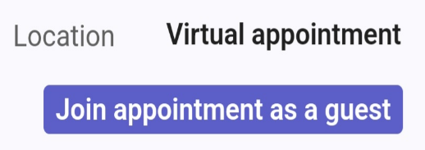

- If you are joining from a laptop for the first time you may see the following popup box asking to “Allow” Microsoft Teams to use the microphone and camera for the call - please click “Allow” to ensure the camera and mic works for your meeting.
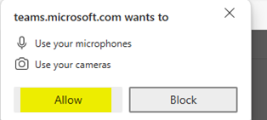

- Input your name when prompted.
- Click on “Join Now”. This will direct you to wait for the clinician/team to admit you at the start time of your appointment. You may see any of the following messages depending on your device.




- You will be admitted into the call as soon as your clinician team is ready for you.

For group sessions: We recommend you use a device other than your phone (if possible) so you can see the screen we share and the videos and other helpful resources with ease. We also encourage you to be somewhere private, quiet and comfortable to be able to fully be ‘present’ for your group therapy treatment.

