New layout and process for booking and outcoming appointments
- This guide is to show the user the new layout of the appointment booking process, as well as the process for booking client related activity when the client is not present.
No FACE TO FACE Tick Box
With the new upgrade, the face-to-face box has now gone. If you are completing Service User related activity and the Service user is not present, you will now need to book the appointment with the appointment type of “indirect patient related activity (patient not present)
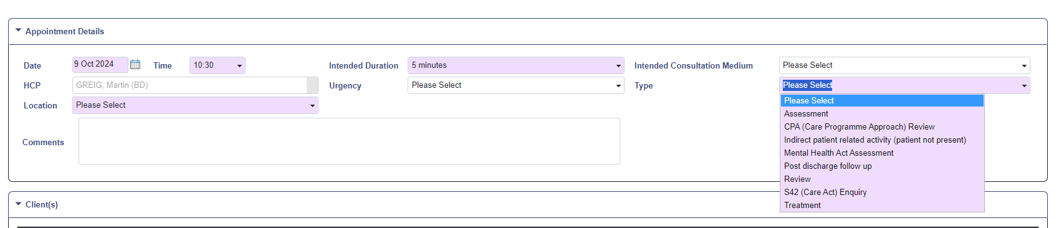
Booking an appointment
- Click on the desired appointment time as usual and find the patient you want to book into that appointment.
- On the appointment booking screen you will notice a number of differences. The repeat appointment, additional HCP and Intended activities tabs are now separate section below the referral column.
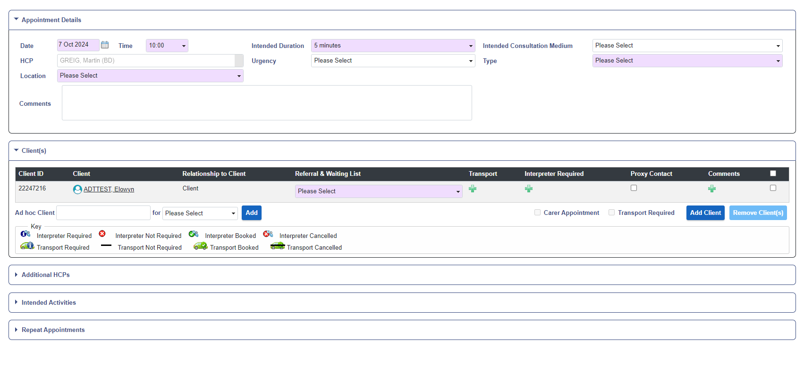
- If the service user is on a waiting list associated with the referral selected, when you select an appointment type linked to that waiting list, the waiting list will appear below the referral, and the outcome appointment, will lead to the removal of that person from the waiting list
- If the appointment is booked as a carer’s appointment, then the carers appointment box will automatically be ticked
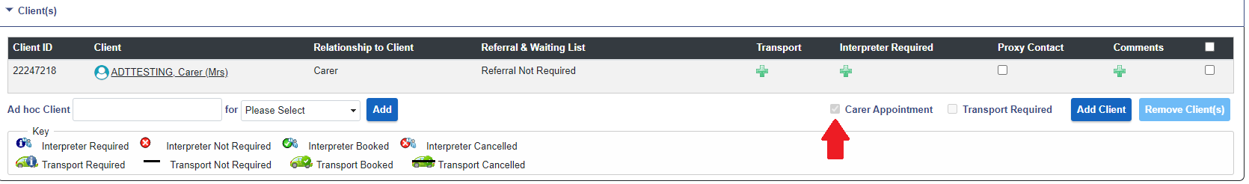
- You can also select the consultation medium if you want to see this in the appointment on the diary page
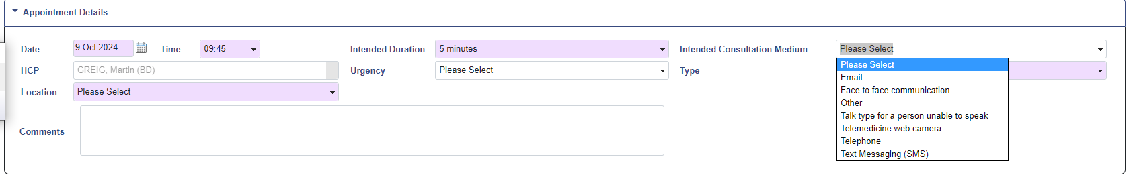
- To add an additional HCP, intended activity or repeat appointment, just click on the relevant box title to open it, and click on it again to close it. The information in these boxes works exactly as it did in previous versions of RiO.
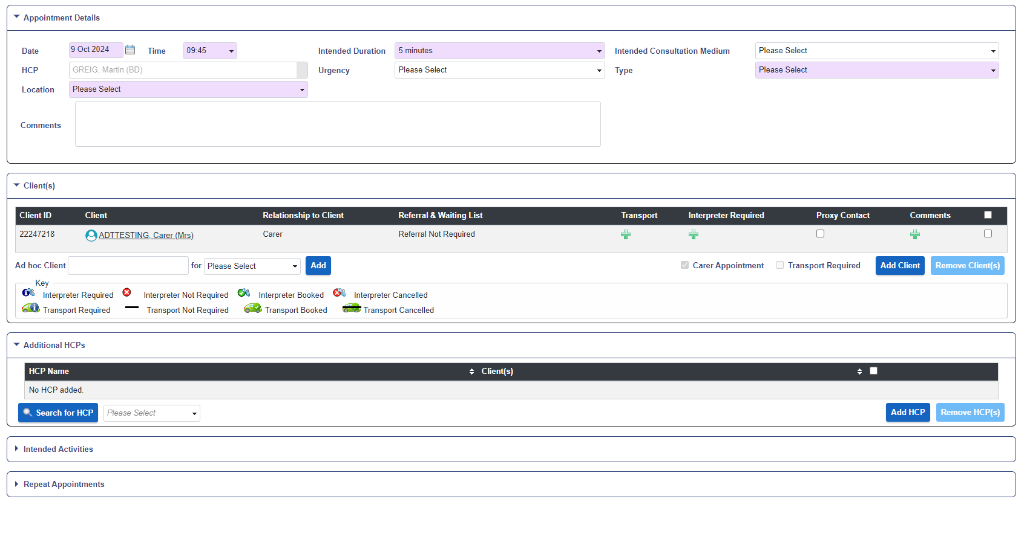
The Diary page
- If you selected the intended consultation medium, you will now see this on the Diary page within the appointment bar

Outcoming an appointment
- The appointment outcome screen follows the same format as the booking screen, with additional functions now within the boxes below the outcome information box.
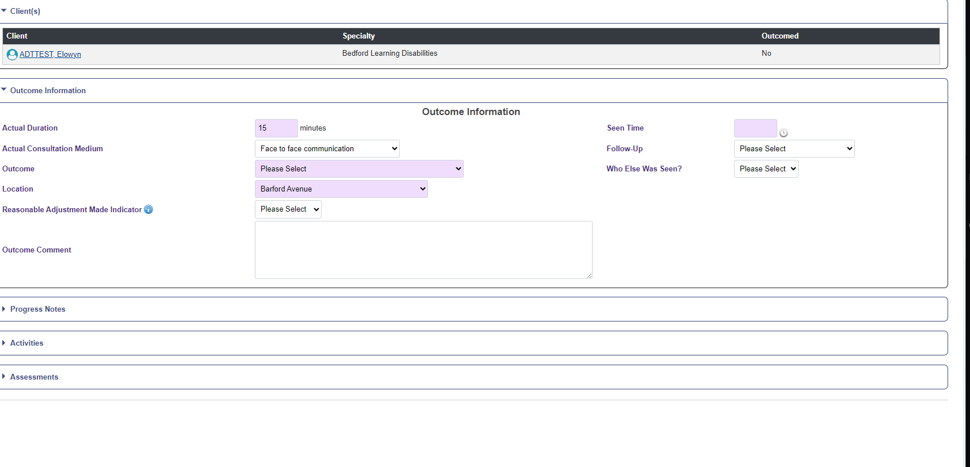

- To add a progress note at the same time as outcoming the appointment, you need to click on the progress notes heading
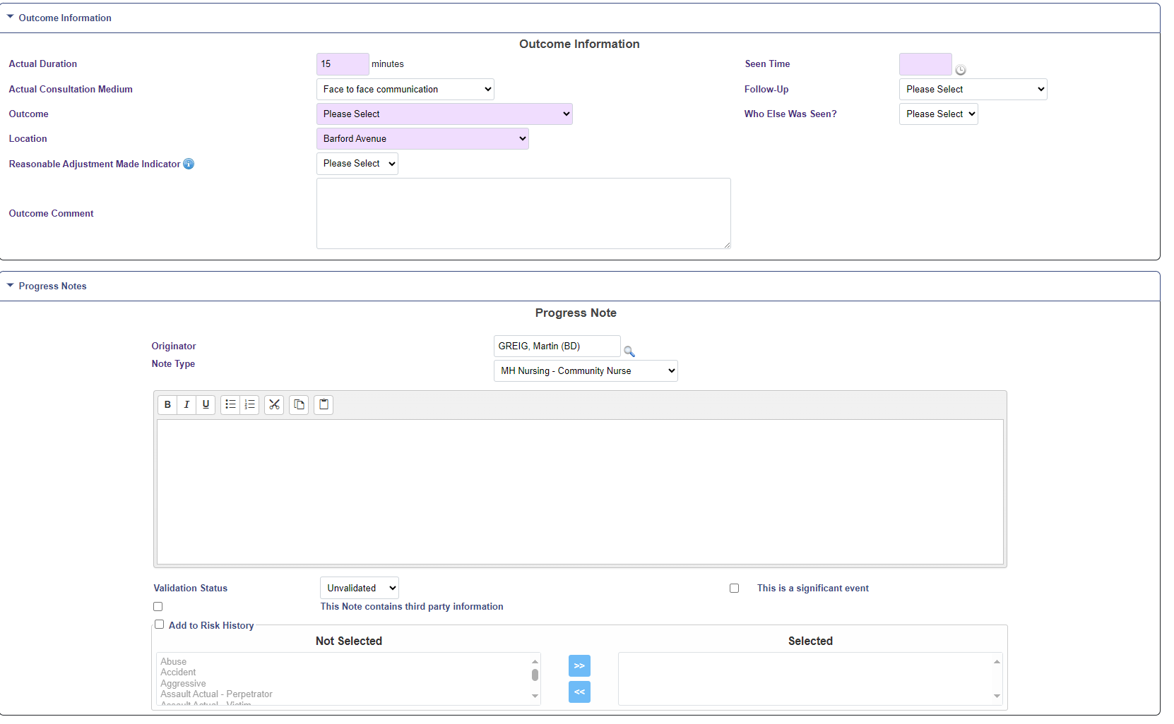
New field in the outcome screen
- There are two new field in the outcome screen. They currently do not feed into any reports but can still be used if you wish.
Follow-up
This allows you to show that a follow-up appointment maybe needed
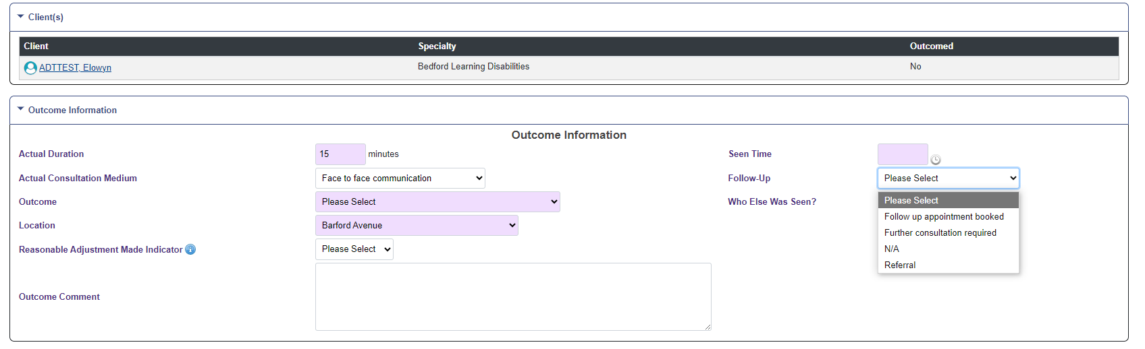

Who else was seen
This will allow you to show if the patient was accompanied by a carer or relative
