PANDO TO MS TEAMS WORKFLOW TRANSFER
Pando workflow | MS Teams workflow
Direct messaging in Pando | Chat in MS Teams  In chats section of MS Teams, you can have 1:1 or group chats with people. To start chatting  - Select New chat .  - Type the name of the person or people you want to contact.  - Select the down arrow to add a name to your chat group.  - Send a message to the selected person or chat group.  For more info, please look up the following links (press ctrl + click to follow the links)  - Page 09 of MS Teams guide from Service Now  - Start chats and calls – NHSmail support  - Video Training Guides.  - Start and pin chats - Microsoft support  - MS Teams on mobile
Message to a team on Pando for following reasons  - Check-in and check out  - Share local news  - Handover information  - Seek advice on teams/forum  - Message a team on Pando for any other reason. | Message in a chat group or MS Teams channel.  Information for managers on group chats and teams channel groups in MS Teams:  Group chats: Managers can create clearly named chat groups for example <service name>check-in/check-out in chat section of MS Teams.  - To create a new chat group:  - Select new chat icon  - Type the name of the person or people you want to contact. (As you are creating the group, you will be automatically added to the group.)  - Select the down arrow to add a name to your chat group.  - Press enter key to confirm creation of the group and start sending messages to the group.  Chat groups can be pinned at the top of the chat list for ease of access.  Video training for creating and pinning group chats can be found here: Start and pin chats - Microsoft support  Team channel group:  - Most departments/services have a teams channel group which have already been created and are in use. If you need a new one created, please request this through Service Now form (If you are not accessing this form from an ELFT site, you will need to be on VPN.)  - Once a teams channel group is created by IT service desk, owners of that group can invite their team members to join. They can also create and manage channels under main teams group. These can be pinned to ensure ease of access.  - Please see further information on setting up and using a teams channel  - Video training on how to manage team settings.  Information for all users:  - Once a chat group or channels are created for a specific use, staff can use it to post new messages and reply to any existing post.  - You can ‘@’ a user to grab their attention.  - Ensure chat group or teams channel notifications are setup optimally for your way of working (remote/lone/WFH/Office). More information on how to do this is listed in below pages.  - Ensure to pin the chat group or teams channel you use according to the priority. Information on how to pin channels is listed in below pages.
Capturing pictures to send to NHSmail account which will be later downloaded and uploaded into EPR | Capture picture in chat to self or another team member/s on MS Teams. Pictures once captured can be downloaded and uploaded into EPR.  - Open a new chat in MS Teams on your mobile.  - Search for the surname of the person who you want to send the image and select their MS Teams account. (Note: You can send the image to yourself. Just search for your own email ID/MS Teams account in the search box. For users who may have more than one teams account, ensure you search and select your MS Teams account associated with ELFT.)  - Message box appears at the bottom with camera icon . Click on the camera icon which will allow you to capture the picture.  - Click the send icon to send the picture to your MS Teams account.  - When staff are back from patient visit, they can open their trust allocated desktop PC/laptop to transfer the images to official departmental network drive. You can drag and drop the images directly into network drive location from MS Teams. Do not use download function as this will download the images on to download folder located on C: drive.  - Important! All images pertaining to patient care need to be uploaded to EPR as soon as possible to ensure the patient record is up to date. Follow the workflow you normally use to upload images and relevant clinical conversations to EPR directly from network location. Any clinical advice sought and obtained must be duly documented in EPR.  - Delete the images from network drive once the upload from EPR is successful.  PS: Please do not save/download any clinical images onto your phone gallery.

IMPORTANT: Any patient related information in MS Teams whether within chats or teams channel or direct messages should be transferred to EPR promptly (within 24 hours) and all patient identifiable information deleted after that.
Ms Teams on desktop/laptop
Pinning teams channels:
Pinning ensures that priority channels are easily accessible and remain in visibility. Right click the channel you want to prioritise and select the pin icon . This will move that channel into the pinned list on the top.
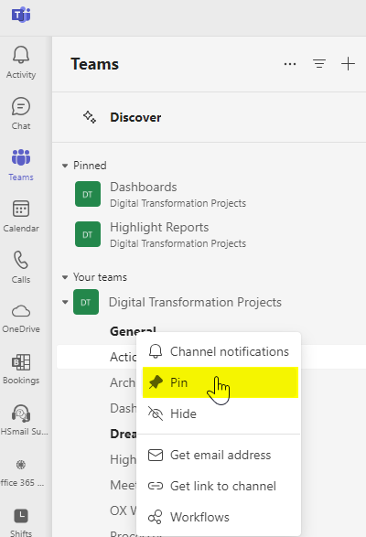
You can pin your chats and chat groups the same way.
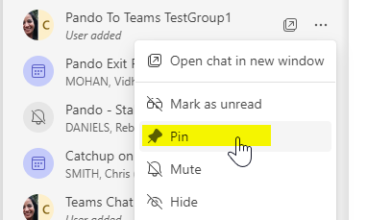

Teams channel notification settings for desktop:
By default, channel mentions are turned off and all new posts will only show in the activity space. MS Teams offers different ways to access, receive, and manage notifications. These settings include how, when, and where your notifications appear, custom settings for channels and chat, appearance and sounds, turning off specific messages, and so on.
To manage your notifications, select settings and more at the top right of Teams, then select settings > notifications and activity .
- You can change sound, display and missed email notifications. 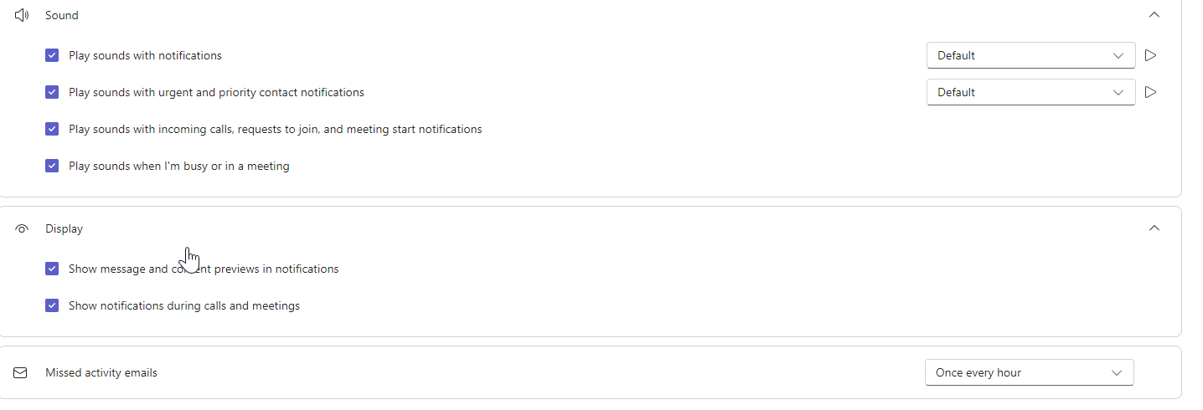
- You can change your notification preferences for chats, new posts and replies in channels, @mentions, etc. You can set the notifications to show just in the “Activity” or “Activity and Banner” (banner aka desktop bubble). You can set them to be off as well. Learn how to choose the right settings to fit your preferences and working needs.
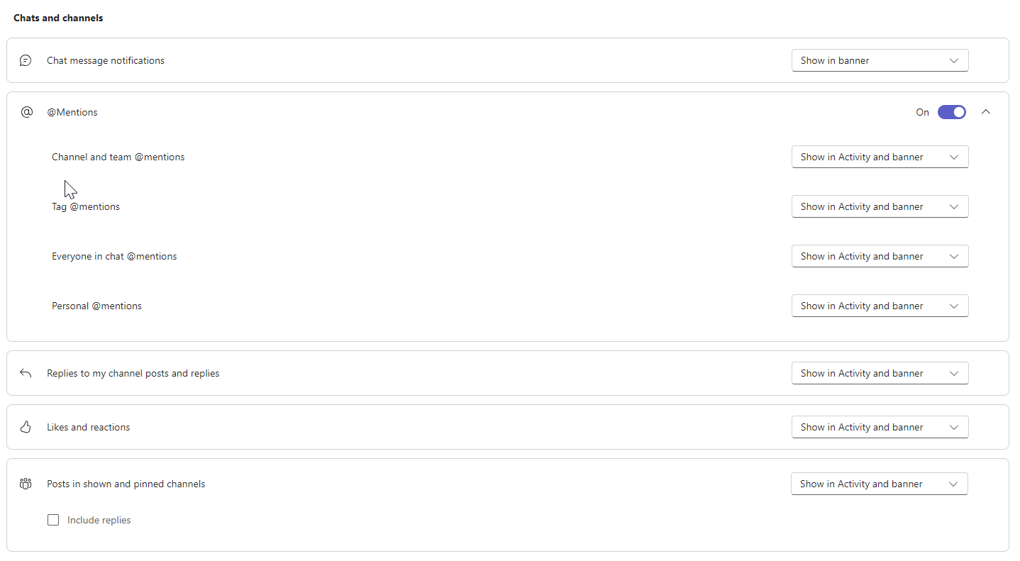
- You can set notifications per channel, too
- Right click or select more options to access channel notifications.
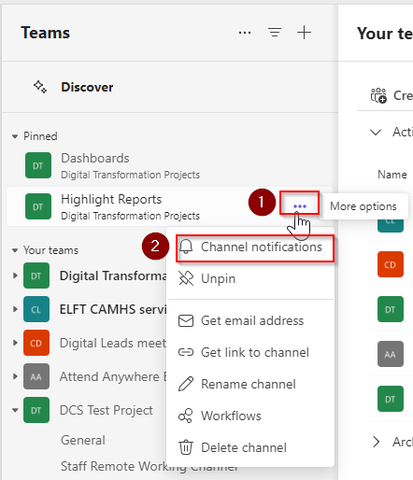
- You can choose how you can get notified for new posts, replies, or mentions.
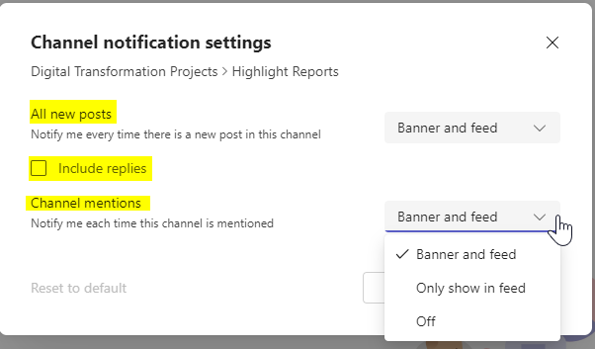
- You can set the notifications for a post on or off.
  - From a post, select more options .
  - Select “Turn on notifications” to be notified of any updates.
  - Select “Turn off notifications” to mute conversation updates alerts.
Note: You’re automatically notified about conversations you’ve already participated in.

MS Teams app on mobile devices:

💡 Instructions for installation and initial login are on Appendix 1.

Staff should log-in and log-off Teams using 2-factor authentication (through text or app) at the start and end of the shifts. This is due to the nature of clinical and patient identifiable information which may be contained in the MSTeams chats and channels.

Notifications setting for MS Teams on mobile:
To customize your notifications, tap your profile picture at the top left of the mobile app, then select notifications. You can customise:
- Chats, Calls, @mentions, channels, and meeting notifications.
- Whether to send notifications to your phone always, or only when you are not active on desktop. (You're considered inactive after 3 minutes of inactivity.)
- Can set your quiet hours. You can set a specific time of day when you want MS Teams to hold your notifications—or choose entire days. Ensure this is up to date so that you do not miss your notifications.

To troubleshoot notification issues on mobile, see troubleshoot notifications for MS Teams mobile app.

Switching notifications on/off:
To switch your notifications off,
- Tap your profile at the top left of the mobile app, then select Notifications.
- Within the “Notify me Section”, select Customised section,
- Switch notifications off using Allow Notifications toggle.
- Exit out of the application

To switch your notifications on,
- Tap your profile at the top left of the mobile app, then select Notifications.
- Select Open Settings,
- Switch notifications on using Allow Notifications toggle.
- Exit out of the application

Setting Notifications to silent:
- Tap your profile at the top left of the mobile app, then select notifications.
- Within the “Notify me Section”, select customised section,
- Application notification screen opens. Under the alerts section, you can choose the “Silent” option to make the notification silent.

Activity feed (for desktop/laptop/mobile app): Stay up-to-date with chats and channels in one place.
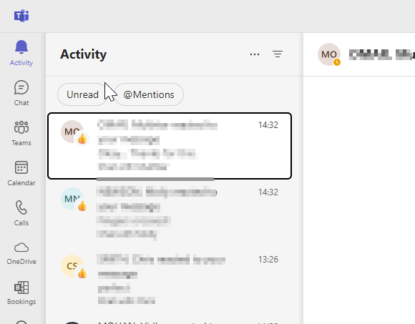
Your activity feed provides you with a range of notifications. These include a colleague mentioning you, liking something you posted or replying to a thread you started and replying in a channel that you are following.

Select filter to find certain types of messages such as unread messages, @mentions, replies, and likes.
In the top right corner, select More options > mark all as read to mark all notifications as read.
To access notifications settings, select your profile picture in the top left, and then select notifications.
When a red circle appears next to activity icon , you have a notification such as an @mention or a reply that you can see in your feed.

We attached unique symbols to different types of notifications in your feed in Appendix 2. That way, you can look through your feed and prioritize based on the symbol

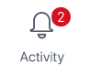

!! Remember!! When your status is set to “Do not Disturb”, your notifications will be muted. It is a good practice to keep your status up to date.

Appendix 1

Installation and initial login:
Installation: Most trust devices are pre-installed with MS Teams app and so you can directly login using your ELFT nhs.net email account. If it is not already pre-installed, you can download MS Teams by going to the respective app store (Google Play Store  or Apple Store  or Miscrosoft Store .) If you have difficulty in downloading/installing, you can open a Service Now ticket and IT helpdesk will then be able to assist you to help you get onboard.

Initial login: Once installed, use the following steps to login.
- Tap on the MS Teams icon  and follow-on screen instructions to get started and navigate to sign-in screen.
- Enter your NHSmail ID and click on next.
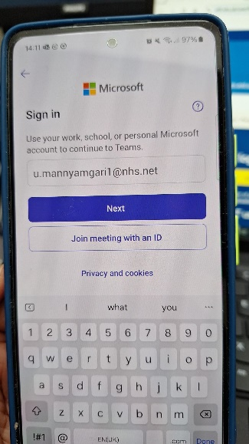

- You will be directed to NHSmail login page. Enter your password.
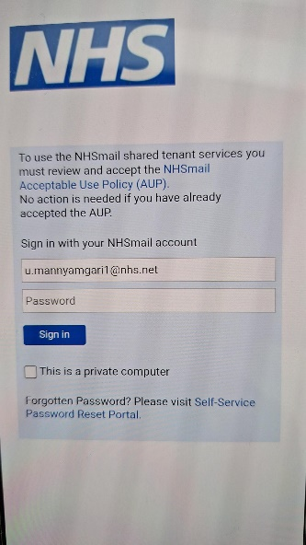
- You would be prompted to do 2-factor authentication. If your normal way to do this is through text messaging, follow through with that process and complete the authentication. However, you may have 2-factor authentication set through the app on the mobile you are trying to login into Teams. If this is the case, there would be a notification appearing when you are trying to login on the top of the mobile. Switch to the authentication app directly or via that notification and complete the authentication process. If your authentication app is setup on your personal mobile, all you need to do is go to personal mobile and complete the process.
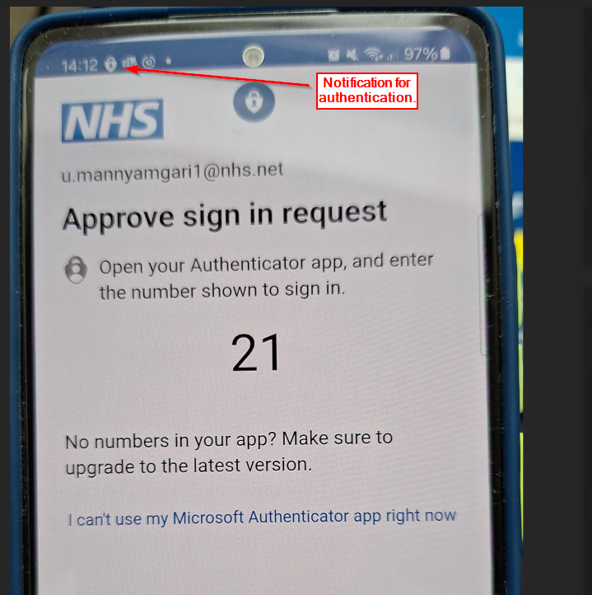
- If the authentication goes through successfully, you will be logged into Teams.

Appendix 2

Activity feed symbols

@mentions of you specifically.
@team mentions for teams you're on.
@channel mentions in teams you're on.
Replies to your posts.
Posts you liked.
You were added to a team.
You were made a team owner.
Trending posts.
Suggested posts.

