Recording and confirming a diagnosis
- Whilst the process within RiO has not changed, the screen and steps are slightly different. You will still need to have an inpatient episode to record a Consultant event and will need to have had a CPA meeting or successfully outcome an appointment to put the referral against an appointment
- Click on the Conditions (SNOWMED) Diagnosis (ICD 10) folder
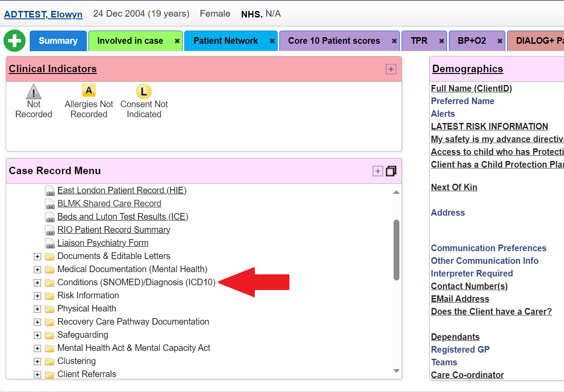

- Click on the Diagnosis (ICD 10) Link
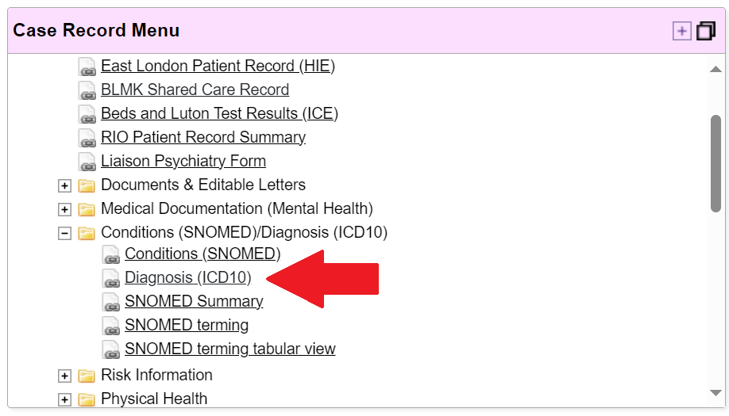
- To add a new diagnosis, click on the add Diagnosis button at the bottom of the page
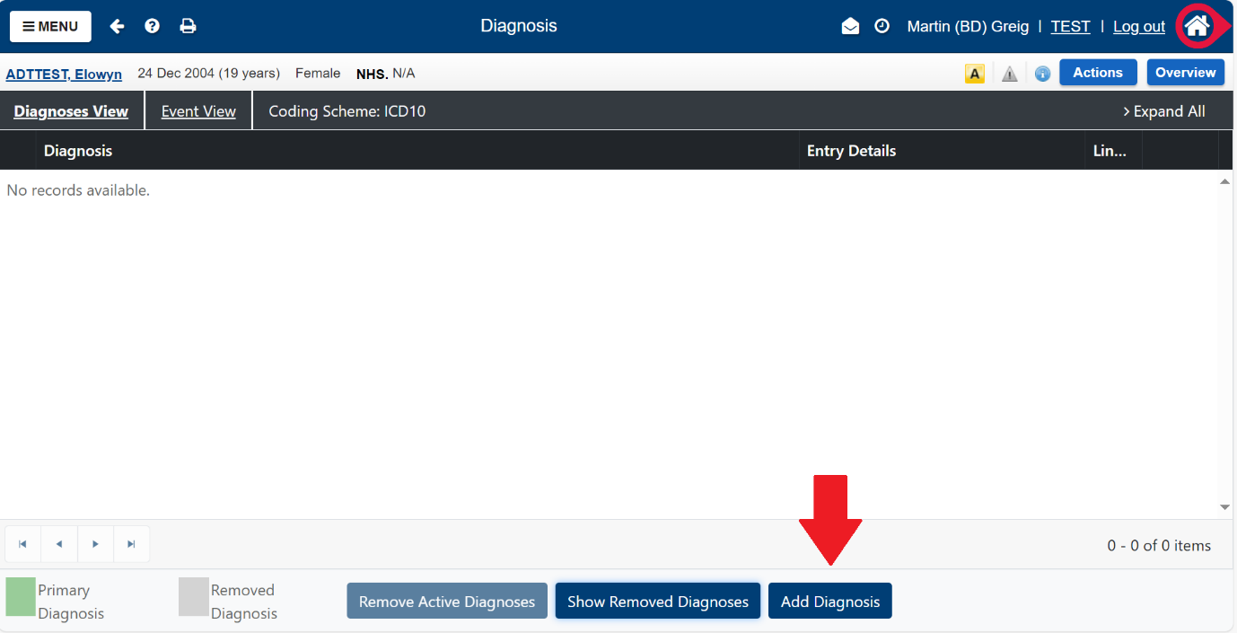

- Select the event to link the referral.
- Consultant episode covers inpatient admissions and discharges
- CPA Review will follow a CPA review
- Referral will go against a completed appointment
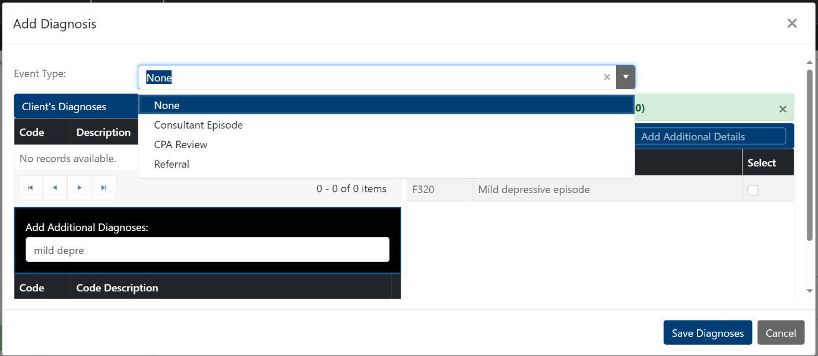
- Next select the inpatient episode or community referral.
You will only see something here is the patient has a valid referral or admission.

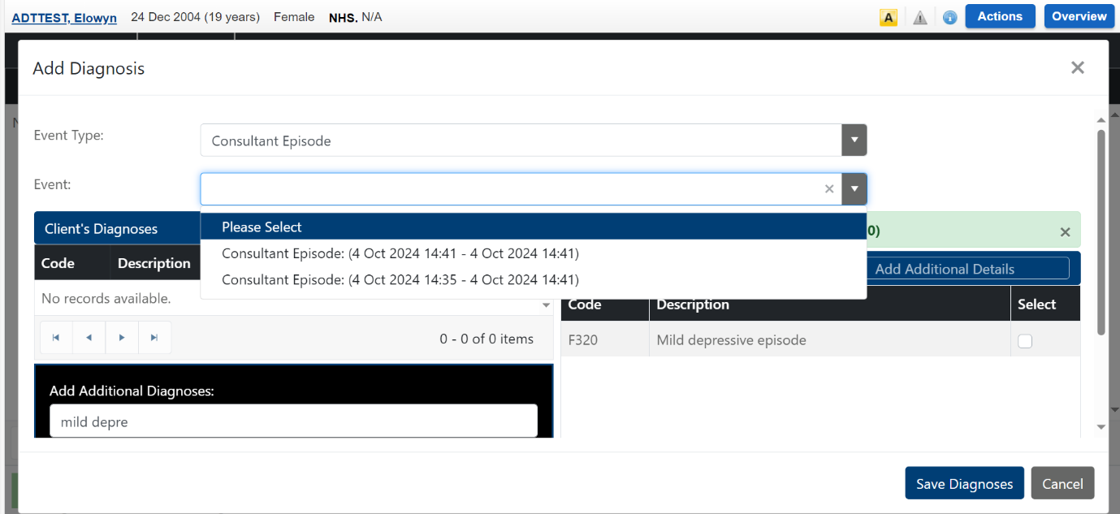

If they do not have one, you will see the following screen
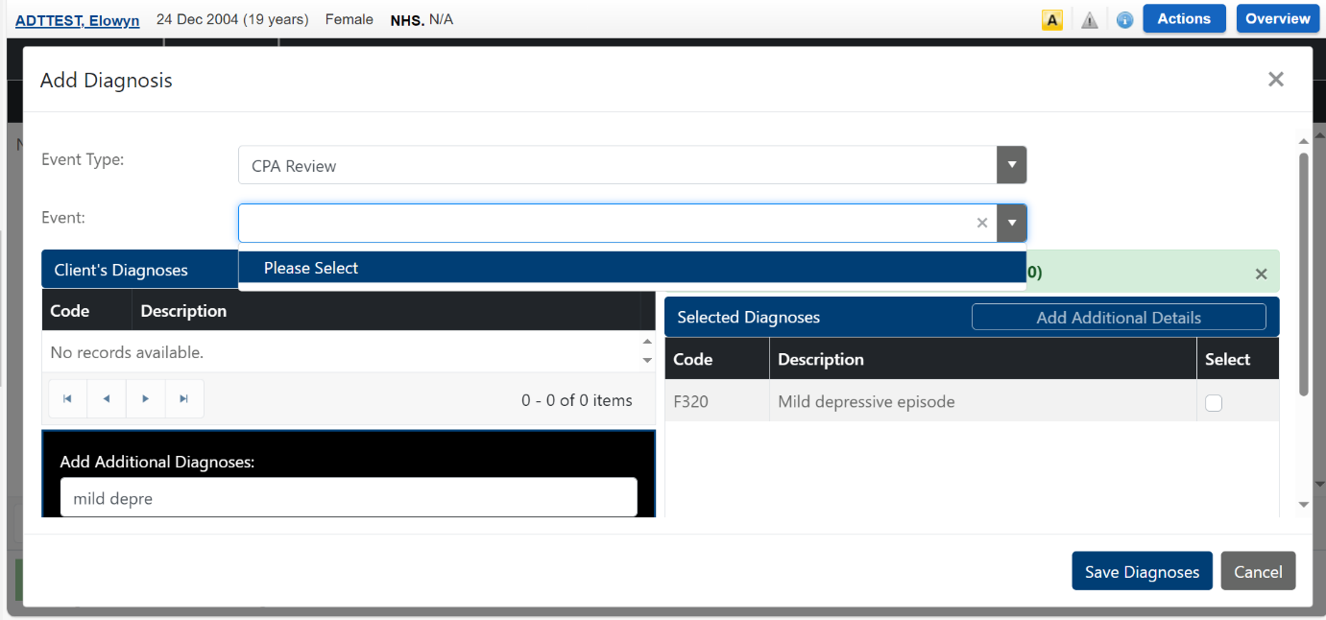
- To set the diagnosis as a primary diagnosis, you need to link it to and event instance (community appointment, CPA review or inpatient stay) and put in a conformation date, after the event.
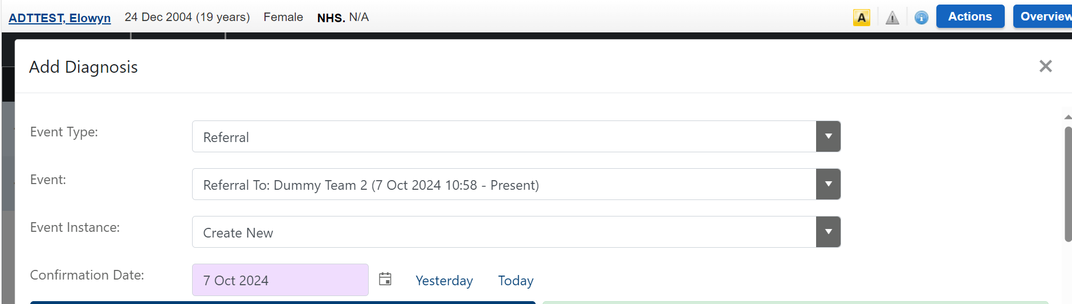
- Next search for the diagnosis in the free text box
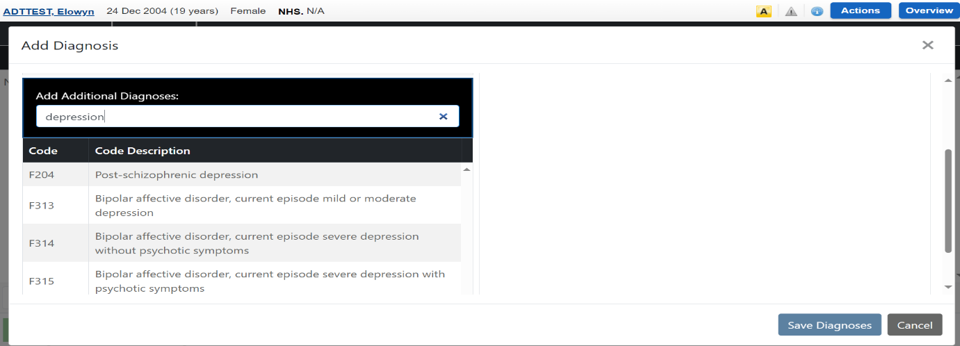
- When you see the diagnosis, you want to select, you then need to DRAG IT TO THE RIGHT-HAND SIDE OF THE SCREEN
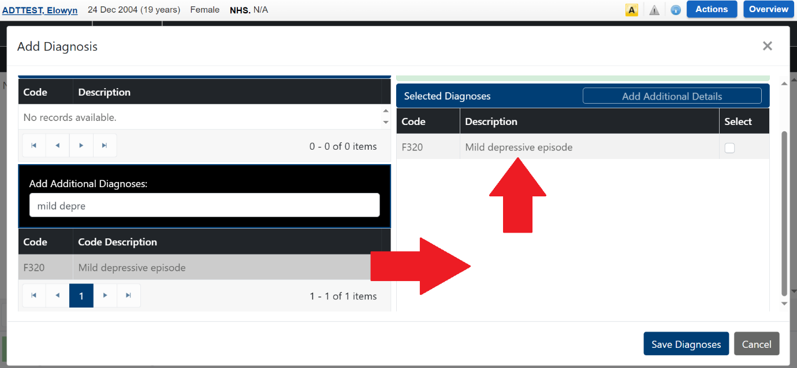.
- When you save the Diagnosis, If you have linked the diagnosis as a primary diagnosis the bar will turn green, otherwise it will remain Blue
Primary diagnosis
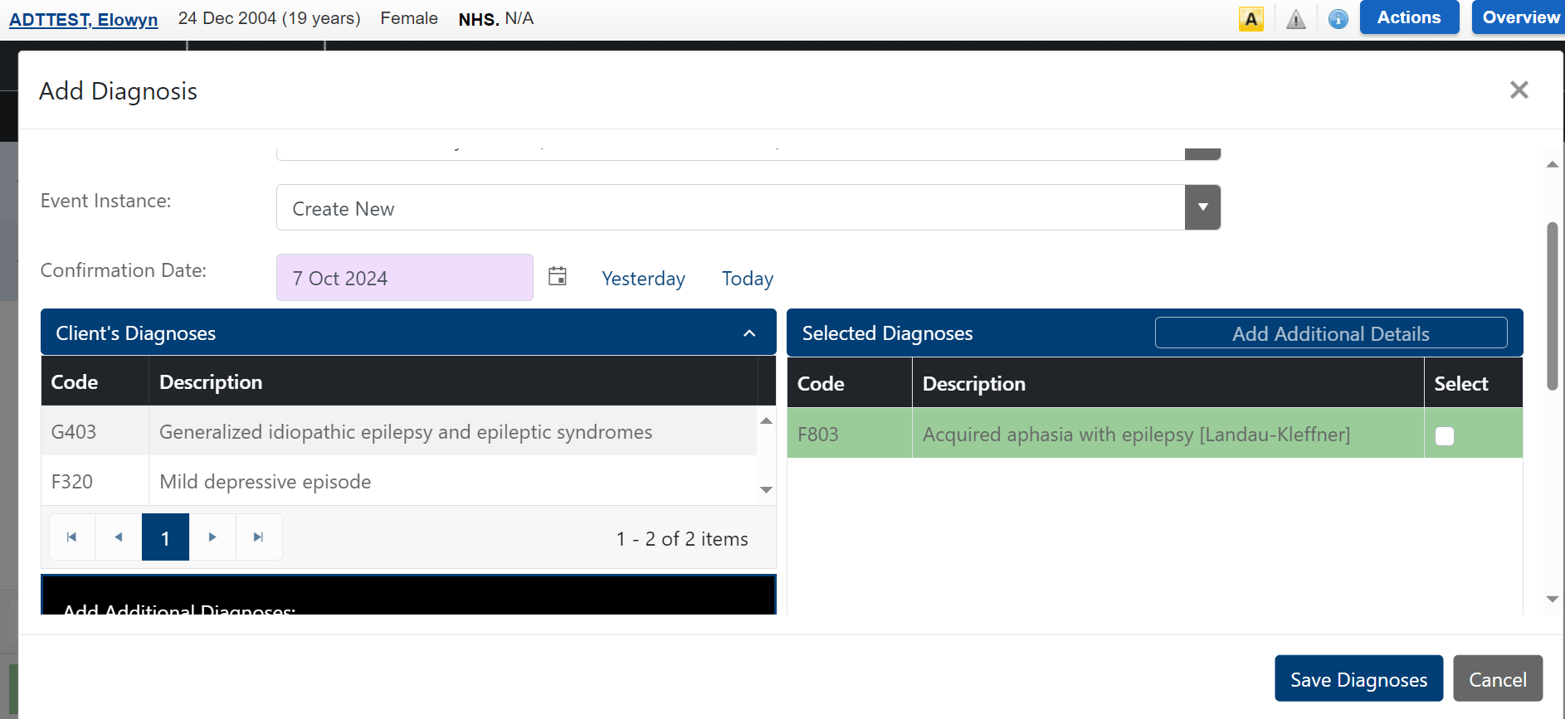
You can now close this Window

If you do not want to confirm the diagnosis against an episode of care, then follow steps 7, 8 and 9, an just click save Diagnosis
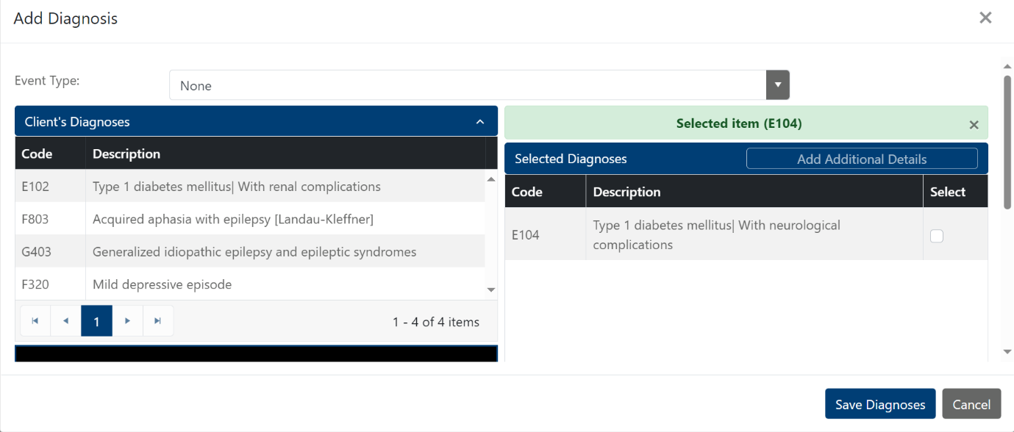

Diagnosis Page
Diagnosis that has been set as primary diagnosis will have a small + to the left of the diagnosis. If you click on that, you will be able to see the diagnosis event linked to this diagnosis. Diagnosis without a linked event will show s blue.
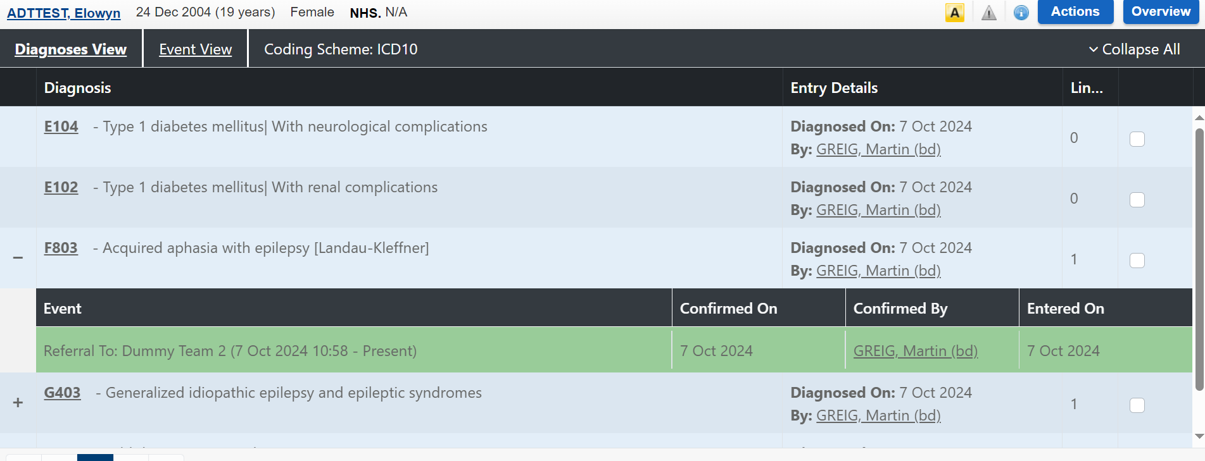

- You can link a previous diagnosis to an event by clicking on add new diagnosis, following the steps to select an event, select create new event and dragging a previous diagnosis across to the Right before clicking on Save diagnosis
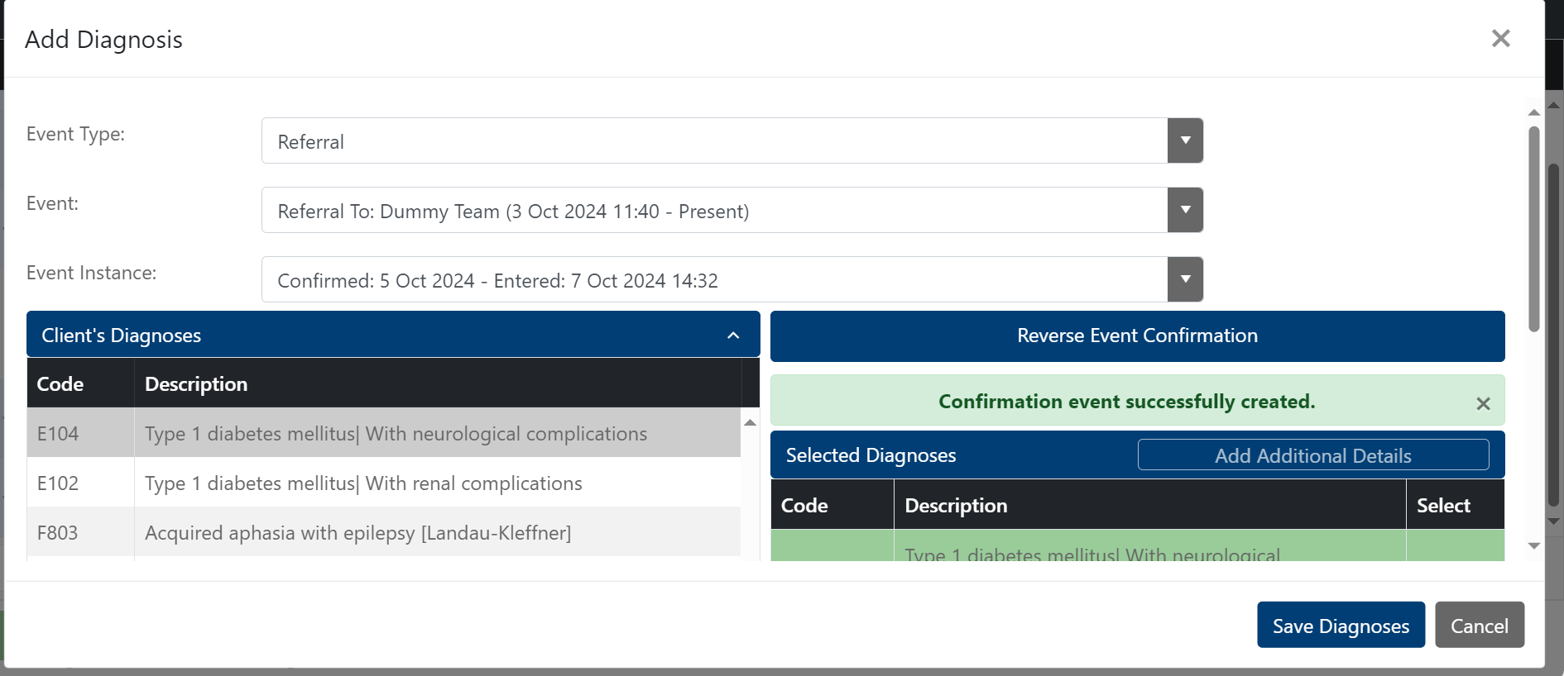
- Adding additional details, tick the box next to the diagnosis and click the additional details box above the diagnosis
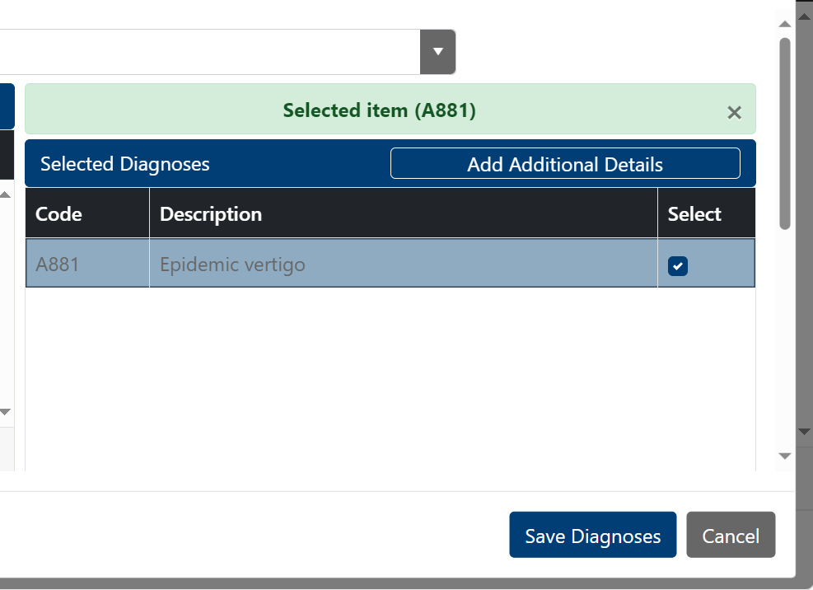
- Use the new box to complete the details of the diagnosis and click update.
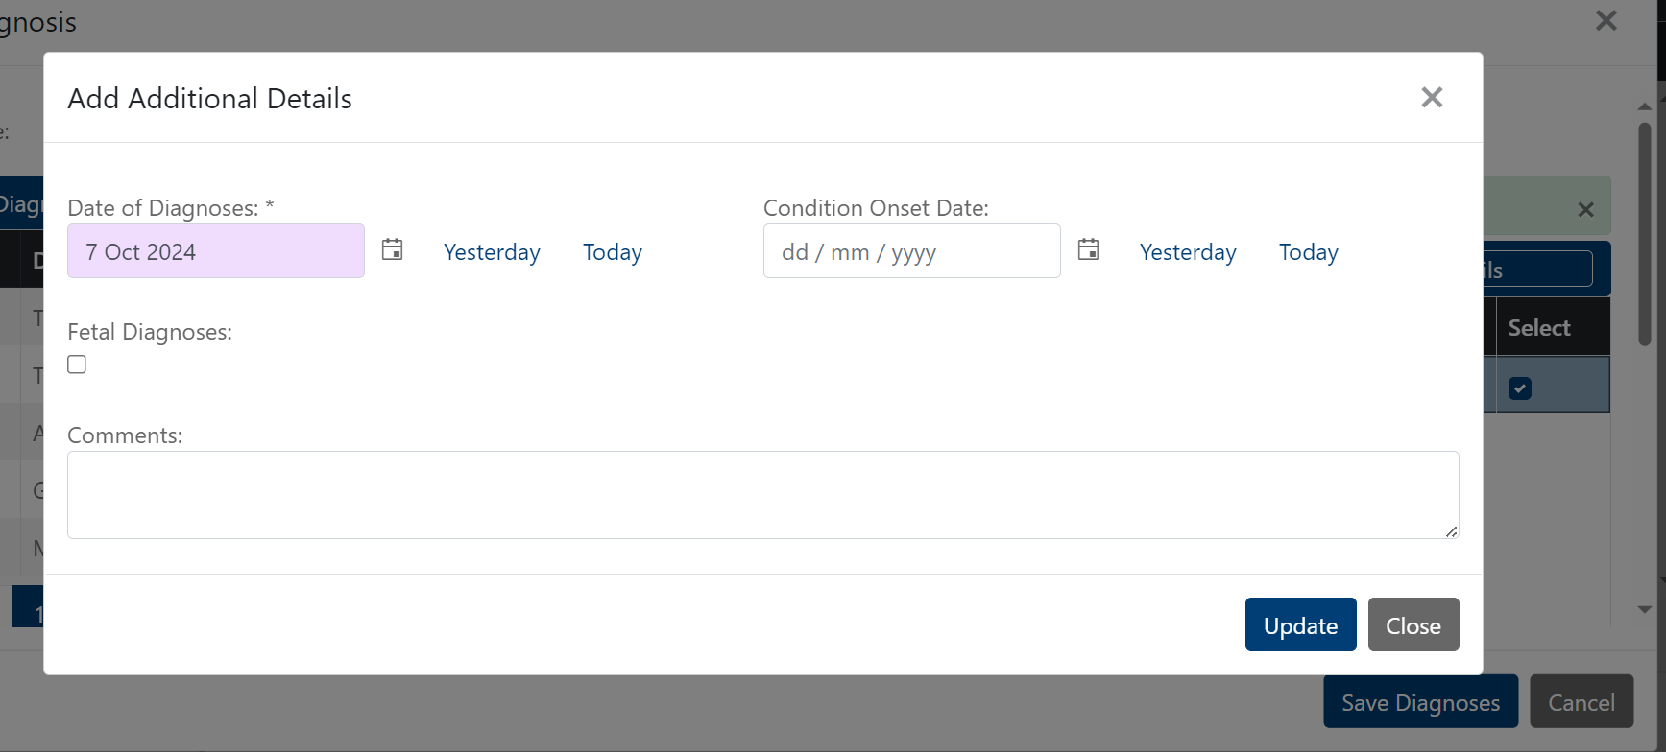

When back on the diagnosis screen you will see the additional text
