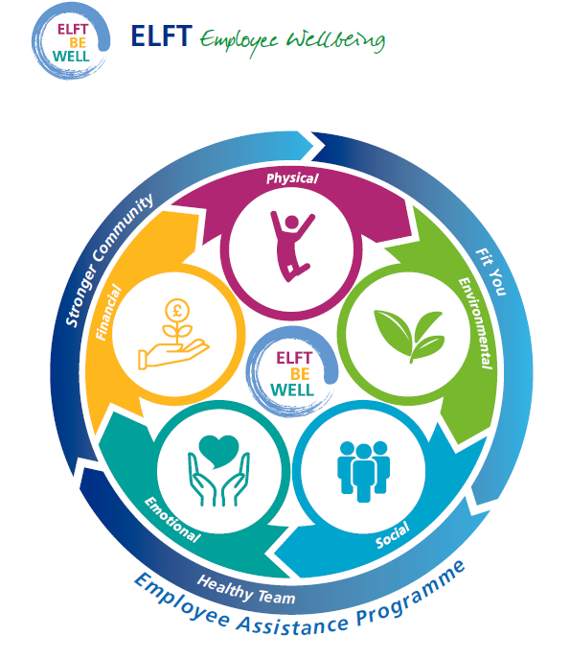
Internal and External Wellbeing Resources for Staff

ELFT’S EMPLOYEE ASSISTANCE PROGRAMME
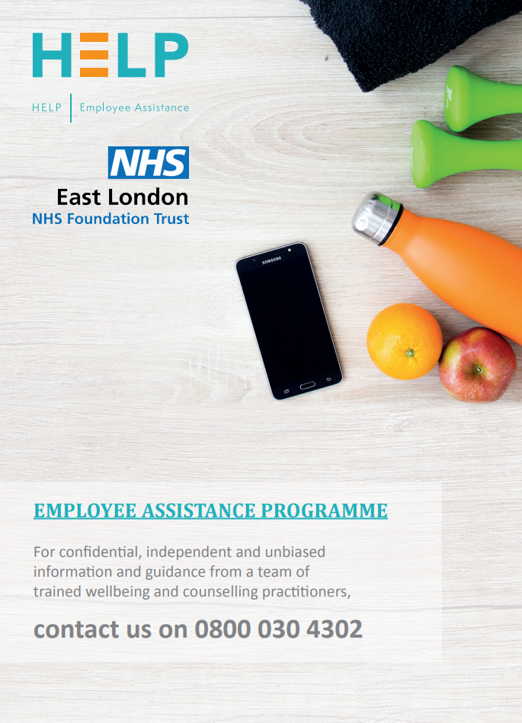

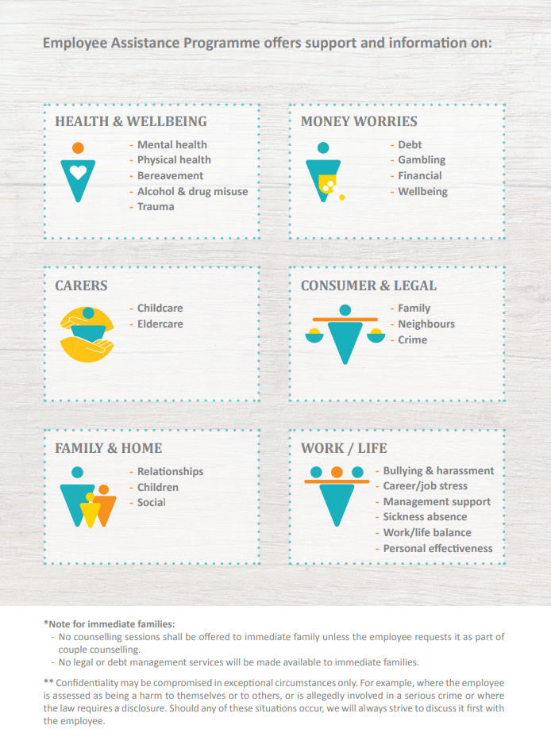

ELFT WELLBEING SUPPORT RESOURCES
There are a number of internal and external wellbeing resources available to ELFT employees. Please kindly see below for these resources, each linked to the ELFT employee wellbeing wheel’s 5 wellbeing areas:
Emotional Wellbeing
Internal Support | ELFT’s Emotional Support Call-Back Service - can be accessed by emailing elft.communications@nhs.net
Internal Support | Occupational Health (Optima Health) - can be contacted on 01327 810777 or by emailing: team4@optimahealth.co.uk
Internal Support | IAPT/Talking Therapies Services - staff who refer themselves to IAPT services run by ELFT will be given priority - so make it known that you are a member of staff, available in Bedford, Newham and Tower Hamlets
Internal Support | Bullying & Harassment Advisors - have you ever felt the need to talk to someone about how a colleague or manager is treating you? Do you feel you are undermined at work? Do you dread going to work because of how someone treats you? Do you find yourself trying to cope with unwanted behaviour? For further information please click on link:  https://www.elft.nhs.uk/intranet/all-about-me/bullying-and-harassment-support-advisers
Internal Support | Freedom to Speak Up - the freedom to speak up team is here to listen. Speaking up about any concern you have at work is really important, in fact, it’s vital because it will help us to keep improving our services for all patients as well as the working environment for our staff. For further information please click on link:  https://www.elft.nhs.uk/intranet/all-about-me/freedom-speak
Internal Support | Coaching - Please see link to access a coach or mentor in ELFT  https://elft.onpld.com/
Internal Support | ELFT Mediation Service - creates an opportunity for all staff to resolve conflict at work in a confidential way. Please contact your People & Culture Advisor for more information.
External Support | Silver Cloud is free to access for all ELFT staff. Silver Cloud provides access to a CBT (Cognitive Behavioural Therapy) online platform by using the access code: kwnelselfhelp https://kwnel.silvercloudhealth.com/signup/
External Support | Suicide Support - National Suicide Prevention Helpline UK offers a supportive listening service to anyone with thoughts of suicide. You can call the National Suicide Prevention Helpline UK on 0800 689 5652 (open 24/7)
External Support | Staff Support Line - NHSEI has a confidential staff support line, operated by the Samaritans and free to access from 7:00am – 11:00pm, seven days a week.  This support line is here for when staff have had a tough day, are feeling worried or overwhelmed. Whatever your worries, trained advisers can help with signposting and confidential listening.  Call: 0800 069 6222  Alternatively, you can text FRONTLINE to 85258 for support24/7 via text
External Support | Bereavement Support Line - NHSEI has a confidential bereavement support line, operated by Hospice UK and free to access 8.00am and 8.00pm, seven days a week.  A team of fully qualified and trained bereavement specialists are available to support with bereavement and wellbeing issues relating to loss experienced through work. Call: 0300 303 4434
External Support | Bright Sky App - Providing support and information for anyone who may be in an abusive relationship or those concerned about someone they know.  The app is also available to use in Polish, Punjabi and Urdu.  For more information, please see details and advice about using the app in your app store:  Bright Sky in Apple Store  Bright Sky in Google Play
External Support | Ocean - which stands for Offering Compassionate and Emotional Support for those living through birth trauma and loss. For more information please click link: https://www.elft.nhs.uk/intranet/news/ocean-service-launch-event-report
External Support | Domestic Abuse Support - please contact a helpline such as Refuge: 0808 2000 247 or visit https://www.refuge.org.uk/
External Support | Headspace - provides mindfulness and mediation tools. Free for NHS staff.  https://help.headspace.com/hc/en-us/articles/360044971154-Headspace-for-the-NHS
External Support | Sleepio - is a personalised sleep improvement programme. Free for NHS staff https://www.nhs.uk/apps-library/sleepio/
External Support | NHS Check my Wellbeing Tool - A self-assessment for Health and Social care staff with a direct link to mental health support resources https://checkwellbeing.leadershipacademy.nhs.uk/
External Support | Every Mind Matters - are podcasts and resources that support the wellbeing of NHS staff https://www.nhs.uk/every-mind-matters/
External Support | Samaritans - Samaritans works to make sure there’s always someone there for anyone who needs someone. If you would like to contact a Samaritan, please call 116 123 for free 24/7 emotional support, there is also a free web chat service which can be accessed on www.samaritans.org
External Support | Good Thinking - provides free wellbeing support to NHS staff https://www.good-thinking.uk/
External Support | Butterfly Hug is an online resource for traumatic stress relief using the 'butterfly hug' technique.: https://www.counselingconnectionsnm.com/blog/try-the-butterfly-hug-to-help-with-ptsd-symptoms
External Support | Thrive LDN - have toolkits on how to support your emotional wellbeing. For more information click link: https://thriveldn.co.uk/
External Support | Unimind - is a mental health platform that empowers staff to proactively improve their mental wellbeing, please follow the link below for access  https://www.england.nhs.uk/supporting-our-nhs-people/support-now/wellbeing-apps/unmind/
External Support | Lateef Project - Inspirited Minds and the Lateef Project have partnered with the NHS Muslim Network and NHS England and NHS Improvement’s Health and Wellbeing Team to provide a free confidential and Islamic-based counselling service for our NHS people, delivered by qualified counselling therapists.  https://www.lateefproject.org/get-support
External Support | Worklife Central – The app offers a curated collection of positive and practical support, delivered through expert-led webinars, seminars, support groups, peer insights, online articles, blogs and podcasts. Their aim is to help improve wellbeing and support a healthy work / life balance. Available free to NHS Staff:  https://www.england.nhs.uk/supporting-our-nhs-people/support-now/wellbeing-apps/worklife-central/
External Support | Supporting our NHS People – for further support offered to all NHS employees, on a wide range of topics, kindly follow the links below:  https://www.england.nhs.uk/supporting-our-nhs-people/  https://www.england.nhs.uk/supporting-our-nhs-people/support-now/
Financial Wellbeing
Internal  Support | ELFT Hardship Fund - provides financial support to help when it is most needed. Details can be found on the Trust intranet: https://www.elft.nhs.uk/intranet/financial-support-and-advice
Internal  Support | Salad Money Mind - if you’re struggling with managing your finances and you need some support, Salad Money Mind is the place to go. Please click link for further information:  https://www.elft.nhs.uk/intranet/financial-support-and-advice
Internal  Support | Home Technology Benefits Scheme - The Trust has introduced a scheme to enable you to spread the cost of home and electronic purchases by deducting monthly amounts from your salary, details can be found on the Trust intranet:  https://www.elft.nhs.uk/intranet/all-about-me/staff-wellbeing-benefits-discounts/salary-sacrifice-deductions
Internal  Support | Discounts with Vivup – The Trust salary sacrifice partner, Vivup, offers staff exclusive discounts on retail, leisure and other services, staff can sign up to access discounts and offers for free https://www.vivup.co.uk/users/sign_in
Internal  Support | Holiday Play Schemes - The Trust offers a 40% subsidy towards the cost of Holiday Play Schemes during school holidays, please see application form below:  https://www.elft.nhs.uk/system/files/2024-09/Holiday%20Playscheme%20Subsidy%20Claim%20Form%20%28v2%29.docx
Internal  Support | The London Capital Credit Union - is a long established savings and loans co-operative that encourages people to save rather than borrow. Thousands of employees across London and surrounding region already take advantage of a payroll savings scheme which allows you to have your savings, or loan repayments, deducted directly from your salary. Further information can be found on the Trust intranet on savings, loans and more, see:  https://credit-union.coop/
Internal  Support | ELFT has joined the ‘Working with’ Cavell Nurses’ Trust membership programme. The Cavell Nurses’ Trust supports UK nurses, midwives and healthcare assistants both working and retired when they’re suffering personal or financial hardship, often due to illness, disability, older age and domestic abuse. Further information can be found on the below link. https://cavellnursestrust.org/#:~:text=We%20help%20nurses%2C%20midwives%20and,impact%20of%20rising%20living%20costs.
Internal  Support | Car Lease Scheme - is a salary sacrifice scheme where staff can purchase a car and pay for it over several months for more information please click intranet link: https://www.elft.nhs.uk/intranet/all-about-me/staff-wellbeing-benefits-discounts/salary-sacrifice-deductions
Internal  Support | Cycle to Work Scheme - allows you to purchase a bike through salary deduction making savings on Tax & NI contributions, for further details please visit www.vivup.co.uk
External support | Barracudas - offer NHS staff £10 off their weekly rate and half price extended hours at their activity camps, book here: https://www.barracudas.co.uk/. Please email elft.employee.engage@nhs.net for the latest discount code.
External support | NHS Telephone Support Line - can be contacted to receive impartial money guidance and it’s free. Call 0800 448 0826.
External support | Budget Planner Tool - puts you in control of your household spending. For more information click link: https://www.moneyhelper.org.uk/en/everyday-money/budgeting/budget-planner
External support | Blue Light Card - is a benefits and discount site which costs £4.99 to register. It offers discounts to a multitude of stores that you wouldn’t want to miss out on. For more information click link: https://www.elft.nhs.uk/intranet/all-about-me/staff-wellbeing-benefits-discounts/discounts-offers
External support | Health Service Discounts - is a free discount site available to all NHS staff. So before purchasing next to anything, first have a look through this website to see if you qualify for a discount. There are hundreds of well-known brands offering discounts to NHS employees that you wouldn’t want to miss. For more information click link: https://healthservicediscounts.com/
External support | Dunham McCarthy - offer NHS staff free will writing webinars as well as free specialist mortgage advice service. Please email elft.employee.engage@nhs.net for upcoming Will Writing Webinar dates.
External support | London Koru Kids - provides help to find part time and after school nannies. www.korukids.co.uk
External support | SearchChildcare - offers information, advice and support on registered childminders https://searchchildcare.org.uk
External support | Busy Bees Childcare - offers care for children age 4 and over with free registration for NHS staff https://www.busybeeschildcare.co.uk/  (This offer depends on each nursery and whether they accept the NHS Blue Light Card. Please inquire at your choice of nursery).
External support | The Debt Respite Scheme (Breathing Space) - will give someone in problem debt the right to legal protections from their creditors. https://www.gov.uk/government/publications/debt-respite-scheme-breathing-space-guidance/debt-respite-scheme-breathing-space-guidance-for-creditors
Physical Wellbeing
Flu Vaccines - if you’re looking to get a flu jab please contact the mailbox below. The flu campaign usually takes place between September/October until March each year
elft.fluleadquries2023-24@nhs.net
 | Cycle to Work Scheme - allows you to purchase a bike through salary deduction making savings on Tax & NI contributions, for further details please visit www.vivup.co.uk
 | Eye Care vouchers – for access to free eye care vouchers, further information can be found on the Trust intranet : https://www.elft.nhs.uk/intranet/eye-tests
Menopause - for further information on how ELFT approaches the Menopause, please see the below guidance:
https://i.emlfiles4.com/cmpdoc/4/5/4/5/8/files/874046_elft_menopause-at-work-guidance.pdf

Are you getting serious about giving up smoking? You may notice the Trust’s new no smoking posters are in position. These are being complemented by leaflets which are available in all areas, if you would like to quit then please contact
elft.stopsmoking@nhs.net for further information.
 | MOT Health Checks – these checks take place throughout the year in each directorate, so please do look out for the adverts in the ELFT bulletins.
 | Yoga & Pilates classes – Yoga & Pilates classes are available to staff throughout the year and details of when sessions will take place will be corresponded in ELFT Bulletins as well as on the Wellbeing intranet page: https://www.elft.nhs.uk/intranet/all-about-me/staff-wellbeing-benefits-discounts/fitness

External  Support | Gym Memberships – All NHS staff are entitled to an NHS corporate discount when you show your NHS ID badge to any local leisure centre/gym that offers this discount.
External  Support | Yoga classes - Dawn Boulanoff facilitates free yoga classes for NHS staff. To find out more info please contact Dawn on dawnyoga4you@hotmail.co.uk
External  Support | Santander & Lime access - Santander offers a 50% discount on their annual membership fees to NHS staff if this of interest- just use your NHS email to contact enquiries@santandercycles.tfl.gov.uk  Lime Access – 50% off of eScooter and eBike rentals with Lime Access https://web.fountain.com/limebike/apply/united-kingdom-uk-lime-access
External  Support | Cooper Box Arena & London Aquatics Centre - offer all staff 20% off on membership fees.
Social Wellbeing
Internal Support | If you are interested in finding out further information regarding the ELFT networks, please make contact with the relevant leads, details for each network can be found using the below link:  https://www.elft.nhs.uk/intranet/search?intranet_search_api_fulltext=networks
Internal Support | ELFT in1Voice – The Trust choir reconvenes for major projects and events across the Trust. If you are interested in joining, contact choir lead on fionakelly2@nhs.net
Internal Support | Annual Staff Awards – Would you like to see what the staff awards event looks like? We encourage you to nominate an individual or team for an award and book tickets for this year’s event, taking place in October, link below:  https://www.elft.nhs.uk/intranet/all-about-me/staff-wellbeing-benefits-discounts/employee-awards
External Support | There are many methods to stay connected with others such as Zoom, which is a free and easy to use video chat https://zoom.us/download
External Support | Spotify - can help you to create collaborative playlists with friends and listen to podcasts. Download the app https://www.spotify.com/
Environment Wellbeing
Internal Support | War on Waste – makes a huge difference to the Trust’s climate change/green plan. https://www.elft.nhs.uk/intranet/news/waste-reduction-campaign-2022
Internal Support | Display Screen Equipment Risk Assessments – if you feel as though you may need an assessment of your working environment, further information can be found on the Trust intranet: https://www.elft.nhs.uk/intranet/risk-management
Internal Support | The Green Travel Plan initiative - As part of the Trust’s ambition to operate more sustainably with the Green ELFT Campaign, a Green Travel Plan has been created. This will play a large part in helping the Trust achieve its carbon commitments of 80% co2 reduction by 2050 https://www.elft.nhs.uk/intranet/news/elft-new-green-plan-2022-2025

