

Media and Social Media Policy

Version number: | 1.0
Consultation Groups | Service Delivery Board/ JSC
Approved by (Sponsor Group) | Service Delivery Board
Date Approved | January 2024
Ratified by: | Joint Staff Committee
Date ratified: | July 2024
Name of originator/author: | Head of Communications
Executive Director lead:
Implementation Date: | July 2024
Next Review date: | March 2026

Services | Applicable
Trust wide | X
Mental Health and LD
Community Health Services

Version Control Summary
Version No. | Date | Author | Reason
1.0 | 05.03.2024 | Janet Flaherty | Merging of previous Media policy and Social Media policy  communications with stakeholders

Content
1 | Executive summary  Introduction | 5
2 | Duties | 5
3 | Process | 5
4 | Training | 6
5 | Other relevant polices | 7
6 | Social media | 7
7 | Stakeholders | 7
8 | Staff Use
9 | Managing Mistakes and Negative Comments
10 | Non-Compliance
11 | Using social media as a Paid Marketing Tool
12 | Accountability and Responsibility
13 | Monitoring and Review
14 | Useful Information
Appendices
Appendix A | Dealing with the Media – procedural notes for staff
Appendix B | Caldicott Principles
Appendix C | ELFT website editorial guidelines
Appendix D | Web writing guidance
Appendix E | Guidance for teams/services requesting social media presence
Appendix F | NHSE London: Supporting and Respecting Each Other at Work
Appendix G | Social Media Playbook
Appendix H | ELFT Media Consent

Executive Summary
Media Management
This policy sets out the roles, responsibilities and procedure for managing print and broadcast media enquiries across the Trust and to ensure a consistent approach to the use of social media is across the Trust.
The Communications team is responsible for dealing with any media enquiries that relate to the Trust, co-ordinating, drafting and managing responses on behalf of the Trust. This policy aims to ensure that the Trust is proactive in managing its reputation, that it has a consistent approach to its relationship with the media and that it has an overview of how the Trust is perceived.
Social Media
This policy also provides guidelines to staff about use of social media within the Trust as a communications tool for the organisation, and by staff members in their professional capacity. This policy has been developed based on best practice from NHS Employers, the Nursing and Midwifery Council, the Royal College of Physicians and Royal College of Psychiatrists. This is a rapidly changing area and this policy will be updated as social media channels evolve and or new developments or insight is acquired which impact on ELFT.

1.0 Introduction – Managing Media
1.1 The media (newspapers, television, radio and web-based news sites) are important tools of communication for the NHS. They have the potential to reach staff, service users, carers and the public more quickly, and in greater numbers than any communication organised by the Trust itself. Positive media coverage can help the Trust attract staff, maintain the confidence of service users and carers and help to break down stigma and misconceptions about mental health. Negative media coverage can have a severe effect on the confidence of the public, patients and service users in the treatment and care we provide, affect staff morale, and create or reinforce negative perceptions of the Trust.
1.2 Although the media are largely independent and have their own pressures, priorities and agendas, the aim should be to ensure that they have a steady stream of positive news stories and that negative news stories are countered with timely and accurate information, which looks at issues from the Trust’s point of view.
1.3 This policy aims to ensure that the Trust is proactive in managing its reputation, that it has a consistent approach to its relationship with the media and that it has an overview of how the Trust is perceived. Media coverage is monitored and reported in a monthly dashboard report to the Chief People Officer, and to the wider Board as appropriate. Copies of media reports are available for inspection as required. These are held on file for three years.
2.0 Duties
2.1 The Communications team is responsible for dealing with the media and all incoming media enquiries should be routed directly to the Communications team (020 7655 4038/4066) or by email: elft.communications@nhs.net
2.2 Out of hours press enquiries are managed by the Director on Call rota meaning that there is senior oversight of out of hours media queries 24 hours a day, 365 days a year. They can be contacted anytime in or out of office hours by calling any Trust switchboard and asking for the Director on Call to be contacted. It is the responsibility of the Director on Call to inform the Communications team of any potential media interest out of hours. The Communications team will brief the Director on Call of any potential media interest that might result in media contact.
2.3 It is the Chief Executive, Chief Operating Officer or relevant Director’s responsibility to sign off reactive media responses on behalf of the Trust.
2.4 It is the responsibility of the Communications team to log all media enquiries, monitor media coverage and ensure all reactive media responses are signed off by the Chief Executive, Chief Operating Officer or relevant Director.
2.5 It is the responsibility of the Caldicott Guardian to give advice and guidance to the Communications team in relation to enquiries or circumstances where personal identifiable information is sought.
2.6 All staff members across the Trust are responsible for informing the Communications team at the earliest possible opportunity about any issue (positive or negative), which would be of potential interest to the media. All media enquiries must be routed directly to the Communications team who will ensure an appropriate response is prepared and signed off.

3.0 Process
3.1 The Communications Team must be contacted at the earliest possible opportunity about any issue (positive or negative), which would be of potential interest to the media, whether or not the media are aware of it. This includes:
- serious untoward incidents of any nature
- complex complaints and legal cases
- inquests
- enquiries from MPs or local councillors
- local campaigns
- staffing issues which might reach the public domain via a tribunal or union action
- Freedom of Information enquiries by the media
3.2 The Communications team will work with the Caldicott Guardian, and other relevant members of staff to prepare information and help manage the issue from a media perspective.
3.3 All statements issued in response to a media enquiry will only be sent following sign-off from the Chief Executive, the Chief Operating Officer, appropriate Director or the Director on call (outside normal working hours).
3.4 Where a spokesperson is required following a media enquiry, the Communications team will facilitate arrangements between the media and relevant staff member. The Communications team, with agreement from the Chief Executive or Board Director, may decline to provide a spokesperson from the Trust.
3.5 The Communications team should be consulted about any plans to promote Trust-based initiatives or to film within the Trust’s premises. Then with the support of the Chief Executive or Board Director, communicate refusal of permission for filming on-site if it is not in the Trust’s best interests.
3.6 If there is a media request to film or to speak to service user(s) about an issue, this will be considered with the individual and their responsible clinician, and permission and written consent sought from the individual service user(s). Where photos are held by the Trust, the Communications team will seek written permission from service users stating the agreed use of the photograph. The Communications team may ask for the support of the relevant clinical team to do this.
3.7 The Communications team will oversee broadcast media team on our premises, inform partner trusts where we share premises and local security teams. They will be involved with pre-filming discussion and planning. The team will monitor background movement to ensure service users are not inadvertently filmed and that people are aware that filming is in progress
3.8 No VIP/celebrity visit can take place without prior arrangement with the Trust to include the Communications team. All such visitors will be accompanied at all times by staff of appropriate seniority. Consideration must be given to the safeguarding implications of such visits.
3.9 If a visit occurs outside normal working hours, or at the weekend, the local service leader should check with the senior ward staff or the on-call Director to ensure that it has been authorised, the visit logged by the Communications Team, and that arrangements for chaperoning have been made.
3.10 During an incident or during the recovery stage, visits by VIPs/Ministers can be anticipated. The Communications team will liaise on behalf of the Trust with the relevant Government department/Communications team. Such visitors will be escorted at all times.
3.11 The Communications team will use a range of channels to disseminate information to the staff and governors via the intranet, email and text messaging if appropriate, and to the public via the website and social media, to complement all media coverage.
4.0 Training
4.1 The Communications team will arrange appropriate media training for individuals where supported by and agreed with their manager/service director. This can be done as one-to-one training or with a group of staff.
4.2 The Communications team can also offer one-to-one coaching with individual staff over the phone or via email if a media request has come in at short notice, to consider key messages, anticipate themes, discuss responses to difficult questions and rehearse simple descriptions or explanations to enable them to be able to convey key points in an accessible way.
5.0 Other relevant policies
5.1 Information Governance and IMT Security Policy
5.2 Major Incident Communications Policy
5.3 VIP Visit policy (in draft)
6.0 Monitoring Media Coverage
6.1 The Communications team is responsible for monitoring media coverage and reporting this to the Chief People Officer.
7.0 Social Media
7.1 ELFT is keen to encourage staff to use social media in a confident coherent way to engage with the communities that we serve. Information is often considered more credible when it comes from actual people - like our staff. It is important that staff are aware what they can and cannot share, how to get the most from social media, and what actions to take in the event of a mistake or if they come under attack (by trolls or hackers).
7.2 Guidelines for functioning in an electronic world are the same as the values, ethics and confidentiality policies employees are expected to use every day, whether on social media or talking with service users and their families.
7.3 Many stakeholders (service users, carers, partners and staff) use social media as a way to interact with others, find out information and leave feedback. In order to ensure the Trust is able to communicate and engage with stakeholders who use social media, corporate accounts are managed and monitored by the Communications team on behalf of the Trust.
7.4 The Trust recognises that many staff use these channels in their own time, using their own computers and smartphones. In addition to personal use, for many, this is an important channel for professional communication, learning and gaining a work profile. This policy confirms that every staff member has permission to use social media at work in line with IT guidance on ‘reasonable’ use.
7.5 This policy provides guidelines about use of social media within the Trust as a communications tool for the Trust and by staff members in their professional capacity. This policy has been developed based on best practice from NHS Employers, Nursing and Midwifery Council, Royal College of Physicians and Royal College of Psychiatrists. This is a rapidly changing area and this policy will be updated as social media channels and any developments relating to these evolve.
7.6 Explanation of Terms and Definitions
Social media: In this policy, social media refers to using tools such as Facebook, X (Twitter), YouTube, WhatsApp, LinkedIn, TikTok, Instagram and Threads. They are used for social and professional networking, are mobile and are instantly available on any number of devices including personal computers, tablets, smart watches and smartphones.
Trolls: A troll is a user who posts content, or engages in separate conversations, with the chief intention of offending or abusing other social media users
Tweets: Comments made on Twitter or X as it is now known
Hacker: Someone who seeks and exploits weaknesses in a computer system security, computer programme or computer network
8.0 Trust use of social media to support communications with stakeholders
8.1 East London NHS Foundation Trust uses the following social media platforms to communicate with patients, the public, staff and the media:
- Twitter/X @NHS_ELFT
- Facebook East London NHS Foundation Trust
- YouTube NHSELFT
- LinkedIn
- NHS Choices/Care Opinion
- Instagram
Corporate social media accounts are managed by the Communications team on behalf of the Trust.
8.2 ELFT’s social media accounts are monitored during office hours: 09:00–17:00, Monday – Friday, excluding public holidays. Occasionally events maybe be reported on outside of these hours live on social media platforms.
8.3 From time to time, social media services such as Twitter/X may be unavailable. The Trust accepts no responsibility for lack of service due to social media service downtime.
8.4 By sharing other social media users’ content, ELFT does not endorse the information or others’ views of that organisation or individual. ELFT will aim to share information which adds to any debate or topic we are involved in.
8.5 If a Trust team or service wishes to set up a social media profile specifically outside of the main Trust accounts, permission must be requested from the Communications team. Guidance for staff is shared in Appendix E of this policy.
9.0 Staff use of social media platforms
9.1 As Trust employees, staff are required to maintain standards of professionalism and maybe held to account in accordance with the Trust's Disciplinary Policy for any inflammatory, derogatory, slanderous or abusive statements posted.
9.2 Staff members are encouraged to ‘follow’ colleagues and comment on posts, retweet them or ‘like’ them, either in support or to question or pose a challenge.
9.3 The following social media websites are accessible from Trust workstations, Smartphones and tablets:
- Twitter/X
- Facebook
- YouTube
- Vimeo
- LinkedIn
- Instagram – by arrangement with specific teams
- TikTok
- Threads
- Care Opinion/NHS Choices

Some new social media channels are gaining audiences such as Quora and WhatsApp Broadcasting. The Trust will consider the application of these if they have a place in advancing ELFT messages.
Staff who feel the use of social media channels could add significant benefit to the breadth of their work and engagement with service users and the public should contact the communications team to scope this. In relation to the TikTok platform they will work with the Trust’s Data Protection Officer and Chief Information Security Officer to review requests to set up accounts on a case-by-case basis taking into consideration the age range of the audience, the reach, and possible benefits or negatives of this and other specific platforms.
9.4 The Trust provides guidance to staff about the use of social media in the Induction training received by all new staff. A bespoke social media presentation and session is also available to teams on request. This gives an overview of social media for novices, and space for questions and queries. (Appendix F)
9.5 All staff using social media in their workplace should consider the following guidance:
- Patient confidentiality should be upheld rigorously. Staff must ensure they do not breach any individual’s right to privacy and that ELFT policies relating to confidentiality and governance are upheld. This includes photographs where consent to take the photo and post it should be sought. Care should be taken when taking photographs to ensure that there is no person identifiable information in the background on whiteboards or visible files.
- Staff should not use social networks to build or pursue relationships with patients and service users as this can blur important professional boundaries. It is important to be aware that even without engaging with patients or service users on social media, members of the public may still be able to access information about individual staff if their privacy settings enable this
- The Professional Boundaries Policy sets out expectations around staff behaviour in all interactions with service users
- If a patient contacts a member of staff about their care or other professional matters through their private profile, the staff member should indicate that they cannot mix social and professional relationship and, where appropriate, direct them to the person’s GP, their service generic email or access information from a reliable source such as NHS Choices.
- Where a member of staff identifies themselves as an employee of the Trust in their social media activities, the tone and content of posts should uphold the Trust’s values of care, respect and inclusivity and uphold the reputation of the Trust.
- Staff should check social media guidance issued by their professional bodies to ensure they abide by these and uphold the profession’s values* Staff should be wary of making any potentially libellous statements about others, and only post information that is accurate and will stand up to scrutiny.
- Staff must be mindful and respectful when using personal social media networks and platforms, of posting content that could potentially breach organisational policy. Although we may have different points of view, these must not be expressed in a way that discriminates, victimises or harasses others. This could cause damage to the reputation of the organisation/NHS and compromise its position as a safe and humanitarian place to receive treatment and care. See Appendix
- If a staff member is uncertain about posting some information, they should probably not do so. They should contact the communications team for advice.
- Never post,’ like’ or share offensive material on an ELFT online platform
- Never use a professional Trust social media account to promote or discuss politics.
- Social media is about engagement, so an informal conversational style is suitable for these communication channels.
9.6 The Trust does not support or endorse the use of WhatsApp for any communication involving the use of personal identifiable information relating to service users or any Trust-related business.
9.7 Any staff member who posts information on an open forum that identifies a service user, even to use their initials, is breaching the NHS Code of Confidentiality. This will be subject to investigation and possible disciplinary action. The Trust could be sued by the individual and/or fined by the Information Commissioners Office and risk affecting ELFT’s reputation and the public’s trust.
9.8 Should evidence be brought to the attention of ELFT or the Communications team of public breaches of patient confidentiality, bullying and harassment and any other potential breaches of the law, the team will contact the author to remove the offending post, report this on Datix/InPhase and/or liaise with the legal department and police liaison manager to take further action. A Disciplinary investigation will follow.
9.9 Using social media to whistleblow without already having raised concerns through ELFT’s internal channels would not normally be considered appropriate. Information about how to contact the Freedom to Speak Up Guardian is widely available on the intranet, or concerns should be raised directly with a senior member of staff.
10.0 Encouraging staff to join social media channels
10.1 The Trust is keen for staff to join social media platforms to comment on health and social care discussions. They will stimulate the spread of news and increase the breadth of the Trust’s reach to increase engagement with new audiences.
10.2 The communications team welcomes invitations to join team meetings to talk about social media to support staff who are not confident and to provide advice and tips.
11.0 Managing mistakes, negative comments and trolling
11.1 If a staff member inadvertently makes an inaccurate or misleading statement, it is important that they acknowledge this, apologise and publish correct information.
11.2 Where a social media user is abusive in response to a posting by a staff member, the staff member should seek advice from the Communications team. The Communications team will intervene when aware of negative comments or feedback expressed online and seek to engage with the individual and signpost them to PALS or the Complaints team. Where comments expressed are defamatory, abusive, or breach the privacy of a third party, the Communications team will intervene and try to resolve by communicating privately/off-line with the author.
11.3 If a social media poster is persistently personal or abusive, the Communications team will develop a phased management plan depending on the type of issue, to support the individual/service, and to manage the organisation’s reputation. This will include private messaging the individual to take the discussion off-line, and if necessary, contacting the social media platform, getting a legal opinion, activating the legal process and/or reporting it to the National Crime Agency who are the police arm responsible for online cyber-crime and fraud. For complaints, individuals should be directed to contact the PALS and Complaints team to discuss their issue in more detail. This will indicate to other social media users that the organisation has made efforts to engage with the individual. If the content is more concerning, speak to the communications team and/or the legal team about further action.
11.4 If a Trust social media platform is hacked into or has posts not authored by the team, contact the communications team or IT team straightway for advice.
12.0 Noncompliance
12.1 East London NHS Foundation Trust policies apply to all forms of communication, whether verbal, printed or online.
12.2 Non-compliance with ELFT policies may lead to disciplinary action in accordance with the East London NHS Foundation Trust Disciplinary Policy.
12.3 Staff are also reminded that actions online can be in breach of the harassment/IT/equality policies. Actions that maybe viewed as harming the Trust's reputation may be treated as conduct issues in accordance with the Trust's Disciplinary Policy and may result in dismissal.
12.4 The process for staff raising concerns at work/ whistleblowing is set out in the Staff Concern at Work/ Whistleblowing Policy. It is important that concerns are raised and reported but social media platforms should not be used to raise such concerns. Staff should contact the Freedom to Speak Up Guardian for further advice.
13.0 Using Social Media as a Paid for Marketing Tool
13.1 Paid social media advertising is a method to target specific group(s) with adverts on social media channels such as Twitter, Facebook and Instagram. Pay-per-click is the process where the advertiser (e.g. service) pays the publisher (e.g. Facebook) for each click made on the advert.
13.2 This could be helpful to services keen to target hard-to-reach groups, or people who are searching for particular areas on the internet who might benefit from ELFT service. It can generate referrals and raise awareness of Trust services.
13.3 Services should contact the communications team for assistance should they be interested in paid social media advertising.
14.0 Accountability and responsibilities
14.1 Overall accountability for this document lies with the Director of Communications.
14.2 All staff are responsible for adhering to this policy when using social media platforms and for following the guidelines in Appendix A when setting up a social media account on behalf of a Trust service.
15.0 Monitoring and review
15.1 The Communications team monitors performance indicators (e.g. number of followers) and captures feedback via the corporate social media channels to support patient experience activity across the Trust.
15.2 This policy and guidance will be reviewed on a bi-annual basis, and additionally reviewed as required in relation to: legislative changes, good practice guidance, case law, significant incidents reported, new vulnerabilities and changes to organisational infrastructure. If this results in any changes, the document will be amended. Otherwise this document is scheduled for a bi-annual update.
16.0 Useful Information
Nursing and Midwifery Council. Social Media Guidance
https://www.nmc.org.uk/standards/guidance/social-media-guidance/
Royal College of Physicians. Social Media Highway Code
http://www.rcgp.org.uk/social-media
NHS Employer’s social media guidelines https://www.nhsemployers.org/yourworkforce/need-to- know/social-media-and-the-nhs/social-media-guidelines
Social media and attributed digital content policy (NHS England) https://www.england.nhs.uk/wp-content/uploads/2018/04/social- media-policy.pdf
Using social media in leadership
https://www.nhsemployers.org/case-studies-and- resources/2017/06/using-social-media-in-leadership
NHS identity guidelines- the guidelines apply to all NHS branded sites in England,
https://www.england.nhs.uk/nhsidentity/
BASW Code of Ethics: https://www.basw.co.uk/about-basw/code-ethics
Royal College of Occupational Therapy Standards and Ethics
https://www.rcot.co.uk/practice-resources/rcot-publications/downloads/rcot-standards-and-ethics
Chartered Society of Physiotherapy
https://www.csp.org.uk/publications/code-members-professional-values-and-behaviour
British Association for Counselling and Psychotherapy
https://www.bacp.co.uk/media/6305/bacp-managing-confidentiality-legal-resource-gpia014-july2019.pdf
British Psychological Society
https://www.bps.org.uk/psychologists/standards-and-guidelines
ELFT Professional Boundaries Policy https://www.elft.nhs.uk/uploads/files/1/Professional_Boundaries_and_Relationships_at_Work_Policy.19.12.2017.pdf

Appendix A
Managing Media Enquiries
Media calls should be directed to the Communications team by phoning 020 7655 4038 or 020 7655 4066 during office hours, or by email: elft.communications@nhs.net. Out of hours, the media should call 020 7540 4380 and ask for the Director on Call to be contacted. The Director on call is on call 24 hours a day and can be contacted any time in or out of hours.
Press Statements
In response to a media enquiry, the Communications team may decide to issue a press statement. Press statements are usually factual statements which have input from relevant staff members.
The Communications team receives requests for statements on individual service users from the media and from the Metropolitan Police. In these cases, the Communications team will liaise with a member of the executive team to agree a response or may contact a member of staff who is caring for the individual. Because of patient confidentiality, the Communications team will only give out the most basic information and will not discuss the particulars of an individual service users’ case. Any information will only be released once, if applicable, the family has been consulted and in discussions with staff, the Caldicott Guardian, and if applicable, other agencies such as the local authorities.
Press statements never include any confidential information and once the Communications have agreed a statement with the relevant service or team, they will send draft text for sign off by an executive director. Statements will only be issued following sign off from the Chief Executive, the relevant Director or the Director on call.
Press Releases
The Communications team use press releases to proactively spread positive news stories and publicise events.
The Communications team will issue all press releases on behalf of the Trust. Staff who wish to announce something to the media must discuss the issue with the Communications team, who will provide assistance, approve/draft press releases and liaise with the media.
Staff should consult the Communications team before speaking to the media or taking part in an event which may be covered by the media (for example making a presentation at a public event where the media may be present). This is to ensure that staff are fully briefed and aware of other factors which might affect the news story, and to help the Trust keep track of any publicity. The team will provide support and advice to staff on speaking to the media to ensure they get the optimum value from the media exposure. They may suggest or develop relevant messages to assist with this.
Interviews
Where a decision is made to provide a spokesperson for interview following a media enquiry, the Communications team will identify relevant spokespeople on the specific issue and will brief them before they need to speak to the media. On some occasions, the Communications team may advise that a statement should be prepared rather than a spokesperson be made available for the media.
On occasions, the Communications team may advise that another spokesperson is more appropriate or that it would be better not to have a spokesperson on a particular issue. If necessary, the team can consult the Chief Executive or senior managerial or clinical colleagues about who would best represent the Trust.
Social Networking
The Communications team will use social networking sites where appropriate to promote positive media coverage about the Trust or the wider NHS. The East London NHS Foundation Trust (ELFT) website is also used to communicate news. These sites are regularly monitored by the Communications team to detect any misuse or inappropriate content.
Speaking to the media
If a member of staff is speaking to the media on their own behalf, as a representative of their profession or as a member of an organisation to which they belong (for example, a union or professional body) it is important to make sure that their views or the views of the body they represent do not come across as the views of the Trust. The Communications team should also be alerted to any query of this kind as it may result in further publicity or media calls.
Staff should not, while speaking to the media on behalf of the Trust, make personal comments about health services which could be construed as party-political.
If the professional press (e.g. BMJ, HSJ or professional journals) contact clinicians, they should alert the Communications team to discuss the media interest. The team may be able to get further positive local media coverage to follow the professional journal article.
Journalists sometimes seek conflict between public sector bodies. Staff should avoid criticising other NHS organisations to the media. If a journalist asks about an issue, which has implications for another NHS organisation, please contact a member of the Communications team as they can broker a coordinated response with the other organisations.
Appendix B
The Caldicott Principles
The Need to Know:
1. Justify the purpose(s) of using confidential information.
2. Only use it when absolutely necessary.
3. Use only the minimum that is required.
4. Access should be on a strict need-to-know basis.
5. Everyone must understand his or her responsibilities.
6. Understand and comply with the law.
Transporting Information – Caldicott Guidance
1. The health record should only be taken off site when absolutely necessary.
2. A record should be made of the removal, why it is being removed, where it is going, and who it is going to.
3. The record must be transported in a sealed container.
4. The record must not be left unattended.
5. The record must be returned as soon as possible.
6. Record the return.
Posting Information – Caldicott Guidance
1. Confirm the name, department, and address of the recipient.
2. Seal the information in a robust envelope.
3. Mark the envelope “Private and Confidential – to be opened by Addressee only”.
4. When appropriate, send the health record by Recorded Delivery.
5. When necessary, ask the recipient to confirm receipt.
Sharing Information by Phone – Caldicott Guidance
1. Confirm the identity of the caller.
2. Confirm the reason for the information request if appropriate.
3. Take a contact telephone number.
4. Check whether the information can be provided. If in doubt, tell the enquirer you
will call them back.
5. Provide the information only to the person who has requested it (do not leave messages).
6. Make a record of the caller, who authorised the release of information, and the nature of the information.

Appendix C
Trust Website Editorial Guidelines
Introduction
East London NHS Foundation Trust is committed to the highest editorial and ethical standards in the provision of all its online content. All websites hosted or managed by the Trust are funded by the East London NHS Foundation Trust. It is committed to providing objective and trustworthy information and guidance on all aspects of mental health and healthcare.
East London NHS Foundation Trust will ensure that content is evidence-based, and that it is founded on the best scientific knowledge currently available.
The following sections set out our editorial principles, standards and processes:
2 Principles
2.1 Accuracy: East London NHS Foundation Trust websites content will be accurate, balanced and transparent. Information given will be judged against the best available scientific evidence and sources named wherever possible. Where content contains conjecture or opinion, this will be clearly indicated.
2.2 Accountability: East London NHS Foundation Trust is accountable to its service users and will deal fairly with them. It will be open in admitting mistakes and encourages a culture of learning via user feedback. The editorial processes will be transparent.
2.3 Serving the public: East London NHS Foundation Trust will put its service users’ interests first when sourcing and developing content. It will consult with relevant professional bodies, charities and other interest groups but serving its local communities will remain of paramount importance.
2.4 Taste and decency: All content on East London NHS Foundation Trust will be suitable for a general audience and will not include material that might reasonably be deemed offensive.
2.5 Impartiality and diversity of opinion: East London NHS Foundation Trust will be objective, impartial and even-handed. Where views differ and no scientific consensus can be found it will reflect all significant strands of opinion and state the uncertainty clearly.
2.6 Privacy: East London NHS Foundation Trust is committed to ensuring that strict privacy controls are maintained. Personal information, including any correspondence, will not be disclosed without the prior explicit consent of the service user, unless the Trust is required to do so for legal reasons (such as a Court Order), or disclosure is in the public interest. Permission will be sought from service users where photographic images are used.
2.7 Funding: the Trust’s online communications are funded by the East London
NHS Foundation Trust. They do not carry advertising and do not accept corporate sponsorship.
3 Standards
East London NHS Foundation Trust has a dedicated team of editors. It has a clear mandate to produce accurate, balanced and transparent information.
No website editor, author, administrator will be asked, or is permitted, to provide favoured treatment to any partner organisation and all editorial staff must fully disclose any financial or other interests they may have in any healthcare-related companies or organisations.
In accordance with Trust policy, all staff, including editorial staff, are required to disclose any conflict of interests with other organisations, including healthcare related companies. The Trust Secretary will investigate any potential conflict of interest to the Trust’. The Director of Communication will report any potential conflict of interest to the Trust Secretary who will investigate the matter and reach a decision.
Where content is produced by outside organisations or individuals, East London NHS Foundation Trust requires that such agents make a similar disclosure of outside interests.
4 Staff Training
All editorial staff are given training to ensure editorial standards are met.
5 Editorial process
5.1 Phase 1 - Research
The evidence-based knowledge that informs all East London NHS Foundation Trust online communications content is derived from the direct experience of clinicians, other health professionals, patients and the wider public.
In pulling together this knowledge to provide service users with a rounded and balanced package of material on a particular subject, East London NHS Foundation Trust requires its content authors to consult the following resources:
For peer-reviewed research, to consult the National Library for Health (NLH), which has developed a system for classifying different types of research evidence with respect to their validity.
For knowledge of direct experience to consult:
- Practising doctors and other clinicians with direct and current experience in dealing with or treating the mental health issue under investigation,
- National charities with a recognised expertise and specialist interest,
- Patients and ordinary members of the wider public who may be directly affected by a topic or issue
5.2 Phase 2 – Production
Once a piece of content has been drafted, it is edited by a member of the Trust’s editorial team. It is checked for:
- Accuracy
- Balance
- Accessibility standards
- Tone
- Common factual errors
- Spelling and grammar
- Adherence to house style
- Clarity

5.3 Phase 3 - Clinical check and policy sign-off
If the content contains clinical information it must be read and signed off by an appropriately qualified and experienced clinician. The Chief Medical Officer (or the Chief Nursing Officer in their absence) is has the final say on the inclusion of clinical information in all Trust’s online communications.
Any Trust policies must be signed off by the appropriate committee and logged by the information governance team before being issued to staff and published online
5.4 Phase 4 - Review of content
The content of the Trust’s websites are reviewed systematically. Major content is reviewed annually, and content less susceptible to change in knowledge and evidence is reviewed at least every two years.
Comments from service users and stakeholders on published content are considered on a day-by-day basis as they arrive, and content reviewed and amended immediately if necessary.
6 Appeals procedure
In the event of a complaint about online content that cannot be resolved by the Director of Communications, the matter will be escalated to the Chief People Officer. The content of the Trust’s websites are reviewed systematically. Major content is reviewed annually, and content less susceptible to change in knowledge and evidence is reviewed at least every two years.
Comments from service users and stakeholders on published content are considered on a day-by-day basis as they arrive, and content reviewed and amended immediately if necessary.

Appendix D
Writing for Online Platform Guidelines
Writing for online platforms is different to writing for printed matter. We tend to scan content on the web hunting for the information we're after, as opposed to reading word-for-word. As a result of this, there are certain guidelines to follow when writing copy for the ELFT website:
1. Use clear and simple language
Reading from computer screens is tiring for the eyes and about 25% slower than reading from printed matter. The easier the style of writing the easier it is for site visitors to understand. The basic rules are:
- Avoid slang or jargon
- Get a colleague to proofread the page and test it for flow and clarity
- Use shorter accessible words where possible. Eg. ‘Used to’ rather than ‘accustomed to’ etc.
- Avoid complex sentence structures - try to include just one idea or concept per sentence
- Use active verbs ahead of passive words - ‘We won the award’ is shorter and easier to comprehend than, ‘The award was won by us’
2. Limit each paragraph to one idea
If you assign just one idea to each paragraph site visitors can:
- Easily scan through each paragraph
- Get the general gist of what the paragraph is about, then move on to the next paragraph
- Limiting each paragraph to just one idea is especially effective when combined with front-loading paragraph content.
3. Front-load content
Front-loading content means putting the conclusion first, followed by the what, how, where, when and why.
The first line of each paragraph should contain the conclusion for that paragraph, so site visitors can:
- Quickly scan through the opening sentence
- Instantly understand what the paragraph is about
- Decide if they want to read the rest of the paragraph or not
Because each paragraph contains just one idea, users can do all this safe in the knowledge that if they jump to the next paragraph they won't be missing any new concepts.
This is also applicable to web pages, as well as paragraphs. The opening paragraph on every page should always contain the conclusion of that page. This way, site visitors can instantly gain an understanding of what the page is about and decide whether they want to read the page or not.
4. Use descriptive sub-headings
Breaking up text with descriptive sub-headings allows site visitors to easily see what each section of the page is about. The main heading on the page provides a brief overall view of what the page is about, and the opening paragraph gives a brief conclusion of the page (because you've front-loaded the page content).
Within the page though, there are various sub-themes which can be quickly put across with sub-headings.
There's no hard and fast rule for how frequently to use sub-headings, but you should probably be roughly aiming for one sub-heading every two to four paragraphs. More importantly though, the sub-headings should group on-page content into logical groups, to allow site visitors to easily access the information that they are after.
5. The most important words should be bold
Another way to help users locate information quickly and easily is to bold important words in some paragraphs. When site visitors scan through the screen this text stands out to them, so do make sure the text makes sense out of context.
Bolden two to three words which describe the main point of the paragraph, and not words on which you're placing emphasis. By seeing these bold words site visitors can instantly gain an understanding of what the paragraph is about and decide whether or not they want to read it.
6. Use descriptive link text
In the same way that bold text stands out to screen-scanning web users, so does link text. Link text such as ‘click here’ makes no sense whatsoever out of context so is useless to site visitors scanning web pages. To find out the destination of the link, site visitors have to hunt through the text both before and after the link text.
7. Use lists
Lists are preferable to long paragraphs because they:
- Allow users to read the information vertically rather than horizontally
- Are easier to scan
- Are less intimidating
- Are usually more succinct

8. Left-align text
Left-aligned text is easier to read than justified text, which in turn is easier to read than centre- or right-aligned text.
When reading through justified text the spacing between each word is different so our eyes have to search for the next word. This slows down our reading speed. Right- and centre-aligned paragraphs slow down reading speed even more because each time you finish reading one line your eye has to search for the beginning of the next line.
9. Images
Images should complement the story. No writing should appear over an image to meet the accessibility standard. Images should have a description to enable people using assistive technology or who are sight-impaired to know what the image is.
Images need to have been taken by ELFT personnel, be copyright-free or be issued with the permission of the owner and consent of the subject of the image if a service user.

Appendix E
Guidance for teams/ services requesting social media presence
1. Setting up a social media profile outside the Main Trust Accounts Permission
1.1 Before establishing a presence on any social networking platform you should contact the Communications team, outlining how this activity will benefit the programme, service or business area and the benefits to be realised, compared to the costs in time and resources in doing so.
1.2 The Communications team will provide advice on areas for consideration such as: management, time and resources and timeframes, risks and issues, exit strategy, how to link this activity to the overall business plan for a programme or business area and stakeholder consultation and approval.
1.3 Given the time and resources involved in effectively managing a social media presence, there must be a clearly evidenced demand from an audience for engagement activity using a particular channel, rather than engagement using existing online networks.
1.4 You will be committed to update and monitor you social media accounts during office hours Monday to Friday between 9-5.
1.5 Once it has been agreed with the Communications team that your team/ service will have a separate social media presence you will need to set up the relevant account, user name and password. The Communications team should be advised of these. Please note that any changes to log in details should be reported to the Communications team immediately.
1.6 The Communications team will help promote the individual channels and work with the team/ service to agree the communications plan for this.
1.7 If you wish to set up a blog to write in your capacity as a Trust employee, then please discuss your proposal with the Communications team in the first instance. They will provide you with advice on how to take this forward.
1.8 Opportunities occasionally arise for employees to blog, in an official capacity, on alternative platforms or websites. To ensure that they are appropriate, and provide benefit to the organisation, these opportunities must be discussed and agreed with the Communications team.
1.9 Video and media file sharing is an excellent medium for providing stimulating and engaging content, which can potentially be seen as many people as it is easily shared on social media sites and embedded on other people websites.
1.10 To reach the widest audience it is important that East London NHS Foundation Trust, all public video content is placed on the Trust’s Youtube and Vimeo channels from where it can be shared, embedded on the Trust owned websites, microsites and those owned by others.
1.11 You must ensure that all video and media (including presentations) are appropriate to share/publish and do not contain any confidential, commercially sensitive or defamatory information. You must also ensure that the written consent forms are obtained before any material can be published on these channels.
1.12If the material is official and corporate, East London NHS Foundation Trust content must be branded appropriately and be labelled and tagged accordingly. It must not be credited to an individual or production company.
1.13 As an organisation we have a moral and legal responsibility to ensure accessibility guidelines are met and that we provide material that is usable by all, regardless of disability or access to the latest technology. For further guidance on appropriate multimedia formats, legal and accessibility considerations contact the Trust’s Communications team
1.14 If you wish to run an online survey please contact the Communications team. It is important that the Trust takes a joined-up approach to contacting stakeholder groups, so survey activity may need to be considered in the context of other pieces of work.
1.15 If you wish to participate in online collaboration using externally facing web-based tools with NHS colleagues or suppliers on East London NHS Foundation Trust projects and documents you must carefully consider security. In the majority of cases, when involved in collaborative working, discussion and the sharing of work-related information and documents must take place in a closed environment, behind a close and secure login, to minimise the risk of unapproved or commercially sensitive material reaching the public domain.
1.16 All information stored on internal or external websites must be held in accordance with the East London NHS Foundation Trust Information Governance Policies.
1.17 The Communications Team will provide guidance and training to empower staff to interact online in a way that is credible, consistent, transparent and relevant.
1.18 Please note that the Trust reserves the right to close any of the accounts e.g. if the volume and quality of user engagement is low or if the content is inappropriate.
2. Further information and assistance
2.1 The Communications team are available to give help and advice and should be consulted in the early stages of the planning process.
3. Monitoring and review
3.1 Performance against Key Performance Indicators will be reviewed on an annual basis and used to inform the development of future procedural document.

Appendix F
NHSE London: Supporting and Respecting Each Other at Work

Appendix G
Social Media Playbook
This playbook explains how ELFT staff and services can get the most out of social media. The Trust uses social media as one of its tools to connect with colleagues, service users and stakeholders – and staff and services are encouraged to do the same. Don’t forget to add @NHS_ELFT or email elft.communciations@nhs.net

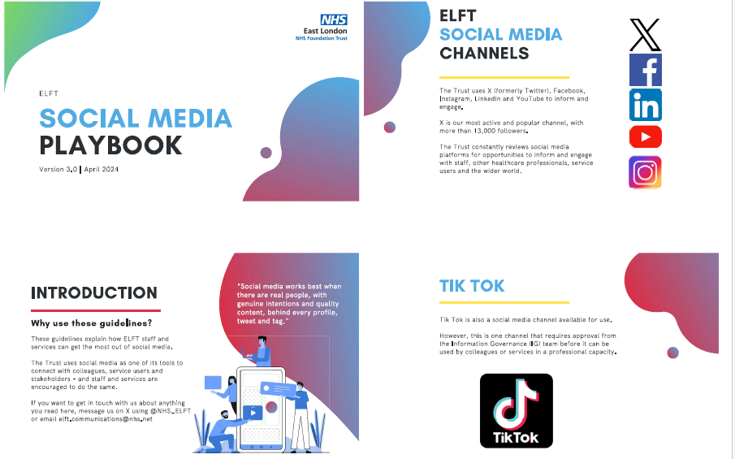

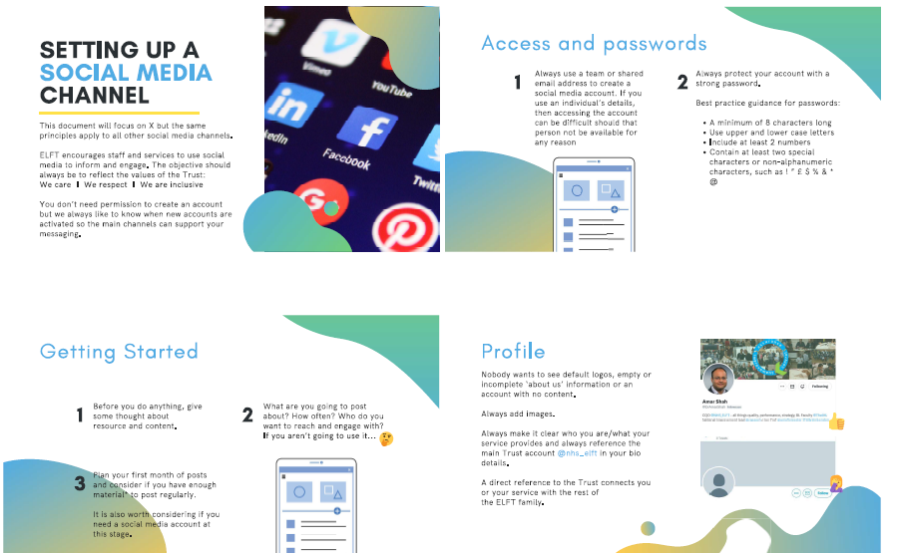
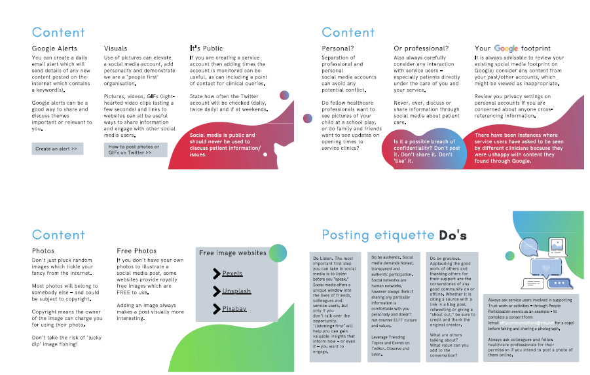
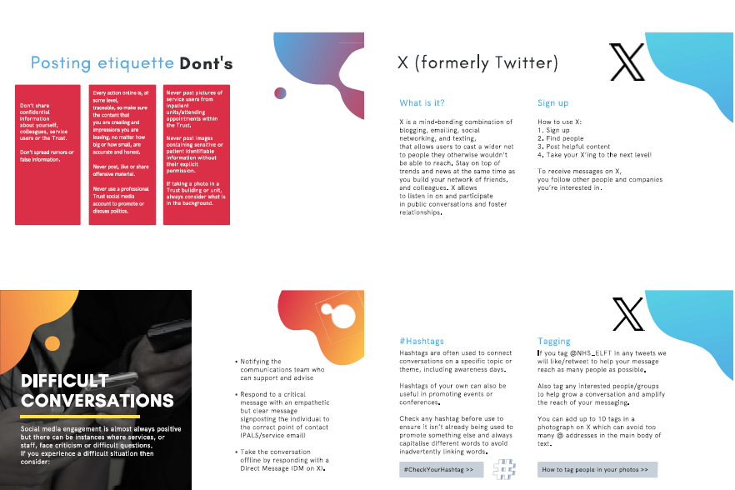

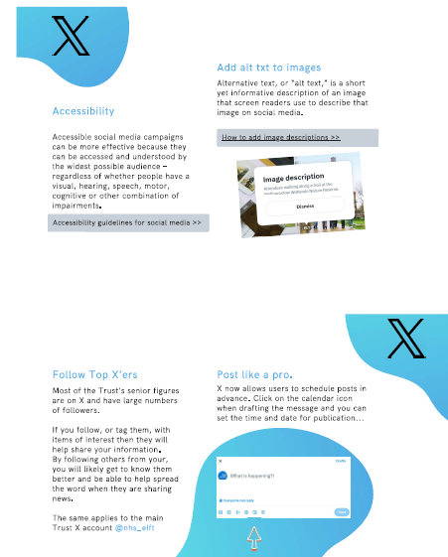

Appendix H – Media Consent Form

You can obtain this from the Communications team: elft.communications@nhs.net

Part 2 to be handed to individual

