Protocol for the Safe Use of Lithium

Version number : | 5.0
Consultation Groups | Medicines Committee
Approved by (Sponsor Group) | Medicine Committee
Date approved | 10th July 2024
Ratified by: | Medicines Committee
Date ratified: | 10th July 2024
Name of originator/author: | Clinical Lead Pharmacist for City & Hackney and Forensics
Executive Director lead : | Lead Pharmacist
Implementation Date : | October 2024
Last Review Date | July 2024
Next Review date: | July 2027

Services | Applicable
Trust wide | x
Mental Health and LD
Community Health Services

Version Control Summary

Version | Date | Author | Comment
1 | February 2011 | Veena Shivnath, Senior Pharmacist;  Shameem Mir, Chief Pharmacist
2 | February 2012 | Veena Shivnath, Senior Pharmacist;  Shameem Mir , Chief Pharmacist | Addition of shared care protocol as an Appendix
3 | March 2016 | Tabassam Beg, Clinical Pharmacist | - Section 1.1 Plasma level target changed in line with NICE guideline. Date of NICE guideline updated  - Section 1.4 added  - References: updated to reflect most recent NICE guideline.  - Plasma level interpretation and toxicity guidelines updated
4 | September 2020 | Poonam Divani, Clinical Pharmacist;  Tabassam Beg, Lead Pharmacist | - References: updated to reflect most recent NICE guideline  - Removal of out-dated NPSA data  - Adjustment to monitoring information to ensure adherence to NICE guidance  - Removal of paper monitoring form  - Addition of electronic Lithium monitoring completion advice  - Amendment of contents page to electronic word format
5 | November 2023 | Wasan Jumah, Clinical pharmacist;  Remika Sharma,  Clinical pharmacist;  Mohamed Abbass  Clinical Lead Pharmacist | - References: updated to reflect most recent NICE guideline  - Amendment to pharmacist and nursing responsibilities  - Adjustment to monitoring information to ensure adherence to NICE guidance  - Appendix 1- amending prescribing section  - Appendix 1- addition of contraindications, cautions, renal, brand information, treatment cessation and pregnancy.  - Appendix 2- Amendment of SOP principles  - Appendix 3- Amendment of lithium levels  - Appendix 5 – Addition of counselling checklist

Contents

Contents
1. Introduction 4
2. Scope 4
3. Responsibilities of the Mental Health Trust 5
3.1 Prescribers/Consultants 5
3.2 Responsibilities of ELFT Pharmacists 6
3.3 Responsibilities of Nurses 7
4. Responsibilities of General Acute Hospital 7
5. Responsibilities of the Integrated Care Boards (ICBs) 8
6. Responsibilities of General Practitioners 8
7. Responsibilities of Community Pharmacists 9
9. Blood Results 9
10. Dissemination and Implementation 9
11. Audit and Review 9
Appendix 1: In-patient Prescribing & Monitoring of Lithium 10
Appendix 2 ELFT Outpatient Lithium Prescribing and Monitoring 16
Appendix 3: Shared Areas of Responsibility Arrangement on Discharge 18
Appendix 4 Drug Interactions 19
Appendix 5. Lithium counselling checklist 21
Appendix 6 Psychotropic Medication Monitoring Form (electronic Lithium Monitoring form) 23
12. References 26

1. Introduction

Lithium has a narrow therapeutic range. Patients who are prescribed lithium must have regular blood tests to ensure the dose they are taking leads to a therapeutic optimum plasma drug level of between 0.4 and 1.0 mmol/L (lower end of the range for maintenance therapy and elderly patients/ 0.8-1 mmol/ L for acute episodes of mania, for patients who have previously relapsed or have sub-syndromal symptoms). Maintaining plasma levels in this range is likely to attain desired therapeutic outcomes, whilst reducing (though not eliminating) the risk of harmful lithium toxicity occurring.

The National Institute for Health and Clinical Excellence (NICE) guideline (CG185) for bipolar disorder recommends that patients prescribed lithium should have weight or BMI, ECG (for people with cardiovascular disease or risk factors for it), renal and thyroid function tests checked before treatment is initiated and then re-checked at least once every 6 months. The guideline also recommends that lithium plasma levels should be checked one week after starting lithium and one week after any dose change, then re-checked at least once every 3 months after levels have stabilised.

Despite the need for regular monitoring, local and national audits have identified a sub-optimal degree of lithium monitoring and of patient information provision, especially with regards to adverse effects, interactions and symptoms of toxicity (refer to Appendix 1 for details about prescribing and monitoring lithium for inpatients, and Appendix 2 for the Standard Operating Procedure for lithium prescribing for outpatients).

In December 2009, the NPSA made recommendations that patients on lithium therapy should be monitored in both primary and secondary care and the results of monitoring should be communicated between both parties and the patient. A patient booklet, alert card and record book have been developed to support communication between healthcare providers and empower patients taking lithium. This informs patients of key aspects of their treatment including side effects and toxicity. These resources should be made available to all patients on lithium therapy and their use supported by healthcare professionals.

The Prescribing Observatory for Mental Health (POM-UK) conducted an audit of lithium monitoring in 2016 in sixty-three participating Trusts including ELFT. Since the baseline audit in 2008, there has been an increase in the proportion of patients who, at initiation of treatment with lithium, were informed of the potential side effects, the signs and symptoms of toxicity, and the risk factors for toxicity at ELFT. Clinical practice in relation to monitoring of patients established on lithium also showed improvement. There was a consistent increase from baseline in the proportion of patients with documented measures over the year of U&Es and creatinine, thyroid function tests, serum lithium, and body weight/obesity. The proportion of such patients with mood disorder who had a documented plasma lithium level between 0.4 and 0.8 mmol/l had increased to more than three-quarters. Nevertheless, the data collected reveal that the documentation of baseline tests and on-treatment monitoring of lithium within mental health services still falls short of the standards derived from specific recommendations in the NICE guidance on bipolar disorder.

2. Scope

- This protocol has been developed to promote the safe use of lithium therapy in line with the previous NPSA alert, the Quality Outcome Framework (QOF) and NICE guidelines CG185 to ensure safety and avoid harm to patients. This protocol pertains to all services and directorates across ELFT together with other primary and secondary care providers to ensure all organisations are working towards the same objective in ensuring safety and monitoring of lithium treatment. It is the responsibility of both primary and secondary care to take necessary actions to improve outcome and experiences of patients on lithium.

3. Responsibilities of the Mental Health Trust

Prescribers/Consultants

- Ensure all baseline tests are carried out at initiation of lithium therapy (Appendix 1, 2). Inform the patient about lithium inclusion in their treatment regime, explain the rationale and importance of behind lithium monitoring, educate patient about benefits and risks of lithium, side effects and the need to inform a health care professional in case of any side effects suffered, recognise signs and symptoms of lithium toxicity, other medication to avoid which may interact with lithium, what to do in case of vomiting, diarrhoea.

- Discuss the risks associated with lithium and pregnancy with female patients, and perhaps consider the need for contraception. The discussion must be fully documented in the notes. The Royal College of Psychiatrists have some useful information about lithium in preganancy and breastfeeding that patients could be signposted to https://www.rcpsych.ac.uk/mental-health/treatments-and-wellbeing/lithium-in-pregnancy-and-breastfeeding

- Ensure the patient has been provided with the information booklet, lithium alert card and record book by contacting the clinical pharmacist. All treatment details (brand, form, dose etc.) and lithium blood results must be entered in the record book together with the relevant blood tests.

- Ensure the Psychotropic Medication Monitoring form on RiO is complete (see Appendix 6).

- Advise the patient to have this record book with them whenever visiting a doctor or community pharmacy and inform loss of this book to the GP or CMHT staff or pharmacist.

- Ensure documentation of the contents of discussion about lithium therapy is completed in medical notes.

- Ensure blood tests are done for maintenance therapy, after each dose change and every 3 months. (See Appendix 1).

- Inform GP on discharge that the patient has been started on lithium, and instruct the GP about monitoring requirements via the discharge letter. A Discharge Medicines Service (DMS) should be completed on discharge if consent received from the patient. (Please see Appendix 3 Shared Areas of Responsibility Arrangement on Discharge).

- Provide advice to GPs if mental state changes or in case of adverse effects.

- Ensure lithium blood levels are done 12 or 24 hours post dose and if patients are on lithium liquid that the morning dose is withheld until the blood test is done.

- Any changes in blood tests results or changes in therapy must be communicated to GPs.

3.2 Responsibilities of ELFT Pharmacists

- Ensure lithium is prescribed by brand name. If it is prescribed generically, the pharmacist must endorse all prescriptions, including discharge summaries, with the brand name.

- Ensure lithium is monitored in accordance with this protocol.

- As part of clinical screening pharmacist should alert MDT of potential medications that is contraindicated with lithium and if they are prescribed to monitor for signs of toxicity.

- Provide education session on lithium therapy to patients and carers, discuss benefits adverse effects, interactions (see Appendix 4) with other medication either prescribed by doctors or bought over the counter such as herbal medicines with diuretic potential, indigestion remedies and any Non-Steroidal Anti-Inflammatory Drugs (NSAIDs).

- Advise ward doctors about lithium monitoring, refer to Appendix 1

- Counsel patient at discharge about adherence/concordance to lithium therapy, to obtain further supplies from GP and report any side effects suffered after discharge either to GP or the community team and the community pharmacist. Check Shared Areas of Responsibility Arrangement on Discharge (Appendix 3).

- Work in collaboration with ward doctors to ensure lithium monitoring is done (see Appendix 1).

- Communicate results of blood tests to the medical team and all parties (including GPs) to facilitate dose optimisation.

- Ensure patient records are up to date regarding most recent lithium blood levels and any other tests (Refer to Appendix 1) relevant to lithium therapy and document details in medical notes. If lithium levels are not within therapeutic range, the prescriber must be contacted. The prescriber must also be notified if any of the tests relevant to lithium therapy are not within normal range.

- Inform Consultant and GP if concomitant interacting drug is prescribed and give advice about dose adjustment of lithium and additional monitoring.

- Ensure blood lithium level is checked at each dispensing and patients are informed about carrying their record book with them to all appointments and when collecting medication from community pharmacies.

- Purple lithium booklet ordered on a named patient basis by pharmacy staff via dispensary during admission (to ensure lithium booklet provided prior to discharge).

- Signpost the patients to utilise the “NHS Health Monitor for Lithium” app developed by South West London and St. George’s NHS Trust, currently available for Android devices only.

- Ensure that Lithium counselling checklist is completed for all new individuals initiated on lithium and uploaded onto RiO. (Appendix 5)

3.3 Responsibilities of Nurses

- Ensure that patients understand rationale for lithium therapy.

- Ensure patient’s weight is recorded at initiation of treatment with lithium and subsequently at regular intervals during admission depending on the length of admission.

- Ensure lithium blood levels are taken 12 or 24 hours post lithium dose administration and if patients are on lithium liquid, the morning dose should be withheld until the blood test is completed.

- Report any side effects experienced by the patient whilst an inpatient to the medical team and make an entry in the medical notes to that effect.

- Inform the medical team if patient suffers from any gastrointestinal problems i.e. diarrhoea, vomiting as this would affect the lithium blood level and can could be a sign of toxicity.

- Counsel patient at discharge about adherence to lithium therapy and obtaining further supplies from GP and the importance of carrying their lithium booklet.

- Encourage patients to report any side effects experienced after discharge either to GP or the community team and community pharmacists.

- Ensure adequate fluid intake and monitor patients’ diet; ideally patients should not have major changes in diet.

- Nurses to familiarise themselves with signs of lithium toxicity and if detected to alert the medical team prior to administration of lithium.

4. Responsibilities of General Acute Hospital

- Ensure patient is prescribed the correct dose and brand of lithium.

- Update patient records with the most recent lithium blood levels and any other relevant tests (please see Appendix 1)).

- Monitor for drug interactions with any new medication prescribed which may alter lithium levels and monitor levels as soon as possible.

- Provide ongoing verbal and written information about new medication with lithium therapy.

- Seek advice from consultant psychiatrist about any concerns relating to lithium therapy.

- Monitor for side effects and in case of renal impairment seek advice about appropriate dose in such cases and monitor lithium levels regularly.

- Ensure patients have their lithium booklet with them and if not then supply one.

- Enter all lithium blood results in the record book together with the relevant blood tests.

5. Responsibilities of the Integrated Care Boards (ICBs)

- Inform all GPs and Community Pharmacies of this Protocol.

- Provide GPs with support relating to responsibilities with lithium patients.

- Provide feedback to Trusts via Medicines /Prescribing / Drug and Therapeutics Committees.

- Liaise with the appropriate parties in case of difficult / interface issues that may arise as a result of this protocol.

6. Responsibilities of General Practitioners

- Ensure that lithium monitoring is carried out in line with the protocol - refer to Appendix 1 and 2.

- Complete patient lithium ‘purple’ record book as necessary with any dose changes and recent lithium blood levels.

- Discuss any concerns relating to lithium therapy with the appropriate consultant psychiatrist for the patient and refer patient back to secondary care if patient discontinues treatment and suffers a worsening mental state.

- Ensure that newly prescribed medicines do not interact with lithium. If a medicine that can alter lithium levels is prescribed, then additional monitoring should be put in place. Ensure patient and consultant are fully informed of any changes to medication to avoid any harm and patient should be fully informed about this.

- Inform the consultant psychiatrist of any concordance/adherence issues.

- Shared Areas of Responsibility Arrangement on Discharge (Appendix 3).

- Provide ongoing advice to the patient and monitor general health.

- In case of signs of lithium toxicity, stop treatment, monitor blood lithium level and inform the relevant consultant psychiatrist.

- If the patient experiences side effects, inform the relevant consultant psychiatrist.

- In case of abnormal renal function and thyroid function tests, liaise with consultant to discuss relevant actions.

- Inform female patients about the need for continuous contraception throughout lithium therapy and seek specialist advice in case patient become pregnant.

7. Responsibilities of Community Pharmacists

- Check that blood tests are monitored in accordance with this protocol by checking lithium booklets before dispensing a repeat prescription for lithium. (See Appendix 2)

- If generic lithium has been prescribed, confirm the brand name with prescriber.

- Check for all drug interactions, including over-the-counter (OTC) medicines.

- At the start of lithium therapy and throughout their treatment, ensure patients have received appropriate verbal and written information.

- Refer the patient back to the Mental Health team or GP if there are any concerns relating to compliance or lithium therapy in general.

9. Blood Results

- Each local site has a designated laboratory where blood samples are sent for analysis. State the urgency of testing on the blood request form if lithium toxicity is suspected and a telephone call should be made to reinforce the need for urgent results.

- Blood results can be viewed via the intranet if clinicians have liaised with their IT departments about access to their local laboratory and blood results. It is very important to complete the blood request form legibly with all requested details otherwise this will delay blood results and sometimes blood results are sent to wrong departments.

10. Dissemination and Implementation

- This protocol will be circulated to Clinical Directors and Service Managers who will be required to cascade the information to team members for briefing and information to encourage safe use of lithium.

11. Audit and Review

- This protocol will be reviewed in 3 years unless legislation changes and lithium use should be audited on a regular basis to ensure safety and appropriate monitoring of lithium therapy.

Appendix 1: In-patient Prescribing & Monitoring of Lithium

Indication | - Treatment and prophylaxis of mania and hypomania  - Treatment and prophylaxis of bipolar affective disorders  - Treatment and prophylaxis of recurrent depression  - Control of aggressive behaviour or intentional self-harm
Contraindications | - Hypersensitivity to the active substance  - Cardiac disease associated with rhythm disorders  - Cardiac insufficiency  - Severe renal impairment  - Untreated or untreatable hypothyroidism  - Breast-feeding- refer to section  - Patients with low body sodium levels e.g. dehydrated patients or those on low sodium diets  - Addison’s disease  - Brugada syndrome or family history of Brugada syndrome
Cautions | - Patients with cardiac disease  - Receiving concurrent electroconvulsive therapy (ECT)- may lower seizure threshold  - Receiving diuretic treatment (risk of toxicity)  - Elderly  - Epilepsy (may lower seizure threshold)  - Myasthenia gravis  - Psoriasis (risk of exacerbation)  - Patients with QT interval prolongation  Lithium dose to be reviewed as necessary in patients:  - With diarrhea  - With intercurrent infection (particularly if sweating profusely)  - Who are vomiting  following surgery
Baseline testing | - Renal function tests- Urea & Electrolytes (U&Es), e-GFR and creatinine  - Calcium levels  - Thyroid Function tests (TFTs): TSH and T4  - Full Blood Count  - Weight or BMI  - ECG- for those with risk factors for or existing/family history cardiovascular disease
Prescribing | - The slow release tablets can be administered as a single daily dose (usually at night).  - Liquid preparation: should be divided into two doses.  - The most common solid dose brand used in ELFT is Priadel®.  - Dose is usually guided by plasma level and clinical status increase dose gradually to minimise risk of side effects  - Priadel® Liquid:  - In patients of average weight (70kg) an initial daily dose of 10-30ml Priadel® Liquid (equivalent to 408-1224 milligrams lithium carbonate) should be given in divided doses, ideally twice a day.  - Elderly/weight <50kg: start at doses of 204 milligrams to 408 milligrams twice daily, with dose increments of 204 to 408 milligrams every 3-5 days.  - Priadel® Tablets:  - In patients of average weight (70 kg) an initial dose of 400-1,200 milligrams given as a single daily dose in the morning or, alternatively, the dose may be divided and given morning and evening  - Elderly/weight <50kg: start at 200 – 400 milligrams with dose increments of 200- 400 milligrams every 3- 5 days
Brand information | - Lithium comes in different brands, formulations and salts have different bioavailability and are not interchangeable.  - Dosage regimens between different preparations are different therefore, lithium must be prescribed by brand and not generically.  - When changing between preparations, serum lithium levels should be checked first and a change of product should be regarded as a new treatment.  - Extra care is needed when switching from lithium carbonate to lithium citrate to ensure that the dose remains therapeutically equivalent. Lithium level is usually checked 7 days (post any change in brand or formulation  - Priadel® Liquid: Lithium citrate tetrahydrate 520 mg is equivalent to lithium carbonate 204 mg.  - Li-Liquid®: Lithium citrate tetrahydrate 509 mg is equivalent to lithium carbonate 200 mg.  - Li-Liquid®: Lithium Citrate tetrahydrate 1018mg is equivalent to lithium carbonate 400mg  Please note that Li-Liquid® is not on the BLMK Formulary – prescribers are required to complete a non-formulary application for it.
  Brand Name: | Form: | Salt: | Strengths:
  Priadel® | Tablet | Lithium carbonate | 200mg, 400mg
  Priadel® | Liquid | Lithium citrate | 520mg/5ml
  Li-Liquid®: | Liquid | Lithium citrate | 509mg/5ml  1018mg/5ml
Renal Impairment | - Lithium is predominantly excreted renally, hence significant accumulation of lithium may occur in patients with renal insufficiency.  - If patients with mild-moderate renal impairment are being treated with lithium, serum lithium levels should be closely monitored every three months, and the dose adjusted accordingly.  - If regular and close monitoring of serum lithium levels and plasma creatinine levels is not possible, lithium should not be prescribed in this population.  - In patients who develop polyuria and/or polydipsia, renal function should be monitored in addition to the routine serum assessment.
  GFR (mL/min) | Dose in renal impairment
  10-50 | 50-75% of normal dose- monitor lithium plasma concentrations closely
  <10 | 25-50% of normal dose- monitor lithium plasma concentrations closely
Pregnancy & Breastfeeding | Pregnancy  - Lithium should not be used during pregnancy, particularly during the first trimester, unless considered essential and no other options are appropriate for the patient.  - It is not recommended for treatment during pregnancy due to a 2-3 fold increase of significant congenital disabilities.  - Lithium crosses the placental barrier. Ebstein’s anomaly is a cardiac defect in infants associated with lithium treatment during pregnancy. Therefore, a pre-natal diagnosis such as ultrasound and electrocardiogram examination is strongly recommended.  - It is crucial to weigh the risks versus benefits of continuing a pregnant patient on lithium.  - In certain cases where a severe risk to the patient could exist if treatment were stopped, lithium has been continued during pregnancy.  - If a patient remains on lithium, monitoring should be done every four weeks until 36 weeks, and then every week after that.  - If a mother receives lithium during delivery, it is essential to monitor the infant for hypotonia, flaccid muscle tone, lethargy and floppy baby syndrome for at least 48- hours.  - It is recommended that lithium be discontinued shortly before delivery (third trimester) and reinitiated a few days post-partum.  Breastfeeding  - Breastfeeding is contraindicated; if a lactating mother is on lithium therapy, breast milk will contain lithium.
Treatment cessation | Reasons for discontinuation of lithium could include (discontinuation could be urgent or planned termination):  - Patients unable to tolerate lithium even at therapeutic serum levels  - If there is significant renal impairment  - If lithium therapy proves clinically ineffective  - Persistent non-compliance or erratic compliance with monitoring  - Toxicity  - ]Patient choice e.g. due to adverse effects of excessive weight gain  If lithium prescription is stopped for any reason, the person monitoring the lithium blood levels should be informed as soon as reasonably possible by the prescriber.  The discontinuation of lithium therapy in bipolar prophylaxis can lead to relapse. The discontinuation should be gradual and managed with additional support.  If stopping lithium, reduce the dose gradually over at least 4 weeks, and preferably up to 3 months, even if the person has started taking another anti-manic drug.  During dose reduction and for 3 months after lithium treatment is stopped, monitor the person closely for early signs of mania and depression.

Monitoring:
Patients must have regular blood tests to ensure the lithium plasma drug level is within the agreed target range as specified by the specialist.
To undertake more frequent tests if there is evidence of clinical deterioration, abnormal results, a change in sodium intake, symptoms suggesting abnormal renal or thyroid function (e.g. unexplained fatigue), or if patient is prescribed medication.
Lithium level:
Plasma levels: Samples should be taken approximately 12 (or 24 for Priadel) hours post dose.
If a twice daily regime is prescribed, the patient should be advised to withhold morning dose until after the blood sample has been taken
Indication for lithium: | Target dose (mmol/L):
Maintenance therapy and elderly patients | 0.4-1
Acute treatment of mania/ patients who have previously relapsed or have sub-syndromal symptoms | 0.8 – 1.0

Monitoring Summary Table:
Test | Baseline | 4-7 days after initiation | 4-7 days after dose change | Weekly until levels are stable | Every 3 months for the 1st year | Every 6 months from initiation (or more frequent – see below)
Weight/BMI
ECG
TFTs
Calcium
U&Es (includes creatinine)
eGFR
FBC
Plasma Lithium level (or more frequent if in patient in group outlined above)

More frequent monitoring if:
Every 3 months also after the first year for: | More frequent testing than 6 months if there is evidence of:
- older people (>65 years of age)  - people taking drugs that interact with lithium  - people who are at risk of impaired renal or thyroid function, raised calcium levels or other complications  - people who have poor symptom control  - people with poor adherence  - people whose last plasma lithium level was 0.8 mmol per litre or higher. | - impaired renal or thyroid function  - raised calcium levels  - increase in mood symptoms that might be related to impaired thyroid function  - clinical deterioration  - abnormal results  - a change in sodium intake  - patient taking other prescribed medication which interacts with lithium e.g. ACE inhibitors, NSAIDs or diuretics
Lithium Toxicity:
- Please note that lithium toxicity is a clinical diagnosis and can occur even at therapeutic lithium plasma levels.
- Toxic effects reliably occur at levels >1.5mmol/L however still may occur at an apparently normal plasma levels as individuals vary in their susceptibility to symptoms of toxicity
- There is no specific antidote to lithium. At the first sign of toxicity the levels should be checked and treatment discontinued immediately.
- If necessary, supportive treatment should be initiated, which includes correction of fluid and electrolyte balance.
- All patients should be observed for a minimum of 24 hours. ECG should be monitored in symptomatic patients. Steps should be taken to correct hypotension.

Lithium level <1 but signs of moderate or severe toxicity: | Lithium level 1.0-1.5 mmol/l: | Lithium level > 1.5 mmol/l AND/OR signs of MILD toxicity | Lithium level > 2 mmol/l AND/OR signs of MODERATE/ SEVERE toxicity
Stop lithium and refer to secondary care. | Examine for signs of toxicity: if none, repeat blood test. If still above target range, reduce dose and repeat blood test after a week. | Stop lithium, immediate referral to Specialist team who initiated lithium treatment, daily follow-up. Note: plasma levels may still be rising, monitor for signs of moderate / severe toxicity over next 7 days. | Stop lithium. Immediate referral to A&E for possible diuresis and inform responsible secondary care clinician. Investigate reason for toxicity.

Symptoms of lithium toxicity:

Mild | Moderate | Severe:
- Nausea  - Diarrhoea  - Blurred vision  - Polyuria  - Light headedness  - Fine resting tremor  - Muscular weakness or drowsiness | - Increased confusion  - Blackouts  - Fasciculation and increased deep tendon reflexes  - Myoclonic twitches/ jerks  - Choreoathetoid movements  - Urinary or faecal incontinence  - Increasing restlessness followed by stupor  - Hypernatraemia | - Coma  - Convulsions  - Cerebellar signs  - Cardiac dysrhythmias  - Hypotension or rarely hypertension  - Circulatory collapse  - Renal failure

Appendix 2 ELFT Outpatient Lithium Prescribing and Monitoring

Standard Operating Procedure
Principles
All NHS organisations are required to have safe systems in place for the prescribing, administration, monitoring and supply of lithium. Pharmacists (including community pharmacists) will not dispense medication to patients who do not have current (as defined within the required monitoring frequency) blood levels, renal function and thyroid function tests. The systems being introduced are similar to those already in place for other high risk medications e.g. Methotrexate and Warfarin.
A Purple Pack has been developed, containing a Patient information book, a results record book, and a contact’s information card

Procedure for The Prescriber
  - When the decision is taken to initiate lithium treatment as an outpatient and the patient has consented, the patient is given the purple lithium information booklet out of the Purple Pack. This is recorded in the patient’s notes.
  - A Patient Information leaflet for lithium must be printed off from the Trust Intranet and given to the patient with attention drawn to interactions with other medicines such as antacids containing sodium, and advice on water and salt intake
  - The patient has the following tests ordered: Urea and Electrolytes, Creatinine, Thyroid Function. An ECG should be requested if there is a history of cardiac disease or the patient has cardiovascular risk factors. The height and weight of the patient must be recorded in the notes. (See Appendix 1)
  - If the blood results are within normal range then lithium treatment can be prescribed. The initial dose, and the blood results must be recorded in the purple record book and the Pack, including the contact details card, given to the patient. The contact details and patient demographics must be also completed by the prescriber
  - The patient will need to show the results record book to the pharmacist when presenting a lithium prescription for medication to be dispensed and bring it with them to every appointment with the doctor.
  - If the blood results are not within normal range then specialist advice should be sought and lithium must NOT be started.
  - After initiating treatment a lithium level must be taken after one week.
  - A dose change can be initiated after receiving the blood result. Both the first level and the new dose must be entered into the patient’s results record booklet.
  - Until a stable dose and satisfactory blood level (usually 0.4 -1.0mmol/l) is achieved, the patient’s lithium level must be measured one week after each dose change. Each time results and dose must entered into the results record booklet.
  - Once a stable dose and satisfactory lithium level is achieved then the lithium level must be measured every three months
  - Undertake more frequent tests if there is evidence of clinical deterioration, abnormal blood test results, a change in sodium intake, or symptoms suggesting abnormal renal or thyroid function such as unexplained fatigue, or other risk factors, for example, if the patient is starting medication such as ACE inhibitors, non-steroidal anti-inflammatory drugs, antacids or diuretics.
  - Arrange thyroid and renal function tests every 6 months, and more often if there is evidence of changed thyroid or impaired renal function.
  - Enter the dates of future tests into the clinic diary with prompts for obtaining and checking results one week later.
  - Initiate closer monitoring of lithium dose and blood serum levels if urea and creatinine levels become elevated, and assess the rate of deterioration of renal function. The decision whether to continue lithium depends on clinical efficacy, and degree of renal impairment; prescribers must consider seeking advice from a renal specialist and a clinician with expertise in the management of bipolar disorder on this.
  - Most patients will have their care handed over to a G.P. once stable. In complex shared care arrangements the important principle that the prescriber monitors must always be adhered to.

Appendix 3: Shared Areas of Responsibility Arrangement on Discharge

    - ELFT London Sites

Referral Criteria

Prescribing responsibility will only be transferred when the consultant and the patient’s GP consider the patient’s condition to be stable. Shared Areas of Responsibility assumes communication between the specialist, GP and patient.

Referral of the patient to the GP will be subject to the GP’s agreement. The areas below indicate the areas of responsibility to be decided by discussion between the GP and consultant.

The patient will be given a supply of lithium sufficient for 2 weeks’ maintenance therapy upon discharge from secondary care.

Patients should be under regular follow-up with their GP, which provides an opportunity to discuss drug therapy.
The monitoring requirements outlined below is essential to ensure the safe prescribing and use of lithium therapy. The clinician (GP / specialist) who prescribes lithium must, before issuing any further prescriptions for lithium, check for up to date lithium levels and other blood test results. (please see Appendix 1)
Shared Areas of Responsibility
GP Responsibilities:
- To prescribe monthly supplies of lithium
- To refer to consultant if:
- Patient relapses
- Patient has intolerable side effects
- Non-compliance is suspected
- To monitor physical health monitoring in community which is summarised in Monitoring Summary Table in Appendix 1
- To arrange the blood tests and check the results and action them if necessary.
- To request and monitoring of lithium levels.
Taking lithium levels: Please refer to Monitoring section in Appendix 1

Community Consultants Responsibilities:
• Outpatient appointments every 1-12 months based on clinical need.

    - ELFT Bedfordshire Luton and Milton Keynes (BLMK) sites
Please follow link below for BLMK Lithium Shared Care Guideline for patients within adult services
https://medicines.bedfordshirelutonandmiltonkeynes.icb.nhs.uk/wp-content/uploads/2024/02/Lithium-approved-with-links-corrected-Dec-23_AG-final.pdf

Appendix 4 Drug Interactions

The list below include some of the common interactions, but is not exhaustive. For a full list of interactions, please check the Summary of Products Characteristics (SmPC) for Priadel Prolonged-Release tablets via this link, https://www.medicines.org.uk/emc/product/13162/smpc#gref

Class of Drug | Example | Interaction Effects
Alcohol |  | Increased tremor/shakiness with  chronic alcohol use
Angiotensin-converting enzyme  (ACE) inhibitors  ACE-2 inhibitor | Enalapril, captopril, Lisinopril  Losartan, candesartan,  valsartan | Lithium toxicity due to sodium  depletion,  Lithium toxicity due to reduced  aldosterone levels
Antibiotic | Doxycycline, tetracycline,  levofloxacin, metronidazole | Can increase lithium level due to reduced lithium excretion
Anticonvulsant/Antiepileptics | Carbamazepine, phenytoin,  Valproate, topiramate | Increased neurotoxicity of both drugs  at therapeutic doses  Valproate may aggravate tremor  Neurotoxicity may occur without any increase of lithium plasma level  Altered Lithium level possible
Antidepressant  TCAs, MAOIs, RIMA  SSRIs | Desipramine, tranylcypromine,  Moclobemide  Fluoxetine, fluvoxamine,  sertraline | Synergistic antidepressant effect in  treatment resistant patients, may  increase lithium tremor  Increase lithium level, possible  neurotoxicity and serotonergic effects
Antihypertensive | Amiloride, spironolactone,  thiazides, triamterene,  methyldopa,  B-blockers: propranolol,  oxprenolol | Increase lithium effects and toxicity  Treatment of lithium tremors,  propranolol lowers glomerular  filtration rate
Antipsychotic | Haloperidol (high doses),  flupentixol, fluphenazine,  chlorpromazine, clozapine | Increased neurotoxicity possible at  therapeutic doses in rare cases
Calcium channel blocker | Verapamil, diltiazem | Increased neurotoxicity with  symptoms such as ataxia, confusion  and somnolence.  May increase lithium level
Caffeine |  | Reduce lithium level by increased  lithium excretion
Diuretics | Bendroflumethiazide,  furosemide | Increase lithium level
Dapaglifozin |  | Concomitant administration may decrease lithium levels due to an increase in lithium renal clearance
NSAIDS | Ibuprofen, diclofenac,  naproxen, mefenamic acid | Increase lithium level, monitor level  regularly
Sodium salt | Antacids, Gaviscon®.  Sodium bicarbonate  containing antacids or urinary  alkalising agents. | Increased intake causes a reduced  lithium level

Appendix 5. Lithium counselling checklist
This checklist should be completed for all new individuals initiated on lithium and uploaded onto RiO
- All information to be discussed with the patient
- Can be completed by prescriber, pharmacy and nursing staff
- Lithium booklet to be provided to the patient
- Nursing staff to reinforce information at the time of discharge
Information provided by:  Date: | Dr | Nurse | Pharmacist
Purple booklet provided
Indication
Dose
Common side effects
- Gastrointestinal disturbances (nausea- take with food)
- Fine tremor
- Polydipsia (increased fluid consumption) having to have more drinks than normal
- Polyuria (increase of urinary frequency)
- Weight gain: monitor food intake, avoid high calorific value beverages (e.g. carbonated soft drinks) and food with high fat content (i.e cakes, pastry).
- Hypothyroidism (underactive thyroid)

Importance of maintaining adequate fluid intake:
- At least drink 10-12 cups of fluid a day (water, juices) and in hot weather/during activities that can lead to sweating (sauna, hot baths, exercise) to be aware of fluid loss.
- To report an increase in thirst or urination to medical team

Maintain same salt intake during lithium treatment (an alteration of salt intake can affect lithium levels)
Blood test monitoring including renal function tests and TFTs
Signs of lithium toxicity:

- Confusion, coarse tremor,
- Loss of balance
- Slurred speech
- Visual disturbances
- Marked trembling
- Nausea, vomiting, stomach ache and diarrhoea
- Abnormal general weakness or drowsiness

To check with doctor/pharmacist whether other medicines bought over the counter may interfere with lithium, avoid taking NSAIDs such as ibuprofen or any other cold/flu remedies which may alter lithium levels.

Women of childbearing age must be informed about the need for contraception whilst on lithium and discuss risks to the foetus if become pregnant- can cause Ebstein’s anomaly, a heart defect
Inform GP/CMHT in case of mood changes
Missed doses
Not to increase or reduce dose, seek advice from consultant psychiatrist/GP if wish to discontinue lithium therapy even when well because of the risk of relapse
Who to contact in an emergency
Treatment length and discontinuation
Importance of taking purple booklet to all appointments and telling other healthcare professionals about being on lithium e.g. dentists, doctors, pharmacists

Appendix 6 Psychotropic Medication Monitoring Form (electronic Lithium Monitoring form)
Please see instructions below on how to access and complete this form. The completion of this form helps ensure all monitoring associated with lithium therapy is recorded and easily accessible.
- Access patient records on RiO
- Open ‘Physical Health’ folder under ‘Case Record Menu’ and select ‘Physical Health Assessment Forms (MH)
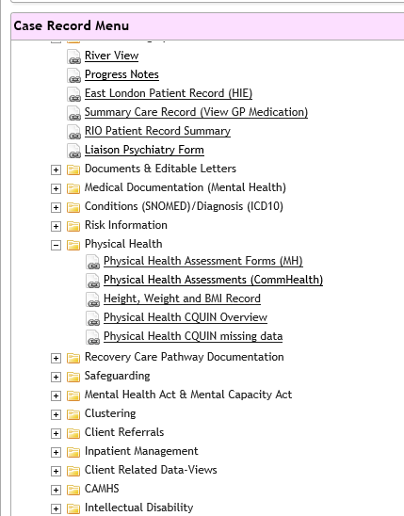
2

- Select ‘Pscyhotropic Medication Monitoring (CQUIN)’

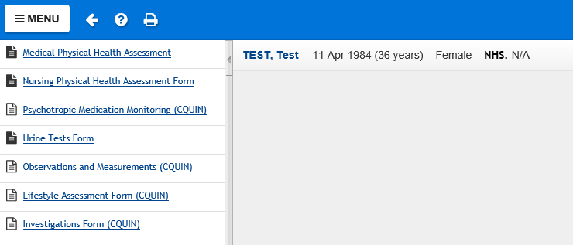
3
- Select the ‘Create new’ tab
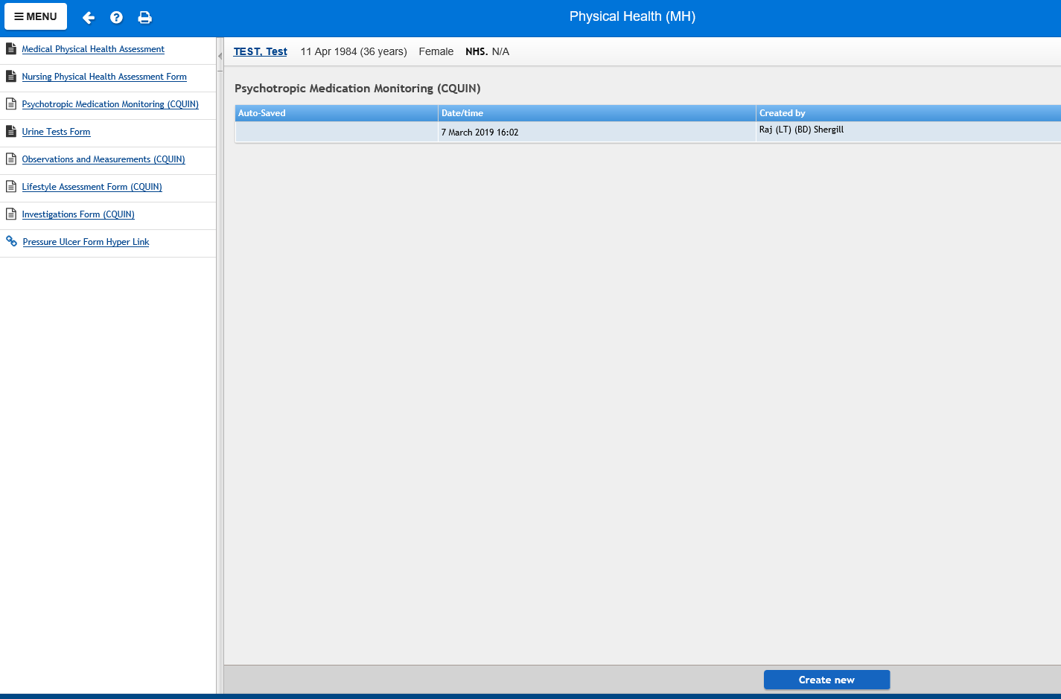
4
- Populate the date/time
- Select the drop down menu next to ‘mood stabilsers’ and select the relevant option
5

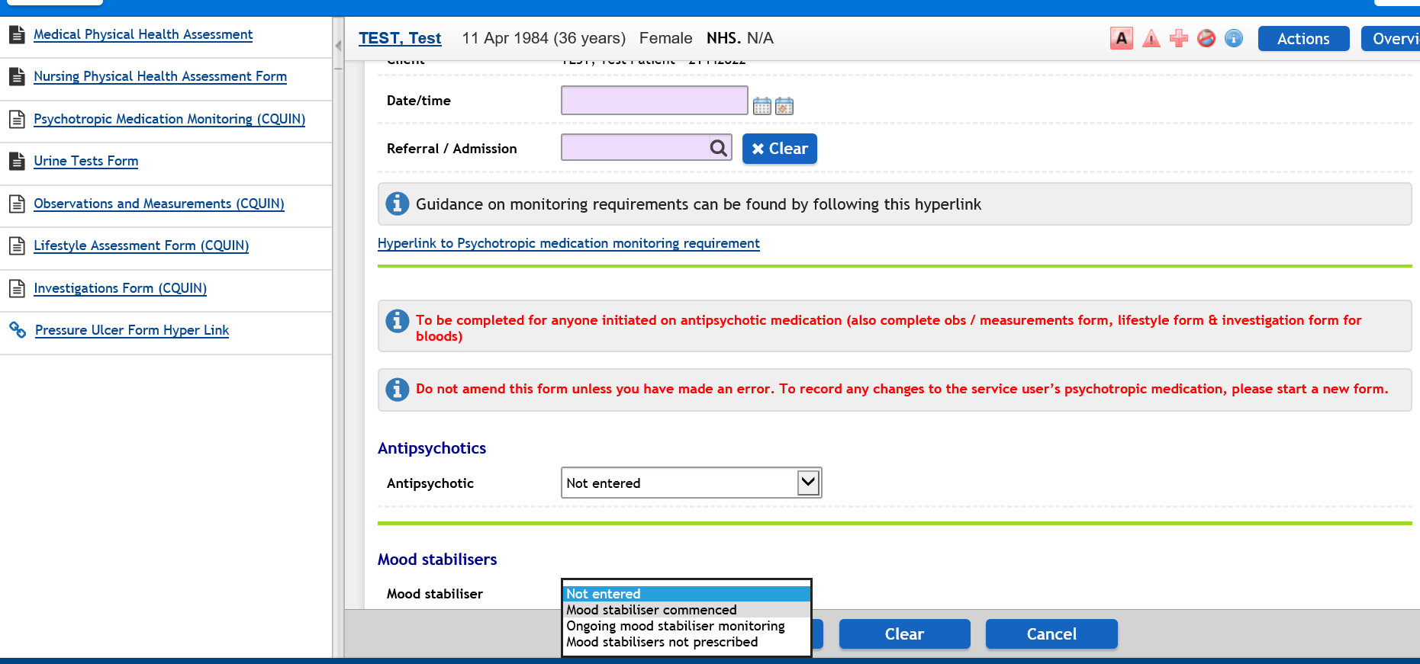
6

- Check to see if measurements, routine investigations, mood stabiliser levels, lifestyle advice have been recorded by clicking on the hyperlinks to the corresponding forms. Select ‘Yes’ or ‘No’ as appropriate.
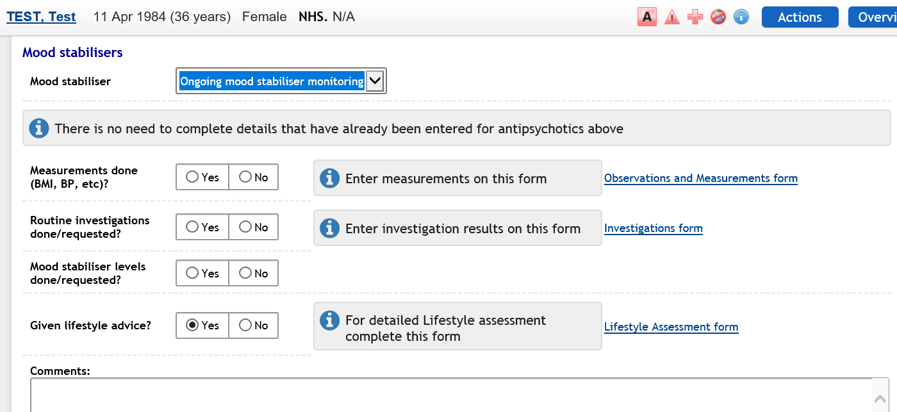
7
- Once complete, click on the ‘Save’ tab.
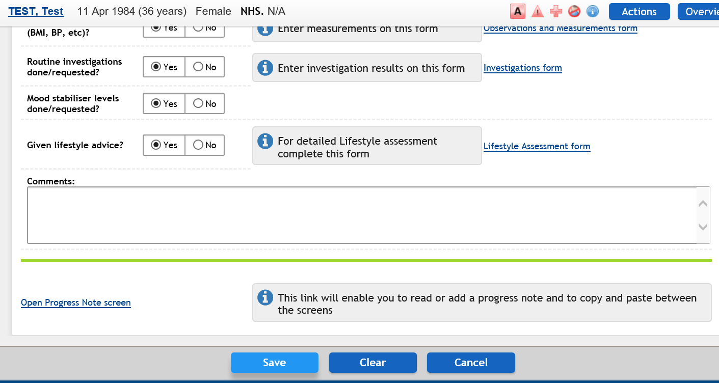

12. References

- Joint Formulary Committee. British National Formulary (online) London: BMJ Group and Pharmaceutical Press < https://bnf.nice.org.uk/drug/lithium-carbonate.html> [Accessed on [30/10/2023]
- Summary of Product Characteristics for Priadel, https://www.medicines.org.uk/emc/ [accessed 26/10/2023]
- National Institute for Health and Clinical Excellence. Bipolar disorder. The management of bipolar disorder in adults, children and adolescents, in primary and secondary care, Clinical Guidance 185, http://www.nice.org.uk, 2020.
- NPSA Patient Safety Alert NPSA 2009/PSA005 Safer lithium therapy December 2009. https://www.sps.nhs.uk/wp-content/uploads/2018/02/2009-NRLS-0921-Safer-lithium-trt-2009.12.01-v1.pdf
- https://www.sps.nhs.uk/wp-content/uploads/2018/02/2009-NRLS-0921-Safer-lithium-tmation-2010.01.12-v1.pdf
- Taylor D et al. Maudsley Prescribing Guidelines 14th edition.
- Bazire S. et al. Psychotropic Drug Directory 2018.
- Bezchlibnyk-Butler et al. Clinical Handbook of Psychotropic Drugs, 16th edition.
- Prescribing Observatory for Mental Health UK (POM-UK). Monitoring of patients prescribed lithium. Prepared by the Prescribing Observatory for Mental Health-UK for East London NHS Foundation Trust. 2013 The Royal College of Psychiatrists.
- https://products.mhra.gov.uk/
- Covid-19 and Lithium. South London and Maudsley NHS foundation Trust COVID 19 alert.
- Overview: Antenatal and postnatal mental health: clinical management and service guidance: Guidance: https://www.nice.org.uk/guidance/cg192
8

