

Resuscitation Policy
Version number: | 13.0
Consultation Groups | Lead Nurses, CHS Policy Alignment Group,  Medical Managers
Approved by (Sponsor Group): | Resuscitation Committee
Date approved: | 19th September 2024
Ratified by: | Quality Committee
Date ratified: | 23rd October 2024
Name of originator/author: | Resuscitation Lead
Executive Director lead: | Chief Medical Officer
Implementation Date: | November 2024
Last Review Date | September 2024
Next Review date: | November 2027

Services | Applicable to
Trust Wide | X
Mental Health and LD

Community Health Services

Version Control Summary

Version | Date | Author | Status | Comment
Version 13.0 | August 2024 | Resuscitation Lead | Draft | Major revision  Clarity of Definitions  Updated The Resuscitation Committee: Terms of Reference  Renaming Training & Development to Learning & Development  Removal of duplicated and contradictory information.  Add Pandemics and other public health emergencies.  Update roles and responsibilities.  Formatting changes for clarity
Version 12 | December 2019 | Lead Nurse for Physical Health and Deputy Director of Infection Control | Final | Review of policy including arrangements at Mile End Hospital implemented Nov 19 staff to call 9-999 previously  2222
Version 11 | October 2014 | Lead Nurse Physical  Health | Draft | Review of CPR policy  Governance responsibilities  Trust risk assessment  Inclusion of alternate methods of training as per resuscitation council quality standards 2014
Version 10 | December 2012 | Lead Nurse Physical  Health | Final | DNAR form reviewed for clarity  NHSLA audit compliance
Version 9 | April 2011 | Lead Nurse Physical  Health | Final | 07.11.11
Version 8 | November 2010 | Physical Health Group | Draft | Update in line with Resuscitation  Guidelines  2010
Version 6 | 2008 | Duncan Gilbert
Version 5 | April 2007 | Sue Simister/Eirlys Evans

Consultation:
Stakeholder/Committee/Group consulted | Date | Changes made as a result of consultation
Note to Simon add in the missing information

Plan for Dissemination of Policy
Audience(s) | Dissemination method | Paper or Electronic | Person Responsible
All clinical and non-clinical staff | Insert missing information | Electronic | Simon Small

Key Changes to policy:
Add information here

Plan for implementation of Policy:
Details on implementation | Person Responsible
Policy will be disseminated | Trust Risk Manager and communications
Contents

1.0 Introduction 6
2.0 Definitions and Explanation of Terms 7
3.0 Purpose of the Policy 9
4.0 Development of the Policy 9
6.0 Roles and Responsibilities 9
6.3 The Quality Committee 10
6.4 Chief Medical Officer 10
6.5 Resuscitation Committee 11
6.6 Resuscitation Lead 11
6.7 Learning and Development Department (L&D) 12
6.8 Pharmacy 12
6.9 Leadership within Directorates 13
6.10 Team Leaders and Ward Managers 14
6.11. Rapid Response Teams 15
6.12 All Registered Nursing Staff, Medical Staff and Allied Health Professionals 15
6.13 Non-registered nursing staff and therapists 17
6.14. Local Hospital Security and Ward staff 18
7.0 Resuscitation Procedure 19
8.0 Post Resuscitation Procedure 22
9.0 Reporting Incidents and Auditing 24
10.0 Resuscitation Training 25
11.0 Resuscitation Equipment 27
12.0 Medical Emergency Drugs 29
Appendix A: Adult Basic Life Support Algorithm 30
Appendix B: Adult in-hospital Resuscitation Algorithm 31
Appendix C: Adult Advanced Life Support Algorithm 32
Appendix D: Adult Choking Algorithm 33
Appendix E: Paediatric Out-of-Hospital Basic Life Support Algorithm 34
Appendix F: Paediatric (in-hospital) Basic Life Support Algorithm 35
Appendix G: Paediatric choking / foreign body airway obstruction algorithm 36
Appendix H: Lifepak CR2 AED Verifying Readiness 37
Appendix I: Philips HS1 AED Verifying Readiness 38
Appendix J: Philips FRx AED Verifying Readiness 39
Appendix K: Automated External Defibrillators (AED) Flowchart 40
Appendix L: Standard AED Sign 41
Appendix M: Standard ‘Nearest AED is Situated at’ Sign 42
Appendix M: SBARD- Communication clinical handover tool 43
Appendix N: The Resuscitation Committee: Terms of Reference (TOR) 44
1.0 Purpose: 44
2.0 Duties: 44
3.0 Constitution, Membership and Procedures: 44
4.0 Accountable to: 45
5.0 Liaison with: 46
6.0 Working between the Board and its Committees 46
7.0 Frequency of meetings: 47
8.0 Conduct of meetings: 47
9.0 Quorum: 47
Appendix O: Equipment – daily checklist Flowchart 48
Appendix P: Quick Reference Guide to the Resuscitation Equipment Check Sheet 49
Appendix R: Medical Emergency
Ambulance Access to the Mental Health Unit at Mile End Hospital 59
Appendix S: Resuscitation Audit Form 61
Appendix T: References and Related Policies 66

Executive Summary
This policy addresses the management of cardiac arrest and resuscitation. It is relevant to any member of staff within East London NHS Foundation Trust (ELFT) who may find that they are required to provide resuscitation to a patient, visitor or colleague, or those who need to know how to access the resuscitation services. It should also provide assurance to the public that the Trust is a modern and ethical organisation in its approach to resuscitation.
It describes the key roles in resuscitation, a description of how an emergency team is contacted, as well as details of training, equipment, drugs, and auditing of a cardiac arrest, particularly acknowledging the various sites within ELFT.

1.0 Introduction
“Healthcare organisations have an obligation to provide a high-quality resuscitation service, and to ensure that staff are trained and updated regularly to a level of proficiency appropriate to each person’s expected role.”

(Resuscitation Council UK May 2020)

- This document outlines the organisation of resuscitation within the East London NHS Foundation Trust (ELFT). It remains the responsibility of all staff to be familiar with its contents and implementation.

1.2 This document embraces the ‘Quality Standards: Mental health Inpatient care’, ‘Quality standards: Mental health inpatient care equipment and drug lists’, ‘Quality Standards: Primary care’ and ‘Quality Standards: Primary care equipment and drug lists’. Access to these documents or any other National Resuscitation guidelines can be found on www.resus.org.uk.

1.3 It is essential that the following links in the chain of survival are in place in the event of a cardiopulmonary arrest':

- Early recognition
- Early basic life support
- Early defibrillation
- Early advanced life support

1.4 The following areas have been identified as main priorities:

- Identification and early recognition of patients who are at risk of cardiopulmonary arrest
- Increased multi-professional working
- Increased training opportunities / resources following Resuscitation Council UK guidance
- Equipment development
- Develop audit processes to monitor the efficacy of the service
- Risk management
- Communication
- Effective, accessible policies.

  - ELFT recognises and accepts its responsibility to employees, patients, carers, visitors and families to ensure the requirements for resuscitation and management of the physically deteriorating patient are satisfied.

  - Everything we do is driven by our values of care, respect and inclusivity. Our patients’ needs matter most and we are constantly working to improve our support for all who use and have contact with our services.

2.0 Definitions and Explanation of Terms
Terms: | Definitions:
Automated External Defibrillator (AED) | An automated medical device designed to provide a measured electrical shock, where the device will direct staff to deliver a shock when indicated.
Basic Life Support (BLS) | Circulation and ventilation maintained by using basic cardio-pulmonary resuscitation techniques, through high quality chest compressions, ventilations, to maintain a flow of oxygenated blood to the brain and the heart thereby buying time before the arrival of more advanced care.
Cardiac Arrest | The sudden cessation of mechanical cardiac activity, confirmed by unresponsiveness, apnoea or agonal gasping respiration and the absence of a detectable pulse and/or signs of life.
Cardio-Pulmonary resuscitation (CPR) | An emergency procedure for people in cardiac or respiratory  Arrest, involving a physical intervention to create artificial circulation using chest compressions and rescue ventilations to inflate the lungs and pass oxygen into the blood (Artificial respiration).
Chocking | An airway obstruction which can be either partial or complete
Defibrillation | A procedure where pads from a defibrillator are applied to a person’s chest and a controlled electrical shock is discharged to treat certain cardiac arrest rhythms. The aim is that the heart will return to a normal functioning rhythm.
Deteriorating Patient  (Peri-Arrest) | Where a patient does not require immediate cardiopulmonary resuscitation, but is recognised as being high risk of doing so.
Do Not Attempt  Cardio-Pulmonary  Resuscitation (DNACPR) | Refers to not commencing CPR to restart the heart in cases of cardiac arrest. It does not refer to any other interventions/ treatment/care such as fluid replacement, feeding, antibiotics etc.
Emergency Grab Bag (MERT bag) | These contain emergency resuscitation equipment which can be taken to the patient.
Immediate life support (ILS) | Resuscitation training level above BLS. Immediate Life Support (ILS) involves the assessment of an acutely unwell/deteriorating patient using the structured ABCDE assessment tool, airway management using adjuncts including bag-valve-mask, the administration of an electric shock to the heart using either an Automated External Defibrillator (AED) or a Manual defibrillator, and the administration of a defined selection of drugs including oxygen.

Terms: | Definitions:
National Early Warning Score (NEWS2) | Early warning risk scoring / deteriorating patient system for adults aged >18 years
Paediatric Immediate Life Support (PILS) | Ventilation and Circulation maintained by using cardiopulmonary resuscitation, airway management including oxygen and use of a defibrillator when indicated in babies or children
Personal Protective Equipment (PPE) | Equipment that is intended to be worn or held by a person to protect them from risks to their health and safety while at work. Examples include masks, gloves, aprons, gowns, eye and face protection.
Resuscitation Council (RCUK) | Resuscitation Council UK is the national expert in resuscitation. The current guidelines are dated 2021 and are updated on a 5 yearly cycle.  RCUK was formed in August 1983. The objective of the Council was, and still is, to facilitate education of both lay and healthcare professional members of the population in the most effective methods of resuscitation appropriate to their needs and to ensure appropriate resuscitation for all.
Resuscitation trolley | These contain emergency resuscitation equipment for use in an emergency and are used in some areas as an alternative to the Emergency Grab Bag
Return of spontaneous circulation (ROSC) | A return of spontaneous, self-supporting breathing and pulse, with a perfusing heart rhythm.
SBARD | Situation, Background, Assessment, Recommendation, Decision  A recommended communication tool to enable effective, timely communication between individuals from different clinical backgrounds and hierarchies. (Appendix 13)
Vital signs | Includes monitoring of respirations, oxygen saturations, pulse, blood pressure, level of consciousness using ACVPU, temperature. Undertaking a NEWS2 score and escalation as appropriate.  Not to be confused with ‘observations’ which has a different context within the mental health setting.

Purpose of the Policy
3.1 To ensure that patient’s, carers, staff at ELFT and the public will receive an appropriate response which will maximise their chances of survival when being seen by a member of Trust staff or when visiting any ELFT site.

3.2 Ensure that all staff are appropriately trained to recognise cardio-respiratory arrest and respond appropriately.

3.3 Outlines the type of response required by ELFT staff on multiple & various sites and details the procedures that should be followed with regards to resuscitation attempts.

3.4 To ensure implementation and adherence of this policy to RCUK Guidelines- (2021) and the National Institute for Health and Care Excellence (NICE) Quality Standards for mental health settings (QS 14), Medicines & Healthcare products Regulatory Agency (MHRA) regulations and standards; and National Audit Office Recommendations.

3.5 The policy is to be used in conjunction with the Anaphylaxis Recognition & Treatment Policy, Infection Control Policy, Management of Medical Devices Policy, Mental Capacity Act Policy, Physical Healthcare Policy and the Rapid Tranquilisation Policy.

3.6 Do Not Attempt Cardio-Pulmonary Resuscitation (also known as DNACPR) and Deteriorating Patient are now contained within their own separate policies.

4.0 Development of the Policy
4.1 This policy has been developed in accordance with the Quality Standards and guidance from Resuscitation Council UK.

4.2 This policy is developed in consultation with the Medical Directors, Chief nurse, Directors of Nursing, Lead Nurses and the Physical Healthcare Committee. The Policy will consult with all ELFT Directorates and be ratified by the Quality Committee and Policy Working Group.

5.0 Pandemics and Other Public Health Emergencies

The clinical guidelines and quality standards referred to in this policy are aligned with current guidance from the RCUK (2021). In the event of a pandemic or other public health emergency these guidelines and quality standards may be temporarily amended to optimise the safety of victims and clinical responders. Should amendments be required these will be published via the trust intranet and communicated through trust emergency briefing.

6.0 Roles and Responsibilities

6.1The Trust

6.1.1 Guided by Resuscitation Council UK quality standards, the Trust has an obligation to provide a high-quality resuscitation service including standardisation of training, emergency equipment and drugs. The Trust has to ensure that quality standards for managing medical emergencies and cardiopulmonary resuscitation meet the needs of patients within the various health settings that the Trust operates in, and that there are clear lines of accountability within the organisation.

6.1.2 The Trust will follow the current recommendations made by the RCUK about matters concerning resuscitation, as part of its duty of care to patients, staff and visitors.

6.1.3 Will provide a resuscitation service for patients, service users, visitors and staff on all Trust sites as defined by local clinical risk assessment.

6.1.4 Will provide resuscitation training for staff according to their Training Compliance Matrix and appropriate to their banding, role and work location.

6.1.5 Will investigate all medical emergency incidents to develop understanding and support learning.

6.1.6 Will make recommendations to current systems and support the implementation of recommendations following the outcomes of incidents that arise from a medical emergency.

6.2 Chief Executive

6.2.1 The Chief Executive of the Trust has overall responsibility for ensuring that the Trust provides an effective resuscitation service.

6.3 The Quality Committee
6.3.1 Will provide a strategic framework to demonstrate compliance with Care Quality Commission (CQC) Standards and NHS Litigation Authority (NHSLA)

6.3.2 Will ratify and monitor the implementation of this policy in relation to managing the deteriorating patient and NICE CG50-Recognition of and response to acute illness in adult hospitals. London: NICE www.nice.org.uk/CG50

6.4 Chief Medical Officer
6.4.1 The Chief Medical Officer has lead responsibility for the Resuscitation Policy and strategies within the Trust.

6.4.2 The Chief Medical Officer is the Executive Lead for ensuring that the Trust Resuscitation Committee takes responsibility for all resuscitation issues within the Trust, including implementation of operational policies governing cardio-pulmonary resuscitation training and practice.

6.4.3 The resuscitation committee under the chair of the Chief Medical Officer will be responsible for identifying the necessary resources to maintain and upgrade clinical and training equipment throughout the organisation for inclusion in the business plan.

6.5 Resuscitation Committee
6.5.1 The Resuscitation Committee is an Executive Committee of the Trust. It forms part of the governance structures and specifically those structures around the management of clinical risk.

6.5.2 It will;

- Ensure the resuscitation policy is aligned with the RCUK guidelines, Medicines & Healthcare products Regulatory Agency (MHRA) and National Audit Office recommendations.

- Monitor implementation and adherence of the resuscitation policy.

- Gain assurance from the Learning and Development Department that staff receive appropriate/timely training and competency assessment in the management of medical emergencies.

- Monitor and support Quality Improvement (QI) projects related to the deteriorating patient and cardiorespiratory resuscitation.

- Review lessons learnt from resuscitation audits so as to inform cross organisational learning, training programs and best practise.

6.6 Resuscitation Lead
6.6.1 The resuscitation Lead will possess as a minimum a current Resuscitation Council UK Advanced Life Support (ALS) Instructor certificate and European Paediatric Advanced Life Support (EPALS) Instructor certificate.

6.6.2 The Resuscitation Lead will advise on current RCUK procedures and clinical guidelines recommendations.

6.6.3 Will have a strategic overview for resuscitation within the Trust, developing systems and reviewing evidence in monitoring this policy.

6.6.3 Will have a responsibility to standardise resuscitation equipment across the Trust, advising the Medical Device Committee on emergency equipment and ensuring those standards are maintained. (Appendix P & Q)

6.6.4 Will report twice a year on progress against this policy to the Patient Safety Committee.

6.6.5 Will advise the Learning and Development Department (L&D) regarding the training requirements for ELFT.

6.6.6 In conjunction with L&D, will work with directorates to ensure staff receive yearly resuscitation training and competency assessment in the management of medical emergencies.

6.6.7 The Resuscitation Lead will make recommendations to clinical staff and directorates on the standardisation of emergency medical equipment.

6.6.8 Will collaborate with key individuals to review adverse incidents involving resuscitation to ensure lessons are learnt in relation to medical emergencies and resuscitation events.

6.6.9 Will support the Operational Directorates to provide the emergency medical devices requirements.

6.6.10 Will make recommendations from local audits and national enquiries.

6.6.11 Will seek advice from the Trusts Medical Devices Lead and/or MHRA on any safety or quality aspects of emergency medical devices management.

6.7 Learning and Development Department (L&D)
6.7.1 L&D will monitor and provide updates on resuscitation courses. They will work with the Trust Resuscitation Lead and provide regular compliance reporting for resuscitation training.

6.7.2 L&D are responsible for the scheduling of training courses in resuscitation. This includes planning, undertaking training needs analysis and content delivery, in line with the National Core Skills Training Framework and the RCUK, with guidance and oversight of the Resuscitation Lead. Further details in section 7.0
6.7.3 Will provide training to staff as outlined in the training needs analysis and ensure its contents meet standards that have been approved by the Resuscitation Council UK, Resuscitation Committee and other statutory bodies such as Care Quality Commission and Health and Safety Executive.

6.7.4 Will ensure trainers have sound working knowledge and understanding of this policy and are trained to a high standard. External providers will be required to evidence appropriate knowledge and skills.

6.7.5 Will ensure that external training providers have systems in place to decontaminate equipment used in training in keeping with the Medical Devices and Infection Control Policies. (IPC Manual V13 November 2022.pdf (elft.nhs.uk)

6.7.6 Will ensure that training equipment is updated as required, with guidance of the Resuscitation Lead.

6.7.7 Will collaborate with the Resuscitation Lead and operational Directorates to ensure training is relevant to service requirements.

6.8 Pharmacy
6.8.1 Will ensure that all emergency drugs, intravenous fluids are available in all designated areas as risk assessed and replaced when used or due to expire when informed by nursing staff.
6.8.2 Will ensure that anaphylaxis packs are available in all clinical areas where medication is administered
6.8.3 Will liaise with the directorate, ward manager on matters relating to emergency drugs for resuscitation as required.
6.8.4 Will liaise with the directorate, ward manager on matters relating to the supply of medical oxygen.

6.9 Leadership within Directorates
6.9.1 Will ensure that the policy and resuscitation guidelines are implemented within their clinical services.

6.9.2 Will ensure that all staff employed within their Directorate has received the appropriate mandatory training and will audit centralised training records accessible accordingly.

6.9.3 Will ensure that there are resources to support the purchasing of medical emergency equipment in all clinical areas and especially in non-clinical areas e.g. reception areas and outpatient departments.

6.9.4 Will ensure that emergency medical equipment is audited annually and maintain a database of audit outcomes which will be reported to clinical area manager and Directorate leaders.

6.9.5 Will work collaboratively to ensure that there are on site arrangements for standardised equipment in non-clinical areas to be checked weekly and that stocks are replenished when required.

6.9.6 Will ensure that there are site arrangements in place to respond to a medical emergency in both clinical and non-clinical areas.

6.9.7 Will ensure that there are response teams in place at in-patient sites to respond to a medical emergency.

6.9.8 Will ensure that all response teams are trained and have the knowledge and skills to respond appropriately to a medical emergency.

6.9.9 Will support in-situ simulation training exercises using relevant scenarios.

6.9.10 Will audit all post resuscitation events on wards and complete relevant documentation to support any necessary recommendations.

6.9.11 Will inform the patients next of kin of the incident, outcome and location of the person resuscitated if this is a member of staff or visitor.

6.10 Team Leaders and Ward Managers
6.10.1 Will ensure that they and their staff are made aware of their responsibilities under this policy and other relevant policies.

6.10.2 Will ensure that all staff has completed their mandatory resuscitation training requirements in keeping with the training needs analysis.

6.10.3 To prevent, where possible, respiratory or cardio-respiratory arrest from occurring:

- By promoting the assessment and treatment of the sick patient by such training as is appropriate to the individual.

- By promoting appropriate observation, recording and alerting, where appropriate, senior medical / nursing staff.

6.10.4 Will ensure that response team members have had a site induction as part of a local induction and are aware of their responsibilities.

6.10.5 Will ensure that all resuscitation equipment is checked on each shift and recorded on the Trust standardised checklist (Appendix P)

6.10.6 Will lead and participate in audit of this activity to ensure checks are rigorous and items that are faulty or expired are replaced immediately.

6.10.7 Will respond immediately to recommendations made from resuscitation equipment or resuscitation events audits to ensure patient safety.

6.10.8 Will allocate registered nurses to carry out emergency bag checks so that staff remain familiar with the equipment available.

6.10.9 Will ensure that all clinical staff including students, bank/agency staff are aware of the procedure to call (or alternative system where applicable) in the event of an emergency the response team and/or (9)999 to access emergency services, and have access to the emergency equipment at all times.

6.10.10 Will ensure for safety reasons, that all emergency equipment is stored safely in a room, to which all staff have access.

6.10.11 In Community Clinical Areas, will ensure that a member of staff trained in Basic Life Support is on duty at all times.

6.10.12 Will ensure that all inpatient clinical areas have a member of staff trained in ILS on duty at all times and that resuscitation training is commensurate to their role.

6.10.13 Will ensure that identified users of emergency equipment have the required level of competence to use this equipment.

6.10.14 Will ensure that changes to the equipment asset base are reported to the Medical Devices Lead and Resuscitation Lead.

6.10.15 Will ensure that contractual warrantees on specific items of equipment used for resuscitation are maintained.

6.11. Rapid Response Teams
6.11.1 Rapid Response team members must be available to respond immediately each time they are called and cannot be constrained by competing responsibilities that prevent them from responding to an emergency call.

6.11.2 Will be confident in the management of medical emergencies procedures, as outlined in the appendices.

6.11.3 Will attend and update their Immediate Life Support or Basic Life Support training annually.

6.11.4 Will ensure they have had a site induction as part of local induction.

6.11.5 Will support the Duty Senior Nurse (DSN) to work as a team member and follow instructions to manage incidents safely.

6.11.6 Will report any deficiencies to the site manager and complete online incident reporting as required.

6.11.7 Will participate in in-situ simulation training of medical emergencies to include nontechnical skills such as team work, communication skills and human factors.

6.11.8 Will work as a team with both Trust and non-Trust staff to ensure the safety of service users, staff and the public are maintained.

6.11.9 Will be aware of local site arrangements for the response to emergency situations in non-clinical areas.

6.11.10 Will be aware of the local procedures for accessing and stocking medical emergency supplies for wards and non-clinical areas.

6.12 All Registered Nursing Staff, Medical Staff and Allied Health Professionals
6.12.1 Will attend BLS or ILS training as defined by the Statutory & Mandatory Training Matrix.

6.12.2 Will be familiar with their responsibilities under this policy and related policies.

6.12.3 Will know how to summon help. This will be by either calling the ambulance service on 9999 via an internal switchboard phone, 999 via a mobile phone, or at City & Hackney Centre for Mental Health by calling the Medical Response Team (MET) on 2222 via an internal phone.

6.12.4 Will communicate effectively the type of emergency, the exact location of the emergency and brief details of the emergency.

6.12.5 Will alert the porters/reception staff/administrative staff if an ambulance has been called, giving details of where to send the emergency services.

6.12.6 Will guide the ambulance crew on arrival such as opening doors to allow quick access.
6.12.7 Will be familiar with the location of emergency equipment and ensure the resuscitation equipment is brought to the patient without delay.

6.12.8 Will be aware of the resuscitation procedures as outlined in the appendices.

6.12.9 Will be aware of safer handling techniques during resuscitation events in keeping with guidance from the Resuscitation Council UK.

6.12.10 Will work as part of a team, collaborating and assisting the Rapid Response Team/Medical Emergency Team (CHCMH)/ambulance crew with the resuscitation attempt using the current Resuscitation Council UK guidelines, according to level of ability.

6.12.11 Will take account of any Do Not Attempt Cardio-Pulmonary Resuscitation orders as per the DNACPR Policy.

6.12.12 Use Personal Protective Equipment when treating a patient or performing cardio-pulmonary resuscitation (IPC Manual V13 November 2022.pdf (elft.nhs.uk)

6.12.13 Will continue with the CPR until the responding medical team or responding ambulance crew take over, or if the patient has a ROSC, with the exception of when a current valid & appropriate DNACPR is discovered.

6.12.14 Only Medical staff and staff who are trained in the verification of life extinct can verify the person dead.

6.12.15 Will maintain respect for the privacy and dignity of the patient, compassion for the relatives and support for other patients and staff.

6.12.16 Will be sensitive to the ritual practices of the patient's faith in order to meet the spiritual needs of both the patient and their family.

6.12.17 Will inform the next of kin of the incident, outcome and location of the person resuscitated.

6.12.18 Will in the event of a death, notify the person in charge of the ward/unit management team/modern matron as soon as possible.

6.12.19 Will report all emergency/resuscitation events using InPhase (formally Datix) online reporting system.

6.12.20 Will ensure that full details of event is recorded within the electronic patient record system.

6.12.21 Will participate and contribute towards the completion of the resuscitation event audit led by the Trust Resuscitation Lead.

6.12.22 Will ensure that all emergency equipment is checked daily or immediately post use, and recorded on the Trust standardised checklist.

6.12.23 Will ensure that the expiry date of emergency equipment including drugs is included within the checking procedure. (Appendix P)

6.12.24 Will replace any items that are expired, soiled, in a damaged or soiled sterile packaging, any disposable items that have not been used for 5 years or more or that are due to expire in the following 2 weeks in accordance with Trust guidelines.

6.12.25 Will participate in simulation exercises of medical emergencies.

6.13 non-registered nursing staff and therapists
6.13.1 Will attend BLS or ILS training as defined by the Statutory & Mandatory Training Matrix.

6.13.2 Will be familiar with their responsibilities under this policy and related policies.

6.13.3 Will know how to summon help. This will be by either calling the ambulance service on 9999 via an internal switchboard phone, 999 via a mobile phone, or at City & Hackney Centre for Mental Health by calling the Medical Response Team (MET) on 2222 via an internal phone.

6.13.4 Will communicate effectively the type of emergency, the exact location of the emergency and brief details of the emergency.

6.13.5 Will alert the porters/reception staff/administrative staff if an ambulance has been called, giving details of where to send the emergency services.

6.13.6 Will guide the ambulance crew on arrival such as opening doors to allow quick access.

6.13.7 Will be familiar with the location of emergency equipment and ensure the resuscitation equipment is brought to the patient without delay.

6.13.8 Will be aware of the resuscitation procedures as outlined in the appendices.

6.13.9 Will be aware of safer handling techniques during resuscitation events in keeping with guidance from the Resuscitation Council UK.

6.13.10 Will work as part of a team, collaborating and assisting the Rapid Response Team/Medical Emergency Team (CHCMH)/ambulance crew with the resuscitation attempt using the current Resuscitation Council UK guidelines, according to level of ability.

6.13.11 Will take account of any Do Not Attempt Cardio-Pulmonary Resuscitation orders as per the DNACPR Policy.

6.13.12 Use Personal Protective Equipment when attending to a patient or performing cardio-pulmonary resuscitation (IPC Manual V13 November 2022.pdf (elft.nhs.uk)
6.13.13 Will continue with the CPR until the responding medical team or responding ambulance crew take over.

6.13.14 Only Medical staff and staff who are trained in the verification of life extinct can verify the person dead.

6.13.15 Will maintain respect for the privacy and dignity of the patient, compassion for the relatives and support for other patients and staff.

6.13.16 Will be sensitive to the ritual practices of the patient's faith in order to meet the spiritual needs of both the patient and their family.

6.13.17 Will report all emergency/resuscitation events using InPhase (formally Datix) online reporting system.

6.13.18 Will ensure that full details of event is recorded within the electronic patient record system.

6.13.19 Will participate and contribute towards the completion of the resuscitation event audit led by the Trust Resuscitation Lead.

6.13.20 Will participate in simulation exercises of medical emergencies.

6.14. Local Hospital Security and Ward staff

6.14.1 Will attend BLS training as required by their Statutory & Mandatory Training Matrix.

6.14.2 Will be familiar with their responsibilities under this policy and related policies.

6.14.3 Will, on receiving an emergency call, repeat back the type of incident to the caller confirming the exact location of the incident.

6.14.4 Will ensure the response team is alerted by the alarm system and will be aware of the local site procedure.

6.14.5 Will be aware of where emergency equipment is available for use in non-clinical areas e.g. hospital grounds, canteen, community centre, reception areas.

6.14.6 Will be aware of location of wheelchairs or evacuation chairs on local sites (might need to obtain from a ward).

6.14.7 Will report any problems regarding lifts during the incident, e.g. whilst the patient is being moved.

6.14.8 Will assist in replace oxygen cylinders used during medical emergencies incidents immediately when request is received.

6.14.9 Will ensure systems are in place to ensure the alarm system is functioning adequately and any faults are reported without delay and escalated if not dealt with immediately.

6.14.10 Will assist the response team by ensuring the emergency services can reach the location as quickly as possible.

6.14.11 Ward staff will telephone for an ambulance as they will be able to give clinical information. The ward staff will need to inform the porters immediately via emergency number or in line with local emergency procedures to make them aware of emergency services arriving on site and so that they can provide directions to the location if required. It is not the responsibility of the porters to give clinical information to the ambulance service.

7.0 Resuscitation Procedure
7.1 If the cardiac arrest is unexpected and no explicit decision about CPR has been considered and recorded in advance, or if staff are unsure if a DNACPR decision exists, staff MUST make the initial presumption in favour of CPR as part of their ‘duty of care’.

7.2 Don PPE appropriate for the risk, task and patient’s known or potential medical conditions.

7.3 CPR must be commenced immediately following the Resuscitation Council UK Guidelines, with the defibrillator being attached at the earliest opportunity. Oxygen must also be administered at the earliest opportunity, via a Bag-mask valve by those trained to use it.

7.4 It is recommended to identify one person to lead the cardiac arrest. This should be the Nurse in Charge or DSN if in a ward environment. In other ELFT settings a team leader should be identified by considering the following factors; experience, level of resuscitation training and confidence.

7.5 Where an ambulance has been called for, a member of staff must be sent to the site main entrance or barrier (if applicable), to await the arrival of the ambulance crew and to direct them to the emergency. Multiple ambulance resources may be sent and these resources may arrive at different times, therefore it is imperative the staff member remains within close proximity of the main entrance/barrier to allow access of further resources as they arrive.

7.6 Fast access to advanced life support is part of the chain of survival in cases of cardiac arrest.

7.7 The response team should assess, treat and stabilise the patient at the scene where possible.
7.8 Neither the Rapid Response Team or the Homerton University Hospital Medical Emergency Team (HUH MET) will bring resuscitation equipment with them, therefore areas must facilitate the collection of equipment from the nearest identified location.

7.9 CPR should continue until the ambulance crew or HUH MET arrive and state they will take over, until it is decided by a medical doctor that the attempt should cease with the agreement of all those involved in the resuscitation attempt, or on the discovery of valid in-date DNACPR decision where the nature of the cardiac arrest fits.

Please refer to the following location specific resuscitation procedures

7.10.1 City & Hackney Centre for Mental Health Site Including MBU

7.10.2 If a cardiac arrest/sudden collapse occurs, then the ELFT Rapid Response Team must be summoned via the PinPoint alarm system and/or two-way radio; immediately followed by summoning the Homerton University Hospital Medical Emergency Team using 2222 from an internal phone.

7.10.3 CPR must be started by staff immediately once assistance has been summoned.

7.10.4 The nearest resuscitation trolley must be collected and taken to the patient.

7.10.5 The unit’s manual defibrillator, located in the Physical Health nurses’ room, should also be collected and taken to the patient. This device has additional functions which may be used by the HUH MET as required. The DSN will have keys to access this room.

7.10.6 A member of staff must be sent to the ward entrance to await the arrival of and allow access to members of the HUH Medical Emergency Team. Note that members of this team may arrive at different times, therefore it is imperative this staff member remains at the ward entrance to allow access of further team members as they arrive.

7.11.1 East Ham Care Centre Wards

7.11.2 If a cardiac arrest/sudden collapse occurs, then the ELFT Rapid Response Team must be summoned via the PinPoint alarm system and/or two-way radio; immediately followed by summoning the ambulance service using 9999 from an internal phone or 999 from a mobile phone.

7.11.3 CPR must be started by staff immediately once assistance has been summoned.

7.11.4 On Sally Sherman and Fothergill wards, the nearest resuscitation trolley must be collected and taken to the patient.

7.11.5 On Cazabon ward, the resuscitation/MERT bag must be collected and taken to the patient.

7.12.1 John Howard Centre & Wolfson House

7.12.2 If a cardiac arrest/sudden collapse occurs, then the ELFT Rapid Response Team must be summoned via the PinPoint alarm system and/or two-way radio; immediately followed by summoning the ambulance service using 9999 from an internal phone or 999 from a mobile phone.

7.12.3 CPR must be started by staff immediately once assistance has been summoned.

7.12.4 The nearest resuscitation/MERT bag must be collected and taken to the patient.

7.12.5 Reception must be informed of the medical emergency/cardiac arrest and that an ambulance has been called for. This is to facilitate rapid access through the security gates and therefore minimising time-to-patient delays.

7.13.1 Tower Hamlets Centre for Mental Health – Inpatient Wards

7.13.2 If a cardiac arrest/sudden collapse occurs, then the ELFT Rapid Response Team must be summoned via the PinPoint alarm system and/or two-way radio; immediately followed by summoning the ambulance service using 9999 from an internal phone or 999 from a mobile phone.

7.13.3 CPR must be started by staff immediately once assistance has been summoned.

7.13.4 The nearest resuscitation/MERT bag must be collected and taken to the patient

7.13.4 Please refer to ‘Medical Emergency – Ambulance Access to the mental Health Unit at Mile End Hospital’ (Appendix R)

7.14.1 Cauldwell Medical Centre (Bedford Hospital South Wing)

7.14.2 If a cardiac arrest/sudden collapse occurs, then the Bedford Acute Hospital Medical must be summoned by dialling 2222 from an internal phone.

7.14.3 CPR must be started by staff immediately once assistance has been summoned.

7.14.4 The nearest resuscitation trolley must be collected and taken to the patient.

7.14.5 A member of staff must be sent to the ward entrance to await the arrival of and allow access to members of the Medical Emergency Team. Note that members of this team may arrive at different times, therefore it is imperative this staff member remains at the ward entrance to allow access of further team members as they arrive.

7.15.1 All Other Wards

7.15.2 If a cardiac arrest/sudden collapse occurs, then the ELFT Rapid Response Team must be summoned via the PinPoint alarm system and/or two-way radio; immediately followed by summoning the ambulance service using (9)999 from an internal phone or 999 from a mobile phone.

7.15.3 CPR must be started by staff immediately once assistance has been summoned.

7.15.4 The nearest resuscitation/MERT bag must be collected and taken to the patient

7.16.1 All Other GP Practices and Patient Facing Teams at ELFT Locations

7.16.2 If a cardiac arrest/sudden collapse occurs, then help must be summoned via either the alarm system (if installed) and/or shouting for help, immediately followed by summoning the ambulance service using (9)999 from an internal phone or 999 from a mobile phone and following the instructions given by the call handler.

7.16.3 CPR must be started by staff immediately once assistance has been summoned.

7.16.4 The nearest AED should be retrieved, switched on and its instructions followed.

7.17.1 Community Staff in People’s Homes

7.17.2 If a cardiac arrest/sudden collapse occurs, then help must be summoned by shouting for help, immediately followed by summoning the ambulance service by dialling 999 from the patients’ home phone or staffs mobile phone and following the instructions given by the call handler. It is advisable to activate the hands free/speaker function on the phone if available.

7.17.3 CPR must be started by staff immediately once assistance has been summoned.

7.17.4 The nearest AED should be retrieved, switched on and its instructions followed.

8.0 Post Resuscitation Procedure
(Formally “In the event of death following resuscitation attempt”)
8.1 For inpatient wards, where the death is unexpected; the nurse in charge must ensure the area is preserved as a potential ‘crime scene’.

8.2 In the community, report the incident to your manager immediately and then ensure that the police have been contacted.

8.3 Where an AED/defibrillator has been attached to a patient, regardless of whether a shock had been delivered or not, the AED/defibrillator must be taken out of service and quarantined, ideally in the manager’s office, in order to preserve the event data for downloading. This applies in all cases. (See Appendix K)

8.4 Whilst the AED is quarantined, arrangements must be put in place locally for neighbouring areas/wards to provide AED support in the event of a medical emergency or cardiac arrest.

8.5 The Resuscitation Lead must be informed of the AED use in order that either, confirmation of data download is provided whereby the device can be made ready and returned to service, or arrangements are made to remove the device in order for the data to be downloaded from the device.

8.6 Staff need to preserve any evidence following a serious incident and replace any equipment taken out of circulation.

8.7 The nurse in charge with the support of the DSN and duty doctor must ensure the police are contacted.
8.8 Staff or patients should not enter the area until the police release the area and/or equipment used during the incident.

8.9 Family members must be contacted, either by the ward team or arrangements made between the police service depending on the time and individual needs of carers and circumstances leading to the death.

8.10 Local mortuary arrangements must be made with either the local acute hospital or funeral directors.

8.11 An InPhase incident form must be completed as soon as possible.

8.12 Senior manager and consultant on call must be informed by DSN and duty doctor respectively.

  - If the incident happens in a ward or residential setting, a meeting with patients should be convened and the patients/residents/service users are to be offered support and appropriate aftercare as necessary.

  - For patients who are under the Mental Health Act arrangements must be made between the ward and Mental Health Act Office to contact the Clinical Commissioning group.

    - Should a patient die whilst in an inpatient setting, usual procedures should apply post serious incident with Patient Safety Incident Review Framework, police and coroner processes followed.

  - In the case of an expected natural death, where no external investigations will be required, arrangements need to be made for the issuing of the Death Certificate, and bereavement advice should be given to the next of kin.

  - Resuscitation attempts are extremely demanding both physically and emotionally for patients, their relatives, carers and staff. Care should be taken; to ensure that those people who may be traumatised by the incident are identified. Every effort should be made to support those involved by listening and offering appropriate practical and emotional support immediately following the incident and at a later stage in accordance with the Trust Incident Policy and current NICE guidance.

  - Debriefing by a person with facilitation experience should take place as soon as possible; as agreed by local arrangement.

  - Debriefing following a cardiac/respiratory arrest must be handled with sensitivity. Team Leaders, Ward Managers, Duty Senior Nurses, Modern Matrons, Heads of Nursing, psychologists, night site managers, consultants and senior medical staff are identified to engage with patients, relatives, carers and staff who may have been affected following an incident. The Trust’s Resuscitation Lead should also be invited as the Subject Matter Expert in resuscitation, to provide guidance and support.

  - Many staff will have little experience of dealing with an event as a cardiac arrest. The objective is to provide support for those involved, for staff to learn from the incident and, to allow those involved the opportunity to discuss the event in a constructive way without feeling blamed in any way.

9.0 Reporting Incidents and Auditing
9.1 All resuscitation incidents must be recorded using the InPhase incident reporting system. A concise report must be completed for incidences.

9.2 A full account of the circumstances including vital signs, ABCDE assessment, NEWS2 scores, actions undertaken, medication administered, equipment used and outcomes of treatment, must be recorded on the electronic patient record.

9.3 It is recommended that all events including ‘near miss events’ are audited by Directorate leaders using the Resuscitation Audit Form at Appendix S. This should be used to learn lessons and minimise further events.

9.4 The purpose of the resuscitation audit process is;

- To review the use of the NEWS2early warning scoring system.
- To review the resuscitation event concerning this incident.
- The audit is used to support any investigations by the Trust.
- Suggest any immediate recommendations to be implemented.
9.5 The audit should examine the following points;
- Implementation of the early warning scores
- Management decisions on high NEWS2 score(s)
- Safety checks and vital signs of the service user
- Response times and interventions during the incident
- The use of Immediate Life Support (ILS) skills
- The use of emergency equipment
- Post resuscitation incident
- ILS/BLS training compliance for staff
9.6 Action plans are to be followed up on a Directorate basis by the Team Leader / Ward Manager and Modern Matron / Lead Nurses.

10.0 Resuscitation Training
10.1.1 Trust staff should receive resuscitation training as per the ELFT Training Needs Analysis (TNA). Please see the ELFT Statutory and Mandatory Training Policy

10.1.2 All Trust employees are responsible for ensuring they attend the required level of resuscitation training identified by the Statutory & Mandatory Training Matrix.

10.1.3 Bank staff are required to have in-date resuscitation training commensurate with the role they are undertaking and their expected clinical responsibilities.

10.1.4 All training will be delivered following current Resuscitation Council UK standards and guidelines.

10.1.5 Staff should NOT withhold administering CPR should their current certificate be ‘out of date’. Staff with prior instruction in BLS/ILS should administer CPR to their current scope of knowledge.

10.2 Staff Training Requirements

10.2.1 All clinical staff in Mental Health Settings:
Adult Basic Life Support (From 2025 onwards; Adult Basic Life Support including Anaphylaxis)

10.2.2 All Clinical Community Health Staff:
Adult Basic Life Support including Anaphylaxis

Consultants and junior doctors who solely work in community:
Adult Basic Life Support including Anaphylaxis.

10.2.3 Immediate Life Support:
- London: All inpatient nurses Band 5 and above, Junior Doctors and Doctors
- Luton & Bedfordshire: All nursing staff Band 4 and above. Junior Doctors and Doctors

Consultants and junior doctors who provide on-call cover will be required to undertake Immediate Life Support training and Anaphylaxis instead of Adult Basic Life Support.

10.2.4 Combined Adult Basic Life Support and Paediatric Basic Life Support:
All clinical staff working with children (under 12 years old) and adults (e.g. Child Health Doctors, Children Occupational Therapists, Community, CAMHS etc.)

10.2.5 Please refer to the Learning & Development Statutory & Mandatory Training Matrix for a breakdown of the exact training requirements for each staff group.

10.3 Adult Basic Life Support Course Content Includes

- Chain of survival
- Recognising and responding to clinical deterioration
- Recognition and management of unconsciousness
- Recognition of cardiac arrest
- Recognition and management of adult choking
- Summon emergency assistance
- Initiate and maintain effective chest compressions
- Use of an Automated External Defibrillator (AED)
- Artificial ventilation
- Roles and responsibilities (including legislation) in an emergency
- Do Not Attempt Cardiopulmonary Resuscitation decisions
- Anaphylaxis management

10.4 Immediate Life Support Course Content Includes

- Structured assessment of the deteriorating patient
- Recognition and management of the deteriorating patient
- Prevention of cardiac arrest
- Initial management and resuscitation of a patient
- Adult Basic Life Support
- Safe defibrillation (AED or manual)
- Airway management with adjuncts
- Universal treatment algorithm for management of cardiac arrest
- Drugs and their delivery
- Cardiac arrest in special circumstances
- Do not attempt resuscitation orders
- Audit
- Resuscitation equipment
- Anaphylaxis management
10.5 Combined Adult & Paediatric Basic Life Support Course Content Includes

- Chain of survival
- Recognising and responding to clinical deterioration
- Recognition of cardiac arrest
- Summon emergency assistance
- Artificial ventilation
- Initiate and maintain appropriate, effective chest compressions
- Recognition and management of unconsciousness
- Use of an Automated External Defibrillator (AED)
- Recognition and management of choking
- Roles and responsibilities (including legislation) in an emergency
- Do Not Attempt Cardiopulmonary Resuscitation decisions.
- Anaphylaxis management

10.6 All training must include practice and assessment on a manikin.

10.7 Staff that do not reach the required standards will be informed at the time of the training event. Both the candidate and candidate’s manager will also be informed in writing that the candidate had not passed. Remedial training will be offered to the candidate on an individual based assessment.

11.0 Resuscitation Equipment
11.1 All clinical service providers must ensure that their staff have immediate access to appropriate resuscitation equipment and drugs to facilitate rapid resuscitation of the patient in cardiorespiratory arrest. (RCUK Quality standards: Mental health inpatient care equipment and drug lists)

11.2 Standardisation of the equipment used for cardiopulmonary resuscitation including defibrillators and emergency suctioning equipment, and the layout of equipment and drugs throughout an organisation is recommended. (RCUK Quality standards: Mental health inpatient care equipment and drug lists)

11.3 For clinical services caring for children under 12 years’ old, the following additional emergency equipment must be available in the resuscitation bag:
- Paediatric nebuliser mask
- Paediatric bag valve mask
- Oropharyngeal size 0 and 1
- An AED capable of delivering a shock at an energy level adjusted for paediatrics, or an AED with paediatric pads and/or AED child key to adjust the energy.

11.4 All community teams in Trust sites must have access to the following equipment:
- Defibrillator (AED machine) in carry case.
- One spare set of AED Defibrillator Pads
- Tuff cut utility scissors, razor, gloves and alcohol wipes
- Spare AED Battery.
- The above equipment should be stored in AED wall mounted cabinet.

11.5 A full list of equipment required for different settings can be found at Appendix Q

11.6 All proposed changes to the resuscitation equipment and/or quantity level must be approved by the Resuscitation Lead.

11.7 AEDs provided in the Trust should be accessible within three minutes of a confirmed cardiac arrest.

11.8 The AED should be checked visually daily to ensure it is ready for use. An annual service by the contract engineers will ensure it is maintained in keeping with manufacture’s guidance. Site managers should ensure arrangements for replacement are in place if an AED is removed for any reason.

11.9 Signs indicating the location of AED must be clearly on display in clinical and communal areas (Appendix L & M).

11.10 Resuscitation equipment should be single-patient-use and latex-free, whenever possible and appropriate.

11.11 The resuscitation equipment should be stored in the clinical room and must be easily accessible by all staff and in a state of readiness.

11.12 Resuscitation equipment must be checked on a DAILY basis and following each use. After checking the equipment, the checklist must be signed and dated, and any action taken documented. (See Appendix P).

11.13 Should any resuscitation equipment found to be missing, faulty, soiled or expired then the ward manager or community service manager should be notified immediately, and a replacement sourced as soon as possible.

11.14 Disposable items should be replenished at the earliest opportunity. Non-disposable items should be de-contaminated / cleaned in accordance with both the manufacturers' policy and the infection control policy.

11.15 Wards/ Directorates are expected to have a spare supply of disposable items available in the event of having to replace at short notice. Areas should follow local procedures of how to restock items if used. The responsibilities for ensuring items are replenished remains with the Team Leader / Ward Manager / Service Manager.

11.16 The ELFT Warehouse maintains a supply of consumable items and should be the first point of contact if replacement items are not held locally, or to back-fill local stock. www.elftwarehouse.co.uk

12.0 Medical Emergency Drugs
12.1 Each in-patient ward will have a Medical Emergency Drugs bag stored in either the Medical Emergency bag (MERT bag) or the resuscitation trolleys as used at City & Hackney Centre for Mental Health (CHCMH) and East Ham Care Centre (EHCC).

The contents are:
- Adrenaline 1:1,000 ampoules 1mg/1ml x3.
- Adrenaline 1:10,000 Pre-Filled Syringe 1mg/10ml x4
- Aspirin 300mg soluble tablet x8.
- Chlorpheniramine 10mg/ml ampoules x5.
- Diazepam 5mg/2.5ml rectal solution tubes x5.
- Flumazenil 500micrograms/5ml ampoules x5.
- Glucagon Hypokit 1mg prefilled syringe x1.
- Glucogel tubes x3
- GTN 400micrograms sublingual spray x1.
- Naloxone 400micrograms ampoules x10.
- Salbutamol Nebules 5mg/2.5ml x5 2

12.2 In addition to the above, the resuscitation trolleys at CHCMH will have a Blue Emergency Box supplied by the Homerton University Hospital (HUH) pharmacy department. These additional drugs are required under the Service Level Agreement that we have with HUH, for use by the HUH Medical Emergency Team when responding to our wards and services at CHCMH.

The contents are;
- Adrenaline 1:10,000 Pre-Filled Syringe 1mg/10ml x4
- Calcium chloride 10% Pre-Filled Syringe 10ml x1
- Glucose 10% w/v 500ml x1

Appendix A: Adult Basic Life Support Algorithm
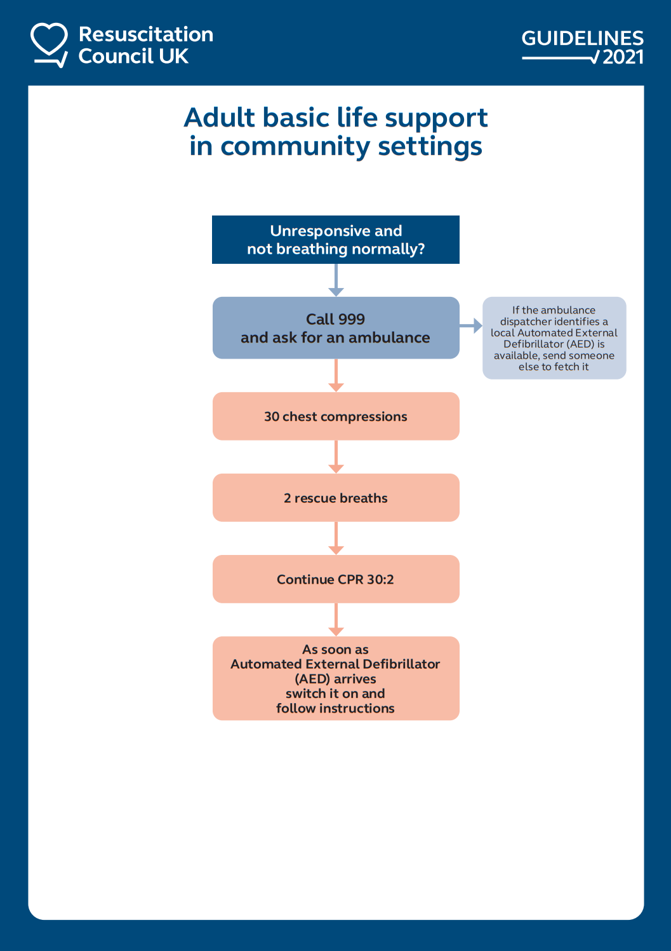

Appendix B: Adult in-hospital Resuscitation Algorithm
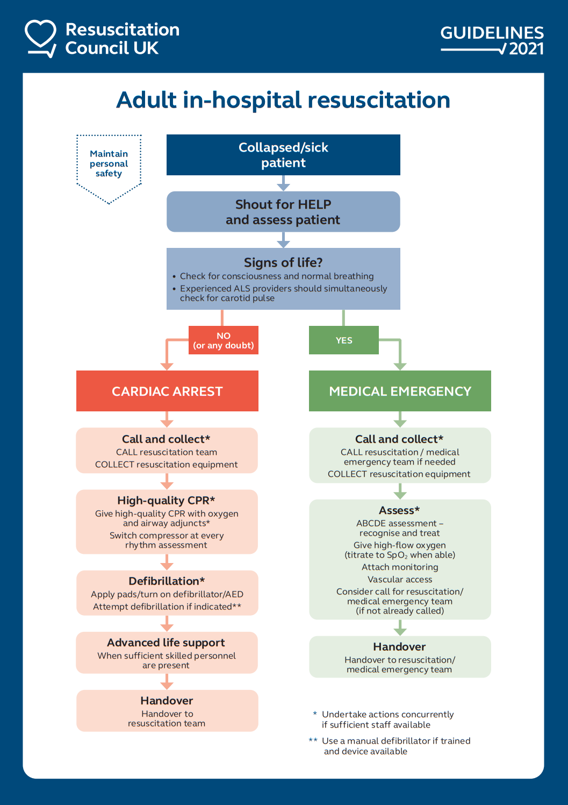

Appendix C: Adult Advanced Life Support Algorithm
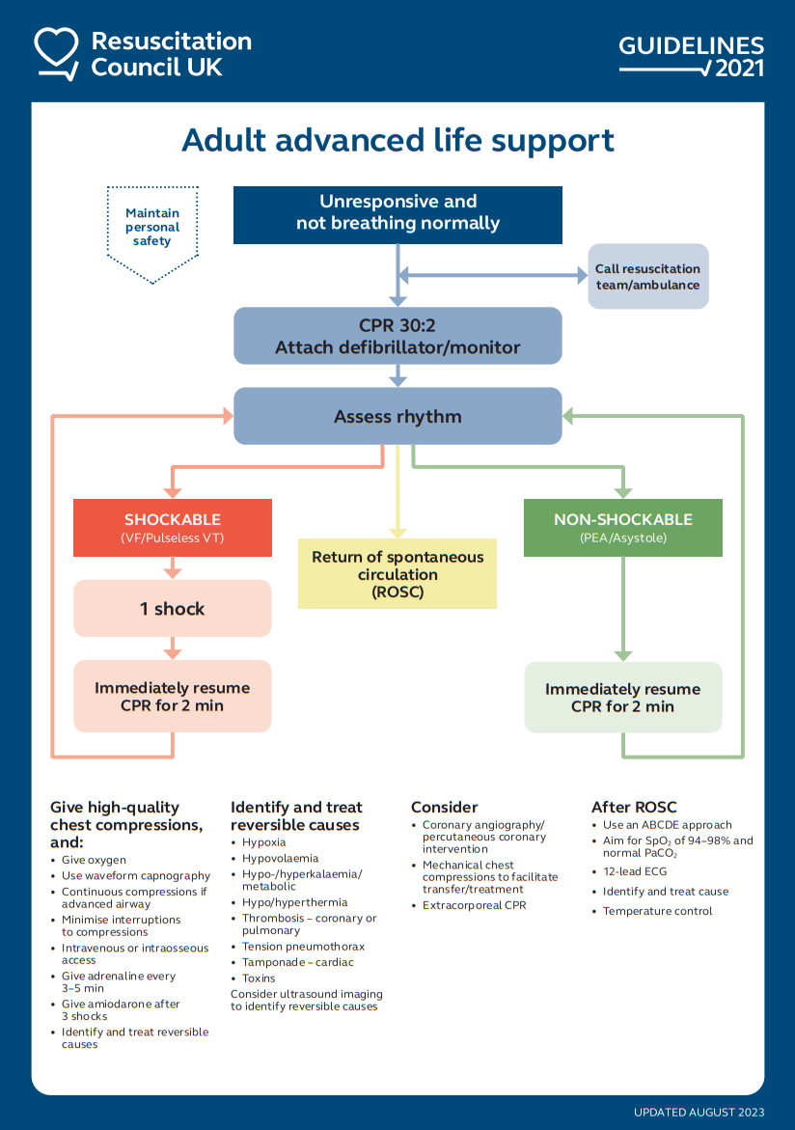

Appendix D: Adult Choking Algorithm
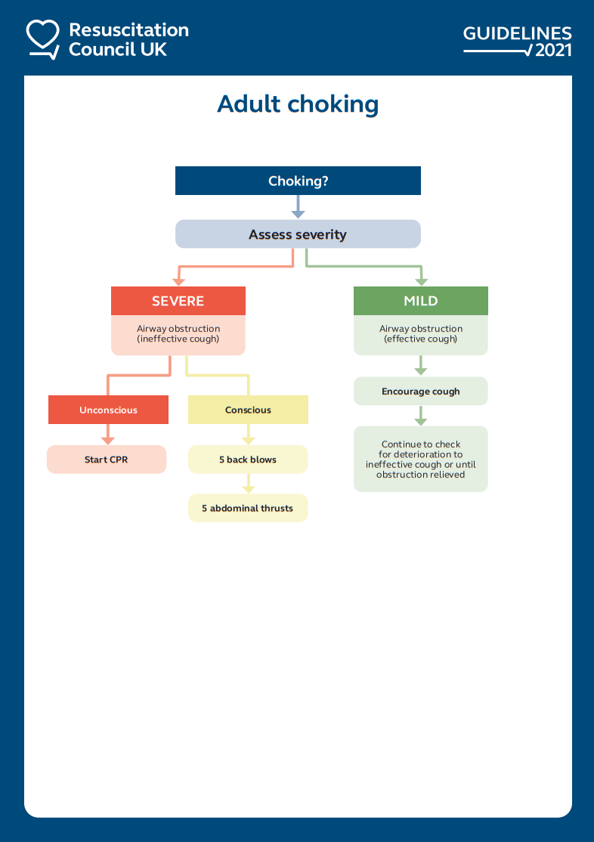

Appendix E: Paediatric Out-of-Hospital Basic Life Support Algorithm
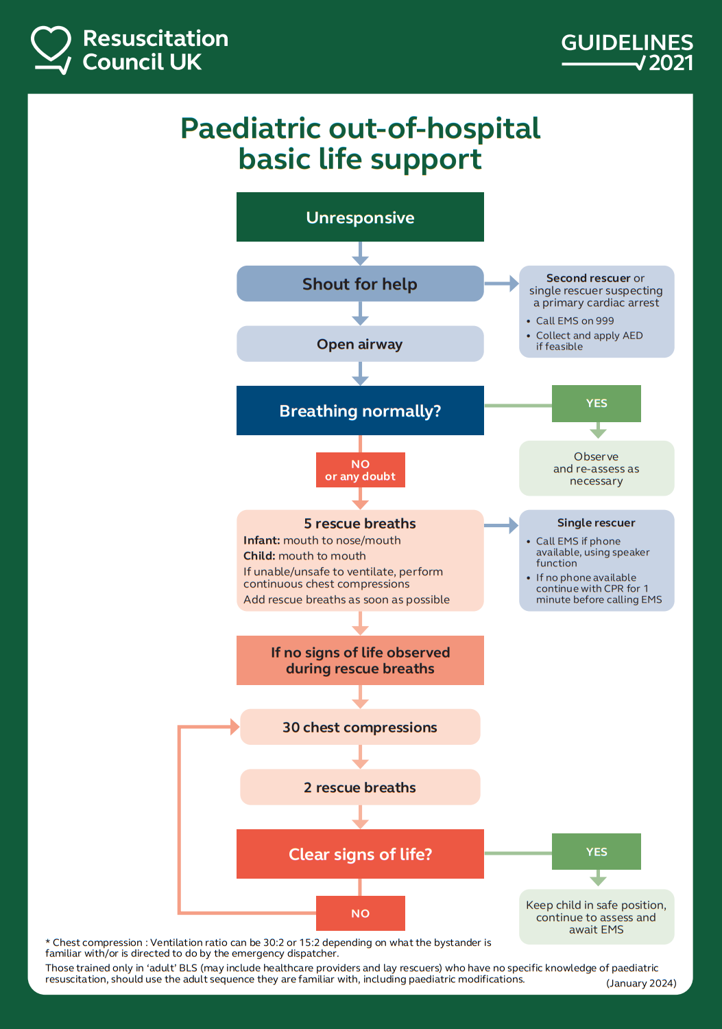

Appendix F: Paediatric (in-hospital) Basic Life Support Algorithm
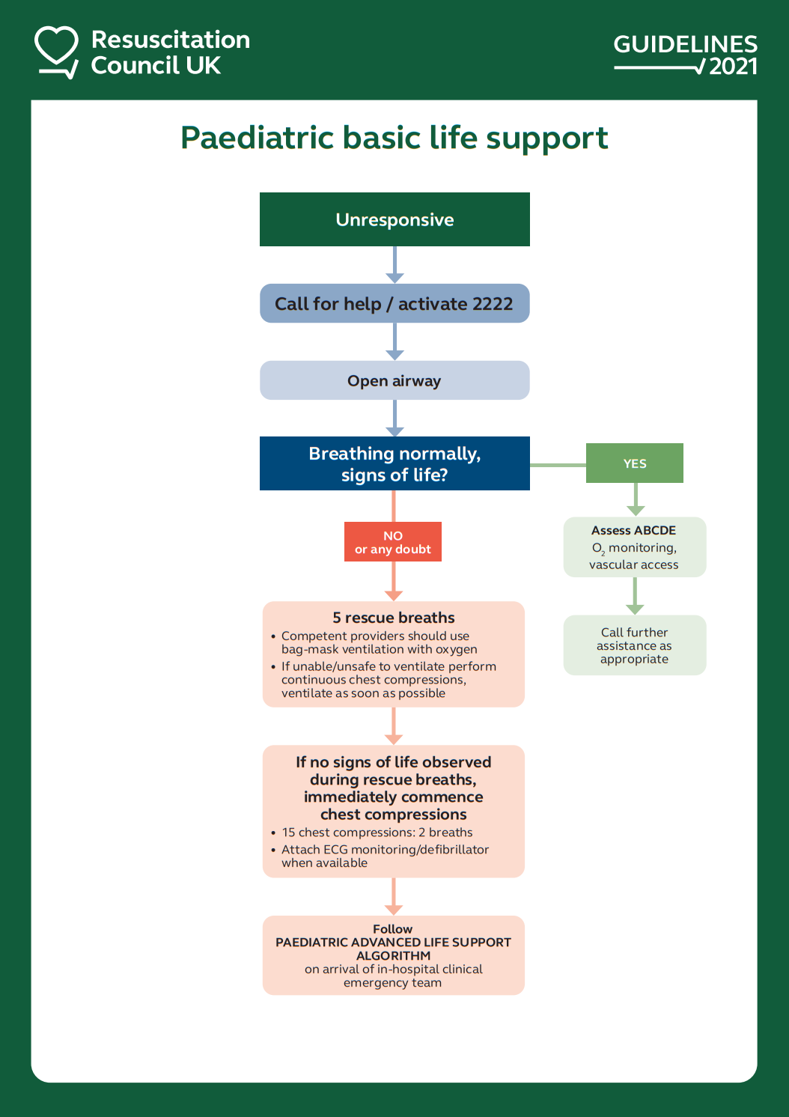

Appendix G: Paediatric choking / foreign body airway obstruction algorithm
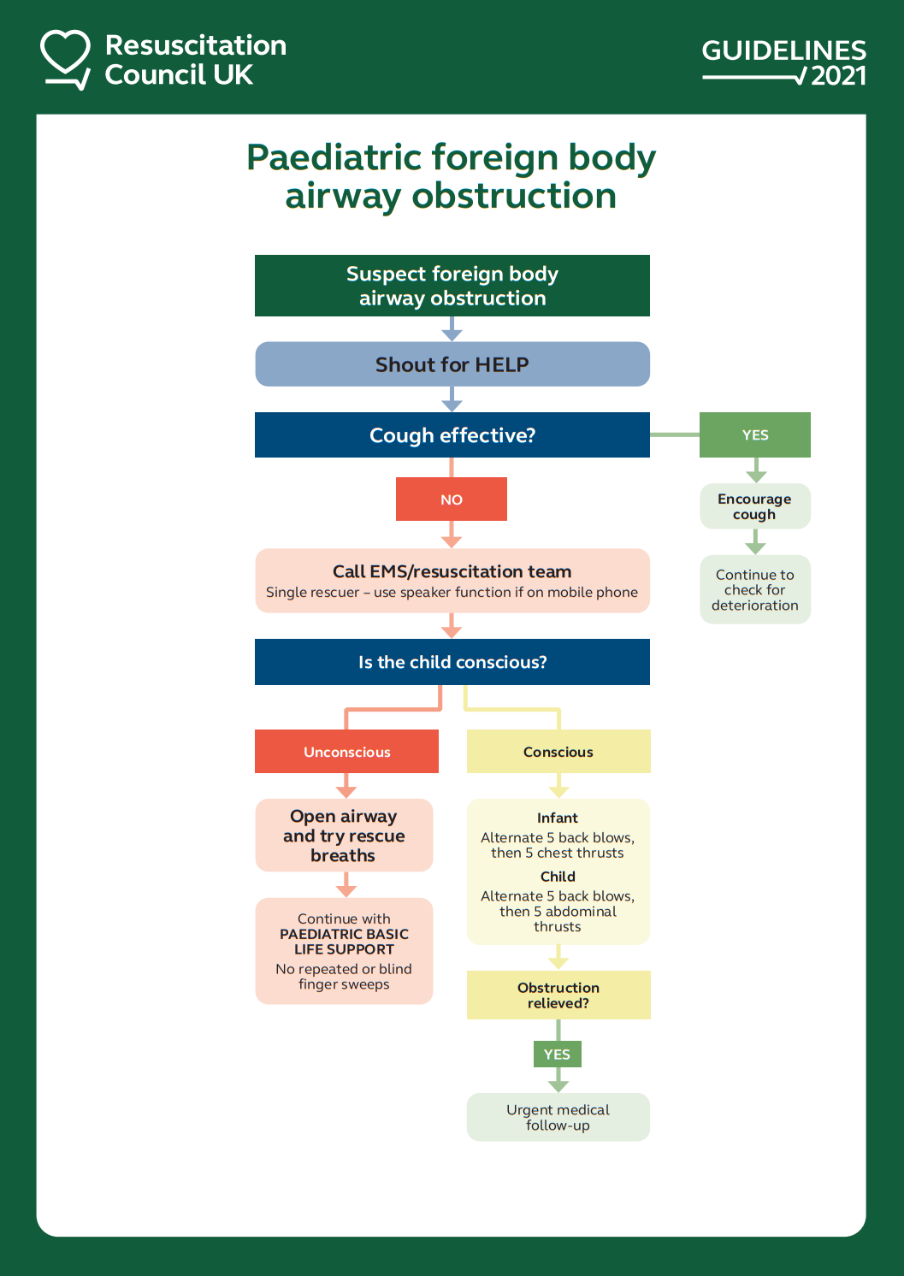

Appendix H: Lifepak CR2 AED Verifying Readiness

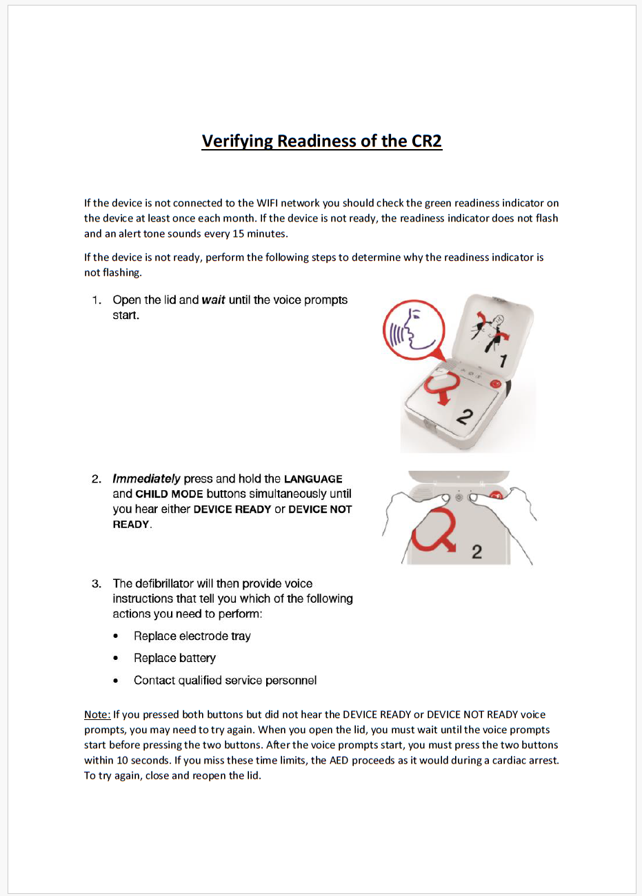

Appendix I: Philips HS1 AED Verifying Readiness
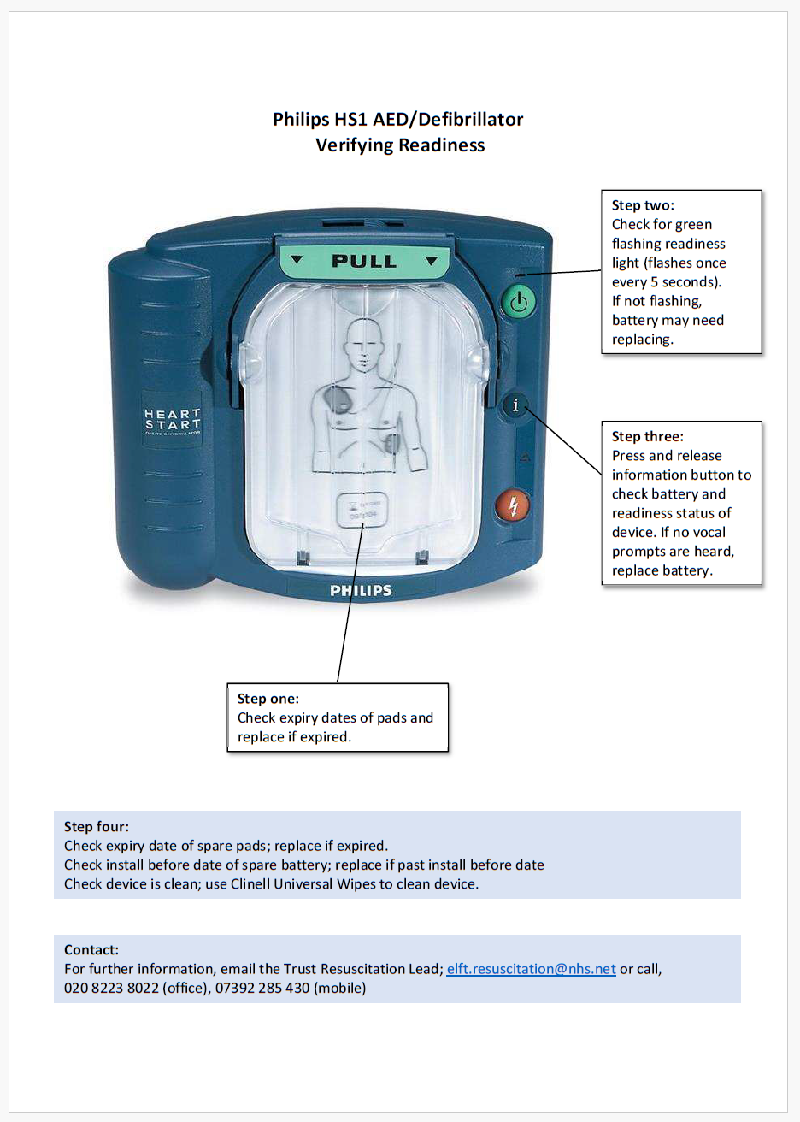

Appendix J: Philips FRx AED Verifying Readiness
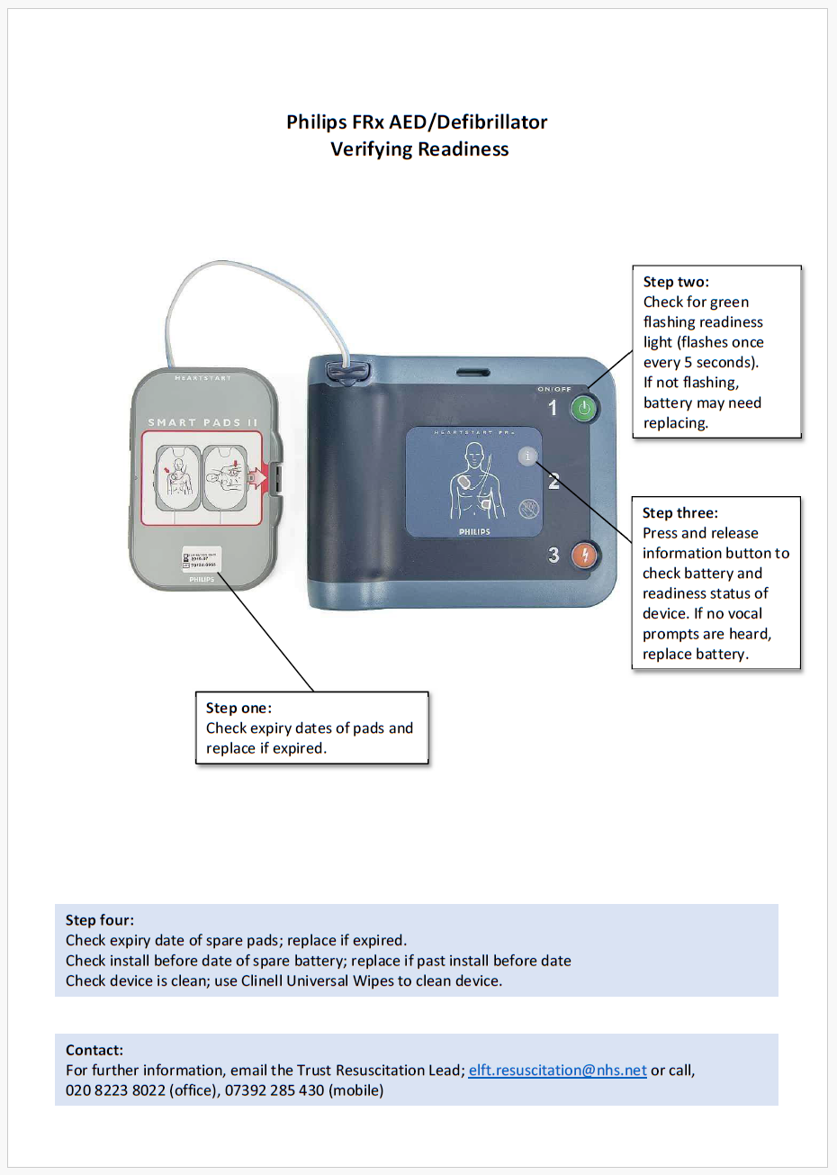

Appendix K: Automated External Defibrillators (AED) Flowchart

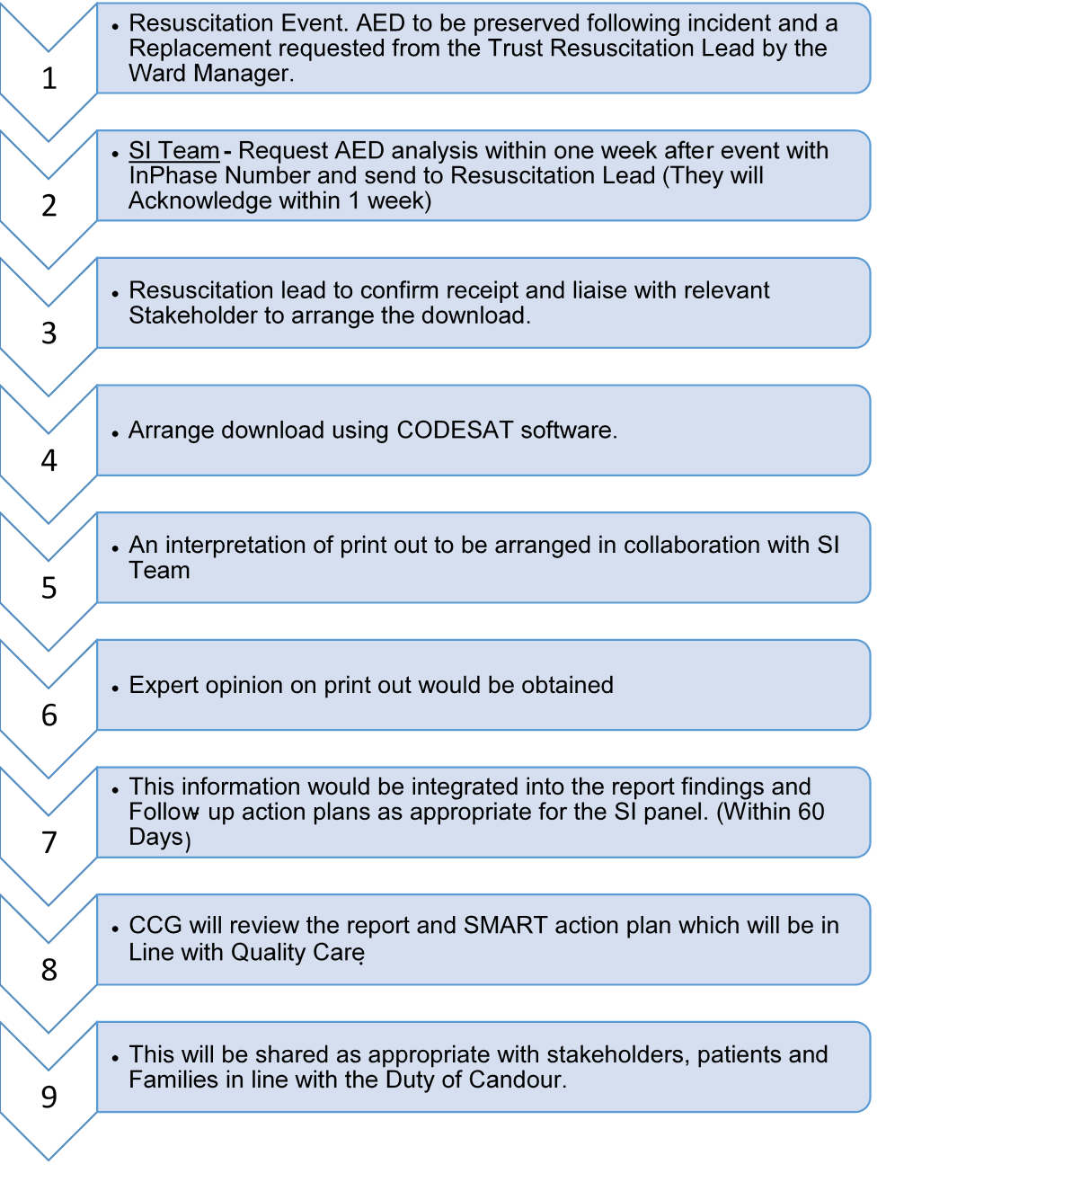

Appendix L: Standard AED Sign
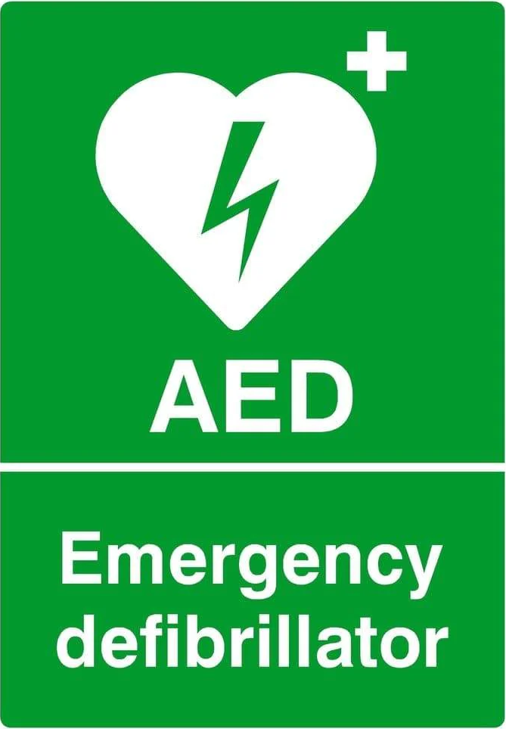
Appendix M: Standard ‘Nearest AED is Situated at’ Sign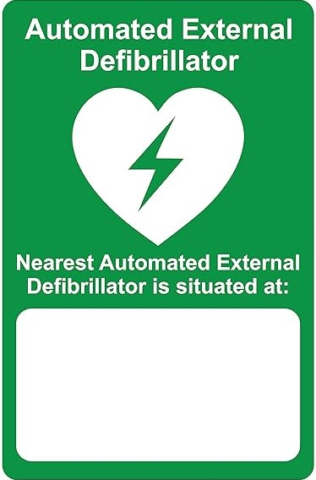
S | Situation  • My name and designation is:  • I am calling from:  • I am calling about (patient or situation):  • I am calling because:
B | Background  • Patient has been admitted to ward or open to service (X) on (date):  • Patient has been known to services since (date):  • Relevant clinical history: physical health, mental health, risk  • Previous concerns relevant to current presentation of patient
A | Assessment  • Current presentation / circumstances / medication  • Physical health observations (vital signs) - contact and non-contact:  • Current risk: harm (self or others), aggression, vulnerability, absent or missing from care  • Capacity / consent issues
R | Recommendation  • Provide necessary information  • Additional advice needed  • Attend to review patient – urgent / routine  • Additional escalation needed
D | Decision  • Additional information received / not received  • Additional advice received / not received  • Patient review will take place at (time):  • Further escalation will be carried out by:  • Further actions will be carried out by:

Appendix M: SBARD- Communication clinical handover tool

Appendix N: The Resuscitation Committee: Terms of Reference (TOR)

1.0 Purpose:
Guided by Resuscitation Council UK quality standards, the Trust has an obligation to provide a high-quality resuscitation service including standardisation of training, emergency equipment and drugs. The Trust has to ensure that quality standards for managing medical emergencies and cardiopulmonary resuscitation meet the needs of patients within the various health settings that the Trust operates in, and that there are clear lines of accountability within the organisation

2.0 Duties:
In carrying out its role, the resuscitation committee will:

- Ensure the resuscitation policy is aligned with the RCUK guidelines Medicines & Healthcare products Regulatory Agency (MHRA) and National Audit Office recommendations.

- Monitor implementation and adherence of the resuscitation policy.

- Gain assurance from the Learning and Development Department that staff receive appropriate/timely training and competency assessment in the management of medical emergencies.

- Monitor and support Quality Improvement (QI) projects related to the deteriorating patient and cardiorespiratory resuscitation.

- Review lessons learnt from resuscitation audits so as to inform cross organisational learning, training programs and best practise.

3.0 Constitution, Membership and Procedures:
3.1 Members:
Chief Medical Officer (Chair)
Resuscitation Lead (Deputy Chair)
DDIPC and Trust Physical Health Lead
Directors of Nursing
Chief Pharmacist / identified deputy in lieu of Chief Pharmacist
Learning & Development
Medical Devices Lead
Representation from Older Adult Lead across the Trust
Representative from Bedfordshire
Representative from CAMHS
Representative from CHN
Representative from City & Hackney
Representative from Forensics
Representative from Luton
Representative from Newham
Representative from Tower Hamlets
Representation from Primary Care
Service user representative
Lead for Duty senior nurses

3.2 All members are expected to attend every meeting or nominate a named deputy.

3.3 A record of attendance shall be kept. All committee members are welcome to attend.

3.4 Other Trust staff will be required to attend to address specific issues as they arise.

- The Chair is the Chief Medical Officer, and is a permanent and full member of the Committee. The Chair shall not serve as one of the Departmental representatives as well as being Chair.

- The Resuscitation Lead is the Deputy Chair, and is a permanent and full member of the Committee.

- The composition of the Committee includes one representative from each of the key clinical departments or boroughs within the entire Trust.

- If the nominated representative from any department cannot attend, they may send a deputy who has been suitably briefed.

- There is no maximum term of office for any member.

- Appropriate representatives from other specialities or departments may be co-opted onto the committee for single meetings or defined periods of time as necessary to assist the committee in its deliberations and discussions.

- All representatives shall be expected to facilitate and maintain two-way communications between those working in the area they represent and this committee.

- Members should maintain a regular attendance at meetings.

- Those missing meetings on a frequent basis should consider standing down so that a new representative may be nominated from that area.

- A quorum is required for the committee meeting to process discussion and action.

- The Resuscitation Lead and the Chief Medical Officer must be present within the quorum for discussion and actions to be processed.

4.0 Accountable to:
The Resuscitation Committee is responsible to the Trust Board of Directors via the Quality Committee & Quality Assurance Committees. As a minimum, the Resuscitation Committee will: provide a briefing note, escalating key issues, to the Quality Committee after each of its meetings; concerns are to be escalated to the Board via the Quality Committee; present areas of specific interest or concern at the request of the committee as required and provide an Annual Report.

5.0 Liaison with:
The resuscitation committee liaises with the:

a) Medical Devices Committee
b) Drugs & Therapeutics Committee
c) Clinical procedures Committee
d) Infection Prevention & Control Committee
e) Electro-Convulsive Therapy Committee
f) Divisional Governance and Patient Safety Improvement Groups
g) Physical Health Group
h) Patient Safety Committee.

6.0 Working between the Board and its Committees
6.1 The Resuscitation Committee will provide a briefing note, escalating key issues, to the Quality Committee after each of its meetings. It will also provide regular reports to the Physical & Mental Health Committee & the Medical Device Committee. The Chairs of the Resuscitation, Physical & Mental Health and the Medical Device Committees should meet regularly in order to discuss the escalation of reports and gaps in assurance or control. The Resuscitation Lead shall also be a member of the Physical & Mental Health Committee and the Medical Device Committees.
6.2 The Resuscitation Committee may remit matters to any other Committee as the Chair finds appropriate, and vice versa. Minutes of the resuscitation Committee will be circulated to other Committee Chairs. The Committee will work with other Committees as appropriate.
6.3 Each Committee will consider the effectiveness of these arrangements as part of their annual review and report to the Quality Committee.

7.0 Frequency of meetings:
- Meetings will be held at least 6 times a year. The Committee Chair may call an
“Extraordinary” meeting of the Committee, as required to support service needs.

8.0 Conduct of meetings:
- All procedural matters in respect of the conduct of meetings shall follow the Trust’s standing orders.
- The Chair and administration support will review the agenda in advance of meetings and the effectiveness of the committee after each meeting.
- Archives of minutes and papers relating to Resuscitation Committee meetings are kept on the Trust shared drive.

9.0 Quorum:
A quorum shall be 6 members to include the following (or their deputy)
- Resuscitation Lead
- Chief Medical Officer
- Deputy Director of Nursing / Assistant Director of nursing, Physical health
- Operational Directorate representatives (at least 4)

Appendix O: Medical Emergency / Resuscitation Equipment – daily checklist FLOWCHART

- To get started the entire contents of the bag/trolley needs to be checked against the RESUSCITION MERT check sheet to ensure the appropriate items are in place, recording the expiry date of each item.
- Check with your manager where spare MERT items can be found, some localities have a store room or cupboard with only MERT bag replacements items.
- Any expired or soiled items must be removed.
- On completion of the checks, lock the main compartment of the MERT bag with a red tamper evident security seal (metro lock)
- The MERT bag/trolley needs to be checked daily against the RESUSCITION MERT check sheet to ensure all of the equipment is in place and ready for emergency or urgent use. This needs to be signed and dated by the checking nurse.
- Only the two front compartments need to be checked daily.
- There is no need to unlock the main compartment unless it is to replace an out-of-date or missing item, after which a check of the entire contents recording the expiry date of each item must be performed.
- If the MERT bag/trolley is found to be unsealed or the security seal number does not match the number on the check sheet check, the bag must be opened and a check of the entire contents recording the expiry date of each item, must be performed.
- Ensure the next item that is first to expire is stated on the checklist, e-mail the ward manager within good time to ensure these items can be replaced.
- Check that the spare oxygen cylinder in the treatment /clinical room is full. Where Oxygen cylinders need replacing the ward manager must be notified who will then arrange re-order oxygen.
- Check that the AED has a flashing ready light – this indicates that it is ready for use. Ensure there are spare pads and a spare battery compatible with the device.
- Check that emergency pharmacy drug bag is locked with a green metro lock. Order a replacement via pharmacy if the bag is unlocked.
- Test the Suction Machine as per the manufactures instructions. The yankauer catheter wrapping must not be opened.
- Ensure used, expired or missing items are replaced and the bag is ready for use. Contact your manager if any items are not available ASAP

Appendix P: Quick Reference Guide to the Resuscitation Equipment New Style Check Sheet

Quick Reference Guide to the
Resuscitation Equipment New Style Check Sheet

Introduction
East London NHS Foundation Trust has introduced a Standardised Cheek Sheet for the MERT bags/trollies, which replaces the variety that are used across the Trust. The purpose is to ensure that the form is fit for current practice and standards, aid the checking of contents and to assist staff when moving from ward to ward or between Directorates to remain familiar with the layout and the forms completion.

Layout
Each Check Sheet covers a two week period and is split into four sections.

Section 1 is to be completed daily.
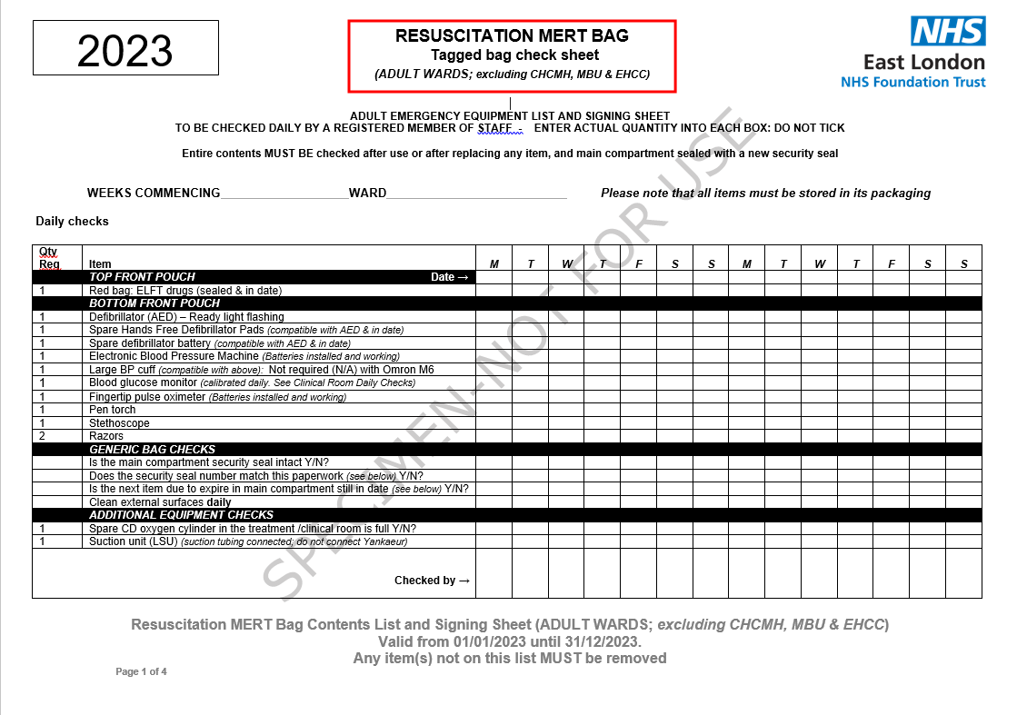

Section 2 is to be completed after use, when replacing an out-of-date/missing item or if found to be unsealed during the daily check.
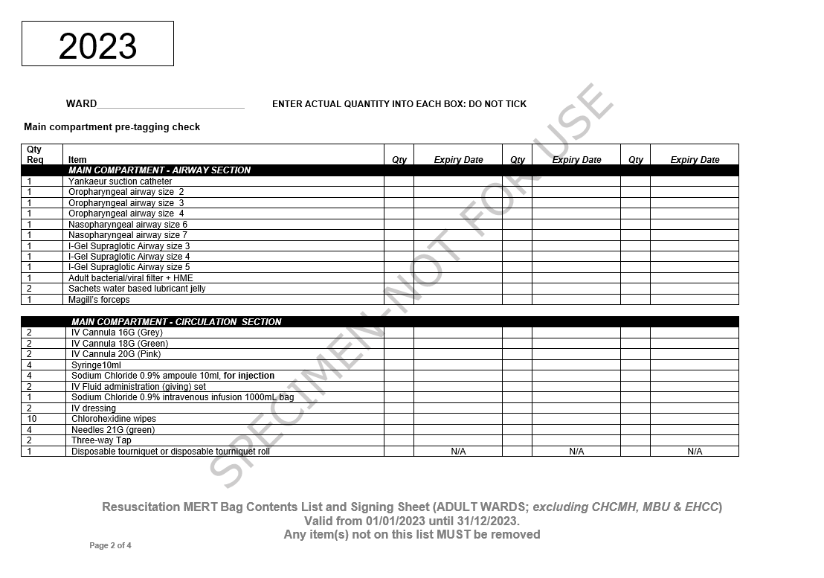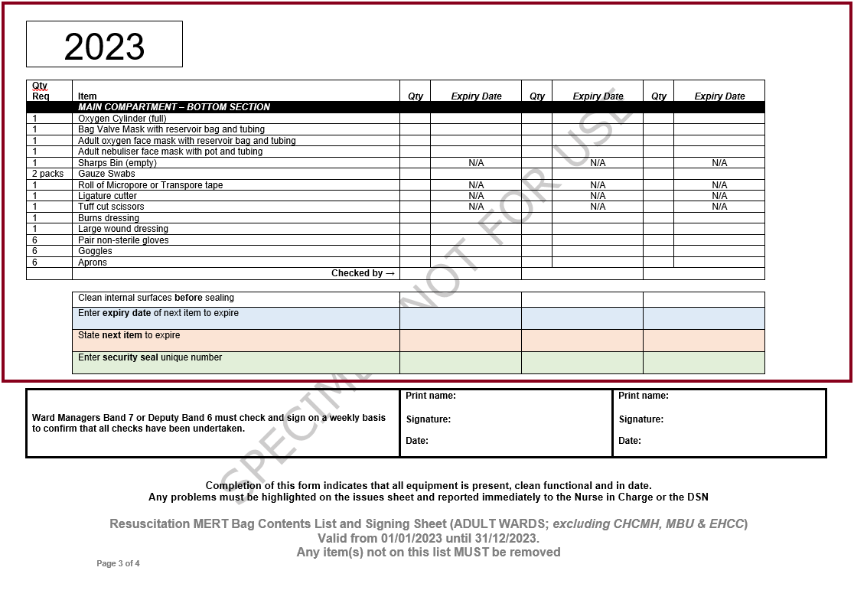

Section 3 is to be completed weekly
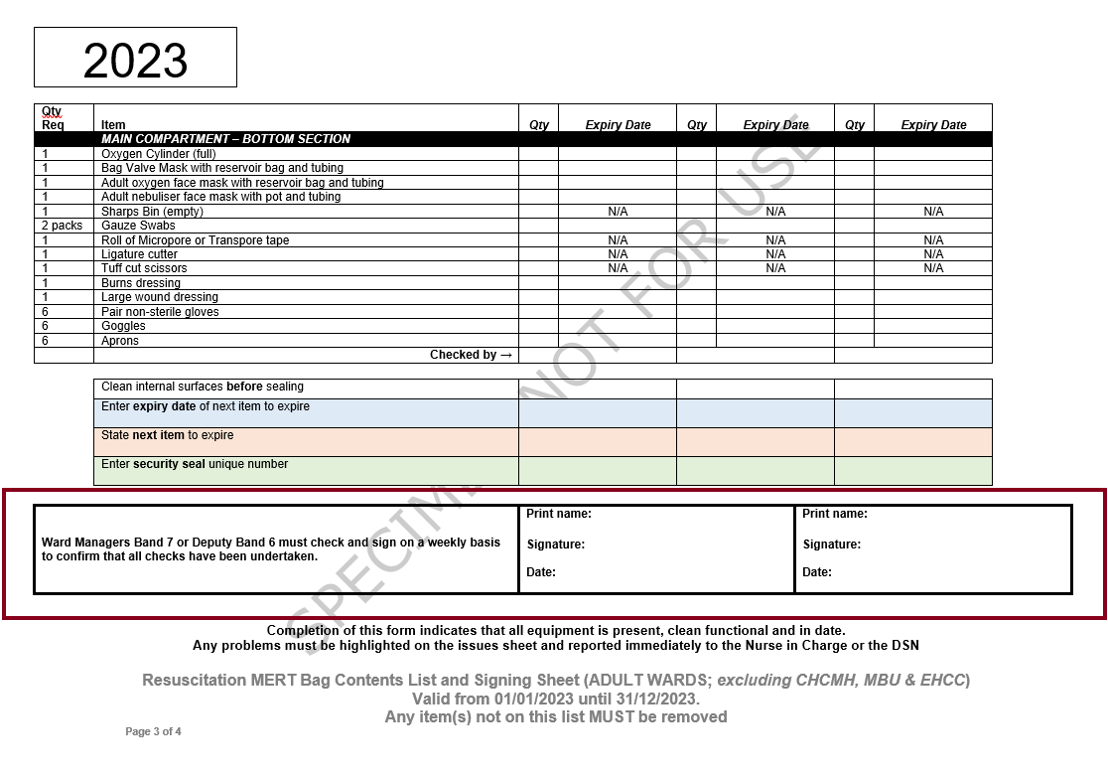

Section 4 is to be completed as required, to report or close an issue
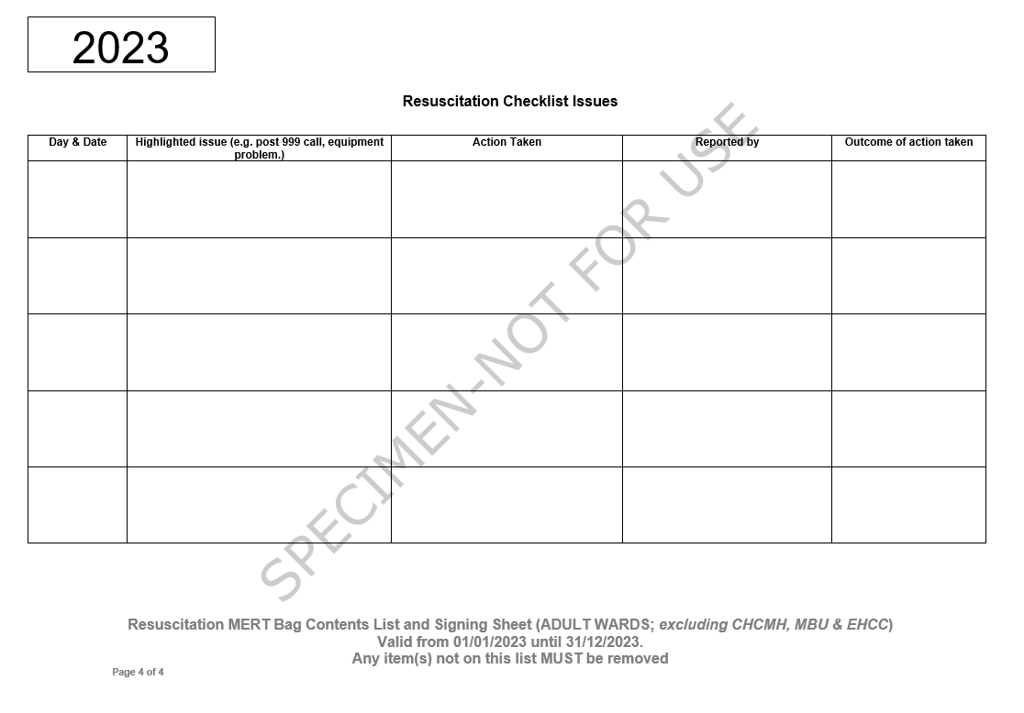

How to complete the Daily Checks

Enter the ‘Weeks Commencing’ date and the ‘Ward’ name

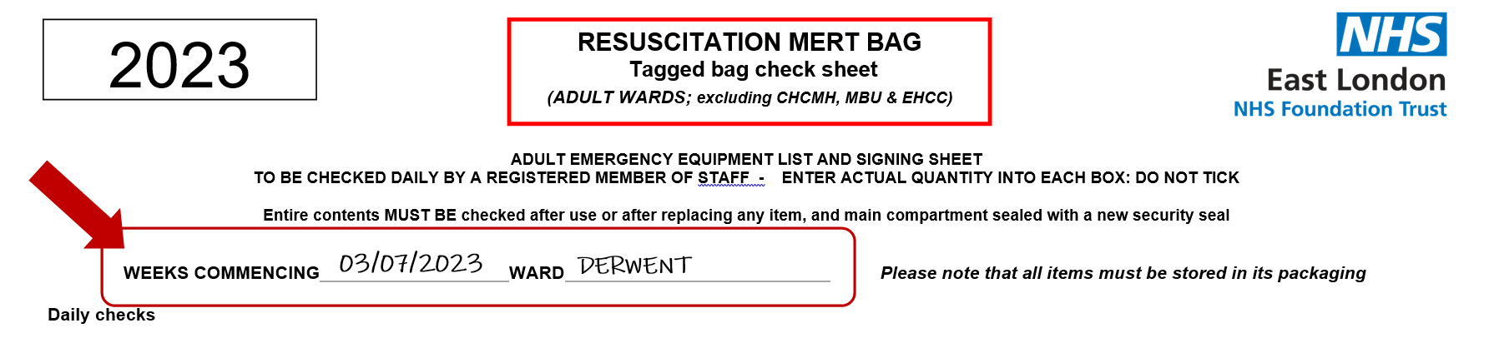

Enter the date for each day.
Enter the actual quantity into each box; do not tick.
Enter your initials.

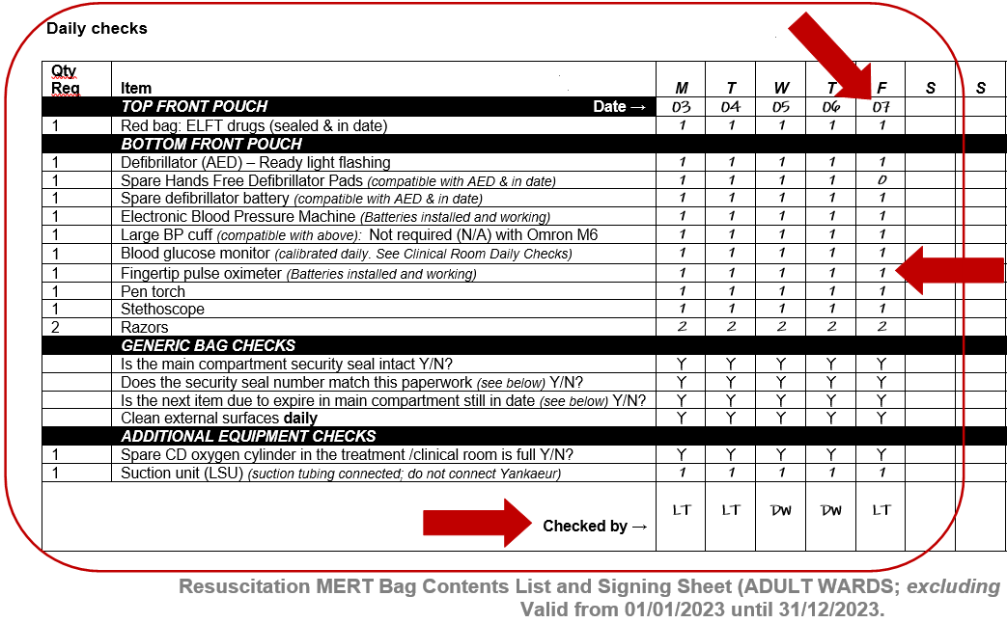

Generic Bag/Trolley Checks.

Cross reference that the security seal number matches the one further down in the document and that the next item due to expire in the main compartment is still in date.

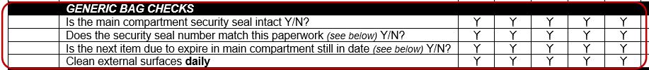

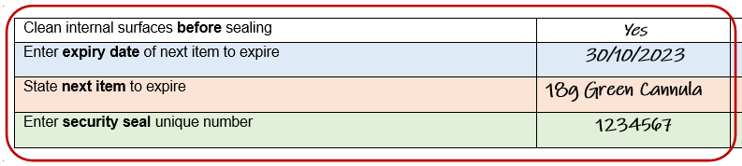
30/10/2150

Check the ‘Resuscitation Checklist Issues’ page for any reported issues. Follow up on those outstanding. Record any issues you have found during your check.

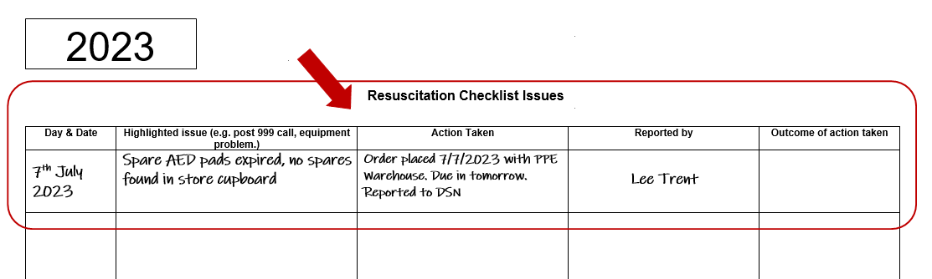

If the security seal number matches the paperwork and there are no items that need replacing or can be replaced from outstanding issues, there is no need to open the sealed compartment(s).

Management Weekly Checks.

Ward Managers Band 7 or Deputy Band 6 must check and sign on a weekly basis to confirm that all daily checks have been undertaken.



You are not signing to confirm the daily checks are accurate, merely that they have been performed daily. You should also review the ‘Resuscitation Checklist Issues’ page so you are aware of any issues, and to ensure outstanding issues are followed up promptly.

How to complete a Full Equipment Check (post incident/replacing equipment/opening).

A full equipment check must be undertaken whenever the main compartment or draws of the bag/trolley has been opened and/or the tamper seal has been removed.

Enter the actual quantity into each box; do not tick.

Enter the expiry date. Where the quantity is more than one for an item and each has a different expiry date, for example ‘2 packs Gauze Swabs’ where one pack expires 01/12/2163 and the second expires 28/02/2164, the date of the first to expiry must be used, therefore ‘01/12/2163’ is entered.
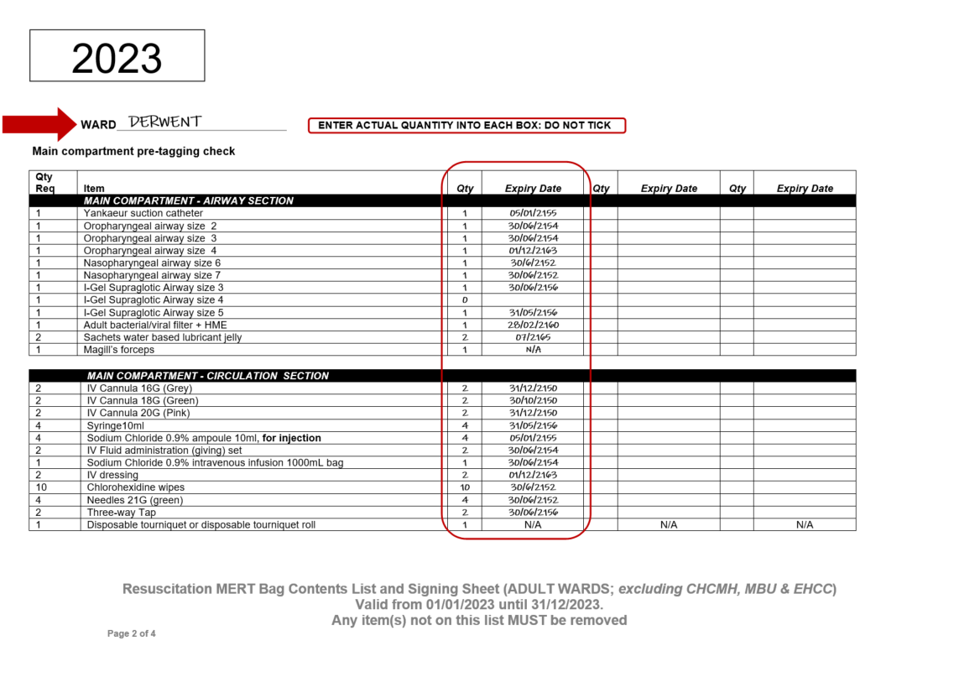

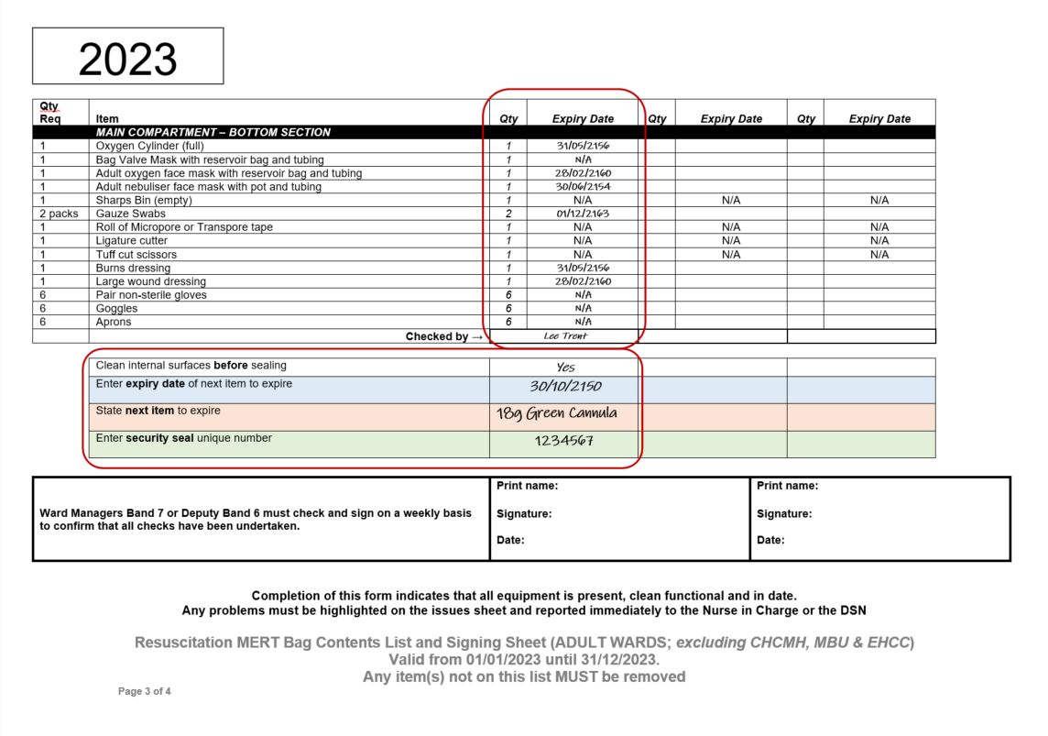

Clean all internal surface before attaching the security seal.
Enter the expiry date of the next item to expire and what that item is.
Attach a new tamper security seal and record its unique number.

30/10/2150

Further Guidance.

Further guidance can be obtained from;
- Physical Health Nurse(s)
- Ward manager(s)
- Resuscitation Lead

Appendix Q: Full List of Equipment

 | Office only sites | Community Teams at ELFT Locations | GP practices (minimum requirement) | Spitalfields Medical Centre - Health E1 | Adult Inpatient Wards (excluding CHCfMH) | CAMHS Inpatient Wards | Adult Wards at CHCfMH | Mother & Baby Unit at CHCfMH | Electro-Convulsive Therapy (ECT)
Defibrillator (AED) - pads pre-attached
Spare defibrillator battery (compatible with AED)
Hands free defibrillator pads (compatible with AED)
Tuff cut scissors
Razor
Non-sterile gloves
Alcohol wipes
Drying towel
Adult oxygen face mask with reservoir bag and tubing
Adult nebuliser face mask with pot and tubing
Bag Valve Mask with reservoir bag and tubing
Adult bacterial/viral filter + HME
Catheter mount
Child Bag Valve Mask with reservoir bag and tubing
Child Mask Size 1
Child Mask Size 2
Child non-rebreather oxygen face mask with reservoir bag and tubing
Oropharyngeal airway size 0
Oropharyngeal airway size 1
Oropharyngeal airway size 2
Oropharyngeal airway size 3
Oropharyngeal airway size 4
Nasopharyngeal airway size 5
Nasopharyngeal airway size 6
Nasopharyngeal airway size 7
I-Gel Supraglotic Airway size 3
I-Gel Supraglotic Airway size 4
I-Gel Supraglotic Airway size 5
Cuffed Endotracheal Tube size 6.0mm
Cuffed Endotracheal Tube size 7.0mm
Cuffed Endotracheal Tube size 8.0mm
Cuffed Endotracheal Tube size 9.0mm
Endotracheal tube introducer 15CH (bougie)
Adult laryngoscope handle
Size 3 Macintosh disposable laryngoscope blade (compatible with handle)
Size 4 Macintosh disposable laryngoscope blade (compatible with handle)
Size C Battery for laryngoscope
10ml syringe for cuff inflation
20ml syringe for cuff inflation
Roll of 3 metre 2’’ ribbon gauze
Sachets water based lubricant jelly
Magill’s forceps
Portable Suction Machine-
Yankaeur suction catheter
Suction catheter size 14CH
Suction catheter size 12CH
CD Oxygen Cylinder
Fingertip pulse oximeter
Stethoscope
Waters circuit
Caresite needle free cannula pack
Curved sterile scissors
IV Cannula 14G (Orange/Brown)
IV Cannula 16G (Grey)
IV Cannula 18G (Green)
IV Cannula 20G (Pink)
Disposable tourniquet or disposable tourniquet roll
IV dressing
Chlorohexidine wipes
Chloraprep sepp 0.67ml
Sodium Chloride 0.9% ampoule 10ml, for injection
Blunt fill needles
Needles 21G (green)
Syringe 20ml
Syringe10ml
Syringe 2ml
Syringe 1ml
Gauze Swabs
Roll of Micropore or Transpore tape
Blood tubes – Urea and electrolytes U&E Serum (Yellow)
Blood tubes – Full Blood Count - FBC (Purple)
Blood tubes – Coagulation (Blue)
Blood tubes – Group & Save/Cross-match (Pink)
Blood tubes – Glucose (Grey)
Arterial Blood Gas Syringe
Three-way Tap
Red bag: ELFT drugs (sealed)
Sodium Chloride 0.9% intravenous infusion 1000mL bag
Sodium Chloride 0.9% intravenous infusion 500mL bag
Gelspan 500ml
Hartmans 1000ml
10% Glucose 500mL bag
5% Glucose 500mL bag
Blue box: Homerton drugs (sealed)
IV Fluid administration (giving) set
Disposable scalpel No10
Electronic Blood Pressure Machine
Large BP cuff (compatible with above): Not required if using Omron M6
Pressure infusion bag
Manual Defibrillator (One only per site)
Hands free defibrillator pads (compatible with defibrillator)
Defibrillator paper (compatible with defibrillator)
Pen torch
Goggles
Aprons
Burns dressing
Large wound dressing
Ligature cutter
Blood glucose monitor
Level 3, AGP PPE in box
Sharps Bin
EZ-IO Intraosseous Vascular Access System

Appendix R: Medical Emergency – Ambulance Access to the Mental Health Unit at Mile End Hospital

Protocol
Medical Emergency – Ambulance Access to the mental Health Unit at Mile End Hospital

APPROVING COMMITTEE(S) | TH DMT | Date approved:
EFFECTIVE FROM | 12/12/22
DISTRIBUTION | Barts Health security manager and staff, All ward managers in MEH, Site Managers and Matrons and all operational staff
RELATED DOCUMENTS
STANDARDS
OWNER | Borough Lead Nurse
AUTHOR/FURTHER INFORMATION | Deputy Borough Lead Nurse
SUPERCEDED DOCUMENTS | None
REVIEW DUE | As required
KEYWORDS | Ambulance Staff Access
LOCATION(S) | DSN Folder – K drive

CONSULTATION | Barts Health

- INTRODUCTION
This prtocall has been drawn up to describe the process which allows emergency ambulance staff to access the Mental Health Unit unimpeded at anytime.
Process
When a medical emergency has been called all members of the rapid response team will attend. The duty senior nurse is responsible for facilitating ambulance staff access to the unit if needed.

When a decision has been made to call for assistance from the amulance service the duty senior nurse will identify one staff member to meet the ambulance staff at the front of the hospital to escort them to the incident.
The staff member calling the ambulance service must inform the call handler that the ambulance team will be met at the main entrance of the hospital.

This staff member will first instruct the security guard in the mental health units reception area to radio and inform the rest of the security team that an ambulance has been called and will be attending the hospital.

Out of hours the security team will need to unlock the main gate to allow the ambulance onto the site. The gate should remain unlocked until the ambulance team have left the hospital. It must be noted that generally more than one amulance unit will attend an emergancy call. The staff member from the rapid response team will escort the amblance team to the incident.

Recording
Any entry in the duty nurse report regarding a medical emergency should include a desription of the process implemented to allow ambulance staff access to the unit.

Security staff should also log all radio calls and actions in relation to providing access to ambulance staff to the Mental Health Unit.

Duties and Responsibilities
Security, Nursing and medical staff on inpatient wards MEH | Be aware of the process for facilitating access to emergency services to the Mental Health Unit.
Site Managers and service managers | Be aware of this process and flag up any issues with its implementation.
Nursing and security managers | Ensure that this process is part of the induction of any new staff members.
Resuscitation leads | Be aware that training for ILS/BLS specifically for Tower hamlets should include this process as appropriate.

Appendix S: Resuscitation Audit Form

Name of patient:
DOB:
Hospital / NHS number:
Reported by:
Designated Ward:
Reported to:
Date of incident:
Datix Incident number:

Audit issues: | Comments: | Recommended Action: | Who for: | R  A  G
1.  2. | Background to the incident- State nature of incident e.g. sudden death, attempted suicide, stroke, Cardiac arrest, fall, seizure, rapid tranquilisation  Overview of the Early Warning Scores (NEWS 2) vital signs chart within the past 7 days of the incident (refer to NEWS audit). Was there evidence that high scores were escalated in keeping with action protocol? Was there a physical care plan in place to highlight risks?

3.  4. | Were the baseline vital signs performed on admission?  Response times and interventions used during Resuscitation event  Was there a delay in starting basic life support/immediate life support? Was help called asap? E.g. alarms activated,  2222/999, did the emergency team respond appropriately?  On finding an unresponsive person, staff are expected to use the Airway Breathing Circulation Disability Exposure approach to assess and treat the patient. If there are no signs of life (based on purposeful movement, normal breathing, coughing) Chest Compressions should be commenced immediately, Oxygen 15L/min via a bagvalve-mask and placing of Defibrillation pads/electrodes on the chest until the arrival of Medical staff who may be able to obtain IV access for fluids and IV drugs.  During the treatment of persistent asystole/Pulseless electrical activity, emphasis is placed on good quality chest compressions between defibrillation attempts, recognising and treating reversible causes and obtaining a secure airway and IV access.  Staff that discovers the patient is expected to begin and continue CPR once a cardiac arrest is confirmed until told otherwise by someone with more experience or until death is confirmed by a doctor or paramedic.  Emergency Equipment used  Was the emergency equipment brought to the scene without delay? Was the equipment used in keeping with the standardised list of contents, were they in good working order and was there evidence of weekly checking to ensure all items were present and not expired? Was equipment stored safely and readily accessible during the incident? Were items used replenished asap (within the same shift)?  Staff training in Basic Life Support (BLS) or Immediate  Life Support (ILS)  Refer to training needs analysis for staff involved in the incident; include bank/agency staff records if available. Did an in-situ simulation of medical emergency including familiarisation of emergency equipment take place in the past 6 months?
5.  6. | Vital signs of the patient prior to the incident occurring  Were the vital signs of the patient in keeping with the Engagement and vital signs policy; were the staffing levels appropriate for the shift? Did a visual handover take place at the beginning of the shift where the incident occurred? In the event of a sudden death at night were vital signs of the patient documented hourly? Was the body warm or cold to touch?  Post resuscitation incident  Was the room preserved as a crime scene in the event of a death on the ward? Was Last offices considered? How was privacy and dignity maintained during and following incident? Were the family and police informed immediately? Did a debrief occur within 72hours post incident? What support was offered to both staff and any patient involved?  Impressions  Was the response to this resuscitation event in keeping with trust policy? Areas of good practice, was there missed opportunities to avoid the incident from occurring in the first place?  Recommendations: What are the immediate recommendations for ensuring patient safety? E.g. risk assessment and risk management, review of staffing levels, investigation of staff performance, staff training.

Appendix T: References and Related Policies
References

Resuscitation Council UK 2021 Resuscitation Guidelines

Resuscitation Council UK Quality Standards: Primary care May 2020

Resuscitation Council UK Quality Standards: Acute Care July 2023

Resuscitation Council UK Quality Standards: Mental health inpatient care May 2020

Resuscitation Council UK Quality Standards: Community hospitals care May 2020

The ECT Accreditation Service (ECTAS)
http://www.rcpsych.ac.uk/workinpsychiatry/qualityimprovement/qualityandaccreditation/ectclinics/ectas/ectasstandards.aspx

Trust Related Policies

Clinical Risk Assessment and Management Policy V4.0 October 2011

Infection control IPC Manual V13 November 2022

Cardio-Pulmonary Resuscitation COVID-19 (Exceptional) Standard Operating Procedure Version 2.2 1st May 2020

Electro-Convulsive Therapy (ECT) Policy V3 July 2019

Resuscitation Information (Trust Intranet)

www.elft.nhs.uk/intranet/teams-support-me/physical-health-teams/resuscitation

