

Severe Weather Plan

Version number: | 2.1
Consultation Groups | Executive Team  Service directors  NHSE (London) EPRR Team  NHSE (Midlands and East) EPRR Team
Approved by (Sponsor Group) | Trust’s Accountable Emergency Officer
Date approved | 15th October 2024
Ratified by: | Quality Committee
Date ratified: | 23rd October 2024
Name of originator/author: | Health, Safety, Security and Emergency Planning Manager
Executive Director lead: | Edwin Ndlovu
Implementation Date: | October 2024
Last Review Date | October 2024
Next Review date: | October 2027

Services | Applicable
Trust wide | X
Mental Health and LD | X
Community Health Services | X

Version Control Summary

Version | Date | Author | Status | Comment
1.0 | July 2014 | Petra Nittel | Final | Separate document from IRP
1.1 | June 2015 | Petra Nittel | Final | Inclusion of L&B
1.2 | Sept 2016 | Richard Harwin | Final | Review date
1.3 | Sept 2017 | John Griffin | Final | Review date
1.4 | Sept 2017 | Martin Westwood/Ola Hill | Final | Add reference to NHS England Mids and East
2.0 | September 2021 | Richard Harwin | Final | Review date
2.1 | October 2024 | Jess Rizwani | Final | No changes made, reviewed in line with 3-year review requirement

Contents
Section | Title | Page
1 | Introduction | 5
2 | Aim | 5
3 | Objective | 5
4 | Plan | 5
4.1 | Trigger | 5
4.2 | Command and Control Arrangements | 6
4.3 | Cold Weather | 6
4.3.1 | Cold Weather Alert System | 6
4.3.2 | Cold Weather Plan for England | 6
4.4 | Severe Weather | 10
4.4.1 | Severe Weather Warnings | 10
5 | Actions | 11
5.1 | Yellow Alert | 11
5.2 | Amber Alert | 111
5.3 | Red Alert | 12
5.4 | Prolonged Episodes of Severe Weather | 13
5.5 | Mutual Aid | 14
5.6 | Debrief | 14
5.7 | Recovery | 14
6 | Reporting | 14
7 | Cost Capture | 14
8 | Staff Absence | 15
9 | Planning for Severe Weather | 15
9.1 | Assessing the impacts of Severe Weather | 16
9.2 | Travelling to and from place of work | 17
9.3 | Communication | 18
10 | Reference Documents | 16

Executive Summary

This policy outlines a comprehensive response framework for the Trust in the event of severe weather incidents, as identified by weather warnings from the Met Office. Effective emergency response hinges on the early and accurate assessment of such incidents, which may include severe gales, heavy snow, heavy rain, or fog. Flooding and heatwaves are addressed in separate plans, ensuring a well-rounded approach to all weather-related emergencies.

The primary aim of this plan is to establish a coordinated management response to severe weather threats, ensuring that the Trust can respond effectively and efficiently to emergencies arising from these conditions.

- Introduction

The key to a successful response to any emergency is an early and accurate assessment of the nature of the incident.

This plan has been produced to address the emergency response to forecast or actual severe weather including the following and are the subject of weather warnings from the Met Office:

- Severe gales or storms
- Heavy snow/blizzard/severe cold weather (prolonged frost)
- Heavy rain
- Fog

Flooding and Heatwaves are addressed in separate plans that are available on the intranet. This plan links to the Incident Response Plan, Surge Plan, Trust Business Continuity Plan and service specific business continuity plans.

- Aim

The aim of this plan is to establish a coordinated management response to the threat of severe weather across the Trust. It also aims to provide a structured response to emergencies arising from severe weather.

- Objective

The objectives of this plan are to

- Set out the responsibilities for planning and management for/of a period of severe weather
- To protect life and to defend key facilities
- Set out the business continuity management arrangements during a period of severe weather

- Plan

4.1 Trigger

This plan will be triggered when a Met Office alert level of yellow or higher is announced for the areas that the Trust covers. The actions that will be taken against each alert level are set out in point 5, page 9.

NHS England (London and Midlands & East) and Commissioners may be informing the Trust and/or ask for assurance on how the Trust is responding.

4.2 Command and Control Arrangements

The Trust will be informed by the MetOffice if any type of severe weather is about to occur. The Emergency Planning Manager, the Associate Director of Assurance or occasionally other delegated members of the Assurance Team receive notifications from the MetOffice. http://www.metoffice.gov.uk/public/weather.

In Bedfordshire & Luton, these notifications are received by the EPRR Leads and regularly cascaded to the Managers-on-call.

In addition, NHS England (London and Midlands & East), Local Authorities and Commissioners will be informing the Trust and/or ask for assurance on how the Trust is responding.

4.3 Cold Weather

4.3.1 Cold Weather Alert System

A Cold Weather Alert service operates from 1 November to 31 March, based on Met Office forecasts and data. This will trigger levels of response from the NHS, local government and public health system, and communication of risks to the public.
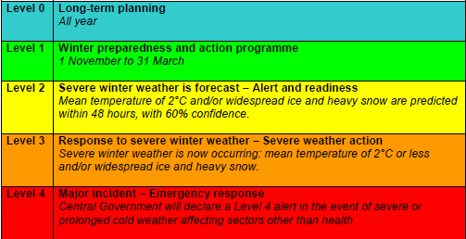

4.3.2 Cold Weather Plans for England

The Cold Weather Plans for England are issued annually and set out the cold weather actions and alert levels.

The plan is for health and social care services and other public agencies and professionals who interact with those most at risk from the health effects of cold weather. It is published on the intranet in the emergency planning section.

Health care professionals should be providing advice and information to the public and particularly to at-risk groups. This includes both general preparation and actions for cold weather and more specific advice when severe cold weather (including snow and ice) is forecast. Public health messages and advice on financial support and benefits can be found in the Keep Warm Keep Well booklet on the www/gov.uk website.

At-risk groups include older people, the very young and people with pre-existing medical conditions as well as those whose health, housing or economic circumstances put them at greater risk of harm from cold weather.

Recommended indoor temperatures

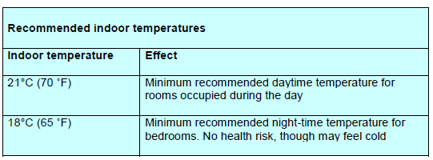

Where it is difficult to achieve such temperatures on Trust premises, staff should be offering hot drinks and ensure that service users are appropriately dressed.

The actions taken by different groups according to the different alert levels are shown in the tables below.
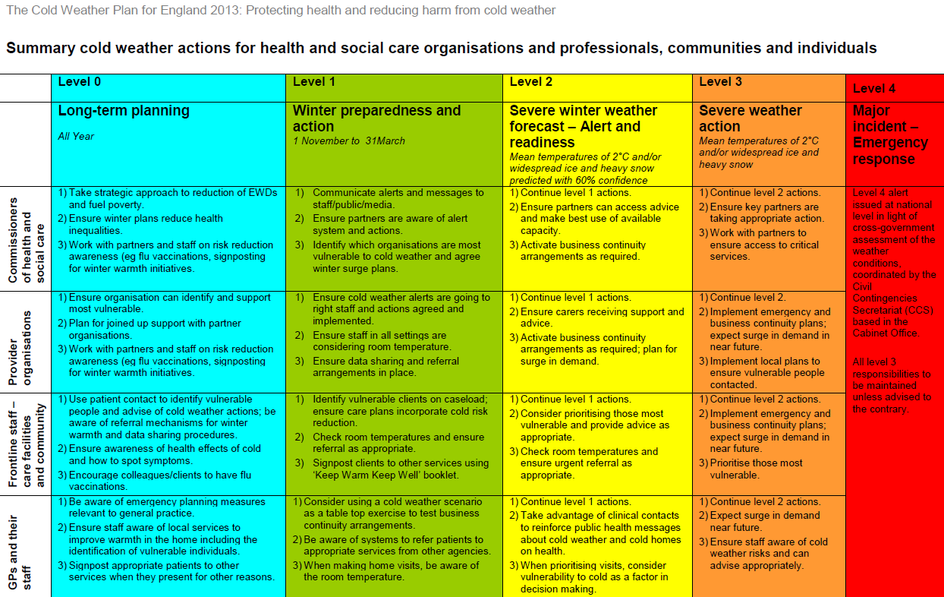
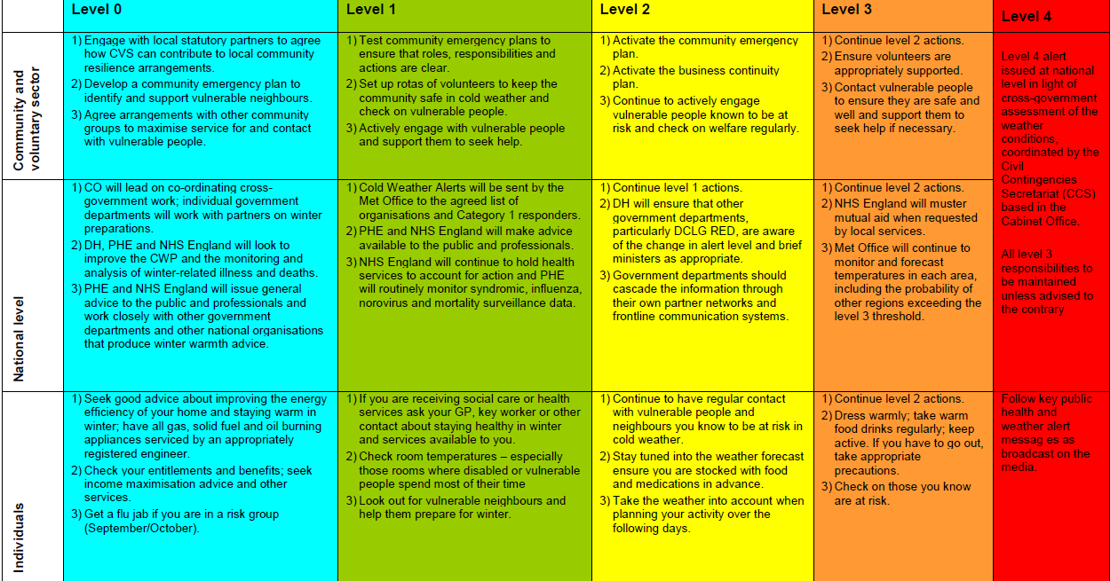
4.4 Severe Weather

4.4.1 Severe Weather Warnings

The Met Office’s National Severe Weather Warning Service (NSWWS) warns organisations and the public about a high-impact weather events, including rain, snow, wind, fog and ice.

This service operates year round across the UK, and can be found on the met office website http://www.metoffice.gov.uk/weather/. A warning will be issued when snow and ice is forecast to cause an impact across a number of sectors, including health. It is issued based on a combination of the impact of the weather, and the likelihood of the weather happening. A NSWWS warning can be issued up to five days in advance of the expected event.

Warning level

Warnings are based on a combination of:
likelihood – how likely the event is to occur
impact – the potential impact the expected conditions may have

Colour of warnings (impact matrix)
Warnings are given a colour depending on a combination of both the likelihood of the event happening and the impact the conditions may have:

red amber yellow
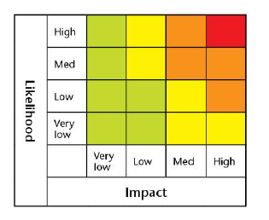

Hazard Manager

Hazard Manager is a one-stop information source for the emergency response community. It is an interactive web portal using maps which can be overlaid with weather and incident related information. It allows users to access their services in one location. "Events" are posted when there is an active incident, which is essential for keeping responders up-to-date with the very latest information and developments as they happen.

The Trust has an account for Hazard Manager, details of which are shown in the Emergency Contact List which is kept on the k-drive. Insert web address.

To receive NSWWS warnings directly, register with hazard manager.
https://register.metoffice.gov.uk/register/hazardmanager/government.html?service=hazardmanager

Informing the Public

Warning and informing the public on the risk of severe weather is the responsibility of the Met Office and Local Authorities.

NHS England for relevant regions, Commissioners, Local Authorities and Public Health England via the local Health Protection Unit may also provide advice to areas affected by severe weather.

Evacuation of affected communities will be led by the Local Authorities, who may contact the Trust for lists of vulnerable people under the Trust’s care. The Trust’s Incident Response Plan sets out how lists of vulnerable people are generated.

5. Actions

5.1 Yellow Alert

On receipt of a Yellow Alert, the Emergency Planning Manager, the Associate Director of Governance & Risk Management or occasionally other delegated members of the Governance Team will inform the Director of Operations, the Director of Nursing, the Director on Call and the Director of Estates and asks the Communications Team to be on standby to inform all staff.

Out of hours the Director on call will monitor the alerts received on the on-call mobile phone and communicate the alerts to on-call managers and activate this plan. An on-call log will be started.

5.2 Amber Alert:

On receipt of an Amber Alert, the Emergency Planning Manager , the Associate Director of Assurance or occasionally other delegated members of the Assurance Team will inform the Director of Operations, the Director of Corporate Affairs, the Director on Call and the Director of Estates.

The Communications Team will be asked to inform all staff.

Service Directors should ensure that teams are aware of the MetFlood Watch and follow the Flood Watch advice.

The planning lists in section 9 should be used.

Service Directors should ensure that teams are aware of the MetOffice website or Hazard Manager and follow MetOffice advice.

Service Directors should nominate a local representative from each site to check whether the severe weather will affect them using the MetOffice website for severe weather warnings. http://www.metoffice.gov.uk/public/weather/warnings/#?tab=map

Immediate Amber Alert Actions:

- Assess the vulnerability of any service users likely to be affected
- Assess impact on travel arrangements for staff to and from work and to and from service users.

5.3 Red Alert

On receipt of a Red Alert, the Emergency Planning Manager, the Associate Director of Assurance or occasionally other delegated members of the Assurance Team will inform the Director of Operations, the Director of Corporate Affairs, the Director on Call and the Director of Estates. The Communications Team will be asked to inform all staff. An Incident Management Team may be established by any of these Directors.

Out of hours the Director on call will monitor the alerts received on the on-call mobile phone and communicate the alerts to on-call managers and activate this plan. An on-call log will be started.

The planning lists in section 9 should be used.

Red Alert Actions:

- Decide what support will be needed by service users in the community based upon the assessment of vulnerability
- Assess whether such support is available, and if not, communicate this to Silver Command
- If severe weather may affect buildings or other risks are imminent, activate the Major Incident Plan.
- Assess whether staff are able to travel to and from work
- Assess whether staff are able to travel to patients and service users.

5.4 Prolonged Episodes of Severe Weather

In a serious or widespread prolonged severe, the Incident Response Plan should be activated and an Incident Response Team appointed as set out in the Incident Response Plan. An Incident Response Centre will be established at Trust Headquarters or, if that is not practicable at any of the other sites that are listed in the Incident Response Plan. The venue used will be decided by the Director leading the Incident Response for the incident taking into account the site(s) affected.

Even if a flood does not directly affect a Trust property, a major incident may still arise. This could be due to many circumstances, for example:

- Loss of critical infrastructure e.g. water or power supply
- Transport difficulties leading to staff absence
- Closure of schools leading to staff absence
- Partner organisations requiring support from the Trust

The Incident Management Team will ensure that:

- a risk assessment should be carried out for the affected location
- risks and consequences from severe weather are appropriately mitigated at Trust and service level
- all parties and agencies required in the response are identified and included in the response (i.e., Estates Department, landlords)
- a communication plan is devised, to inform internal and external stakeholders, service users and carers
- up to date information from the MetOffice is obtained http://www.metoffice.gov.uk/public/weather
- liaison with emergency services is established where required
- liaison with Local Authorities is established where required to obtain information or notify of issues and request assistance or action
- recovery is planned and achieved
- costs are recorded (see section 6)
- the Surge Plan is activated, if required

Contact details

Contact details for local partner Trusts, Local Authorities and Estates Teams of multi-occupied sites are listed in the Incident Response Plan.

  - Mutual Aid

The Incident Management Team will be overseeing mutual aid arrangements with other providers to support the delivery of essential services.

NHS England (London) may be assisting with mutual aid and will be communicating this to the On-Call Director.

5.6 Debrief

Debriefing will proceed as set out in the Incident Response Plan.

  - Recovery

Recovery will proceed as set out in the Incident Response Plan.

6 Reporting

It is likely that NHS England (London and Midlands & East), Local Resilience Forums and Commissioners will introduce a reporting process. This may be via the existing SitRep system or a bespoke system and will be by exception only.

The Incident Management Team will establish an internal reporting system. This may be in advance of sit reps required by external organisations.

Where there are instances of loss, harm or damage, these will be captured on the Inphase Incident Reporting System and the Incident Policy followed.

7 Cost Capture

A cost centre for expenses incurred during and as a result of the severe weather incident incident should be established. The cost centre in the Incident Response Plan may be used if the severe weather incident was unexpected.

Action:
The Director of Operations or nominated deputy should establish a budget record for all costs incurred so that expenditure relating to the incident may be tracked and forwarded to NHS England (London and/or Midlands & East) following the incident if required.

Apportion of costs will need to be agreed by Incident Management Team / Executive Team.

Action:

The Director of Operations will issue clear guidance to staff on how to record costs and expenses in relation to staff absence.

8 Staff Absence

There might be instances where staff are unable to attend work.

Action:
Human Resources may also need to issue guidance to staff on how to record absences and financial implications if they are unable to travel to work due to the transport or weather conditions as per Leave Policy. Local business continuity plans should be activated.

9 Planning for Severe Weather

The most effective way to prepare the Trust for severe weather is to put together business continuity arrangements before a disruption occurs. This will equip services to recover from the incident. Services are required to assess the risk of severe weather and how life and property can be protected as part of business continuity planning.

The Trust’s main role during a period of severe weather will be to ensure business continuity of critical and essential services across the Trust.

The following lists identify important and specific activities that can be done to prepare for severe weather many of the activities will also have contributed to the development of general business continuity plans.

These lists are not exhaustive and not all measures listed are suitable for all services. Depending on the service, its location and its functions, severe weather will affect service delivery and business continuity plans in place differently. I.e.in terms of location, it may be possible to share some resources or staff between services or Directorates.

9.1. Assessing the impacts of severe weather
The list below gives some guidance to basic steps that could make a service more resilient.
Complete | In progress | Not started | Not applicable
 |  |  |  | Identify key services that must be maintained
 |  |  |  | Identify the key services which would be affected by the severe weather .
 |  |  |  | Which critical activities and resources (including employees) support the key services (e.g. raw materials, suppliers, sub-contractor services/products, security)?
 |  |  |  | Consider how internal resources could be re-allocated to ensure the delivery of key services is maintained. Are staff able to safely cover other roles to ensure that key services can be delivered? Will additional training be required?
 |  |  |  | Consider whether service users might need to be evacuated and know where they will be evacuated to how this will happen.
 |  |  |  | In relationship with the Estates Team or landlords, consider what flood protection equipment needs to be put in place.
 |  |  |  | Consider which critical equipment needs to be moved, where to and how.
 |  |  |  | Discuss with suppliers/subcontractors whether they have robust Business Continuity Plans in place – your service’s resilience is only as good as those on whom it depends. Ask your suppliers how they plan to respond to the severe weather and what support they will give to your organisation. Consider whether future contracts should reflect concerns.
 |  |  |  | Decide how a reduction in service could be achieved while still delivering key services. How non-critical work would be stopped safely, smoothly and restarted again when possible to do so.
 |  |  |  | How will the support functions be affected by a severe weather incident? E.g. building maintenance, cleaning, food provisions for staff.
 |  |  |  | Assess the feasibility of increasing flexible working for staff (e.g. working from home).

9.2. Travelling to and from the place of work

Getting staff to their place of work can be difficult during a adverse weather, but there are various options to consider in order to overcome this obstacle.
Complete | In progress | Not started | Not applicable
 |  |  |  | Document how staff usually travel to work and whether and what alternative forms of transport would be available if required
 |  |  |  | Consider whether it is possible for staff to work from home and support this where feasible.
 |  |  |  | Consider the use of satellite offices, if you have them. Staff may live closer to these offices and therefore it may be easier for staff to get to those locations to work.
 |  |  |  | Is car-sharing possible for some staff?
 |  |  |  | Encourage staff to use alternative means of transport instead of private vehicles, this may take longer but may enable staff to get to the organisation’s premises. This could take the form of offering flexibility in their working time or providing relevant facilities e.g. bike racks, showers etc.
 |  |  |  | Is it possible to organise communal travel for some staff, for example by taxi or minibus.
 |  |  |  | Are there local hotels or other facilities where staff could stay?

9.3. Communication
It is crucial to have clear and concise messages ready to give to your staff, stakeholders, and suppliers in the event of disruption.
It is important to ensure that the appropriate message is delivered to the correct people be they a staff member or a service user or carer.

Complete | In progress | Not started | Not applicable
 |  |  |  | Have an agreed procedure on how to communicate plans to staff and what might trigger the business continuity plan being Implemented.
 |  |  |  | Have clear and concise messages ready, and a means of communicating to your staff that you are implementing some business continuity measures and how this will affect them.
 |  |  |  | Ensure that you have a named contact that people within the organisation are aware of and emergency contact details of staff.
Have clear and concise messages ready,
and a means of communicating them to your staff,
to let them know that business is returning to normal and that business continuity measures are no longer in effect.
Consider the messages you might need to give to service users and other stakeholders and the process for doing so. In
some circumstances it may be useful to discuss possible
impacts in advance. This dialogue will help inform planning on
both sides and will be particularly important if services are
likely to be affected.
Consider how your suppliers are going to be affected by a severe weather event in the area . Ensure there are clear lines of communications between you both and a process of keeping supplier and organisation informed of progress.
Discuss with your suppliers how they intend to respond to a severe weather incident in the area.

10. Reference Documents

London Strategic Emergency Plan, March 2010, version 6, published by the
Government Office for London

Cold Weather Plan for England 2013, published by Public Health.

