
Annual planning template for 2025-26

Team/Service: …………………………………………………..

REFLECTIONS ON THE 24-25 ANNUAL PLAN

What have been your key achievements and challenges in delivering your 24-25 plan?

Changes anticipated for 25-26 - please outline any changes anticipated to your service in 2025-26 through local or national policy or commissioning changes

POPULATION HEALTH

Sources of data and resources to support the discussion:

- Population Health Team: laura.austincroft@nhs.net
- Population Health Annual Report
- Outcome measures available in PowerBI
- https://www.england.nhs.uk/integratedcare/phm/
- https://www.england.nhs.uk/wp-content/uploads/2014/06/mecc-guid-booklet.pdf
- Population health data pack – https://www.elft.nhs.uk/information-about-elft/our-strategy-vision-and-values/population-health

The 24/25 trustwide population health priorities focused on the following areas alongside action against specific objectives as set out in the ELFT strategy:
- Improving physical healthwith a focus on people with Severe Mental Illness and learning disabilities
- Improving employment support for service users, carers and residents in service areas
- Improving income maximization support

What are the main areas where you can make an impact on population health,including work with partners?
What have been your main achievements with regards to population health in 2024/25?

What are the major challenges you face in making improvements to the health and well-being of population groups you are in close contact with?

What are the major inequalities in the health of these populations that need to be addressed?
Are there gaps in service provision that are impacting population health?

QUALITY, SAFETY, PERFORMANCE AND SERVICE USER EXPERIENCE

Sources of data and resources to support the discussion:

- Working Together Group and directorate People Participation lead
- Trustwide Working Together Group priorities
- Service user feedback, quality and safety data, activity data in PowerBI
- Monthly contract reports
- Benchmarking Reports and Model Health System

The 24/25 trustwide Working Together Group priorities for people participation are:
- Addressing inequalities ensuring services are accessible to all
- Highlight and expand people participation initiatives
- Create more opportunities for service users/carers to gain education and become educators
- Foster meaningful engagement to enhance participation and co-production
- Focus on removing barriers to care and increasing employment opportunities for service users
- Promote creative and healthy lifestyle options

How are you actively integrating co-production with service users and carers into your priorities? In what ways are they involved in decision-making and shaping these priorities?
What does your service user feedback tell you about the gaps and opportunities to improve the service you provide?

What does your broader quality and safety data say about emerging themes, strengths and opportunities for improvement?

What areas of quality, safety, performance and service user experience will you be prioritising in 25-26, and how will you be addressing these areas?

STAFF EXPERIENCE

Sources of data and resources to support the discussion:

- Model Health System (National Workforce Benchmarking Reports)
- People and Culture business partners
- PowerBI data on people – vacancies, turnover, recruitment, sickness, training, supervision, pulse survey
- NHS annual Staff Survey results

What is your summary of people and workforce issues for the team (e.g. recruitment, retention, wellbeing, engagement, sickness, staff feedback)?

What plans will you put in place to address vacancies that you expect for 2025/26? Will you aim to recruit to these, amend skill-mix, or remove posts?

Do you expect to have agency roles in the team in April 2025, and if so what are your exit plans to resolve this?

What people areas do you plan to focus on in 2025/26, and how?

IMPROVING VALUE

Sources of data and resources to support the discussion:
- Royal College of Psychiatrists 10 key areas for clinical services to make changes to meet climate action requirements
- Finance Business Partners
- Contracts and Commissioning team

What areas within sustainability have you made progress in over the last 2 years?

Which areas will you focus on for sustainability in the next year? Please add specific measurable goals you intend to achieve

What are the cost pressures that you anticipate will be present in 25-26, and your plans to address these?

What are your plans for cost savings in 25-26?

PRIORITIES FOR 2025/26

Please complete the attached Power Point, Driver Diagram.
Based on the above prompts, please create the one-page plan (using the separate attached PPT template), and insert below. The table on the second page will help you describe the quarterly milestones, lead for each workstream, and support needed to deliver.

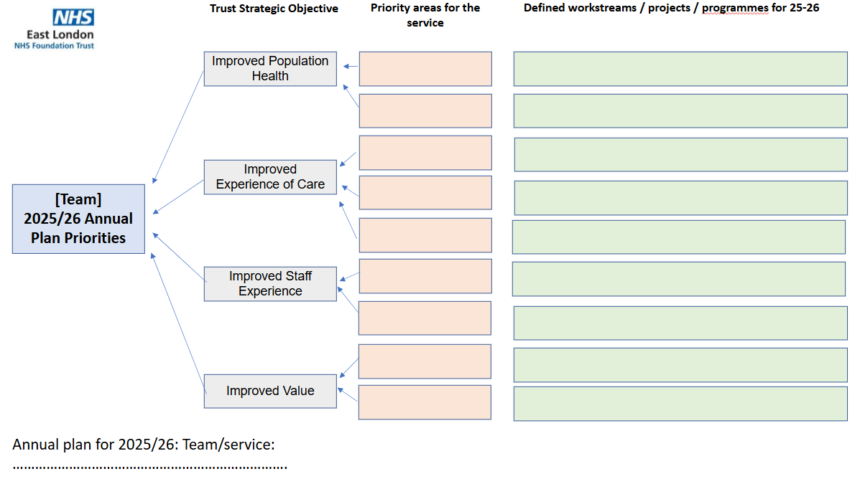
Priority area | Where do we expect to be by |  |  |  | What data will be used to monitor progress? | What support is required to achieve this? | Accountable lead
Priority area | Q1 | Q2 | Q3 | Q4 | What data will be used to monitor progress? | What support is required to achieve this? | Accountable lead

