
Annual planning template for 2025-26

Directorate: …………………………………………………..

REFLECTIONS ON 24-25 ANNUAL PLAN & CORPORATE 5-YEAR VISION

What have been the key achievements and challenges with working towards the Corporate Services 5-year vision (see image above)?

Based on past DMT Away Day vision exercises for corporate functions, how do you see the team evolving and where are there opportunities to do things differently?

POPULATION HEALTH

Sources of data and resources to support the discussion:

- Population Health Team: laura.austincroft@nhs.net
- Population Health Annual Report
- Outcome measures available in PowerBI
- https://www.england.nhs.uk/integratedcare/phm/
- https://www.england.nhs.uk/wp-content/uploads/2014/06/mecc-guid-booklet.pdf
- Population health data pack – https://www.elft.nhs.uk/information-about-elft/our-strategy-vision-and-values/population-health

The 24/25 trustwide population health priorities focused on the following populations:
- Improving physical health
- Improving employment support
- Improving income maximization

How will you support DMTs to make improvements to the health of their populations?

QUALITY, SAFETY, AND PERFORMANCE

Sources of data and resources to support the discussion:

- Working Together Group and directorate People Participation lead
- Trustwide Working Together Group priorities
- Service user feedback, quality and safety data, activity data in PowerBI
- Monthly contract reports
- Benchmarking Reports and Model Health System

The 24/25 trustwide working together group priorities for people participation are:
- Addressing inequalities ensuring services are accessible to all
- Highlight and expand people participation initiatives
- Create more opportunities for service users/carers to gain education and become educators
- Foster meaningful engagement to enhance participation and co-production
- Focus on removing barriers to care and increasing employment opportunities for service users
- Promote creative and healthy lifestyle options

How are you actively integrating co-production with service users and carers into your priorities? In what ways are they involved in decision-making and shaping these priorities?
What performance and quality indicators will be used to measure success in corporate productivity?
Are there opportunities to improve decision-making processes and governance within your corporate function to enhance responsiveness and agility?

STAFF EXPERIENCE

Sources of data and resources to support the discussion:

- Model Health System (National Workforce Benchmarking Reports)
- People and Culture business partners
- PowerBI data on people – vacancies, turnover, recruitment, sickness, training, supervision, pulse survey
- NHS annual Staff Survey results

What is your summary of people and workforce issues in the directorate (e.g. recruitment, retention, wellbeing, engagement, sickness, staff feedback)?

How well do you understand capacity within your teams (through demand/capacity planning at service level, and job planning), and what plans do you have to better maximise capacity in 25-26?

What plans will you put in place to address vacancies that you expect for 2025/26? Will you aim to recruit to these, amend skill-mix, or remove posts?

What people areas do you plan to focus on in 2025/26, and how?

IMPROVING VALUE

Sources of data and resources to support the discussion:
- Royal College of Psychiatrists 10 key areas for clinical services to make changes to meet climate action requirements
- Finance Business Partners
- Contracts and Commissioning team

What areas within sustainability have you made progress in over the last 2 years?

Which three areas will you focus on for sustainability in the next year? Please add specific measurable goals you intend to achieve

Reflecting on the initial opportunities discussed to ensure financial viability within corporate services, what other opportunities are there to explore in 2025/26?
How can we streamline corporate structures to reduce inefficiencies and duplication of roles? Are there opportunities to share functions, responsibilities and resources across services?
How can your team be optimised to deliver better value for money?

Is the alignment of your work better suited to a different model, or should it be integrated into another team?
What are the cost pressures that you anticipate will be present in 25-26, and your plans to address these?

PRIORITIES FOR 2025/26

Please complete the attached Power Point, Driver Diagram.
Based on the above prompts, please create the one-page plan (using the separate attached PPT template), and insert below. The table on the second page will help you describe the quarterly milestones, lead for each workstream, and support needed to deliver.

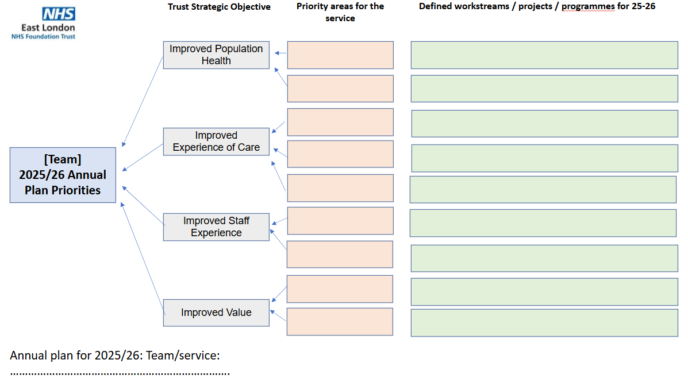
Priority area | Where do we expect to be by |  |  |  | What data will be used to monitor progress? | What support is required to achieve this? | Accountable lead
Priority area | Q1 | Q2 | Q3 | Q4 | What data will be used to monitor progress? | What support is required to achieve this? | Accountable lead

